ARMA-GARCH approach for modeling the mean and volatility of Bitcoin price

Dr. Yong Zheng

Illinois Institute of Technology  
Department of Information Technology & Management

yzheng66@iit.edu

Nastaran Ghane

Illinois Institute of Technology  
Department of Industrial Technology & Management

nghane@hawk.iit.edu

Milad Sabouri

Illinois Institute of Technology  
Department of Information Technology & Management

msabouri@hawk.iit.edu

**ABSTRACT**

In this paper, we tried to model the price of Bitcoin based on autoregressive moving average-generalized auto regressive conditional heteroscedasticity (ARMA-GARCH) approach.

**CCS Concepts**

**Keywords**

GARCH, Bitcoin

# INTRODUCTION

Blockchain is a new phenomenon which is going to change many aspects of modern societies. Most popular application of blockchain is digital crypto currencies. Digital cryptocurrencies are one of the hottest topics in data science, economics, finance, and technology. Currently, Bitcoin is the most famous digital cryptocurrency. So, exploring and discovering the relations and finding the patterns between data which are produced by selling and buying the Bitcoin can be valuable. In this paper, we are going to find a prediction model for the Bitcoin price. We have the previous data of Bitcoin market and try to use Time-Series techniques to predict the future price in the market.

# Experimental Setup

## Data Set

Data Set which is used for this paper is downloaded from Kaggle website [1]. However, it originally is collected from the CoinMarketCap [2] and is accessible for Kaggle website’s users. The data set includes the price for 1,783 days which is equivalent of 257 weeks.

## Configuration

To apply Time-Series techniques, the original data were transformed to return values. According to ACF plot for return values, it does not meet the stationary requirement. So, the return daily data were transformed to return weekly data which is illustrated in Figure 1.

Figure 1 indicates that the data have approximately constant mean, however, the variance still is not constant. Hence, we try to use GARCH approach [3, 4] to find out whether we can model the price or not. We use the data for 247 weeks to build the model. Then, predict values for the next 10 weeks. The results show on Figure 2.

# Conclusion

Figure 2 shows the predicted values (red line) which are predicted by GARCH model. The green line is the observed data. It seems that the prediction values cannot fit exactly on the observed values. So, it can be concluded that price is not the only factor for predicting the future and probably there are other factors which have effects on the price.

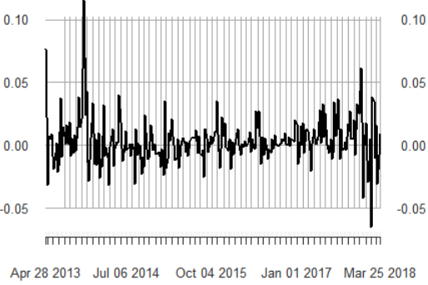

Figure 1. Bitcoin weekly price Time-Series plot

A close up of a map

Description generated with very high confidence  
Figure 2. Predicted price vs. Observed price for the last 10 weeks of the data set

# REFERENCES

1. <https://www.kaggle.com/jessevent/all-crypto-currencies>
2. <https://coinmarketcap.com>
3. Engle RF. GARCH 101: the use of ARCH/GARCH models in applied economics. J Econ Perspect 2001
4. René Carmona, Statistical Analysis of Financial Data in R, Springer 2014