# Bitcoin Price Prediction

**Nastaran Ghane** (A20388942) / Monday

**Milad Sabouri** (A20389859) / Monday

**Time-Series Models**

# Introduction

Blockchain is a new phenomenon which is going to change many aspects of modern societies. Most popular application of blockchain is digital crypto currency. Digital cryptocurrencies are one of the hottest topics in data science, economics, finance, and technology. Currently, Bitcoin is the most famous digital cryptocurrency. So, exploring and discovering the relations and finding the patterns between data which are produced by selling and buying the Bitcoin can be valuable. In this project, we are going to find a prediction model for the Bitcoin price. We have the previous data of Bitcoin market and try to use Time-Series technique to predict the future price in the market.

# Data Sets

Data Set which is used for this project is downloaded from Kaggle website. However, it originally is collected from https://coinmarketcap.com/ and is accessible for Kaggle website’s users. As mentioned earlier, the goal for this project is to create a Time-Series model to forecast Bitcoin’s price in future. The dependent variable for the model is price. There are eight variables in the dataset which are:

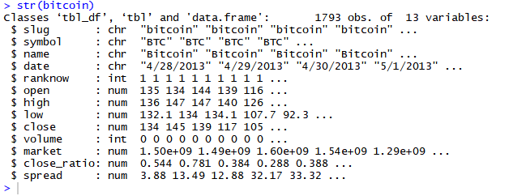

The following are descriptions of each variables:

$ **open**: The $ amount in US Dollars that the day started at

$ **high**: The highest $ amount it got to in US dollars that day

$ **low**: The lowest $ amount it got to in US dollars that day

$ **close**: The $ amount in US dollars that the day finished at

$ **volume**: The $ value in US dollars of how many were exchanged that day

$ **market**: The total amount of market capital (combined worth) in US dollars

$ **Close**_ratio = The daily close rate, min-maxed with the high and low values for the day.

$ **Spread** = The $USD difference between the high and low values for the day.

Moreover, data is collected from 28/04/2013 to 25/03/2018 and it contains 1793 records.

# Research Problems

Cryptocurrency’s market is so attractive for individuals who are interested on Stock market. However, there are many uncertainties about its future market. Since, blockchain technology is an inevitable fact for near future, reducing the uncertainties are so important. To do so, we are trying to apply Time-Series modeling technique to find an appropriate prediction model for most recent valuable cryptocurrency, Bitcoin.

The problem that we are going to solve with doing this project is providing a reasonable and convincing reason for making decision about investment on Bitcoin.

# Potential Solutions

In this problem we have price with its timestamp and we need to use previous data to predict future. So, it is a Time-Series problem. To solve this problem, first, we need to confirm whether it is a linear Time-Series or not. To do that we checkout the following requirements:

* 1. **Stationarity**
     + **Time-Series Plot (Mean, Variance)**

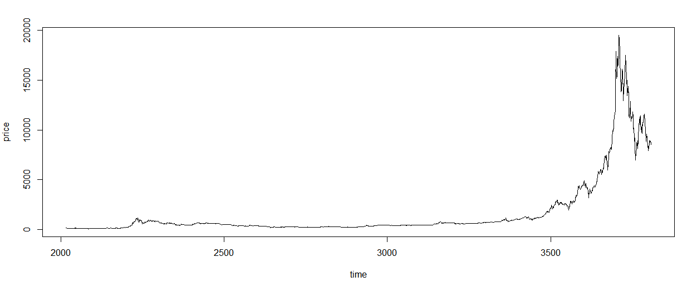

The above plot shows trend and sessional variation so, we need to convert the data. We Applied Simple Return and create the plot again:

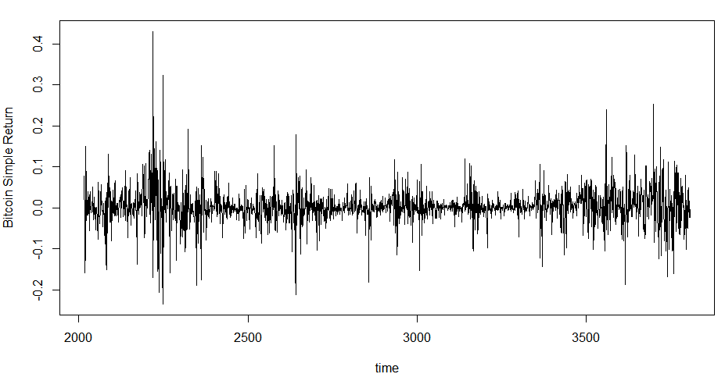

In terms of constant mean we can consider that the above plot has a constant mean.

* **ACF Plot**

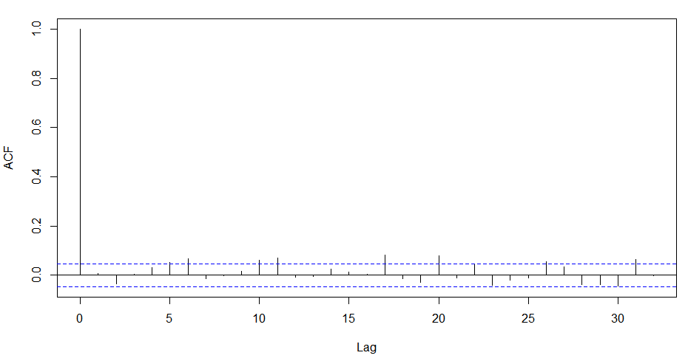

* 1. **Serial Dependency**

**ACF Plot:** There is at least one ACF significant non-zero value. It means that in our data set at timestamp ***t*** it has strong correlation with previous data, so we can use the previous data to predict the future.

**LJUNG-BOX:** according to Ljung-Box test for lag 12 the p-value is less than α:

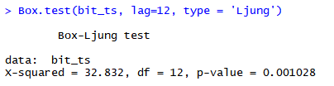

According to above results, it seems that we can use linear Time-Series on our data set to predict the future price.

Moreover, we examined the Histogram and QQ-Plot of simple return data:

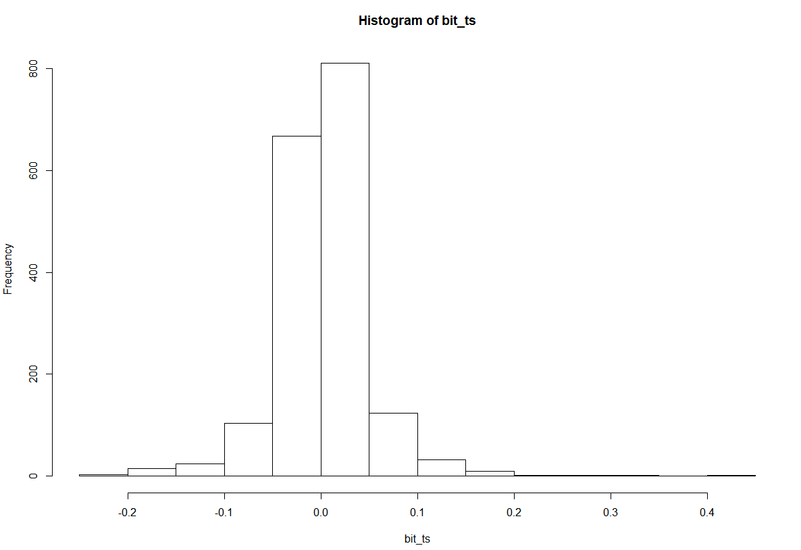

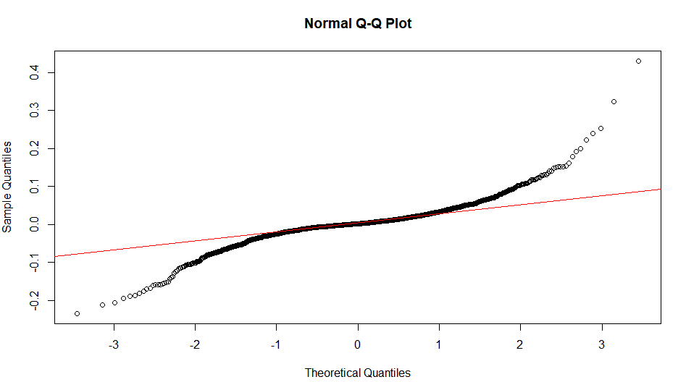

# Evaluations

Our dataset includes 1793 records so, we’ll use hold-out evaluation method to evaluate our model.

# Expected Outcomes

Our expected outcome is employing last five-years daily Bitcoin price to achieve a Time-Series prediction model to forecast future price for the Bitcoin appropriately.