**Group Number: Title of your Projects**

For example: Group 5: Build a recommender systems using collaborative filtering

|  |  |  |  |
| --- | --- | --- | --- |
| First Name | Last Name | Monday or Tuesday class | Share project with ITMD 525? (Y or N) |
|  |  |  |  |
|  |  |  |  |
|  |  |  |  |

Table of Contents

**1. Introduction** 2

**2. Data** 2

**3. Problems to be Solved** 2

**4. Data Processing** 2

**5. Methods and Process** 2

**6. Evaluations and Results** 2

6.1. Evaluation Methods 2

6.2. Results and Findings 2

**7. Conclusions and Future Work** 2

7.1. Conclusions 2

7.2. Limitations 2

7.3. Potential Improvements or Future Work 2

# **1. Introduction**

Blockchain is a new phenomenon which is going to change many aspects of modern societies. Most popular application of blockchain is digital crypto currency. Digital cryptocurrencies are one of the hottest topics in data science, economics, finance, and technology. Currently, Bitcoin is the most famous digital cryptocurrency. So, exploring and discovering the relations and finding the patterns between data which are produced by selling and buying the Bitcoin can be valuable. In this project, we are going to find a prediction model for the Bitcoin price. We have the previous data of Bitcoin market and try to use Time-Series technique to predict the future price in the market.

# **2. Data**

Data Set which is used for this project is downloaded from Kaggle website. However, it originally is collected from https://coinmarketcap.com/ and is accessible for Kaggle website’s users. As mentioned earlier, the goal for this project is to create a Time-Series model to forecast Bitcoin’s price in future. The dependent variable for the model is price. There are eight variables in the dataset which are:

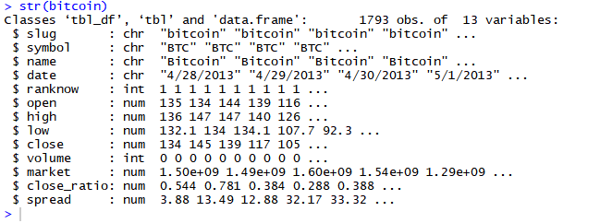

The following are descriptions of each variables:

$ **open**: The $ amount in US Dollars that the day started at

$ **high**: The highest $ amount it got to in US dollars that day

$ **low**: The lowest $ amount it got to in US dollars that day

$ **close**: The $ amount in US dollars that the day finished at

$ **volume**: The $ value in US dollars of how many were exchanged that day

$ **market**: The total amount of market capital (combined worth) in US dollars

$ **Close**_ratio = The daily close rate, min-maxed with the high and low values for the day.

$ **Spread** = The $USD difference between the high and low values for the day.

Moreover, data is collected from 28/04/2013 to 25/03/2018 and it contains 1793 records.

# **3. Problems to be Solved**

Xxxxx

# **4. Data Processing**

# **5. Methods and Process**

Introduce the details about your methods and process

Provide necessary snapshot of the outputs and expalantions

# **6. Evaluations and Results**

## 6.1. Evaluation Methods

xxxx

## 6.2. Results and Findings

xxx

# **7. Conclusions and Future Work**

## 7.1. Conclusions

xxx

## 7.2. Limitations

xxx

## 7.3. Potential Improvements or Future Work

Xxx