|  |
| --- |
| **Faculty of technical sciences**  **Novi Sad**  **Library information system**  **Authors: Dejan Dopudj SW 25/2019, Dušan Lazić SW 4/2019, Pavle Glušac SW 19/2019, Milan Sekulić SW 54/2019**  **Subject: Software Specification and Modeling**  **Mentor: Vejnović Mina**  **Novi Sad, July 2021.** |

Table of contents

1. Introduction
   1. Purpose
   2. Document conventions
   3. Intended audience and reading suggestions
   4. Scope
   5. References
2. Overall Description
   1. Product perspective
3. Functional requirements
   1. Color coding
   2. System
   3. Unregistered user
   4. Member
   5. Librarian
   6. Administrator
4. Non-functional requirements
5. Design mockup
6. Introduction
   1. Purpose

This document is intented to describe this library system and its most important components.

* 1. Document conventions

Header contains the name of the section, while footer contains number of page. Every section contains numerous subsections that follow the same theme.

* 1. Intended audience and reading suggestions

This document is intended for helping develepors write software in an easier manner by the means of functional and non functional requirements and helping new users accommodate into the software package which is being described. It is recommended to read the entire document. As previously stated, document is divided in section which are then divided in subsections and therefore searching for something important is trouble-free.

* 1. Scope

This project is intended to simplify and expedite library staff experience, as well as members experience. It is designed to allow minimization of human contact through online reservations which is more then necessary with today's world situation. It also allows administrators to have in depth analysis over staff, members and books.

* 1. References

IEEE document template

1. Overall description
   1. Product perspective

Storing data without a properly developed system is both dangerous and irresponsible. This software solves both problems and creates decentralized system that can be easily upgraded if necessary. Opening new libraries is also supported and will not cause any problems since they are all connected.

1. Functional requirements
   1. Color coding

Functionality importance

Implementation plan

● high priority

● medium priority

● low priority

▲ mandatory

▲ if possible

▲ not planned

* 1. System

● ▲ Software should generate reports for administrators

● ▲ It should send notifications to users sent a day before membership expiration, book returndue or reservation due.

● ▲ It should be accesible to anyone who has internet connection.

● ▲ Of course, based on their role they will have different levels of clearance.

● ▲ Based on their category, number of book which can be taken varies, as well as time window in which you can return said book without consequences. This data is presented in table below.

|  |  |  |  |  |  |  |
| --- | --- | --- | --- | --- | --- | --- |
|  | Scholar | Student | Employed | Pensioners | Honorary | Kids |
| numOfDays | 15 | 15 | 15 | 21 | 30 | 15 |
| numOfBooks | 3 | 5 | 5 | 3 | 10 | 3 |

* 1. Unregistered user

● ▲ Unregistered user should be able do search book based on authors, contributors, tags, editions and publishers.

* 1. Member

● ▲ Book can be reserved and taken only by members.

● ▲ Members can also see their reservation history as well as book taken history.

● ▲ It should also be possible for them to write reviews for books they have already returned.

* 1. Librarian

● ▲ Librarians have to mark a book as returned and taken.

● ▲They handle reservations.

● ▲They also needs to check every review before approving it.

● ▲They are also responsible for data maintenance on members and books.

* 1. Administrator

● ▲Administrator can alter data of prices, rules, librarians and objects.

1. Nonfunctional requirements

* This software should work on every majorly used browsers (Google Chrome, Apple Safari, Firefox,Microsoft Edge) provided that cookies are allowed.
* Running queries shouln't take longer then 5 seconds.
* This software should support up to 10000 visitors at once, and its performance shouldn't decrease before 5000 visitors.
* With library expansions, system should be able to upgrade to support up to 40% of active members at once.
* Supported operating systems are linux, windows 7 and newer versions of windows.
* Recommended hardware requirements are 2.0GHz or faster processor, dual core or better and at least 1 GB of RAM.
* Software will be available 24 hours a day with monthly maintenace down time (every first day of the month for maximum of 2 hours).

1. 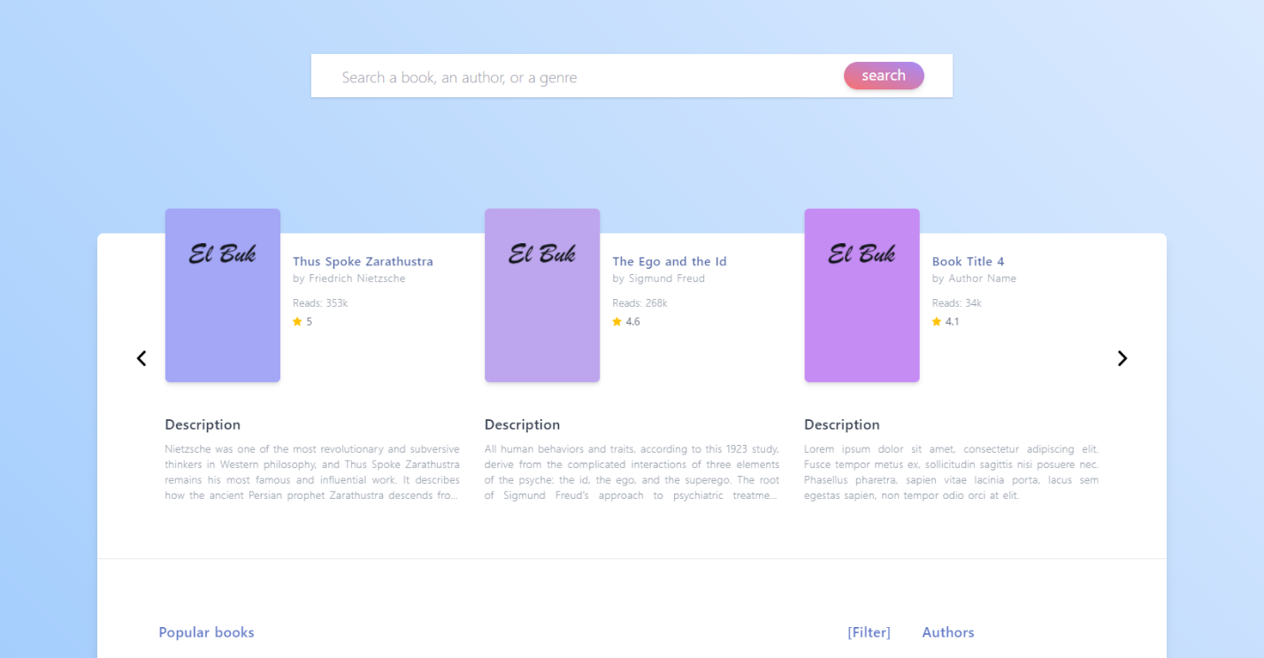Design mockup