User Manual

**Basics**

The game is turn based is a web-board game where up to 4 players can play at a time. As you first open the site you will be prompted to play the game, if you click on “Play Game” you will be asked to define the amount of players that will be playing.

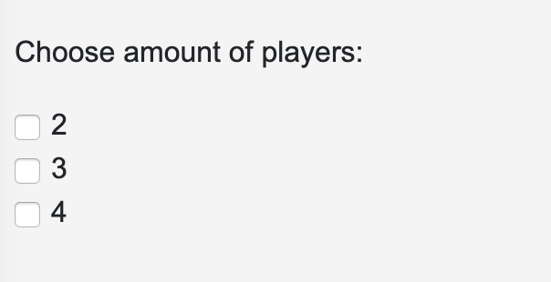

Once the amount of players is chosen and the game is started, a sidebar will slide from the left of the screen and the board will show up. The sidebar serves as a menu from which the current player will be displayed as well as the amount of money it holds for that turn, the amount of available moves, and the information related to any of the player’s items/characters.

As a default the castle item is chosen when a turn or the game starts. The sidebar displays the actions the any item is able to do such as create characters in case of the castle item (characters: troops and constructions).

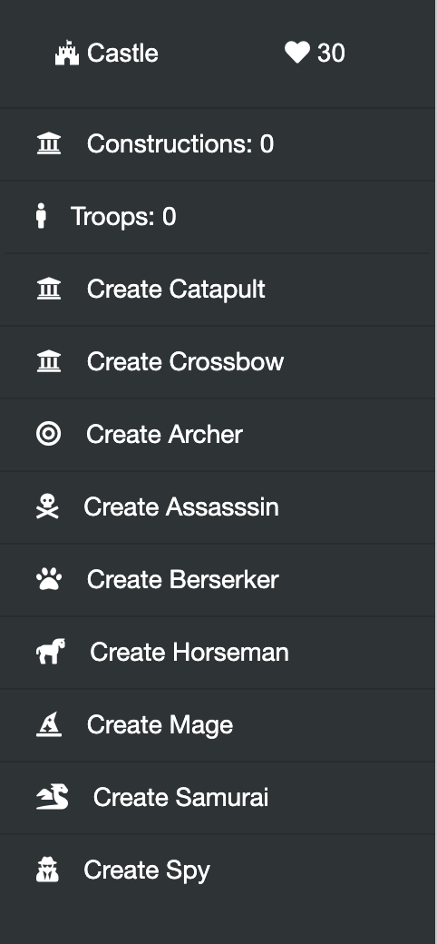

If the character hovers over a character's creation menu option a screen wills how the respective stats for that character.

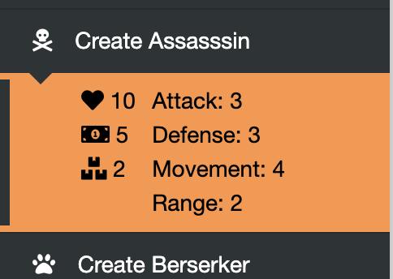

Construction will take 30 seconds to be created and added to the players constructions.

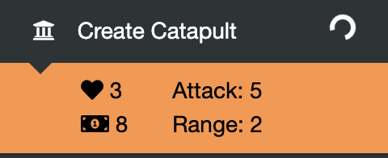

Upon creating the character it will be added to the players troops or constructions, from which a player can deploy a troop or attack in case it is a construction. The available moves or attacks will be highlighted in the board.

Available moves:

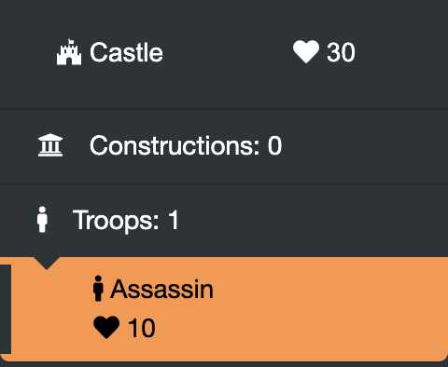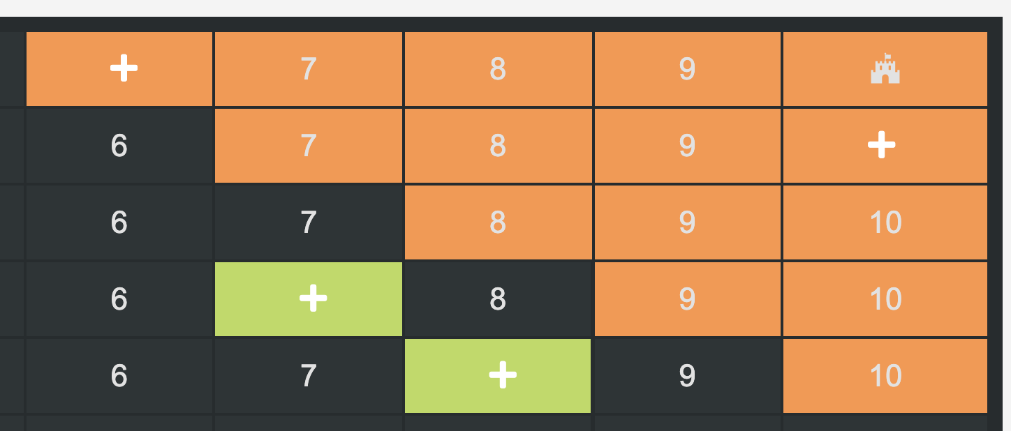

Available attacks:

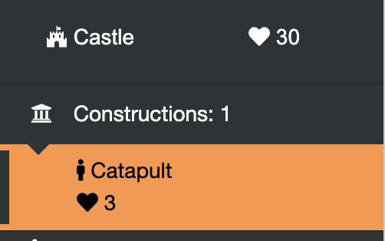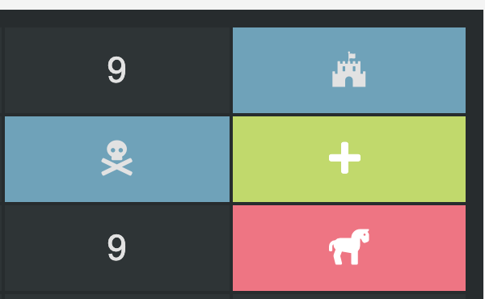

**Power-Ups**

Upon starting the game there will be cases highlighted in a different color with a plus “+” sign on it. Each one of these cases represents a power-up waiting to be picked.

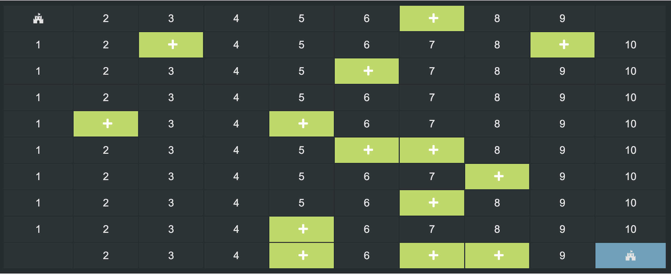

When a character lands on it the player will be prompted to keep it. If the power-up is kept it will be found on that character menu. The power-up will take effect as soon as it is used and will wear out on the players next turn. There are four types of power-ups boos attack, boost defense, reduce attack and reduce defense, the player won’t be able to tell apart from the boost or reduce so using power-ups has a risk to it.

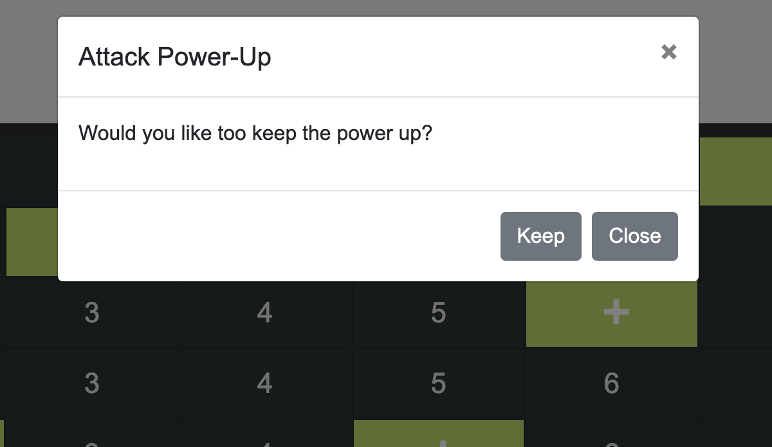

**Gems**

Similar to the power-ups there are cases that hold gems which are waiting to be picked. These cases however are not highlighted, the player must step over one and if there is a gem on it a message will pop out asking the player whether or not the found gem should be picked. If it is picked the gem will be transformed into gold for the castle to use if the character holding the gem manages to get back to the castle.

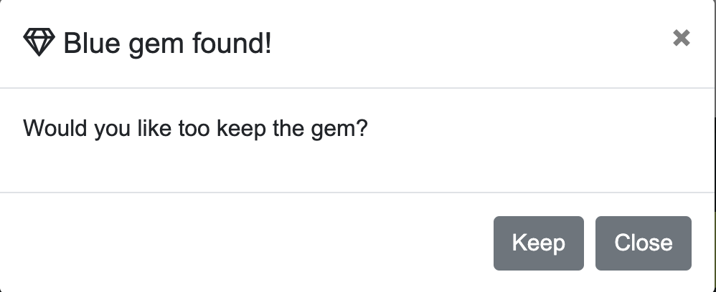

There are three types of gems, each with a different gold value equivalent:

1. White Gem: 1
2. Blue Gem: 2
3. Green Gem: 3

**Spy:**

There is a player character called the spy which has the unique ability to turn invisible to the opponents player if said character is within a 5 cases range from the opponents castle. Besides this the spy also has the ability to infiltrate an opponent's castle and steal gems from it.

**Game win**

In order to win the game the player must destroy all enemy castles.