BeeAware Global
Product + Data + Engineering Blueprint
From community safety map to global location-risk intelligence
Working document for Product Owner, Engineering & Data
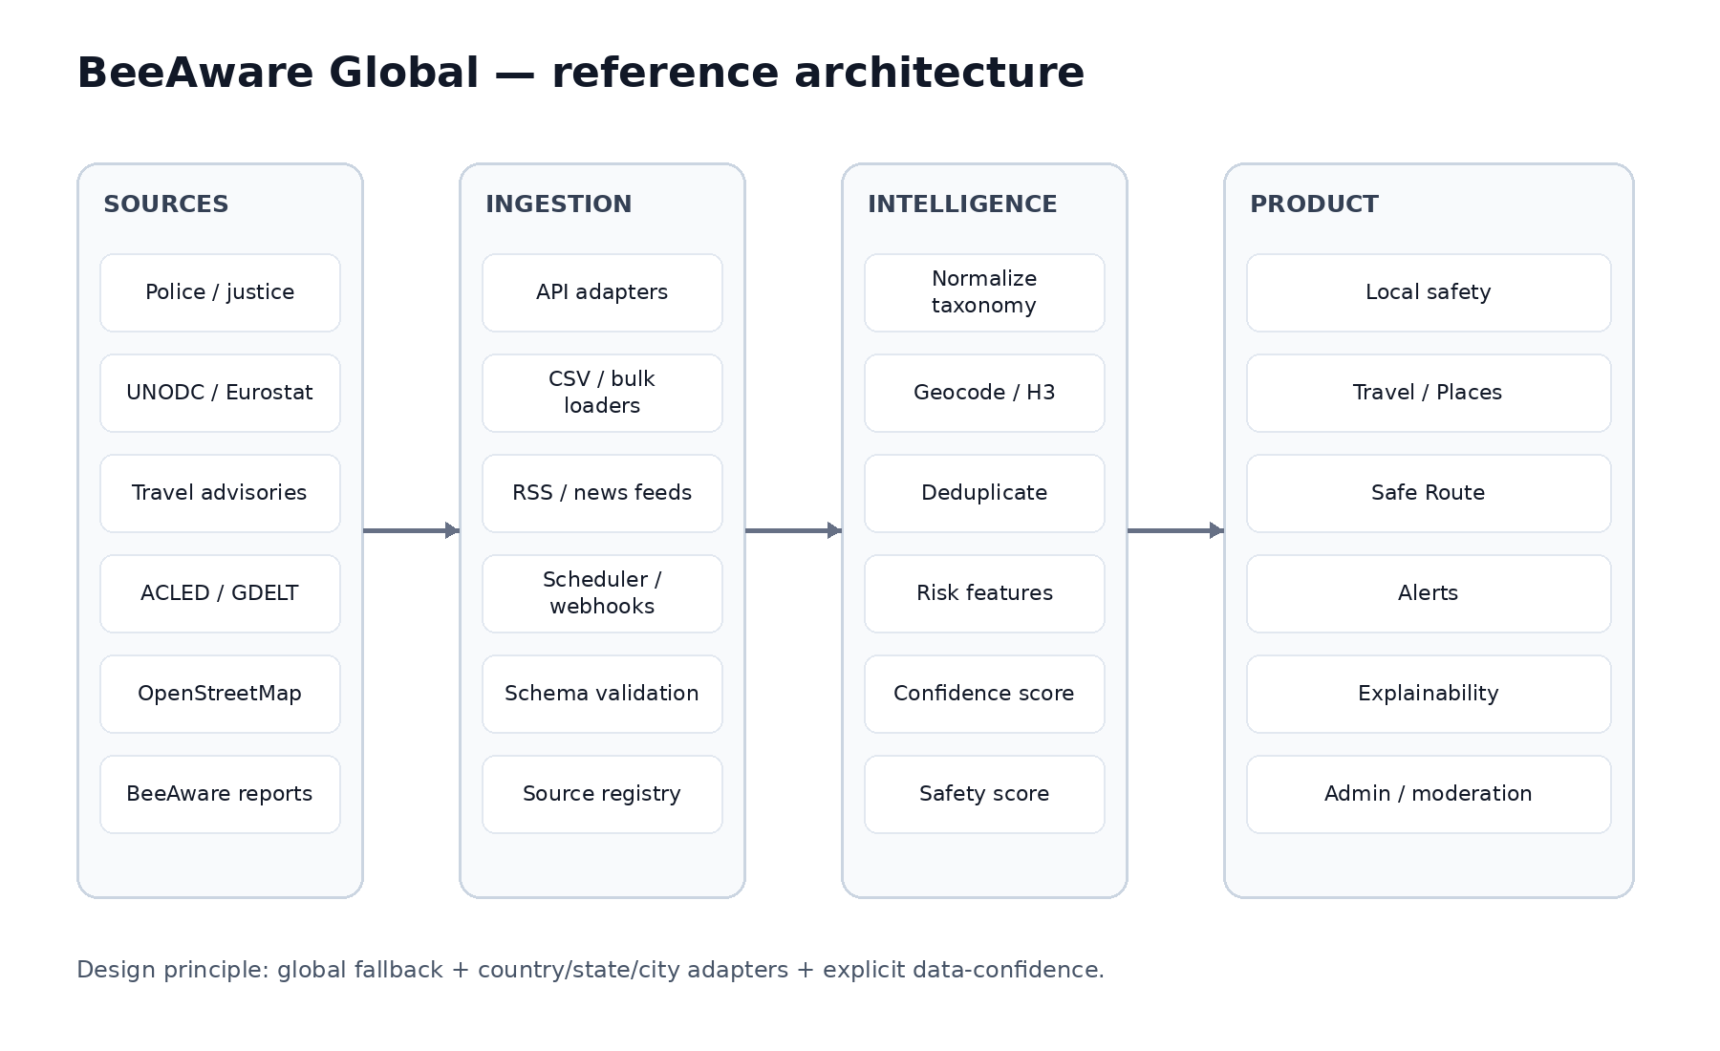
Version 0.1 · 22 August 2026

1. Executive brief
BeeAware should evolve from an incident map into a global location-safety intelligence platform. The same data engine should support residents, travellers and route decisions, while making data quality and provenance explicit.
Product surface | Core user question | Primary output
BeeAware Local | What is the risk around me? | Neighbourhood safety, recent incidents, alerts
BeeAware Travel / Places | Where should I stay? | Place comparison, day/night and traveller risk
BeeAware Routes | How should I get there? | Fastest / Balanced / Safest route exposure
BeeAware Alerts | What changed? | Location-aware, time-sensitive risk notifications

Product principles
- Global coverage through fallbacks; local precision through country/state/city adapters.
- Never equate 'no data' with 'safe'. Data confidence is a first-class output.
- Separate observed facts, official advisories, community reports and modelled/inferred risk.
- Every score must be explainable: source, freshness, geography, transformation and confidence.
- Use a global canonical taxonomy (preferably aligned to UNODC ICCS) and map each local source into it.
- Do not expose source coordinates as exact incident addresses when the publisher anonymises or aggregates them.

2. Target user journeys
Persona | Trigger | Decision | BeeAware job
Resident | Moving / daily awareness | Is this area changing? | Baseline + recent incidents + alerts
Traveller | Choosing hotel / district | Where is safer for my party? | Compare places + traveller-specific risk
Commuter | Walking/transit journey | Which route reduces exposure? | Route risk by time of day
Parent | Family outing / school route | What is the lower-risk option? | Contextual route/place safety
Operations / moderator | Source/report review | Can this signal be trusted? | Provenance, dedupe, moderation, audit

3. Reference architecture

The architecture deliberately decouples ingestion from product surfaces. A new source should be integrated once, normalised once, then become reusable across Local, Travel, Routes and Alerts.

3.1 Data flow
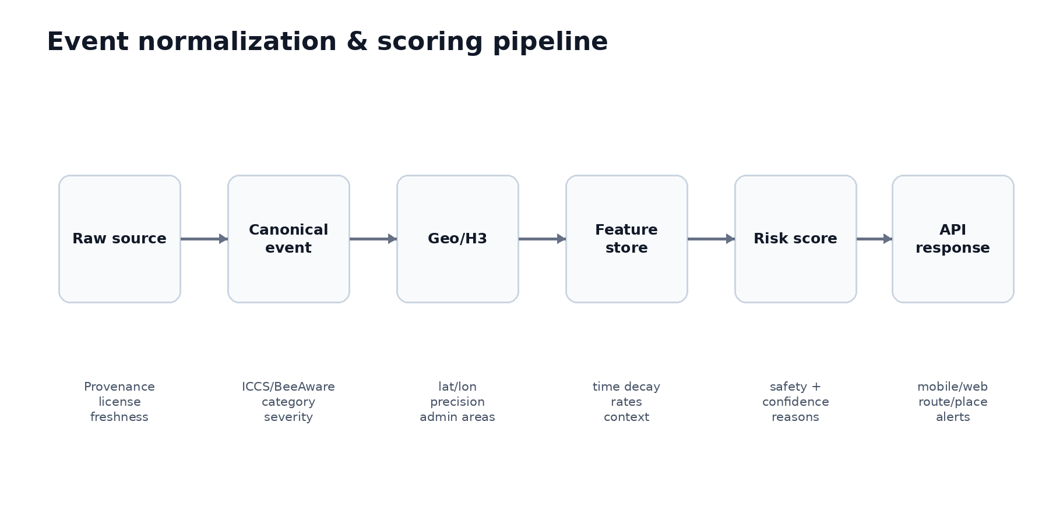

3.2 Recommended logical services
Service | Responsibility | Suggested interface
Source Registry | Metadata, licence, freshness, geo/time resolution, health | Admin + internal API
Ingestion Workers | API pulls, bulk CSV, RSS/news, retry/idempotency | Scheduled jobs / queues
Normalizer | Map local offence/event fields to canonical schema | Async worker
Geo Service | Geocode, admin boundaries, H3 indexing, precision flags | Internal API
Risk Feature Store | Precomputed time-window and context features | Postgres/PostGIS + materialized views
Risk Engine | Safety/confidence/reasons by cell/place/route | REST/Edge function
Routing Risk Layer | Scores route segments; does not replace routing provider | Route-risk API
Moderation | Community report verification / abuse / duplicates | Admin UI
Public API/BFF | Mobile/web response shaping, auth, caching | REST/GraphQL/BFF

4. Canonical data model
Entity | Minimum fields | Notes
source_registry | source_id, authority, country, type, endpoint, licence, cadence, geo_resolution, reliability | Control plane for every feed
raw_events | source_id, source_record_id, payload, ingested_at, checksum | Immutable/raw; supports replay
normalized_events | event_id, category, subcategory, occurred_at, lat/lon, geo_precision, severity, provenance | Canonical event record
geographies | geo_id, country, admin levels, geometry, H3 indexes | Boundaries and spatial joins
risk_cells | h3, window, category features, current alerts, confidence | Precomputed serving layer
travel_advisories | issuer, country/region geometry, level, text summary, effective_at | Keep issuer-specific level
community_reports | report_id, category, location, time, verification, moderation | Never merge trust state silently
places | place_id, type, point/geometry, external ids | Hotel/POI comparison surface
route_risk | route_id, segment/cell, exposure, reasons, time_context | Ephemeral or cached

4.1 Canonical event example
{
"event_id": "bea_...",
"source_id": "uk_police",
"source_record_id": "...",
"country": "GB",
"category": "THEFT",
"iccs_code": "...",
"occurred_at": "2026-07-01T00:00:00Z",
"location": {"lat": 51.3, "lon": -0.3, "precision": "ANONYMISED_POINT"},
"severity": 2,
"verification": "OFFICIAL",
"freshness_days": 30,
"provenance": {"authority": "...", "licence": "..."}
}

5. Global source strategy
Use a layered source hierarchy. The platform should remain functional when street-level police data does not exist, but must downgrade confidence and avoid false precision.
Layer | Examples | Typical resolution | Use
Global crime baseline | UNODC; World Bank derived indicators | Country / selected subnational | Fallback and benchmarking
Regional official | Eurostat crime datasets | Regional (e.g., NUTS) | Europe fallback
National / local police | UK Police; FBI/UCR; state/city portals; SINESP; SESNSP | Street → municipality → national | Primary historical/local risk
Conflict/civil unrest | ACLED | Geocoded event | Dynamic political/civil risk
News signal | GDELT / curated publishers | Geocoded or extracted | Near-real-time corroborating signal
Travel advisory | FCDO; US State; Smartraveller; Canada | Country / region | Traveller risk and exclusion polygons
Environment/context | OpenStreetMap / public POIs | Point/line/polygon | Transport, police, hospitals, street context
Community | BeeAware reports | User-selected location | Fresh local signal with trust state

5.1 Priority source/adaptor matrix
Geo | Source | Access | Resolution | BeeAware use | Priority | Official entry point
Global | UNODC Data Portal | Official datasets/downloads | Country + selected detail | Crime baseline/taxonomy | P0 | https://data.unodc.org/
UK | data.police.uk | REST API | Anonymised street points | Local incidents/outcomes | P0 | https://data.police.uk/docs/
Brazil | MJSP / SINESP VDE | Bulk/open datasets | National/state; some municipal historical | Baseline + state adapters | P0 | https://www.gov.br/mj/pt-br/assuntos/sua-seguranca/seguranca-publica/estatistica
USA | FBI Crime Data Explorer/UCR | API/download | Agency/state/national; city portals separately | US baseline + agency trends | P1 | https://cde.ucr.cjis.gov/
Canada | Statistics Canada | Tables/geospatial explorer | Multiple geographies | CSI/crime rates/homicide etc. | P1 | https://www.statcan.gc.ca/en/subjects-start/crime_and_justice
Mexico | SESNSP / datos.gob.mx | CSV/open data | State/municipality | Municipal crime trends | P1 | https://www.datos.gob.mx/busca/dataset?tags=incidencia-delictiva
Colombia | datos.gov.co / Policía | Socrata/open datasets | Department/municipality; dataset-dependent | Crime + traveller-victim datasets | P1 | https://www.datos.gov.co/
France | SSMSI / data.gouv.fr | Bulk open data | Commune/department/region | Local crime trends | P1 | https://www.data.gouv.fr/
Europe | Eurostat | API/download | Country/regional datasets | Fallback across Europe | P1 | https://ec.europa.eu/eurostat/web/crime
Australia | ABS + state sources e.g. NSW BOCSAR | Bulk/open datasets | National/state/suburb varies | Crime + daily/local where available | P1 | https://bocsar.nsw.gov.au/statistics-dashboards/open-datasets.html
New Zealand | NZ Police / policedata.nz | Open data/visualisation | Area-dependent | Recorded victims/offenders/activity | P1 | https://www.police.govt.nz/about-us/publications-statistics/data-and-statistics
Global | ACLED | Authenticated API | Geocoded event | Conflict/protest/civil risk | P1 | https://acleddata.com/acled-api-documentation
Global | GDELT | Public APIs/data | News-derived geo | Recent signal / corroboration | P2 | https://www.gdeltproject.org/
Global travel | UK FCDO | Web/data feed investigation required | Country/region | Travel advice | P1 | https://www.gov.uk/foreign-travel-advice
Global travel | US State Department | Web/data feed investigation required | Country/region | Travel advisories | P1 | https://travel.state.gov/content/travel/en/traveladvisories/traveladvisories.html
Global travel | Smartraveller | Web/data feed investigation required | Country/region | Travel advisories | P1 | https://www.smartraveller.gov.au/destinations
Global travel | Government of Canada | Web/data feed investigation required | Country/region | Travel advisories | P1 | https://travel.gc.ca/travelling/advisories
Global context | OpenStreetMap | Overpass/planet extracts/providers | Global geo | POIs/network/context | P1 | https://wiki.openstreetmap.org/wiki/Overpass_API
Engineering note: 'official entry point' is not a guarantee of a stable production API. Before implementation, validate terms/licence, rate limits, bulk-download availability, authentication, update cadence and redistribution rights. Prefer bulk/open-data feeds for scheduled ingestion where available.

6. Risk model v1
Start interpretable. Avoid an opaque ML score until the product has enough observed outcomes and calibration data.
Dimension | Example features | Output
Personal safety | violent crime rate, severity, recent violent events | 0–100 subscore
Property safety | theft, robbery, burglary, vehicle crime | 0–100 subscore
Current risk | 7/30-day events, alerts, civil unrest, verified community reports | 0–100 modifier
Traveller risk | consular levels, tourist-targeted crime, tourist-zone patterns | 0–100 subscore
Mobility risk | route cell exposure, time of day, recent route-adjacent events | Route exposure
Confidence | source grade, geo precision, freshness, coverage, cross-source agreement | Very low → Very high

6.1 Suggested scoring shape
SafetyScore = 100 − clamp(BaseRisk × RecencyModifier × TimeModifier × ContextModifier, 0, 100). Keep weights configurable by country and category. Store the feature contribution vector so the UI can explain why a score moved.
Confidence should be calculated separately from Safety. A high safety score with low confidence must never be displayed as equivalent to a high score backed by recent granular official data.

6.2 Source grades
Grade | Example | Product treatment
A+ | Official geocoded event with strong freshness | Highest evidence
A | Official municipality/district data updated regularly | Strong evidence
B | Regional official data | Useful baseline
C | National official/global baseline | Low local precision
D | Modelled/inferred signal | Must be labelled as inferred
U | Community report | Show verification/moderation state

7. Safe Route design
The routing provider generates candidate routes; BeeAware scores exposure. Do not build a routing engine in v1.
Step | Implementation
1. Candidate routes | Request 2–3 alternatives from routing provider
2. Segment route | Sample polyline / map to H3 cells
3. Time context | Estimate arrival time per segment and apply day/night/event modifiers
4. Risk lookup | Fetch risk features for intersected cells
5. Exposure | Σ(segment distance × segment risk × time modifier)
6. Rank | Fastest / Balanced / Safest
7. Explain | Show extra minutes, relative exposure reduction and top reasons
H3 is a strong candidate for a consistent global spatial index; validate the chosen resolution by urban density and source precision before fixing it in the schema.

8. Wireframes

8.1 Local — neighbourhood safety
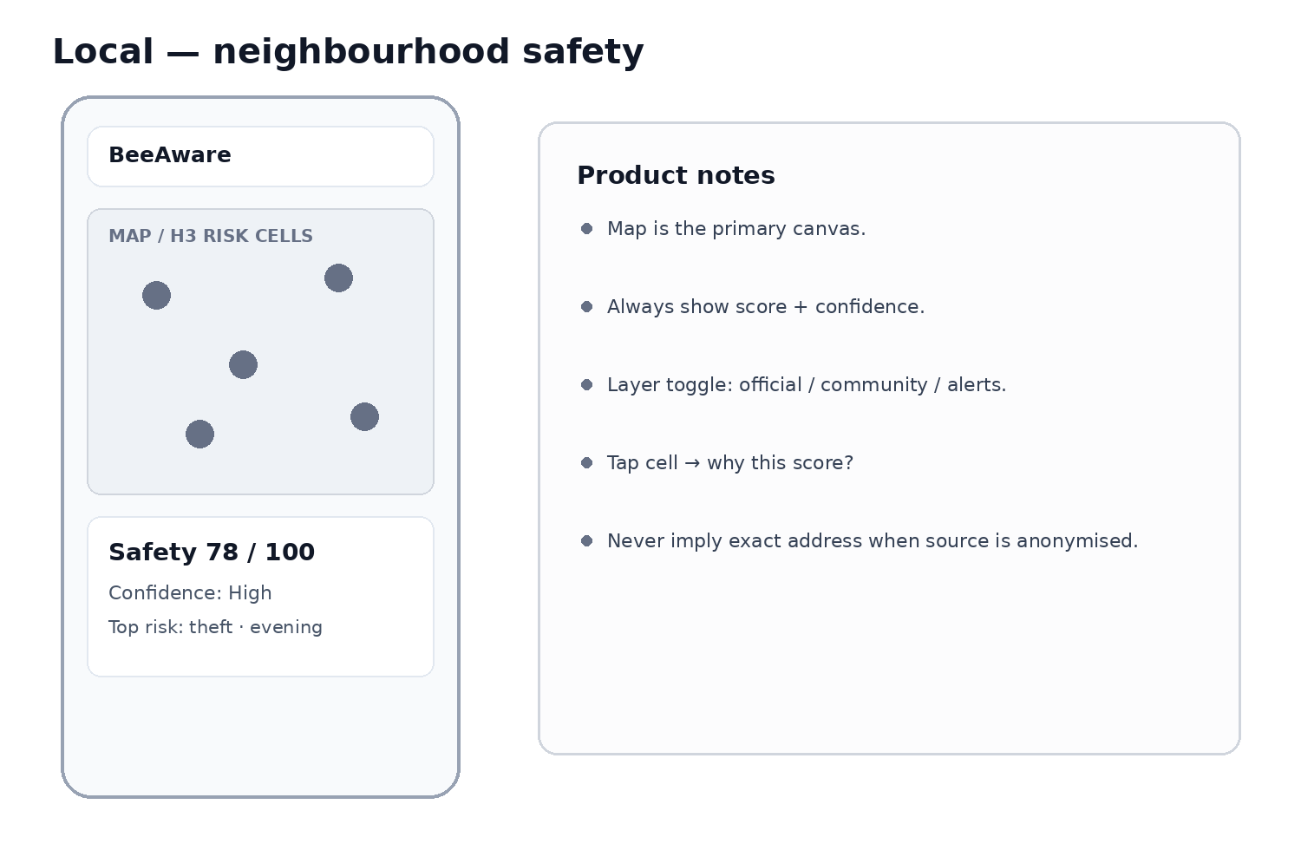
Low-fidelity wireframe for product/engineering alignment; visual design is intentionally neutral.

8.2 Travel — compare places
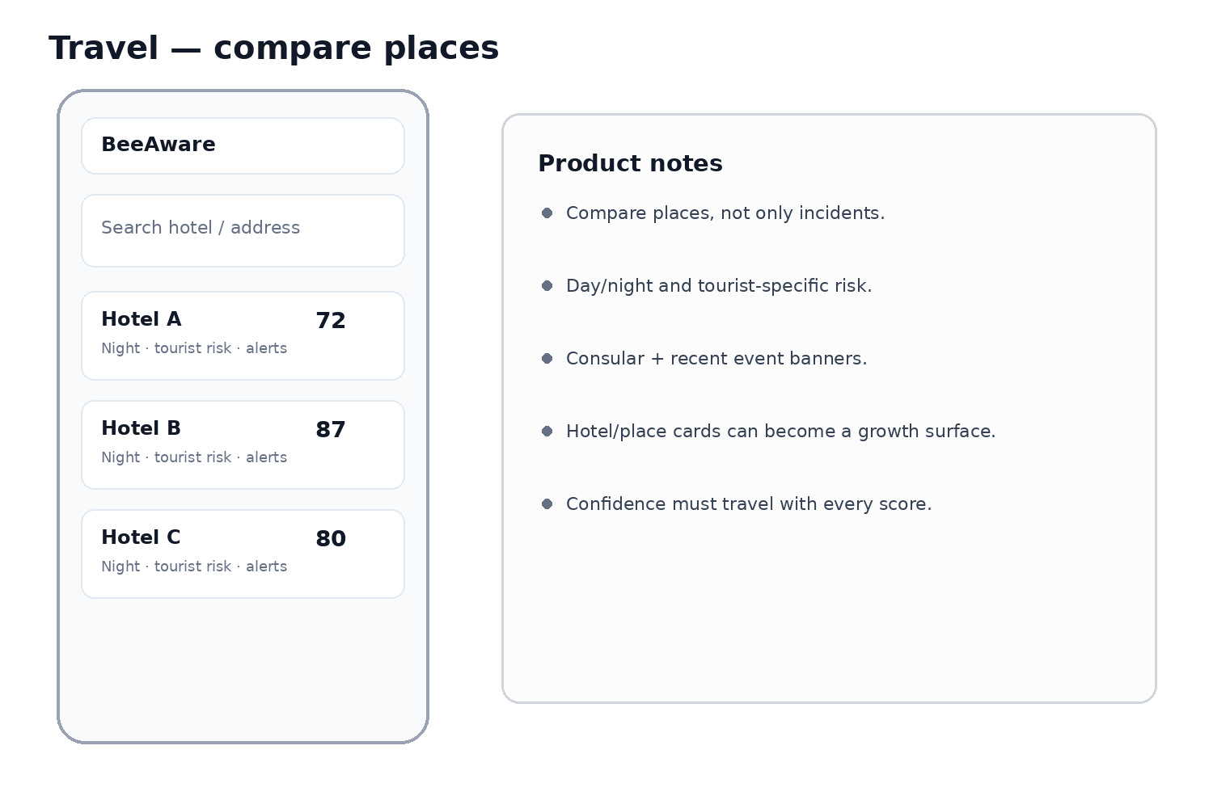
Low-fidelity wireframe for product/engineering alignment; visual design is intentionally neutral.

8.3 Route — safer journey
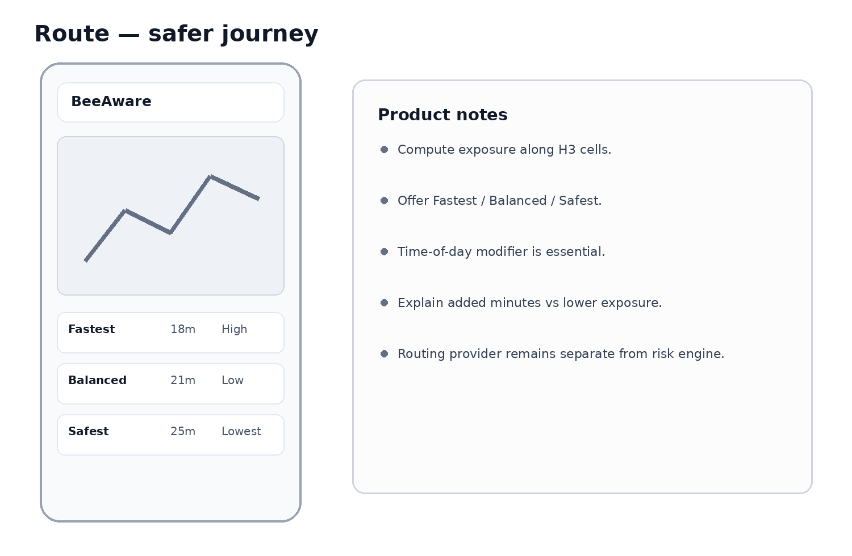
Low-fidelity wireframe for product/engineering alignment; visual design is intentionally neutral.

8.4 Explainability — why this score?
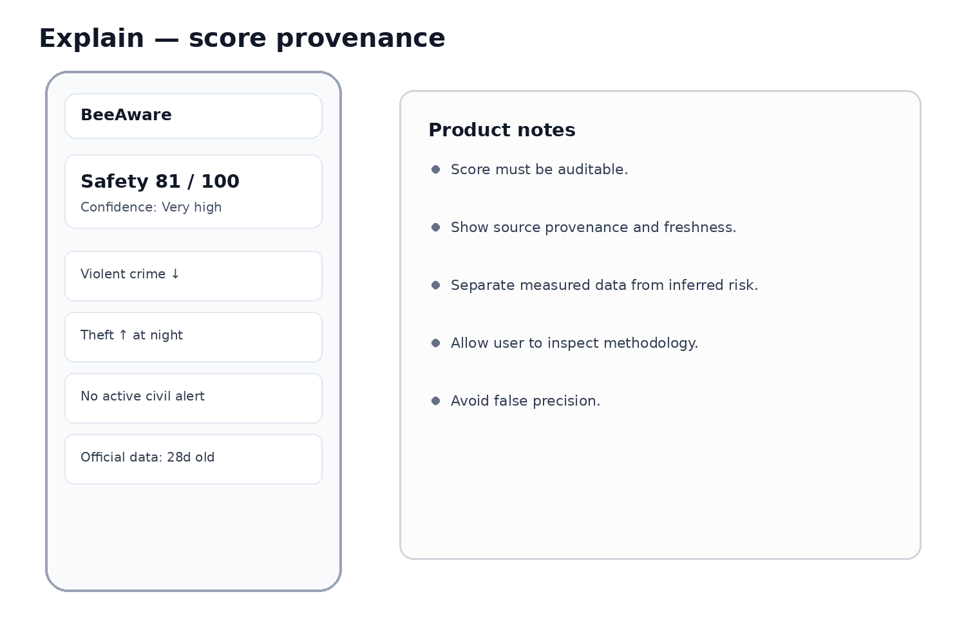
Low-fidelity wireframe for product/engineering alignment; visual design is intentionally neutral.

9. API contract sketch
Endpoint | Purpose | Key response
GET /v1/safety/point?lat=&lon=&at= | Safety around a point | score, confidence, reasons, coverage, source freshness
GET /v1/safety/area/{geo_id} | Area profile | subscores, trend, top categories, advisories
POST /v1/places/compare | Compare hotels/POIs/addresses | ranked places + day/night/traveller dimensions
POST /v1/routes/score | Score candidate route polylines | exposure, relative rank, risky segments, reasons
GET /v1/events?bbox=&from=&to=&category= | Map events | normalised events with provenance/precision
GET /v1/advisories?country=&bbox= | Travel/civil advisories | issuer, level, region, effective date
POST /v1/community/reports | Create report | report id + moderation/verification state
GET /v1/sources/coverage?lat=&lon= | Data transparency | available layers, grade, freshness, geo resolution

9.1 Example point response
{
"location": {"lat": 40.4168, "lon": -3.7038},
"safety_score": 82,
"confidence": {"level": "HIGH", "score": 0.86},
"dimensions": {
"personal": 85, "property": 74, "current": 90, "traveller": 81
},
"reasons": [
{"factor": "PROPERTY_THEFT", "direction": "NEGATIVE", "weight": 0.22},
{"factor": "NO_ACTIVE_CIVIL_ALERT", "direction": "POSITIVE", "weight": 0.12}
],
"coverage": [
{"layer": "OFFICIAL_CRIME", "grade": "A", "freshness_days": 31},
{"layer": "TRAVEL_ADVISORY", "grade": "B", "freshness_days": 4}
]
}

10. Product backlog / delivery roadmap
Phase | Outcome | Engineering deliverables | PO deliverables
0 — Foundation | Global-ready data model | source_registry; raw/normalised events; ICCS mapping; provenance; confidence | taxonomy, score principles, source policy
1 — Global baseline | Useful coverage beyond current countries | UNODC + travel advisory ingestion; coverage endpoint; country fallback | global coverage UX; 'limited data' states
2 — Priority adapters | High-quality markets | UK/Brazil hardening; US/Canada/Mexico/Colombia/France/Australia/NZ adapters | market priority + acceptance criteria
3 — Travel / Places | Hotel/address comparison | places compare API; day/night; traveller dimensions | Travel journey, ranking rules, copy
4 — Dynamic risk | Recent non-police signals | ACLED; GDELT/news classifier; dedupe/corroboration | alert thresholds; false-positive policy
5 — Safe Route | Route exposure ranking | routing integration; H3 segment scoring; caching | Fastest/Balanced/Safest UX
6 — Learning loop | Calibrated risk | evaluation set, calibration, drift/coverage monitoring | metric framework and trust KPIs

10.1 Definition of Done for a new country adapter
- Source authority and licence recorded in source_registry.
- Update cadence and failure/retry behaviour documented.
- At least 95% of ingested rows pass schema validation or are quarantined with reason.
- Local offence taxonomy mapped to canonical BeeAware/ICCS categories.
- Geographic precision explicitly encoded; no fabricated coordinates.
- Freshness and coverage metrics exposed to product.
- Deduplication strategy tested on a representative sample.
- Data-quality checks cover missing periods, sudden count shifts and schema drift.
- Product fallback verified when the adapter is unavailable.
- Source attribution text approved for UI.

11. Non-functional requirements
Area | Requirement
Privacy | Do not expose PII; minimise community-report precision where necessary; support deletion/moderation workflows.
Safety/trust | No 'safe/unsafe' absolute claims; scores are comparative indicators with evidence/confidence.
Licensing | Track source licence and redistribution restrictions before public display.
Reliability | Idempotent ingestion, retries, dead-letter/quarantine, source health dashboard.
Observability | Freshness, row counts, schema failures, coverage gaps, score shifts, adapter latency.
Performance | Precompute H3 risk cells; cache point/place queries; keep route scoring bounded.
Internationalisation | Country taxonomy mappings, local language labels, timezone-aware timestamps.
Auditability | Version score formula, weights, parser and source snapshot used for each result.

12. Key product metrics
- Coverage: % of active-user locations with ≥B confidence and ≥2 independent layers.
- Freshness: median age of the best official/local source by market.
- Trust: % of score views that open 'why this score?' and report usefulness.
- Travel conversion: place comparisons → saved place / route / return visit.
- Route utility: % choosing Balanced/Safest and median added minutes accepted.
- Signal quality: precision of news/community alerts after moderation/corroboration.
- Data health: adapter success rate, schema-drift incidents and stale-source hours.

13. Decisions needed from Product + Engineering
- Choose canonical taxonomy and confirm ICCS alignment depth.
- Choose H3 resolutions and rules for sparse vs dense areas.
- Define Safety Score v1 weights and what can/cannot influence it.
- Define Confidence Score and minimum evidence required to show a numeric score.
- Select routing provider and place-search provider; keep them replaceable behind interfaces.
- Set first expansion markets after Brazil/UK based on data quality + user opportunity.
- Define advisory/news ingestion legal review and redistribution policy.
- Agree on community-report verification states and moderation SLAs.

14. Source references for implementation
UNODC Data Portal: https://data.unodc.org/
UK Police API documentation: https://data.police.uk/docs/
Brazil MJSP security statistics / SINESP: https://www.gov.br/mj/pt-br/assuntos/sua-seguranca/seguranca-publica/estatistica
FBI Crime Data Explorer: https://cde.ucr.cjis.gov/
Statistics Canada — Crime and justice: https://www.statcan.gc.ca/en/subjects-start/crime_and_justice
Mexico open data portal: https://www.datos.gob.mx/
Colombia open data portal: https://www.datos.gov.co/
France open data portal: https://www.data.gouv.fr/
Eurostat Crime: https://ec.europa.eu/eurostat/web/crime
NSW BOCSAR open datasets: https://bocsar.nsw.gov.au/statistics-dashboards/open-datasets.html
New Zealand Police data & statistics: https://www.police.govt.nz/about-us/publications-statistics/data-and-statistics
ACLED API documentation: https://acleddata.com/acled-api-documentation
GDELT Project: https://www.gdeltproject.org/
UK FCDO foreign travel advice: https://www.gov.uk/foreign-travel-advice
US State Department travel advisories: https://travel.state.gov/content/travel/en/traveladvisories/traveladvisories.html
Australia Smartraveller: https://www.smartraveller.gov.au/destinations
Canada travel advice: https://travel.gc.ca/travelling/advisories
OpenStreetMap Overpass API: https://wiki.openstreetmap.org/wiki/Overpass_API
H3 documentation: https://h3geo.org/docs/

Important: this blueprint is a product/engineering design, not a legal determination that every source can be republished commercially. Validate source-specific terms, attribution, rate limits and redistribution rights before production use.

