INSERTED TEXT HERE



Project Drake Solution Overview

Version Number & Status: | V1.0
Document date: | 21/05/10
Security Classification: | Confidential
Author: | Duane McLeod  David Leach  David Frost  Brad McEvoy

Confidentiality
The information contained in this document is confidential to Enterprise IT Ltd and New Zealand Post. It may not be used, reproduced, or disclosed to others except employees of the recipient of this document who have the need to know for the purposes of this assignment.
Document Information
Revision History
Date | Version | Author | Description
8 May 2010 | 0.1 | David Frost | First draft
09 May 2010 | 0.2 | David Leach | Updated solution description.
10 May 2010 | 0.3 | David Frost | Reformatted.  Added high level data model.
11 May 2010 | 0.4 | David Frost | Updated data model and added descriptions of entities.
15 May 2010 | 0.5 | David Frost | Added overview text.  Updated sections on Oracle.  Added section on MySQL.
16 May 2010 | 0.6 | David Frost, Duane McLeod, David Leach | Updated at workshop
19 May 2010 | 0.8 | David Leach, Duane McLeod | Updated
20 May 2010 | 0.9 | David Frost | Updated
21 May 2010 | 1.0 | Duane McLeod | - Reflected feedback from Alan Sinclair & Craig Holden re application & data integration with future CRM & Billing capability and likely feed back to PO BOX database, and specific site capacity requirements to cater for peak usage.  - Reflected feedback from Barry Polly re NZ Post’s existing PostgreSQL in-house support capability and current NZ Post infrastructure-as-a-service RFP process opportunity.  - Reflected feedback on Data Strategy from Lindsay Welsh, NZ Post Targeted Communications.

Document Approval
Name | Title | Version | Date
Blair Glubb | Digital Media Consultant, Project Drake
Tracey Voice | General Manager, Business Enabling, Postal Services
Barry Polley | Strategy and Architecture Manager, NZ Post
Craig Holden | PricewaterhouseCoopers Director
Alan Sinclair | PricewaterhouseCoopers Partner

Distribution and Intended Audience
Name | Title | Version | Date
Ken Holley | Project Manager, Project Drake
Sophie Haslem | Strategy and Performance, NZ Post

Table of Contents

Revision History 2
Document Approval 2
Distribution and Intended Audience 3
1 Document Summary 5
1.1 Purpose 5
1.2 Document References 5
2 Background 6
3 Solution Description 7
3.1 Introduction 7
3.2 Technical Summary 7
3.3 Architecture 8
3.3.1 Overview 8
3.3.2 Solution Overview Diagram 9
3.3.3 Technology Components 10
3.4 Hardware Architecture Diagram 18
3.5 Data Strategy 20
3.5.1 Proposed Solution 21
3.5.2 Resourcing 22
3.6 High Level Data Model 23
3.6.1 Overview 23
3.6.2 Entities 23
3.7 Delivery 27
3.7.1 Methodology 27
3.7.2 Source Control 27
3.7.3 Bug Tracking 27
4 Drake Technical Solution Costings 28
Appendix A – Oracle Database Solution 29

Document Summary

Purpose
This document presents a high-level overview of the proposed technical solution for the Project Drake Requirements. It has been produced in advance of any technical discussions with New Zealand Post (NZ Post). Development of the solution will require a detailed technical design specification to be produced by Enterprise IT (e-IT), incorporating technical feedback from NZ Post, and the exclusion of requirements that will not be delivered in the first go-live.
The scope of this document is limited to the infrastructure on which the solution will reside, and the integration of the components comprising this infrastructure, both hardware and software. A Data Strategy is included to ensure the quality of the core data required for the solution is understood, and a process to improve the existing data quality is proposed. Excluded are any detail designs of individual web pages described in the requirements document. A wire-framing design process will be the enabler for this detail after the Drake business case has been accepted.

Document References
Ref | Title | Author | Version
 | Project Drake High Level Requirements | Paul Newby | 1.0
 | e-IT Drake Pricing | Duane McLeod | 1.0

Background
Project Drake has been created by NZ Post to deliver a new online capability that will leverage NZ Post’s customer data. Blair Glubb, director of Transmuter Ltd, has requested Enterprise IT to create a requirements document and this solution overview to enable a high-level costing for the Project Drake Business Case.
Key resources represented by e-IT have been selected to produce these documents for several reasons;
- These resources worked together to significantly contribute to the design and development of Yellow’s online capability
- In the last 8 months these resources have spent nearly 700 hours specifying and designing a similar capability to that proposed by Project Drake. For several reasons this design had not yet eventuated into a public website. The requirements specification representing the first phase of this work has been presented to Blair Glubb, however there are other key areas of work which could be reused to help meet the tight Drake timeframe, including;
- A complete physical database schema and integrated full-text search engine
- A scalable media storage and delivery solution (storing and retrieving video and photos from the cloud)
- A partially-executed data collection strategy including Ontology, Location Hierarchy and Name-Address-Telephone listing enrichment
Each resource brings a different skill set, all of which add value to Drake. This includes non-technical capability such as the creation and design of the site reflected in the requirements documents, the creation of the User & Advertiser Propositions, Competitor Analysis, Usage & Revenue Strategies, and Drake’s Critical Success Factors.

Solution Description

Introduction
Project Drake requires the creation of an online directory and community web portal that:
- Is user-centric (friends, reviews and ratings).
- Has location-based features (e.g.: Google Maps).
- Promotes the creation of user communities and business groups.
- Is integrated with social networking sites (e.g.: Facebook).
- Provides relevant and location-specific editorial content.
- Provides an acceptable return on investment for NZ Post.

The solution has been designed to enable delivery of the site’s content to browsers and smart mobile phones, and to also support expected growth in traffic over the first three years and to scale thereafter.
It is proposed that the physical hardware included in this design will reside in a designated Data Centre, and the high-level pricing estimate (supplied separately) reflects this.

Technical Summary
The key design guidelines of the proposed solution are:
- Support for multiple client platforms (PC browsers, mobiles).
- Integration with existing and future NZ Post systems (e.g.: PO Box database, Drake Print solution).
- Integration with APIs on the web.
- Use of industry-standard technologies and languages (Java, XML, HTML).
- Flexibility – support for future enhancements.
- Low cost – which generally leads to use of open-source technology.
- High performance for a fast user experience.
- Scalability.
- Security.
- High Availability – no single point of failure.

Architecture

Overview
The proposed solution is based on a standard three-tier architecture:
- Web tier
- Application tier
- Database tier
Open-source components are used in all three tiers.
The proposed database tier is MySQL. E-IT has also considered NZ Post’s existing infrastructure and concluded that their preference may be to use Oracle as the database, and have included this as an alternative option. It is worthwhile stating here that the $300k additional licensing and associated shared SAN storage for Oracle RAC is a high price to pay for the advantages that Oracle will bring, however e-IT understands that most organisations have not extended their open source strategy to the database tier.

Solution Overview Diagram
The following diagram shows the proposed live system (production) architecture, once all currently-identified requirements have been implemented. See later sections of this document for details of pre-production and development environments.
Please note that hardware specifications in the diagram are indicative only
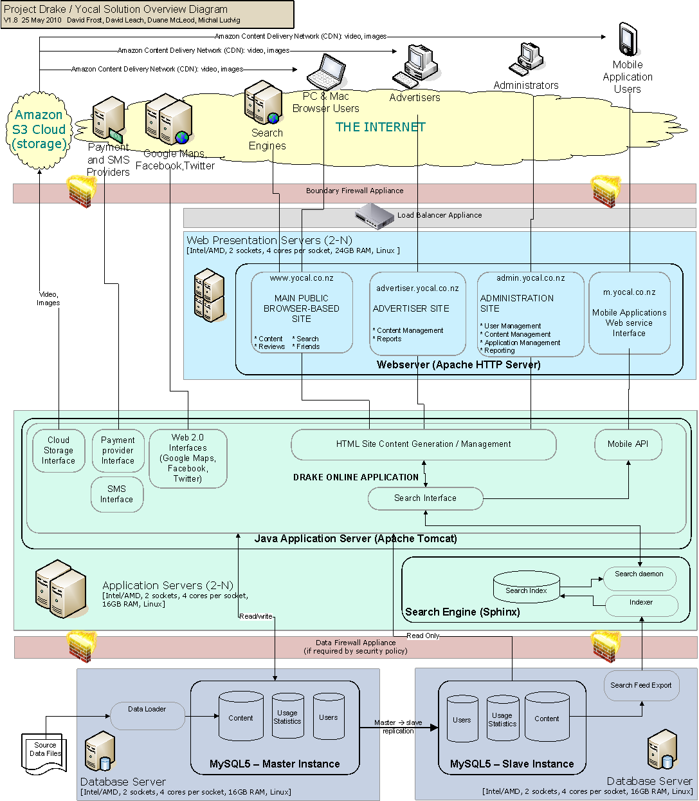
Also see Appendix A for a more costly alternative solution that utilises Oracle in the database tier.

Technology Components

Summary of Components
This solution is based around a 3-tier architecture for a web application. It utilises the following common and well-established components:
Component | Technology selected | Comments
Server Hardware | Intel/AMD based,  64-bit | Low cost.  High Performance.  Readily available (e.g.: HP).
Operating System | Linux | 64-bit Red Hat Enterprise Linux 5.4 recommended for:  - Supported with MySQL 5.  - Stability.  - Performance.
Web Server | Apache HTTP Server | Very widely used due to its high performance and robustness. It is free, open-source software.
Application Language | Java | Excellent for enterprise integration. Widely used, high performance, powerful.
Application Server | Apache Tomcat | Very widely used due to its high performance and robustness. It is free, open-source software.
Search Engine | Sphinx | Very high performance and scalability.  Powerful feature set: phrase proximity relevance ranking, stemming, stop-words.  Integrates with many databases (particularly with MySQL) and application languages.  Free for commercial use
Database | MySQL | Very high performance and scalability.  May not fit with client’s existing architecture. Alternative is Oracle. See Appendix A – Oracle Database Solution for additional information
Firewall | See comments. | TBA.
Cloud Storage | Amazon S3 Cloud | For high-volume, scalable storage of video and photo content.  Provides Disaster Recovery (DR) capability.
Storage | Local Disk | For web application, static content, Sphinx Index, Text content

Web Server – Apache HTTP Server
Apache HTTP Server is a popular web server, selected for its robustness, performance and powerful configuration options. For example, the software allows:
- Caching
- Compression of traffic between client and server
- URL rewriting
All traffic between client and server passes through Apache HTTP Server.
Caching
Both memory and disk caching will be utilised in order to improve response times and the site’s ability to scale. Caching enables the web server to respond to frequently requested pages faster and with less CPU, as dynamic requests do not need to go down the stack and back up in order to build the response. Over time, if required, the intention is that Squid will be implemented.
Compression
HTTP compression (deflate) improves response times between client and server by decreasing the amount of data transmitted over the network, resulting in faster web experience for visitors.
URL rewriting
URL rewriting enables friendly and keyword rich URLs, which are useful for providing clean URLs as well as assist with search engine crawling.

Java Application Server – Apache Tomcat
Apache Tomcat is a popular Java application server, selected for its robustness and also its familiarity amongst Java developers. Apache Tomcat supports clustering.
Within Apache Tomcat is the Java application that manages the incoming requests from the Web Server, then prepares and delivers the response. Most of the business logic resides here.
The Java application provides:
- End user website for browsers and mobile devices
- Secure, login-only website for site and content management
- Secure, login-only website for advertisers
- Integration with APIs available on the web, e.g. Facebook
- Integration with Sphinx for search queries
- Integration with the database for retrieval of persisted data
In addition, the Java application will expose a web service interface for use with other applications, such as applications for iPhone, Blackberry and Android devices. See Mobile Web Service API section.

Search Engine – Sphinx
Sphinx is a full-text search engine. Some key features are:
- High Search Performance: Sphinx can search over 1GB of text within 10 to 100 milliseconds.
- Scalability:
  - Up to 100 GB of text, up to 100 Million documents on a single CPU.
  - Scales horizontally by adding nodes. In the proposed solution, Sphinx will initially reside on the Application Server, but can be shifted to separate server(s) in future as traffic increases.
- High Indexing Performance: In the proposed solution, Sphinx will obtain and index data from the database, storing the data in its own index format to enable very fast searching. Sphinx indexing is extremely fast, usually meaning it can be done “online”.
- Search Relevance: Sphinx has multiple ranking algorithms, including a phrase-based ranking algorithm.
  - For example: if you search a table of song lyrics for “I love you, dear”, then a song that contains that exact phrase will turn up at the top, before songs that just contain “love” or “dear” many times.
- Advanced Search Features: including:
  - Stemming: e.g.: searching for “run” will also return text that includes “runs” and “running”.
  - Stop Words: words that are automatically ignored
- Real-time Index Updates: Searches continue to run even while the index is being updated or rebuilt.
- Free: Sphinx is free for commercial use, licensed under the GNU General Public License v2.0.
- Programming Interfaces: Sphinx comes out of the box with interfaces for a number of programming languages such as Java, PHP, Python and Perl, as well as database interfaces and an XML interface.

Some large public websites that use Sphinx:
- Boardreader.com: has 2 billion searchable documents, over 2 TB of data
- Craigslist.com: believed to have over 50 million searches per day. Has been using Sphinx since November 2008.
- Dailymotion.com: has a cluster of 40 MySQL / Sphinx servers. In June 07 they had 37 million unique user visits, 1.3 billion page views.
- Aok.dk: The largest city guide website in Denmark.
See http://www.sphinxsearch.com/
An alternative to using an internal search engine would be to use Google’s search capability – the Google Search Appliance (GSA). Of the various GSA models, the GB-7007 is the best fit for Drake as it offers redundancy and disaster recover options fundamental to this design. It comes as a rack-mounted two-unit appliance capable of searching up to 10 million documents, running Google Linux and Google’s hugely popular search engine. The approximate cost to Drake including the disaster recovery option would exceed $25k per year for a fully supported version, ongoing. This is not a substantial cost, however e-IT recommends Sphinx as it provides more search flexibility, allowing a more customised search and this is important particularly on new sites like Drake.
A second alternative considered was a search engine called Solr. It is more advanced than Sphinx in some respects, but uses substantially more memory and CPU, and is slower when re- indexing. Nor does it have the tight coupling with MySQL.

Database – MySQL
Our recommendation for MySQL over Oracle is based on the following key points:
- Performance and Stability: MySQL is a mature database that is being relied upon in major websites such as eBay and Facebook, and locally for example in NZ Herald Online. It has proven to be well suited for a busy web application environment.
- High Availability: High Availability can be implemented in MySQL using a pair of databases in master-slave configuration. Multiple slaves can be linked to the master and any slave can instantly take over the master role should the original master fail.
- Disaster Recovery: The common approach for DR is to deploy some slaves in a DR location. When the primary location becomes unavailable one of the DR slaves assumes the master role for the DR location. Once the primary location comes back online the primary master can easily be resynchronised to the DR master and then re-assume the master role. Third party solutions for DR are also available, however their use is not required in this relatively uncomplicated setup.
- Storage: Unlike Oracle Real Application Clusters (RAC), MySQL does not require the use of shared storage, saving the cost of a SAN.
- Resourcing and support: MySQL is one of the most popular databases powering web applications and a large number of web developers have had some exposure both to programming with and administration of MySQL. Thanks to its widespread use and zero cost the MySQL skills are readily available.
- Compatibility: MySQL is very well supported in Java as well as in most other programming languages.
- Price: MySQL can be used free of charge even in commercial deployments. However there is also a MySQL Enterprise release supported by Oracle that costs between US$600 and US$5000 per server per year. See http://globalspecials.sun.com/store/mysql/ContentTheme/pbPage.categoryEnterprise. No per-developer, per-connection or per-socket license is needed.
- Certainty: Oracle clearly articulated their plans for MySQL and a commitment to continue with MySQL development: Refer to http://www.youtube.com/watch?v=C0OkjtlbqVs

The proposed solution utilises MySQL. Oracle could alternatively be used if NZ Post prefers it. Refer to Appendix A.

PostgreSQL is another low cost alternative to MySQL, and could replace MySQL as part of this solution. It does not have the same tight coupling with Sphinx, rather it offers a database internal search engine called tsearch2 which is robust and mature. However PostgreSQL and tsearch2 have not had the same commercial exposure to large websites and tsearch2 is not as well supported as Sphinx. e-IT understands that NZ Post has PostgreSQL DBAs and therefore would be better positioned to support this option. This can be discussed further and agreed upon in the detailed Drake Solution Design. It will have some impact on cost as e-IT has already spent considerable time prototyping a solution similar to Drake working with Sphinx and MySQL, however e-IT has the required expertise in PostgreSQL to make this happen.

Content Management
The current high level content management requirements include the ability to:
- create, edit and delete editorials/features;
- moderate the content created and uploaded by advertisers and users;
- create, edit and delete business profile information;
- manage banner advertising on the site;
- edit the content for information pages, such as About Site, Terms of Use and Privacy Policy pages.
These requirements do not necessitate the inclusion of a dedicated content management system (CMS). The web application will provide secure administration pages for management of content, built specifically for the above requirements.

Mobile Web Service API
The Mobile API will provide a web service interface, specifically designed for use with smart phone applications running on devices such as the iPhone, iPad and Blackberry.
This enables the development of mobile applications, and in fact any external application, adhering to the published web service interface. It will provide core functionality, such as content and search capabilities to end users.

Integration with Popular APIs and Websites
The following table lists the current high level requirements that require integration with popular APIs and websites on the internet.
High level requirement | Solution Description
Display New Zealand weather forecasts | MetService to provide weather feed via FTP download. An Ant script will be scheduled to download the feed daily (at least) and import it into the database for subsequent viewing on the site.
Display upcoming events | Eventfinder to provide events feed via the REST-based API interface. A script will be scheduled to download the events daily (at least) and import it into the database for subsequent viewing on the site.
Authorise users using Facebook and Google accounts | Integration with Facebook and Google for user authentication, much like how it is done at www.tripit.com.
Display business locations on a map view | Integration with Google Maps API. e-IT has assumed Google Maps use is free as per commercial terms outlined at  http://code.google.com/apis/maps/signup.html
Provide traffic updates | Real time, or near real time, integration with NZTA’s InfoConnect API.
Like Button | Facebook social plugin with very simple iFrame HTML tag.

Payment Processing Interfaces
Initially this will include a credit card payment service, and may later be expanded to include a range of payment options such as Direct Debit.

SMS Interface
This will provide the ability for users to send text messages to mobile phones. It may be possible to use an existing SMS Gateway already in place at NZ Post.

NZ Post PO Box Data Interface
Although advertisers will have access to update their details via a Self Service capability, it is important that changes to PO Box data are also captured and presented as an opportunity to keep listing data up-to-date. The exact merge rules must be defined and agreed in the final detailed solution design.
A return data feed back to the PO Box database should also be considered, to ensure that data entered by businesses via Self Service that is useful to other NZ Post departments is made available.

CRM & Billing Exchange Interfaces
Both Online & Print systems are being proposed for Drake. An over-arching Customer Relationship Management application providing support for a defined sales process and other common CRM-related processes (including Billing) will be delivered by Drake. Considerations to date have included fully supported on-demand and off-the-shelf solutions such as RightNow CX and SugarCRM.
In the likely scenario that one of these solutions is purchased, the Online solution will need to push customer related data created or changed via Self Service to its master source in CRM, including sales transactions along with user-generated click statistics (for billing) to the CRM application. New customer and sales data created by account managers via the CRM interface will also need to be pushed to the Online database. Consideration needs to be given to how product packaging will be mastered, allowing combinations of print and online advertising to be presented in CRM and via Online Self Service. The Online database design already caters for mastering of Product, however this may not be the chosen repository.

Storage
Three storage tiers are proposed:

Local Disk
Used by the web and application tiers for:
- The application itself
- Static application content
- User and advertiser text content
- The Sphinx search index

SAN
Will not be required if MySQL is chosen for the database tier.
However, Oracle RAC requires shared storage, so a SAN is required for Oracle.

Amazon S3 Cloud
This will be used for storage and retrieval of user-uploadable content. According the current high level requirements this is currently videos, photos and documents (PDFs). Over time the storage requirements are expected to grow exponentially as the site grows in popularity, which is why this scalable solution was selected.
Amazon S3 Cloud features include:
- Scalable.
- Inexpensive.
- Provides Automatic DR.
Web scale media storage, generation and content delivery require high end computing capacity which is often not cost effective to own and operate. Large amounts of multi-media content often cannot be easily backed up to tape, and server capacity demands can be difficult to predict and can fluctuate wildly.
'Cloud computing' generally refers to products offered by very large infrastructure providers such as Google and Amazon which provide this capacity at low marginal costs and with little or no capital outlay. The capacity available from Cloud computing can usually be assumed to be unlimited. This is a huge benefit when developing an internet site because of the "bursty" nature of the internet, where sudden loads can be orders of magnitude greater then average, because additional capacity can be brought online as needed and released when the surge has passed. To own and maintain this kind of spare capacity is often impractical.
The following are estimates of data volumes and the corresponding cloud infrastructure requirement.
Storage: If we assume 4000 videos, and that each video is about 50Mb, then we will require about 200 GB of durable storage. Users typically upload much more data as pictures than videos, usually of a factor of about 5, so estimate about 1000GB of pictures (assuming typical consumer grade resolution). Storage for other documents, such as PDFs, will tend to be much smaller unless there is a particular need for them (e.g. the Companies Office stores all official documents as PDFs). Total storage requirement: 1200GB.
- Compute Time: Images generally will need thumbnails to be generated, and probably a range of other resolutions. Videos will need to be converted to a streamable format such as flash movie (like YouTube) or the HTML5 video (Wikipedia). Documents such as PDFs will usually need thumbnails generated. This can consume quite a bit of server compute time. Typically, pictures and documents require 5-10 seconds and a video will take about 1 minute on a single core equivalent device. Total storage requirement: 26 days of single core equivalent (over the period of time it takes to accumulate the number of files specified above)
- Video Conversion Software: Converting video can be tricky, because of the number of video codecs, variations and versions in use by consumers. Arguably the most complete video conversion software is the open source ffmpeg. It is very widely used by media conversion experts, but if can be difficult to get all of the features running. The open source Panda streaming project provides a complete machine image with ffmpeg which greatly simplifies the setup process.
- Queuing Service: Because conversion is a slow process there needs to be a queue of items to process. Maintaining a reliable and fault-tolerant queue is critical to the successful operation of this system.
- Auto-Scaling: The average load, based on calculations above, is quite low. Probably only 10% of a single core equivalent machine. However, it should be assumed that there will be times when the load is orders of magnitude higher then the average load. Maintaining a stable and responsive system depends on being able to bring online additional compute capacity as it is needed. This is best done automatically and is referred to as auto-scaling the system.
- Content Delivery Network: If a cloud storage solution is used the data will be stored in a major internet hub like Singapore or the US west coast, but we would like content to be delivered from a local source for best performance. This can be achieved by using a Content Delivery Network (CDN) where files are cached at "edge servers" scattered all over the world.

The solution described above can be implemented in Amazon's Web Services (AWS) cloud computing environment. Amazon's storage product (S3) is extremely durable and they claim never to have lost a file, a claim which has not been contested. Storage costs are 15c (all prices in US) per month per Gb. Based on the assumed requirement above we would incur storage charges of $180US/month. Servers are available from 8c/hour, but the rate is doubled if auto-scaling is enabled, giving a relatively small cost component of about $10US/month.

Hardware Architecture Diagram
The hardware specification in this document is assumed to cover website traffic and processing volumes for the first three years of the site’s operation. The solution is scalable at each tier.
Feedback from PSG on the configuration below reflects a desire to move away from external hosting not only for early stage projects but for the long haul. This reduces capital risk and allows for variable costing based on resource consumption. PSG are currently completing (early June) an infrastructure-as-a-service RFP process, which will indicate preferred provider(s). The Drake team have been offered the opportunity to consider this as an option.
The configuration below is already virtualised on two tiers, and there is no issue virtualising the database tier with MySQL or PostgreSQL to take advantage of the approach recommended by PSG. This will not be possible with Oracle RAC however due to its licensing restrictions on virtual servers.
e-IT priced fully virtualised and managed environments with Revera as an alternative to purchasing and deploying the capability below in a data centre. The estimates supplied were approximately 10% more for this option than the cost of the solution depicted below over a 3 year period, but would only supply 25% of the peak processing power. e-IT have moved away from this option, as after 3 years NZ Post would not own the environment, and from year-3 and beyond the costs for a managed virtual solution would be more than twice that of what has been proposed according to estimates received. However e-IT appreciates that PSG may have a significantly lower cost option after the infrastructure-as-a-service RFP process has been completed, and this should be considered and agreed with PSG as part of the final detailed Drake Solution Design.
Revera pointed out that providing the same processing power below on a virtual managed environment would not be comparable in price, and also provided a quote. However they are no longer accepting vendor hardware within their data centre unless it uses Revera’s SAN. Other Data Centres, including Datacom however provide such service, and e-IT priced this approach with Maxnet.
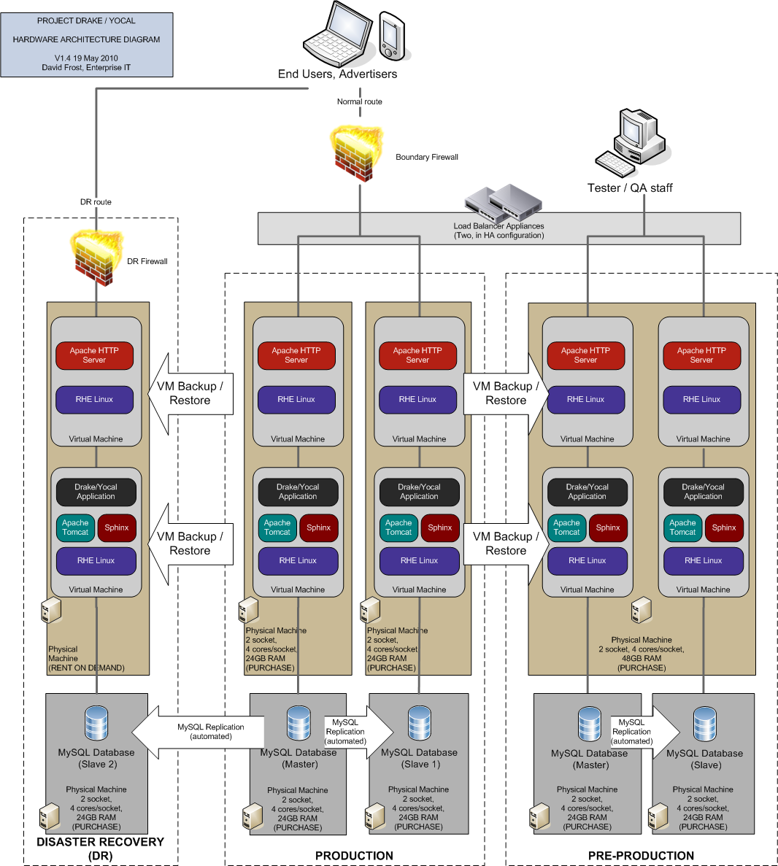
Note: The Development Environment is not shown, and will be a hosted solution.

Data Strategy
The scope of the Data Strategy for Drake is limited to the components attached to a Name-Address-Telephone (NAT) listing. As per the Business Profile Page requirements, these attributes are listed below;

- Business Name
- Phone Numbers (Mobile, Business,0800, Other, Fax)
- Physical Address
- Postal Address
- Categories
- Email
- Website
- Opening Hours
- Payment Options
- Parking Options
- Groups e.g. Master Plumbers Association
- Business Description
- Reviews

The first step is to establish how NZ Post can leverage their existing data. The most promising data set seems to be the PO Box data which is captured on an annual contract form sent to all PO Box holders each year. These forms are sent to each business PO Box as their contract expires. The written information is received back via post as part of the contract process and manually keyed into a database.

Approximately 105,000 PO BOX ‘listings’ exist in the PO Box database. Of these approximately 40,000 are based in the wider Auckland area. e-IT requested 500 PO Box sample business listings for the Auckland area and analysed the key data components required for Drake.

The results were as follows:

Attribute | Populated | % | Comment
Website URL | 16 | 3.2%
ANZSIC | 62 | 12.4% | This drops to 8.7% on non-excluded listings
Opt Out of Directory |  | 36.6% | 36.6 cannot be used at all
Email | 228 | 45.6% | 10% go to www
Phone | 436 | 87.2% | (Home 354, Mobile 77)
POC | 451 | 90.2%
Address 1 | 494 | 98.8%
Suburb | 499 | 99.8%
Name | 500 | 100.0%

Data Challenges:

- Over one third of PO Box companies have opted out of being in any Directory or Marketing list. These will most likely be excluded.
- The Website data is very poor.
- The ANZSIC code is also poor and this is the most important piece of information to be able to further filter the listings that we do not want to have on the site. Only 300 of over 2000 possible categories are being selected for this directory. However if we have don’t have a category or ANZSIC code this is impossible.

Proposed Solution

The following steps need to be taken to resolve these primary issues. An online directory relies on solid listing data, before additional rich content is added. These listings are like the foundations of a house and without them an online directory for Auckland cannot be successful.

- Identify the category for the remaining two-thirds of 40,000 listings (26,000).
- Carefully select groups of listings of less than 5000 and request ANZSIC code from DataMarket, Axciom, Veda Advantage and Martins. There have been anti-competitive issues raised in this area, so approaching these vendors needs to be carefully managed. Axciom is not competitive in the B2B market, and Veda Advantage is less competitive than Martin’s and DataMarket.
- For remaining listings that cannot be coded by the vendors above, the business name should be manually scanned for obvious signs of category type information e.g. ‘Slipper Electrical’.
- Trade Association lists can then be matched on business name to further categorise listings
- Website URL can be searched, and scripts that check the internet for various combinations of a potential website based on business name or email address can be attempted and recorded if successful. This is followed by a manual check of the websites Contact Us page contact details against the listings contact details. If a match is found as much data as possible should be manually copied from the website to the PO Box listing. This is a more expensive time-consuming approach so has been left until last.

- All listings that have an ANZSIC code which does not fit the 300 chosen categories for Drake should now be excluded. The remaining listings must be processed as follows.

  - Repeat the last step of (1) above attempting to find websites for listings that do not have websites.
  - For all listings that have no matching website, send a marketing promotion to the business requesting that they either post back a written copy of the designated data values required or for the business owner to enter the details via a Self Service website using a code on the marketing promotion leaflet to access the site. Incentives are a must here.
  - Providing no response is received via post, email remaining advertisers if possible, and send URL link to Self Service with unique code and incentive to complete request.
  - As a last resort, one week after emails have been sent, follow up with a phone call and request details over phone.

- Other more passive option for obtaining the required data are;
  - Counter displays notices at NZ Post branches promoting Drake supplying business owners with forms to complete. Branch staff to enter the data via ‘Self Service’ site. However the engagement of the Retail side of NZ Post may bring challenges to the Project, and must be managed carefully.
  - URL for self service site should be published on Annual Renewal PO Box form
  - Other NZ Post marketing promotions including material sent with Drake print book

It is important that these activities are agreed with NZ Post, and that a Self Service site is designed and deployed as soon as possible to allow data analysis. Administrator account must be set up and communicated for all potential NZ Post branch staff and data analysts.

Reviews
Drake listings require seeded reviews before site launch. Ideally most listing would have 2 reviews. This is a substantial task. Although editorial type reviews can be written, these are often not the type of verbatim that attracts users to the site. One suggestion here is that primary schools are used, targeted with an offer of fundraising. A letter to the school from NZ Post stating the terms and conditions with an access code to Self Service would enable parents of the school to enter Self service and review local businesses. These reviews would be checked by a data analyst and if passed, $2 would be donated to the school for the review.

Ontology Data
Most Online Directories have an Ontology which is a group of interlinked categories (in a hierarchy), properties and terms. Categories are the lowest level groups you find in the ANZSIC code list, and are normally in a hierarchy with only 20 groups at the top. A typical category would be ‘Restaurants’. Categories are critical as they easily allow users to focus their search on a particular set of related listings. They are highly searchable, and the key component of defining verticals.

Although not searchable themselves, the properties within a category also represent the Refine elements e.g. for the Category Restaurants, some Properties are:
- Cuisine
- Payment Methods
- Facilities

and within those properties you will have relevant keywords e.g.
- Cuisine - Chinese, French, Seafood …
- Payment Methods: Cash, Credit Card, Cheque
- Facilities: Parking, Bar, Highchairs

Without Properties, you cannot provide relevant Refine sub-categories. Also Properties allow us to structure keywords into related groupings which make it easier for businesses to choose their keywords and easier to present on the site (in Refine and on the Business Info page). They also allow us to provide different rules for different properties depending on the category e.g. For the category restaurants, you would want all the keywords in the property Cuisine to be searchable and refinable, but you may only want the keywords in the property Payment Methods to be refinable, not searchable. This would mean that a restaurant would be searchable by the term 'chinese restaurant', but not by the term 'credit card' which makes sense.
Terms attached to a listing are called keywords.

e-IT has a basic Ontology constructed using several websites such as Google keywords. This Ontology data set can be used for go-live with another 3-5 man days of effort from a resource with Ontology skills.

Resourcing
It is estimated that between 10,000 and 15,000 listings will have to go through the process defined above to ensure they are complete and checked. Manual re-keying and checking of data, checking and writing reviews copying data from business websites sending and receiving lists from data-matching Vendors etc will require at least 3 full time data analysts for 5 months. These resources have been included separately in the overall e-IT pricing (separate spreadsheet).

High Level Data Model
A high-level entity model - containing only key entities - is shown below:
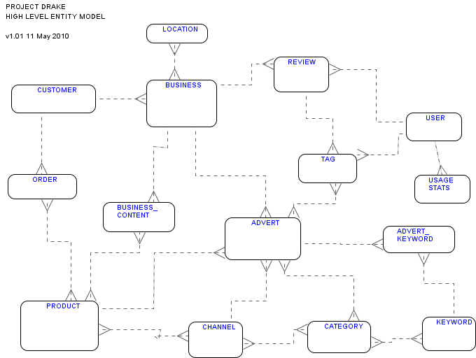

Overview
One of the key design goals for the data model is flexibility. For example:
- It should allow a single business to be represented over many types of media, such as online websites and also print media.
- It should support the creation of future products.

Entities
A brief overview of each entity is given below.

Advert
ADVERT is an instance of a BUSINESS that has been provisioned/setup for public access via a CHANNEL.
An ADVERT is a more generic form of the concept of “Listing”, and can encompass other forms of advertising such as banners and print typeset adverts.
An ADVERT is not necessarily paid for. It is envisaged for example that for certain CHANNELs, a ‘free’ ADVERT would be created for each BUSINESS.

Advert Keyword
An ADVERT_KEYWORD is a KEYWORD chosen for use in search enhancement for an ADVERT.
ADVERT_KEYWORDs can be manually chosen by a CUSTOMER.

Business
BUSINESS is any real-world entity about which content can be gathered. A BUSINESS may belong to a CUSTOMER, but also exists in its own right.
A BUSINESS is the entity about which BUSINESS_CONTENT is gathered, for provisioning as one or more ADVERTs.
A BUSINESS may record the fact of a real-world RELATIONSHIP (not shown) with another BUSINESS.

Business Content
BUSINESS_CONTENT is any piece of data that may usefully be stored about a BUSINESS for the purposes of:
- provisioning via a CHANNEL
- search

BUSINESS_CONTENT may include:
- text
- images
- multimedia

Category
CATEGORY is a named classification for a BUSINESS. Used for grouping and searching, and also for defining verticals.
Each CATEGORY is associated with a CHANNEL. Each CHANNEL can have a different set of CATEGORIES.
A BUSINESS may be in more than one CATEGORY.

Channel
CHANNEL is a medium by which an ADVERT can be published or otherwise made available to the public. Examples of a CHANNEL might be:
- Auckland website
- New Zealand nationwide website
- Auckland print book

Customer
CUSTOMER is the financial entity that relates to one or more BUSINESSes.

Keyword
KEYWORD is a piece of text that may be chosen to enhance the search-ability of an ADVERT.

Location
LOCATION represents the group of entities dealing with a BUSINESS’s geographic location. This data is used in location-based search. The LOCATION of a BUSINESS may not necessarily be a physical geographic location – it may be a notional location (e.g.: “nationwide 0800 number”).

Order
ORDER is an order placed by a CUSTOMER for provisioning of an ADVERT. Relates to the Billing area of the overall data model (not shown).

Product
PRODUCT is a named collection of components and characteristics (not shown) that define how an ADVERT is provisioned in a CHANNEL. A PRODUCT does not necessarily have an associated price. Examples of PRODUCT:
- Free Listing
- Gold Listing
- Silver Listing
- Advertiser promotion
- Banner Advertisement – top of search page
- Banner Advertisement – side of search page

Review
REVIEW is textual content added to a CHANNEL by a USER, describing the USER’s opinion of a BUSINESS.
A REVIEW can be rated by other USERs.

Tag
TAG is a short piece of content added to a CHANNEL by a USER, e.g.: “cool”, “likes this”. A TAG can relate to an ARTICLE (not shown) or a REVIEW.

Usage Stats
Usage Statistics are data automatically collected by the system for a CHANNEL as a normal part of the use of a website. This only relates to CHANNELs that are for online media (so does not relate to print CHANNELs).

User
USER is a system account representing a logged-in real-world person. Only logged-in USERs may add content to the website.
A USER may record the fact of a real-world RELATIONSHIP (not shown) with another USER.

Delivery

Methodology
The Agile time-boxing method will be used due to the small team size and the absence of day to day contact with, and approval of business stakeholders. The team can work on the highest priority functionality and deliver it in small blocks working together rather than each resource working without regular communication with the rest of the team. Time is of the essence so formalised detail design will be a challenge – and agile supports less paperwork.

Source Control
We will use Subversion. Subversion is powerful, mature, widely used, open-source, and free.
See http://subversion.apache.org/

Bug Tracking
A free bug-tracking tool that integrates with Subversion will be used, such as Trac.
See http://trac.edgewall.org/

Drake Technical Solution Costings

Refer to separate Drake Pricing spreadsheet.

Appendix A – Oracle Database Solution
The diagram below shows the database tier changes only, should Oracle be chosen instead:
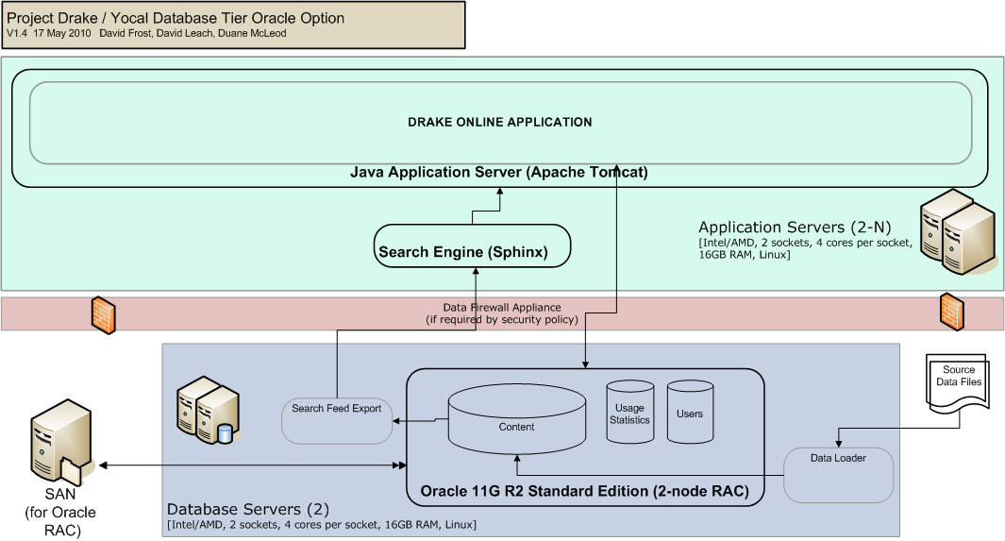
This section has been included to support e-IT’s recommendation to use MySQL over Oracle. Oracle’s high availability option (RAC) requires shared storage in the form of a SAN. Although RAC comes free as part of the cheaper Oracle SE licence, the costs for the first 3 years, along with the third part product DB Visit for DR and an entry level SAN are over $300k more than MySQL over a 3 year period. NZ Post may choose to state their preference for Oracle as their chosen DBMS, irrespective of this additional cost.
Some of the reasons for choosing Oracle are:
- Fit: An Oracle-based solution is believed to be a good fit for NZ Post’s existing enterprise architecture.
- High Availability: When it comes to high availability Oracle leads the world with Oracle Real Application Cluster (RAC) which comes free with Oracle Standard Edition (SE).
- Disaster Recovery: Oracle Enterprise Edition (EE) includes Oracle DataGuard, however we would recommend using Oracle Standard Edition (SE) and using a third-party tool named DBVisit for DR. DBVisit uses Oracle’s built-in application log shipping capability.
- Oracle Support: Oracle’s support for their DBMS is unparalleled. No other database has as much widespread knowledge and paid support available.

e-IT has qualified DBAs for both Oracle and MySQL so can provide support in either case.

