SOFTWARE ENGINEERING PROJECT:

LATEX EDITOR
A “KISS PRINCIPLE” USER MANUAL

Team Members:
Vasiliades Miltiades (2944)
Delia Styliani (2430)

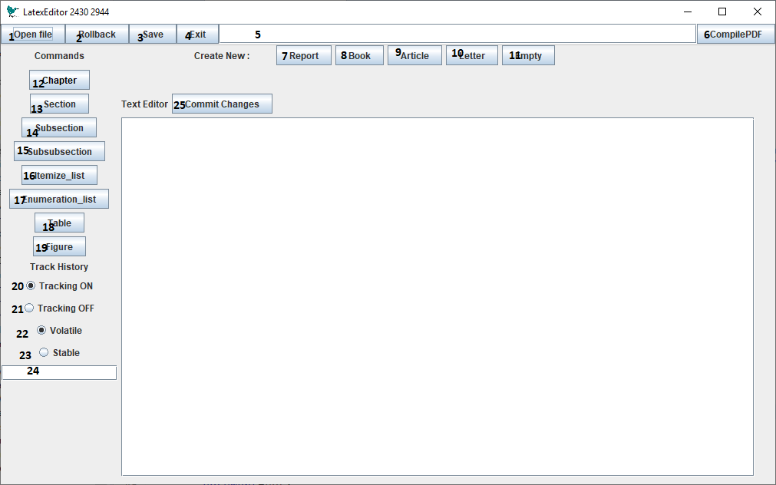
- Clicking this button will open a window for the user to choose an existing tex file to be loaded in the application.
- This button will undo the last committed change in the document.
- This button will open a window for the user to choose a location and a file name then stores the .tex file to that location.
- This exits the application.
- This displays where the file is opened/saved from.
- Clicking this will compile the tex file loaded to a pdf in the same folder as the application is run from (Warning: this functionality requires windows OS and pdflatex (or miktex) installed and added to %path)
- This creates a new Report Document
- This creates a new Book Document
- This creates a new Article Document
- This creates a new Letter Document
- This creates a new Empty Document
- This will add a chapter command to the current caret position in the document
- This will add a section command to the current caret position in the documentThis will add a chapter command to the current caret position in the document
- This will add a subsection command to the current caret position in the document
- This will add a subsubchapter command to the current caret position in the document
- This will add an itemize command to the current caret position in the document
- This will add an enumeration command to the current caret position in the document
- This will add a table command to the current caret position in the document
- This will add a figure command to the current caret position in the document
- Clicking on this will enable the versioning subsystem (It’s on by default)
- Clicking on this will disable the versioning subsystem. This also disables the buttons 22-25
- Clicking on this will make the system save previous versions of the document in main memory
- Clicking on this will have the system write any previous versions of the document in a binary file in storage so a user can recover the file whole file history later. Clicking on this, will also open a new window to choose the location of this file
- This displays the location of the file mentioned in 23
- This will add the current version of the document in the document history.

Using the “stable” versioning system.
Clicking on button 23 will let the user either create a new binary file or select an existing one. This is what allows the user to recover a previous document with its history. As soon as the existing file is selected the user then must click on button 2 “Rollback” this will load the last version of the document on the application and the text editor area.

