LATEX EDITOR
Design Recovery and Quality Assessment Report
Version <1.0>

Βασιλειάδης Μιλτιάδης 2944
Θωμά Αθανάσιος 2979

Table of Contents
Introduction 4
Design Recovery 4
Architecture 4
Detailed Design 4
Implementation 4
Quality Assessment 5

Introduction
The goal of this project is to reengineer a Java application. At a glance, the objective of this project is to develop a simple Latex editor for inexperienced Latex users. Latex is a well known high quality document preparation markup language. It provides a large variety of styles and commands that enable advanced document formatting. Typically, a Latex document is compiled with a tool like MikTex, Lyx, etc. to produce a respective formatted document in pdf, ps, etc. Formatting documents with Latex is like a programming process as it involves the proper usage of Latex commands which are embedded in the document contents. The goal of the Latex editor is to facilitate the usage of Latex commands for the preparation of Latex documents. One of the prominent features that distinguishes the LatexEditor from other similar applications is its multi-strategy version tracking functionalities that enable undo and redo actions.

Design Recovery

Architecture

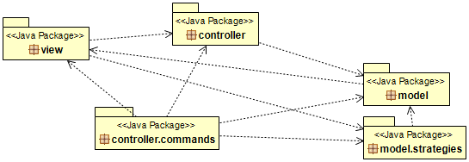

Detailed Design

Implementation
- For each class give a brief description in terms of a CRC card (see the format below)
Class Name:
Responsibilities | Collaborations
- List the responsibilities of the class in simple precise statements - don't use passive voice.  - E.g., This class is responsible for this task.  - This class performs this activity... | - List the dependencies and associations of this class with the other classes of the project

Quality Assessment
Prepare here a report for the quality problems that you found in this phase.
Report here more general problems and justify them:
- Possibilities of problematic classes with many responsibilities,
- Detect possibilities of similar classes with duplicated code
- Detect possibilities of similar methods with duplicated code
- Possibilities of problematic classes with very few responsibilities

