Telerik course
Python Core
Programming fundamentals
What is a variable?
In Python, a variable is like a labeled storage box. It’s a way you can name a piece of data so that your program can remember it and use it later. Variables help keep track of the data.
Unlike some other programming languages where you must declare exactly what kind of data you are storing ahead of time, Python is super flexible. You just give the variable a name and assign a value to it using the equals sign (=):
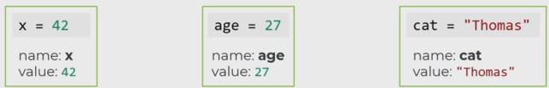
Using Variables
We can simply refer to the variable by its name
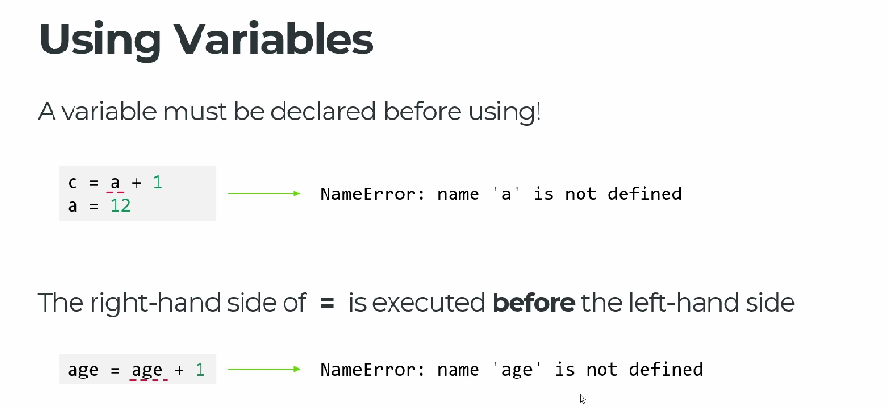
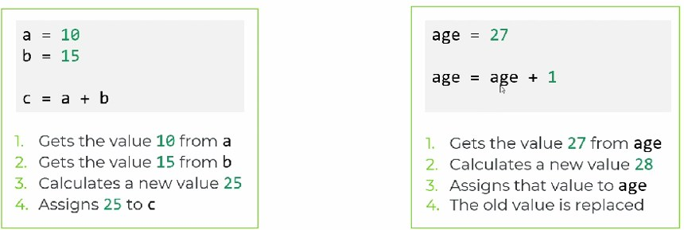
Key Things to Know About Python Variables
- They can change (Dynamic Typing): A variable isn't locked into one type of data. You can change a variable from a number to a piece of text whenever you want.
score = 10 # Right now, it's a number
score = "Ten" # Now it's text, and Python is totally fine with that!
- Case-Sensitive: Python cares about capital letters. User, user, and USER are treated as three completely different variables.
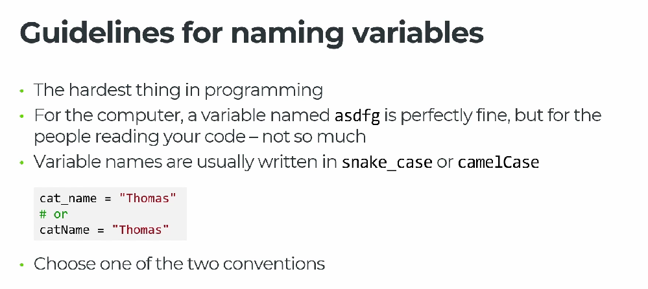
- No Spaces Allowed: Variable names must be one continuous word.
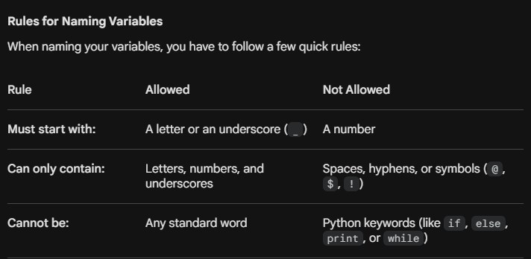
Code structure
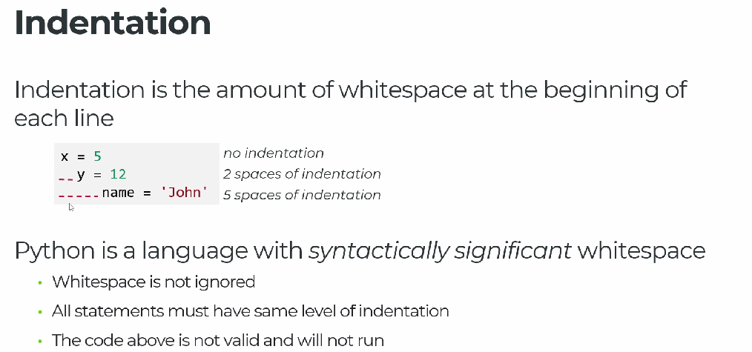

In Python, whitespace isn't just about making your code look pretty—it is a fundamental part of the language's syntax. While many programming languages use curly braces {} to define blocks of code, Python uses indentation. Here is a breakdown of how whitespace works in Python, where it matters, and where it doesn't.
Where Whitespace is Mandatory: Indentation
Python uses whitespace at the beginning of a line (indentation) to determine the grouping of statements (like loops, functions, and conditionals).
The Golden Rule
All lines of code within the same block must be indented by the exact same amount of whitespace.
- Standard Practice: The Python community standard (PEP 8) recommends using 4 spaces per indentation level.
- Tabs vs. Spaces: You can use either spaces or tabs, but never mix them in the same script. Doing so will trigger an IndentationError.
# Correct
if 5 > 2:
print("Five is greater than two!") # Indented by 4 spaces
# Incorrect (Will cause an IndentationError)
if 5 > 2:
print("Five is greater than two!")
Where Whitespace is Ignored (Implicit Line Continuation)
Inside parentheses (), brackets [], and braces {}, Python completely ignores whitespace. This is incredibly useful for breaking up long lines of code to make them readable.
# Python doesn't care about the spacing or line breaks inside these brackets
my_list = [
1, 2, 3,
4, 5, 6
]
def total_sum(a, b, c):
return a + b + c

# This works perfectly fine
result = total_sum(
10,
20,
30
)
Best Practices for Clean Code (PEP 8)
While Python might not throw an error if you bunch everything together, the official style guide (PEP 8) suggests using whitespace to make your code readable.
Use Blank Lines to Separate Code
- Use two blank lines surrounding top-level functions and class definitions.
- Use a single blank line inside a function to separate logical sections.
Spaces Around Operators
- Put a single space before and after assignment operators (=), comparisons (==, <, >), and Booleans (and, or).
# Good practice
x = 5
y = 10
if x < y and x > 0:
print("Looks good!")
# Avoid doing this (too cramped)
x=5
y=10
if x<y and x>0:
print("Harder to read")
Common Pitfalls to Watch Out For
IndentationError vs TabError
- IndentationError: expected an indented block: You forgot to indent after a colon : (like after an if, for, or def).
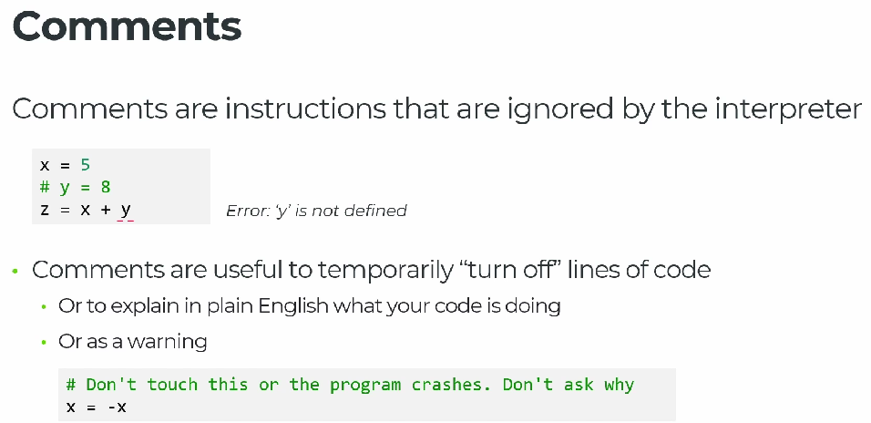
- TabError: inconsistent use of tabs and spaces in indentation: You accidentally hit the Tab key on one line and used spaces on the next. Most modern code editors (like VS Code or PyCharm) automatically convert tabs to spaces to prevent this.

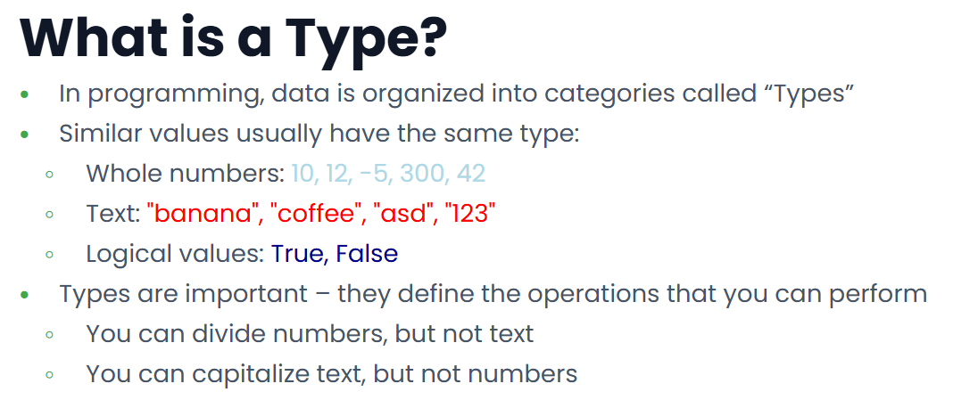

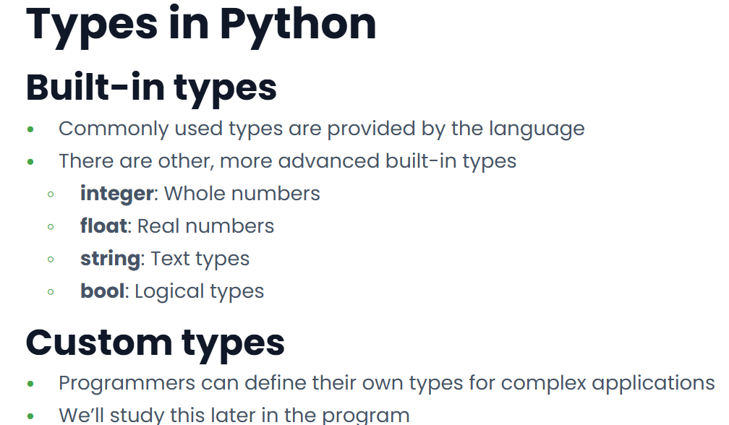

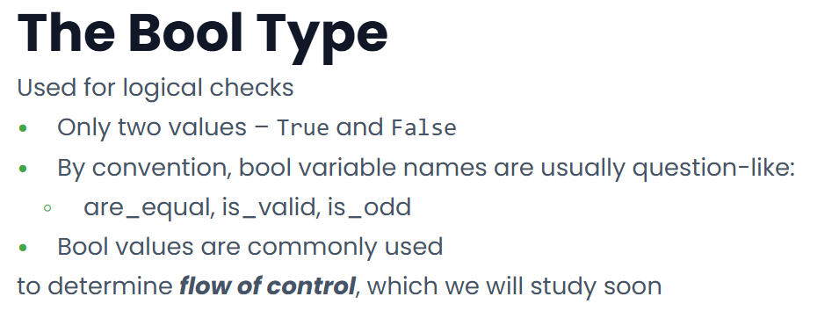
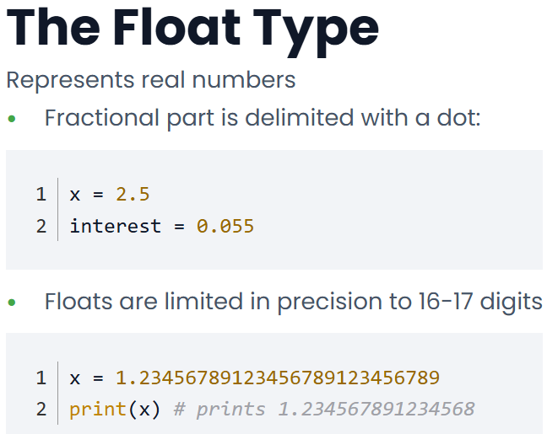
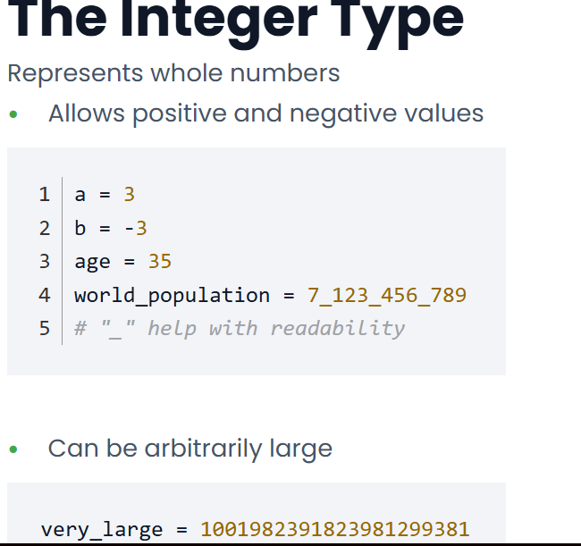

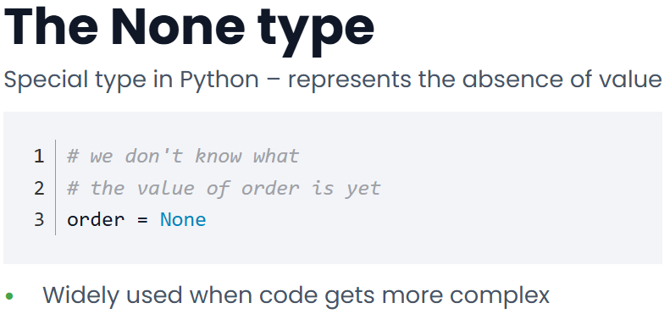
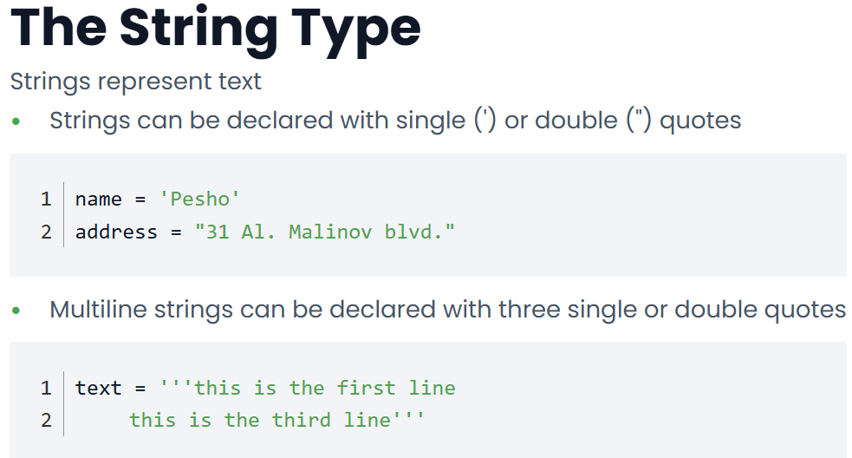

Operators
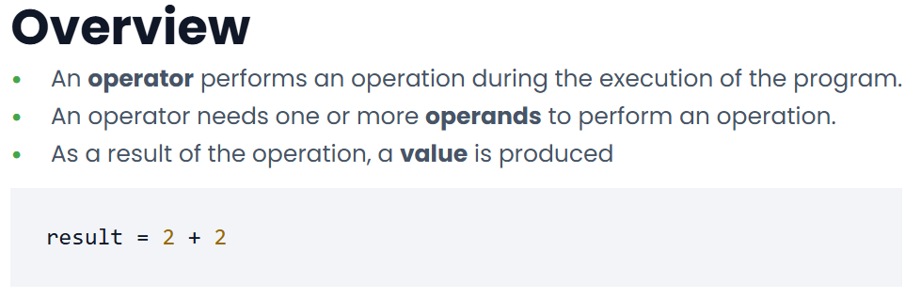

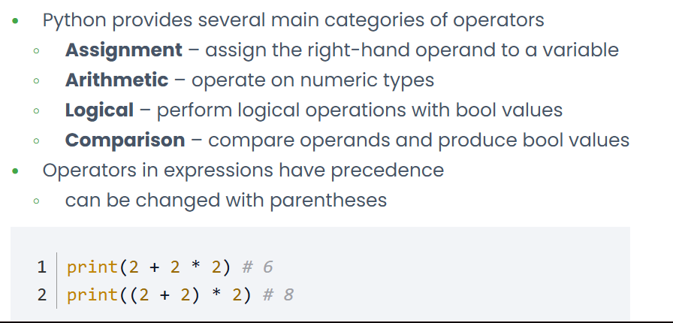

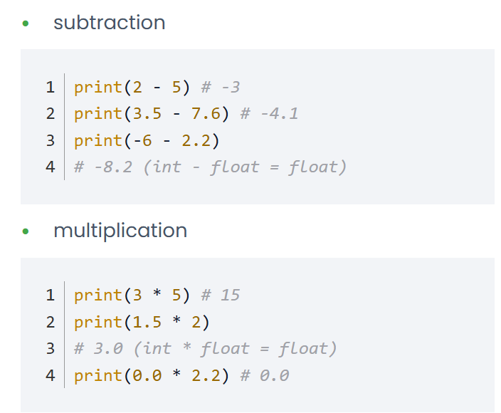
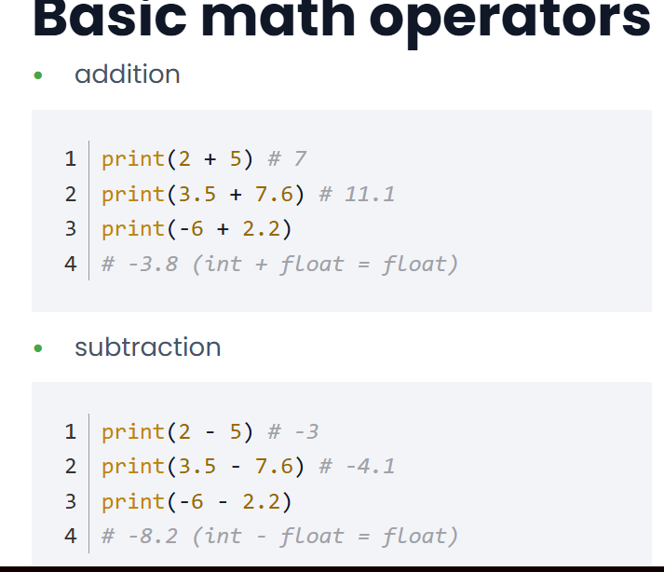

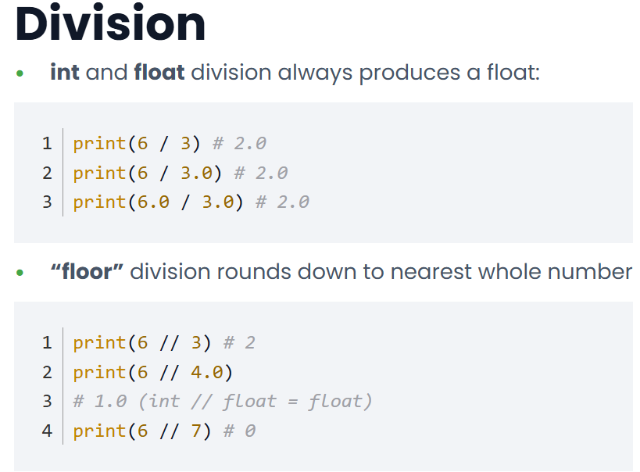

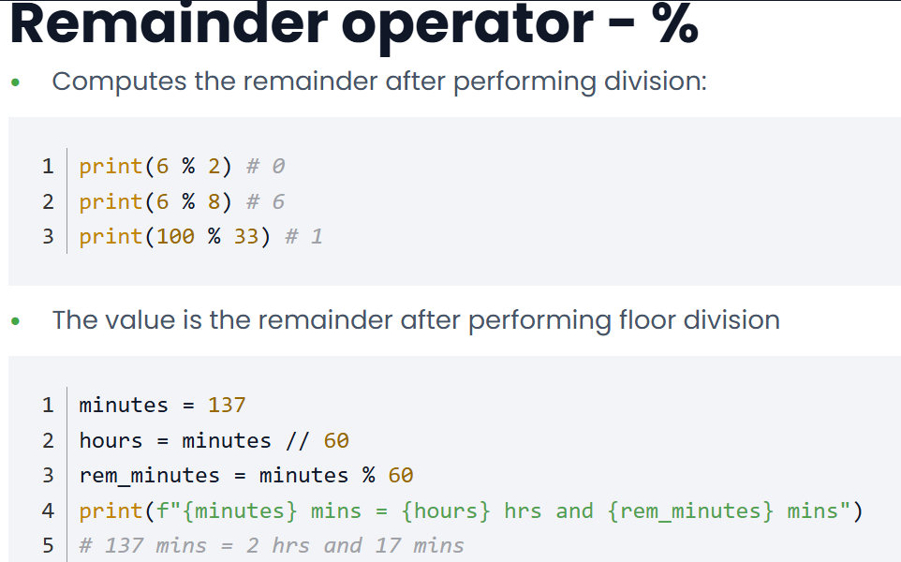

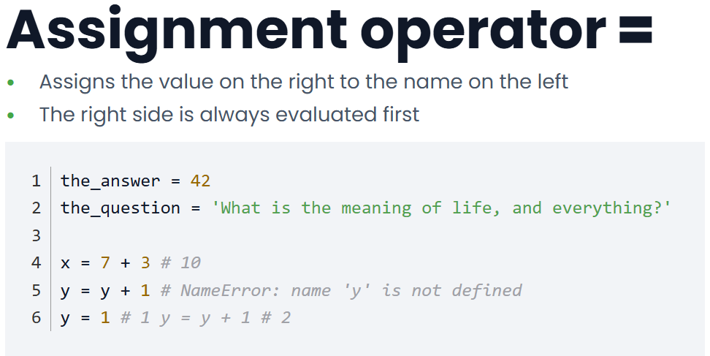

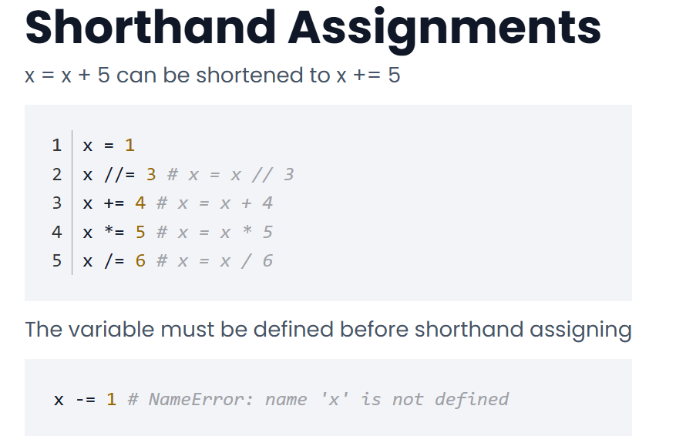

Function

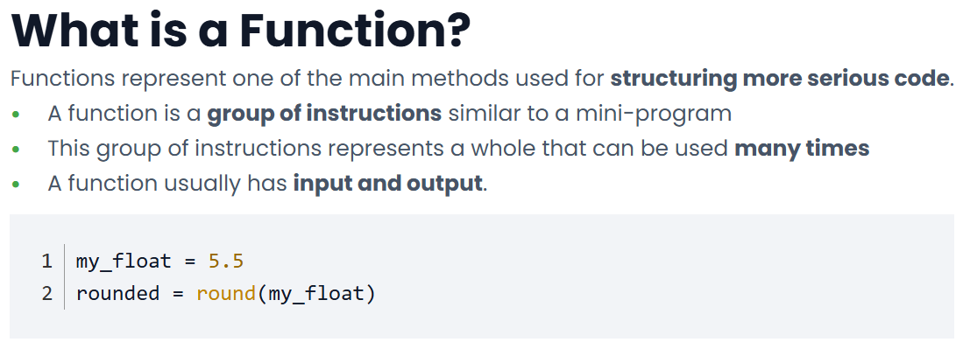

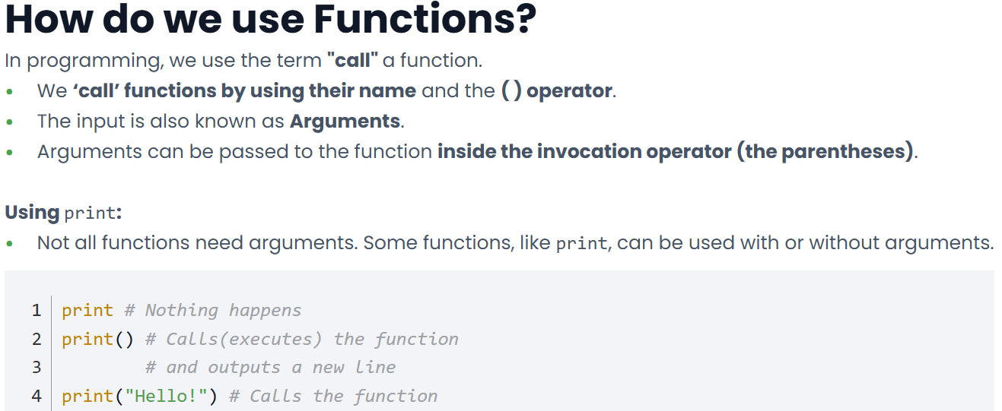

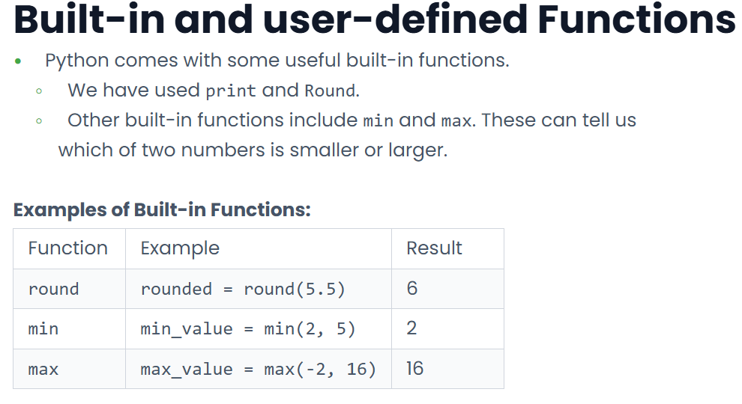

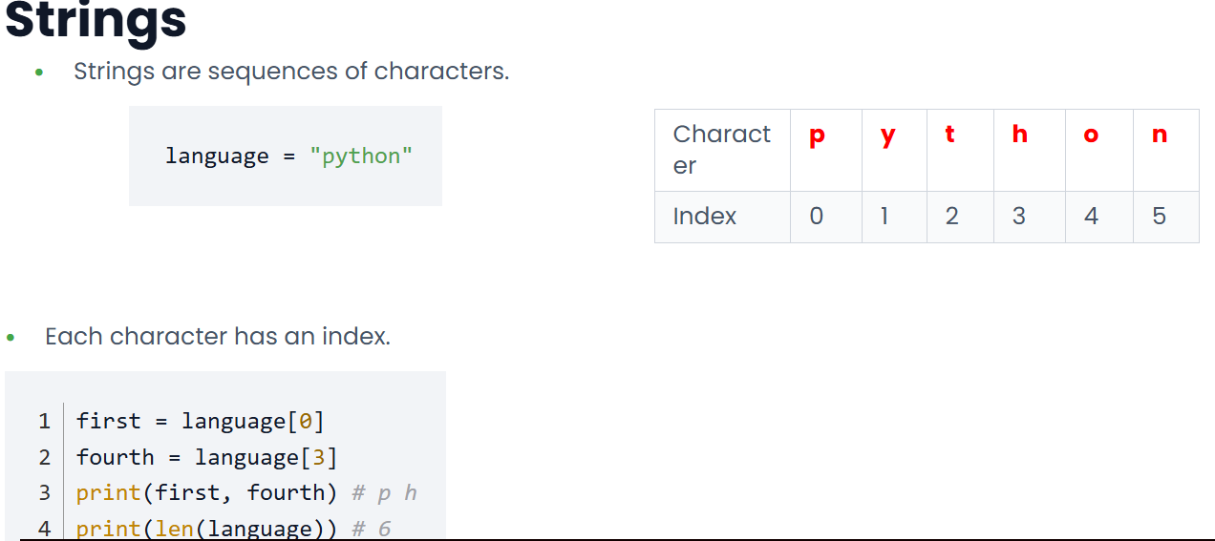
Strings

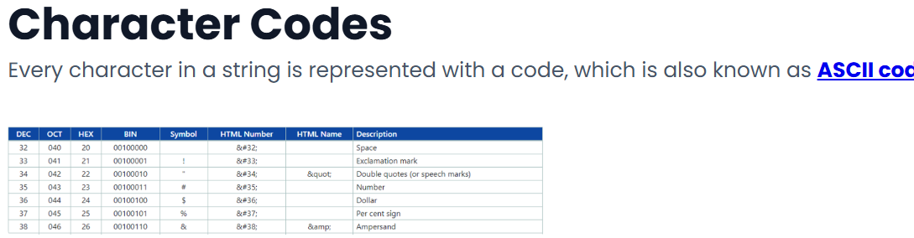

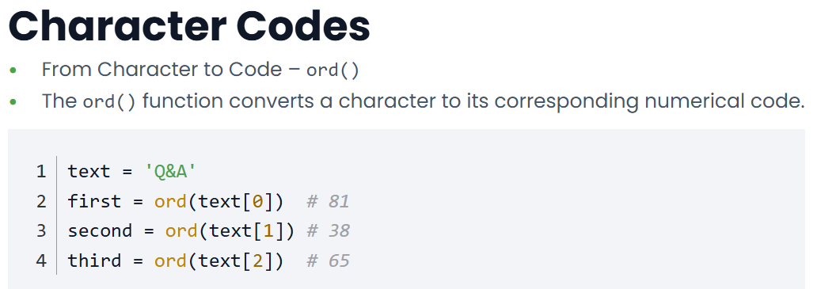

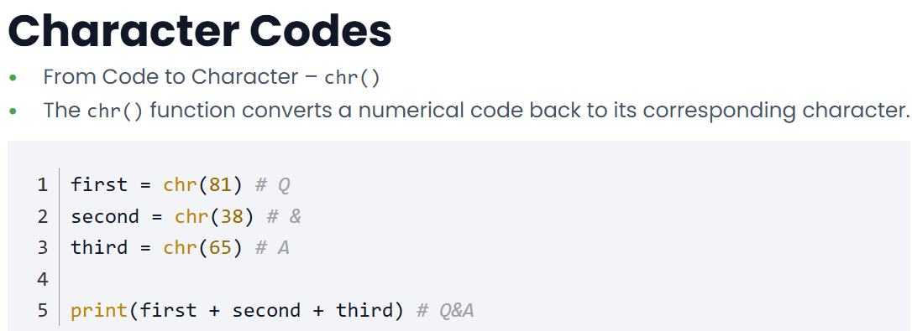

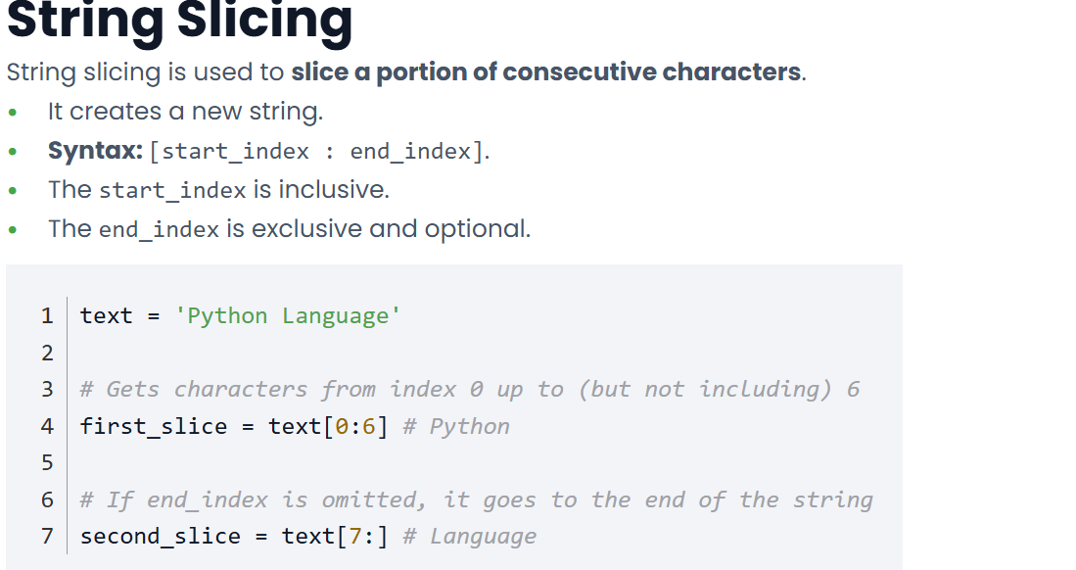

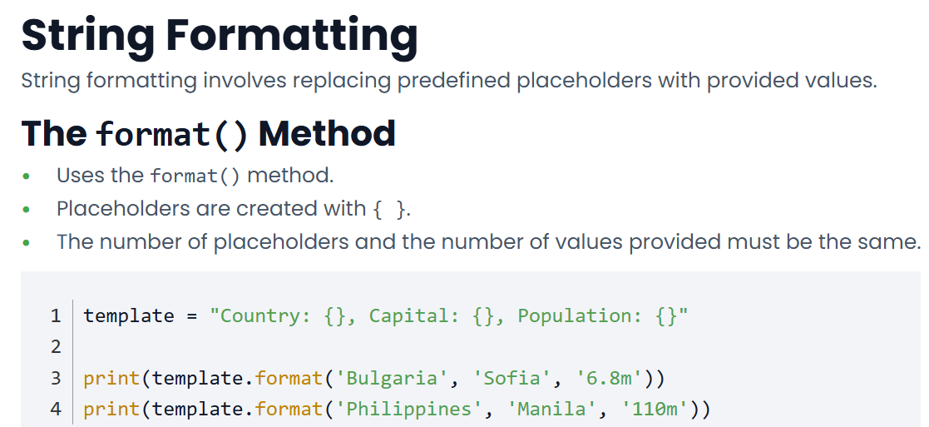

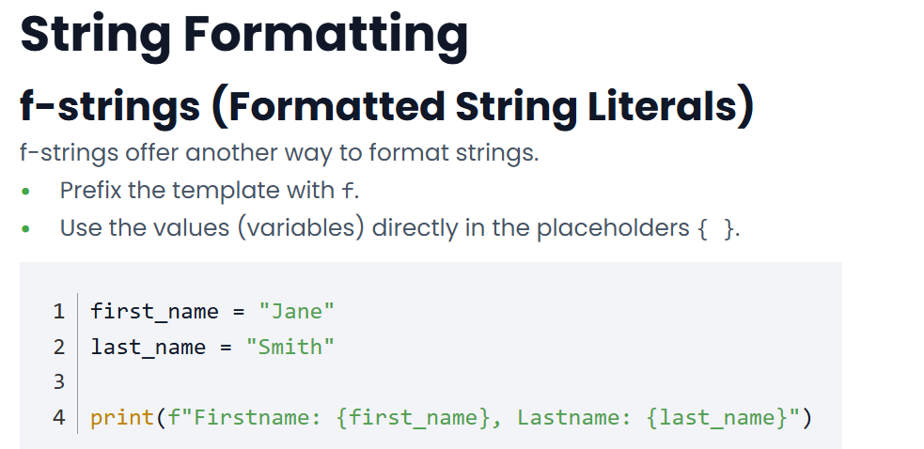

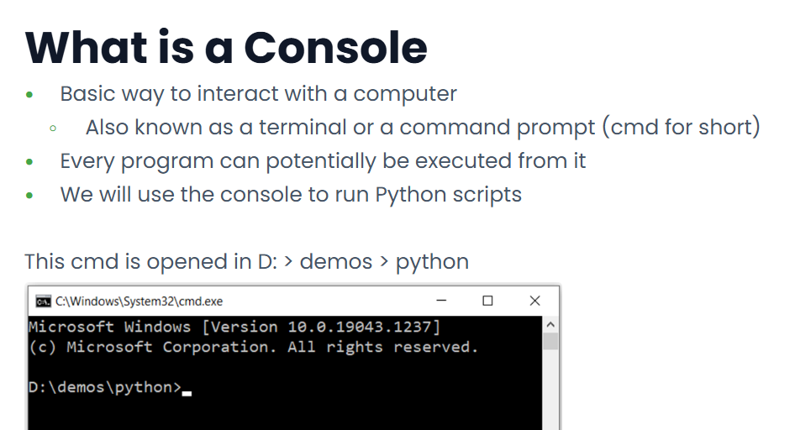
Console input and output

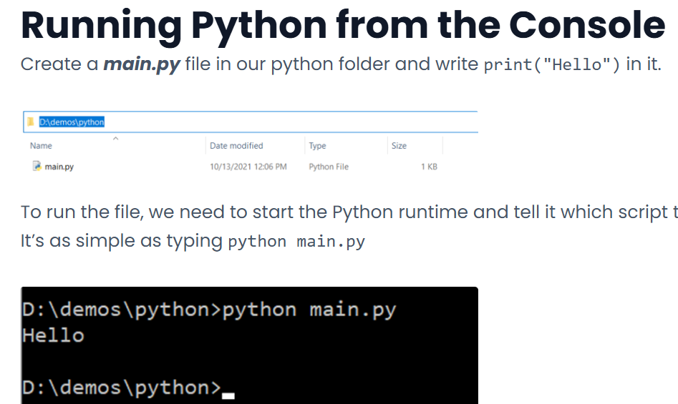

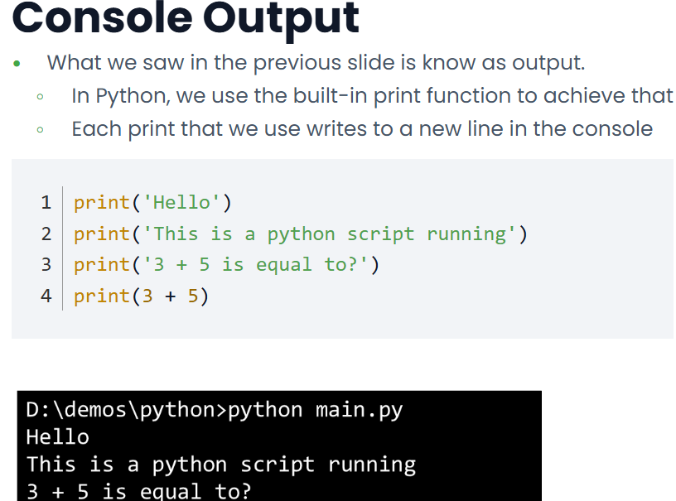

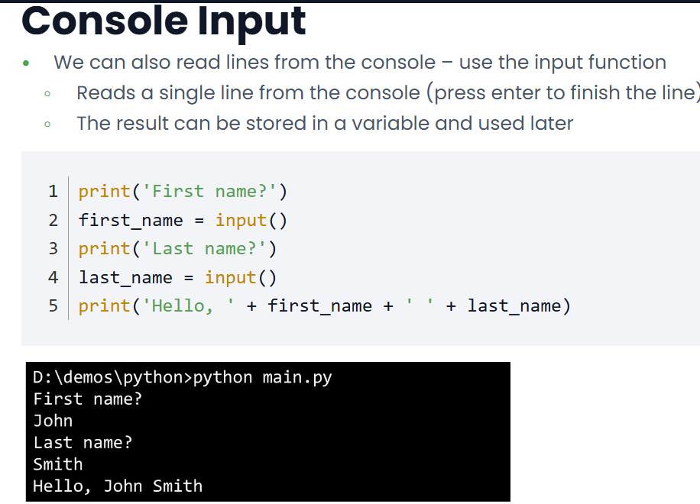

Parsing

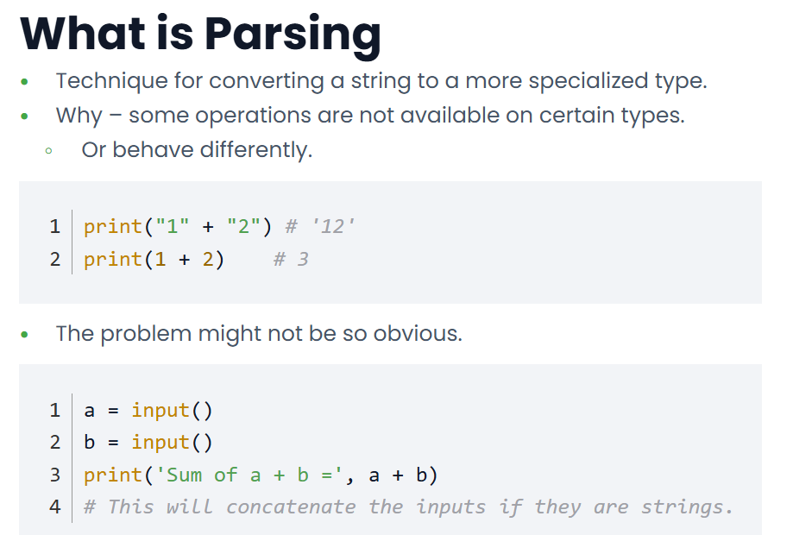

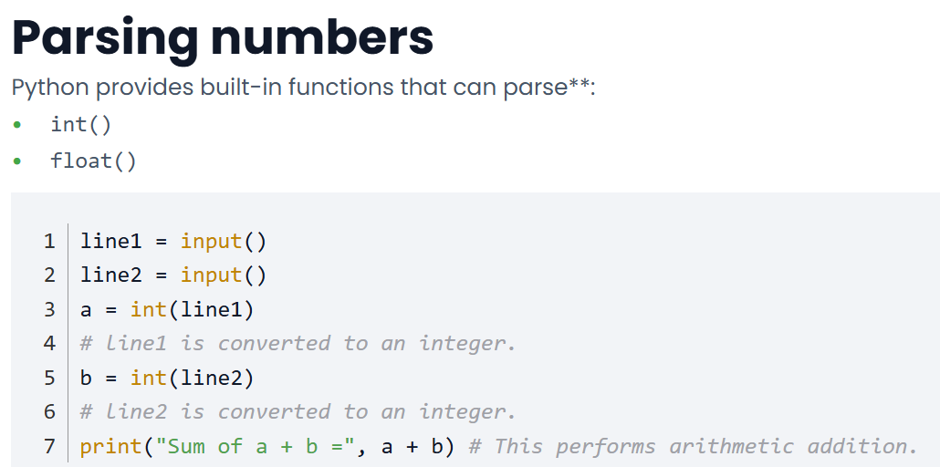

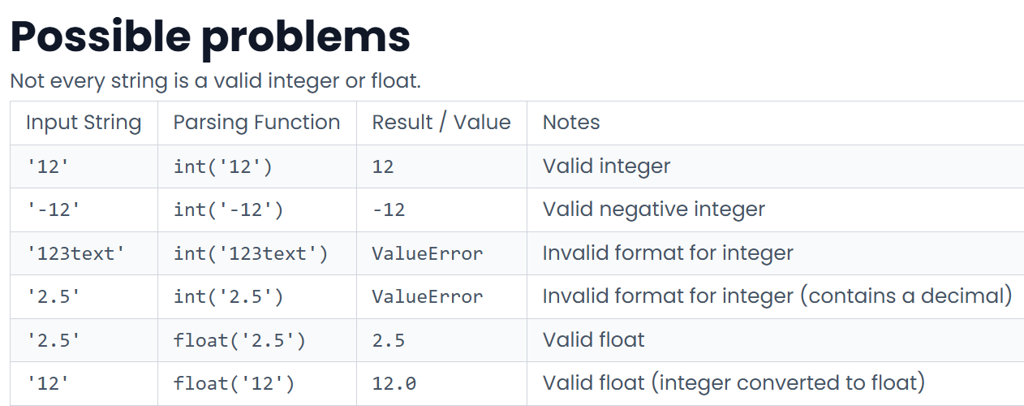

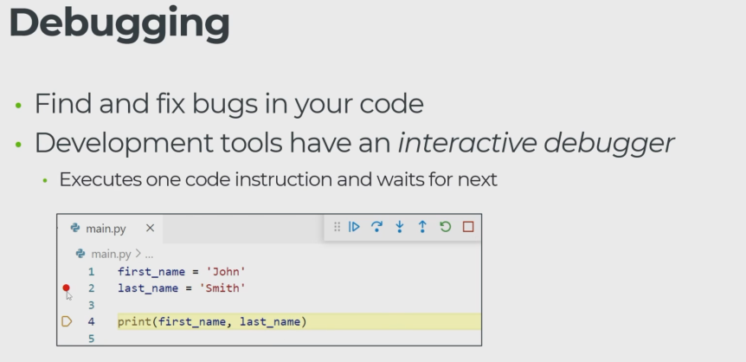

Conditional instructions

Logical and comparison operators

Equity Operators
== evaluates to True if values are equal
print(1 == 1) # True
print(2 == 3) # False
print('Telerik' == 'telerik') # False

!= evaluates to True if values are not equal
print(1 != 1) # False
print(2 != 3) # True
print('Telerik' != 'telerik') # True

Comparison Operators
The operators >, <, <=, and >= compare numeric types
print(1 > 1) # False
print(1 >= 1) # True

Strings can be compared for alphabetical order
- Uppercase letters have a lower order than lowercase
print('apple' < 'banana') # True
print('apple' < 'Banana') # False

Logical Operators
Operators that perform logical calculations with bool values
- and - both values must be True
- or - one value must be True
- not - flips True to False and False to True
name = 'Pesho'
age = 25
print(name == 'Pesho' and age > 30) # False
print(age > 20 and age < 30) # True
print(name == 'Pesho' or age > 30) # True
print( not (name == 'Pesho')) # False

Truth Table - conditional logical operators table
value A | value B | A and B | A or B
True | True | True | True
True | False | False | True
False | True | False | True
False | False | False | False

Operator Precedence Table
Precedence | Operators | Description
Highest | () | Parentheses
 | ** | Exponentiation
 | *, /, //, % | Multiplication, Division, Floor division, Modulus
 | +, - | Addition, Subtraction
 | <, >, <=, >= | Comparison operators
 | ==, != | Equality operators
 | not | Logical NOT
 | and | Logical AND
Lowest | or | Logical OR
Note: Prefer adding () to expressions for clarity and readability

Expressions and Statements

Statements
Python code is built out of statements
- Statements are used to instruct Python what to do
- One line is usually equal to one statement
x = 5
y = 12
name = 'John'

One line can contain more than one statement by delimiting with ;
x = 5; y = 12; name = 'John'

Example Statements
Variable declaration is not the only statement We will soon study

- if / elif / else to conditionally execute instructions
- while to repeat instructions
- for to loop over sequences
- break / continue to control loops

Expressions
An expression is a code unit that is evaluated and produces a value
2 + 3
7 * (2 + 4)
"Hello" + " " + "Python"
Statements cannot be used inside expressions
y = 3 + (x = 5) # Invalid syntax

Statements vs Expressions
Statements never produce a value
- They act like commands telling Python what to do
Expressions always produce a value
- The created value can be:
  - Used inside bigger expressions
  - Assigned to a variable
  - Passed to functions
  - Used to control if and while statements
  - Many other examples
Conditional statements
if statement
Used for conditional code execution
Relies on bool values
Indentation is important!
bool_value = True
print('Always executed')
if bool_value:
print("this code is executed only if bool_value is True")
print("this line also belongs to the 'if' statement") #same indentation as the line above line
print('always executed')

if / else statement
Adds additional branch to if statements
- Executed if the condition is False
- Again proper indentation is required
a = 1
b = 2
if a > b:
print('a is greater than b')
else:
print('b is greater than a')

