# Visoka strukovna škola za informacione i komunikacione tehnologije



Documentation

Subject : Web PHP 2

Milutin Velisic 195/17

LinkedIn profile : https://www.linkedin.com/in/milutin-velisic-25203a135/

# 1.0 Introduction

1.1 Used programming languages

1.2 Template

1.3 Website functionalities

# 2.0 Website organization scheme

2.1 Database

2.2 Folders organization

**1.0 Introduction**

“Deluxe” is online hotel reservation website.

# 1.1 Used programming languages

HTML5, CSS3, Bootstrap, JavaScript, jQuery, Laravel 6.14, MySQL.

Code was written in Visual Studio Code.

# 1.2 Template

Template has been downloaded from <https://colorlib.com/>. Website is fully responsive for all devices with some of my little alteration.

# 1.3 Website functionalities

**Logging users**: The procedure is done by submitting form values to controller that checks the data in custom request and if everything is successfully checked, passes it to controller and method called from appropriate model. First method will check if sent username exists in database. If it exists, second method is called to update that user ‘active’ column to ‘1’. If everything is valid, that method will return row with that user which is then put inside of session and redirected back to home page. If there were any errors, the errors will be printed above the login form. But before sending any data to server, all data is validated with laravel request.

**Register users** : The procedure is done in similar way like logging users. All goes to controller that checks the data in custom request and if everything is successfully checked, passes it to method. That method will try to add user to database. In database ‘username’ column is set to be unique, so if new user is trying to register with username that already exists, that error will be printed above register form. If everything is valid, after user has been added, second method will extract that user and put it inside session and redirect to home page.

**Filtering rooms :** On page rooms, on right side there are 3 filters for rooms: for room type, min price and max price. All three filters are done in combination of AJAX and PHP. When user click on some filter, with javascript value is collected and sent with AJAX to controller which is then passed to method that filters rooms base on that sent data.

**Admin panel :** Its separate section of website, available only to admins. There admins can do CRUD operations on users and rooms. It has a dashboard with user activities and page activities.

**Blog and pagination :** On Blog page there is a search input and paginated blog posts. There are limited to 8 posts per page. Filter and pagination are done with AJAX.

**Room reservation :** : The procedure is done with Javascript and PHP code. Data from form is first checked in javascript before being sent to server side with AJAX. If everything is in right format, data will be sent to query that checks given date for give room. Information of room availability will be shown shortly after “Check room” button is clicked. If there is a available room, user can click button to complete reservation on next page that will automaticly fill form with given data and user information if user is logged in. If he isn’t, he must fill form that will register him and complete reservation.

# 2.0 Website organization scheme

# 2.1 Database

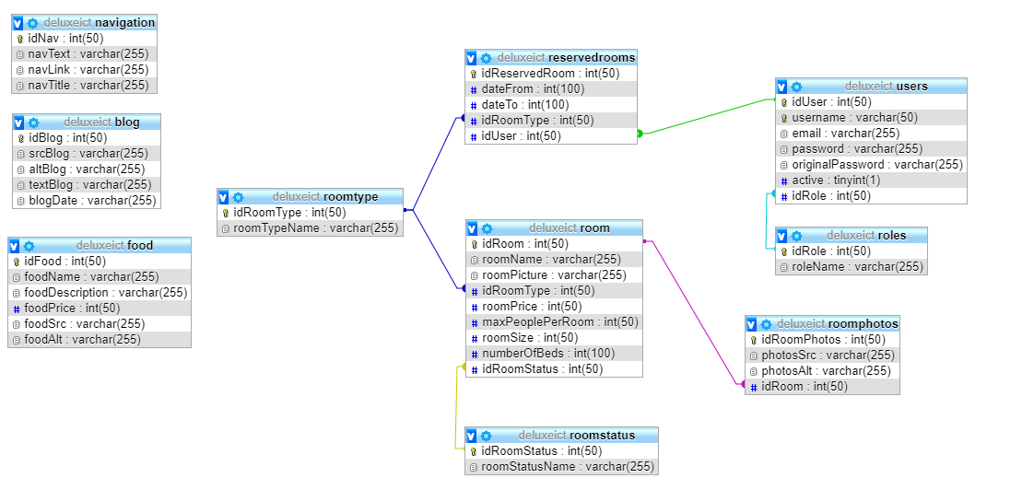

# 2.1 Folder Organization

