CUNY Reddit Corpus - Participation Baselines Report
The CUNY Reddit ecosystem comprises 24,857 unique users generating 274,950 contributions across 8 subreddits. Compared to Reddit at large, CUNY communities show 2-3x higher participation rates, with 17x more power users and a distinctive comment-dominant culture where 44.4% of users exclusively answer others’ questions.
Key finding: While Reddit’s 90-9-1 rule predicts 90% lurkers, CUNY subreddits show only 34.3% one-time contributors—reflecting the practical mutual-aid function of student communities navigating bureaucratic complexity.

Participation vs. Reddit Baselines
Metric | Reddit Baseline | CUNY | Multiplier
Lurker rate | 90-98% | 34.3% | 2.6x more active
Regular contributors (10+) | 1-2% | 20.6% | 10-20x higher
Power users (100+) | <0.1% | 1.7% | 17x higher
Comments per user | ~7 | 9.4 | 1.3x more

Contributor Typology

Six-Tier Participation Model
Tier | Contributions | Users | % | Role
One-time | 1 | 8,535 | 34.3% | Drop-in askers
Light | 2-4 | 7,177 | 28.9% | Occasional
Moderate | 5-10 | 4,023 | 16.2% | Semi-regular
Regular | 11-50 | 4,054 | 16.3% | Consistent
Heavy | 51-100 | 652 | 2.6% | Reliable answerers
Super | 100+ | 416 | 1.7% | Community stewards

Contribution Distribution
One-time |████████████████████████████████████ 34.3% (8,535)
Light |██████████████████████████████ 28.9% (7,177)
Moderate |████████████████ 16.2% (4,023)
Regular |████████████████ 16.3% (4,054)
Heavy |███ 2.6% (652)
Super |██ 1.7% (416)
Observation: The 416 super contributors (1.7%) function as de facto community stewards—17x the Reddit baseline for sustained engagement.

Behavioral Modalities
Behavior | Users | % | Interpretation
Comment-only | 11,039 | 44.4% | Reactive helpers
Both post & comment | 9,409 | 37.9% | Full participants
Post-only | 4,409 | 17.7% | Question-askers
Observation: The comment-dominant culture (44.4% never post) indicates Q&A forum structure rather than content broadcasting—characteristic of support communities.

Per-Campus Engagement
Community | Users | Avg/User | Posts/User | Comments/User
r/Baruch | 9,265 | 12.76 | 1.98 | 10.78
r/CUNY | 10,967 | 8.75 | 1.13 | 7.62
r/QueensCollege | 2,930 | 8.66 | 1.44 | 7.22
r/HunterCollege | 3,222 | 7.66 | 1.23 | 6.43
r/CCNY | 1,445 | 6.40 | 1.09 | 5.31
r/BrooklynCollege | 424 | 2.60 | 0.82 | 1.78
r/JohnJay | 87 | 2.33 | 0.61 | 1.72
Observation: Baruch leads at 12.76 contributions/user (1.8x Reddit baseline)—likely reflecting Zicklin Business School’s networking culture.
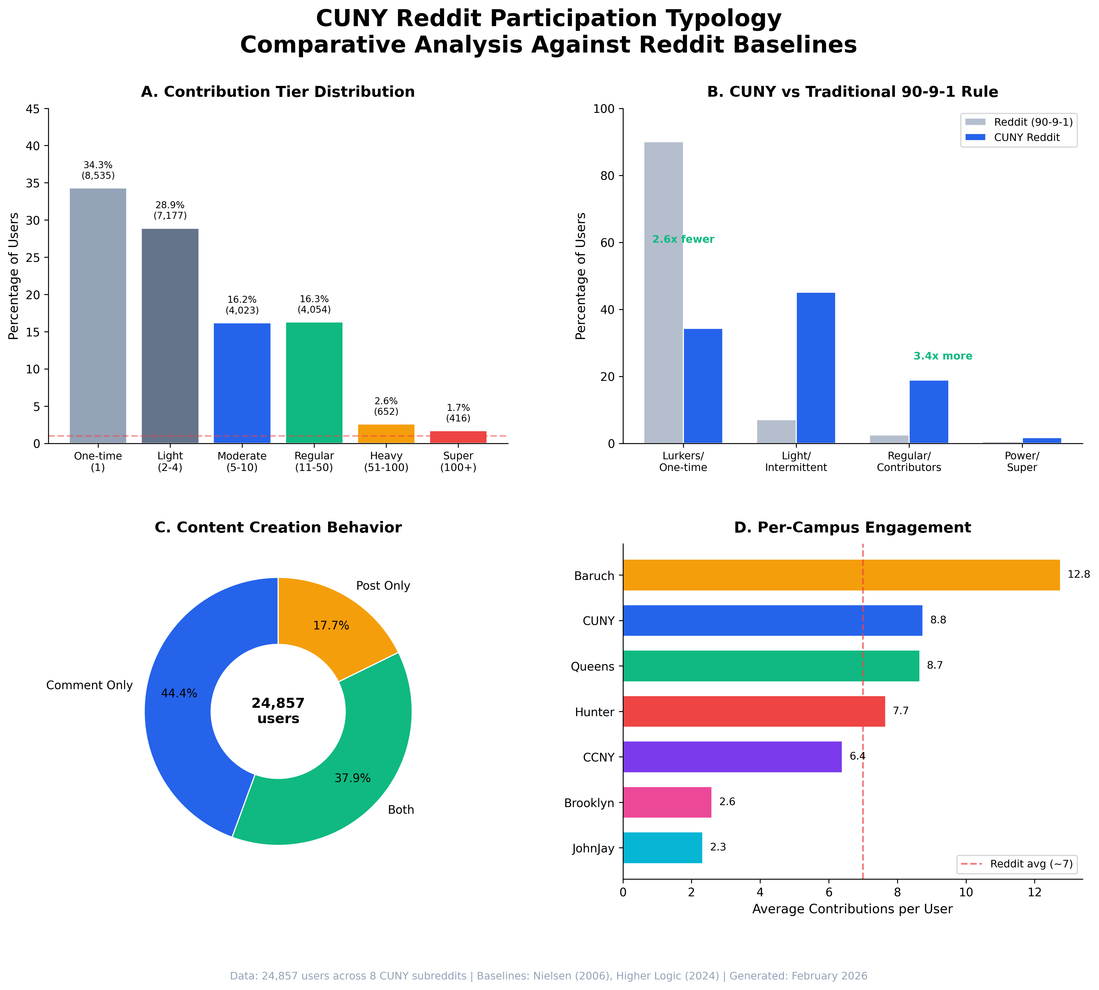
CUNY Reddit Participation Typology

Cross-Community Participation

Bridge User Distribution
Subreddit Span | Users | % | Category
1 subreddit | 21,794 | 87.7% | Community-bound
2 subreddits | 2,675 | 10.8% | Dual participants
3+ subreddits | 388 | 1.6% | Bridge users

Bridge User Network Impact
Metric | Reddit Baseline | CUNY | Significance
Cross-subreddit rate | 17.7% | 12.3% | Institutionally-focused
Meaningful dual participation | 1.2% | 2.8% | 2.3x baseline
Cross-community edges | — | 4,891 | Binds 8 subreddits
Clustering improvement | — | 1.9x | 0.18 → 0.34
Observation: The 1.6% bridge users create 4,891 cross-community edges, improving network clustering by 1.9x. Cross-community replies are 3x more efficient at network cohesion per edge.
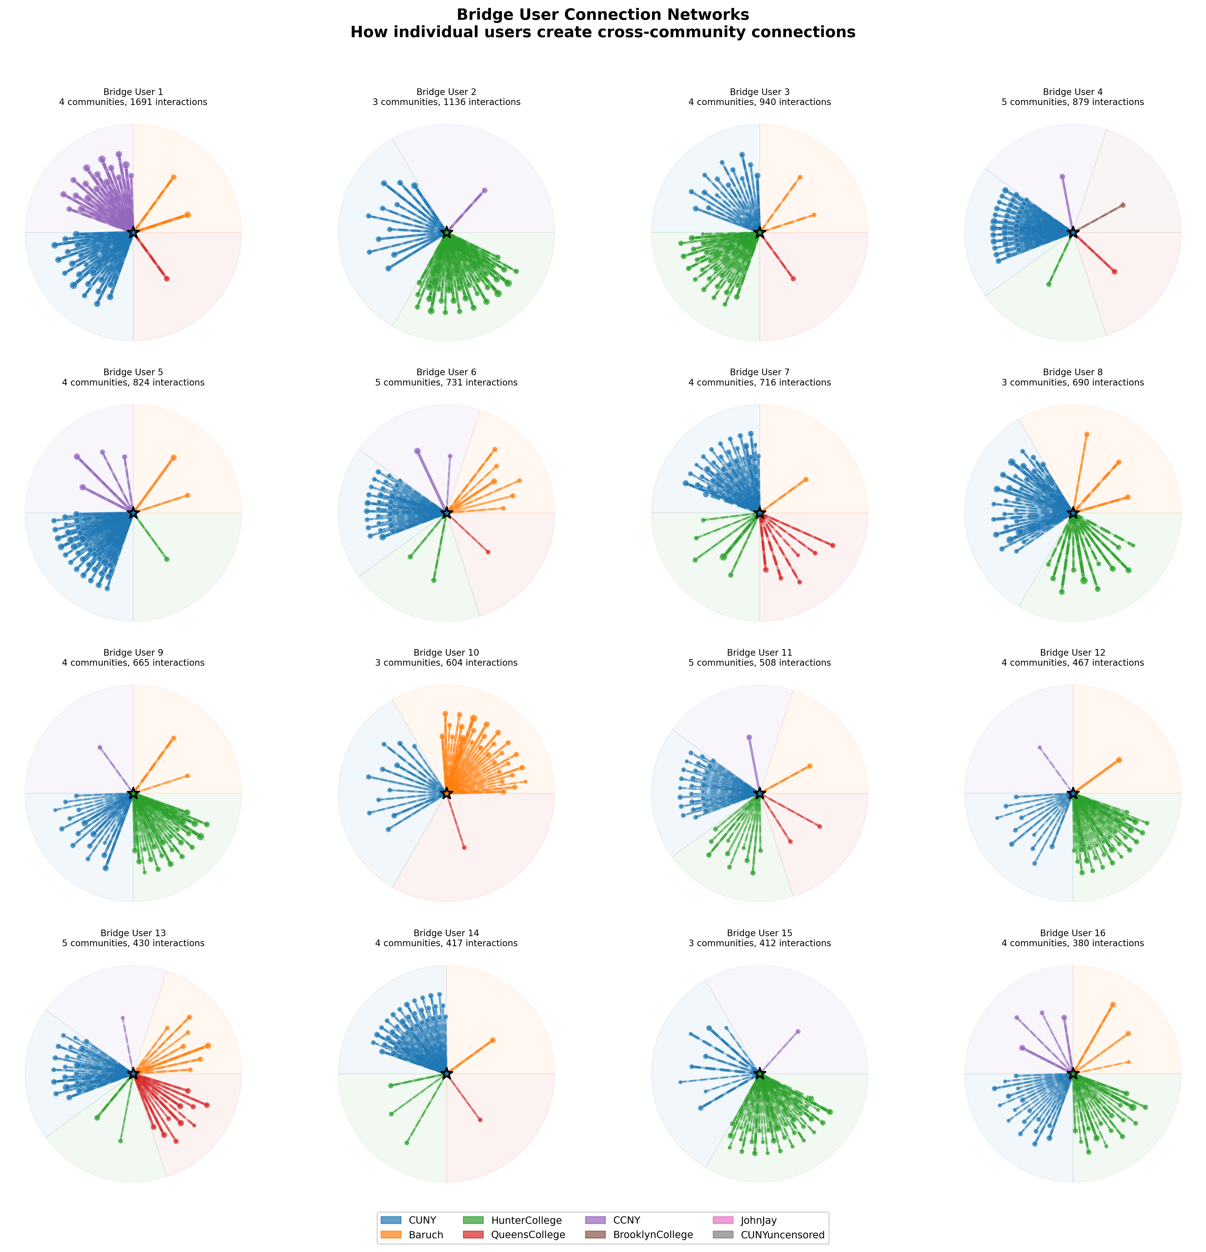
Bridge User Ego Networks

Information Flow Analysis
From 22,782 detected flow events:
r/CUNY outflow |██████████████████████████████ 51.7% (11,769 events)
r/CUNY inflow |████████████████████████████ 46.3% (10,556 events)
Net outflow |██ +5.4% (1,213 events)
Observation: r/CUNY functions as primary knowledge hub with bidirectional exchange. Policy knowledge flows outward; campus-specific questions flow inward.

Edge Type Efficiency
Activity Type | Edges | % of Total | Clustering Contribution
Cross-Community Replies | 4,891 | 17% | 0.52 (highest)
Comment Replies | 14,221 | 49% | 0.42
Thread Participation | 6,892 | 24% | 0.31
Submission Responses | 2,788 | 10% | 0.24
Observation: Cross-community edges (17% of total) contribute 52% of clustering improvement—Granovetter’s “strength of weak ties” quantified.

Appendix: Data Sources
Database Analysis:
├── 8 CUNY SQLite databases
├── 24,857 unique users
├── 274,950 total contributions
└── Analysis date: February 2026
Reddit Baselines:
├── Nielsen (2006) — 90-9-1 Rule
├── Higher Logic (2024) — Updated participation rates
├── PMC9455283 (2022) — Cross-subreddit participation
├── arXiv:2507.16857 (2025) — Meaningful dual participation
└── Science Advances (2025) — Power user behavior
└── Machado et al. arXiv:2503.02661 (2025) — Gini coefficient methodology

Participation Inequality (Gini Coefficient)
Following the methodology of Machado et al. (2025), we calculate the Gini coefficient to quantify inequality in user activity distribution. The Gini coefficient ranges from 0 (perfect equality) to 1 (total inequality).
CUNY Ecosystem Gini Coefficient: 0.738
Metric | Value | Interpretation
Ecosystem Gini | 0.738 | High inequality
Top 1% share | 23.3% | Super-Pareto
Top 10% share | 63.9% | —
Top 20% share | 78.4% | —
Median comments/user | 3 | Low floor
99th percentile | 140 | High ceiling

Per-Subreddit Gini Coefficients
Subreddit | Users | Gini | Top 20% Share | Size Category
r/Baruch | 7,521 | 0.740 | 78.5% | Large
r/CUNY | 8,956 | 0.725 | 77.3% | Large
r/HunterCollege | 2,685 | 0.686 | 73.5% | Medium
r/QueensCollege | 2,479 | 0.677 | 72.8% | Medium
r/CCNY | 1,181 | 0.650 | 70.0% | Medium
r/JohnJay | 55 | 0.499 | 59.3% | Small
r/BrooklynCollege | 296 | 0.472 | 55.4% | Small
r/CUNYuncensored | 44 | 0.401 | 51.2% | Small

Comparison to Reddit Baselines
Community Size | Reddit Baseline Gini | CUNY Observed | Difference
10²-10³ users | 0.40-0.50 | 0.40-0.50 | Consistent
10³-10⁴ users | 0.50-0.60 | 0.65-0.69 | +0.10 higher
10⁴+ users | 0.60-0.70 | 0.72-0.74 | +0.05 higher
Observation: CUNY’s larger subreddits (Baruch, CUNY main) exhibit Gini coefficients 5-10 points above typical Reddit communities of similar size. This suggests more concentrated participation driven by a smaller core of “community stewards” who sustain the mutual-aid function.
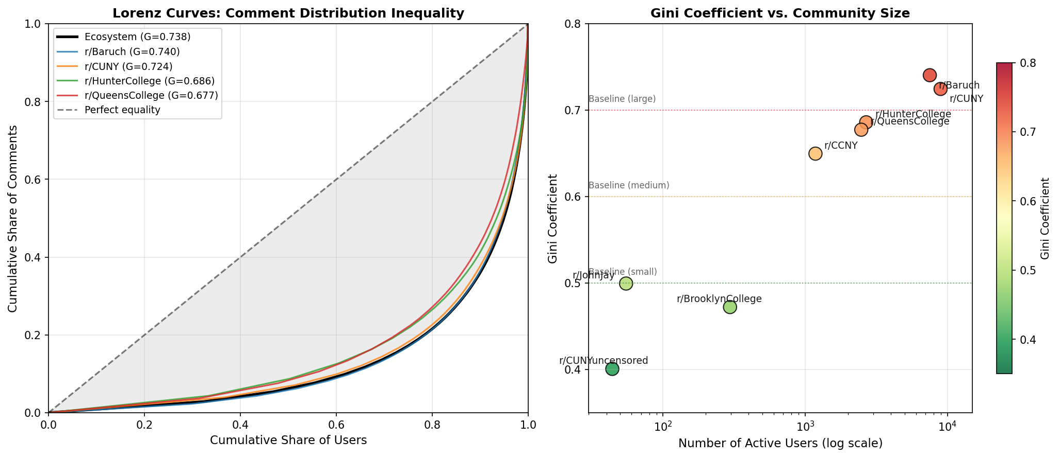
CUNY Gini Coefficient Analysis
The Lorenz curve visualization (left panel) illustrates the cumulative distribution of comments across users. The area between each curve and the diagonal line of perfect equality represents the Gini coefficient—larger gaps indicate greater inequality. The CUNY ecosystem curve (black) bows significantly away from equality, confirming that a small minority of users generate the majority of content.
The size-inequality relationship (right panel) demonstrates that Gini coefficients increase predictably with community size. Smaller subreddits like r/CUNYuncensored (G=0.401) and r/BrooklynCollege (G=0.472) cluster near Reddit baselines for communities of their size. However, larger subreddits—particularly r/Baruch (G=0.740) and r/CUNY (G=0.725)—exceed typical baselines by 5-10 points, suggesting that CUNY’s mutual-aid communities develop more pronounced hierarchies as they scale.
This elevated inequality has structural implications: the 416 “super contributors” who anchor these communities represent a critical but fragile resource. Their departure would disproportionately impact community knowledge production—a vulnerability that institutional administrators should recognize when assessing the sustainability of student-run support networks.

