For the purposes of this visualization, bridge users can be defined as individuals whose routine participation spans three or more CUNY-affiliated subreddits, and whose contributions exceed a total interaction weight based on a composite of comment volume and response chains. The top sixteen constitute the sample examined here. Four metrics characterize the communities reached by each user (three to five across the dataset) and a reciprocity ratio measuring the balance between outgoing and incoming interactions, directional flow of those interactions, and the distribution of activity across individual subreddits. Users who circulate broadly across the network differ in consequential ways from those who concentrate their labor in a smaller set of linked communities. That distinction matters because it shapes how information travels through a university system with no centralized communication infrastructure connecting its campuses or their respective online forums. Each user in the sample is anonymized and labeled sequentially rather than identified by username.
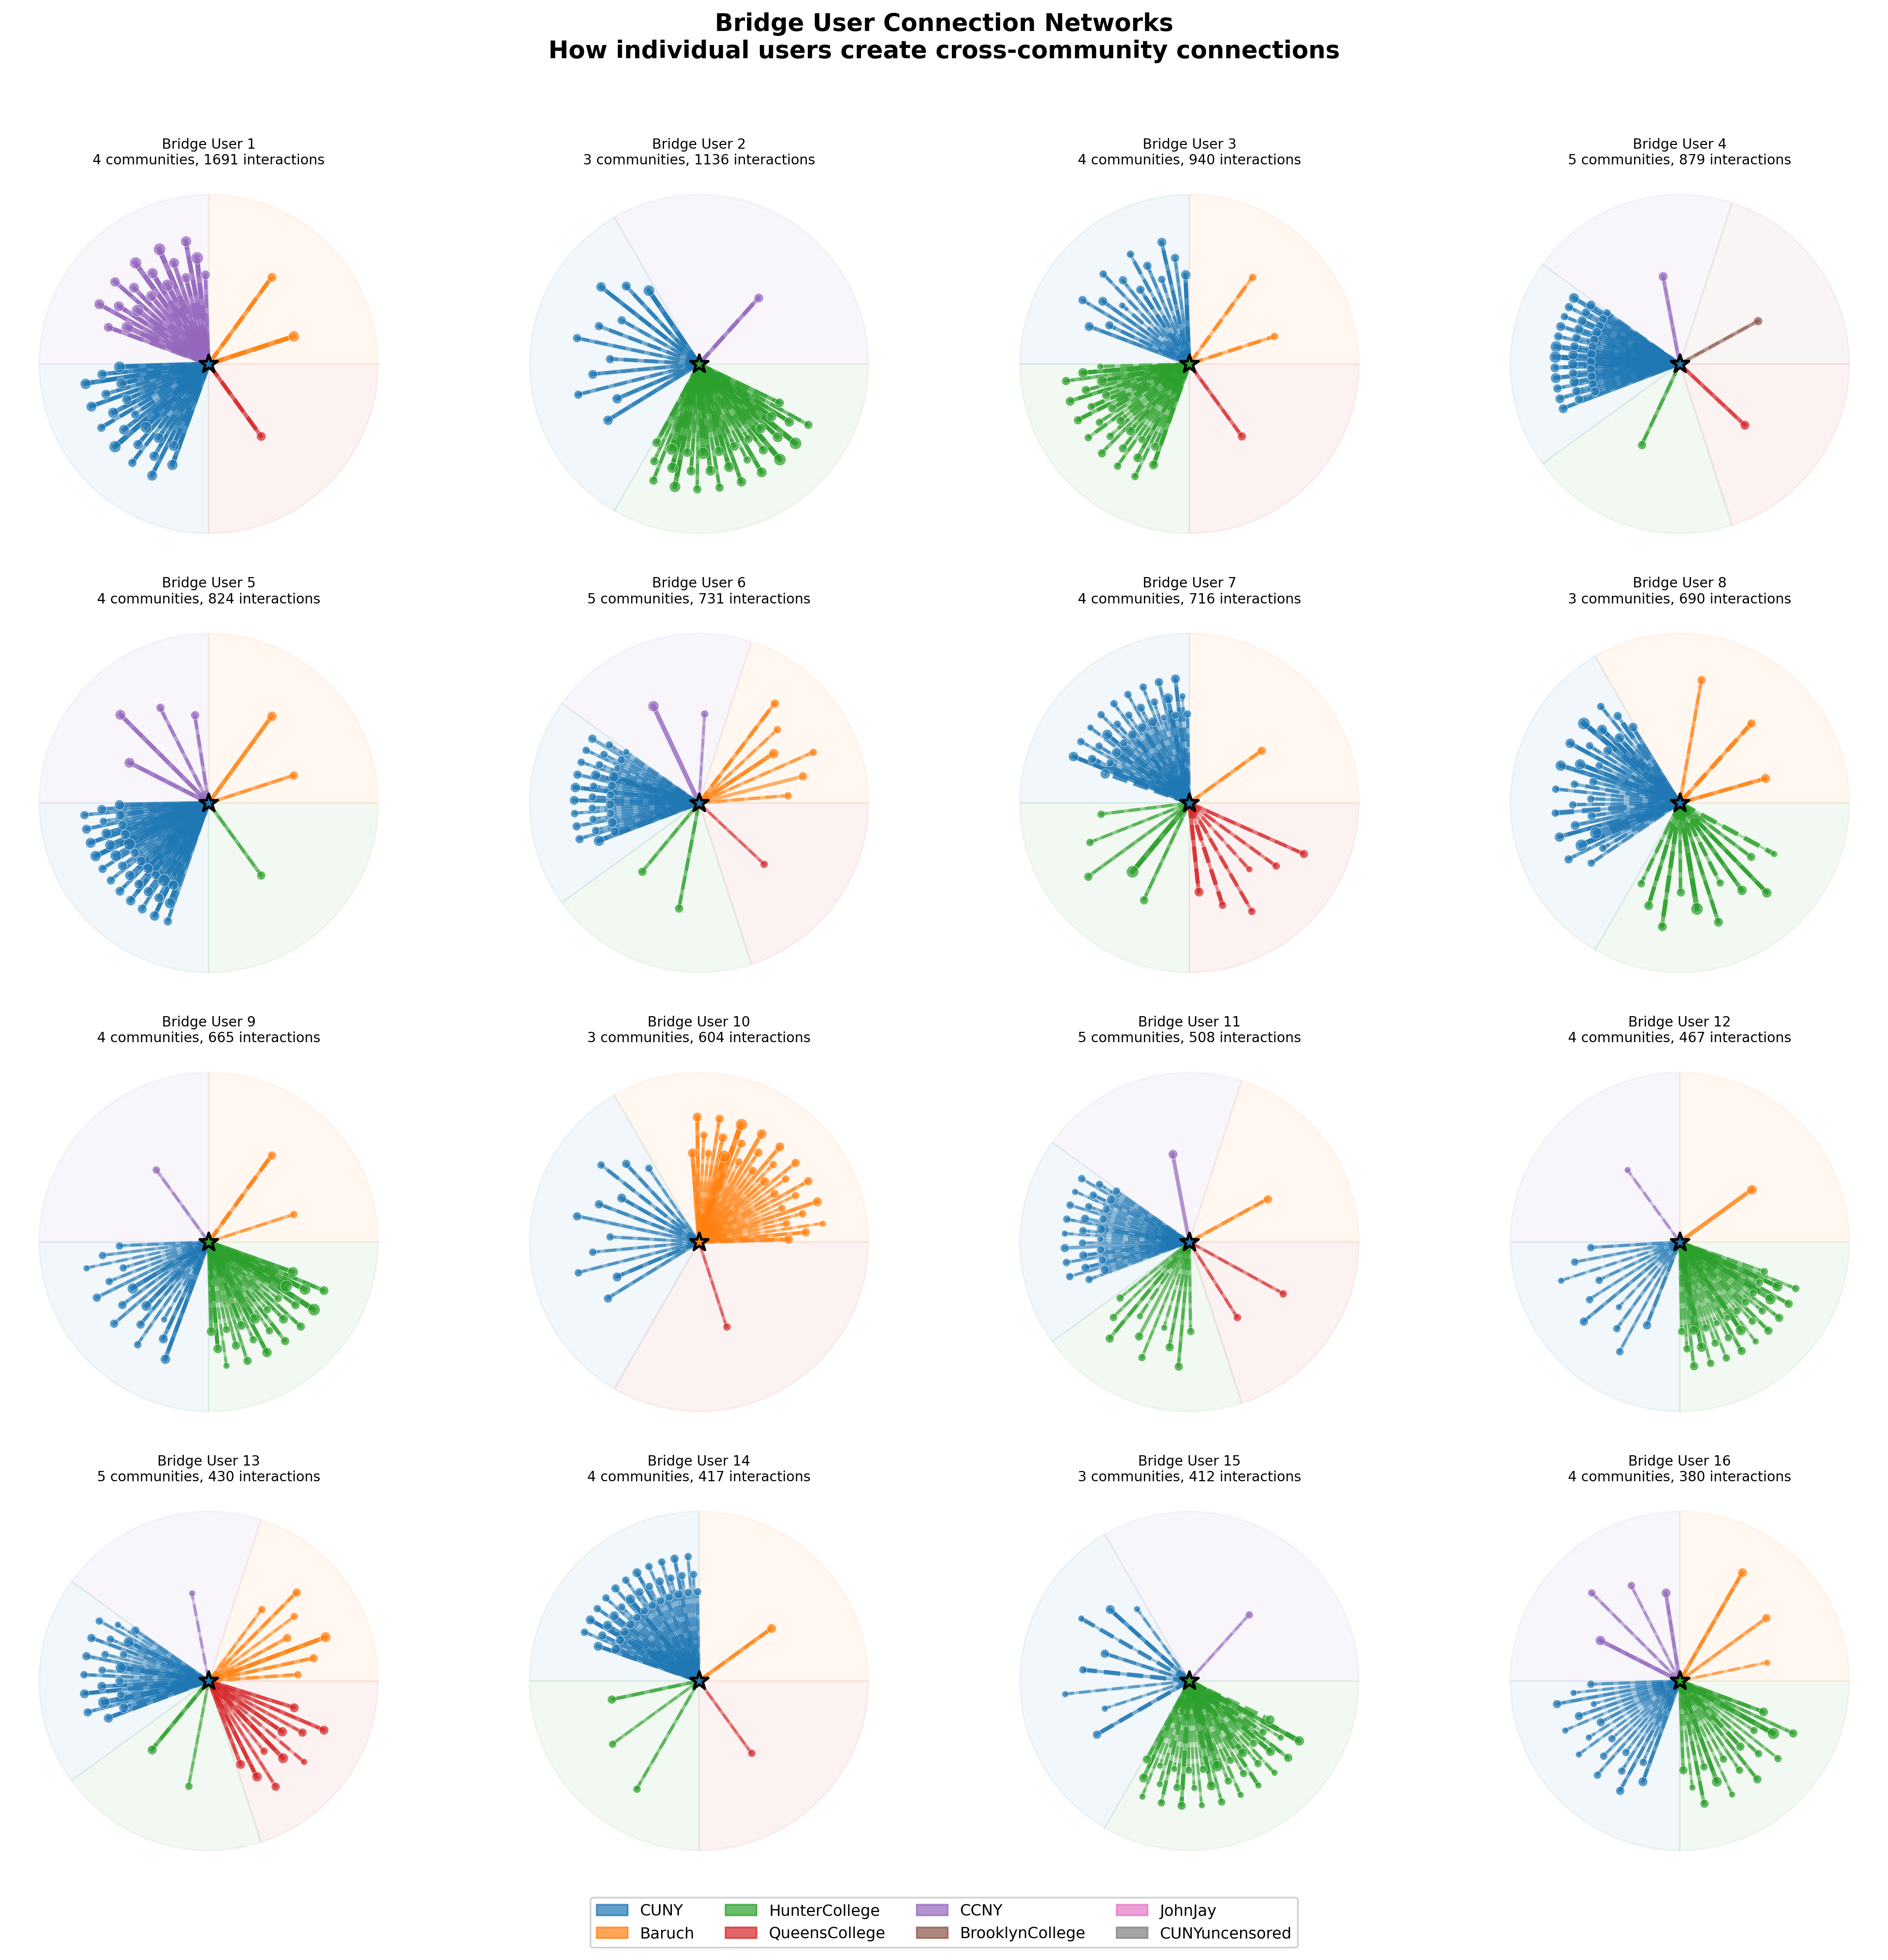
Visualization 12: Bridge User Connection Networks
Sixteen bridge users appear across six subreddits in this visualization: CUNY, Hunter College, Baruch, CCNY, Queens College, and Brooklyn College. Nine of the sixteen claim the general CUNY subreddit as their primary community, which positions that forum as the connective hub through which most cross-community traffic passes. Edges form predominantly through commenting rather than posting, a pattern that reframes network density as the product of responsive engagement rather than content broadcasting. Reciprocity ratios range from 0.36 to 0.98, and that variance exposes distinct engagement styles: some users maintain nearly symmetrical exchanges, while others operate in an advisory mode, fielding questions without receiving equivalent responses. Even the least active bridge user sustains 380 weighted interactions across four communities, which suggests that cross-community ties persist at relatively low activity thresholds. Two research questions follow from these patterns. How does network coherence persist across a decentralized multi-campus system? And who sustains the cross-community information flows that hold otherwise separate forums together, through what kinds of engagement?
Where bridge users sit in the structure is now visible, but why they occupy those positions, and what motivates their sustained cross-community labor, remains opaque. The sixteen users surfaced here represent a purposive sample for interview-based follow-up, selected by demonstrated structural significance rather than convenience. Conversations with these users would pursue how they understand their own participation, what institutional knowledge they carry between communities, and whether they recognize the coordinative role their activity patterns reveal. At the mesoscopic level, this visualization maps network positions and interaction patterns that aggregate individual behavior into community structure. Interviews would bring microscopic depth to those computationally identified positions, grounding structural metrics in the lived experience of users who coordinate the production and exchange of cross-community information and resources more broadly. Bridge users do not simply participate in multiple communities. They actively link them, carrying questions, strategies, and institutional workarounds across subreddit boundaries that mirror the physical boundaries separating CUNY’s twenty-five campuses. Following these users into conversation is where the research turns next.

