RE-MATCH

Matching Reliability and Data Quality Design

STATUS  Proposal |  | OWNER  RE-MATCH Engineering |  | LAST UPDATED  October 10, 2026

Authors | RE-MATCH engineering
Reviewers | Project maintainers
Related docs | docs/ARCHITECTURE.md; docs/API.md
Scope | Reliability and matching-quality fixes for six reported issues

1. Abstract
This proposal addresses six reported defects in RE-MATCH: inconsistent MFD geography scoring, low scores for partial addresses, stale review filters, workspace URL oscillation, slow initial loading, and fragile large matching jobs. The design canonicalizes geography before scoring, treats partial address overlap as review evidence, makes URL state authoritative, bounds result queries, and streams datasets through disk-backed job storage with resumable checkpoints. Address enrichment remains review-gated and records its source.
The pipeline must support CSV/XLSX datasets with hundreds of thousands of rows under bounded PHP memory, a Meilisearch candidate index, and resumable queue execution. Existing MFD files and selected mappings determine geography resolution. This change does not infer a business identity from address similarity alone, silently rewrite source datasets, or promise a benchmark until measured on representative production-sized files.

2. Goals and Non-Goals
Goals | Non-goals
Canonicalize equivalent MFD district values before scoring. | Infer business identity from address similarity alone.
Keep partial-address candidates review-gated and auditable. | Mutate uploaded source data automatically.
Bound UI queries and large-job memory/retry behavior. | Promise throughput targets before representative benchmarks.
Resume only compatible, durably committed chunks. | Replace Meilisearch as the candidate-generation service.

3. Background and Problem Statement
Observed screenshots show [74] JAKARTA BARAT scoring 0% against JAKARTA BARAT, while province text reaches 100%. Address overlap such as JL RAWAJATI TIMUR versus a longer address is scored too low to expose a safe enrichment path. Review tabs can retain rows from a previous filter; workspace changes can oscillate the query string. Initial pages remain in loading states, and large matching runs can exhaust retries or memory. These defects reduce trust in review decisions and make long jobs difficult to recover.
The React client owns URL-selected workspace state and cancels obsolete review requests. Laravel controllers return bounded workspace summaries and status-filtered review rows. MatchingEngineService resolves mapped geography via WilayahDictionaryService, scores address evidence via AddressComparator, and persists working rows/checkpoints through MatchingRowStore and MatchingCheckpointManager. Meilisearch generates candidates; Laravel remains authoritative for scores, decisions, and audit. Invariant: partial or contradictory evidence cannot silently produce a final identity decision.

4. Proposed Architecture

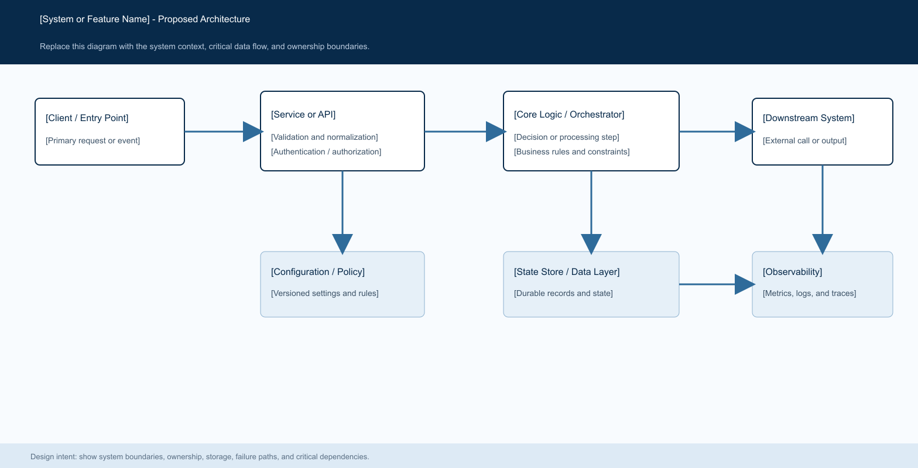
Figure 1. Browser URL and review queries → Laravel API → matching/review services → MySQL + job-local SQLite; candidate generation uses Meilisearch. Laravel owns final decisions and audit.

Core components

Component | Responsibility | Primary storage | Failure behavior
React results and review pages | URL-driven workspace selection; keyed/cancelled review queries. | Browser URL and query cache | Hide stale data; show explicit loading/error state.
Workspace and review API | Ownership checks; bounded summary and status-filtered rows. | MySQL | Return scoped errors; avoid full payload scans.
MatchingEngineService | MFD normalization, scoring, candidate ranking, bounded chunks. | MySQL results; SQLite spill | Fail chunk explicitly and preserve last checkpoint.
WilayahDictionaryService | Resolve code/name aliases to canonical MFD IDs. | Local MFD JSON | Unresolved values fall back to text comparison; no guessed ID.
AddressComparator | Detect compatible subset, contradictions, richer side, and safe proposal. | Result evidence and export | Keep conflicting or partial identity evidence in review.

5. Request Lifecycle
- A user selects a workspace and matching job; review requests carry the active status filter, paging/search inputs, and an optional signal to omit expensive case-group aggregates.
- Laravel authenticates and checks workspace/job ownership. Mapped geography names and code/name composites are resolved against the local MFD dictionary; address text is normalized without parsing legal-form tokens as company names.
- The engine loads mappings, field weights, thresholds, MFD dictionaries, job checkpoint version, and the Meilisearch host/key. The browser uses the URL as the single selected-workspace source and query keys include the active workspace, job, filter, and page inputs.
- Candidate generation uses Meilisearch in bounded multi-search batches; exact checks and composite scoring happen in Laravel. MFD-equivalent districts receive equal canonical values. Compatible partial addresses can raise their field score and emit richer-side evidence; hard numeric/directional conflicts cap the score.
- Before each chunk advances progress, result rows and the matching checkpoint are committed together. Checkpoints are keyed by job, inputs, mappings, normalization version, thresholds, and chunk configuration so incompatible work is not replayed as if equivalent.
- Meilisearch indexing and search tasks are checked for terminal failure. The queue worker is configured for three attempts with 30/120/300-second backoff, a six-hour job timeout, and a 21,900-second database retry-after window. Worker concurrency and chunk sizes are capped; failed chunks retain the last committed checkpoint. Cancellation, success, exhausted retries, and unrecoverable checkpoint mismatch are explicit terminal outcomes.
- The job records terminal status, counts, elapsed time, peak memory, index reuse, search/scoring/write timings, and a concise failure reason. Review pages return the selected status only; summary endpoints omit large duplicate-detail payloads unless requested.

6. API and Data Contracts

Primary data contract

Field | Type | Required | Description
workspace_id | UUID | Yes | Workspace selected by the results page; ownership checked server-side.
matching_job_id | UUID | Yes | Specific completed or running job within the workspace.
status | enum | Yes | Review status filter; maps to effective latest decision.
include_groups | boolean | No | Omit case-group/quality aggregates on ordinary record-list requests.
input_record_key | string | Yes | Stable input-row identity for decisions and exports.
field_scores | JSON | Yes | Per-mapping score, conflicts, and address evidence.
enrichment_changes | JSON array | No | Proposed old/new values and source field; emitted only for accepted matches.

Contract guarantees

- A chunk is reported processed only after its matching results and resumable checkpoint are durable; an incomplete checkpoint is rejected rather than silently treated as complete.
- Chunk number, job ID, checkpoint signature, input record key, candidate rank, and decision ID define replay and ordering. A retried chunk must produce the same candidate rows for the same versioned inputs.
- Persist matching-job and dataset IDs, mapping/configuration snapshot, engine/checkpoint version, input record key, candidate reference key, score evidence, selected decision, and enrichment source/value changes.
- The matching result and latest non-undone review decision are the application’s decision record. Meilisearch is a rebuildable candidate index, and an enrichment proposal is not a source-dataset mutation.
The versioned API contract is described in
docs/API.md; update it with each contract release.

7. Consistency, Idempotency, and Replay

Workspace selection is encoded in one URL parameter and drives the displayed data. Every review query is keyed by its workspace, matching job, filter, and pagination; changing any of these aborts or hides stale responses. Chunk commits are idempotent by job/chunk and checkpoint signature. Candidate indexing can be rebuilt, but committed result rows are retained across retry. Manual decisions are ordered by creation time and ID; undo restores the previous effective state. A partial address match is always reviewable before enrichment.
Scenario | Expected behavior | Reasoning
Duplicate input rows | Deduplicate on disk and retain occurrence counts. | Avoid a second full in-memory row collection.
Repeated chunk attempt | Upsert or recognize same job/chunk output. | Prevent duplicate results and progress inflation.
Worker exits before commit | Keep prior checkpoint and mark current chunk failed. | No false progress or lost committed chunks.
MFD code and equivalent name | Normalize both to one MFD ID; equal field score. | A code/name representation difference is not a geography mismatch.

8. Security and Privacy Considerations

- Keep existing user authentication and resource-ownership checks on workspace, job, review, and export endpoints. Do not expose rows across workspace ownership boundaries.
- Keep Meilisearch documents limited to fields needed for candidate generation. Logs contain job IDs, phase, timings, counts, and sanitized failure messages; avoid full company or address payloads.
- Read Meilisearch credentials from the configured secret environment; never persist keys in checkpoints, result metadata, or client responses.
- Bound worker count, chunk size, request batch size, and queue retry attempts. Require a matching checkpoint signature for resume, and do not delete committed results after an ambiguous restore failure.
- Temporary SQLite files are job-scoped and removed by the owning process after completion; retained audit decisions and source/enriched address differences follow the project’s configured retention policy. Confirm cleanup behavior after forced worker termination.

9. Operational Readiness
Signal | SLO or alert | Owner | Launch gate
Job completion | Measure success rate and time by row-count band. | Backend | Required: baseline at 100k and 500k.
Peak memory | Track per-job peak RSS / PHP memory. | Backend / Ops | Required: stay within worker limit.
Checkpoint recovery | Verify resumed jobs retain committed row counts. | Backend | Required: failure injection / resume dry-run.
Review filter accuracy | Returned status matches selected status. | Frontend / Backend | Required: no cross-filter stale rows.
Workspace navigation | URL stable after one selection. | Frontend | Required: no repeated history replace loop.
Required: failed Meili task is surfaced.

10. Alternatives Considered

Alternative | Why it was considered | Why it was not selected
Keep all rows in PHP arrays | Simple and fast for small input. | Memory grows with both entire datasets and per-row metadata.
Treat address overlap as an exact match | Raises recall for incomplete source addresses. | Can conflate different entities; use review evidence and enrichment proposal.
Load all review cases on every tab | Avoids separate requests. | Adds query cost and makes stale-response bugs more likely.
Retry all failed jobs from row one | Easy recovery behavior. | Wastes work and risks deleting valid progress; use signed chunk checkpoints.

11. Open Questions
- Confirm the minimum address evidence policy (currently two distinctive shared tokens plus no detected hard conflict) against representative Indonesian addresses.
- Choose and document the data owner’s retention period for matching checkpoints, temporary spill files, and decision audit history.
- Measure runtime, peak PHP memory, Meilisearch index size, and DB write load at 100k and 500k rows before setting formal SLOs.
- Confirm who owns queue-worker resource limits and when the updated worker configuration is applied in deployed environments.

12. Decision and Next Steps
Adopt the changes as a staged reliability release. First validate syntax and frontend build, then run backend regressions when the Docker service is available. Next dry-run representative datasets and verify MFD equivalence, review filter isolation, workspace URL stability, checkpoint recovery, and measured memory/runtime. Enable broader use only after no stale rows appear, partial addresses remain review-gated, and large runs complete or resume without losing committed chunks.
Milestone | Deliverable | Exit criteria
M1 | Canonical MFD + guarded address evidence | [74] JAKARTA BARAT and JAKARTA BARAT score equal; partial address stays in review.
M2 | URL/filter/query corrections | Workspace switch is stable; unmatched tab shows only effective unmatched rows.
M3 | Disk-backed matching and resumable chunks | Representative large run stays within limits and resumes without missing/duplicate rows.
M4 | Operational rollout | Queue/Meili metrics and retention policy reviewed; worker configuration deployed.

Use footnotes for definitions, assumptions, or terms that need precision without interrupting the main narrative.

