Chapter 8. Error Concealment

• Techniques for Audio Loss Concealment
• Techniques for Video Loss Concealment
• Interleaving

Earlier chapters described how RTP running over UDP/IP provides an unreliablepacket delivery service, and how this means an application may have to deal with anincomplete media stream. There are two things the application can do when packetloss occurs: try to correct the error, or try to conceal it. Error correction is discussed

in HTUChapter 9UTH. In this chapter we discuss techniques by which a receiver can concealthe effects of loss.

Techniques for Audio Loss Concealment

When an RTP packet containing audio data—whether music or speech—is lost, thereceiver has to generate a replacement to preserve the timing of the media stream.
This can be done in many ways, and the choice of concealment algorithm can havea significant impact on the perceived quality of the system in the case of loss.

Measuring Audio Quality

Human perception of sound is a complex process, and the perceptual significance ofdistortion depends not just on the amount the signal has changed, but also on thetype of damage caused, and where it occurred in the signal. Some types of
distortion are more noticeable to listeners than others, even if—by some objectivemeasure—they change the signal by the same amount. It is also common fordifferent listeners to perceive a particular type of distortion in different ways, and torate concealment schemes differently depending on the material to which they areapplied.

This makes it very difficult to devise objective quality measurements for differentrepair schemes. It is not sufficient to measure the difference between the originalwaveform from the source and the waveform recovered at the receiver, because theperceived quality has no direct relation to the differences in the waveforms. Simplemeasures, such as the signal-to-noise ratio, are effectively useless. More complexschemes (for example, those in ITU recommendations P.861 and P.862HTPU63UTPH,HPT U64UTPH) giveresults that are approximately correct for speech, but even these are not 100%reliable.

When objective measurements fail, we need to resort to subjective tests. By
conducting listening tests with a wide range of subjects, materials, and error
conditions, we can measure the effectiveness of different repair schemes in amanner meaningful to the listener. These tests involve playing different types ofmusic, or a range of words, phrases, and sentences subject to different error
conditions and concealment techniques, with the listener rating their quality and/orintelligibility according to a particular scale.

The choices of material and rating scale depend on what is being measured. If youare attempting to measure the perceived quality of speech (does it sound good?),then rating samples on the basis of a Mean Opinion Score (MOS) is appropriate. TheMOS is a five-point rating scale, the results of which are converted into numericform (excellent = 5, good = 4, fair = 3, poor = 2, bad = 1) and averaged across all

the listeners, giving a numeric result between 1 and 5. For the results to be
statistically valid, it is necessary to make a large number of tests comparing
different samples.

Typical MOS scores for unimpaired speech are 4.2 for the G.711 codec (that is,standard telephone quality) and between 3.5 and 4 for mobile telephony (for
example, GSM, QCELP). Packet loss will lower these numbers, with the degree ofloss and the type of concealment determining the actual result.

MOS scores provide a reasonable measure of perceived quality, allowing
comparison between different codecs and repair techniques, but they do not
measure intelligibility (that is, whether the audio is understandable). There is adifference between what sounds good and what conveys information; it is possibleto define a concealment scheme that gets very good marks for sound quality butmay not produce intelligible speech. In tests for intelligibility, listeners copy downsentences or words played with different impairments, or answer questions on apassage of text, and the result is a measure of how many errors are made. Again, alarge number of tests must be conducted for the results to be statistically
meaningful.

Perhaps the most important point learned from listening tests is that the resultsvary depending on the persons listening, the material they are listening to, the typeof distortion present in the sound, and the task they are performing. Depending onthe application, it may be important to conduct tests of both perceived quality andintelligibility, and it is always necessary to ensure that the test material and packetloss rates match those of typical usage.

Silence Substitution

The simplest possible repair technique is silence substitution, in which gaps causedby packet loss are filled with silence of the appropriate duration, as shown in HTUFigure8.1UTH. This is the cheapest and easiest method to implement, and one of the mostcommonly used techniques.

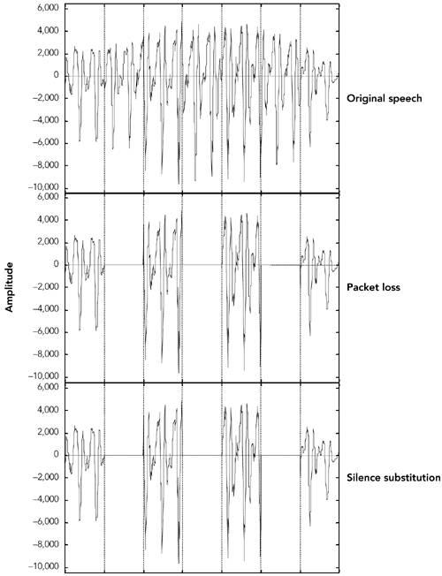
Figure 8.1. Repair Using Silence Substitution (Adapted from C.

Perkins, O. Hodson, and V. Hardman, &quot;A Survey of Packet LossRecovery Techniques for Streaming Media,&quot; IEEE NetworkMagazine, September/October 1998. © 1998 IEEE.)

Unfortunately, silence substitution is also the worst repair scheme, consistentlyrated last in listening tests designed to evaluate repair quality.HTPU114UTPH Listening trialshave shown that silence substitution is effective only with short-duration packets(&lt;16 milliseconds) and low packet loss rates (&lt;2%). Performance degrades rapidly

as the packet size and loss rate increase, becoming rapidly unusable with the packetsizes used in voice-over-IP applications, and with the loss rates encountered inmany networks.HTPU75UTPH,HPT U82UTPH

Implementations should not use silence substitution. Any of the techniques
described next will give better-quality sound, with a very small increase in
complexity.

Noise Substitution

Because silence substitution has been shown to perform poorly, the next choice is tofill the gap left by a lost packet with background noise of some sort—a processknown as noise substitution (see HTUFigure 8.2UTH).

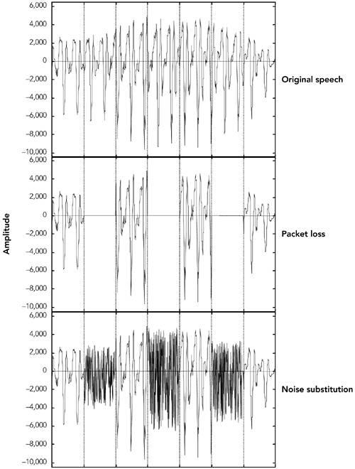
Figure 8.2. Repair Using Noise Substitution (Adapted from C.

Perkins, O. Hodson, and V. Hardman, &quot;A Survey of Packet LossRecovery Techniques for Streaming Media,&quot; IEEE NetworkMagazine, September/October 1998. © 1998 IEEE.)

At its simplest, noise substitution is the addition of white noise—noise with uniform
amplitude at all frequencies—in place of the missing signal, amplitude matched tothe previous packet. Here it is represented in pseudocode:

void
}
substitute_noise(sample previous_frame[samples_per_frame],
sample missing_frame[samples_per_frame)
{
double energy;

// Calculate energy (amplitude) of the previous frame
energy = 0.0;
for(j = 0; j &lt; samples_per_frame; j++) {
energy += previous_frame[j] * previous_frame[j];
}
energy = sqrt(energy);
// Fill in the noise
for(j = 0; j &lt; samples_per_frame; j++) {
missing_frame[j] = energy * random(-1,1);
}

Note that a real implementation will likely replace the arrays with a rotating bufferof the last few frames received, discarding old frames after they have been playedout.

Listening tests with speech have shown that, when compared to silence substitution,the use of white-noise substitution with approximately the same amplitude as thesignal gives both subjectively better qualityHTPU88UTPH and improved intelligibility.HTPU114UTPH Thereis a perceptual basis to this improvement in quality: Studies have shown that
Tphonemic restorationT, the ability of the human brain to subconsciously repair
missing segments of speech with the correct sound, occurs for speech repaired withnoise, but not when silence is used as the repair. Because white noise is almost aseasy to generate as silence, it is to be recommended as a replacement for silencesubstitution.

If the spectral characteristics of the signal are known, it may be possible to tailor thegenerated noise to match the original more closely than can be done with whitenoise. Many payload formats facilitate this task by providing comfort noise indicatorpackets to be sent during silence periods. Support for comfort noise allows thereceiver to play an appropriate form of background noise when there is otherwisenothing to hear, and it can make the system seem more natural.

For payload formats that don&apos;t include native support for comfort noise, there is astandard comfort noise payload format that may be used to transport this
information (static payload type 13 in the default audio/video profileHTPU42UTPH). This
comfort noise format conveys two pieces of information: the amplitude of the noise,and the spectral parameters. The amplitude allows the receiver to generate

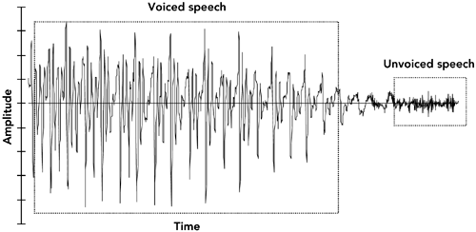
amplitude-matched noise; the spectral parameters enable shaping of the noise tomatch the surrounding signal.

Repetition

Depending on the content of the audio signal, it may be possible to provide a
replacement for a lost packet that is somewhat similar to the original. This is
especially true of speech signals, which are interspersed with repetitive patterns,known as Tpitch cyclesT, that typically last from 20 milliseconds to 100 milliseconds.
Losses that occur during pitch cycles have a good probability of being concealed.

HTUFigure 8.3UTH shows a typical speech signal. Although many features can be
recognized, the main differentiation is between voiced and unvoiced speech. Voicedspeech, generated by the periodic opening and closing of the vocal folds (commonlycalled the vocal cords), generates regular, high-amplitude pitch cycles with
frequency in the approximate range of 50Hz to 400Hz. Voiced segments often lastfor many tens or even hundreds of milliseconds, allowing the loss of a single packetof voice speech to be effectively repaired by substitution of the contents of thepreceding packet. This phenomenon is reflected in HTUFigure 8.4UTH, which shows thatloss repaired by repetition can be very similar to the original, except for the sharpdiscontinuity at the edges of the repaired region.

Figure 8.3. Speech Waveform

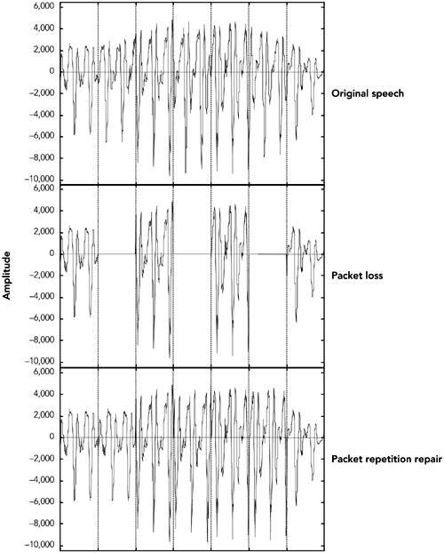
Figure 8.4. Repair of Voiced Speech Using Packet Repetition(Adapted from C. Perkins, O. Hodson, and V. Hardman, &quot;ASurvey of Packet Loss Recovery Techniques for StreamingMedia,&quot; IEEE Network Magazine, September/October 1998. ©1998 IEEE.)

Unvoiced speech—consisting of sounds such as Ts, fT, and TshT—is generated by airbeing forced through a constriction in the vocal folds, and it closely resembleslow-amplitude noise. Again, replacing a lost period of unvoiced speech with thecontents of the previous packet produces reasonably good repair.

Repetition clearly works best when the gap is small, because the characteristics ofthe signal are likely to be similar across the gap. One can improve the performanceof repetition with longer gaps by gradually fading the repeated signal. For example,the GSM mobile telephony system recommends an identical repeat for the first lostpacket, followed by a gradual fade to zero amplitude over the next 16 packets (320milliseconds total duration), or until the next packet is received.HTPU60UTPH
}
}
}

The repetition algorithm can be outlined in pseudocode like this:

void
repeat_and_fade_frame(sample previous_frame[samples_per_frame],
sample missing_frame[samples_per_frame],
int consecutive_lost)
{
// Repeat previous frame
for (j = 0; j &lt; samples_per_frame; j++) {
missing_frame[j] = previous_frame[j];
}
// Fade, if we&apos;ve lost multiple consecutive frames
if (consecutive_frames_lost &gt; 0) {
fade_per_sample = 1 / (samples_per_frame *
fade_duration_in_frames);
scale_factor = 1.0 – (consecutive_frames_lost *
samples_per_frame * fade_per_sample);
if (scale_factor &lt;= 0.0) {
// In case consecutive_frames_lost &gt;
// fade_duration_in_frames
scale_factor = fade_per_sample = 0.0;
}
for (j = 0; j &lt; samples_per_frame; j++) {
missing_frame[j] *= scale_factor
scale_factor -= fade_per_sample

Note that the Tprevious_frame[]T array represents the previous frame received, notany previously repaired frame. The playout buffer should maintain the variableTconsecutive_lostT based on the RTP sequence numbers, and should keep track oforiginal versus repaired frames (in case one of the original frames was merelydelayed).

Listening tests show that repetition works better than noise substitution for speechsignals, and it is simple to implement. Repetition works better with speech than with

music because the characteristics of music are more varied. Noise matched to thefrequency spectrum of the signal may be a better choice for music signals.

Other Techniques for Repairing Speech Signals

The three simple repair techniques—silence substitution, noise substitution, andrepetition—form the basis of many error concealment systems, and when correctlyapplied they can give good performance with low implementation complexity.
Researchers have also studied a range of more specialized error concealmenttechniques for speech. These techniques typically trade increased complexity ofimplementation for a modest improvement in performance, and they are oftentailored to particular types of input.

Various techniques based on waveform substitution have been proposed for usewith speech. These techniques generate a suitable replacement packet based oncharacteristics of the speech signal surrounding a lost packet, and they can beviewed as extensions of packet repetition. Unlike basic packet repetition, waveformsubstitution algorithms adapt the repair to avoid discontinuity at the edges of thegap, and to match the characteristics of the signal better.

As an example of waveform substitution, consider the algorithm proposed by
Wasem et al.,HTPU107UTPH building on earlier work by Goodman et al.HTPU74UTPH This algorithm firstclassifies speech as voiced or unvoiced (for example, by detecting the periodicspikes due to voiced pitch cycles). If the speech surrounding the loss is unvoiced,packet repetition is used to fill the gap. If the surrounding speech is voiced, apattern-matching repair algorithm is used to find the region to repeat.

The pattern-matching repair algorithm uses the last few milliseconds of speechbefore the gap as a template. A sliding window algorithm is then used to comparethe template with the rest of the packet, noting the location of the best match. Theregion between the template and its best match forms a complete pitch cycle, whichis repeated to fill in the gap. Because the template closely matches the original,there is no significant discontinuity at the start of the repair. In pseudocode, thealgorithm can be written this way:

void pattern_match_repair(sample previous_frame[samples_per_frame],
sample missing_frame[samples_per_frame],
int consecutive_frames_lost)
{
// Find best match for the window of the last few samples
// in the packet
window_start = samples_per_frame - window_length;
target = infinity;
for(i = 0; i &lt; window_start; i ++) {

score = 0;
}
}
}
for(j = i, k = 0; k &lt; window_length; j++, k++) {
score += previous_frame[j] -
previous_frame[window_start + k];
}
if (score &lt; target) {
target = score;
best_match = i; // The start of the best match for the
// window
}

pattern = best_match + window_length;
pattern_length = samples_per_frame – pattern;
// &quot;pattern&quot; now points to the start of the region to repeat.
// Copy the region into the missing packet
dest = 0;
for (remain = samples_per_frame; remain &gt; 0;
remain -= pattern_length) {
for (j = 0; j &lt; min(remain, pattern_length); j++) {
missing_frame[dest++] = previous_frame[pattern + j];
}

// Fade, if we&apos;ve lost multiple consecutive frames
if (consecutive_frames_lost &gt; 0) {
fade_buffer(missing_frame, consecutive_frames_lost);
}

There is still a boundary discontinuity at the end of the repair. We can patch this bymerging the repair with the original data, provided that the two overlap. Such apatch is illustrated in HTUFigure 8.5UTH, where the weighted average of the two waveformsis used in the overlap region, providing a smooth transition. Weighting means totake more of the first waveform at the beginning of the overlap region and more ofthe second waveform at the end.

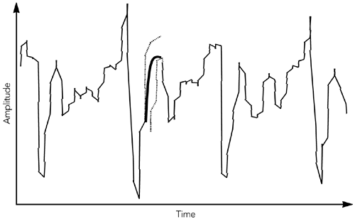
Figure 8.5. Packet Merging at the Boundary of a Repair

The result is a very effective repair algorithm for speech, which noticeablyoutperforms repetition. A sample speech waveform repaired by waveformsubstitution is shown in HTUFigure 8.6UTH.

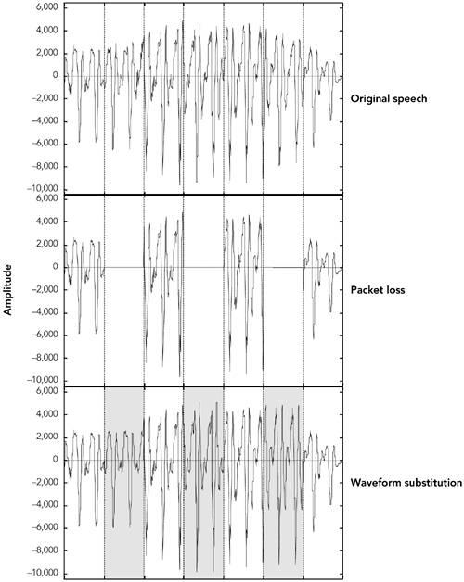
Figure 8.6. Repair Using Waveform Substitution (Adaptedfrom C. Perkins, O. Hodson, and V. Hardman, &quot;A Survey ofPacket Loss Recovery Techniques for Streaming Media,&quot; IEEENetwork Magazine, September/October 1998. © 1998 IEEE.)

Researchers have proposed a seemingly endless series of error concealment
techniques that offer incremental improvements over those discussed here. Thesetechniques include the following:

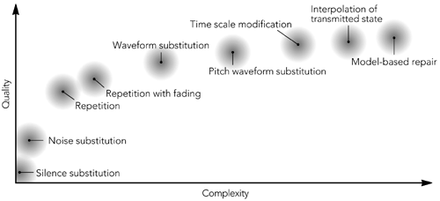
• T imescale modificationT, which stretches the audio on either side of a loss
across the gap. For example, Sanneck et al.HTPU102UTPH have proposed a scheme inwhich pitch cycles are stretched to cover the loss from either side, andaveraged where they meet.
• TRegenerative repairT, which uses knowledge of the audio compression
algorithm to derive the appropriate codec parameters to recover a lostpacket.
• TInterpolation of codec stateT, which allows codecs based on linear
prediction (for example, G.723.1) to derive the predictor coefficients byinterpolating the frames on either side of a loss.
• TModel-based repairT, which attempts to fit the signals on either side of the
loss to a model of the vocal tract/codec, and uses this model to predict thecorrect fill-in.

Applications that deal solely with speech may want to consider these more complex
repair schemes. Be aware, however, that the gains are incremental and the increasein complexity is considerable (see HTUFigure 8.7UTH for a rough chart of quality versuscomplexity).

Figure 8.7. Rough Quality/Complexity Trade-off for ErrorConcealment in Speech Signals (From C. Perkins, O. Hodson,

and V. Hardman, &quot;A Survey of Packet Loss RecoveryTechniques for Streaming Media,&quot; IEEE Network Magazine,September/October 1998. © 1998 IEEE.)

Techniques for Video Loss Concealment

Most video codecs use interframe compression, sending occasional full frames andmany intermediate frames as updates to the parts of the frame that have changed

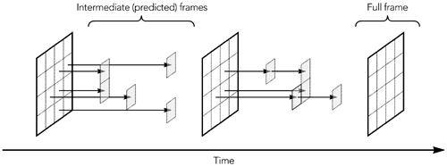
or moved, as shown in HTUFigure 8.8UTH. This technique, known as Tpredictive codingTbecause each frame is predicted on the basis of the preceding frame, is essential forgood compression.

Figure 8.8. Basic Operation of Video Codecs

Predictive coding has several consequences for loss concealment. The first is thatloss of an intermediate frame may affect only part of a frame, rather than the wholeframe (similar effects occur when a frame is split across multiple packets, some ofwhich are lost). For this reason, concealment algorithms must be able to repairdamaged regions of an image, as well as replace an entire lost image. A commonway of doing this is through motion-compensated repetition.

The other consequence of predictive coding is that frames are no longer
independent. This means that loss of data in one frame may affect future frames,making loss concealment more difficult. This problem is discussed in the sectiontitled HTUDependency ReductionUTH later in this chapter, along with possible solutions.

Motion-Compensated Repetition

One of the widely used techniques for video loss concealment is repetition in thetime domain. When loss occurs, the part of the frame affected by the loss is replacedwith a repeat of the preceding frame. Because most video codecs are block based,and the missing data will often constitute only a small part of the image, this type ofrepair is usually acceptable.

Of course, repetition works only if the image is relatively constant. If there is
significant motion between frames, repeating a portion of the preceding frame willgive noticeable visual artifacts. If possible, it is desirable to detect the motion andtry to compensate for it when concealing the effects of loss. In many cases this iseasier than might be imagined because common video codecs allow the sender touse motion vectors to describe changes in the image, rather than sending a newcopy of moved blocks.

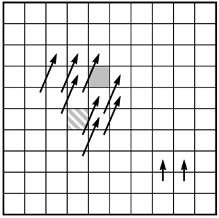
If only a single block of the image is lost, a receiver may use the motion vectorsassociated with the surrounding blocks to infer the correct position for the missingblock, on the basis of the preceding packet. For example, HTUFigure 8.9UTH shows how themotion of a single missing block of the image can be inferred. If the highlightedblock is lost, the original position can be derived because the motion is likely thesame as that for the surrounding blocks.

Figure 8.9. Motion-Compensated Repetition of a Missing VideoBlock

Motion-compensated repetition relies on loss affecting only a part of the image. Thismakes it well suited to network transport that corrupts single bits in the image, butless suited to transport over IP networks that lose packets containing several, mostlikely adjacent, blocks. HTUInterleavingUTH—discussed later in this chapter—is one
solution to this problem; another is to use the motion vectors from the precedingframe to infer the motion in the current frame, as shown in HTUFigure 8.10UTH. The
assumption here is that motion is smooth and continuous across frames—an
assumption that is not unreasonable in many environments.

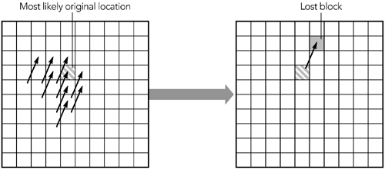
Figure 8.10. Inferred Motion across Frames

The two schemes can work together, inferring lost data either from other blocks inthe current frame or from the previous frame.

It is recommended that implementations should, at least, repeat the contents of thepreceding frame in the event of packet loss. It is also worth studying the codecoperation to determine whether motion compensation is possible, although this is alesser benefit and may be predetermined by the design of the codec.

Other Techniques for Repairing Video Packet Loss

Besides repetition, two other classes of repair may be used: repair in the spatialdomain and repair in the frequency domain.

Repair in the spatial domain relies on interpolation of a missing block, on the basisof the surrounding data. Studies have shown that human perception of video isrelatively insensitive to high-frequency components—detail—of the image. Thus areceiver can generate a fill-in that is approximately correct, and as long as this isjust a transient, it will not be too visually disturbing. For example, the average pixelcolor for each of the surrounding blocks can be calculated, and the missing block canbe set to the average of those colors.

Similar techniques can be applied in the frequency domain, especially for codecsbased on the discrete cosine transform (DCT), such as MPEG, H.261, and H.263. Inthis case the low-order DCT coefficients can be averaged across the surroundingblocks, to generate a fill-in for a missing block.

Simple spatial and temporal repair techniques give poor results if the error rate ishigh, and generally they do not work well with packet loss. They work better withnetworks that give bit errors, and they corrupt a single block rather than losing anentire packet containing several blocks. There are various more advanced spatial

and temporal repair techniques—the surveys by Wang et al.HTPU105UTPHP,HPT U106UTPH provide a goodoverview—but again, these are generally unsuited to packet networks.

Dependency Reduction

Although predictive coding is essential to achieving good compression, it makes the
video sensitive to packet loss and complicates error concealment. On the other hand,if each frame of video is independently coded, a lost packet will affect only a singleframe. The result will be a temporary glitch, but it will rapidly be corrected when thenext frame arrives. The penalty of independently coded frames is a much higherdata rate.

When predictive coding is used and the frames are not independent, loss of a singlepacket will propagate across multiple frames, causing significant degradation to thevideo stream. For example, part of a frame is lost and has to be inferred from thepreceding frame, producing a repair that is, by necessity, inexact. When the nextframe arrives, it contains a motion vector, which refers to the part of the image thatwas repaired. The result is that the incorrect data remains in the picture acrossmultiple frames, moving around according to the motion vectors.

Error propagation in this manner is a significant problem because it multiplies theeffects of any loss and produces results that are visually disturbing. Unfortunately,there is little a receiver can do to correct the problem, because it has insufficientdata to repair the loss until a complete frame update arrives. If the loss exceeds aparticular threshold, a receiver might find it better to discard frames predicted fromlost data, displaying a frozen image, than to use the erroneous state as a basis anddisplay damaged pictures.

A sender can ease this problem by using less predictive coding when packet loss is
present, although doing so may reduce the compression efficiency and lead to anincrease in the data rate (see HTUChapter 10UTH, Congestion Control, for a related
discussion). If possible, senders should monitor RTCP reception report feedback andreduce the amount of prediction as the loss rate increases. This does not solve theproblem, but it means that full frame updates occur more often, allowing receiversto resynchronize with the media stream. To avoid exceeding the available
bandwidth, it may be necessary to reduce the frame rate.

There is a fundamental trade-off between compression efficiency and loss tolerance.
Senders must be aware that compression to very low data rates, using predictivecoding, is not robust to packet loss.

Interleaving

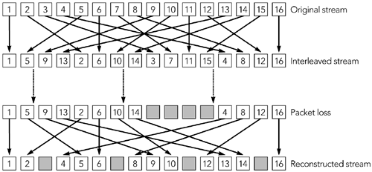
At the start of this chapter, it was noted that error concealment is something done
by a receiver, without help from the sender. In general this is the case, but
sometimes a sender can ease the task of error concealment without having to sendextra information. One such example was noted for video, in which a sender canreduce the interframe dependency to ease the job of a receiver. A more
general-purpose technique is interleaving, which can be used with both audio andvideo streams, as long as low delay is not a requirement.

The interleaving process reorders data before transmission so that originally
adjacent data is separated by a guaranteed distance during transport. Interleavingis useful because it makes bursts of consecutive packet loss in the transport streamappear as isolated losses when the original order is restored. In HUFigure 8.11UH, forexample, the loss of four consecutive packets in the interleaved stream is
transformed into four single-packet losses when the original order is reconstructed.
The actual loss rate is unchanged, but it is typically easier for a receiver to conceala series of single-packet losses than it is to conceal a longer burst of loss.

Figure 8.11. Interleaving, Transforming Burst Loss to IsolatedLoss (From C. Perkins, O. Hodson, and V. Hardman, &quot;A Survey
of Packet Loss Recovery Techniques for Streaming Media,&quot;IEEE Network Magazine, September/October 1998. © 1998
IEEE.)

The simplest implementation of an interleaving function is with a pair of matrices, asshown in HUFigure 8.12UH. Frames of media data are read into the first matrix by rowsuntil that matrix is full. At that time the two matrices are switched, with data beingread out of the first by columns, as the second is filled by rows. The process
continues, with frames being read into one matrix as they are read out of the other.

Figure 8.12. An Interleaving Matrix

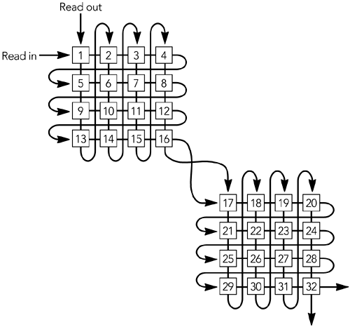
Both sender and receiver must maintain buffer matrices as arrays of an appropriatesize. The sender takes the output by columns and inserts it into packets for
transport. The receiver takes the packets from the transport stream and passesthem into the matrix buffer by rows, and as they are read out by columns theoriginal order is restored.

Interleaving may be done at the RTP packet level, but more often multiple frameswithin each packet are interleaved. When interleaving is done at the RTP packetlevel, the codec data is packed into RTP packets as usual. The interleaving operateson complete packets, resulting in a series of packets that have nonconsecutive RTPtimestamps. The RTP sequence number should be generated after interleaving,resulting in packets that have consecutive sequence numbers as sent.

When interleaving is done with multiple frames within each packet, the RTP
timestamp and sequence number are unchanged from the noninterleaved format.
Putting multiple codec frames into each RTP packet so that each column of theinterleaver forms an RTP packet keeps these values constant.

The interleaving function should be chosen so that adjacent packets in the originalstream are separated by more than the maximum consecutive loss length in thetransport stream. A matrix-based implementation with n rows of m columns will

produce output with originally adjacent symbols separated by n others. Put anotherway, as m or fewer packets are lost during transport of each matrix, each group ofn packets after deinterleaving will have at most one loss.

The transport process must communicate the size of the interleaving group—thedimensions of the matrix—and the position of each packet within that group. Thesize of the interleaving group may be fixed and communicated out of band, or it maybe included within each packet, allowing the interleaving function to vary. Theposition of each packet within an interleaving group must be included with thepacket if the group size can vary, or it may be inferred from the RTP sequencenumber if the group size is fixed.

A good example of the use of interleaving is the loss-tolerant payload format for
MPEG Audio Layer-3 (MP3),HPU38UPH which was developed in response to the lack ofresilience of the original payload formatHPU12UPH to packet loss. Other examples of
interleaving may be found in the payload formats for AMR (Adaptive Multi-Rate) andAMR-WB (Adaptive Multi-Rate Wideband) audio.HPU41UPH There is no single standard for
interleaving; each payload format must implement it individually.

Interleaving adds considerable latency to the transmission process.HPU97UPH The samenumber of packets as in the interleave group at both sender and receiver will bebuffered. For example, if a 5 x 3 matrix implementation is used, 15 packets will bebuffered at the sender, and 15 at the receiver, in addition to the network delay. Thismakes interleaving unsuitable for interactive applications; however, interleavingworks well for streaming.

Summary

One of the key points to remember when designing an RTP application is robustness.
Error concealment is a major part of this, allowing the application to operate evenwhen the network misbehaves. A good error concealment scheme provides thedifference between a tool that can be used in the real world and one that continuallyfails when subjected to the wide variation in loss rates inherent in the Internet. Forthis reason, all applications should implement some form of error concealment.

