Title: Digital Reproductive Health Information Access and Reproductive Health Literacy Among Adolescent in Bangladesh


A thesis submitted for the partial fulfillment of the Weekend Master of Public Health in Public Health and Informatics
Submitted by-
Student ID - 2020504037
WMPH
Batch - 04
Session- 2025-26
Registration No- 0210
Department of Public Health and Informatics
Jahangirnagar University
October 2026

May 2019

Declaration
This dissertation is written by me on basis of the results of my own work and includes nothing which is the outcome of work done in collaboration except where specifically indicated in the text. No parts of this dissertation have been submitted for any other qualification nor have I used this dissertation in any other form at any other institution.

The copyright of this thesis rests with the author. Quotation is permitted from it with full acknowledgement and references. This thesis may not be reproduced without the prior written consent of the author.

I warrant that this authorization does not, to the best of my belief, infringe the rights of any third party.

Submitted by-
Student ID- 202504037
WMPH (Thesis)
Session- 2025-26
Department of Public Health and Informatics
Jahangirnagar University
Email- khnirjona@gmail.com

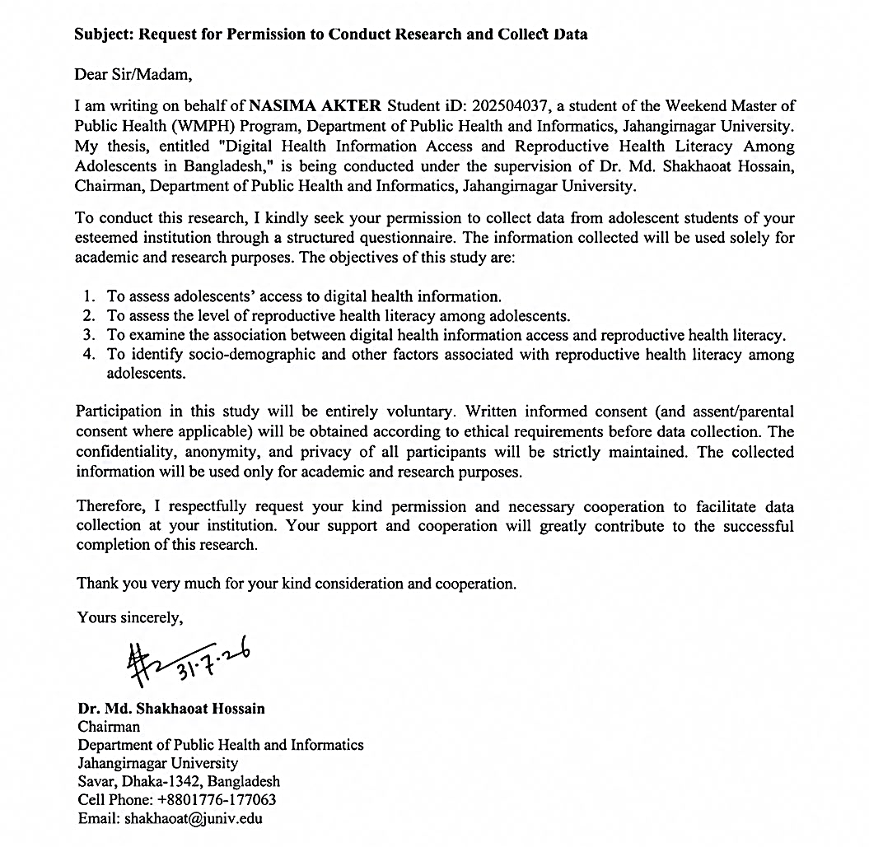
Certification

Table of Contents
Declaration II
Certification III
List of Tables VIII
Lists of Figures IX
Abbreviations X
Abstract XVI
Chapter 1 - Introduction 1
Chapter 2 - Literature Review 4
1. Adolescent Sexual and Reproductive health knowledge, attitudes and practices in Bangladesh 4
2. Sources of information: family, school and peers 5
3. Media, digital access and Knowledge, Attitude and Practice (KAP) 6
4. Digital interventions for adolescent Sexual and Reproductive Health (SRH) 7
5. Digital inequality and the quality of online information 8
6. Research gaps 9
7. Significance of the Study 10
8. Problem Statement 11
Chapter 3 - Objectives 12
1. General Objectives 12
2. Specific Objectives 12
Chapter 4 - Methodology 13
1. Study Design 13
2. Study Area and Setting 13
3. Study Population and Participants 14
4. Sample Size 15
5. Sampling Technique 17
5.1. Eligibility Criteria 18
6. Study Instrument 19
7. Scoring and Categorization 20
8. Questionnaire Development and Pretesting 21
9. Validity and Reliability 22
10. Data Collection Procedure 23
11. Data Quality Control and Management 24
12. Statistical Analysis 25
13. Ethical Considerations and Confidentiality 27
14. Summary of Methodology 28
Chapter 5 - Results 29
1. Characteristics of Study Participants 29
2. Distribution of Digital Reproductive Health Literacy, Knowledge, Attitude and Practice among Adolescents 32
2.1. Overall Observation of Digital Reproductive Health Literacy, Knowledge, Attitude and Practice among Study Participants 32
2.2. Distribution of Digital Reproductive Health Information Access, Knowledge, Attitude and Practice among Study Participants 33
2.3. Instrument Reliability and Validity 36
3. Univariate Association among Study Participants 40
3.1. Normality Assessment of Digital Reproductive Health Information Access, Knowledge, Attitude and Practice Score of Participants 40
3.2. Outlier Detection of Digital Reproductive Health Information Access, Knowledge, Attitude and Practice Score among Participants 42
3.3. Distribution Characteristics among Adolescents 43
4. Bivariate Associations with Demographic Variables of Study Participants 47
4.1. Comparison Digital Reproductive Health Information Access, Knowledge, Attitude and Practice scores by Residence 47
4.2. Comparison of Reproductive Health’s Digital Reproductive Health Information Access, Knowledge, Attitude and Practice Score by Age Group of Participants 50
5. Intercorrelations Between Digital Reproductive Health Information Access, Knowledge, Attitude and Practice of Adolescents Scales 53
6. Multivariate Linear Association of Digital Reproductive Health Information Access with Knowledge, Attitude and Practice Scales of Study Participants 56
6.1. Multivariate Linear Association of Digital Reproductive Health Information Access with Knowledge, Attitude and Practice Scores of Adolescents 56
6.2. Linear Regression Model Fit 57
6.3. Regression Diagnostics: Interpretation 60
7. Ordinal Logistic Regression with Predicting Practice Categories 62
7.1. Predicted Probabilities 64
Chapter 6 - Discussion 67
1. Introduction paragraph 67
2. Sources of Reproductive Health Information 68
3. Level of Reproductive Health Knowledge 69
4. Attitudes Toward Reproductive Health 70
5. Reproductive Health Practices and the Attitude-Practice Gap 71
6. Factors Associated with Access to Digital Health Information 72
7. Association Between Digital Access and KAP 73
8. Polarized Distributions and Their Implications 74
9. Public Health and Policy Implications 75
10. Strengths of the Study 76
11. Limitations 77
12. Recommendations 78
13. Suggestions for Future Research 79
Chapter 7 - Conclusion 80
References 81
Appendices 87
1. Consent from Participants for Data Collection 87
2. Data Collection Questionnaire 87

List of Tables
Table 4.1. Demographic Characteristics of Study Participants 29
Table 4.2.1. Observation of Adolescents Digital Reproductive Health Information Access, Knowledge, Attitude and Practice 32
Table 4.2.2. Distribution of participants by Digital Reproductive Health Access, Knowledge, Attitude and Practice category 33
Table 4.2.3.1. Internal consistency reliability of the Digital Reproductive Health Information Access, Knowledge, Attitude and Practice scales (N = 239) 36
Table 4.2.3.2. Quality check of the questionnaire scales (Digital Reproductive Health Information Access, Knowledge, Attitude and Practice) 37
Table 4.2.3.3. Assessment of each scale fit together as a single concept, and assessment of each scale fit weakly 38
Table 4.2.3.4. Agreement of individual questions with the overall scale score 39
Table 4.3.1. Shape of the score distribution for Digital Reproductive Health Information Access, Knowledge, Attitude and Practice 40
Table 4.3.2. Check for extreme scores on the Digital Reproductive Health Information Access, Knowledge, Attitude and Practice Scales 42
Table 4.4.1. Comparison of Digital Reproductive Health Information Access, Knowledge, Attitude and Practice scores by residence 48
Table 4.4.2. Comparison of Digital Reproductive Health Information Access, Knowledge, Attitude and Practice scores across age groups 51
Table 4.5. Intercorrelation among the Digital Reproductive Health Information Access, Knowledge, Attitude and Practice of Adolescents 53
Table 4.6.1. Multivariate Linear Association of Digital Reproductive Health Information Access with Knowledge, Attitude and Practice scores (N = 239) of Participants 57
Table 4.6.2. Fit statistics of the multivariable linear regression models for knowledge, attitude and practice scores 58
Table 4.7. Predictors of Practice Category with Ordinal Logistic Regression Estimates for Digital Reproductive Health Information Access, Knowledge and Attitude 63

Lists of Figures
Figure 1. BDHS 2022 Report on Child Marriage and Adolescent Pregnancy scenario of Bangladesh 2
Figure 4.2.2. Distribution of Digital Reproductive Health Information Access, Knowledge, Attitude, and Practice scores. Histograms show observed densities (bars) with superimposed normal curves (dashed red lines).. 35
Figure 4.3.3.1. Distribution of Digital Reproductive Health Information Access, Knowledge, Attitude, and Practice scores. 44
Figure 4.3.3.2.. Normal Q-Q plots for the KAP scales. Points deviating from the diagonal reference line (red) indicate departures from normality.. 45
Figure 4.3.3.3. Box plots of the KAP scale scores with jittered individual responses. 46
Figure 4.4.1. Comparison of KAP scores between rural and urban adolescents. 49
Figure 4.4.2. "KAP scores across four age groups (10–12, 13–15, 16–18, 18+ years).. 52
Figure 4.5. Spearman correlation matrix of the four KAP domains (N = 239).. 55
Figure 4.6.1. Diagnostic plots for the linear regression models of (A) Knowledge, (B) Attitude and (C) Practice.. 59
Figure 4.6.2. Observed versus predicted scores from the adjusted linear regression models for Knowledge, Attitude and Practice. Each dot is one participant (N = 239). 61
Figure 4.7.1. Probability curves.. 65
Figure 4.7.2. Confusion matrix of predicted versus actual practice categories (N = 239; overall accuracy = 73.2%).. 66

Abbreviations
Term | Full form | Brief definition
Adj. R² | Adjusted R-squared | R² corrected for the number of predictors in the model. It is a fairer measure of fit when a model has many predictors.
AIC | Akaike information criterion | A model-fit index that balances fit and simplicity. Lower values indicate a better model. It is only comparable between models fitted to the same data.
AIDS | Acquired immunodeficiency syndrome | The advanced stage of HIV infection.
α (alpha) | Cronbach's alpha | A reliability coefficient from 0 to 1 showing how consistently the items in a scale measure the same concept. Higher values mean greater consistency.
α (alpha) | Significance level | The cut-off for calling a result statistically significant. It is 0.05, or 0.0125 after Bonferroni adjustment (0.05/4). In the ordinal model, αj denotes the cut-points between categories.
aOR | Adjusted odds ratio | An odds ratio calculated after accounting for other variables in the model.
B | Unstandardized regression coefficient | The change in the outcome score for each one-point increase in the predictor, in the units of the outcome.
BDHS | Bangladesh Demographic and Health Survey | A nationally representative household survey on population, health and nutrition in Bangladesh.
BDT | Bangladeshi taka | The currency of Bangladesh, used here for family income categories.
β (beta) | Standardized regression coefficient | The change in the outcome, in standard-deviation units, for a one-standard-deviation change in the predictor. It allows comparison across predictors.
BIC | Bayesian information criterion | Similar to AIC but penalizes model complexity more strongly. Lower values indicate a better model.
Brant test | Brant test | A test of the proportional odds assumption, which means each predictor has the same effect across all boundaries between practice categories. A significant p-value means the assumption is violated.
Breusch-Pagan test | Breusch-Pagan test | A test of whether the spread of regression residuals is constant. A significant result means the spread is not constant (heteroscedasticity).
Ceiling effect | Ceiling effect | Many respondents score at or near the maximum, so the scale cannot distinguish among high scorers.
CI | Confidence interval | The range within which the true value is likely to lie. A 95% CI means the method captures the true value in 95 of 100 repeated samples.
Cochran's formula | Cochran's formula | A formula for the sample size needed to estimate a proportion with a chosen margin of error.
Cook's distance | Cook's distance | A measure of how much a single observation influences the regression results. Large values flag influential cases.
df | Degrees of freedom | The number of independent values available to estimate a statistic. For Kruskal-Wallis it is the number of groups minus 1.
DRHIA | Digital Reproductive Health Information Access | The study's main exposure: access to reproductive health information through digital means.
ε² (epsilon-squared) | Epsilon-squared | An effect size for the Kruskal-Wallis test. Values near 0 mean the groups differ very little.
F | F statistic | Tests whether the regression model as a whole explains more variation than a model with no predictors.
Fisher z | Fisher z transformation | A method used to estimate the sample size or power needed to detect a correlation.
H | Kruskal-Wallis H statistic | The test statistic for comparing scores across three or more groups. Larger values indicate larger differences between groups.
HC3 | Heteroscedasticity-consistent standard errors (type 3) | Robust standard errors that keep p-values and confidence intervals valid when the spread of residuals is not constant.
HIV | Human immunodeficiency virus | A virus that weakens the immune system and can lead to AIDS.
IQR | Interquartile range | The distance between Q3 and Q1, covering the middle 50% of scores. It is also used to flag outliers (below Q1 − 1.5 × IQR or above Q3 + 1.5 × IQR).
KAP | Knowledge, attitudes and practices | The three outcome domains measured in this study.
KMO | Kaiser-Meyer-Olkin measure | Shows whether the data are suitable for factor analysis. Values closer to 1 indicate better suitability.
Kurtosis | Kurtosis | Describes how flat or peaked a distribution is compared with a normal curve. Negative values are flatter and positive values are more peaked.
McFadden's pseudo-R² | McFadden's pseudo-R-squared | A model-fit index for logistic models. Values closer to 1 indicate better fit, and they are usually much lower than ordinary R².
Mdn | Median | The middle score when all scores are ordered. It is less affected by extreme values than the mean.
MICS | Multiple Indicator Cluster Survey | A household survey programme that collects data on women and children.
N, n | Sample size | N is the total number of participants analyzed (239). n is the number in a subgroup (for example, rural n = 133).
ns | Not significant | The result did not reach the chosen significance level.
OR | Odds ratio | Compares the odds of an outcome between groups, or per unit change in a predictor. A value above 1 means higher odds, 1 means no difference, and below 1 means lower odds.
p, p-value | Probability value | The probability of a result at least this extreme if there were truly no effect. A p-value below 0.05 is called significant unless corrected.
p (Bonferroni) | Bonferroni-adjusted p-value | The p-value multiplied by the number of tests (four scales). It is stricter and reduces false-positive findings.
p (Holm) | Holm-adjusted p-value | A stepwise adjustment for multiple tests, here the six correlation pairs. It is less strict than Bonferroni.
Q1, Q3 | First and third quartiles | The scores below which 25% (Q1) and 75% (Q3) of respondents fall.
Q-Q plot | Quantile-quantile plot | A graph that compares the data with a normal distribution. Points on a straight line suggest normality.
r | Correlation or effect size | In group comparisons, the effect size of the Wilcoxon test (Z divided by the square root of N). In item analysis, the corrected item-total correlation. Values range from 0 to 1 in size.
R² | R-squared (coefficient of determination) | The proportion of variation in the outcome explained by the model, from 0 to 1. For example, 0.615 means about 61.5%.
ρ (rho) | Spearman's rank correlation coefficient | Shows how closely two scores rise and fall together, from -1 to +1. In this study: negligible below 0.20, weak 0.20-0.39, moderate 0.40-0.69, strong 0.70 or above.
RMSE | Root mean square error | The typical size of the model's prediction error, in the units of the outcome score.
RR | Risk ratio (relative risk) | The ratio of the probability of an outcome in one group to that in another.
SD | Standard deviation | How widely scores spread around the mean.
SDG | Sustainable Development Goal | The United Nations goals for 2030. SDG 3 covers health, and target 3.7 covers access to sexual and reproductive health services.
SE | Standard error | The precision of an estimate. Smaller values mean more precise estimates.
Skewness | Skewness | Describes the lopsidedness of a distribution. Negative values mean scores bunch at the high end with a tail towards low scores.
SRH | Sexual and reproductive health | A state of physical, mental and social well-being in matters related to sexuality and reproduction.
STD / STI | Sexually transmitted disease / infection | Infections passed mainly through sexual contact.
Threshold | Threshold (cut-point) | In ordinal regression, the cut-points between adjacent categories (for example Poor
U | Wilcoxon rank-sum statistic | The test statistic for comparing two groups, such as rural and urban adolescents. It is equivalent to the Mann-Whitney U.
VIF | Variance inflation factor | Checks whether predictors overlap too much (multicollinearity). High values, commonly above 5 to 10, signal a problem.
W | Shapiro-Wilk statistic | A test of normality. Values near 1 suggest normal data, and a p-value below 0.05 indicates non-normal scores.
WHO | World Health Organization | The United Nations agency for international public health. It defines adolescence as 10 to 19 years.
Z | Standard normal score (z-statistic) | In regression tables, the coefficient divided by its standard error. In sample-size equations, Z = 1.96 corresponds to 95% confidence.
*** | Significance marker | Used in tables to show p < 0.001.

Abstract
Background: Adolescents in Bangladesh often lack accurate sexual and reproductive health information, and mobile phones and the internet are now another possible source. How digital access relates to adolescents' reproductive health knowledge, attitudes and practices (KAP) is not well documented.
Objective: To assess the association between Digital Reproductive Health Information Access (DRHIA) and reproductive health KAP among adolescents, to identify their main sources of information, and to examine factors associated with access.
Methods: This cross-sectional study used convenience sampling in five schools and colleges in Dhaka and Rajbari. Adolescents completed a Google Form on their mobile phones from August to September 2026. Of 250 responses, 239 were analyzed (133 rural, 106 urban). Because scores were not normally distributed, the analysis used non-parametric group comparisons, Spearman correlation, linear regression with robust standard errors and ordinal logistic regression, with adjustment for multiple testing.
Results: Parents (31.8%) and schools (30.5%) were the main sources of information, followed by the internet (15.5%) and friends (14.6%). DRHIA was moderate (mean 8.97 of 18) and higher among urban than rural adolescents (median 11.5 vs 9; Bonferroni-adjusted p = 0.002), with a small effect. Knowledge and practice were polarized: 51.88% had excellent knowledge and 31.80% poor knowledge, and 53.97% had excellent practice and 24.27% poor practice. Attitudes were favorable for 95.8%. DRHIA correlated moderately with practice (ρ = 0.698) and knowledge (ρ = 0.683) and weakly with attitude (ρ = 0.384). After adjustment for socio-demographic factors, higher DRHIA was associated with higher knowledge (β = 0.670), practice (β = 0.776) and attitude (β = 0.390) scores (all p < 0.001). In the ordinal model, higher DRHIA (OR 1.52; 95% CI 1.36 to 1.71) and higher knowledge (OR 1.35; 95% CI 1.18 to 1.54) were associated with higher odds of a better practice category, whereas attitude was not (OR 1.01; 95% CI 0.96 to 1.07).
Conclusion: Family and school were the main sources of information. DRHIA was associated with better knowledge and practice, and less strongly with attitude. These cross-sectional findings do not show causation, and the convenience sample limits generalization. They suggest that strengthening school and family communication and narrowing the rural-urban digital gap may help improve adolescent reproductive health in Bangladesh.
Keywords: adolescents; Digital Reproductive Health Information Access; reproductive health; knowledge, attitudes and practices; Bangladesh

Chapter 1 - Introduction
Adolescence, defined by the World Health Organization as the period from 10 to 19 years of age, is when people form the knowledge, attitudes and habits that shape their sexual and reproductive health (SRH). About 90% of the world's adolescents live in low- and middle-income countries, where girls face overlapping health, social and economic disadvantages (Meherali et al., 2021) . Bangladesh is one such setting. Adolescents make up roughly one-fifth of the population, yet cultural taboo, limited accessibility and poor communication channels make relevant SRH information hard to obtain (Hasan et al., 2025) .
National data show the consequences. Analyses of the Bangladesh Demographic and Health Survey (BDHS)(Bangladesh Demographic And Health Survey Report, 2022) identify early marriage as a key predictor of childbirth at high-risk maternal ages, defined as 18 years or younger, or 40 or older (Siam et al., 2026) . Across four BDHS rounds from 2011 to 2022, only 53.2% of sexually active adolescent females used a modern contraceptive method. Use was higher in urban areas and among those with mass media exposure and family planning knowledge (M. A. Hossain et al., 2026) . The gaps are wider in vulnerable groups. Among 311 street adolescents in Sylhet, only 2.33% knew how sexually transmitted diseases are transmitted, and 14.14% used contraception (Y. Ahmed et al., 2026) .

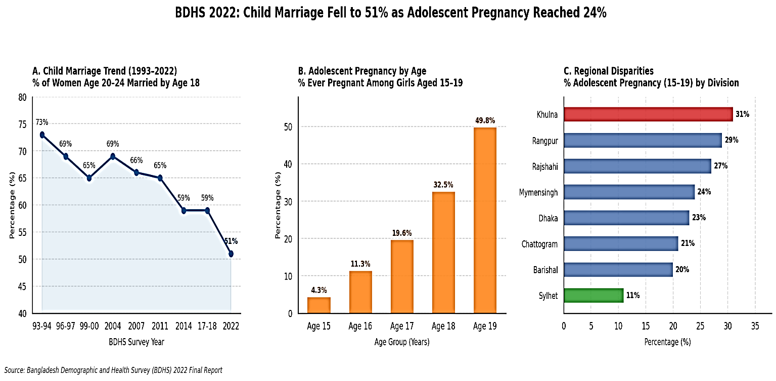
Families and schools are the traditional sources of SRH information, and both have limits. In Chattogram, 62% of 1,174 school girls named their mother as their main source of reproductive health knowledge (Zakaria et al., 2019) . Mother-daughter communication was nonetheless judged poor overall and centred mainly on menstruation (Zakaria et al., 2019) . Among 792 college girls aged 16-17, knowledge of puberty, family planning, maternal health and HIV/AIDS was unsatisfactory, and menstrual myths were common in rural areas (Zakaria et al., 2020) .
Figure 1. BDHS 2022 Report on Child Marriage and Adolescent Pregnancy scenario of Bangladesh
Mobile phones and the internet may offer a more private alternative. In a community-engaged study, young adults in Bangladesh said the digital shift had transformed their access to SRH and HIV information. They also reported misinformation, weak confidentiality and stigma (Pickard et al., 2024) . Regional studies are consistent with this. Among married adolescents and young women in Bangladesh, internet or mobile phone access was associated with higher odds of antenatal care (adjusted OR 1.57) (Pickard et al., 2024) . Among 10,425 adolescent girls in Bihar and Uttar Pradesh, India, social media exposure was associated with better knowledge of sexual intercourse and pregnancy, contraception and HIV/AIDS, but the benefit went mainly to girls who were educated, urban and wealthier (Saha et al., 2022).
Being online does not guarantee access to accurate SRH information. Access also depends on devices, connectivity, cost, skills, trust and the ability to verify what is found. In this study, Digital Reproductive Health Information Access covers internet and smartphone availability, online searching for reproductive health information, platforms used, trust in and verification of online content, and use of health apps. The study examines how this access relates to reproductive health knowledge, attitudes and practices (KAP) among school and college students in urban and rural settings of Dhaka and Rajbari.

Chapter 2 - Literature Review

Adolescent Sexual and Reproductive health knowledge, attitudes and practices in Bangladesh
Several Bangladeshi KAP studies report gaps (Zakaria et al., 2020) found unsatisfactory knowledge of puberty, family planning, maternal health and HIV/AIDS among older adolescent girls in Chattogram. (Siddique et al., 2023) surveyed 1,214 young women across five regions using convenience sampling. Mean menstrual-hygiene scores were 4.9 of 6 for knowledge, 12.58 of 14 for attitude and 8.80 of 12 for practice. Higher scores were associated with education and other socio-demographic factors.
Gaps appear wider in vulnerable groups. Street adolescents in Sylhet had very low STD knowledge and low contraceptive use, and 61.79% reported sexual abuse (Y. Ahmed et al., 2026) . Orphaned adolescent girls faced barriers to accurate SRH knowledge, and a structured intervention improved all five knowledge indicators examined (F. Rahman et al., 2026) . Baseline data from 2,713 adolescents in rural Bangladesh showed gender differences in knowledge about conception and contraception (Alam et al., 2025) . The same authors noted that longitudinal evidence on adolescent SRH in Bangladesh is limited. An indirect, BDHS-based estimate of premarital sex among ever-married women rose from 1.5% in 2011 to 27.8% in 2022. The authors linked this partly to shifting norms and greater access to information (Rabbi et al., 2025) .

Sources of information: family, school and peers
Mothers are often the first and main source of SRH information, but the quality of communication is a concern. In Chattogram, students whose main source was friends or media were less likely to report good communication with their mothers, and communication was dominated by menstruation (Hasan et al., 2025; Zakaria et al., 2019) describe a context in which taboo and poor communication channels restrict access to relevant SRH information.

Media, digital access and Knowledge, Attitude and Practice (KAP)
Several studies associate media exposure with better KAP. Among college girls in Chattogram, reading or watching SRH content on media was positively associated with knowledge (β = 0.21), attitude (β = 0.22) and hygienic practice (β = 0.18). Urban residence predicted more positive attitudes and better practice (Zakaria et al., 2020) . Mass media exposure and family planning knowledge were associated with modern contraceptive use among sexually active adolescent females in Bangladesh (M. A. Hossain et al., 2026) . In India, family planning mass media exposure was associated with 46% lower odds of teenage pregnancy (Singh & Shri, 2025) . Social media exposure was associated with higher odds of SRH knowledge, with ORs of about 1.4 to 2.2 across three topics (Saha et al., 2022) . In Bangladesh, internet or mobile phone access was associated with more antenatal care among married adolescents and young women (Pickard et al., 2024) . Most of these studies measure "media exposure" broadly, or service use, and not digital access with a structured measure.

Digital interventions for adolescent Sexual and Reproductive Health (SRH)
Systematic reviews describe digital SRH approaches as feasible and acceptable, but evidence on effectiveness is limited. An umbrella review of 17 reviews concluded that effectiveness evidence in low- and middle-income countries is insufficient for strong recommendations (Huang et al., 2022) . A review of 35 studies on digital literacy for adolescent girls found that mobile and internet-based tools can improve access to health information and services. It also called for more rigorous, longer-term studies (Meherali et al., 2021) . A Cochrane review of mobile-device client communication found that it may increase adolescents' sexual health knowledge (RR 1.45) and contraceptive use (RR 1.19), both with low-certainty evidence. All but one of the adolescent trials were in high-income countries (Palmer et al., 2020) . In Bangladesh, students, teachers and officials saw a peer-led app (Mukhorito) as a safe space for discussing taboo topics. Limited smartphone access, unreliable internet and economic factors hindered adoption, especially in rural settings (Hasan et al., 2025) .

Digital inequality and the quality of online information
Digital benefits are unevenly distributed. The knowledge gains linked with social media in India were concentrated among educated, urban and wealthier girls (Saha et al., 2022) . Rural Bangladeshi adolescents face connectivity and cost barriers (Hasan et al., 2025) . Young adults in Bangladesh also reported misinformation, confidentiality concerns and stigma online (Pickard et al., 2024) . Heavy device use is not necessarily informed use. In one face-to-face survey of 542 Bangladeshi adolescents and young adults, 61.44% showed problematic smartphone use (Islam et al., 2024) .

Research gaps
Several studies have these five gaps:
- Bangladeshi adolescent KAP studies are largely limited to girls and to single districts.
- Most use broad "media exposure" and not a structured measure of Digital Reproductive Health Information Access.
- Few analyse knowledge, attitude and practice together in relation to digital access.
- Few compare rural and urban adolescents with the same instrument.
- Evidence on digital SRH interventions comes mostly from high-income settings, and longitudinal data are scarce (Alam et al., 2025; Huang et al., 2022; Palmer et al., 2020) .

Significance of the Study
This study examines whether access to digital reproductive health information is associated with better knowledge, attitudes and practices among adolescents in Bangladesh. The findings may help school health programmes and adolescent-friendly services decide where to place digital content, and whether to pair it with family, teacher and face-to-face support. Mothers and schools are the existing channels, and both have recognised limits (Zakaria et al., 2019, 2020) .
The study covers urban and rural adolescents in Dhaka and Rajbari, so it can describe digital inequality. Evidence from the region suggests digital benefits accrue mainly to advantaged groups (Saha et al., 2022) . Rural adolescents face connectivity and cost barriers (Hasan et al., 2025) . Identifying who has low access can help target outreach and digital literacy support.
The study uses scored scales for digital access, knowledge, attitude and practice, and it assesses their reliability and validity. Later studies can reuse and refine these scales. The study also provides baseline data for the longitudinal and intervention studies that the literature calls for (Alam et al., 2025; Huang et al., 2022) . Finally, it relates to Sustainable Development Goal 3, target 3.7, on universal access to sexual and reproductive health information and education.

Problem Statement
Adolescents in Bangladesh need accurate SRH information, but family and school channels are constrained by taboo and weak communication (Hasan et al., 2025; Zakaria et al., 2019) . Studies report unsatisfactory knowledge, wide gaps in vulnerable groups, low contraceptive use and early childbearing (Y. Ahmed et al., 2026; M. A. Hossain et al., 2026; Siam et al., 2026; Zakaria et al., 2020) . Mobile phones and the internet are also changing how young people look for health information. They bring opportunity and risk, including misinformation, confidentiality concerns and unequal access (Pickard et al., 2024; Saha et al., 2022) .
Little is known about how digital access relates to adolescents' reproductive health KAP in Bangladesh. Existing studies focus mainly on girls and on single districts. They measure media exposure broadly and not digital access directly. They seldom examine knowledge, attitude and practice together, or compare rural and urban adolescents. Evidence on digital SRH interventions comes mostly from high-income countries and is of limited certainty (Huang et al., 2022; Palmer et al., 2020) . Without evidence on how digital access relates to KAP, and on who is left behind, programmes may invest in digital delivery without knowing whether it reaches the adolescents who need it.
This study therefore asks: Among adolescent students in urban and rural Dhaka and Rajbari, how is access to digital reproductive health information associated with reproductive health knowledge, attitudes and practices, and which socio-demographic factors are associated with that access?

Chapter 3 - Objectives

General Objectives
- To assess the association between access to digital health information and reproductive health knowledge, attitudes, and practices among adolescents in Bangladesh.

Specific Objectives
- To identify the major sources of reproductive health information among adolescents.
- To measure the level of reproductive health knowledge.
- To assess adolescents' attitudes toward reproductive health issues.
- To evaluate reproductive health-related practices.
- To determine socio-demographic and other factors associated with access to reproductive health information.

Chapter 4 - Methodology

Study Design
A quantitative, cross-sectional study was conducted to assess the association between access to digital reproductive health information and reproductive health knowledge, attitudes and practices (KAP) among adolescents in Bangladesh. A cross-sectional design was appropriate because the study measured access, knowledge, attitudes and practices in the same adolescents at one point in time.

Study Area and Setting
Data were collected from five educational institutions in urban and rural settings: Mirpur-14 (Dhaka) and Rajbari district. The institutions were:
- Glory School & College, Mirpur-14, Dhaka
- Shaheed Bir Uttam Lt. Anwar Girls' School & College, Dhaka
- Rajbari Government Girls' High School, Rajbari
- Barat Vakla School and College, Rajbari
- Rajbari Government College, Rajbari
Institutions in Dhaka and Rajbari were selected to include adolescents from different geographical and educational contexts. Participants' residence (rural or urban) was recorded by self-report, so it describes where adolescents lived and not where their institution was located.

Study Population and Participants
The study population was adolescent students enrolled in the selected schools and colleges. Adolescence was defined as 10-19 years. Participants were recruited from the five institutions, and 250 completed questionnaires were received. After data cleaning, 239 responses (see Section- Data Quality Control and Management) were analyzed.

Sample Size
The sample size was set at 250 adolescents, based on feasibility and on access to the selected institutions. Because convenience sampling was used, the sample size could not be calculated for a probability sample. Its adequacy was therefore checked in two ways, and the results are indicative only.
Precision. For a single proportion, Cochran's formula (Equation 1) with a 95% confidence level (Z = 1.96) and the most conservative expected proportion (p = 0.50) gives about 267 participants for a margin of error of 6%. The target of 250 gives a margin of error of about ±6.2% (Equation 2), and the 239 analyzed responses give about ±6.3%. These margins assume random sampling, so they describe precision only and do not make the sample representative.
Association analysis. The sample was also checked for its power to detect correlations, using the Fisher z approximation (Equation 3). With 80% power and a two-sided α of 0.05, about 194 participants are needed to detect a correlation of r = 0.20 and about 240 for r = 0.18. The 239 analyzed participants can therefore detect correlations of about r = 0.18 or larger, which covers the associations between digital access and knowledge, attitude and practice examined in this study.
The number of participants from each institution was fixed in advance, as shown in the table below.
Sl. No. | Institution | Location | Participants
1 | Glory School & College | Mirpur-14, Dhaka | 30
2 | Shaheed Bir Uttam Lt. Anwar Girls' School & College | Dhaka | 50
3 | Rajbari Government Girls' High School | Rajbari | 40
4 | Barat Vakla School and College | Rajbari | 100
5 | Rajbari Government College | Rajbari | 30
 | Total |  | 250

Equations
Equation 1, Cochran's formula:
$$n=\frac{Z^{2}p\left(1-p\right)}{d^{2}}=\frac{{1.96}^{2}×0.50×0.50}{{0.06}^{2}}≈267$$

Equation 2, achieved margin of error:
$$d=Z\sqrt{\frac{p\left(1-p\right)}{n}}=1.96×\sqrt{\frac{0.25}{250}}≈0.062$$

Equation 3, sample size for correlation (Fisher z):
$$n={\left(\frac{Z_{\frac{α}{2}}+Z_{β}}{C}\right)}^{2}+3, C=0.5\ln\left(\frac{1+r}{1-r}\right)$$

Sampling Technique
A non-probability convenience sampling technique was used. Five educational institutions in urban and rural settings (Dhaka and Rajbari) were selected to include adolescents from different geographical contexts, and a fixed number of participants was set for each institution (Section 3.4). After permission was obtained from the institutional authorities, the data collector approached the eligible students who were available and willing to participate during the data collection period. Students who met the inclusion criteria and agreed to take part received the link to the online questionnaire. Participants were therefore selected by availability and accessibility, and not through a random selection procedure.

Eligibility Criteria
Inclusion criteria: students who
(1) were enrolled in one of the selected institutions,
(2) were aged 10-19 years ,
(3) were present during data collection,
(4) had a mobile phone or digital device to complete the form,
(5) were willing to participate, and
(6) met the consent and assent requirements.
Exclusion criteria: students who
(1) did not meet the age criterion,
(2) declined to take part,
(3) submitted substantially incomplete responses, or
(4) submitted duplicate responses that could be identified.

Study Instrument
Data were collected with a structured questionnaire built in Google Forms. It was developed from the study objectives and the literature on Digital Reproductive Health Information Access and adolescent reproductive health, and items were adapted to the Bangladeshi context. Questions and response options were provided in English and Bangla where needed. The questionnaire had five sections:
- Section A: Socio-demographic characteristics (9 items): age, sex, residence, main source of reproductive health information, father's and mother's education, school type, living arrangement and monthly family income.
- Section B: Digital Reproductive Health Information Access (10 items): home internet access, smartphone ownership, frequency of searching for reproductive health information online, main online platform, daily internet hours, social media use for health information, ability to find reliable information, use of health apps, trust in online information, and verification of online information.
- Section C: Reproductive health knowledge (8 items): puberty, menstrual hygiene or nocturnal emission, sexually transmitted infections, where to find services and help, personal hygiene during puberty, early treatment, and identifying reliable information.
- Section D: Attitudes (9 items): statements about reproductive health education, digital media, communication with parents and professionals, and willingness to use reliable digital sources.
- Section E: Practices (10 items): verifying and sharing information, consulting health workers, discussing with parents, using trusted websites, attending awareness programs, and applying information in daily life.

Scoring and Categorization
Each scale was scored as a total (sum) score: Digital Reproductive Health Information Access 0-18, Knowledge 0-8, Attitude 9-45 (nine statements scored 1-5) and Practice 10-50 (ten items scored 1-5). Scores were also converted to percentages of the maximum, and a composite KAP score was calculated as the mean of the knowledge, attitude and practice percentages. For frequency analysis, scores were grouped into categories: Digital Health Access as low, moderate or high; Knowledge and Practice as poor, fair, good or excellent; and Attitude as unfavorable, neutral, favorable or very favorable.

Questionnaire Development and Pretesting
The questionnaire was pretested among a small group of eligible adolescents not included in the final sample. Pretesting checked clarity, wording, sequence and appropriateness of the questions, and the form was revised according to the feedback before final data collection.

Validity and Reliability
The internal structure of the scales was assessed after data collection, and the results are reported in Chapter Four.
- Internal consistency: Cronbach's alpha (Equation 4), standardized alpha (Equation 5) and the average inter-item correlation. Alpha values of 0.70 or above were considered acceptable, 0.80 or above good and 0.90 or above excellent.
- Sampling adequacy: the Kaiser-Meyer-Olkin (KMO) measure, with values of 0.80 or above considered good.
- Construct validity: one-factor exploratory factor analysis with minimum residual estimation, with loadings of 0.40 or above considered adequate.
- Item quality: corrected item-total correlations, with 0.30 or above considered acceptable.

Equation 4, Cronbach's alpha:
$α=\frac{k}{k-1}×\left(1-\frac{Σσ_{i}^{2}}{σ_{T}^{2}}\right)$

Equation 5, standardized alpha:
$$α_{std}=\frac{k \bar{r}}{1+\left(k-1\right)\bar{r}}$$

Data Collection Procedure
Permission was obtained from the authorities of the selected institutions before data collection. The researcher explained the purpose of the study to eligible students, who then opened the Google Form on their own mobile phones and submitted their responses electronically. Responses were recorded automatically, so manual transcription was not needed. When a participant needed clarification, the researcher explained the question without suggesting an answer. Data were collected at both urban and rural institutions, and 250 completed responses were obtained from August to September 2026.

Data Quality Control and Management
The form was reviewed for ambiguous or duplicated questions before use, and submitted responses were checked for completeness and consistency. Duplicate or substantially incomplete responses were excluded, which left 239 of the 250 responses for analysis. Due to uncompiled responses 11 responses were exclude from dataset.. The data were exported from Google Forms, coded and cleaned in R before analysis.

Statistical Analysis
Analyses were performed in R (version 4.6.1) using the tidyverse, gtsummary, psych, rstatix, MASS, brant, lmtest, sandwich, car, Hmisc, corrplot, flextable and patchwork packages. All tests were two-sided, and p < 0.05 was considered statistically significant unless a correction for multiple testing was applied.
Descriptive statistics. Frequencies and percentages summarized the categorical variables. Means, standard deviations, medians, interquartile ranges and ranges summarized the scale scores.
Distribution checks. Normality was assessed with the Shapiro-Wilk test, skewness and kurtosis, histograms and Q-Q plots. Outliers were identified with the interquartile range rule (Equation 6) and were retained when they were valid responses. Because the scores were not normally distributed, non-parametric methods were used.
Group comparisons Scores were compared between rural and urban adolescents with the Wilcoxon rank-sum test (effect size r, Equation 7), and across the four age groups with the Kruskal-Wallis test (effect size epsilon-squared, Equation 8). Because four scale scores were tested, a Bonferroni correction was applied (adjusted α = 0.05/4 = 0.0125).
Correlation. Associations among the four scales were examined with Spearman's rank correlation, with Holm adjustment for the six pairs. Correlations were interpreted as negligible (< 0.20), weak (0.20-0.39), moderate (0.40-0.69) or strong (≥ 0.70).
Multiple linear regression. Separate models were fitted for Knowledge, Attitude and Practice as outcomes (Equation 9). Digital Reproductive Health Information Access was the main predictor, adjusted for age, sex, residence, main source of information, parental education, school type, living arrangement and family income. Because residuals were not normal and the variance was not constant, heteroscedasticity-consistent (HC3) standard errors were used. Model fit was summarized with R², adjusted R², F-statistic and residual standard error, and assumptions were checked with residual plots, the Shapiro-Wilk test, the Breusch-Pagan test, variance inflation factors and Cook's distance.
Ordinal logistic regression. Practice category (poor < fair < good < excellent) was modeled with a proportional odds model using Digital Reproductive Health Information Access, knowledge and attitude as predictors (Equation 10). Odds ratios with 95% confidence intervals were reported. Model fit was assessed with the likelihood ratio test, McFadden's pseudo-R² (Equation 11), AIC and BIC, and the proportional odds assumption with the Brant test. Predicted probabilities and a confusion matrix were used to assess classification.
Equation 6, outlier limits:
$$Lower=Q_{1}-1.5×IQR, Upper=Q_{3}+1.5×IQR$$

Equation 7, effect size for the Wilcoxon test:
$$r=\frac{Z}{\sqrt{N}}$$

Equation 8, epsilon-squared for Kruskal-Wallis:
$$ε^{2}=\frac{H\left(n+1\right)}{n^{2}-1}$$

Equation 9, linear regression:
$$Y_{i}=β_{0}+β_{1}DHIA_{i}+β_{2}Age_{i}+β_{3}Sex_{i}+β_{4}Residence_{i}+β_{5}Source_{i}+β_{6}FatherEdu_{i}+β_{7}MotherEdu_{i}+β_{8}SchoolType_{i}+β_{9}LivesWith_{i}+β_{10}Income_{i}+ε_{i}$$

Equation 10, proportional odds model:
$$logit\left[P\left(Y_{i}≤j\right)\right]=\ln\left(\frac{P\left(Y_{i}≤j\right)}{P\left(Y_{i}>j\right)}\right)=α_{j}-\left(β_{1}DHIA_{i}+β_{2}Knowledge_{i}+β_{3}Attitude_{i}\right), j=1,2,3$$

Equation 11, McFadden's pseudo-R²:
$$R_{McF}^{2}=1-\frac{lnL_{model}}{lnL_{null}}$$

Ethical Considerations and Confidentiality
Permission was obtained from the Jahangirnagar University’s Department of Public Health and Informatics authorities. The purpose of the study, the voluntary nature of participation and the confidentiality of information were explained to participants. Participants were told that they could decline or withdraw. For participants under 18 years, parental or guardian consent and the adolescent's assent were obtained and it was added on the first page of the Google Form. The form collected no personally identifying information. Data were used only for academic purposes, stored securely, and made accessible only to the researcher and authorized academic staff. No identifying information is reported in the thesis or any publication.

Summary of Methodology
This quantitative cross-sectional study included 250 adolescent students from five urban and rural educational institutions in Dhaka and Rajbari, with 239 analyzed. Data were collected with a pretested, structured Google Form completed on mobile phones. The questionnaire measured socio-demographic characteristics, Digital Reproductive Health Information Access, knowledge, attitudes and practices. Scale quality was assessed by Cronbach's alpha, KMO, factor analysis and item-total correlations. Because the scores were non-normal, the analysis used non-parametric group comparisons, Spearman correlation, linear regression with robust standard errors and ordinal logistic regression, with adjustment for multiple testing. Ethical principles of voluntary participation, consent and confidentiality were followed.

Chapter 5 - Results

Characteristics of Study Participants
A total of 239 adolescents (age range 10–18+ years) participated in this cross-sectional study. The sample was diverse across demographic characteristics. Approximately 54% of participants were female, and the majority (56%) lived in rural areas. Age distribution showed fairly even representation across categories: 10–12 years (n=52, 21.8%), 13–15 years (n=62, 25.9%), 16–18 years (n=71, 29.7%), and 18+ years (n=54, 22.6%).

Table 4.1. Demographic Characteristics of Study Participants
Characteristic | N = 239¹
What is your age?
10–12 years | 52 (22%)
13–15 years | 62 (26%)
16–18 years | 71 (30%)
Above 18 years | 54 (23%)
What is your sex?
Female | 129 (54%)
Male | 110 (46%)
Where do you live?
Rural | 133 (56%)
Urban | 106 (44%)
What is your main source of reproductive health information?
Doctor/Health Worker | 11 (4.6%)
Friends | 35 (15%)
Internet | 37 (15%)
Parents | 76 (32%)
School | 73 (31%)
Television/Radio | 7 (2.9%)
What is your father's educational qualification?
Graduate or above | 30 (13%)
Higher Secondary | 53 (22%)
No formal education | 49 (21%)
Primary | 52 (22%)
Secondary | 55 (23%)
What is your mother's educational qualification?
Graduate or above | 16 (6.7%)
Higher Secondary | 47 (20%)
No formal education | 43 (18%)
Primary | 56 (23%)
Secondary | 77 (32%)
What type of school do you study in?
Government | 120 (50%)
Madrasa | 46 (19%)
Others | 16 (6.7%)
Private | 57 (24%)
Who do you live with?
Father only | 13 (5.4%)
Mother only | 34 (14%)
Others | 18 (7.5%)
Parents | 155 (65%)
Relatives | 19 (7.9%)
What is your family's monthly income?
15,000–30,000 BDT | 77 (32%)
30,001–50,000 BDT | 59 (25%)
Above 50,000 BDT | 25 (10%)
Below 15,000 BDT | 78 (33%)
¹n (%)

Distribution of Digital Reproductive Health Literacy, Knowledge, Attitude and Practice among Adolescents

Overall Observation of Digital Reproductive Health Literacy, Knowledge, Attitude and Practice among Study Participants
The four KAP domains showed varied distributions across the sample (N = 239). Digital Reproductive Health Information Access scores ranged from 0.50 to 17.50 on the 0-18 scale, with a mean of 8.97 (SD = 4.22) and a median of 10.50, indicating a moderate overall level of access. Knowledge scores covered the full possible range of 0 to 8, with a mean of 5.05 (SD = 3.22) and a median of 7.00. The median being higher than the mean indicates a left-skewed distribution: most participants scored high, while a smaller group scored very low. Attitudes toward reproductive health were predominantly favorable (M = 36.58, SD = 5.64, range 9-45; median = 37.00), with a mean of about 81% of the maximum possible score. Reproductive health practices showed moderate implementation (M = 32.81, SD = 13.11, range 10-50), and the median (39.00) was again higher than the mean, indicating a left-skewed distribution with a large spread. The mean composite KAP score was 70.01% (SD = 22.42, range 21.33-100.00; median = 79.41%), indicating an overall moderate-to-good level of KAP among adolescents.

Table 4.2.1. Observation of Adolescents Digital Reproductive Health Information Access, Knowledge, Attitude and Practice
Scale | N | Mean | SD | Median | Minimum | Maximum | Range
Digital Reproductive Health Information Access (0-18) | 239 | 8.97 | 4.22 | 10.50 | 0.50 | 17.5 | 17.00
Knowledge (0-8) | 239 | 5.05 | 3.22 | 7.00 | 0.00 | 8.0 | 8.00
Attitude (9-45) | 239 | 36.58 | 5.64 | 37.00 | 9.00 | 45.0 | 36.00
Practice (10-50) | 239 | 32.81 | 13.11 | 39.00 | 10.00 | 50.0 | 40.00
Composite KAP (%) | 239 | 70.01 | 22.42 | 79.41 | 21.33 | 100.0 | 78.67

Distribution of Digital Reproductive Health Information Access, Knowledge, Attitude and Practice among Study Participants
Participants were most commonly in the moderate category of Digital Reproductive Health Information Access: Low (n = 61, 25.52%), Moderate (n = 120, 50.21%), and High (n = 58, 24.27%). Knowledge showed a polarized distribution, with just over half of the participants in the Excellent category and nearly one-third in the Poor category: Poor (n = 76, 31.80%), Fair (n = 20, 8.37%), Good (n = 19, 7.95%), and Excellent (n = 124, 51.88%). Attitudes showed a pronounced ceiling effect, with most participants reporting very favorable attitudes: Unfavorable (n = 2, 0.84%), Neutral (n = 8, 3.35%), Favorable (n = 62, 25.94%), and Very Favorable (n = 167, 69.87%). Practice was also polarized: Poor (n = 58, 24.27%), Fair (n = 22, 9.21%), Good (n = 30, 12.55%), and Excellent (n = 129, 53.97%). Overall, more than half of the adolescents reached the highest category in knowledge and practice, while about one-quarter to one-third remained in the lowest category, indicating a clear gap within the sample.
Table 4.2.2. Distribution of participants by Digital Reproductive Health Access, Knowledge, Attitude and Practice category
Scale | Category | n (%)
Digital Health Access | Low | 61 (25.52%)
Digital Health Access | Moderate | 120 (50.21%)
Digital Health Access | High | 58 (24.27%)
Knowledge | Poor | 76 (31.8%)
Knowledge | Fair | 20 (8.37%)
Knowledge | Good | 19 (7.95%)
Knowledge | Excellent | 124 (51.88%)
Attitude | Unfavorable | 2 (0.84%)
Attitude | Neutral | 8 (3.35%)
Attitude | Favorable | 62 (25.94%)
Attitude | Very Favorable | 167 (69.87%)
Practice | Poor | 58 (24.27%)
Practice | Fair | 22 (9.21%)
Practice | Good | 30 (12.55%)
Practice | Excellent | 129 (53.97%)
_n = 239

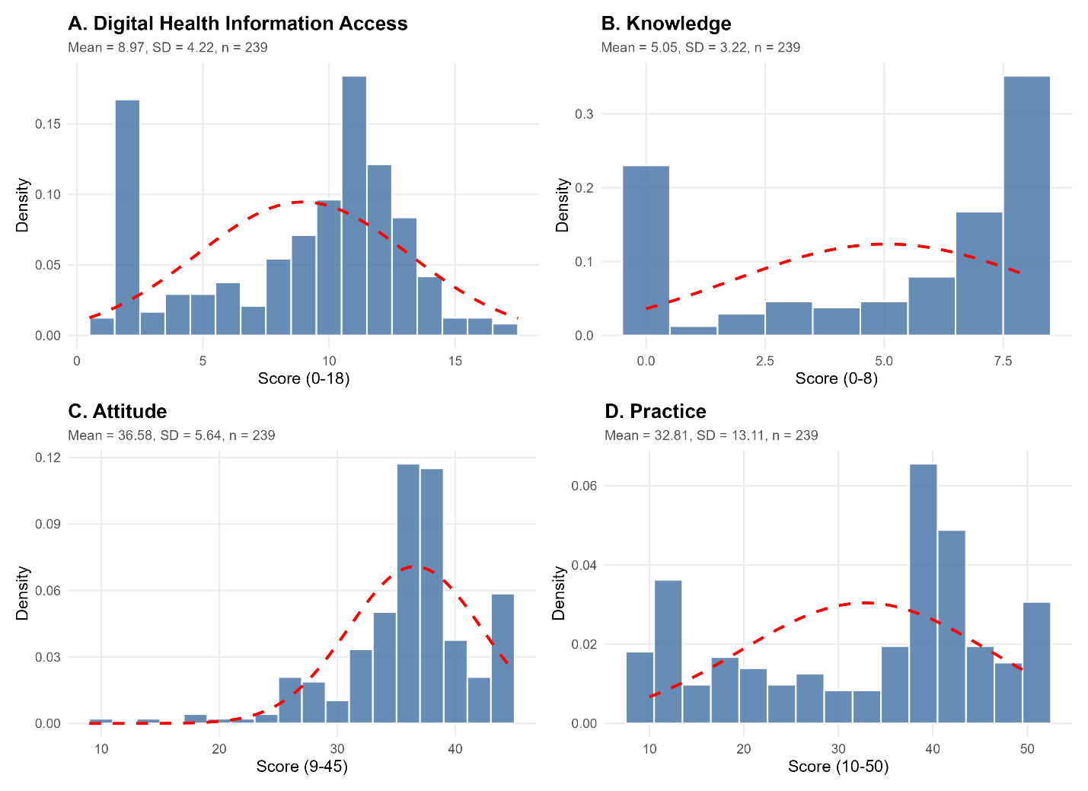
Figure 4.2.2. Distribution of Digital Reproductive Health Information Access, Knowledge, Attitude, and Practice scores. Histograms show observed densities (bars) with superimposed normal curves (dashed red lines). Knowledge and Practice were left-skewed and bimodal, with a cluster of low scorers (Knowledge = 0; Practice = 10-15) and a larger concentration at the high end. Attitude was left-skewed, with most scores between 35 and 45 (ceiling effect). Digital Reproductive Health Information Access was multimodal, with peaks near 2 and 10-12. None of the scales followed the normal curve, so non-parametric tests are appropriate.

Instrument Reliability and Validity

Internal Consistency of Digital Reproductive Health Information Access, Knowledge, Attitude and Practice Score among Participants
DRHIA and KAP scales showed good to excellent internal consistency, except the Practice scale, whose raw alpha was low. Digital Reproductive Health Information Access showed good reliability (α = 0.857; standardized α = 0.882; average inter-item r = 0.427) across its 10 items. The Knowledge scale achieved excellent reliability (α = 0.939; average inter-item r = 0.658) for its 8 items, indicating strongly consistent responses across the knowledge items. The Attitude scale showed good internal consistency (α = 0.898; average inter-item r = 0.496) across 9 items. The Practice scale had a low raw alpha (α = 0.600, poor), but its standardized alpha was high (0.937; average inter-item r = 0.596). This gap suggests the 10 practice items are on different response scales, which lowers the raw alpha. The standardized value is therefore the more appropriate indicator of its reliability.

Table 4.2.3.1. Internal consistency reliability of the Digital Reproductive Health Information Access, Knowledge, Attitude and Practice scales (N = 239)
Scale | Items | Cronbach's alpha | Standardized alpha | Avg inter-item r | Mean (SD) | Interpretation
Digital Health Access | 10 | 0.857 | 0.882 | 0.427 | 8.97 (4.22) | Good
Knowledge | 8 | 0.939 | 0.939 | 0.658 | 5.05 (3.22) | Excellent
Attitude | 9 | 0.898 | 0.898 | 0.496 | 36.58 (5.64) | Good
Practice | 10 | 0.600 | 0.937 | 0.596 | 32.81 (13.11) | Poor

Quality Check of the Digital Reproductive Health Information Access, Knowledge, Attitude and Practice scales
KMO values indicated that the data were suitable for factor analysis across all scales. Digital Reproductive Health Information Access had a meritorious KMO (0.888), while Knowledge (0.917), Attitude (0.920), and Practice (0.947) were all in the marvelous range. All values exceeded the recommended threshold of 0.80, indicating strong inter-item correlations and adequate sampling for factor analysis.

Table 4.2.3.2. Quality check of the questionnaire scales (Digital Reproductive Health Information Access, Knowledge, Attitude and Practice)
Scale | Items | N | Alpha | Mean | SD | KMO
Digital Health Access | 10 | 239 | 0.857 | 8.97 | 4.22 | 0.888
Knowledge | 8 | 239 | 0.939 | 5.05 | 3.22 | 0.917
Attitude | 9 | 239 | 0.898 | 36.58 | 5.64 | 0.920
Practice | 10 | 239 | 0.952 | 32.81 | 13.11 | 0.947
Note: Alpha (Cronbach's alpha) shows how consistently the items in a scale measure the same concept. Values range from 0 to 1, and higher values mean the items agree more closely with each other. Values of 0.70 or above are generally considered acceptable, 0.80 or above good, and 0.90 or above excellent. Alpha was calculated separately for each scale. SD = standard deviation; KMO = Kaiser-Meyer-Olkin measure of sampling adequacy

Assessment of Each Scale
One-factor solutions using minimum residual estimation showed that each scale had an acceptable single-factor structure. Digital Health Access explained 46.6% of the variance, with loadings ranging from 0.27 to 0.87. Nine of the 10 items loaded above 0.40, while the item "Do you trust online reproductive health information?" showed a low loading (0.27). The Knowledge scale explained 66.0% of the variance, with strong loadings (0.76-0.87) on all 8 items, supporting a unidimensional structure. The Attitude scale accounted for 50.0% of the variance, with all 9 items loading adequately (0.58-0.81). The Practice scale explained 62.3% of the variance, with loadings from 0.32 to 0.87. Nine of the 10 items loaded above 0.40, and one item fell below the threshold (0.32). Overall, 35 of the 37 items exceeded the 0.40 threshold, while two items (one in Digital Health Access and one in Practice) showed low loadings.

Table 4.2.3.3. Assessment of each scale fit together as a single concept, and assessment of each scale fit weakly
Scale | Variance explained (%) | Items with loading > 0.40 | Loading range | Items with loading < 0.40 | Interpretation
Digital Health Access | 46.6 | 9 of 10 | 0.27-0.87 | Do you trust online reproductive health information? | Acceptable one-factor structure; low-loading item(s) noted
Knowledge | 66.0 | 8 of 8 | 0.76-0.87 | None | Unidimensional; all items load adequately
Attitude | 50.0 | 9 of 9 | 0.58-0.81 | None | Acceptable one-factor structure; all items load adequately
Practice | 62.3 | 9 of 10 | 0.32-0.87 | Knowledge Percentage | Acceptable one-factor structure; low-loading item(s) noted
Note: Variance explained is the share of the differences in answers that the single concept accounts for. Loading shows how strongly a question relates to that concept; values below 0.40 indicate a weak fit.

Agreement of Individual Questions with Overall Scale Score
Corrected item-total correlations were generally good. In the Knowledge scale, correlations ranged from 0.73 to 0.84, and in the Attitude scale from 0.55 to 0.75, with no item below 0.30. In the Practice scale, correlations ranged from 0.30 to 0.70, so all items met the minimum threshold of 0.30, although the lowest was borderline. In the Digital Health Access scale, correlations ranged from 0.21 to 0.79, and one item fell below 0.30. This is probably the same item with the low factor loading ("Do you trust online reproductive health information?"). Overall, 36 of the 37 items showed acceptable discrimination, and the one weak item was retained because of its content relevance

Table 4.2.3.4. Agreement of individual questions with the overall scale score
Scale | Items | Min r | Max r | Items with r < 0.30
Digital Health Access | 10 | 0.21 | 0.79 | 1
Knowledge | 8 | 0.73 | 0.84 | 0
Attitude | 9 | 0.55 | 0.75 | 0
Practice | 10 | 0.30 | 0.70 | 0
Note: r shows how closely a question agrees with the remaining questions in its scale. Values below 0.30 suggest the question fits weakly. Min = lowest value; Max = highest value.

Univariate Association among Study Participants

Normality Assessment of Digital Reproductive Health Information Access, Knowledge, Attitude and Practice Score of Participants
All four scales violated the normality assumption (Table 4.3.1). Digital Reproductive Health Information Access (W = 0.904, p < 0.001) departed significantly from normality, with mild left skewness (-0.52) and a flat distribution (kurtosis = -0.94). Knowledge (W = 0.776, p < 0.001) showed the strongest departure from normality, with moderate left skewness (-0.64) and the flattest distribution (kurtosis = -1.28). This reflects the polarized pattern of a large group of very low scorers and a larger group of high scorers, rather than a simple ceiling effect. Attitude (W = 0.904, p < 0.001) was the most strongly left-skewed (-1.25) and the only scale with a peaked distribution (kurtosis = 3.26), consistent with most participants scoring at the high end. Practice (W = 0.886, p < 0.001) was also left-skewed (-0.50) with a flat distribution (kurtosis = -1.17). Overall, all scales were left-skewed, with responses concentrated at higher scores. Because normality was violated, non-parametric tests (Mann-Whitney U, Kruskal-Wallis, Spearman correlation) were used for group comparisons and association analyses.

Table 4.3.1. Shape of the score distribution for Digital Reproductive Health Information Access, Knowledge, Attitude and Practice
Scale | N | W statistic | p-value | Skewness | Kurtosis | Interpretation | Reason for non-normality
Digital Reproductive Health Information Access | 239 | 0.904 | < 0.001 | -0.52 | -0.94 | Not normal | Left-skewed with flat (platykurtic) distribution; responses concentrated at high scores
Knowledge | 239 | 0.776 | < 0.001 | -0.64 | -1.28 | Not normal | Left-skewed with flat (platykurtic) distribution; responses concentrated at high scores
Attitude | 239 | 0.904 | < 0.001 | -1.25 | 3.26 | Not normal | Left-skewed; responses concentrated at high scores
Practice | 239 | 0.886 | < 0.001 | -0.50 | -1.17 | Not normal | Left-skewed with flat (platykurtic) distribution; responses concentrated at high scores
Note. A p-value below 0.001 means the scores do not follow a normal pattern. Skewness shows whether scores bunch toward one end; a negative value means most scores are high. Kurtosis shows whether the distribution is flatter or more peaked than a bell shape. W is the test statistic.

Outlier Detection of Digital Reproductive Health Information Access, Knowledge, Attitude and Practice Score among Participants
Outlier detection using the IQR method (values below Q1 − 1.5×IQR or above Q3 + 1.5×IQR) showed that outliers were limited to one scale (Table 9). Digital Reproductive Health Information Access (acceptable range -4.25 to 21.75), Knowledge (-7.00 to 17.00), and Practice (-11.75 to 74.25) had no outliers. Their bounds are much wider than the possible score ranges, so no value could fall outside them. The Attitude scale had 24 outliers (10.0% of the sample), all on the low side, with scores from 9 to 28 (lower bound = 29.00). This is expected: the Attitude scores are tightly clustered at the high end (Q1 = 35, Q3 = 39, IQR = 4), so the fence is narrow and the minority of participants with less favorable attitudes fall outside it. These low scores are valid responses, not data errors, so they were retained in the analysis. Non-parametric tests, which are robust to such values, were used

Table 4.3.2. Check for extreme scores on the Digital Reproductive Health Information Access, Knowledge, Attitude and Practice Scales
Scale | N | Q1 | Q3 | IQR | Lower bound | Upper bound | Outliers (n) | Outliers (%) | Outlier range
Digital Reproductive Health Information Access | 239 | 5.5 | 12 | 6.5 | -4.25 | 21.75 | 0 | 0 | None
Knowledge | 239 | 2.0 | 8 | 6.0 | -7.00 | 17.00 | 0 | 0 | None
Attitude | 239 | 35.0 | 39 | 4.0 | 29.00 | 45.00 | 24 | 10 | 9-28
Practice | 239 | 20.5 | 42 | 21.5 | -11.75 | 74.25 | 0 | 0 | None

Distribution Characteristics among Adolescents
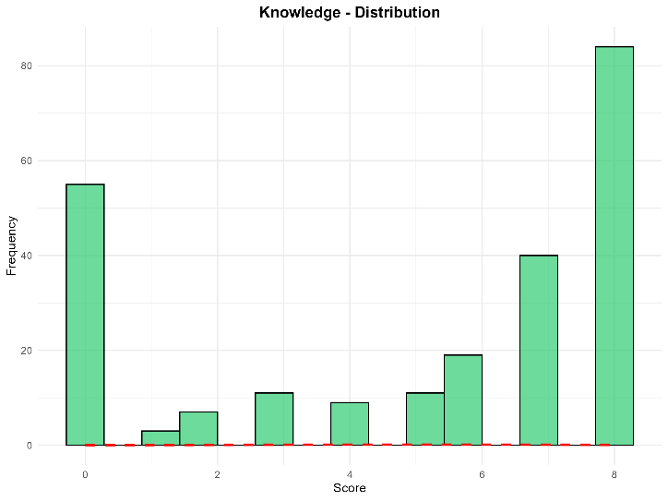
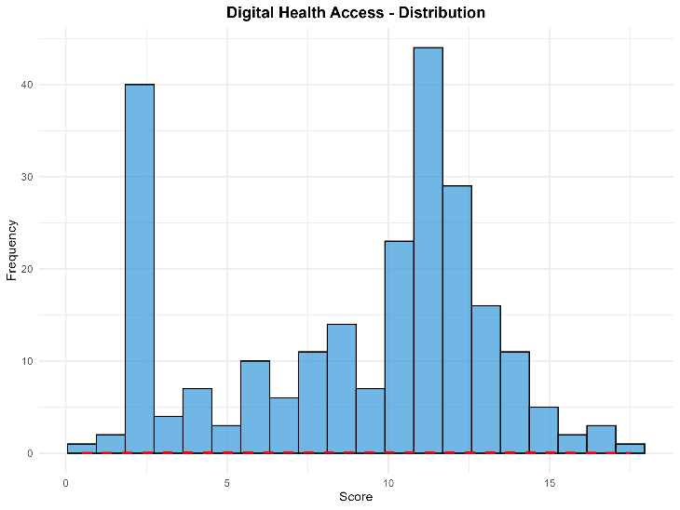
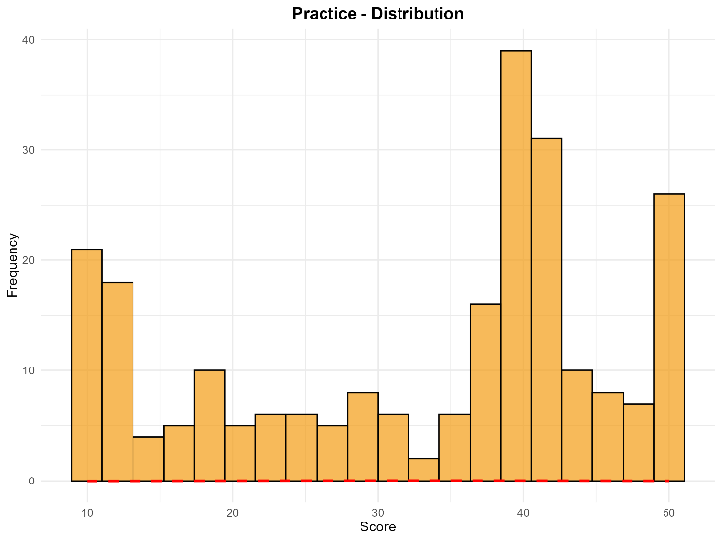
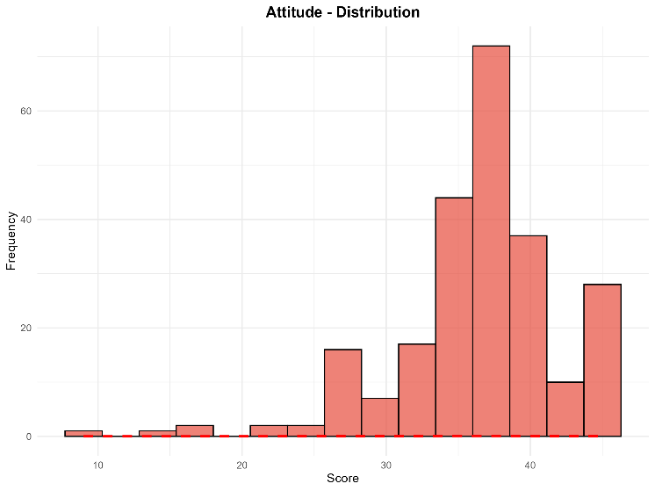
Histograms revealed that none of the scales followed a normal distribution. Attitude was left-skewed with a single peak at about 36-38 and a ceiling effect, with 69.87% of participants in the "Very Favorable" category. Knowledge and Practice were bimodal: most participants clustered at the high end (51.88% "Excellent" in Knowledge and 53.97% in Practice), while a distinct group scored at or near the minimum (about 55 participants scored 0 in Knowledge). Digital Reproductive Health Information Access was multimodal, with a spike at low scores (about 2), a main peak at 10-12, and a tail toward the lower scores. These patterns indicate a polarized sample, with some adolescents scoring very high and others very low, rather than uniformly positive knowledge and practices.
Figure 4.3.3.1. Distribution of Digital Reproductive Health Information Access, Knowledge, Attitude, and Practice scores. Histograms show the observed frequencies of total scores. Attitude was left-skewed with a peak at about 36-38 and a ceiling at the maximum score. Knowledge and Practice were bimodal, with clusters at both low and high scores. Digital Reproductive Health Information Access was multimodal, with peaks at about 2 and 10-12

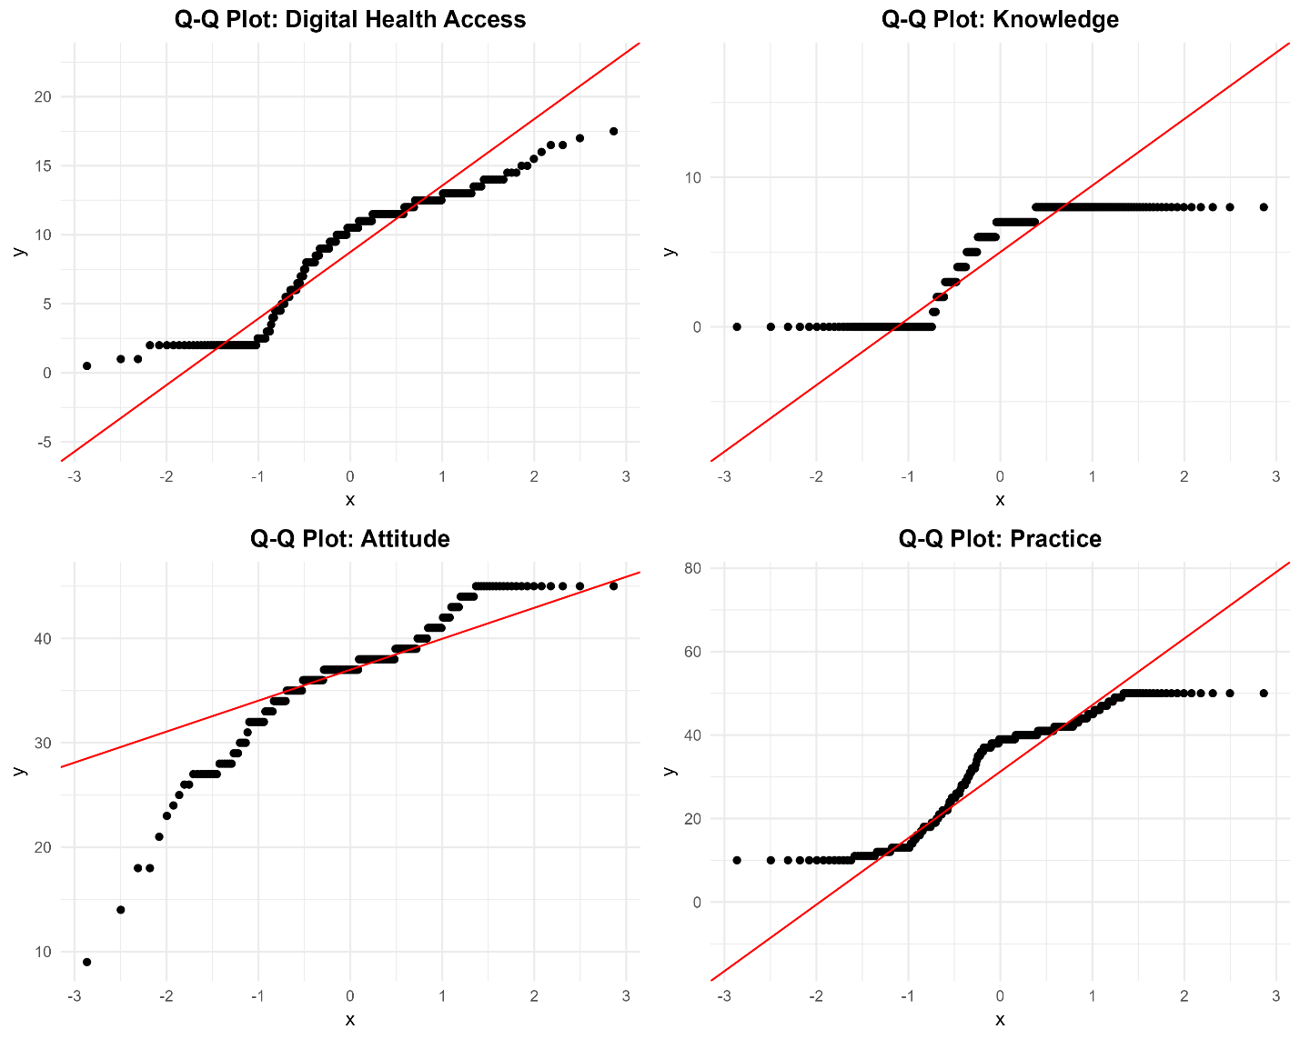
Figure 4.3.3.2.. Normal Q-Q plots for the KAP scales. Points deviating from the diagonal reference line (red) indicate departures from normality. All four scales deviated from the line. Attitude showed a long lower tail and a ceiling at the maximum score (45), consistent with left skewness. Knowledge and Practice showed S-shaped patterns with flat segments at both the minimum and maximum scores, indicating floor and ceiling clusters (polarized distributions). Digital Reproductive Health Information Access showed a cluster at low scores (about 2) and a flattened upper tail. The step-like pattern reflects tied, discrete scores. Together with the Shapiro-Wilk results, these plots confirm non-normality and support the use of non-parametric tests.

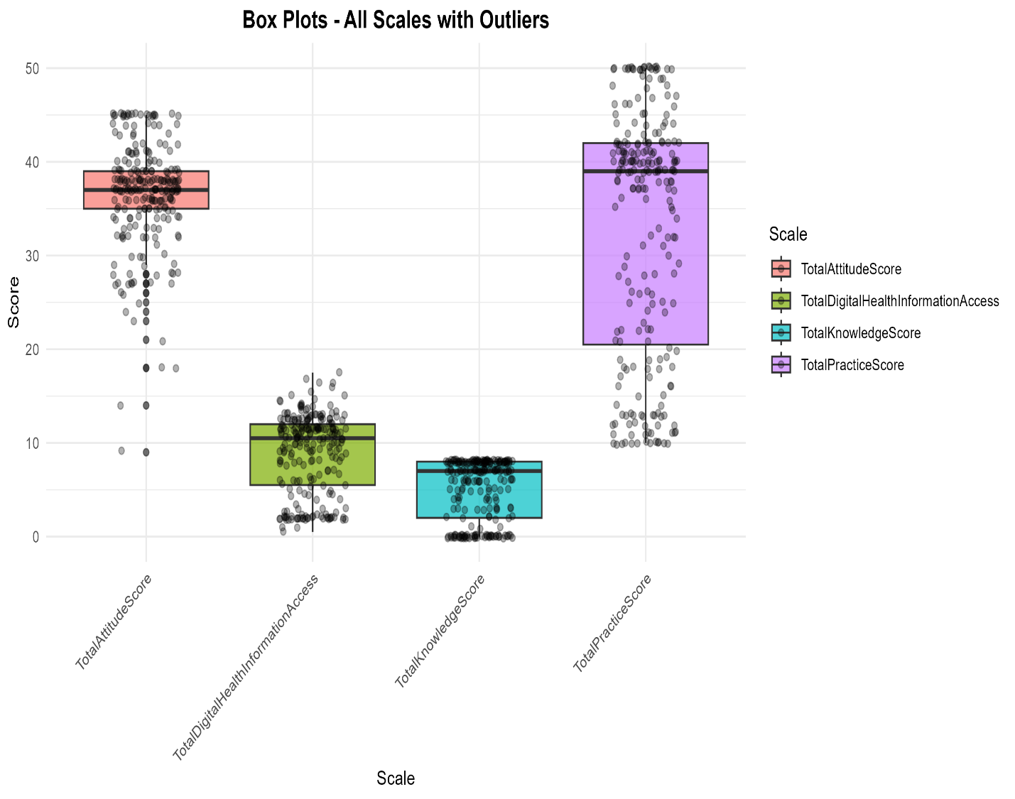
Figure 4.3.3.3. Box plots of the KAP scale scores with jittered individual responses. Boxes show the median and interquartile range, and whiskers extend to 1.5×IQR. Each dot is one participant (N = 239). Scales have different score ranges (Knowledge 0-8, Digital Health Access 0-18, Attitude 9-45, Practice 10-50), so boxes should be compared within each scale only. The Attitude scale had 24 low-score outliers (scores 9-28) below the lower whisker; no outliers were found in the other scales. Medians were higher than the box midpoints in Knowledge, Attitude, and Practice, consistent with left-skewed distributions.

Bivariate Associations with Demographic Variables of Study Participants

Comparison Digital Reproductive Health Information Access, Knowledge, Attitude and Practice scores by Residence
Wilcoxon rank-sum tests compared DRHIA and KAP scores between rural (n = 133) and urban (n = 106) adolescents, because the scores were not normally distributed (Table 4.4.1). Digital Reproductive Health Information Access differed significantly by residence (U = 5219, p < 0.001; Bonferroni-adjusted p = 0.002), with urban adolescents scoring higher (Mdn = 11.5, IQR 9-12.5) than rural adolescents (Mdn = 9, IQR 4-11.5). The effect size was small (r = 0.22), so rural adolescents had somewhat lower access to digital health information.
Knowledge was higher among urban adolescents (Mdn = 7, IQR 4-8) than rural adolescents (Mdn = 6, IQR 0-8). This difference was significant before correction (U = 5817, p = 0.017) but not after Bonferroni adjustment for the four tests (adjusted p = 0.067), and the effect was small (r = 0.15). It should therefore be interpreted cautiously, as a possible trend rather than a confirmed difference.
No significant differences were found for Attitude (U = 7003, p = 0.931; r = 0.01) or Practice (U = 6041, p = 0.057; adjusted p = 0.230; r = 0.12). Attitude medians were identical in both groups (Mdn = 37). Practice medians were higher in the urban group (40 vs. 36), but this was not statistically significant. A non-significant result does not prove the groups are equivalent, only that no difference was detected in this sample.
Overall, residence was clearly associated only with Digital Reproductive Health Information Access, and the effect was small. Knowledge, attitude and practice did not differ significantly between rural and urban adolescents after correction for multiple testing.

Table 4.4.1. Comparison of Digital Reproductive Health Information Access, Knowledge, Attitude and Practice scores by residence
Scale | n_Rural | n_Urban | Median (IQR)_Rural | Median (IQR)_Urban | U | p | p (Bonferroni) | r | Magnitude
Digital Reproductive Health Information Access | 133 | 106 | 9 (4-11.5) | 11.5 (9-12.5) | 5,219 | < 0.001 | 0.002 | 0.22 | small
Knowledge | 133 | 106 | 6 (0-8) | 7 (4-8) | 5,817 | 0.017 | 0.067 | 0.15 | small
Attitude | 133 | 106 | 37 (34-40) | 37 (36-39) | 7,003 | 0.931 | 1.000 | 0.01 | small
Practice | 133 | 106 | 36 (18-42) | 40 (28-42) | 6,041 | 0.057 | 0.230 | 0.12 | small

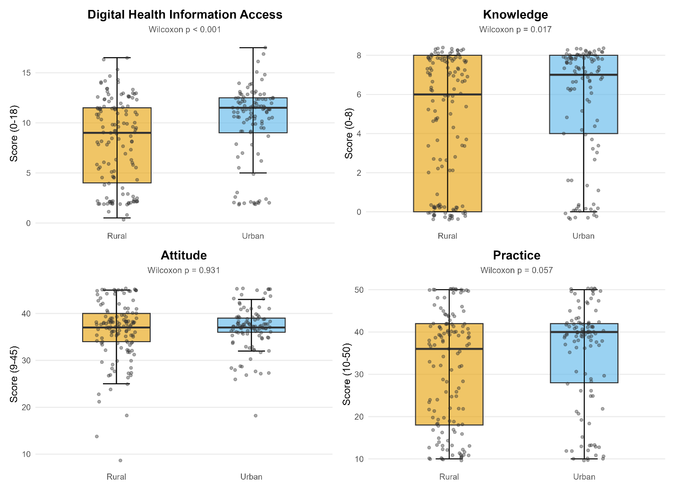
Figure 4.4.1. Comparison of KAP scores between rural and urban adolescents. Box plots show medians and interquartile ranges, with individual responses as jittered points. Urban adolescents scored higher in Digital Reproductive Health Information Access (p < 0.001; Bonferroni-adjusted p = 0.002). The Knowledge difference (p = 0.017) was not significant after Bonferroni adjustment (adjusted p = 0.067), and Attitude and Practice did not differ significantly between groups (p = 0.931 and p = 0.057)

Comparison of Reproductive Health’s Digital Reproductive Health Information Access, Knowledge, Attitude and Practice Score by Age Group of Participants
Kruskal-Wallis H tests compared KAP scores across four age groups (10-12, 13-15, 16-18 and above 18 years; N = 239), because the scores were not normally distributed (Table 4.4.2.). Digital Reproductive Health Information Access differed across age groups before correction (H = 9.35, df = 3, p = 0.025), but not after Bonferroni adjustment for the four tests (adjusted p = 0.100), and the effect size was small (ε² = 0.027). Median scores rose steadily with age, from 9.0 in the 10-12 group to 10.0 (13-15), 10.5 (16-18) and 11.5 (above 18). This pattern is suggestive of greater access in older adolescents, but it should be treated as a possible trend, not a confirmed difference.
No significant differences were found for Knowledge (H = 2.81, df = 3, p = 0.422), Attitude (H = 1.45, df = 3, p = 0.694) or Practice (H = 4.05, df = 3, p = 0.256), and the effect sizes were negligible (ε² = 0.000-0.004). Medians were similar across groups for Attitude (36.5-38.0). Knowledge (4.5-7.0) and Practice (33.5-40.0) were numerically lower in the youngest group, but these differences were not statistically significant. A non-significant result shows only that no difference was detected, not that the groups are equivalent.
Overall, age was not significantly associated with any KAP score after correction for multiple testing. Because no result remained significant, post hoc tests (Dunn's test) are not required.

Table 4.4.2. Comparison of Digital Reproductive Health Information Access, Knowledge, Attitude and Practice scores across age groups
Scale | N | H statistic | df | p-value | p (Bonferroni) | Epsilon-sq | Magnitude | Interpretation | Mdn: 10–12 years | Mdn: 13–15 years | Mdn: 16–18 years | Mdn: Above 18 years
Digital Reproductive Health Information Access | 239 | 9.35 | 3 | 0.025 | 0.100 | 0.027 | small | Significant before, but not after, Bonferroni correction | 9.0 | 10.0 | 10.5 | 11.5
Knowledge | 239 | 2.81 | 3 | 0.422 | 1.000 | 0.000 | small | No significant difference between age groups | 4.5 | 6.0 | 7.0 | 7.0
Attitude | 239 | 1.45 | 3 | 0.694 | 1.000 | 0.000 | small | No significant difference between age groups | 36.5 | 37.0 | 37.0 | 38.0
Practice | 239 | 4.05 | 3 | 0.256 | 1.000 | 0.004 | small | No significant difference between age groups | 33.5 | 37.5 | 39.0 | 40.0

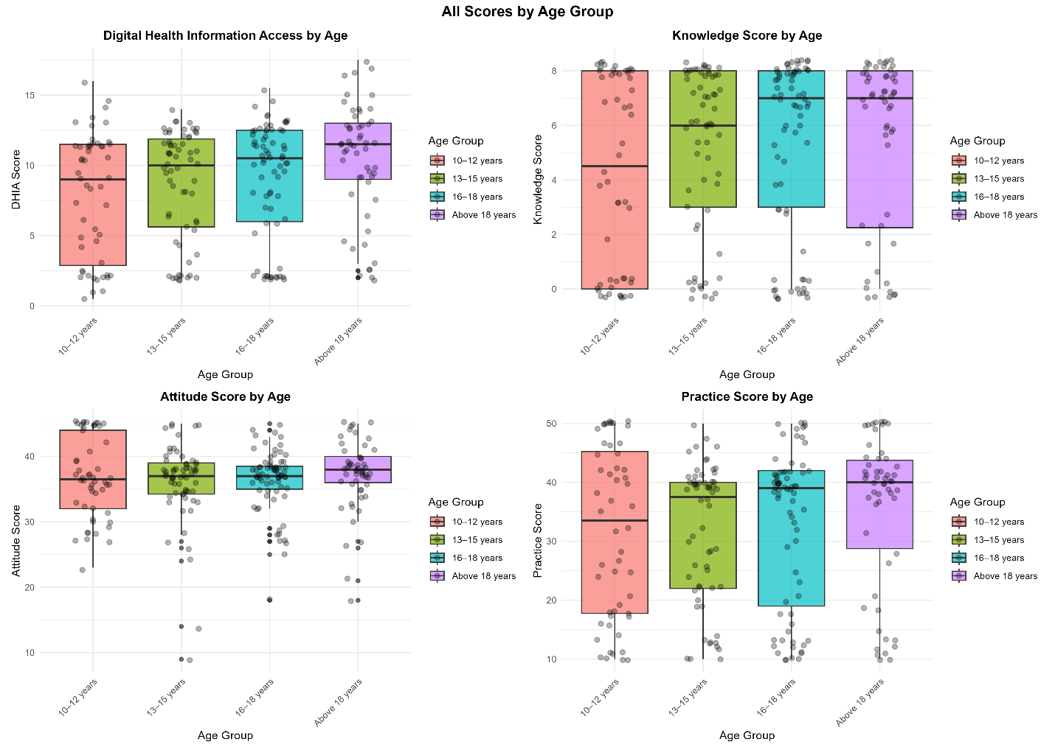
Figure 4.4.2. "KAP scores across four age groups (10–12, 13–15, 16–18, 18+ years). Box plots show considerable overlap across age categories for all four scales, visually confirming the lack of statistically significant age differences in Kruskal-Wallis tests.

Intercorrelations Between Digital Reproductive Health Information Access, Knowledge, Attitude and Practice of Adolescents Scales
Spearman rank correlations showed significant positive associations among all four KAP domains (Table 4.5, Figure 4.5; all p < 0.001, also after Holm adjustment for the six pairs). Digital Reproductive Health Information Access had the strongest correlation with Practice (ρ = 0.698, 95% CI 0.622 to 0.761), followed by Knowledge (ρ = 0.683, 95% CI 0.604 to 0.749). Adolescents with greater access to digital health information therefore tended to have better practices and higher knowledge. Knowledge and Practice were also moderately to strongly correlated (ρ = 0.623, 95% CI 0.534 to 0.699).
Attitude showed weaker correlations with the other domains: Digital Reproductive Health Information Access (ρ = 0.384), Practice (ρ = 0.367) and Knowledge (ρ = 0.337). These are weak to moderate, suggesting that attitudes are only partly related to information access, knowledge and practice. No negative correlations were found. Overall, the KAP domains were related but distinct constructs. These are associations only and do not show that one domain causes another.

Table 4.5. Intercorrelation among the Digital Reproductive Health Information Access, Knowledge, Attitude and Practice of Adolescents
Variable 1 | Variable 2 | N | rho | 95% CI | p-value | Strength
Digital Health | Knowledge | 239 | 0.683 | 0.604 to 0.749 | < 0.001 | Moderate
Digital Health | Attitude | 239 | 0.384 | 0.264 to 0.493 | < 0.001 | Weak
Digital Health | Practice | 239 | 0.698 | 0.622 to 0.761 | < 0.001 | Moderate
Knowledge | Attitude | 239 | 0.337 | 0.213 to 0.451 | < 0.001 | Weak
Knowledge | Practice | 239 | 0.623 | 0.534 to 0.699 | < 0.001 | Moderate
Attitude | Practice | 239 | 0.367 | 0.245 to 0.478 | < 0.001 | Weak
Note: rho (Spearman's rank correlation coefficient) shows how closely two scores rise and fall together. Values range from -1 to +1. A positive value means that adolescents with higher scores on one scale tend to have higher scores on the other. Values closer to 1 indicate a stronger relationship. CI = confidence interval. Strength labels (weak, moderate) describe the size of rho. Correlation shows that two scores go together, not that one causes the other.
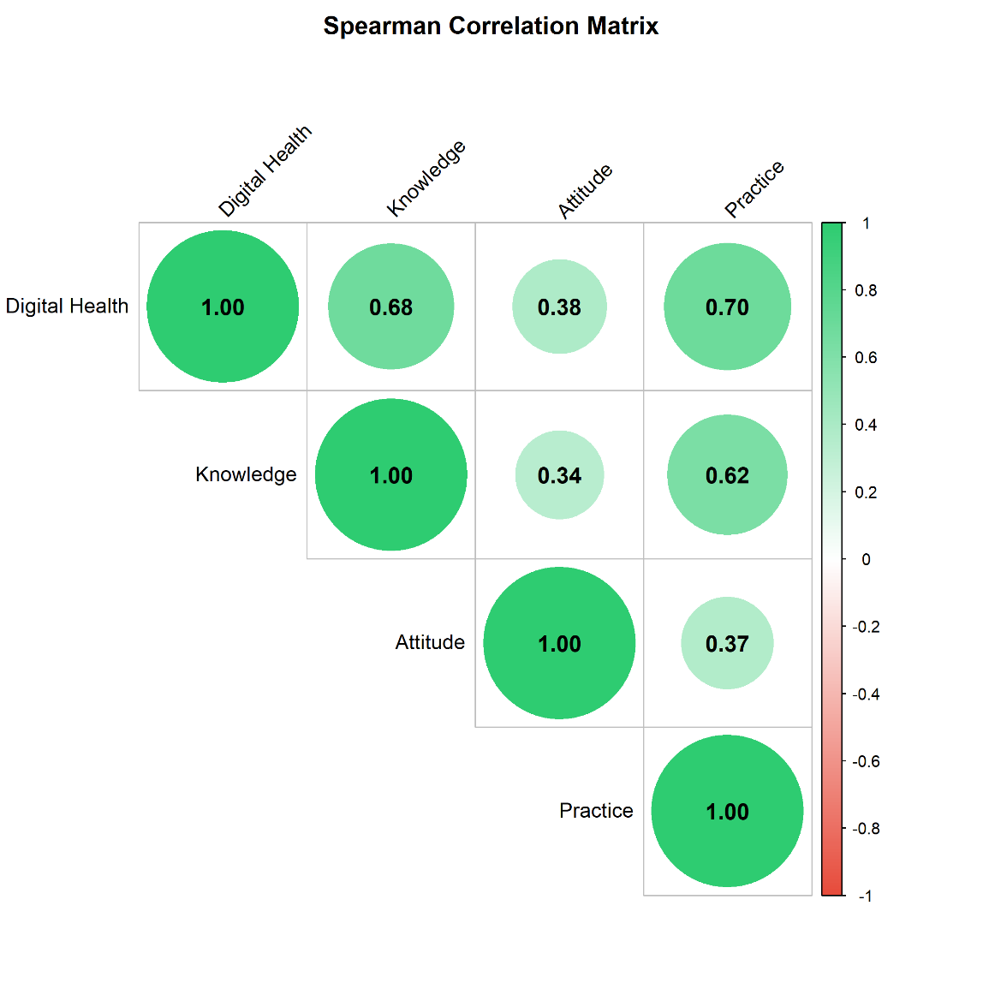

Figure 4.5. Spearman correlation matrix of the four KAP domains (N = 239). Circle size and colour intensity show correlation strength (green = positive; red = negative; white = near zero), and the number in each circle is Spearman's ρ. All correlations were positive and significant (p < 0.001). Digital Reproductive Health Information Access showed the strongest associations with Practice (0.70) and Knowledge (0.68), while Attitude showed weaker associations with the other domains (0.34-0.38).

Multivariate Linear Association of Digital Reproductive Health Information Access with Knowledge, Attitude and Practice Scales of Study Participants

Multivariate Linear Association of Digital Reproductive Health Information Access with Knowledge, Attitude and Practice Scores of Adolescents
Multiple linear regression, adjusted for socio-demographic factors, showed that Digital Reproductive Health Information Access was significantly and positively associated with all three outcomes (Table 4.6.1; heteroscedasticity-consistent HC3 standard errors were used).
Knowledge: Each 1-point increase in digital health access was associated with a 0.512-point higher knowledge score (95% CI 0.414 to 0.611, p < 0.001; β = 0.670). The model explained about 61.5% of the variance (adjusted R² = 0.615).
Attitude: Each 1-point increase in access was associated with a 0.521-point higher attitude score (95% CI 0.320 to 0.723, p < 0.001; β = 0.390). This was the weakest association, and the model explained only 17.6% of the variance (adjusted R² = 0.176), so most of the variation in attitudes was due to other factors.
Practice: Each 1-point increase in access was associated with a 2.413-point higher practice score (95% CI 2.046 to 2.781, p < 0.001; β = 0.776). This was the strongest association, and the model explained 64.8% of the variance (adjusted R² = 0.648).
Overall, adolescents with greater access to digital health information had higher knowledge and better practices, and a smaller but significant gain in attitude scores. The associations are statistically strong for Knowledge and Practice, and moderate for Attitude. These findings are cross-sectional associations and do not show that access causes the differences.
Model Equation:
$$Y_i=β_0+β_1 DHIA_i+β_2 Age_i+β_3 Sex_i+β_4 Residence_i+β_5 Source_i+β_6 FatherEdu_i+β_7 MotherEdu_i+β_8 SchoolType_i+β_9 LivesWith_i+β_10 Income_i+ε_i$$

Table 4.6.1. Multivariate Linear Association of Digital Reproductive Health Information Access with Knowledge, Attitude and Practice scores (N = 239) of Participants
Outcome | B | 95% CI | Beta | p | Adj. R²
Knowledge | 0.512 | 0.414 to 0.611 | 0.670 | < 0.001 | 0.615
Attitude | 0.521 | 0.32 to 0.723 | 0.390 | < 0.001 | 0.176
Practice | 2.413 | 2.046 to 2.781 | 0.776 | < 0.001 | 0.648
Note: B shows how many points the outcome score changes for each one-point increase in the Digital Reproductive Health Information Access score. Beta is the same relationship expressed in standard units, so it can be compared across outcomes. Values closer to 1 indicate a stronger association. p shows how likely a result this strong would be if there were no real association; a value below 0.001 means this is very unlikely. Adj. R² is the share of the differences in the outcome score that the model accounts for. For example, 0.615 means about 61.5%. It is adjusted for the number of variables in the model. CI = confidence interval, the range within which the true value is likely to lie. These results show association, not cause and effect.

Linear Regression Model Fit
Table 14 shows the fit of the three adjusted models. All were statistically significant overall (all p < 0.001; F(29, 209) = 14.12, 2.76 and 16.13).
Knowledge: The model explained 66.2% of the variance (R² = 0.662; adjusted R² = 0.615), a good fit. The typical prediction error was about 2.00 points on the 0-8 scale (RMSE = 2.00).
Attitude: The model explained only 27.7% of the variance (R² = 0.277; adjusted R² = 0.176), the weakest fit. The gap between R² and adjusted R² suggests that many covariates add little. The RMSE was 5.11 points on the 9-45 scale.
Practice: The model explained 69.1% of the variance (R² = 0.691; adjusted R² = 0.648), the best fit. The RMSE was 7.78 points on the 10-50 scale.
Overall, the models explained a large share of the variance in Knowledge and Practice, and a modest share in Attitude. Other factors not measured here probably influence attitudes. RMSE and AIC cannot be compared across outcomes, because the outcomes have different scales and AIC depends on the outcome scale.
Model Equation:

$$Knowledge_i=β_0+0.512×DHIA_i+(covariates)+ε_i$$

Table 4.6.2. Fit statistics of the multivariable linear regression models for knowledge, attitude and practice scores
Outcome | N | R-squared | Adj. R-squared | F statistic | df | p-value | RMSE | AIC
Knowledge | 239 | 0.662 | 0.615 | 14.12 | 29, 209 | < 0.001 | 2.00 | 1,039.4
Attitude | 239 | 0.277 | 0.176 | 2.76 | 29, 209 | < 0.001 | 5.11 | 1,488.4
Practice | 239 | 0.691 | 0.648 | 16.13 | 29, 209 | < 0.001 | 7.78 | 1,688.6
Note: R² is the proportion of variance in the outcome explained by the model, and adjusted R² corrects it for the number of predictors. The F statistic tests whether the model as a whole explains more variance than a model with no predictors; df gives its numerator and denominator degrees of freedom (the 29 numerator df indicate the number of model terms). RMSE (root mean square error) is the typical size of the prediction error, expressed in the units of each outcome score. AIC (Akaike information criterion) is a relative fit index in which lower values indicate a better balance of fit and complexity. AIC and RMSE are not comparable across outcomes because the scales differ in range.

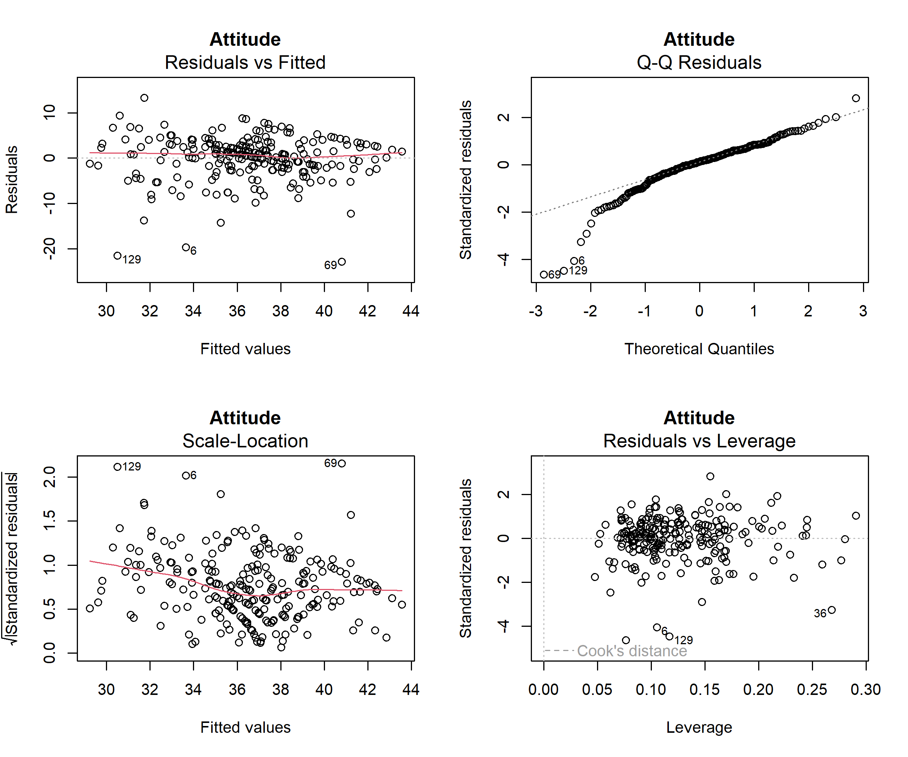
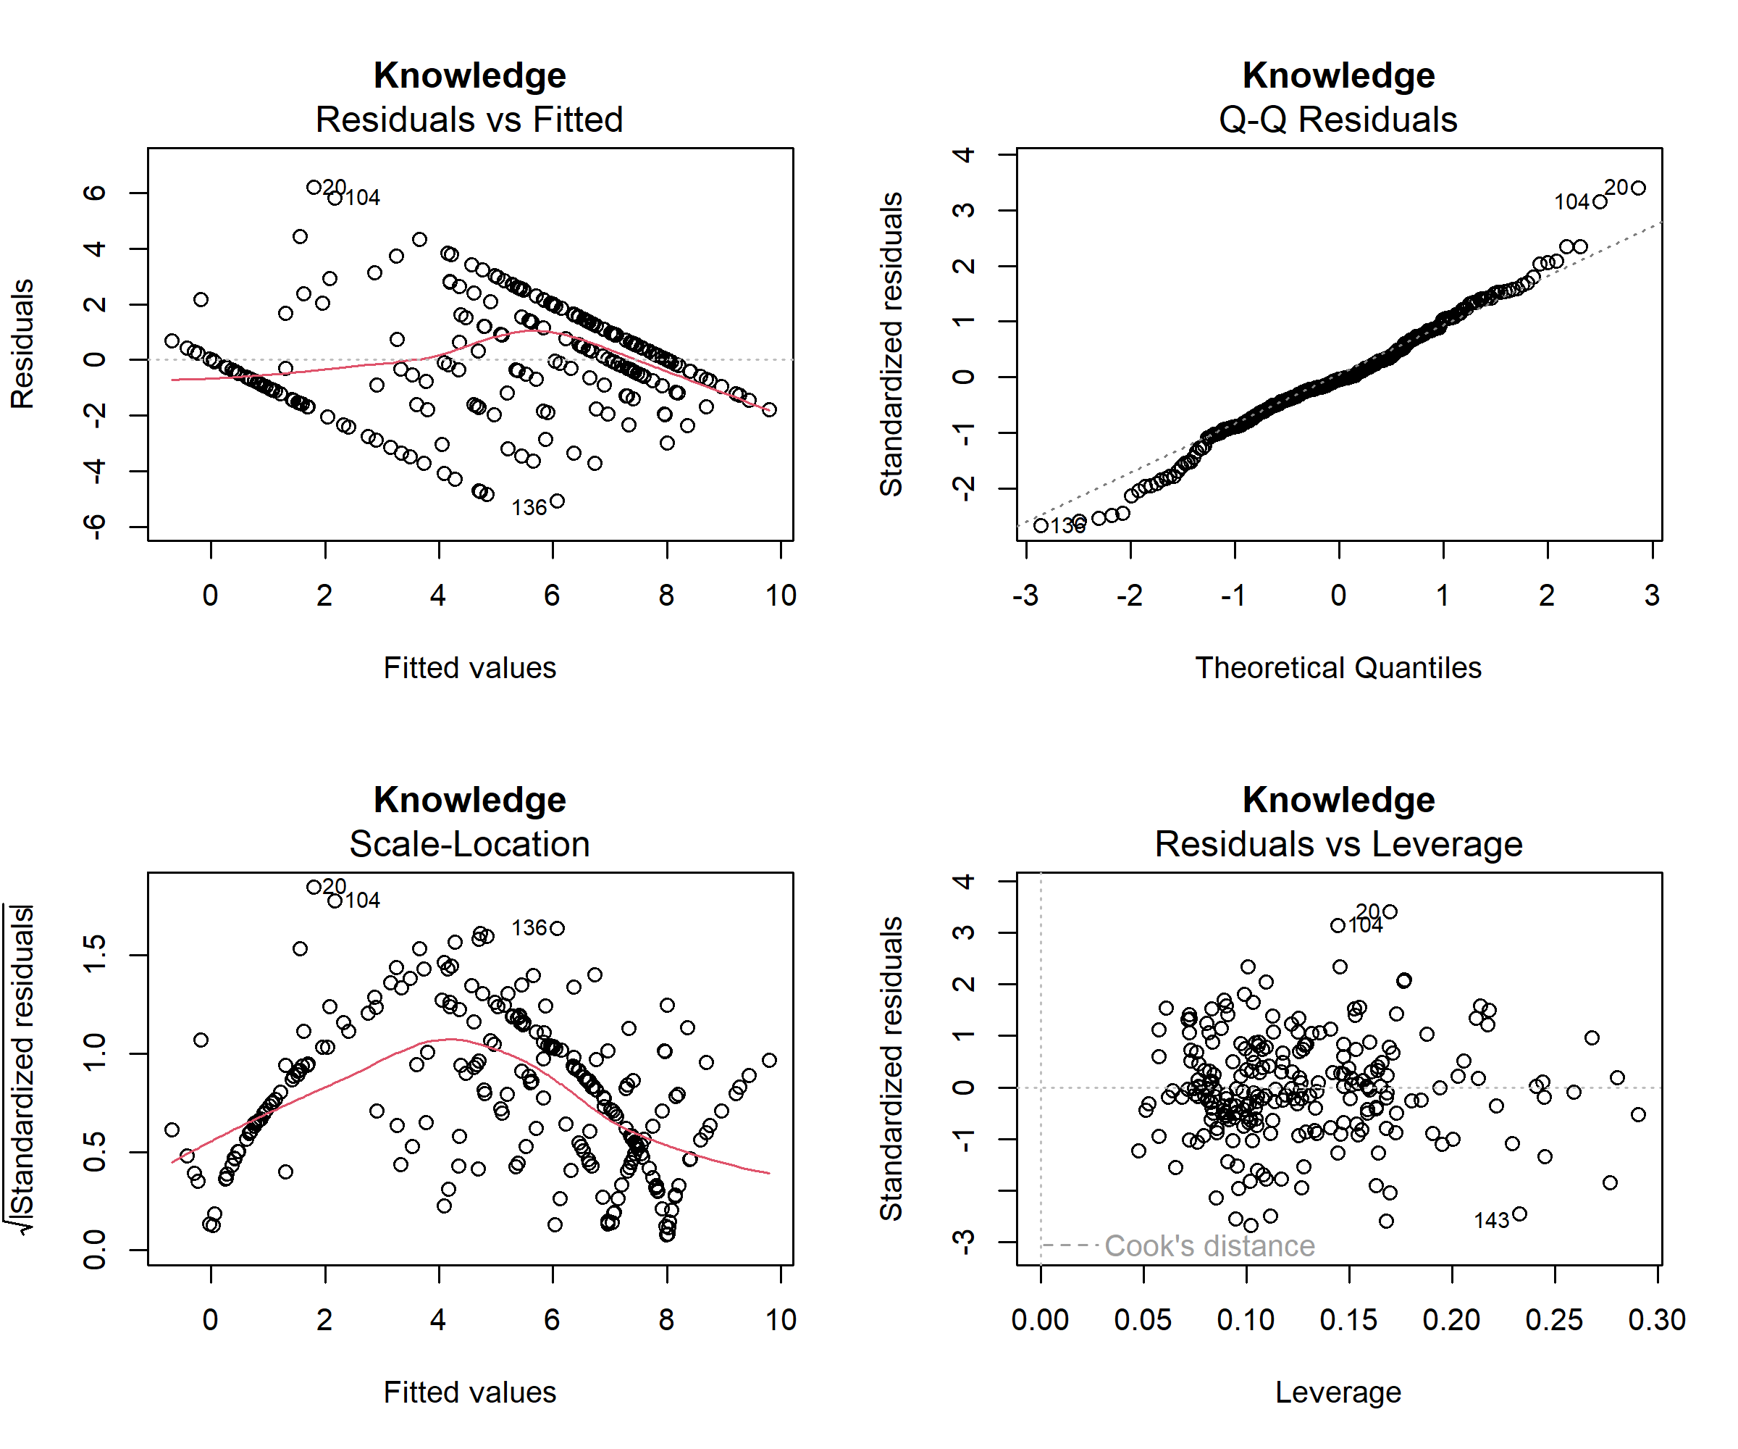
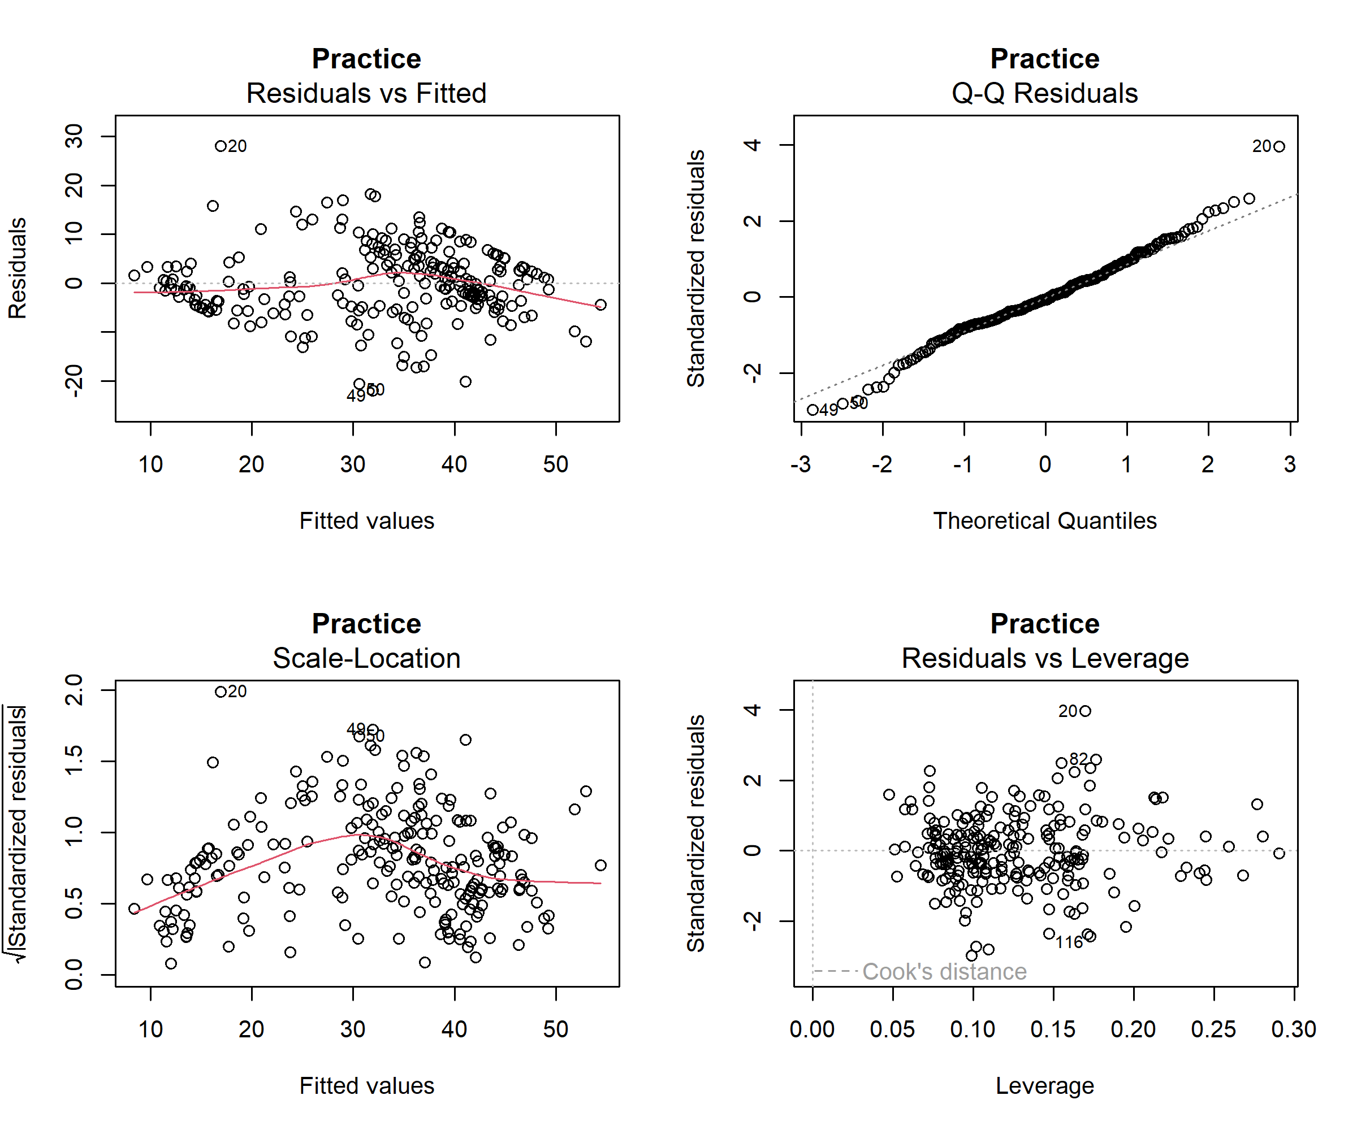
Figure 4.6.1. Diagnostic plots for the linear regression models of (A) Knowledge, (B) Attitude and (C) Practice. Each panel set shows residuals vs fitted values, a normal Q-Q plot, a scale-location plot and residuals vs leverage with Cook's distance. Relationships were approximately linear in all models. Residuals departed from normality in the tails, most strongly for Attitude (lower tail). The scale-location plots indicated non-constant variance for Knowledge and Practice, so heteroscedasticity-consistent (HC3) standard errors were used. No observation exceeded Cook's distance thresholds, indicating no highly influential cases. The stepped residual pattern in Knowledge reflects its discrete, bounded 0-8 score.

Regression Diagnostics: Interpretation
Knowledge model
- Residuals vs Fitted: The smoother is roughly flat, so linearity is acceptable. The residuals form diagonal bands because the outcome is a discrete 0-8 score, and some fitted values fall below 0 (the minimum is about -0.7), which is impossible for this scale.
- Q-Q: Residuals follow the line closely in the middle, with mild deviation in both tails (cases 20, 104 and 136).
- Scale-Location: The smoother rises and then falls (an inverted U), so variance is not constant.
- Leverage: No point is near Cook's distance lines, so no observation is highly influential.
Attitude model
- Residuals vs Fitted: The smoother is flat, so linearity is good. A few large negative residuals appear (cases 6, 69 and 129, about -20).
- Q-Q: The lower tail departs strongly from the line (down to about -4.5 standardized), while the rest follows it. This is the left skew and the 24 low-score outliers.
- Scale-Location: The smoother is nearly flat, so variance is approximately constant, the best of the three models.
- Leverage: No highly influential points. Cases 6, 36 and 129 have large residuals, but low to moderate leverage.
Practice model
- Residuals vs Fitted: The smoother is close to flat. Case 20 is a clear positive outlier (residual about +28), and cases 49 and 50 are negative.
- Q-Q: The residuals fit the line well, with slight deviations at both ends (cases 20, 49 and 50).
- Scale-Location: The smoother rises then declines, indicating mild heteroscedasticity.
- Leverage: No points cross Cook's distance lines. Case 20 has a large residual but modest leverage.

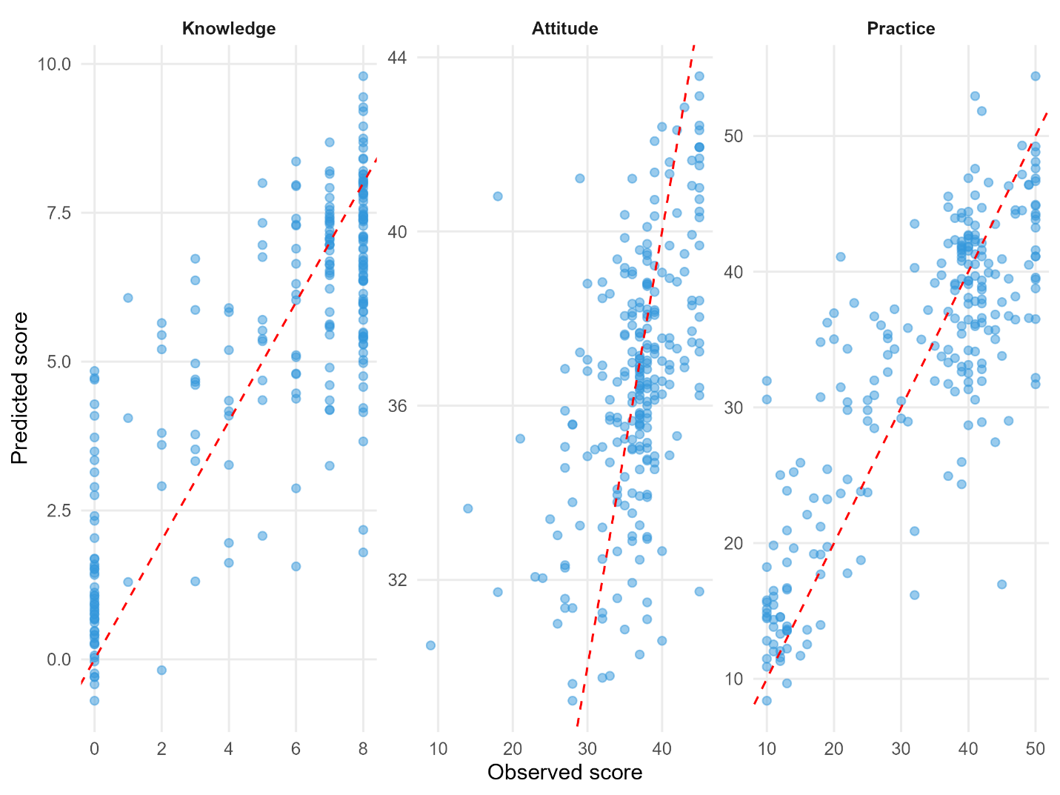
Figure 4.6.2. Observed versus predicted scores from the adjusted linear regression models for Knowledge, Attitude and Practice. Each dot is one participant (N = 239). The red dashed line shows perfect agreement (predicted = observed). Knowledge and Practice predictions followed the line, with Practice showing the closest fit (adjusted R² = 0.648 vs 0.615 for Knowledge). Attitude predictions were compressed into a narrow range (about 30-44), and low observed scores were over-predicted, consistent with its weaker fit (adjusted R² = 0.176). Knowledge scores formed vertical columns because the outcome is discrete (0-8), and some predictions fell below 0 or above 8, outside the possible range.

Ordinal Logistic Regression with Predicting Practice Categories
A proportional odds logistic regression was fitted to model the probability of being in a higher Practice category (Poor < Fair < Good < Excellent) using Digital Reproductive Health Information Access (DRHIA), Knowledge and Attitude as predictors (Tables 4.7).
Model fit. The model improved significantly on the intercept-only model (likelihood ratio χ²(3) = 211.13, p < 0.001). McFadden's pseudo-R² was 0.382, and values of 0.2-0.4 are generally considered a good fit. The AIC and BIC were 353.7 and 374.6. However, the Brant omnibus test was significant (χ² = 17.31, df = 6, p = 0.008), so the proportional odds assumption was violated. The odds ratios below should be read as an average effect across the three category thresholds, and the results should be treated with caution.
Coefficients and odds ratios. DRHIA was a significant predictor (β = 0.421, SE = 0.058, Z = 7.25, p < 0.001). The odds ratio of 1.52 (95% CI 1.36 to 1.71) means that each 1-point increase in DRHIA multiplied the odds of being in a higher Practice category by 1.52 (a 52% increase), holding Knowledge and Attitude constant. Knowledge was also significant (β = 0.298, SE = 0.069, Z = 4.29, p < 0.001; OR = 1.35, 95% CI 1.18 to 1.54), so each additional knowledge point increased the odds of a higher category by 35%. Attitude was not significant (β = 0.011, SE = 0.028, Z = 0.38, p = 0.701; OR = 1.01, 95% CI 0.96 to 1.07), meaning it added no detectable prediction once DRHIA and Knowledge were included.
Thresholds. The three thresholds were 3.405 (Poor|Fair), 4.679 (Fair|Good) and 5.881 (Good|Excellent). They increase in order, as expected. They are cut-points on the underlying scale and are not interpreted on their own.
Overall, higher digital health access and higher knowledge were associated with better practice categories, whereas attitude was not. These are cross-sectional associations and do not show causation.
Model Equation: Proportional odds model

$$logit[P(Y_i≤j)]=l n⁡(P(Y_i≤j)/P(Y_i>j) )=α_j-(β_1 DHIA_i+β_2 Knowledge_i+β_3 Attitude_i ), j=1,2,3$$

Fitted model
$$logit[P(Y≤Poor)]=3.405-(0.421 DHIA+0.298 Knowledge+0.011 Attitude)$$
$$logit[P(Y≤Fair)]=4.679-(0.421 DHIA+0.298 Knowledge+0.011 Attitude)$$
$$logit[P(Y≤Good)]=5.881-(0.421 DHIA+0.298 Knowledge+0.011 Attitude)$$

Odds ratio:
$$OR=e^{β}$$
Table 4.7. Predictors of Practice Category with Ordinal Logistic Regression Estimates for Digital Reproductive Health Information Access, Knowledge and Attitude
Predictor | Coefficient (β) | SE | Z | p-value | Odds ratio | 95% CI (OR) | Significance
Digital Reproductive Health Information Access | 0.421 | 0.058 | 7.25 | < 0.001 | 1.52 | 1.36 to 1.71 | ***
Knowledge | 0.298 | 0.069 | 4.29 | < 0.001 | 1.35 | 1.18 to 1.54 | ***
Attitude | 0.011 | 0.028 | 0.38 | 0.701 | 1.01 | 0.96 to 1.07 | ns
Threshold: Poor|Fair | 3.405 | 0.993 | 3.43 | - | - | - | -
Threshold: Fair|Good | 4.679 | 1.021 | 4.58 | - | - | - | -
Threshold: Good|Excellent | 5.881 | 1.068 | 5.51 | - | - | - | -
Note: The outcome is practice level, ordered from poor to excellent. The odds ratio (OR) shows how the chance of being in a higher practice level changes with each one-point increase in a predictor, with the other predictors held constant. An OR above 1 means a higher chance, an OR of 1 means no change, and an OR below 1 means a lower chance. For example, an OR of 1.52 means 52% higher odds of being in a higher practice level for each one-point increase. The coefficient (β) is the same effect on a log scale, SE is its standard error, and Z is the coefficient divided by its SE. CI = confidence interval, the range within which the true OR is likely to lie; if it includes 1, the result is not significant. *** p < 0.001; ns = not significant. The threshold rows mark the cut-points between practice levels and are not effects to interpret.

Predicted Probabilities
Predicted probabilities from the ordinal model show how the probability of each Practice category changes with the predictors (Table 4.7.1, Figure 4.7.1).
Example cases (Table 4.7.1). For an adolescent with low scores (10th percentile: DRHIA = 2.0, Knowledge = 0, Attitude = 28.8), the model predicted a 90.5% probability of "Poor" practice, and only 0.9% for "Excellent". For a typical adolescent (median: DRHIA = 10.5, Knowledge = 7, Attitude = 37.0), the "Excellent" category was most likely (73.4%), and "Poor" was only 3.0%. For high scorers (90th percentile: DRHIA = 13.0, Knowledge = 8, Attitude = 44.0), the probability of "Excellent" practice rose to 92.0%, and "Poor" was 0.7%. The middle categories (Fair and Good) were never the most likely outcome in these examples, which fits the polarized Practice distribution.

Table 4.7.1 Predicted probabilities of Practice category for example cases (low = 10th, medium = 50th, high = 90th percentile of predictors)
Example scenario | Digital Health | Knowledge | Attitude | Poor | Fair | Good | Excellent | Most likely category
Low | 2.0 | 0 | 28.8 | 90.5% | 6.6% | 2% | 0.9% | Poor
Medium | 10.5 | 7 | 37.0 | 3% | 6.9% | 16.8% | 73.4% | Excellent
High | 13.0 | 8 | 44.0 | 0.7% | 1.8% | 5.5% | 92% | Excellent

Probability curves (Figure 4.7.1.). As DRHIA increased from the minimum to the maximum (other predictors at their means), the probability of "Poor" practice fell from about 78% to nearly 0%, while "Excellent" rose from about 2% to about 97%. "Fair" and "Good" peaked at middle DRHIA scores (about 5 and 8), at roughly 30% each, then declined. The "Excellent" curve crossed the "Poor" curve at a DRHIA score of about 6, and became the most likely category above about 9. Knowledge showed a gentler pattern: as Knowledge increased from 0 to 8, "Excellent" rose from about 15% to 66%, and "Poor" fell from about 32% to 4%. No category was above 70% at any Knowledge level, so DRHIA changes predicted practice more strongly than Knowledge does, as the odds ratios indicate (1.52 vs 1.35).
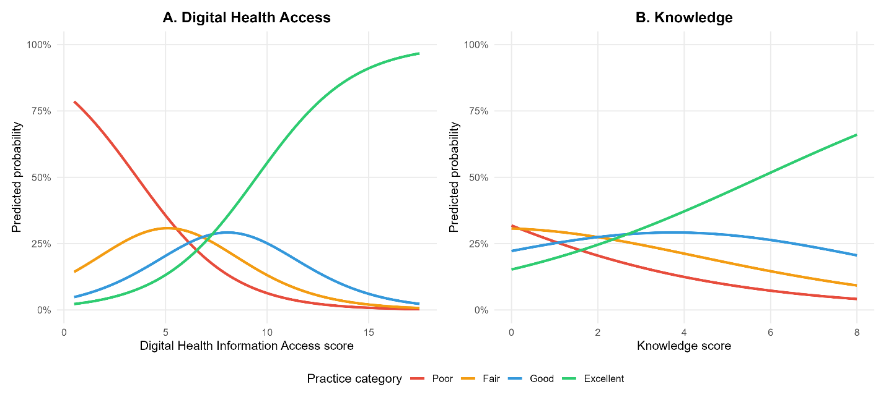
Figure 4.7.1. Probability curves. As DRHIA increased from the minimum to the maximum (other predictors at their means), the probability of "Poor" practice fell from about 78% to nearly 0%, while "Excellent" rose from about 2% to about 97%. "Fair" and "Good" peaked at middle DRHIA scores (about 5 and 8), at roughly 30% each, then declined. The "Excellent" curve crossed the "Poor" curve at a DRHIA score of about 6, and became the most likely category above about 9. Knowledge showed a gentler pattern: as Knowledge increased from 0 to 8, "Excellent" rose from about 15% to 66%, and "Poor" fell from about 32% to 4%. No category was above 70% at any Knowledge level, so DRHIA changes predicted practice more strongly than Knowledge does, as the odds ratios indicate (1.52 vs 1.35).
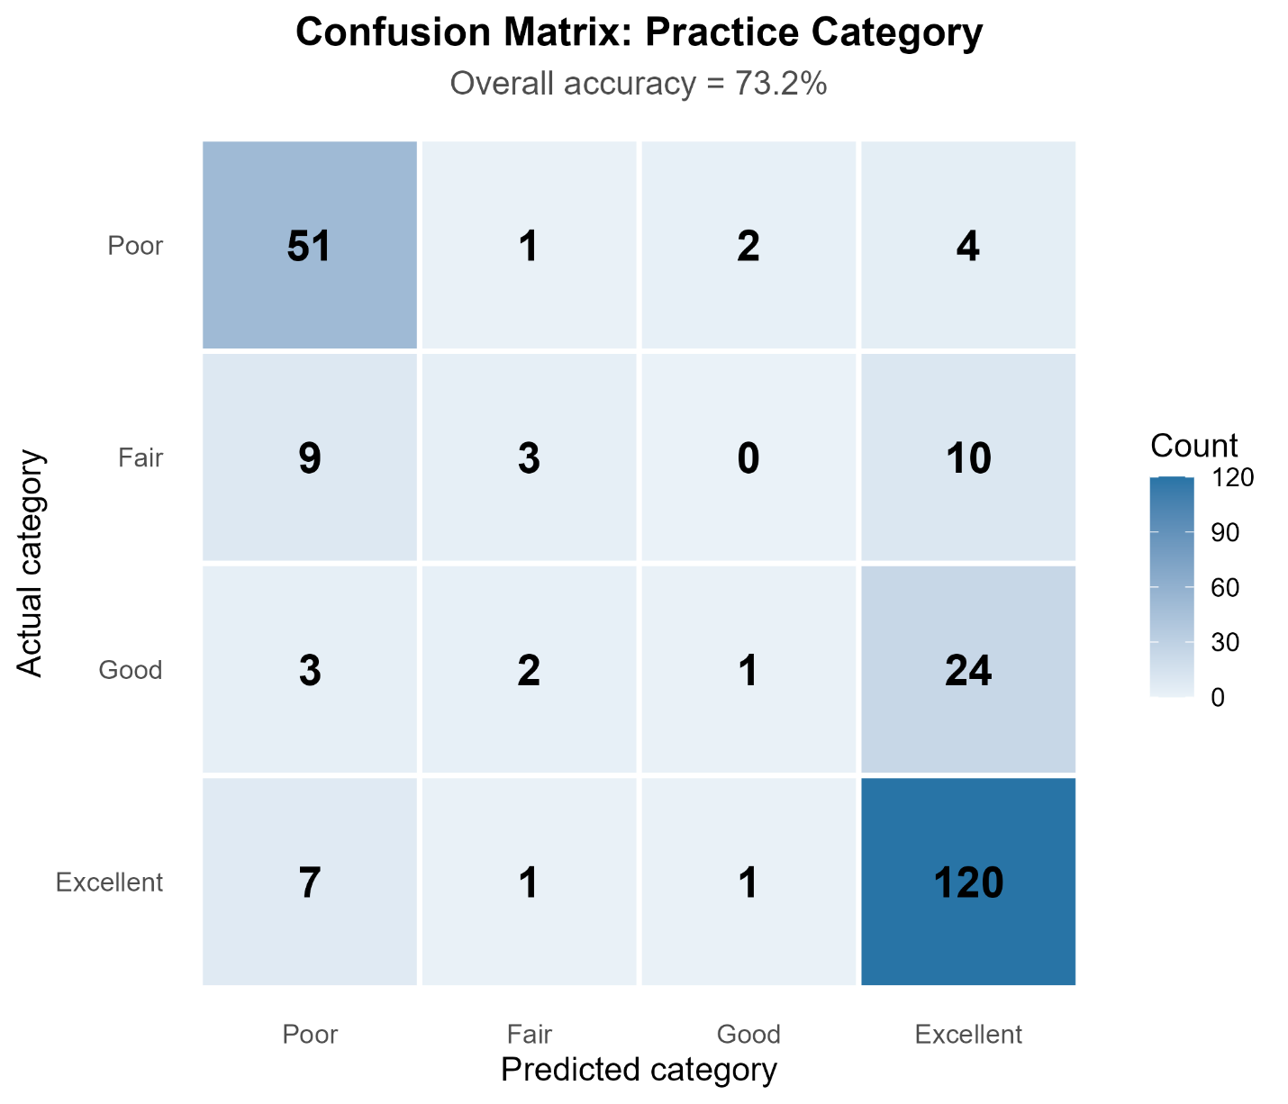
Figure 4.7.2. Confusion matrix of predicted versus actual practice categories (N = 239; overall accuracy = 73.2%). Rows represent actual categories and columns represent predicted categories; cell values are respondent counts, with darker shading indicating higher frequencies. Diagonal cells show correct classifications. Off-diagonal cells show misclassifications, which were concentrated in the Excellent column, particularly Good and Fair respondents predicted as Excellent.

Chapter 6 - Discussion

Introduction paragraph
This study assessed the association between access to reproductive health information and knowledge, attitudes and practices (KAP) among 239 adolescents in Bangladesh. It also identified the main sources of reproductive health information, measured levels of knowledge, attitudes and practices, and examined factors associated with access to digital health information.
Parents (32%) and schools (31%) were the most common main sources of information, followed by the internet (15%) and friends (15%). Doctors or health workers (4.6%) and television or radio (2.9%) were rarely reported. Access to digital health information was moderate overall (mean = 8.97 of 18). It was higher among urban than rural adolescents (median 11.5 vs 9; Bonferroni-adjusted p = 0.002), although the effect was small.
Knowledge and practice were polarized. Just over half of the adolescents had excellent knowledge (51.88%) and excellent practice (53.97%), while nearly one-third had poor knowledge (31.80%) and about one-quarter had poor practice (24.27%). Attitudes were mostly favorable (69.87% very favorable), with a clear ceiling effect.
Digital Reproductive Health Information Access was moderately and positively correlated with practice (ρ = 0.698) and knowledge (ρ = 0.683), and more weakly with attitude (ρ = 0.384). After adjustment for socio-demographic factors, higher access was significantly associated with higher knowledge (β = 0.670), practice (β = 0.776) and attitude scores (β = 0.390). In the ordinal model, higher access (OR = 1.52) and higher knowledge (OR = 1.35) were associated with higher odds of a better practice category, whereas attitude was not (OR = 1.01). These findings are cross-sectional associations and do not show that access causes better knowledge or practice.

Sources of Reproductive Health Information
Parents (31.8%) and schools (30.5%) were the main sources of reproductive health information. The internet (15.5%) and friends (14.6%) followed, and doctors or health workers (4.6%) and television or radio (2.9%) were rarely reported.
The prominence of family agrees with Bangladeshi school-based studies. In Chattogram, 62% of girls named their mother as their main source, yet the authors judged mother-daughter communication to be poor overall and mostly limited to menstruation (Zakaria et al., 2019) (Zakaria et al., 2019) . In Khulna City, 92% of girls reported their mother as a source (Chandra et al., 2020) . The large role of schools is encouraging, but Bangladeshi evidence points to barriers within them, including limited teacher training, social taboos and institutional constraints (Kamruzzaman et al., 2022) .
Few adolescents named health professionals as their main source. A systematic review in low- and middle-income countries found that parents, health workers and teachers were trusted sources, but adolescents often received most of their information from peers and other relatives (Munakampe et al., 2018) . The internet was the main source for about one in seven adolescents. This is far below the 97.3% who used online media in an online survey of 18-24-year-olds in Jakarta (Karima et al., 2023) , but that sample was recruited online and is not comparable. A semi-urban Bangladeshi survey found that only 7.2% of device owners used their devices for health information or services (Y. Ahmed et al., 2026) . Together, these findings suggest that family and school remain the primary channels in Bangladesh, and that digital sources are a smaller, complementary channel.

Level of Reproductive Health Knowledge
Knowledge was moderate on average (mean 5.05 of 8, SD = 3.22, median 7), but the average hides a polarized distribution. Of the adolescents, 51.88% had excellent knowledge and 31.80% had poor knowledge, with few in between. Most earlier Bangladeshi studies report gaps. Knowledge of puberty, family planning, maternal health and HIV/AIDS was unsatisfactory among 792 older adolescent girls in Chattogram (Zakaria et al., 2020) , and more than half of tenth-grade students in Khulna had knowledge gaps (M. S. Rahman & Abusaleh, 2024) . Other studies found good knowledge among female adolescents in south-western Bangladesh, varying by age, schooling, living arrangement, residence and income (Md. T. Hossain et al., 2022) . In Dhaka, ninth-grade girls had higher knowledge than boys (66.4% vs 52.5%) (Shahan et al., 2025) . In rural Pakistan, knowledge scores did not differ between males and females and were linked to marital status and father's occupation (Inayat Ali et al., 2025) .
In our sample, knowledge did not differ significantly by residence or age after correction for multiple testing, but it correlated with digital access (ρ = 0.683). This pattern is consistent with exposure to information mattering more than basic demographics. Longitudinal designs are needed to test this.

Attitudes Toward Reproductive Health
Attitudes were favorable overall (mean 36.58 of 45), and 95.8% of adolescents were in the favorable or very favorable categories. This agrees with a Dhaka study in which 84.1% of students supported reproductive health education, although only 51.4% felt comfortable discussing sexual health (Shahan et al., 2025) . In rural Indonesia, adolescents also held positive attitudes despite low knowledge (Adjie et al., 2022) .
The ceiling effect should be read with care. Items that ask whether schools or parents should provide education are easy to endorse. KAP surveys also record what people say, not what they do, so large gaps between stated and actual behavior are possible (Sharma, 2024) . The 10% of adolescents with markedly low attitude scores are a small group, but favorable attitudes cannot be assumed for them. Attitude did not differ by residence in our data (r = 0.01), whereas urban residence predicted more positive attitudes among girls in Chattogram (Zakaria et al., 2020) . Differences in sample, measurement and outcome definitions may explain this.

Reproductive Health Practices and the Attitude-Practice Gap
Practice was polarized. About 54% of adolescents had excellent practice and 24% had poor practice, compared with 95.8% with favorable attitudes. The gap between attitude and practice, about 40 percentage points, is one of the main findings. Attitude correlated weakly with practice (ρ = 0.367) and did not predict practice category once access and knowledge were in the model (OR = 1.01).
This agrees with the wider literature: digital and educational interventions typically raise knowledge and attitudes more reliably than behavior (Aguilar-Quesada et al., 2025; Dowling et al., 2025; Sewak et al., 2023) . Practice depends on more than beliefs, including skills, privacy, family permission and access to services. Adolescents may also hold back from acting on online information without parental or professional advice (Taba et al., 2022) . In rural Indonesia the reverse pattern was reported, with low knowledge but mostly good practice (Adjie et al., 2022) , so the sequence from knowledge to attitude to practice should not be assumed. Several of our practice items, such as verifying information and using trusted websites, are themselves linked to digital access, so the practice score partly reflects information behavior (see Limitations).

Factors Associated with Access to Digital Health Information
Urban adolescents had higher access than rural adolescents (median 11.5 vs 9; Bonferroni-adjusted p = 0.002), with a small effect (r = 0.22). Access tended to rise with age (median 9.0 to 11.5), but this was not significant after correction (adjusted p = 0.100). In adjusted models, almost none of the socio-demographic covariates were significant, and access was the main significant predictor of KAP.
The rural-urban gap fits evidence on digital inequality in Bangladesh. In a survey of 6,500 rural people, age, gender, education, income and location explained differences in internet access, and a second level of divide appeared in browsing and information-seeking skills (Siddiquee & Islam, 2024) . Access to digital health also involves more than device ownership: health literacy, material resources and technical skill all matter (T. Ahmed et al., 2020) . In India, exposure to social media was associated with better reproductive health knowledge, but the benefit went mainly to educated, urban and wealthier girls (Saha et al., 2022) . Among married Bangladeshi adolescents and young women, internet or mobile access was associated with more antenatal care (Pickard et al., 2024) . The weak age effect should be treated as a possible trend. Only residence and age were tested individually here, so other factors cannot be ruled out.

Association Between Digital Access and KAP
Digital access was moderately correlated with practice (ρ = 0.698) and knowledge (ρ = 0.683) and weakly with attitude (ρ = 0.384). After adjustment for socio-demographic factors, higher access was associated with higher knowledge (β = 0.670), practice (β = 0.776) and attitude (β = 0.390), and with higher odds of a better practice category (OR = 1.52). These results are consistent with studies in the region. Reading or watching reproductive health content on media was associated with knowledge, attitude and practice among girls in Chattogram (Zakaria et al., 2020) . Social media exposure was associated with higher odds of knowledge about intercourse and pregnancy, contraception and HIV/AIDS in India (Saha et al., 2022) . Reviews also report that digital and mobile interventions can improve knowledge and attitudes, with less consistent effects on behavior (Borji-Navan et al., 2024; Feroz et al., 2021; Sewak et al., 2023) .
Attitude had the weakest relationship, and the model explained only 17.6% of its variance (adjusted R²). This suggests that attitudes depend largely on factors we did not measure, such as culture, religion and peers. Two cautions apply. The design is cross-sectional, so access may follow from existing interest and knowledge instead of causing it. Access and practice items also overlap in content. The associations should therefore be read as correlations and not as effects.

Polarized Distributions and Their Implications
Knowledge and practice were bimodal, with one cluster at the top and another at or near the minimum, and the access scale was multimodal. The sample appears to contain a well-informed group and a poorly informed group, not a single group with average knowledge. One plausible explanation is unequal exposure. Digital inequality has multiple layers, including access, skills and use (Siddiquee & Islam, 2024) , and the benefits of digital media can accrue mainly to those already advantaged (Saha et al., 2022) . This study did not test this explanation directly.
Overall, our results agree with the Bangladeshi and South Asian literature on the role of family and school, the unsatisfactory or uneven level of knowledge, and the link between media exposure and better KAP. They add a direct measure of digital access in both rural and urban adolescents, and they show polarized levels of knowledge and practice, not uniformly low or high ones. A mapping review of Bangladeshi research notes that important evidence gaps remain in adolescent reproductive health, which this study partly addresses (Williams et al., 2022) .

Public Health and Policy Implications
Four implications follow. First, schools and families are the main existing channels, so reproductive health education should be strengthened in both, including training for teachers and guidance for parents (Kamruzzaman et al., 2022; Zakaria et al., 2019) . Second, digital delivery may help reach adolescents who do not use formal services. Mobile and digital tools can improve knowledge and attitudes, and their uptake depends on technological literacy, network coverage and privacy (Feroz et al., 2021; Sewak et al., 2023) . Third, because digital benefits accrue unevenly (Saha et al., 2022; Siddiquee & Islam, 2024) , programs should target rural and low-scoring adolescents and combine digital access with digital health literacy. Fourth, because behavior is harder to change than knowledge, digital content should be combined with face-to-face activities and links to services (Aguilar-Quesada et al., 2025; Dowling et al., 2025) .

Strengths of the Study
The study measured access, knowledge, attitude and practice in the same adolescents, which allowed the associations between them to be examined directly. The scales were internally consistent, with Cronbach's alpha of 0.857 to 0.939 and KMO values above 0.88 for the access, knowledge and attitude scales. The analysis suited the data. Non-parametric tests were used for non-normal scores, effect sizes and corrections for multiple testing were reported, robust standard errors were used for the regressions, and the ordinal model was checked for the proportional odds assumption. Both rural and urban adolescents were included, and the findings were consistent across correlation, linear regression and ordinal regression.

Limitations
- Cross-sectional design. Temporal order cannot be established, and reverse causation is possible.
- Self-report. Social desirability may inflate attitudes and practices, which is consistent with the ceiling effect (Sharma, 2024) .
- Sampling and size. The 239 adolescents were selected by convenience sampling from five institutions in Dhaka and Rajbari, so the sample is not representative and the findings cannot be generalized to all Bangladeshi adolescents. The sample could detect correlations of about r = 0.18 or larger.
- Score properties. Scores were bounded, non-normal and polarized. Linear predictions fell outside the possible range for knowledge and practice.
- Overlapping items. Some access and practice items overlap conceptually, which may inflate their association. The practice scale's reliability should be re-estimated after its item range is corrected.
- Violated proportional odds assumption. The Brant test was significant (p = 0.008), so the ordinal odds ratios are average effects and the predicted probabilities are approximate.
- Multiple testing and model size. Several tests were run, and the adjusted models included 29 model terms for 239 adolescents (Table 4.6.2).
- Limited analysis of associated factors. Only residence and age were tested individually against access.
- Classification. The accuracy of 73.2% should be read against the baseline of 53.97%, which would be reached by always predicting the "Excellent" category.

Recommendations
- Integrate digital health literacy, including how to verify online information, into school reproductive health curricula.
- Train teachers and support parents to communicate about reproductive health, since both are leading sources.
- Develop trusted, Bangla-language, adolescent-friendly digital content from health authorities, with privacy protections.
- Prioritize rural and low-access adolescents in outreach, and combine digital content with face-to-face sessions and links to services.
- Monitor knowledge and practice with medians and category distributions, not averages alone.
.

Suggestions for Future Research
Future studies should use larger, representative samples and test all socio-demographic factors, including sex, parental education and income, against access. Longitudinal designs, such as the adolescent cohort now running in rural Bangladesh (Alam et al., 2025) , could show whether access precedes gains in knowledge and practice. Future work should also include validated digital health literacy measures, add qualitative work on why a poorly informed group exists, and evaluate interventions that combine digital and face-to-face components. Finally, generalized or partial proportional odds models, or multilevel models, can handle the violated assumption and clustering by school.

Chapter 7 - Conclusion
Among adolescents in this study, family and school were the main sources of reproductive health information, and the internet was a smaller but notable source. Knowledge and practice were polarized, attitudes were almost uniformly favorable, and the gap between attitude and practice was large. Digital Reproductive Health Information Access was associated more strongly with knowledge and practice than with attitude, including after adjustment, and it was higher among urban adolescents. These findings are cross-sectional associations. They suggest that closing the digital information gap, together with strengthening school and family communication, may be a promising path to better adolescent reproductive health in Bangladesh.

References
Adjie, J. S., Kurniawan, A. P., & Surya, R. (2022). Knowledge, Attitude, and Practice Towards Reproductive Health Issue of Adolescents in Rural area, Indonesia: A Cross-sectional Study. The Open Public Health Journal, 15(1). https://doi.org/10.2174/18749445-V15-E2206275
Aguilar-Quesada, A., Sierra-Yagüe, A., González-Cano-Caballero, M., Zafra-Egea, J. A., & Lima-Serrano, M. (2025). Effectiveness of digital interventions to reduce school-age adolescent sexual risks: A systematic review. Journal of Nursing Scholarship, 57(2), 342–353. https://doi.org/10.1111/JNU.13015;PAGEGROUP:STRING:PUBLICATION
Ahmed, T., Rizvi, S. J. R., Rasheed, S., Iqbal, M., Bhuiya, A., Standing, H., Bloom, G., & Waldman, L. (2020). Digital health and inequalities in access to health services in Bangladesh: Mixed methods study. JMIR MHealth and UHealth, 8(7), e16473. https://doi.org/10.2196/16473
Ahmed, Y., Khan, M. A. S., Afroz, L., Nurunnabi, M., & Abbas, M. G. (2026). Sexual and reproductive health challenges among street adolescents in Sylhet city, Bangladesh: A cross-sectional study. PLOS ONE, 21(1), e0340865. https://doi.org/10.1371/JOURNAL.PONE.0340865
Alam, A., Shiblee, S. I., Rana, M. S., Sheikh, S. P., Rahman, F. N., Sathi, S. S., Alam, M. M., Sharmin, I., Arifeen, S. E., Rahman, A. E., Ahmed, A., & Nahar, Q. (2025). Baseline sociodemographic and sexual and reproductive health characteristics of the AdSEARCH adolescent cohort study participants in rural Bangladesh: a cohort profile. BMJ Open, 15(9), e102156. https://doi.org/10.1136/BMJOPEN-2025-102156
Bangladesh Demographic And Health Survey Report. (2022). National Institute of Population Research and Training (NIPORT). https://niport.gov.bd/pages/publications/6922dad781fc96cef9eb753b
Borji-Navan, S., Maleki, N., & Keramat, A. (2024). Efficacy of Digital Health Interventions Used for Adolescent’s Sexual Health: An Umbrella Review. Health Science Reports, 7(12), e70212. https://doi.org/10.1002/HSR2.70212;CTYPE:STRING:JOURNAL
Chandra, D., Islam, F., Polly, A., & Golder, B. (2020). KNOWLEDGE OF REPRODUCTIVE HEALTH AMONG ADOLESCENT GIRLS AT KHULNA CITY CORPORATION AREA IN BANGLADESH. Khulna University Studies, 17(2), 105–118. https://doi.org/10.53808/KUS.2020.17.1AND2.2008-S
Dowling, R., Howell, E. M., Dasco, M. A., & Schwartzman, J. (2025). Digital Adolescent Sexual and Reproductive Health in Low- and Middle-Income Countries: A Scoping Review. Youth 2025, Vol. 5, Page 15, 5(1), 15. https://doi.org/10.3390/YOUTH5010015
Feroz, A. S., Ali, N. A., Khoja, A., Asad, A., & Saleem, S. (2021). Using mobile phones to improve young people sexual and reproductive health in low and middle-income countries: a systematic review to identify barriers, facilitators, and range of mHealth solutions. Reproductive Health 2021 18:1, 18(1), 9-. https://doi.org/10.1186/S12978-020-01059-7
Hasan, K., Mahmood, H. R., Ether, S. T., Hayder, T., Zannat, S., Sayeed, A., Rumayan Hasan, A. M., Rahman, A. E., Chiu, C., Ahmed, A., & Zaman Sajib, M. R. U. (2025). From Taboo to Touchscreen: A Qualitative Study of Digital Sexual and Reproductive Health Intervention for Bangladeshi Adolescents. Journal of Medical Internet Research, 27(1), e78514. https://doi.org/10.2196/78514
Hossain, M. A., Arafat, M. Y., Saha, B. R., Mothashin, M., Abu Sayed, A. S. M., & Hossain, M. G. (2026). Trends and determinants of modern contraceptive use among sexually active adolescent females in Bangladesh: Evidence of four national surveys (2011–2022). Contraception and Reproductive Medicine 2026 11:1, 11(1), 34-. https://doi.org/10.1186/S40834-026-00446-Y
Hossain, Md. T., Shohel, T. A., Jahan, N., & Sultana, N. (2022). KNOWLEDGE OF FEMALE ADOLESCENTS ABOUT REPRODUCTIVE HEALTH IN SOUTH-WESTERN REGION OF BANGLADESH. Khulna University Studies, 149–161. https://doi.org/10.53808/KUS.2017.14.1AND2.1615-S
Huang, K. Y., Kumar, M., Cheng, S., Urcuyo, A. E., & Macharia, P. (2022). Applying technology to promote sexual and reproductive health and prevent gender based violence for adolescents in low and middle-income countries: digital health strategies synthesis from an umbrella review. BMC Health Services Research 2022 22:1, 22(1), 1373-. https://doi.org/10.1186/S12913-022-08673-0
Inayat Ali, A., Azam, I., Tikmani, S. S., & Saleem, S. (2025). Sexual and reproductive health knowledge, attitudes and practices among adolescents in rural Thatta, Pakistan: a cross-sectional study. BMJ Open, 15(4), e096404. https://doi.org/10.1136/BMJOPEN-2024-096404
Islam, M. R., Mondol, A. A., Kundu, R., Baroi, J. A., Akter, S., Urmi, T. J., Roknuzzaman, A. S. M., Hossain, M. A., Parves, M. M., Omer, H. B. M., & Kabir, E. R. (2024). Prevalence, associated factors and consequence of problematic smartphone use among adolescents and young adults in Bangladesh: A cross-sectional study. PLOS ONE, 19(8), e0308621. https://doi.org/10.1371/JOURNAL.PONE.0308621
Kamruzzaman, K., Roy, S., & Singh, A. K. (2022). Barriers facing Bangladeshi Adolescents in Learning about Sexual and Reproductive Health. Khazanah Sosial, 4(1), 26–46. https://doi.org/10.15575/KS.V4I1.14774
Karima, U. Q., Pristya, T. Y. R., & Herbawani, C. K. (2023). Information-seeking behavior of reproductive health based on socio-demographic among adolescents in Jakarta, Indonesia. Journal of Education and Health Promotion, 12(1), 271. https://doi.org/10.4103/JEHP.JEHP_1131_22
Meherali, S., Rahim, K. A., Campbell, S., & Lassi, Z. S. (2021). Does Digital Literacy Empower Adolescent Girls in Low- and Middle-Income Countries: A Systematic Review. Frontiers in Public Health, 9, 761394. https://doi.org/10.3389/FPUBH.2021.761394/TEXT
Munakampe, M. N., Zulu, J. M., & Michelo, C. (2018). Contraception and abortion knowledge, attitudes and practices among adolescents from low and middle-income countries: a systematic review. BMC Health Services Research, 18(1), 909–909. https://doi.org/10.1186/S12913-018-3722-5
Palmer, N. H., Villaneva, G., Maayan, N., Bergman, H., Glenton, C., Simon, L., Fonhus, M. S., Tamrat, T., Mehl, G. L., & Free, C. (2020, July 14). Targeted client communication via mobile devices for improving sexual and reproductive health - Palmer, MJ - 2020 | Cochrane Library. Cochrane Library. https://doi.org/https://doi.org/10.1002/14651858.CD013680
Pickard, A., Islam, M. I., Ahmed, M. S., & Martiniuk, A. (2024). Role of internet use, mobile phone, media exposure and domestic migration on reproductive health service use in Bangladeshi married adolescents and young women. PLOS Global Public Health, 4(3), e0002518. https://doi.org/10.1371/JOURNAL.PGPH.0002518
Rabbi, A. M. F., Mamun, A. Al, Hossain, M. A., Alam, M. Z., & Hossain, M. B. (2025). Rising Prevalence of Premarital Sex and Its Correlates among Bangladeshi Reproductive-Aged Women: Evidence from Demographic and Health Surveys, 2011–2022. Archives of Sexual Behavior 2025 55:1, 55(1), 71–87. https://doi.org/10.1007/S10508-025-03299-9
Rahman, F., Rokaiya, R., Naznin, S., Patwary, M. H., Rahman, S. M., Hossain, L., Arafath, Y., Munir, Z., Sayeed, A., Momtaz, S., Ether, S. T., Siddique, A. B., Munir, N., Hossain, M. M., Hoque, M. S., Mohsin, M., Nahar, Q., El Arifeen, S., Rahman, A. E., & Ahmed, A. (2026). From hope to health: improving sexual and reproductive health knowledge among adolescent orphan girls through the ‘HopeBox’ intervention in Bangladesh. Journal of Global Health, 16, 04312. https://doi.org/10.7189/JOGH.16.04312
Rahman, M. S., & Abusaleh, K. (2024). Knowledge on adolescent and reproductive health among secondary school students in Khulna City, Bangladesh. Discover Social Science and Health 2024 4:1, 4(1), 58-. https://doi.org/10.1007/S44155-024-00117-W
Saha, R., Paul, P., Yaya, S., & Banke-Thomas, A. (2022). Association between exposure to social media and knowledge of sexual and reproductive health among adolescent girls: evidence from the UDAYA survey in Bihar and Uttar Pradesh, India. Reproductive Health 2022 19:1, 19(1), 178-. https://doi.org/10.1186/S12978-022-01487-7
Sewak, A., Yousef, M., Deshpande, S., Seydel, T., & Hashemi, N. (2023). The effectiveness of digital sexual health interventions for young adults: a systematic literature review (2010–2020). Health Promotion International, 38(1), 1–14. https://doi.org/10.1093/HEAPRO/DAAC104
Shahan, Md. S., Emi, S. S., Khandaker, Md. A., Ferdausi, R. Y., & Saha, S. (2025). Sexual and reproductive health rights: Knowledge, attitude, and practice among adolescents in Dhaka, Bangladesh. International Journal of Research in Medical Science, 7(1), 46–50. https://doi.org/10.33545/26648733.2025.V7.I1A.90
Sharma, M. V. (2024). Knowledge, Attitude, and Practice Survey in Health Care – How Does it Matter? Journal of Advanced Lung Health, 4(1), 2–3. https://doi.org/10.4103/JALH.JALH_52_23
Siam, A. T. M. A. K., Tusra, T. T., & Hossain, M. A. (2026). Uncovering the determinants of high-risk age at childbirth in Bangladesh: A machine learning analysis of the BDHS 2022 data. PLOS ONE, 21(8), e0356362. https://doi.org/10.1371/JOURNAL.PONE.0356362
Siddique, A. B., Deb Nath, S., Mubarak, M., Akter, A., Mehrin, S., Hkatun, M. J., Parvine Liza, A., & Amin, M. Z. (2023). Assessment of knowledge, attitudes, and practices regarding menstruation and menstrual hygiene among early-reproductive aged women in Bangladesh: a cross-sectional survey. Frontiers in Public Health, 11, 1238290. https://doi.org/10.3389/FPUBH.2023.1238290/TEXT
Siddiquee, M. S. H., & Islam, M. S. (2024). Factors determine the first and second level of digital divide in rural Bangladesh. SN Social Sciences 2024 4:10, 4(10), 189-. https://doi.org/10.1007/S43545-024-00988-5
Singh, S., & Shri, N. (2025). Wealth based inequality in the prevalence of teenage pregnancy and its correlates: Evidence from National Family Health Survey, 2019-21. BMC Pregnancy and Childbirth 2025 25:1, 25(1), 1027-. https://doi.org/10.1186/S12884-025-07965-7
Taba, M., Allen, T. B., Caldwell, P. H. Y., Skinner, S. R., Kang, M., McCaffery, K., & Scott, K. M. (2022). Adolescents’ self-efficacy and digital health literacy: a cross-sectional mixed methods study. BMC Public Health 2022 22:1, 22(1), 1223-. https://doi.org/10.1186/S12889-022-13599-7
Williams, A., Hasan, A. S., Hussain, M. M., Ruwanpura, E., Doraiswamy, S., Crosbie, C., Zaman, S. Bin, & Hoque, D. M. E. (2022). What we know and don’t know: a mapping review of available evidence, and evidence gaps, on adolescent sexual and reproductive health in Bangladesh. Sexual and Reproductive Health Matters, 29(2). https://doi.org/10.1080/26410397.2022.2083813
Zakaria, M., Karim, F., Mazumder, S., Cheng, F., & Xu, J. (2020). Knowledge on, Attitude towards, and Practice of Sexual and Reproductive Health among Older Adolescent Girls in Bangladesh: An Institution-Based Cross-Sectional Study. International Journal of Environmental Research and Public Health 2020, Vol. 17, Page 7720, 17(21), 7720. https://doi.org/10.3390/IJERPH17217720
Zakaria, M., Xu, J., Karim, F., & Cheng, F. (2019). Reproductive health communication between mother and adolescent daughter in Bangladesh: a cross-sectional study. Reproductive Health 2019 16:1, 16(1), 114-. https://doi.org/10.1186/S12978-019-0778-6

Appendices

Consent from Participants for Data Collection
ডাটা সংগ্রহের জন্য সম্মতিপত্র
আইনগত ভিত্তি: বাংলাদেশে তথ্য গোপনীয়তা ও সুরক্ষা বিধিমালা, ২০১৯ অনুযায়ী, ব্যক্তিগত তথ্য সংগ্রহ, সংরক্ষণ ও ব্যবহার করার ক্ষেত্রে নির্দিষ্ট বিধিনিষেধ রয়েছে। এই বিধিমালার অধীনে, আপনার সম্মতি ছাড়া আপনার ব্যক্তিগত তথ্য সংগ্রহ করা যাবে না। আপনার তথ্য শুধুমাত্র নির্দিষ্ট উদ্দেশ্যে, যেমন গবেষণা বা পরিসংখ্যানগত বিশ্লেষণের জন্য ব্যবহার করা হবে। তথ্য সংগ্রহের সময়, আপনার অধিকার সম্পর্কে আপনাকে অবহিত করা হবে এবং আপনি চাইলে আপনার সম্মতি প্রত্যাহার করতে পারবেন। আপনার তথ্যের গোপনীয়তা রক্ষা করা হবে এবং তা সুরক্ষিত থাকবে।

সম্মতির বিবৃতি:
আমি সম্মতি দিচ্ছি যে, আমার ব্যক্তিগত তথ্য শুধুমাত্র গবেষণার উদ্দেশ্যে সংগ্রহ ও ব্যবহার করা হবে।আমার তথ্যের গোপনীয়তা রক্ষা করা হবে এবং কোনো তৃতীয় পক্ষের কাছে প্রকাশ করা হবে না।আমার সম্মতি প্রদান না করলে আমার সেবার মান বা প্রাপ্যতায় কোনো পরিবর্তন আসবে না।আমি জানি যে, যেকোনো সময় আমি আমার সম্মতি প্রত্যাহার করতে পারি।
সামগ্রিক নির্দেশনাঃ নিন্মের প্রশ্ন-উত্তরে কোন ভুল বা সঠিক উত্তর নেই, এগুলো কেবলমাত্র অংশগ্রহণকারীর মতামত ও অভিজ্ঞতা জানার জন্য ব্যবহার করা হবে। প্রক্রিয়া টি সম্পন্ন হতে ১০ থেকে ১৫ মিনিট সময় প্রয়োজন হবে।

Data Collection Questionnaire
Section A: Socio-demographic Information (সাধারণ তথ্য)
1. What is your age? / আপনার বয়স কত?
☐ 10–12 years / ১০–১২ বছর
☐ 13–15 years / ১৩–১৫ বছর
☐ 16–18 years / ১৬–১৮ বছর
☐ Above 18 years / ১৮ বছরের বেশি
2. What is your sex? / আপনার লিঙ্গ কী?
☐ Male / ছেলে
☐ Female / মেয়ে
3. Where do you live? / আপনি কোথায় বসবাস করেন?
☐ Urban / শহর
☐ Rural / গ্রাম
4. What is your main source of reproductive health information? / প্রজনন স্বাস্থ্য সম্পর্কিত তথ্যের আপনার প্রধান উৎস কী?
☐ School / বিদ্যালয়
☐ Parents / বাবা-মা
☐ Friends / বন্ধু
☐ Internet / ইন্টারনেট
☐ Doctor/Health Worker / চিকিৎসক/স্বাস্থ্যকর্মী
☐ Television/Radio / টেলিভিশন/রেডিও
5. What is your father's educational qualification? / আপনার পিতার শিক্ষাগত যোগ্যতা কী?
☐ No formal education / প্রাতিষ্ঠানিক শিক্ষা নেই
☐ Primary / প্রাথমিক
☐ Secondary / মাধ্যমিক
☐ Higher Secondary / উচ্চ মাধ্যমিক
☐ Graduate or above / স্নাতক বা তদূর্ধ্ব
6. What is your mother's educational qualification? / আপনার মাতার শিক্ষাগত যোগ্যতা কী?
☐ No formal education / প্রাতিষ্ঠানিক শিক্ষা নেই
☐ Primary / প্রাথমিক
☐ Secondary / মাধ্যমিক
☐ Higher Secondary / উচ্চ মাধ্যমিক
☐ Graduate or above / স্নাতক বা তদূর্ধ্ব
7. What type of school do you study in? / আপনি কোন ধরনের শিক্ষাপ্রতিষ্ঠানে পড়াশোনা করেন?
☐ Government / সরকারি
☐ Private / বেসরকারি
☐ Madrasa / মাদ্রাসা
☐ Others / অন্যান্য
8. Who do you live with? / আপনি কার সঙ্গে বসবাস করেন?
☐ Parents / বাবা-মা
☐ Father only / শুধু বাবা
☐ Mother only / শুধু মা
☐ Relatives / আত্মীয়-স্বজন
☐ Others / অন্যান্য
9. What is your family's monthly income? / আপনার পরিবারের মাসিক আয় কত?
☐ Below 15,000 BDT / ১৫,০০০ টাকার কম
☐ 15,000–30,000 BDT / ১৫,০০০–৩০,০০০ টাকা
☐ 30,001–50,000 BDT / ৩০,০০১–৫০,০০০ টাকা
☐ Above 50,000 BDT / ৫০,০০০ টাকার বেশি
Section B: Digital Reproductive Health Information Access (ডিজিটাল স্বাস্থ্যতথ্য প্রাপ্তি
)
10. Do you have access to the internet at home? / আপনার বাড়িতে কি ইন্টারনেট সুবিধা আছে?
☐ Yes / হ্যাঁ
☐ No / না
11. Do you own a smartphone? / আপনার কি নিজস্ব স্মার্টফোন আছে?
☐ Yes / হ্যাঁ
☐ No / না
12. How often do you search online for reproductive health information? / আপনি কত ঘন ঘন অনলাইনে প্রজনন স্বাস্থ্য সম্পর্কিত তথ্য খোঁজেন?
☐ Never / কখনও না
☐ Rarely / খুব কম
☐ Sometimes / মাঝে মাঝে
☐ Often / প্রায়ই
☐ Always / সবসময়
13. Which online platform do you use most for health information? / স্বাস্থ্যতথ্য জানার জন্য আপনি কোন অনলাইন মাধ্যমটি সবচেয়ে বেশি ব্যবহার করেন?
☐ Google / গুগল
☐ YouTube / ইউটিউব
☐ Facebook / ফেসবুক
☐ Health Websites / স্বাস্থ্যবিষয়ক ওয়েবসাইট
☐ Others / অন্যান্য
14. How many hours do you use the internet daily? / আপনি প্রতিদিন কত ঘণ্টা ইন্টারনেট ব্যবহার করেন?
☐ Less than 1 hour / ১ ঘণ্টার কম
☐ 1–2 hours / ১–২ ঘণ্টা
☐ 3–4 hours / ৩–৪ ঘণ্টা
☐ More than 4 hours / ৪ ঘণ্টার বেশি
15. Do you use social media to obtain reproductive health information? / প্রজনন স্বাস্থ্য সম্পর্কিত তথ্য পাওয়ার জন্য কি আপনি সামাজিক যোগাযোগমাধ্যম ব্যবহার করেন?
☐ Yes / হ্যাঁ
☐ No / না
16. Can you easily find reliable reproductive health information online? / আপনি কি অনলাইনে সহজে নির্ভরযোগ্য প্রজনন স্বাস্থ্য সম্পর্কিত তথ্য খুঁজে পান?
☐ Always / সবসময়
☐ Often / প্রায়ই
☐ Sometimes / মাঝে মাঝে
☐ Rarely / খুব কম
☐ Never / কখনও না
17. Have you ever used a health-related mobile application? / আপনি কি কখনও স্বাস্থ্যবিষয়ক কোনো মোবাইল অ্যাপ্লিকেশন ব্যবহার করেছেন?
☐ Yes / হ্যাঁ
☐ No / না
18. Do you trust online reproductive health information? / অনলাইনে পাওয়া প্রজনন স্বাস্থ্য সম্পর্কিত তথ্যের ওপর কি আপনি আস্থা রাখেন?
☐ Strongly Agree / সম্পূর্ণ সম্মত
☐ Agree / সম্মত
☐ Neutral / নিরপেক্ষ
☐ Disagree / অসম্মত
☐ Strongly Disagree / সম্পূর্ণ অসম্মত
19. Do you verify online health information before believing it? / অনলাইনে পাওয়া স্বাস্থ্যতথ্য বিশ্বাস করার আগে কি আপনি তা যাচাই করেন?
☐ Always / সবসময়
☐ Often / প্রায়ই
☐ Sometimes / মাঝে মাঝে
☐ Rarely / খুব কম
☐ Never / কখনও না
Section C: Reproductive Health Literacy (প্রজনন স্বাস্থ্য-সাক্ষরতা
)
20. Have you heard about puberty? / আপনি কি বয়ঃসন্ধি সম্পর্কে জানেন?
☐ Yes / হ্যাঁ
☐ No / না
21. Do you know about menstrual hygiene (girls) or nocturnal emission (boys)? / আপনি কি মাসিক স্বাস্থ্যবিধি (মেয়েদের) বা স্বপ্নদোষ (ছেলেদের) সম্পর্কে জানেন?
☐ Yes / হ্যাঁ
☐ No / না
22. Have you heard about sexually transmitted infections (STIs)? / আপনি কি যৌনবাহিত সংক্রমণ (STIs) সম্পর্কে শুনেছেন?
☐ Yes / হ্যাঁ
☐ No / না
23. Do you know where to get reproductive health services? / প্রজনন স্বাস্থ্যসেবা কোথায় পাওয়া যায় তা কি আপনি জানেন?
☐ Yes / হ্যাঁ
☐ No / না
24. Do you know the importance of maintaining personal hygiene during puberty? / বয়ঃসন্ধিকালে ব্যক্তিগত স্বাস্থ্যবিধি বজায় রাখার গুরুত্ব সম্পর্কে কি আপনি জানেন?
☐ Yes / হ্যাঁ
☐ No / না
25. Do you know where to seek help for reproductive health concerns? / প্রজনন স্বাস্থ্য-সংক্রান্ত কোনো সমস্যায় কোথায় সাহায্য নিতে হয় তা কি আপনি জানেন?
☐ Yes / হ্যাঁ
☐ No / না
26. Do you know that early treatment can prevent complications of reproductive health problems? / আপনি কি জানেন যে দ্রুত চিকিৎসা গ্রহণ করলে প্রজনন স্বাস্থ্য সমস্যার জটিলতা কমানো যায়?
☐ Yes / হ্যাঁ
☐ No / না
27. Can you identify reliable reproductive health information from unreliable information? / আপনি কি নির্ভরযোগ্য ও অনির্ভরযোগ্য প্রজনন স্বাস্থ্যতথ্যের মধ্যে পার্থক্য করতে পারেন?
☐ Yes / হ্যাঁ
☐ No / না
Section D: Attitude (মনোভাব)
28. Reproductive health education should be included in schools. / বিদ্যালয়ে প্রজনন স্বাস্থ্য শিক্ষা অন্তর্ভুক্ত করা উচিত।
☐ Strongly Agree / সম্পূর্ণ সম্মত
☐ Agree / সম্মত
☐ Neutral / নিরপেক্ষ
☐ Disagree / অসম্মত
☐ Strongly Disagree / সম্পূর্ণ অসম্মত
29. Digital media is a good source of reproductive health information. / ডিজিটাল মাধ্যম প্রজনন স্বাস্থ্যতথ্যের একটি ভালো উৎস।
☐ Strongly Agree / সম্পূর্ণ সম্মত
☐ Agree / সম্মত
☐ Neutral / নিরপেক্ষ
☐ Disagree / অসম্মত
☐ Strongly Disagree / সম্পূর্ণ অসম্মত
30. I feel comfortable discussing reproductive health issues with healthcare professionals. / স্বাস্থ্যকর্মীদের সঙ্গে প্রজনন স্বাস্থ্য বিষয় নিয়ে আলোচনা করতে আমি স্বাচ্ছন্দ্যবোধ করি।
☐ Strongly Agree / সম্পূর্ণ সম্মত
☐ Agree / সম্মত
☐ Neutral / নিরপেক্ষ
☐ Disagree / অসম্মত
☐ Strongly Disagree / সম্পূর্ণ অসম্মত
31. Parents should openly discuss reproductive health with adolescents. / বাবা-মায়ের উচিত কিশোর-কিশোরীদের সঙ্গে প্রজনন স্বাস্থ্য নিয়ে খোলামেলা আলোচনা করা।
☐ Strongly Agree / সম্পূর্ণ সম্মত
☐ Agree / সম্মত
☐ Neutral / নিরপেক্ষ
☐ Disagree / অসম্মত
☐ Strongly Disagree / সম্পূর্ণ অসম্মত
32. Accurate reproductive health information helps adolescents make healthy decisions. / সঠিক প্রজনন স্বাস্থ্যতথ্য কিশোর-কিশোরীদের সঠিক সিদ্ধান্ত নিতে সাহায্য করে।
☐ Strongly Agree / সম্পূর্ণ সম্মত
☐ Agree / সম্মত
☐ Neutral / নিরপেক্ষ
☐ Disagree / অসম্মত
☐ Strongly Disagree / সম্পূর্ণ অসম্মত
33. Schools should organize reproductive health awareness programs regularly. / বিদ্যালয়ে নিয়মিত প্রজনন স্বাস্থ্য সচেতনতামূলক কর্মসূচি আয়োজন করা উচিত।
☐ Strongly Agree / সম্পূর্ণ সম্মত
☐ Agree / সম্মত
☐ Neutral / নিরপেক্ষ
☐ Disagree / অসম্মত
☐ Strongly Disagree / সম্পূর্ণ অসম্মত
34. I am interested in learning more about reproductive health. / আমি প্রজনন স্বাস্থ্য সম্পর্কে আরও জানতে আগ্রহী।
☐ Strongly Agree / সম্পূর্ণ সম্মত
☐ Agree / সম্মত
☐ Neutral / নিরপেক্ষ
☐ Disagree / অসম্মত
☐ Strongly Disagree / সম্পূর্ণ অসম্মত
35. Online reproductive health information should be provided by trusted organizations. / অনলাইন প্রজনন স্বাস্থ্যতথ্য বিশ্বস্ত প্রতিষ্ঠান থেকে প্রদান করা উচিত।
☐ Strongly Agree / সম্পূর্ণ সম্মত
☐ Agree / সম্মত
☐ Neutral / নিরপেক্ষ
☐ Disagree / অসম্মত
☐ Strongly Disagree / সম্পূর্ণ অসম্মত
36. I am willing to use reliable digital sources for reproductive health information in the future. / ভবিষ্যতে প্রজনন স্বাস্থ্যতথ্যের জন্য আমি নির্ভরযোগ্য ডিজিটাল উৎস ব্যবহার করতে আগ্রহী।
☐ Strongly Agree / সম্পূর্ণ সম্মত
☐ Agree / সম্মত
☐ Neutral / নিরপেক্ষ
☐ Disagree / অসম্মত
☐ Strongly Disagree / সম্পূর্ণ অসম্মত
Section E: Practice (অনুশীলন)
37. Do you verify health information before sharing it? / স্বাস্থ্যতথ্য শেয়ার করার আগে কি আপনি তা যাচাই করেন?
☐ Always / সবসময়
☐ Often / প্রায়ই
☐ Sometimes / মাঝে মাঝে
☐ Rarely / খুব কম
☐ Never / কখনও না
38. Do you consult a doctor or health worker when you have a reproductive health problem? / প্রজনন স্বাস্থ্য-সংক্রান্ত কোনো সমস্যা হলে কি আপনি চিকিৎসক বা স্বাস্থ্যকর্মীর পরামর্শ নেন?
☐ Always / সবসময়
☐ Often / প্রায়ই
☐ Sometimes / মাঝে মাঝে
☐ Rarely / খুব কম
☐ Never / কখনও না
39. Do you discuss reproductive health issues with your parents or guardians? / আপনি কি বাবা-মা বা অভিভাবকের সঙ্গে প্রজনন স্বাস্থ্য বিষয় নিয়ে আলোচনা করেন?
☐ Always / সবসময়
☐ Often / প্রায়ই
☐ Sometimes / মাঝে মাঝে
☐ Rarely / খুব কম
☐ Never / কখনও না
40. Do you use trusted websites for reproductive health information? / প্রজনন স্বাস্থ্যতথ্যের জন্য কি আপনি বিশ্বস্ত ওয়েবসাইট ব্যবহার করেন?
☐ Always / সবসময়
☐ Often / প্রায়ই
☐ Sometimes / মাঝে মাঝে
☐ Rarely / খুব কম
☐ Never / কখনও না
41. Have you ever participated in a reproductive health awareness program? / আপনি কি কখনও প্রজনন স্বাস্থ্যবিষয়ক সচেতনতামূলক কর্মসূচিতে অংশগ্রহণ করেছেন?
☐ Yes / হ্যাঁ
☐ No / না
42. Do you avoid sharing unverified health information on social media? / যাচাই না করা স্বাস্থ্যতথ্য সামাজিক যোগাযোগমাধ্যমে শেয়ার করা থেকে কি আপনি বিরত থাকেন?
☐ Always / সবসময়
☐ Often / প্রায়ই
☐ Sometimes / মাঝে মাঝে
☐ Rarely / খুব কম
☐ Never / কখনও না
43. When you have a reproductive health question, do you first search reliable online sources? / প্রজনন স্বাস্থ্য-সংক্রান্ত কোনো প্রশ্ন থাকলে কি আপনি প্রথমে নির্ভরযোগ্য অনলাইন উৎসে খোঁজ করেন?
☐ Always / সবসময়
☐ Often / প্রায়ই
☐ Sometimes / মাঝে মাঝে
☐ Rarely / খুব কম
☐ Never / কখনও না
44. Do you regularly use digital media to learn about reproductive health? / প্রজনন স্বাস্থ্য সম্পর্কে জানার জন্য কি আপনি নিয়মিত ডিজিটাল মাধ্যম ব্যবহার করেন?
☐ Always / সবসময়
☐ Often / প্রায়ই
☐ Sometimes / মাঝে মাঝে
☐ Rarely / খুব কম
☐ Never / কখনও না
45. Have you ever discussed reproductive health with a healthcare professional? / আপনি কি কখনও কোনো স্বাস্থ্যকর্মী বা চিকিৎসকের সঙ্গে প্রজনন স্বাস্থ্য নিয়ে আলোচনা করেছেন?
☐ Yes / হ্যাঁ
☐ No / না
46. Do you apply reproductive health information in your daily life? / আপনি কি দৈনন্দিন জীবনে প্রজনন স্বাস্থ্য সম্পর্কিত তথ্য প্রয়োগ করেন?
☐ Always / সবসময়
☐ Often / প্রায়ই
☐ Sometimes / মাঝে মাঝে
☐ Rarely / খুব কম
☐ Never / কখনও না

