ISMIR 2015

Proceedings of the 16th International Society
for Music Information Retrieval Conference

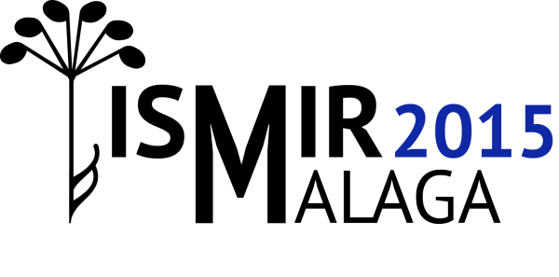

October 26 - 30, 2015
Málaga, Spain

Edited by
Meinard Müller and Frans Wiering

