Table of Contents
Developing the Network System and Load Balancing for RADIAL INTERNATIONAL LTD………………………………………………………………………………………………II
Abstract…………………………………………………………………………………………III
Letter of Transmittal………………………………………………………………………….. IV
Student’s Declaration……………………………………………………………………………V
Acknowledgements……………………………………………………………………………..VI
Supervisor’s Certification……………………………………………………………………. VII
Department Certification…………………………………………………………………….VIII
Chapter 1………………………………………………………………………………………
Introduction…………………………………………………………………………………
  - Objective of BCSE program…………………………………………………………
  - Objective of Internship Program…………………………………………………………
  - Source of the Report……………………………………………………………………
  - Background of the Report………………………………………………………………..
  - Utility of the Report……………………………………………………………………..
  - Methodology……………………………………………………………………………..
    - Primary Sources……………………………………………………………….
    - Secondary Sources…………………………………….
  - Main Goals of this Report……………………………………..
Chapter 2…………………………………………………………………………………………
Organization Overview…………………………………………………………………
2.1 Company Profile ………………………………………………………………..
2.3 Mission and Vision of Radial International Ltd……………………………………
2.4 Corporation Information……………………………………………………………….
Chapter 3………………………………………………………………………….
Network Structure of RADIAL INTERNATIONAL LTD………………………………….
- Core Layer…………………………………………………………………………….
- Distribution Layer……………………………………………………………………….
- Access Layer…………………………………………………………………………
- Benefits of Three-Layer Hierarchical Model……………………………………………
- Existing Network of RADIAL INTERNATIONAL LTD……………………………….
3.5.1 Working Process of Existing System……………………………………………….
3.5.2 Drawbacks of Existing System…………………………………………………….
Chapter 4…………………………………………………………………………………….
Proposed Network………………………………………………………………………………
- Proposed Project RADIAL INTERNATIONAL LTD…………………………………
- SNAT (Secure network address translation)…………………………………………..
- Ether-Channel……………………………………………………………………….
- Advantages of Either-Channel…………………………………………………….
- EIGRP protocol and its work procedure……………………………………………
- Significance proposed network…………………………………………………………
- VLAN (Virtual LAN)………………………………………………………………
- DHCP (Dynamic Host Configuration Protocol)………………………………………..
- VTP (VLAN Trunking Protocol)…………………………………………………
4.10 Spanning Tree Protocol…………………………………………………………..
4.11 Redesigned Network System …………………………………………………………
4.12 Proposed network design & configuration in Gazipur Branch………………….
4.12.1 Configuration……………………………………………………
4.12.2 Port Distributions…………………………………………….
4.12.3 Inter VLAN Configuration……………………………………
4.12.4 Dynamic Host Configuration Protocol………………………
4.12.5 Ether-Channel Configuration…………………………
4.12.6 Access Control List…………………………………………….
4.13 Branch communication Core Network Configuration……………
4.13.1 EIGRP Configuration…………………………………………..
4.13.2 CLOUD (ISP) Configuration……………………………………
4.14 Working Process of Proposed System……………………………
4.15 Working Sections of Proposed Network System…………………

Chapter 5………………………………………………………………..
Result and Discussion………………………………………………
- Result…………………………………………………………..
- Load balancing features with SNAT (Secure NAT)…………………………..
- Comparison……………………………………………………
- Discussion………………………………………………………………..
Chapter 6…………………………………………………………………………
Conclusion………………………………………………………………………..
- Conclusion………………………………………………………………
- Limitation……………………………………………………………….
- Future Work……………………………………………………………..
Bibliography………………………………………………………………………
Books…………………………………………………………………………..
References………………………………………………………………………..

List of Figures

Figure 3.1: Three−Tier (Three Layers) Network Model of RADIAL INTERNATIONAL LTD……………………………………………………………………………………………..
Figure 3.2: Model: Cisco Catalyst Switch-3750 C……………………………………….
Figure 3.3: Model: Cisco WS-C3650-24TD-L……………………………………………….
Figure 3.4: 4-port 10BASE-T Ethernet hub………………………………………………….
Figure 3.5: Cisco 1941 Integrated Services Router……………………………………….
Figure 3.6: The existing network of RADIAL INTERNATIONAL LTD……………..
Figure 3.7: Example scenario of using lease line………………………………………..
Figure 4.1: Load Balancer Device with Server…………………………………..
Figure 4.2: Proposed network for RADIAL INTERNATIONAL LTD…………….
Figure 4.3: Proposed Design in Gazipur Branch……………………………………..
Figure 4.4: First Floor Port Distributions……………………………………………..
Figure 4.5: Second Floor Port Distributions…………………………………………
Figure 4.6: Ether-Channel Connections…………………………………………..
Figure 4.7: Core network Configuration………………………………………..
Figure 4.8: Configuration in CLOUD (ISP)…………………………………..
Figure 5.1: Scenario 1……………………………………………………………………
Figure 5.2: Scenario 2…………………………………………………………………….
Figure 5.3: Scenario 3……………………………………………………………………
Figure 5.4: Scenario 4……………………………………………………………………
Figure 5.5: Scenario 5………………………………………………………………..
Figure 5.6: Scenario 6………………………………………………………………………
Figure 5.7: SNAT with Load Balancer and Servers……………………………………..
Figure 5.8: Comparisons between Existing and Proposed System………………………….

Chapter 1

Introduction

Data communications means the exchange of data between two devices via some form of transmission medium. For data communications to occur the communicating devices must be part of a communication system made up of a combination of hardware and software and computer network allows nodes to share resources. In computer networks, networked computing devices exchange data with each other using a data link. The connections between nodes are established using either cable media or wireless media. As a network is the interconnection of the set of devices capable of communication, these devices can be a host or an end system, and also can be connecting devices such as switches, routers, modems and so on. This practicum report is prepared after completing the three months (September 12 to December 12, 2018) duration internship program under the MIS Department along with the networking system, RADIAL INTERNATIONAL LTD., Gazipur, Bangladesh. The main goal of this practicum work is to study and practically learn the above mentioned network. To achieve this goal, the overview of data communication and networking including IP addressing, Open System Interconnection (OSI) model and Transmission Control Protocol/Internet Protocol (TCP/IP) protocol suite, the existing network including network devices, physical communication, routing protocols and so on are studied thoroughly. The overall performance of the existing network is not so impressive. So there are some necessary steps are demanding to improve the existing network system. Therefore, these steps are addressed and designed in the proposed network. A well-known packet tracer software known as CISCO Packet Tracer has been utilized to demonstrate the performance of the existing network and proposed network.

1.1 Objective of BCSE Program
The main goal of the Bachelor of Computer Science and Engineering (BCSE) program is to prepare students for a career in industry, academia or government by developing in them the necessary technical capabilities and interpersonal skills. The major target is to provide students with the advanced conceptual framework and the technical expertise required to meet the new developing markets. BCSE Program provides students a thorough understanding of the principles and concepts underpinning computing systems. This enables students to analyze and resolve issues with today’s software systems and provide a foundation on which to design the next generation of computational systems.
The BCSE program is under the College of Engineering and Technology (CEAT) consists of 143 credit hours and it requires 4 years for a student to complete the program. The program requires the students to work as an internee with suitable organizations after completing the requisite courses.

1.2 Objective of Internship Program
IUBAT – International University of Business Agriculture and Technology provides a great emphasis on the importance of practical work experience in the BCSE program. Practicum which is known as work placement is a graduate level course in a specialized field of study. It has designed to give students practical knowledge of a previously or concurrently studied theory in software, hardware or networking. The practicum process resembles an internship that has been done under an organization. A student participates in the internship program for the duration of twelve weeks which is going to be supervised by one of the faculties of the department.
An internship provides a variety of benefits for young workers who want to broaden their chances for landing a job and jump-starting their careers. Internships give the student a taste of what a profession is like, help them to build their perfect resume and let them meet people who can help them in the career. The internship assists the student's development of employer-valued skills such as teamwork, communications and attention to detail. It exposes the student to the environment and expectations of performance on the field of professionalism. And also, it will expose the student to professional role models or mentors who will provide the student with support in the early stages of the internship and provide an example of the behaviors expected in the intern's workplace.
The practicum forms of a placement-cum-project work based on some real-life IT operations. In the internship phase, a student is placed in a department in an organization that will enable him/her to work within the selected area of concentration. Finally, the student is required to submit a report and present it before an interview board which will include academics, practitioners and organizational representative.

1.3 Source of the Report
This report has been prepared as an integral part of the internship program for the practicum of IUBAT – International University of Business Agriculture and Technology and with the organization RADIAL INTERNATIONAL LTD., Gazipur Branch where the internship was completed. The RADIAL INTERNATIONAL LTD. involves the responsibility of the practicum attachments. The honorable faculty members Prof. Dr. Abdul Haque, Prof Dr Utpal kanti Das, and Dr. Hasibur Rashid Chayon of the Department of Computer Science and Engineering are the persons who have provided the kind consideration academically and supervise the practicum program from the university. The RADIAL INTERNATIONAL LTD., Gazipur Branch has provided the opportunity to work with them and supplied the necessary information to prepare this report.

1.4 Background of the Report
This report is based on RADIAL INTERNATIONAL LTD., Gazipur Branches networking system. Along with this, the report will also partially describe the whole RADIAL INTERNATIONAL LTD. Network System. This report is the combinations of twelve weeks’ internship program. This report is mainly important for the IT related organizations to understand the network system that includes network devices, physical and wireless communication, routing protocols, network monitoring tools, network security tools and so on.

1.5 Utility of the Report
The utility of this practicum report is to understand about the network system of RADIAL INTERNATIONAL LTD., Gazipur branch. The computer network knowledge is required to start the internship with any network related organization. To gather the information of basic network parts, overview of computer network including major networking criteria, basic components of data communication systems, different types of computer networks such as LAN, MAN, WAN, major network devices, network architectures, OSI model and TCP/IP, and the IP addresses are discussed.

1.6 Methodologies
In this report, the data-information collection has been done by considering the following steps:

Primary Sources

- Personal interview–Face to face conversation and in-depth interview with the respective officers of the branch.
- Personal observation – Observing the procedures of the company activities followed by each department.
➢ Practical work exposure on different areas of the department.

- Informal conversation with the employees.

- Relevant documents related to the study as provided by the officers.

Secondary Sources

- Some Reference books.

- Internet is also used as theoretical sources of information.

- Website and journals are also used as major sources.

1.7 Main Goals of this Report
The main goals of this report are to fulfill the requirements of the BCSE program and to present the knowledge and information that has been achieved during the internship period under the organization.
The other important goals are as follows –
- To understand the basic networking application in practical environment.
- To understand the infrastructure functionality.
- To understand the basic security concept.
- To know the network monitoring and maintenance.
- Proposed an idea for the existing network to facilitate the organization.

Chapter 2

Organization Overview

2.1 Company Profile:
Established in 1991 Radial International Ltd. is one of the sister concerns of Radiance Group. It is a fully composite knitwear project with knitting, dyeing, cutting, sewing and finishing done at the same premises. It is a 100% export-oriented readymade knitwear project. Radial International Ltd. is a Oekotex certified company that ensures safety and clean working environment.

2.2 Mission and vision of Radial International Ltd.
Mission is to deliver high-quality products and exceptional services to the customers by harmoniously blending safety, quality and efficiency while diligently maintaining the integrity, honesty and dedication towards environmental and social responsibilities.
Vision is to become the benchmark manufacturing company for the textiles and garments industry providing world-class products through integrity, teamwork and creativity of the people driven by the constant commitment to outstanding overall satisfaction.

2.6 Corporate Information

MANAGING DIRECTOR
MD. SHAHIDUL ISLAM (SHAHED)
Cell : +880-1711-52 19 12
Telephone No. : +880-2-8829371
Email : shahed@radiancegroup-bd.com ,
Email : s_islam@radiancegroup-bd.com

DIRECTOR
SALMAN FARSY SUNNY
Email : salman@radiancegroup-bd.com
Email : gt3600@yahoo.com

DIRECTOR(CHQ)
MD. FAZLUR RAHMAN
Commodore (E) psc, BN(Retd)
BSc Engg(BUET), MESC(India), MDS, ISMC(USA), FIEB
PHONE : +880-2-8414697, 8417385, 8416113
Cell : +880-1730-35 29 57
Email : shipping@radiancegroup-bd.com

MR. LOUIS DIAZ
Chief Operating Officer(COO)
Phone: +880-2-7701934, +880-1713000276
Email : louis@radiancegroup-bd.com

REZAUL KARIM NOMAN
AGM (HR and Compliance)
Phone No: ++880-1811413826
Email: noman@radiancegroup-bd.com

MR. LOUIS DIAZ
Chief Operating Officer(COO)
Phone : +880-2-7701934,+880-1713000276
Email : louis@radiancegroup-bd.com
REZAUL KARIM NOMAN
AGM (HR and Compliance)
Phone No: ++880-1811413826
Email : noman@radiancegroup-bd.com

Chapter 3

Network Structure of RADIAL INTERNATIONAL LTD.

Into this following chapter the core network of RADIAL INTERNATIONAL LTD. will be discussed, where network diagram will take place and some hardware equipment will be showed. Benefits of the system and the devices also included here.

RADIAL INTERNATIONAL LTD. follows Cisco Three−Tier (Three Layer) hierarchical network model that consists of three layers: The Core layer, the Distribution layer, and the Access layer. Three-Layer network model is the preferred approach to network design. Figure shows an example of data communication.

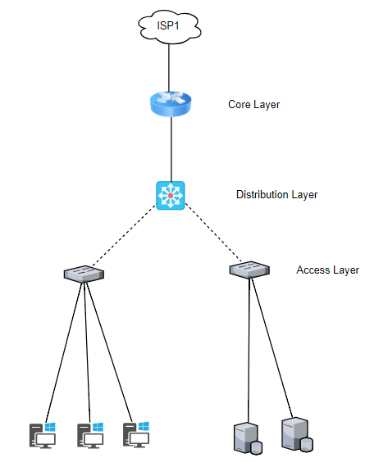
Figure 3.1: Three−Tier (Three Layers) Network Model of RADIAL INTERNATIONAL LTD.

3.1 Core Layer
Core Layer consists of biggest, fastest, and most expensive routers with the highest model numbers and Core Layer is considered as the back bone of networks. Core Layer routers are used to merge geographically separated networks. The Core Layer routers move information on the network as fast as possible. The switches operating at core layer switches packets as fast as possible.

3.2 Distribution layer
The Distribution Layer is located between the access and core layers. The purpose of this layer is to provide boundary definition by implementing access lists and other filters. Therefore, the
Distribution Layer defines policy for the network. Distribution Layer includes high-end layer 3 switches. Distribution Layer ensures that packets are properly routed between subnets and VLANs in dedicated enterprise.

3.3 Access layer
Access layer includes access switches which are connected to the end devices (Computers, Printers, and Servers etc.). Access layer switches ensures that packets are delivered to the end devices.

3.4 Benefits of Three-Layer Hierarchical Model
The main benefits of Three-Layer hierarchical model are that it helps to design deploy and maintain a scalable, trustworthy, cost effective hierarchical internetwork.

- Better Performance: Cisco Three Layer Network Model allows in creating high performance networks.
- Better management & troubleshooting: Cisco Three Layer Network Model allows better network management and isolates causes of network trouble.
- Better Filter/Policy creation and application: Cisco Three Layer Network Model allows better filter/policy creation application.
- Better Scalability: Cisco Three Layer Network Model allows us to efficiently accommodate future growth.
- Better Redundancy: Cisco Three Layer Network Model provides better redundancy. Multiple links across multiple devices provides better redundancy. If one switch is down, 4gnetworkbd will have another alternate path to reach the destination.

List of devices of RADIAL INTERNATIONAL LTD.
Device: Multilayer Switch.

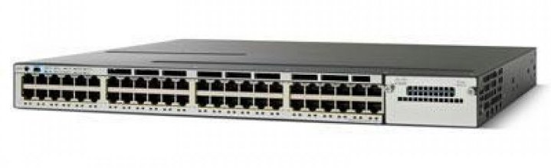

Figure 3.2: Model: Cisco Catalyst Switch-3750 C

Features:
- 3750 Series are next-generation, energy-efficient, Layer 3 Fast Ethernet stackable switches.
- It manages the power consumption of your network and reduce energy costs and carbon footprint.
- Ease of Use and Deployment.
- Cisco Energy Wise.
- Superior Redundancy for Fault Backup.
- High-Performance IP Routing.
- Integrated Cisco IOS Software Features for Bandwidth Optimization.
- Scalable Stacking (Cisco Stack Wise stacking creates a 32-Gbps switch interconnection.).
- Granular Rate Limiting.
- Network-wide Security Features.
- Superior Manageability.
- Cisco Network Assistant Software.
- Smart ports.
- Easy Web Setup.
- Cisco-Works Support.

Device: Access switch
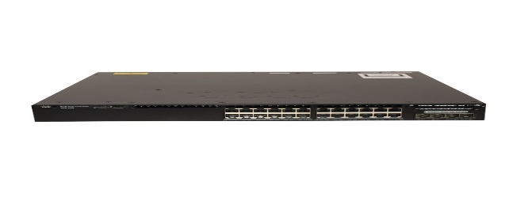

Figure 3.3: Model: Cisco WS-C3650-24TD-L

Features:
- Connects devices together on a computer network by using packet switching to receive, process, and forward data to the destination device.
- Integrated wireless controller capability with Up to 40G of wireless capacity per switch (48-port models.
- Support for up to 50 access points and 1000 wireless clients on each switching entity (switch or stack).
- 24 and 48 10/100/1000 data and PoE+ models with energy-efficient Ethernet (EEE) supported ports.
- 24 and 48 100-Mbps and 1-, 2.5-, 5-, and 10-Gbps (multigigabit) Cisco UPOE and PoE+ models with EEE.
- Five fixed-uplink models with four Gigabit Ethernet, two 10 Gigabit Ethernet, four 10 Gigabit Ethernet, eight 10 Gigabit Ethernet, or two 40 Gigabit Ethernet Quad Small Form-Factor Pluggable Plus (QSFP+) port.
- 24-port and 48-port 10/100/1000 PoE+ models with lower noise and reduced depth of 11.62 inches for shallow depth cabinets in enterprise, retail, and branch-office environments.
- Optional Cisco StackWise-160 technology that provides scalability and resiliency with 160 Gbps of stack throughput.
- Dual redundant, modular power supplies and three modular fans providing redundancy[2]
- Support for external power system RPS 2300 on the 3650 mini SKUs for power redundancy.
- Full IEEE 802.3at (PoE+) with 30W power on all ports in 1 rack unit (RU) form factor
- Cisco UPOE with 60W power per port in 1 rack unit (RU) form factor
- IEEE 802.3bz (2.5GBASE-T and 5GBASE-T) to go beyond 1 Gbps with existing Category 5e and Category 6
- IEEE 802.1ba Audio Video Bridging (AVB) built in to provide a better AV experience, including improved time synchronization and quality of service (QoS)
- Software support for IPv4 and IPv6 routing, multicast routing, modular QoS, Flexible Net-Flow (FNF) Version 9, and enhanced security feature.
- Single universal Cisco IOS® Software image across all license levels, providing an easy upgrade path for software features
- Enhanced limited lifetime warranty (E-LLW) with next business day (NBD) advance hardware replacement and 90-day access to Cisco Technical Assistance Center (TAC) support.

Device: HUB

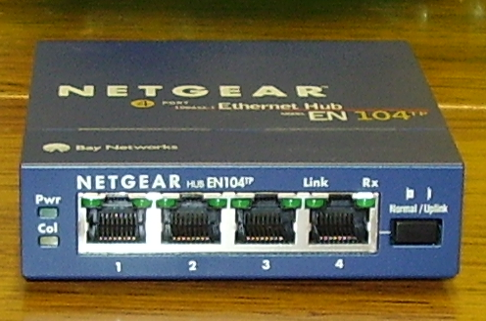
Figure 3.4: 4-port 10BASE-T Ethernet hub.

An Ethernet hub, active hub, network hub, repeater hub, multiport repeater, or simply hub is a network hardware device for connecting multiple Ethernet devices together and making them act as a single network segment.
Features:
- It has multiple input/output (I/O) ports, in which a signal introduced at the input of any port appears at the output of every port except the original incoming.
- A hub works at the physical layer (layer 1) of the OSI model. A repeater hub also participates in collision detection, forwarding a jam signal to all ports if it detects a collision. In addition to standard 8P8C ("RJ45") ports, some hubs may also come with a BNC or an Attachment Unit Interface (AUI) connector to allow connection to legacy 10BASE2 or 10BASE5 network segments.

Device: Router
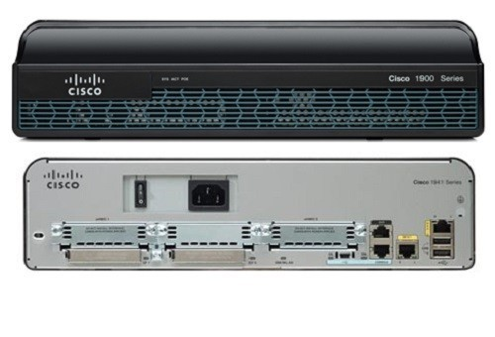
Figure 3.5: Cisco 1941 Integrated Services Router
The Cisco 1941 Integrated Services Router (ISR) delivers highly secure data, mobility, and application services. Key features include:
- 2 integrated 10/100/1000 Ethernet ports.
- 2 enhanced High-Speed WAN Interface Card slots that can host 2 single wide or 1 double wide and 1 single wide (e)HWIC.
- 1 Internal Services Module slot.
- Fully integrated power distribution to modules supporting 802.3af Power over Ethernet (PoE) and Cisco Enhanced PoE.
- Security:
  - Embedded hardware-accelerated VPN encryption
  - Secure collaborative communications with Group Encrypted Transport VPN, Dynamic Multipoint VPN, or Enhanced Easy VPN
  - Integrated threat control using Cisco IOS Firewall, Cisco IOS Zone-Based Firewall, Cisco IOS IPS, and Cisco IOS Content Filtering.
  - Identity management that uses authentication, authorization, and accounting (AAA), and public key infrastructure.
Device: Server
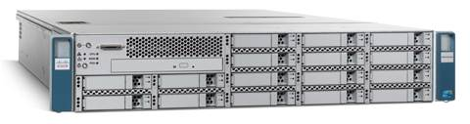
Figure 3.6: Cisco UCS C210 M2 Server.
Features:
The Cisco UCS C210 M2 server extends Cisco’s product portfolio to meet the needs of customers that choose to deploy rack-mount servers. The server enables organizations to deploy systems incrementally - using as many or as few servers as needed - on a schedule that best meets the organization's timing and budget.
Designed to operate both in standalone environments and as part of the Cisco Unified Computing System, the server combines high-capacity disk storage and I/O configurations with Cisco innovations, including a unified network fabric and network-aware Cisco VN-Link technology.
The server brings differentiation and value to what has been a commodity market with products not optimized to meet the needs of virtualized data centers. Available from Cisco and its data center network infrastructure (DCNI) partners, the server advances the rack-mount server market with the features given below:
- 10-Gbps unified network fabric.
- Virtualization optimization.
- Unified management*(when integrated into the Cisco Unified Computing System).
- Six-core Intel Xeon 5600 series processors.
- High-capacity, flexible internal storage.
- RAID 0, 1, 5, 6, 10, 50, and 60 support.
- Cisco UCS Integrated Management Controller.
- Fast-memory support.
- Redundant fans and power supplies.
- 5 PCI Express (PCIe) 2.0 slots.
- Integrated dual-port Gigabit Ethernet.
- Optional optical drive.

Applications
The Cisco UCS C210 M2 server combines the fastest Intel processors on the market today with a substantial amount of internal storage, creating a platform that speeds up standard and virtualized environments while helping optimize performance of storage-intensive applications:
- Virtualization workloads using a single or a large pool of servers; the optional Cisco UCS P81E Virtual Interface Card* brings the full power of the Cisco Unified Computing System to the platform, including the capability to support up to 128 Ethernet or Fibre Channel virtual interfaces that are programmed on demand to meet the needs of both virtualized and nonvirtualized environments, and Intel Virtualization Technology for Direct I/O further speeds virtual machine I/O operations by facilitating direct control over physical interfaces from virtual machines
- Database management systems can thrive on the server’s abundant internal storage.
- The Cisco UCS C210 M2 is an ideal application server, where multiple processor cores contribute directly to performance.
- I/O-intensive applications, including data warehousing, medical imaging, video surveillance, document imaging, and content distribution, have up to 16 TB of disk storage for application data.

3.5 Existing Network of RADIAL INTERNATIONAL LTD.

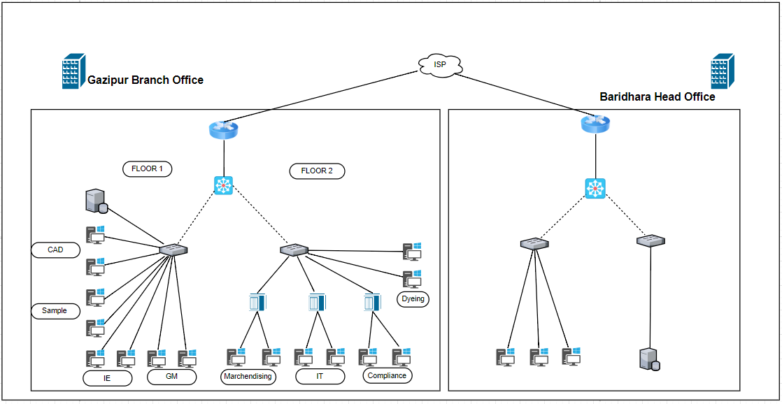
Figure 3.7: The existing network of RADIAL INTERNATIONAL LTD.

The existing network of RADIAL INTERNATIONAL LTD. network diagram is illustrated in figure 3.7. In the figure 3.7, RADIAL INTERNATIONAL LTD. takes internet connection from one internet service provider that is My-internet communication ltd. My-internet communication ltd. Line provide speed of 160 Mbps. This line is connected to Cisco Cloud Core Router CCR1009-7G-1C-1S+ with Optical Fiber line

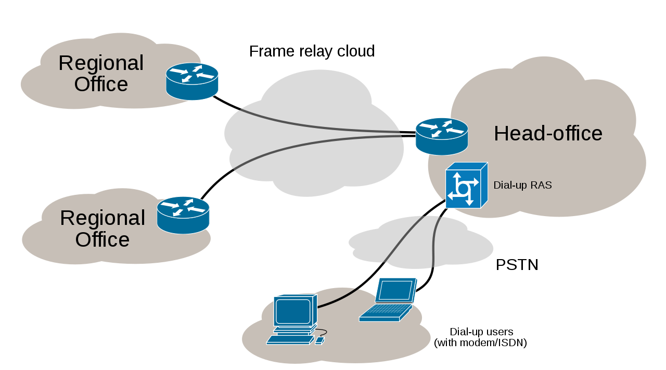

Figure 3.7: Example scenario of using lease line.

The RADIAL INTERNATIONAL LTD. is using lease line to connect with the main office in Baridhara. Typically, leased lines are used by businesses to connect geographically distant offices. Unlike dial-up connections, a leased line is always active.

The fee for the connection is a fixed monthly rate. The primary factors affecting the monthly fee are distance between end points and the speed of the circuit. Because the connection does not carry anybody else's communications, the carrier can assure a given level of quality.

An Internet leased line is a premium Internet connectivity product, normally delivered over fiber, which provides uncontended, symmetrical speeds with full duplex. It is also known as an Ethernet leased line, dedicated line, data circuit or private line.

3.5.1 Working Process of Existing System:
The existing network system of the RADIAL INTERNATIONAL LTD. is consisting of 8 departments (GM, CAD, GS, IE, IT, Dyeing, Marchendising, and Compliance). Every department consists of several computers. Each of the computers is configured with static IP configuration. With the static IP configuration every department is opened to communicate with each other without any restriction. There is no access control in between the departments.
The connection device 10BASE-T Ethernet hub is used to connect several departments computer. The catalyst switch is used to connect the HUB and other departments. The Multilayer switch is used to connect the floor 1 and floo2’s departments. There is a server in the first floor with whom the hosts can connect and store related files from different departments.

There are several departments in the existing system. Their responsibility has been described below briefly:

General Manager (GM): Business is full of terms that seem self-explanatory on the surface but often have nuances that aren't understood or considered. The title of general manager, sometimes simply called a GM, is one of those terms. This individual has broad, overall responsibility for a business or a business unit within a larger organization.

In existing system GM basically manage over all activities of the organization. Controlling, monitoring, communicating, and directing all the staffs in the organization. General Manager of administration is simply a title indicating that she specializes in the administrative field or oversees administrative tasks.

Computer-aided Design (CAD) Department: This department uses the computer systems (or workstations) to aid in the creation, modification, analysis, or optimization of a design. CAD software is used to increase the productivity of the designer, improve the quality of design, improve communications through documentation, and to create a database for manufacturing. CAD output is often in the form of electronic files for print, machining, or other manufacturing operations.

As this organization is a garments company it basically takes orders from their clients. Clients basically provides their desired design to the company. Then the design goes to CAD department in where the design basically analyzed and designed through the CAD (Computer-aided design) software.

Industrial Engineering (IE) Department: Industrial engineering department is concerned with the optimization of complex processes, systems, or organizations by developing, improving and implementing integrated systems of people, money, knowledge, information, equipment, energy and materials.

Industrial engineers use specialized knowledge and skills in business administration, management, mathematics, physical sciences, social sciences and methods of engineering analysis and design to specify, predict, and evaluate the results obtained from systems or processes.

From these results, they are able to create new systems, processes or situations for the useful coordination of man, materials and machines and improve the quality and productivity of systems, physical or social.

Depending on the sub-specialties involved, industrial engineering may also overlap with, operations research, systems engineering, manufacturing engineering, production engineering, management science, management engineering, financial engineering, ergonomics or human factors engineering, safety engineering, or others, depending on the viewpoint or motives of the user.
Garment Store (GS) Department: It keeps the record about the amount of incoming and outgoing products from the store. From the mass production of products and the amount of outgoing products a yearly summary can be made. From which the organization can find out the yearly sales and the profit and the loss of the company.

Information Technology (IT) Department: The information technology department in the organization is responsible for the architecture, hardware, software and networking of computers in the company. IT professionals, need to perform a number of duties to ensure that employees have full access to the computer systems. Professionals working in the department may be responsible for one area of IT for the company, such as programming, website updates or technical support.

The IT department the organization provides support to computer users in the company. This includes installing new software, repairing hardware problems, installing new hardware, troubleshooting problems and training employees how to use new software programs. Many businesses maintain an IT help desk in the company to assist employees with computer-related issues.

IT professionals are responsible for installing and setting up the computer network in an organization. They ensures that the network is operating properly and that all employees have the ability to communicate through the internet and company intranet. Professional information technology employees keep the system secure and troubleshoot the system in the event of a problem.

Dyeing Department: Dyeing department works with the application of dyes or pigments on textile materials such as fibers, yarns, and fabrics with the objective of achieving color with desired fastness. Dyeing is normally done in a special solution containing dyes and particular chemical material. Dye molecules are fixed to the fiber by absorption, diffusion, or bonding with temperature and time being key controlling factors. The bond between dye molecule and fiber may be strong or weak, depending on the dye used. This departments works with both Dyeing and printing; in printing color is applied to a localized area with desired patterns and in dyeing it is applied to the entire textile.

Marchendising Department: This department generally perform a very hard liability in a tight schedule if we observe their job routine carefully. They have to coordinate with all the concerned departments of suppliers, manufacturing factory, logistics and the buyer in order to satisfy consumers by delivering specified goods of specified quality on designated date.

The merchandising section also looks for the sources for procuring yarns to produce fabric. They have to keep an eye on the production status regularly and ensure timely delivery of the shipment to meet the consumers demand.

They have no scope to show any negligence in their profession. Merchandiser’s has to work as a team. They consolidate endeavor to make the raw materials of finished goods which are displayed on the outlets in various shopping malls to draw the consumer’s attention.

Compliance Department: The compliance department ensures that a financial services business adheres to external rules and internal controls. A compliance department has five areas of responsibility: identification, prevention, monitoring and detection, resolution, plus advisory.

Compliance identifies risks that an organization faces and advised on them. It designs and implements controls to protect the organization from those risks.

Compliance monitors and reports on the effectiveness of controls in the management of the organizations risk exposure. The department also resolves compliance issues as they arise and advised the business on rules and controls.

Relationship in between departments: The departments need to work together to continue daily work of the company. Here the marchendising department takes order or deal with clients and CAD department takes the given design by the client and process it. Dyeing department works with colors and printing as well as the amount of materials that needed to produce the products. The IE department checks all the equipments in the company and keep the equipment in working progress. The compliance department manage all the financial issue of the department and the company. And after producing products garment store (GS) department store the products. As the working process goes on, the report based on whole process basically goes to general manager who basically direct all the departments how to do the works in which way. The IT department provides the technical support and maintenance to the employees so that the overall progress can continue smoothly without any problem.

3.5.2 Drawbacks of Existing System:
- As because the computers are configured with static IP configuration, every new host in the network needs to be configured physically.
- The departments are wide open to each other which is not a good practice.
- The use of old devices like HUB makes the multiple departments act as a single network segment.
- Multiple departments are connected with only one switch. It decreases the normal life span of that switch. If the switch goes down, one portion of the network will go offline which will be very much harmful for the company.
- There is no redundant path facility in the existing system.
- There is no backup path facility for server in the system.
- No load balancer device has been used in existing system to balance the load on server in existing system.

Chapter 4

Proposed network

4.1 Proposed Project RADIAL INTERNATIONAL LTD.:
During my internship at RADIAL INTERNATIONAL LTD. Gazipur branch, I have found that they do have a network system which is nice but not well-developed. A well-developed network system with load balancing feature is an important thing for any company. As we know a company or organization should have a stable communication system to run its daily works smoothly. So if there any device or link breakdown due to heavy traffic then the connection will be lost that will create a problem. By providing a load balancing features with ether-channel configuration will be a good solution with some protocols in the proposed network. As the load balancing mechanism cannot be measured through scenario. I try to provide a fast communication path in between the departments, so that departments can communicate with each other more smoothly. In the proposed network system, I have redesigned the system with backup path, ether-channel configuration, load balancing features and other facilities.

So I decided to maximized the work speed and reduce the extra cost and use the man power effectively by connecting the main branch and gazipur branch office.

The main performance of the internship period was the observation of the network system and the infrastructures. Along with these functionalities during the internship, an idea to create a backup communication path among RADIAL INTERNATIONAL LTD office and main office.

I used SNAT for load balancing with a load balancer device and EIGRP to connect the two branches with backup path. By this every one of each company can communicate and share the resources. Ether-channel for redundancy, VLAN configuration for separating the departments, ACL (Access control List) for dividing the access permission across the departments and used dynamic IP allocation for easy configuration for every department.

4.2 SNAT (Secure network address translation)
Secure network address translation (SNAT) is a network address translation (NAT) technique that enables private network security by providing a public Internet Protocol (IP) address to remote users/systems. It allows multiple computers that are connected within a private local area network (LAN) to use a single IP address to access the Internet.
In a SNAT-based network environment, all devices connect to the local SNAT device/router/modem, but each computer has a distinct and unique IP address. The SNAT-configured router sends its request by replacing the source IP address with its IP address. When the destination device receives the packet from the local device, it sees the SNAT-configured source IP address - not the device's actual IP address. This secures the internal network from exposure to external networks while allowing the same IP address to be used by multiple devices.
It’s “Secure” because hosts can’t initiate traffic to a SNAT, the “translation” addresses are never known by the host initiating the traffic. In short a SNAT is made of up three components:
  - Translation – Options: an IP address (single address), a SNAT Pool (multiple addresses), or an Automap (self IP(s) of the Local Traffic Manager). This is what the Source address of the client is translated to.
  - Origin – Options: All addresses (everything coming in on the VLAN you specify, or an Address list (specific addresses you provide). These are indeed the source addresses of the client.
  - VLAN Traffic – Options: All Vlans (every VLAN), Enabled on (only on the vlans specified), or Disabled on.

SNAT with Load Balancer:
Setting up SNAT (Secure Network Address Translation) allows you to provide load balancing for client and virtual server connections, even if the IP routing load balancing is not set as the default route. Without SNAT, the risk of communications disruptions if TCP connections bypass the load balancing system. In this configuration we need to configure a load balancer device with SNAT which actually balance the load on the server.
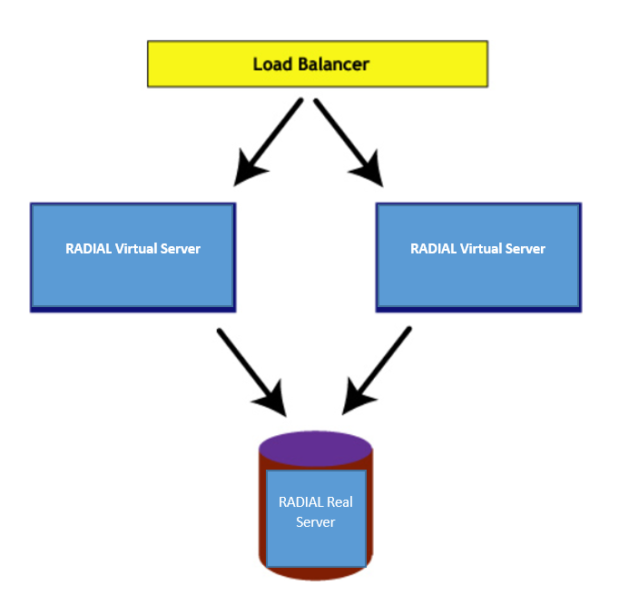
Figure 4.1: Load Balancer Device with Server.

When SNAT configured on load balancer the incoming request sees the IP address of the load balancer as the servers IP address. The request then processed by the load balancer by sending them to virtual servers that has been created automatically by the load balancer and then the request goes to real server. So when the traffic is high at that time the load balancer can easily balance the load and keep the server in working process normally.

4.3 Ether-Channel:
Ether-Channel allows us to achieve greater speed by bundling Fast Ethernet or Gigabit Ethernet links, which makes a switch or router use the merged ports as a single port. Ether-Channel uses a Cisco-proprietary hashing algorithm to achieve this link bonding.
Ether-Channel can be configured on many different switch platforms such as the 6500/6000, 5500/5000, 4500/4000, and 2950/2960 series.
Few basic things about Ether-Channel:
- All interfaces using Ether-Channel must be set up with the same speeds and duplex modes.
- Specifically, for the Catalyst 2950 switches, the Ether-Channels are limited to six with eight ports per Ether-Channel, and all must have the same speed and be configured on Layer 2 interfaces.
- While it might seem obvious, don't forget that the interfaces must be enabled. If not, the switch thinks that there is a problem and will use another interface path unnecessarily.
- The Data link layer has a Frame Check Sequence (FCS) that adds a preamble (a series of alternating 0's and 1's) along with other information, to the front of a data packet and inserts it into the destination and source address.
- Ether-Channel balances the traffic on the network by reducing part of the binary pattern formed from the addresses in the frame, which is in the Network layer (Layer 2 – Data Link layer), to a numerical value.
- Since your Fast Ethernet links are now combined into one channel, it allows for redundancy, in case one of the links goes down.

Negotiation protocols:
There are two ether-channel negotiation protocols, as described below.
PAGP – port aggregation protocol:
Port Aggregation Protocol (PAgP) is a Cisco Systems proprietary networking protocol, which is used for the automated, logical aggregation of Ethernet switch ports, known as an Ether-Channel. The PAgP is proprietary to Cisco Systems. A similar protocol known as LACP — released by the IEEE and known as 802.3ad or 802.1ax recently — is an industry standard and is not tied to a specific vendor:
PAgP can be configured on a Cisco switch to operate in three different modes:
- auto - passive negotiation of the channel
- desirable - active negotiation of the channel
- on - no protocols are used: it assumes the other side has enabled link aggregation.
On Cisco network devices running CatOS, a single switch module may only be configured to run in either LACP or PAgP modes. Cisco devices that run IOS (native and/or non-hybrid mode boxes) support individual port configuration for LACP and are not restricted to per module settings as with CatOS.
Advantage: With Port Aggregation Protocol "the line speed of an agport is the total of the line speeds of each of its physical ports." This does not automatically means that a single transfer will use all of the aggregated interfaces bandwidth; rather, this depend on the distribution method of choice.
Most Cisco switches use src/dst MAC address hash as distribution method, meaning that a single session will use the bandwidth of a single interface. Other Cisco switches uses a proprietary distribution method which enable true frame round-robin, enabling maximum link speed to be the same as the sum of the interfaces composing the aggregation group. This mean packet order can be altered, however.

Plain Ether-Channel load-balancing works by having the switch assign a hash result from 0-7 based on the configured hash method (load-balancing algorithm) for the type of traffic. This hash result is commonly called a Result Bundle Hash (RBH). They are then divided out over the available links.
Therefore, no single flow can exceed the speed of a physical port. However, some PagP-enabled switches can negotiate between a "maximize load balancing" and "preserve ordering" link: the former give maximum aggregated bandwidth at the expense of packet ordering, while the latter assures no packet reordering to occur but limit a single transfer to the bandwidth of a single interface.

Link Aggregation Control Protocol
Within the IEEE specification, the Link Aggregation Control Protocol (LACP) provides a method to control the bundling of several physical ports together to form a single logical channel. LACP allows a network device to negotiate an automatic bundling of links by sending LACP packets to the peer (directly connected device that also implements LACP).
LACP Features and practical examples
- Maximum number of bundled ports allowed in the port channel: Valid values are usually from 1 to 8.
- LACP packets are sent with multicast group MAC address 01:80:c2:00:00:02 (01-80-c2-00-00-02)
- During LACP detection period
  - LACP packets are transmitted every second
  - Keep alive mechanism for link member: (default: slow = 30s, fast=1s)
- LACP can have the port-channel load-balance mode :
  - link (link-id) Integer that identifies the member link for load balancing. The range is from 1 to 8.
- LACP mode :
  - active: Enables LACP unconditionally.
  - passive: Enables LACP only when an LACP device is detected. (This is the default state)
Advantages over configuration:
Static Configuration: Failover occurs automatically: When a link fails and there is (for example) a media converter between the devices, a peer system will not perceive any connectivity problems. With static link aggregation, the peer would continue sending traffic down the link causing the connection to fail.
Dynamic configuration: The device can confirm that the configuration at the other end can handle link aggregation. With Static link aggregation, a cabling or configuration mistake could go undetected and cause undesirable network behavior.

4.4 Advantages of Either-Channel
- Increased Bandwidth: Use Ether-Channel and combine two or four links into one logical link. It will double or quadruple your bandwidth. For example, four 100Mb Fast Ethernet connections bonded into one could provide you up to 800Mb/second, full duplex.
- Provides Redundancy: Since there are many Ethernet links combined into one logical channel, it automatically allows more available links in case one or more links go down.
- Load Balance Traffic: Ether-Channel balances the traffic load across the links, thereby increasing efficiency on your networks.

4.5 EIGRP protocol and its work procedure:
EIGRP is a Cisco proprietary routing protocol loosely based on their original IGRP (Interior Routing Protocol). EIGRP is an advanced distance-vector routing protocol, it can only use it in an all-Cisco network, but EIGRP more than makes up for this deficiency by being easy to configure, fast, and reliable.
Like RIP, EIGRP is based on a distance vector algorithm that determines the best path to a destination. But EIGRP uses a more complex metric than RIP’s simple hop count. The EIGRP metric is based on the minimum bandwidth and net delay along each possible path, which means that EIGRP can accommodate larger networks than RIP.
Cisco included so many useful features such as automatic two-way redistribution that make the migration from IGRP to EIGRP relatively straightforward.
EIGRP operates very efficiently over large networks. It achieves this efficiency in part by sending non-periodic updates. This means that, unlike RIP, EIGRP only distributes information about routes that have changed, and only when there is a change to report. The rest of the time, routers only exchange small “Hello” packets to verify that routing peers are still available. So, in a relatively stable network, EIGRP uses very little bandwidth. This is especially useful in WAN configurations.
It is also extremely efficient over LAN portions of a network. On each network segment, routers exchange routing information using multicast packets, which helps to limit bandwidth usage on segments that hold many routers.
Every router in an EIGRP network includes a topology table, which is a central feature of the DUAL algorithm. Every time a router receives a new piece of routing information from one of its neighbors, it updates the topology table. This helps to give it a reliable and up-to-date image of all of the connections in the network that are currently in use. Every destination subnet known to EIGRP appears in the topology table.
EIGRP includes many of the features such as Classless Inter-Domain Routing (CIDR) and Variable Length Subnet Masks (VLSM) that are needed in larger networks.
Features of EIGRP:
EIGRP is an advanced distance vector or hybrid routing protocol that includes the following features:
Rapid convergence: EIGRP uses the Diffusing Update Algorithm (DUAL) to achieve rapid convergence. A router that uses EIGRP stores all available backup routes for destinations so that it can quickly adapt to alternate routes. If no appropriate route or backup route exists in the local routing table, EIGRP queries its neighbors to discover an alternate route.
Reduced bandwidth usage: EIGRP does not make periodic updates. Instead, it sends partial
updates when the path or the metric changes for that route. When path information changes,
DUAL sends an update about only that link rather than about the entire table.
Classless routing: Because EIGRP is a classless routing protocol, it advertises a routing
mask for each destination network. The routing mask feature enables EIGRP to support
discontinuous sub networks and variable-length subnet masks (VLSM).
Multiple network layer support: EIGRP supports AppleTalk, IP version 4 (IPv4), IP version
6 (IPv6), and Novell Internetwork Packet Exchange (IPX), which use protocol-dependent
modules (PDM). PDMs are responsible for protocol requirements that are specific to the
network layer.
Less overhead: EIGRP uses multicast and unicast rather than broadcast. As a result, end
stations are unaffected by routing updates and requests for topology information.
Load balancing: EIGRP supports unequal metric load balancing, which allows
administrators to better distribute traffic flow in their networks.

4.6 Significance proposed network:
- Limited Professional Manpower to be utilized more effectively.
- Highly valued for ease deployment.
- Very low usage of network resource during normal operation.
- Simplification of system design.
- Implementation of dynamic ip.
- Preventing load balancing problem.
- Proper utilization of network devices.

4.7 VLAN (Virtual LAN):
A virtual LAN (VLAN) is any broadcast domain that is partitioned and isolated in a computer network at the data link layer (OSI layer 2). LAN is the abbreviation for local area network and in this context virtual refers to a physical object recreated and altered by additional logic. VLANs work by applying tags to network packets and handling these tags in networking systems – creating the appearance and functionality of network traffic that is physically on a single network but acts as if it is split between separate networks. In this way, VLANs can keep network applications separate despite being connected to the same physical network, and without requiring multiple sets of cabling and networking devices to be deployed.
VLANs allow network administrators to group hosts together even if the hosts are not directly connected to the same network switch. Because VLAN membership can be configured through software, this can greatly simplify network design and deployment. Without VLANs, grouping hosts according to their resource needs necessitates the labor of relocating nodes or rewiring data links. VLANs allow networks and devices that must be kept separate to share the same physical cabling without interacting, improving simplicity, security, traffic management, or economy. For example, a VLAN could be used to separate traffic within a business due to users, and due to network administrators, or between types of traffic, so that users or low priority traffic cannot directly affect the rest of the network's functioning. Many Internet hosting services use VLANs to separate their customers' private zones from each other, allowing each customer's servers to be grouped together in a single network segment while being located anywhere in their data center. Some precautions are needed to prevent traffic "escaping" from a given VLAN, an exploit known as VLAN hopping.
To subdivide a network into VLANs, one configures network equipment. Simpler equipment can partition only per physical port (if at all), in which case each VLAN is connected with a dedicated network cable. More sophisticated devices can mark frames through VLAN tagging, so that a single interconnect (trunk) may be used to transport data for multiple VLANs. Since VLANs share bandwidth, a VLAN trunk can use link aggregation, quality-of-service prioritization, or both to route data efficiently.

Advantage of VLAN
VLAN provides following advantages:-
- Solve broadcast problem
- Reduce the size of broadcast domains
- Allow us to add additional layer of security
- Make device management easier
- Allow us to implement the logical grouping of devices by function instead of location

4.8 DHCP (Dynamic Host Configuration Protocol)
The Dynamic Host Configuration Protocol (DHCP) is a network management protocol used on UDP/IP networks whereby a DHCP server dynamically assigns an IP address and other network configuration parameters to each device on a network so they can communicate with other IP networks.
A DHCP server enables computers to request IP addresses and networking parameters automatically from the Internet service provider (ISP), reducing the need for a network administrator or a user to manually assign IP addresses to all network devices.
In the absence of a DHCP server, a computer or other device on the network needs to be manually assigned an IP address, or to assign itself an APIPA address, which will not enable it to communicate outside its local subnet.
DHCP can be implemented on networks ranging in size from home networks to large campus networks and regional Internet service provider networks. A router or a residential gateway can be enabled to act as a DHCP server. Most residential network routers receive a globally unique IP address within the ISP network. Within a local network, a DHCP server assigns a local IP address to each device connected to the network.

4.9 VTP (VLAN Trunking Protocol):
VLAN Trunking Protocol (VTP) is a Cisco proprietary protocol that propagates the definition of Virtual Local Area Networks (VLAN) on the whole local area network. To do this, VTP carries VLAN information On Cisco Devices, VTP (VLAN Trunking Protocol) maintains VLAN configuration consistency across a single Layer 2 network.
VTP uses Layer 2 frames to manage the addition, deletion, and renaming of VLANs from switches in the VTP client mode. VTP is responsible for synchronizing VLAN information within a VTP domain and reduces the need to configure the same VLAN information on each switch thereby minimizing the possibility of configuration inconsistencies that arise when changes are made. to all the switches in a VTP domain.

4.10. Spanning Tree Protocol (STP):
STP stand for Spanning Tree Protocol. In my proposed network I used it for redundancy solution. Redundancy means to be in excess. Redundant network topologies are designed to ensure that networks continue to function in the presence of single points of failure.

IT administrators have to implement redundancy in their hierarchical networks. In a hierarchical design, redundancy is achieved at the distribution and core layers by adding extra equipment and cabling to create alternate network paths.

When the destination of the traffic is unknown to a switch, it floods traffic out all ports except the port that received the traffic. Broadcasts and multicasts are also forwarded out every port except the port that received the traffic.

This traffic can be caught in a loop. In the Layer 2 header, there is no Time to Live (TTL) value. If a frame is sent into a Layer 2 looped topology of switches, it can loop forever. As more and more frames end up looping on the network, a broadcast storm occurs that causes the network to fail.

A host caught in a network loop is not accessible to other hosts on the network. Because the MAC address table is constantly changing with the updates from the broadcast frames, the switch does not know which port to forward the unicast frames out to reach the final destination.

The unicast frames end up looping around the network as well. To overcome this there is a way of Solution. A physical topology that contains switching or bridging loops is necessary for reliability, yet a switched network cannot have loops.

The solution is to allow physical loops, but create a loop free logical topology. To address this issue, Spanning Tree Protocol (STP) which was developed by Digital Equipment Corporation (DEC) and was revised in the IEEE 802.1d specification.

STP ensures that there is only one logical path between all destinations on the network by intentionally blocking redundant paths that could cause a loop. The physical paths still exist to provide redundancy, but these paths are disabled to prevent the loops from occurring.

4.11 Redesigned Network System:

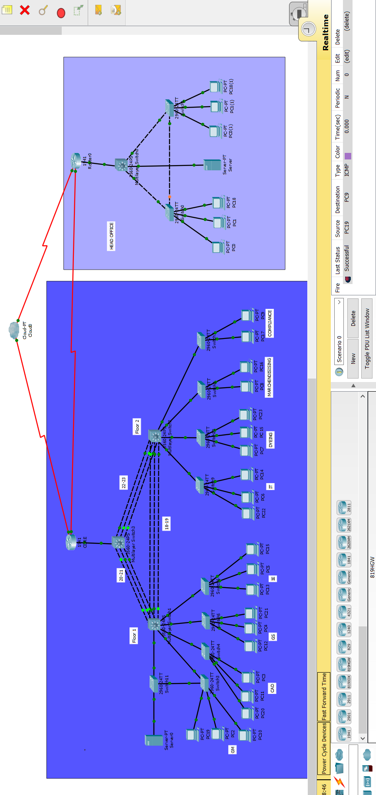
Figure 4.2: Proposed network for RADIAL INTERNATIONAL LTD.
Required Tools to simulate the project:
For the implementation of the project the Cisco Packet Tracer 7.1 has been used. In the project a good number of regular switches & multi-layer switches and two core router and a cloud are being activated as the major infrastructures.

4.12 proposed Network Design & Configuration in Gazipur Branch:

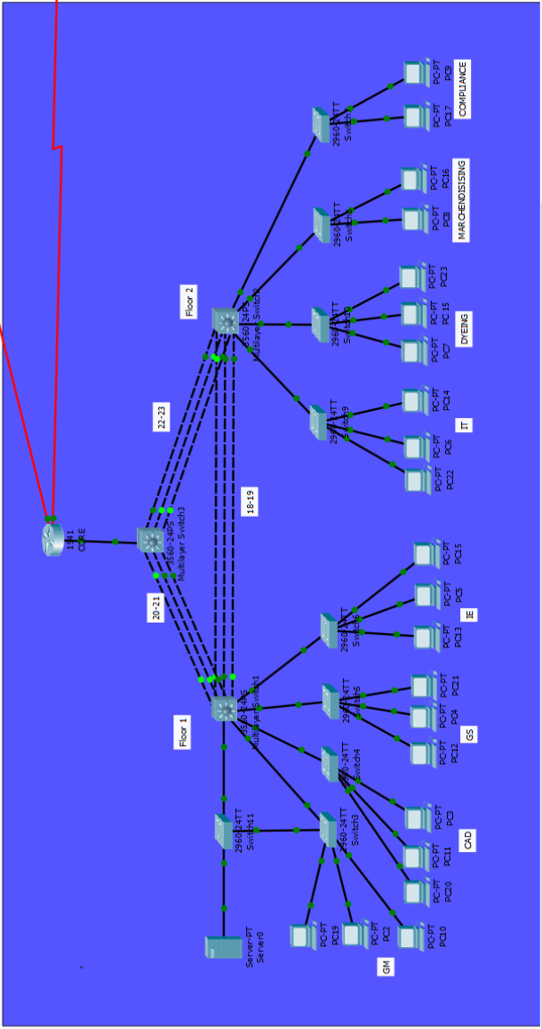

Figure 4.3: Proposed Design in Gazipur Branch.

In this garments IT section there is 8 existing departments for all of those I use private IP as because I want to keep this network private at the same time minimizing the cost. Here I used 192.168.0.0 network which holding the 255.255.255.0 subnet.
For each department I fixed the IP range. As every department having minimum of 15 workstations so I allocate one 24 port switch for each.

4.12.1 Configuration
Our main focus was to redesign the whole system so we started to redesign the system. We divided each and every department into different VLANs. We gave id and name to every VLAN. In every switch we put the same information.

Configuration in layer 2 switches:

Switch>enable
Switch#Config terminal
Switch (Config): hostname GM
GM(config):vlan 10
GM(config):name GM

GM(config):vlan 20
GM(config):name CAD

GM(config):vlan 30
GM(config):name GS

GM(config):vlan 40
GM(config):name IE

GM(config):vlan 50
GM(config):name IT
GM(config):vlan 60
GM(config):name DYEING

GM(config):vlan 70
GM(config):name MARCHEN

GM(config):vlan 80
GM(config):name COMP

GM(config):vlan 90
GM(config):name NATIVE

GM(config):vlan 100
GM(config):name SERVER

Same information has given to all switches and according to the demand the ports of the switches was distributed. The information related to all departments should have to be there in every catalyst and multilayer switches. So that we can configure the VLAN in the system.

4.12.2 Port Distributions
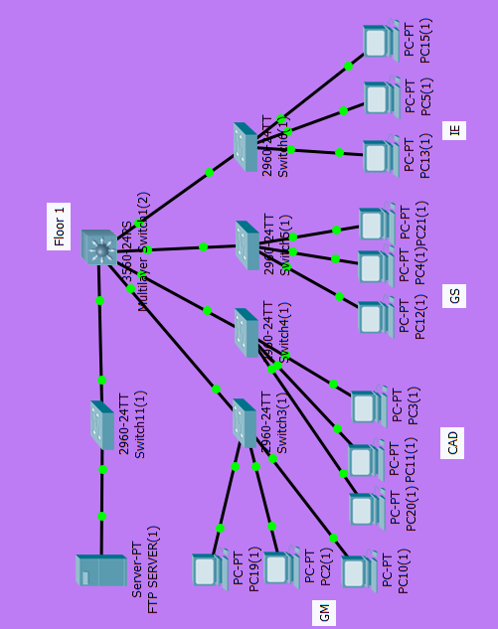
Figure 4.4: First Floor Port Distributions.

First Floor:

Port Distribution in GM vlan:
GM(config): int range Fastethernet0/1-4.
GM(config): switchport mode access.
GM(config): switchport access vlan 10.

Port Distribution in CAD vlan:
CAD (config): int range Fastethernet0/2-10.
CAD (config): switchport mode access.
CAD (config): switchport access vlan 20
Port Distribution in GS vlan:
GS (config): int range Fastethernet0/2-10.
GS (config): switchport mode access.
GS (config): switchport access vlan 30.

Port Distribution in IE vlan:
IE (config): int range Fastethernet0/2-10.
IE (config): switchport mode access.
IE (config): switchport access vlan 40.

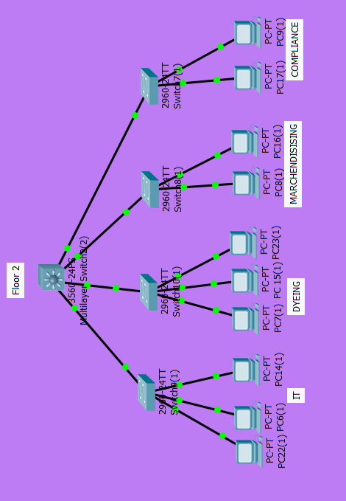
Figure 4.5: Second Floor Port Distributions.
Second Floor:
Port Distribution in IT vlan:
IT (config): int range Fastethernet0/1-10.
IT (config): switchport mode access.
IT (config): switchport access vlan 50.

Port Distribution in DYEING vlan:
DYEING (config): int range Fastethernet0/1-10.
DYEING (config): switchport mode access.
DYEING (config): switchport access vlan 60.

Port Distribution in MARCHEN vlan:
MARCHEN (config): int range Fastethernet0/1-10.
MARCHEN (config): switchport mode access.
MARCHEN (config): switchport access vlan 70.

Port Distribution in COMP vlan:
COMP (config): int range Fastethernet0/1-10.
COMP (config): switchport mode access.
COMP (config): switchport access vlan 80.

4.12.3 Inter VLAN configuration:
As all the hosts were configured with static ip , so we configured the host pcs with dynamic ip allocation, in this point we worked on our branch core router. We created the interfaces for vlans and created dhcp pool to provide ip address dynamically to every vlans.

Router>enable
Router#config terminal
Router(config):hostname CORE.

CORE(config-if)#int g0/1.10
CORE(config-subif)#encap dot
CORE(config-subif)#encap dot1Q 10
CORE(config-subif)#ip address 192.168.10.254 255.255.255.0

CORE(config-subif)#int g0/1.20
CORE(config-subif)#encap dot1Q 20
CORE(config-subif)#ip address 192.168.20.254 255.255.255.0

CORE(config-subif)#int g0/1.30
CORE(config-subif)#encap dot1Q 30
CORE(config-subif)#ip address 192.168.30.254 255.255.255.0

CORE(config-subif)#int g0/1.40
CORE(config-subif)#encap dot1Q 40
CORE(config-subif)#ip address 192.168.40.254 255.255.255.0

CORE(config-subif)#int g0/1.50
CORE(config-subif)#encapsulation dot
CORE(config-subif)#encapsulation dot1Q 50
CORE(config-subif)#ip address 192.168.50.254 255.255.255.0

CORE(config-subif)#int g0/1.60
CORE(config-subif)#encapsulation dot1Q 60
CORE(config-subif)#ip address 192.168.60.254 255.255.255.0

CORE(config-subif)#int g0/1.70
CORE(config-subif)#encapsulation dot1Q 70
CORE(config-subif)#ip address 192.168.70.254 255.255.255.0

CORE(config-subif)#int g0/1.80
CORE(config-subif)#encapsulation dot1Q 80
CORE(config-subif)#ip address 192.168.80.254 255.255.255.0
CORE(config-subif)#exit

4.12.4 Dynamic Host Configuration Protocol:
CORE(config)#ip dhcp pool GM
CORE(dhcp-config)#default-router
CORE(dhcp-config)#default-router 192.168.10.254
CORE(dhcp-config)# network 192.168.10.0 255.255.255.0
CORE(dhcp-config)#exit

CORE(config)#ip dhcp pool CAD
CORE(dhcp-config)#default-router 192.168.20.254
CORE(dhcp-config)# network 192.168.20.0 255.255.255.0
CORE(dhcp-config)#exit

CORE(config)#ip dhcp pool GS
CORE(dhcp-config)#default-router 192.168.30.254
CORE(dhcp-config)# network 192.168.30.0 255.255.255.0
CORE(dhcp-config)#exit

CORE(config)#ip dhcp pool IE
CORE(dhcp-config)#default-router 192.168.40.254
CORE(dhcp-config)# network 192.168.40.0 255.255.255.0
CORE(dhcp-config)#exit

CORE(config)#ip dhcp pool IT
CORE(dhcp-config)#default-router 192.168.50.254
CORE(dhcp-config)# network 192.168.50.0 255.255.255.0
CORE(dhcp-config)#exit

CORE(config)#ip dhcp pool DYEING
CORE(dhcp-config)#default-router 192.168.60.254
CORE(dhcp-config)# network 192.168.60.0 255.255.255.0
CORE(dhcp-config)#exit

CORE(config)#ip dhcp pool MARCHEN
CORE(dhcp-config)#default-router 192.168.70.254
CORE(dhcp-config)# network 192.168.70.0 255.255.255.0
CORE(dhcp-config)#exit

CORE(config)#ip dhcp pool COMPLIANCE
CORE(dhcp-config)#
CORE(dhcp-config)#default-router 192.168.80.254
CORE(dhcp-config)# network 192.168.80.0 255.255.255.0
CORE(dhcp-config)#exit

4.12.5 Either Channel Configuration:
To make the connection in between the departments smoother we configured either channel with link aggregation technology. We configured it within the layer 3 switches.

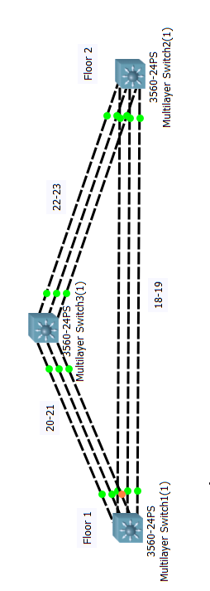
Figure 4.6: Ether-Channel Connections.

Configuration in M1 switch:
M1>enable
M1# config terminal
M1(config): interface ra Fastethernet0/18-19
M1(config): channel-group 3 mode active
M1(config): interface port-channel 3
M1(config): switchport trunk encapsulation dot1q
M1(config): switchport mode trunk
M1(config): switchport trunk allowed vlan 10,20,30,40,50,60,70,80,90,100.

M1(config): interface ra Fastethernet0/20-21
M1(config):channel-group 1 mode active
M1(config):interface port-channel 1
M1(config):switchport trunk encapsulation dot1q
M1(config): switchport mode trunk
M1(config): switchport trunk allowed vlan 10,20,30,40,50,60,70,80,90,100

Configuration in M2 switch:
M2>enable
M2# config terminal
M2(config): interface ra Fastethernet0/18-19
M2(config):channel-group 3 mode passive
M2(config):interface port-channel 3
M2(config):switchport trunk encapsulation dot1q
M2(config): switchport mode trunk
M2(config): switchport trunk allowed vlan 10,20,30,40,50,60,70,80,90,100

M1(config): interface ra Fastethernet0/22-23
M1(config):channel-group 2 mode passive
M1(config):interface port-channel 2
M1(config):switchport trunk encapsulation dot1q
M1(config): switchport mode trunk
M1(config): switchport trunk allowed vlan 10,20,30,40,50,60,70,80,90,100

Configuration in M3 switch:
M2>enable
M2# config terminal
M2(config): interface ra Fastethernet0/20-21
M2(config):channel-group 1 mode passive
M2(config):interface port-channel 1
M2(config):switchport trunk encapsulation dot1q
M2(config): switchport mode trunk
M2(config): switchport trunk allowed vlan 10,20,30,40,50,60,70,80,90,100

M1(config): interface ra Fastethernet0/22-23
M1(config):channel-group 2 mode active
M1(config):interface port-channel 2
M1(config):switchport trunk encapsulation dot1q
M1(config): switchport mode trunk
M1(config): switchport trunk allowed vlan 10,20,30,40,50,60,70,80,90,100

4.12.6 Access Control list:
To control the access of different VLAN we configured ACL in router. Here in the branch office GM and IT can communicate with everyone and everyone also can communicate with IT and GM but they cannot communicate in between themselves except CAD. CAD can communicate with MARCHENDISING section only

Creating Access Control List for different VLANs:
CORE>en
CORE#conf ter
CORE(config)#ip access-list extended CADS
CORE(config)#deny ip 192.168.20.0 0.0.0.255 192.168.30.0 0.0.0.255
CORE(config)#deny ip 192.168.20.0 0.0.0.255 192.168.40.0 0.0.0.255
CORE(config)#deny ip 192.168.20.0 0.0.0.255 192.168.60.0 0.0.0.255
CORE(config)#deny ip 192.168.20.0 0.0.0.255 192.168.80.0 0.0.0.255
CORE(config)#permit ip any any
CORE(config)#exit

CORE(config)#ip access-list extended GS
CORE(config)#deny ip 192.168.30.0 0.0.0.255 192.168.20.0 0.0.0.255
CORE(config)#deny ip 192.168.30.0 0.0.0.255 192.168.40.0 0.0.0.255
CORE(config)#deny ip 192.168.30.0 0.0.0.255 192.168.60.0 0.0.0.255
CORE(config)#deny ip 192.168.30.0 0.0.0.255 192.168.80.0 0.0.0.255
CORE(config)#deny ip 192.168.30.0 0.0.0.255 192.168.70.0 0.0.0.255
CORE(config)#permit ip any any
CORE(config)#exit

CORE(config)#ip access-list extended IE
CORE(config)#deny ip 192.168.40.0 0.0.0.255 192.168.20.0 0.0.0.255
CORE(config)#deny ip 192.168.40.0 0.0.0.255 192.168.30.0 0.0.0.255
CORE(config)#deny ip 192.168.40.0 0.0.0.255 192.168.60.0 0.0.0.255
CORE(config)#deny ip 192.168.40.0 0.0.0.255 192.168.80.0 0.0.0.255
CORE(config)#deny ip 192.168.40.0 0.0.0.255 192.168.70.0 0.0.0.255
CORE(config)#permit ip any any
CORE(config)#exit

CORE(config)#ip access-list extended DYEING
CORE(config)#deny ip 192.168.60.0 0.0.0.255 192.168.30.0 0.0.0.255
CORE(config)#deny ip 192.168.60.0 0.0.0.255 192.168.40.0 0.0.0.255
CORE(config)#deny ip 192.168.60.0 0.0.0.255 192.168.70.0 0.0.0.255
CORE(config)#deny ip 192.168.60.0 0.0.0.255 192.168.80.0 0.0.0.255
CORE(config)#deny ip 192.168.60.0 0.0.0.255 192.168.20.0 0.0.0.255
CORE(config)#permit ip any any
CORE(config)#exit

CORE(config)#ip access-list extended MARCHEN
CORE(config)#deny ip 192.168.70.0 0.0.0.255 192.168.30.0 0.0.0.255
CORE(config)#deny ip 192.168.70.0 0.0.0.255 192.168.40.0 0.0.0.255
CORE(config)#deny ip 192.168.70.0 0.0.0.255 192.168.60.0 0.0.0.255
CORE(config)#deny ip 192.168.70.0 0.0.0.255 192.168.80.0 0.0.0.255
CORE(config)#permit ip any any
CORE(config)#exit

CORE(config)#ip access-list extended COMP
CORE(config)#deny ip 192.168.80.0 0.0.0.255 192.168.30.0 0.0.0.255
CORE(config)#deny ip 192.168.80.0 0.0.0.255 192.168.40.0 0.0.0.255
CORE(config)#deny ip 192.168.80.0 0.0.0.255 192.168.60.0 0.0.0.255
CORE(config)#deny ip 192.168.80.0 0.0.0.255 192.168.70.0 0.0.0.255
CORE(config)#deny ip 192.168.80.0 0.0.0.255 192.168.20.0 0.0.0.255
CORE(config)#permit ip any any
CORE(config)#exit

Applying ACL for different VLANs:

CORE(config)#int g0/1.20
CORE(config-subif)#ip access-group CADS in
CORE(config-subif)#exit

CORE(config)#int g0/1.30
CORE(config-subif)#ip access-group GS in
CORE(config-subif)#exit

CORE(config)#int g0/1.40
CORE(config-subif)#ip access-group IE in
CORE(config-subif)#exit

CORE(config)#int g0/1.60
CORE(config-subif)#ip access-group DYEING in
CORE(config-subif)#exit

CORE(config)#int g0/1.70
CORE(config-subif)#ip access-group MARCHEN in
CORE(config-subif)#exit

CORE(config)#int g0/1.80
CORE(config-subif)#ip access-group COMP in
CORE(config-subif)#exit

4.13 Branch communication Core Network Configuration:
To establish the branch connectivity, I used Dynamic routing protocol EIGRP.
EIGRP protocol has the following standout characteristics and features: -
- It supports both Ipv4 and Ipv6.
- Supports both class-full as well as classless networks.
- It includes subnet information in the routing table.
- Supports both VLSM and CIDR networks.
- Supports both contiguous and dis-contiguous networks.
- Eigrp supports both Auto-Summarization and Manual Summarization.
- It Uses DUAL (Diffusing Update Algorithm) for best path selection strategy.
- Its uses RTP (Reliable Transport Protocol) to send route updates.
- In Eigrp the update is change triggered not periodic as in RIP. Change triggered earns the update will not be send to the neighbor unless and until there is a change in network topology.
- It uses Multicast (224.0.0.9) and no broadcast for sending update.
- It has load balancing feature.

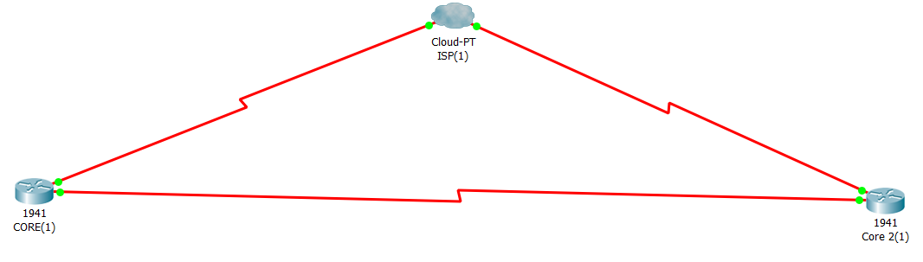
Figure 4.7: Core network Configuration.

4.13.1 EIGRP Configuration:

CONFIGURING INTERFACE WITH IP (IPv4)

CORE(config)#interface Loopback0
CORE(config)#ip address 192.168.1.1 255.255.255.0
CORE(config)#interface Serial0/0/0
CORE(config)# no ip address
CORE(config)#encapsulation frame-relay
CORE(config)#no shutdown
CORE(config)#interface Serial0/0/0.102 point-to-point
CORE(config)# ip address 10.0.0.1 255.255.255.252
CORE(config)#frame-relay interface-dlci 102

CORE(config)#router eigrp 10
CORE(config)#passive-interface default
CORE(config)#no passive-interface Serial0/0/0.102
CORE(config)#no passive-interface Serial0/0/0.103
CORE(config)# network 192.168.1.1 0.0.0.0
CORE(config)#network 10.0.0.1 0.0.0.0
CORE(config)# network 10.0.0.5 0.0.0.0

CORE2(config)# interface Loopback0
CORE2(config)# ip address 192.168.2.1 255.255.255.0
CORE2(config)# interface Serial0/0/0
CORE2(config)# description Frame Relay Connection to R1
CORE2(config)# ip address 10.0.0.2 255.255.255.252
CORE2(config)# encapsulation frame-relay
CORE2(config)# no shutdown

CORE2(config)# router eigrp 10
CORE2(config)# passive-interface default
CORE2(config)# no passive-interface Serial0/0/0
CORE2(config)# network 192.168.2.1 0.0.0.0
CORE2(config)# network 10.0.0.2 0.0.0.0

4.13.2 CLOUD (ISP) Configuration

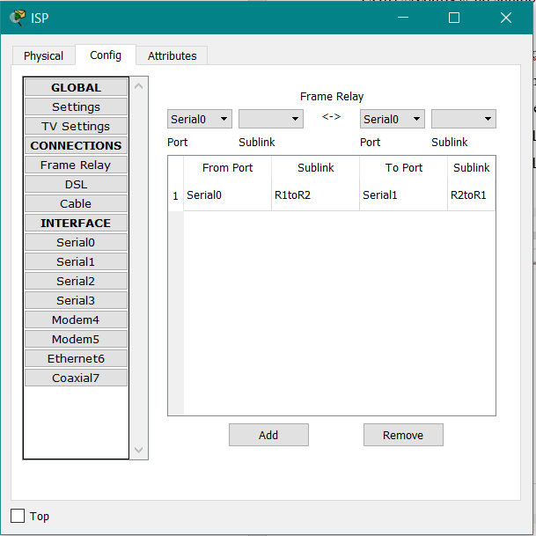
Figure 4.7: Configuration in CLOUD (ISP).

4.14 Working Process of Proposed System:
The proposed system is redesigned with two extra multilayer switches and Cisco WS-C3650-24TD-L switches for each department. The proposed network system is configured with Virtual LAN configuration which divides the existing departments so the departments are not opened to communicate with each other freely. The hosts of the same department can communicate with each other freely without any restriction.

The static IP configuration is removed and dynamic host configuration protocol is configured in the proposed system for each virtual LAN. So that the new hosts in the network system in a LAN need not to be configured physically.

Every department has individual switch and during the configuration of Virtual LAN a range of ports has been distributed for each LAN. If any department’s switch go offline, it will be possible to distribute several ports from another departments switch to continue the working process. It is possible to add new LANs in the network system in future if needed.

By configuring access control list in the core router the access permission for every department is configured. In the proposed network system GM can communicate with everyone because this department is the most important department in the organization.

IT department also can communicate with everybody. CAD department can communicate with Marchendising department. This way the permission has been distributed across the department.

Ether-Channel configuration with link aggregation technology has been configured in between the multilayer switches. Because the multilayer switches are the connection point which connects all the departments with each other. It combines multiple paths as a group channel as recognize multiple links as a single path.

Through ether-channel configuration the communication path in between the multilayer switches become redundant which can transmit the data in between the departments faster and it can balance load of data transmission. If a link or multiple links goes down the data transmission in between department will not stop because of redundant path.

The network system has a server in where the backup path has been provided using spanning tree protocol. If the primary path goes down the secondary path will go online within a moment and the data transmission will not stop.

As the organization uses lease line to connect with the main branch a backup path is provided in the redesigned proposed network system. So that in future the organization can communicate with main branch in case of internet service provider’s failure or avoid the lease line and use their backup path as the main path that connects the main branch with Gazipur branch directly. Through which the cost for lease line can be avoided.

4.15 Working Sections of Proposed Network System:
- Dividing the departments.
- Controlling the access permission.
- Providing dynamic IP configuration.
- Providing redundant path to make the communication faster and load balancing.
- Providing continuous data transmission system between departments.
- Minimizing the physical cost.
- Need less men power.
- Creating a scope to broaden the network system in future.
- Increasing the normal life span of the connecting devices.
- Providing alternative scope in case of any departments switch failure.
- Continuous data transmission to server through backup path in case primary path failure.

Chapter 5

Result and Discussion

5.1 Result:
In this section I will try to show the difference of the situation without having the proposed idea and with the proposed idea.

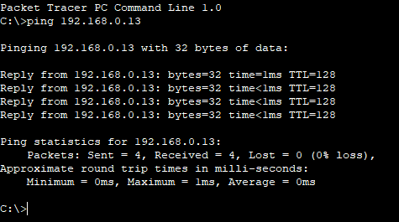
Figure 5.1: Scenario 1.

Previously as all the hosts were configured with static IP, they can easily communicate with each other, no restriction or access range there where the data and information was insecure and the use of old devises like HUB made the system more vulnerable. Above scenario 1 showing the data transmission in between two department’s computer.

Now take a look at scenario no 2 which shows the after Inter VLAN and ACL configuration situation of the ping in between two departments (CAD and DYEING):

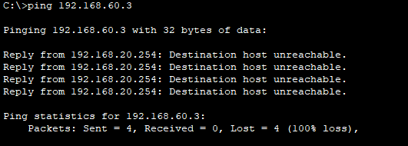
Figure 5.2: Scenario 2.

Scenario 2 shows that the access permission is now divided and CAD department will not be able to ping the computer of DYEING department. Only the permitted departments can only communicate with each other. In the access list only GM and IT department can communicate with everyone let’s have a look in scenario 3.

Have a look into scenario 3 and 4 below

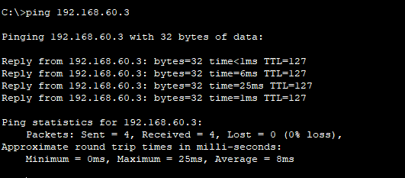
Figure 5.3: Scenario 3
In scenario 3 it shows that same IP can be pinged successfully from GM computer. That is GM can communicate with DYEING department without any restriction. DYEING and CAD can be pinged from GM, they also can ping GM but cannot in between them. Scenario 4 is showing communication between DYEING departments to GM department.

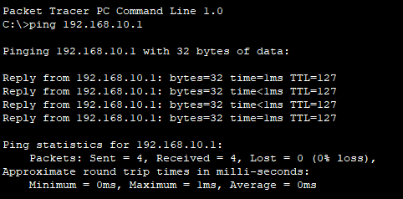
Figure 5.4: Scenario 4.

To make the communication faster and balanced we use redundant path with the help of either channel which has the link aggregation technology. Scenario 6 is going to show if any of the path broken data will pass to the destination.

Scenario 5 shows when all links are all right:

Figure 5.5: Scenario 5.
Scenario 5 is showing the data transmission scenario in between two departments PC (GM to Compliance). In where the result is successful. GM has the permission to communicate with all the existing departments in the organization so this department can communicate with everyone. When all the links are up the communication is successful.

Data will pass even when the multiple links are broken shown in scenario 7 below:

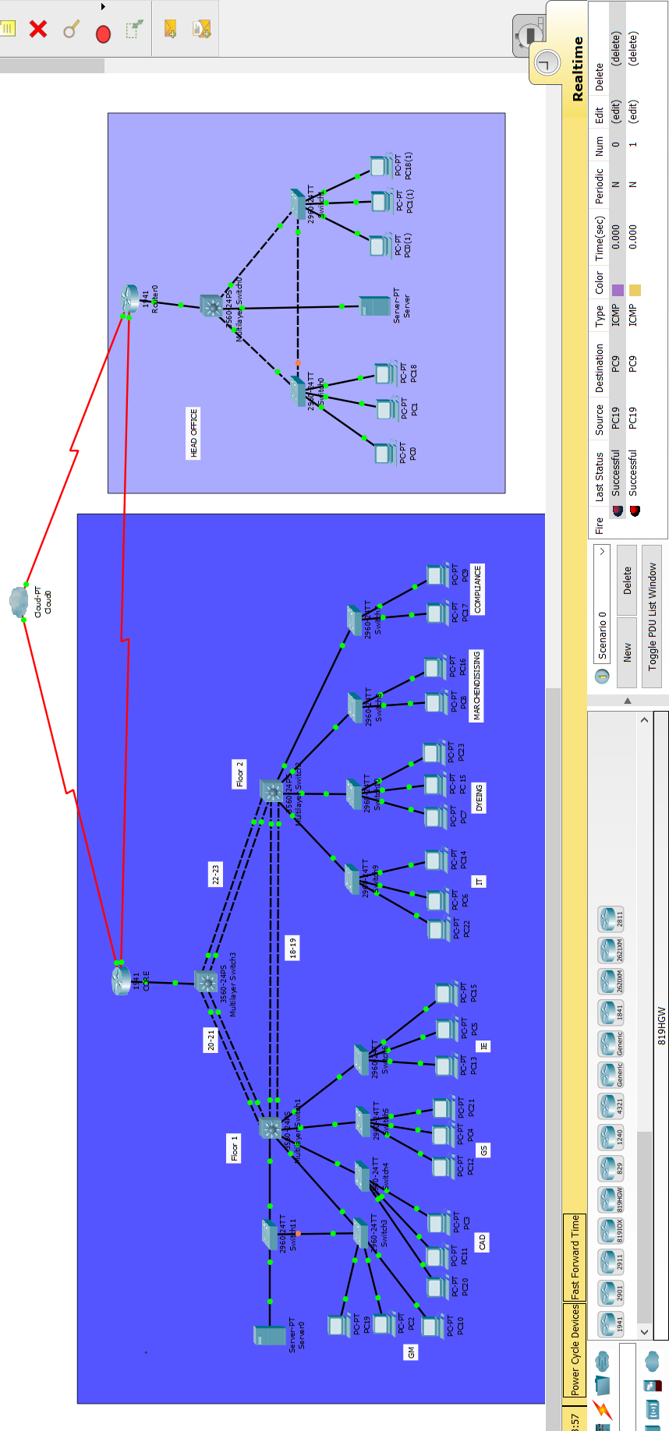
Figure 5.6: Scenario 6.

In this scenario 6 we can see multiple paths are broken but PC 19 can still send data successfully to PC9 which is in the second floor. So if any link goes down during work, the communication between departments will not stop.

5.2 Load balancing features with SNAT (Secure NAT):
Because it is not possible to implement SNAT on the server without load balancer device, it cannot be implemented in packet tracer. So the recommendation for SNAT has been proposed in the redesigned system to balance the load on the server. How it will work is shortly briefed here.

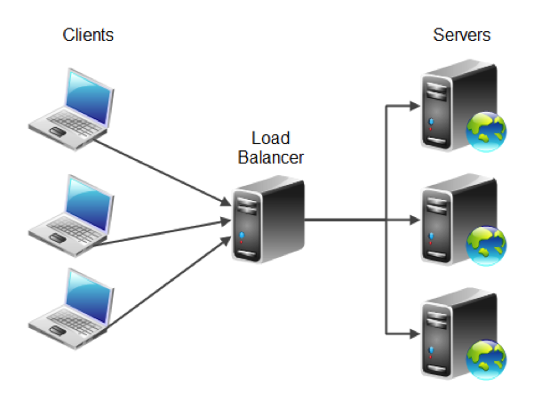
Figure 5.7: SNAT with Load Balancer and Servers.

The network diagram for the Layer 7 HAP Roxy SNAT mode is very similar to the Direct Routing
except that no re-configuration of the real servers is required. The load balancer proxies the application traffic to the servers so that the source of all traffic becomes the load balancer. As with other modes a single unit does not require a Floating IP. SNAT is a full proxy and therefore load balanced servers do not need to be changed in any way.

Because SNAT is a full proxy any server in the cluster can be on any accessible subnet including across the Internet or WAN. SNAT is not TRANSPARENT by default i.e. the real servers will see the source address of each request as the load balancers IP address. The clients source IP address will be in the X-Forwarded-For for header.

5.3 Comparison:

Figure 5.8: Comparisons between Existing and Proposed System.

Comparison in between the existing network system and proposed network system has shown in Figure>. It is showing that before doing and VLAN configuration in scenario 1 the computers in between the departments can ping each other, there was no restriction. As because the existing system using hub it was less secure.

There are no redundant paths in existing system so if the one and only existing path got break down the whole section will go offline. In scenario 2 shows after VLAN configuration and ACL configuration the departments computers cannot ping each other except those are permitted it indicates the security level has increased in proposed system. Scenario 3 shows the permitted department can only ping each other.
Scenario 6 indicates the successful data transmission in between departments after the break down of multiple links in switches. SO over all the communication will continue in between departments successfully through ether channel.

5.4 Discussion
From the result part we can see that the dividing of departments through VLAN and ACL configuration with the dynamic IP allocation is helpful. It actually reduces the cost. Because of DHCP configuration the computers of different department will get IP automatically from individual VLAN specified network. As we configured a limited number of port for VLAN it could be possible to add new VLANs in the switch or if any of the switch go offline it could be possible to add the declared VLANs in any switch in the network just by declaring the port number and giving the access. Redundancy path is helpful for data travelling while there some path broken occurs. And as we know the in a garment who works, they always need to be active in network. If the system goes offline for only one hour, huge loss will take place because of the absence of the communication. So in this scenario if there was no redundancy path and on that same time the natural path has been broken somehow then the service holder may need to wait for long period of time on basis of fixing the path. But now having the redundancy path it will just take no time to active. As because the IT section of the garment is growing in future there will be more load on server. So we suggest Secure NAT to balance the load on server. And using lease line to connect with main branch is not a good option so we proposed a backup path directly in between branch and main office which could be the alternative of lease line. So over all we can say that the proposed system could provide a far better result in long term run of that IT section in the garment which could provide the most stable connection as much it requires.

Chapter 6

Conclusion

6.1 Conclusion
Internships are one of the best ways to truly learn about field from a real-world perspective. While the classroom certainly teaches students important information, there’s something different about implementing those teachings with a real life scenario.

In this chapter I would like to give an overall summery of the whole report. In my internship I have got a chance to work in a garment’s IT section. The organization is known as RADIAL INTERNATIONAL LTD. They are quite known now a days and they are spreading their service day by day nationwide as well as on abroad.

They are providing multiple services toward the clients. While I was started working under their office circumstances I found that the IT section is new and they have most advance equipment in their office. But in their office system design I got some issue where I can utilize my knowledge and give the solution of that particular issue. In this practicum period I have learned some new aspects which I didn’t know before.

I would like to say that I have tried to work hard as much I can to make this project full-fill but as we are human being there always be some errors. I tried to my level best to minimize the errors as far as possible and successful in every step. I hope this project serve well to its benefactor.

On our internship phase we have to find a problem and then we will give a proposed idea which will solve the problem. One can also research if he/she wish. On this phase I tried to find a problem in my organization. When I got a problem I tried to breakdown the problem and tried to know how I can solve this. I searched in goggle and gather some knowledge about the specific problem solution. Some problems solution cannot be implemented right now so I suggest the solution. I followed the method step by step and using the information to solve that problem in simulation. I have found that the problem can be solve by redesigning the system with dynamic IP allocation and redundant path with load balancing features.

Before implementing the proposed idea through the simulation we can see that if new computer added to any department, organization need not to configure computers physically. If the path broken, then the data travel will be stop until that path fixed by the organization physically. So it would be a negative side for the organization as we know and organization has to give much better service as much they can.

After implementing the proposed idea through the simulation we can see that if any new computer added to any department it will be configured automatically. If any one of the path broken somehow other paths can send and receive their data. So it will be a positive approach from the organization towards its service holders.

6.2 Limitation
The organization under which I passed my internship phase I had some limitation. As they are garments organization and as we are not even their permanent worker they couldn’t believe us. So for the security purpose and other internal issue they hardly share their info with us which create lacking on deep knowing about the networking in field work. There I had faced some technical issue like understanding the network system as they were not sharing anything with us. I couldn’t implement by proposed idea in real as they didn’t have the dummy devices through which I can do the work. There are some more minor problems i had to face which was my limitation for this project.

6.3 Future work
In future with gathering more advance knowledge in networking I would try to do the works in more effective way which will provide more efficiency. I will try to remove the complexity gaining more knowledge on advance routing system which will be more effective. In future I would try to work with the dummy devices having their permission so that I can really know about the result in real. There are some other works like security, firewall, vpn tunnel and so on. I would try to work on those things as well in my future work.

Bibliography

Books and Data

[1]. Frozen, Beerhouse. Data Communication and Networking: 4th Ed. New Delhi: McGraw Hill, 2006.

[2]. Radia Perlman. Interconnections: Bridges, Routers, Switches, and Internetworking Protocols 2nd edition September 24th 1999.

References:
[1]. Network Design. Penttinen A., Chapter 10 – Network Planning and Dimensioning, Lecture Notes: S 38.145 - Introduction to Teletraffic Theory, Helsinki University of Technology, fall 1999.

[2]. Cisco Devices: https://www.cisco.com/c/en/us/products/routers/index.html

[3]. Network Design: https://en.wikipedia.org/wiki/Network_planning_and_design

[4].https://www.cisco.com/c/en/us/products/collateral/servers-unified-computing/ucs-c-series-rack-servers/data_sheet_c78-587522.html

[5].https://www.cisco.com/c/en/us/products/collateral/switches/catalyst-3750-series-switches/product_data_sheet0900aecd80371991.html

[6].https://www.cisco.com/c/en/us/products/collateral/switches/catalyst-3650-series-switches/data_sheet-c78-729449.html

[7].https://www.cisco.com/c/en/us/products/routers/1941-integrated-services-router-isr/index.html

[8]. https://en.wikipedia.org/wiki/Ethernet_hub#/media/File:4_port_netgear_ethernet_hub.jpg

[9]. https://docs.oracle.com/cd/E19199-01/816-6775-10/a_loadbalancer.html

[10]. https://computer.howstuffworks.com/internet/basics/internet-infrastructure.html

[11]. https://radiancegroup-bd.com/radial-international-ltd/

[12]. https://searchnetworking.techtarget.com

[13]. https://www.techopedia.com

[14]. https://www.itprotoday.com/management-mobility/build-redundancy-your-lanwan

[15]. http://www.mustbegeek.com/understanding-basics-of-eigrp-routing-protocol/

[16]. Singh, A., Korupolu, M., & Mohapatra, D. (2008, November). Server-storage virtualization: integration and load balancing in data centers. In Proceedings of the 2008 ACM/IEEE conference on Supercomputing (p. 53). IEEE Press.

[17].Gandhi, R., Hu, Y. C., & Zhang, M. (2016, April). Yoda: A highly available layer-7 load balancer. In Proceedings of the Eleventh European Conference on Computer Systems (p. 21). ACM.

[18].Khare, S., & Chauhan, A. (2014). A review on load balancing model based on cloud partitioning for the public cloud. International Journal of Emerging Technology and Advanced Engineering, 4(7), 736-744.

[19].Desai, T., & Prajapati, J. (2013). A survey of various load balancing techniques and challenges in cloud computing. International Journal of Scientific & Technology Research, 2(11), 158-161.

