|  |  |  |  |  |  |  |
| --- | --- | --- | --- | --- | --- | --- |
| MON | tUE | wED | tHU | fRI | sAT | sUN |
|  |  |  |  |  |  | 1 |
|  |  |  |  |  |  |  |
| 2 | 3 | 4 | 5 | 6 | 7 | 8 |
|  |  |  |  |  |  |  |
| 9 | 10 | 11 | 12 | 13 | 14 | 15 |
|  |  |  |  |  |  |  |
| 16 | 17 | 18 | 19 | 20 | 21 | 22 |
|  |  |  |  |  |  |  |
| 23 | 24 | 25 | 26 | 27 | 28 | 29 |
|  |  |  |  |  |  |  |
| 30 |  |  |  |  |  |  |
|  |  |  |  |  |  |  |

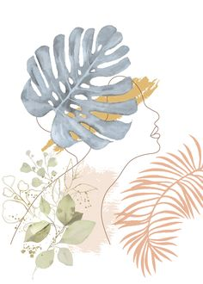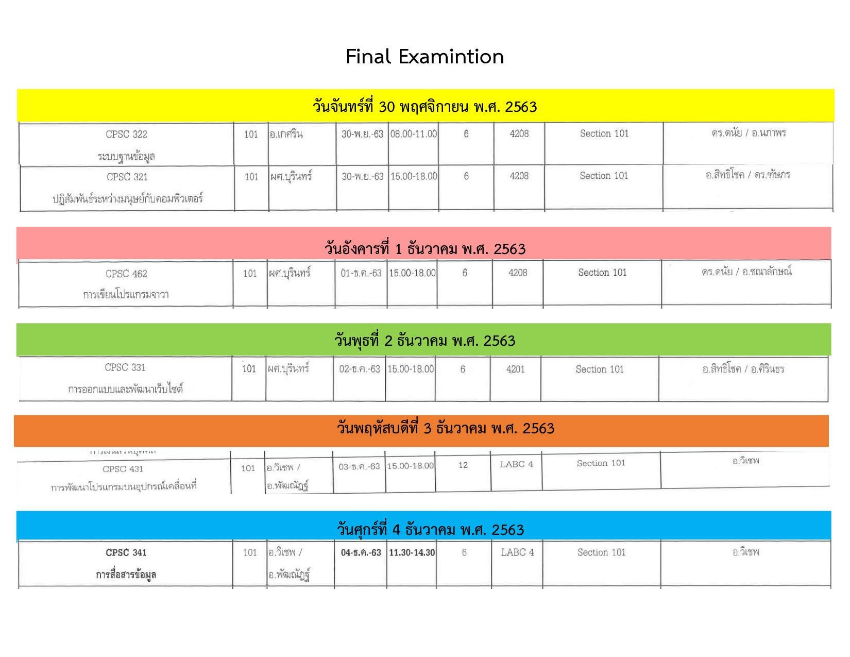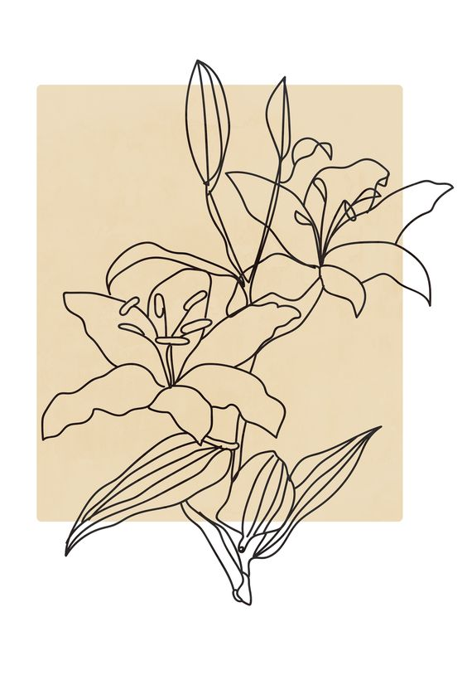**December**