Experiment – LAB MST

Student Name: Mimanshu Gahlaut UID: 24BAI70038
Branch: CSE - AIML Section/Group: 24AIT_KRG-1_B
Semester: 5 Date of Performance: 28/9/26
Subject Name: ADBMS Subject Code: 24CSP-310

(A)
A company stores employees and their departments. Display employees whose salary is greater than the average salary of their own department, but only from departments having at least 3 employees.
Display Department Name, Employee Name, and Salary.
Constraint: Only a solution using JOINS and SUBQUERIES is allowed. Window Functions are not allowed.
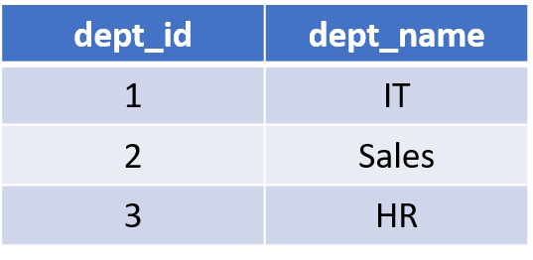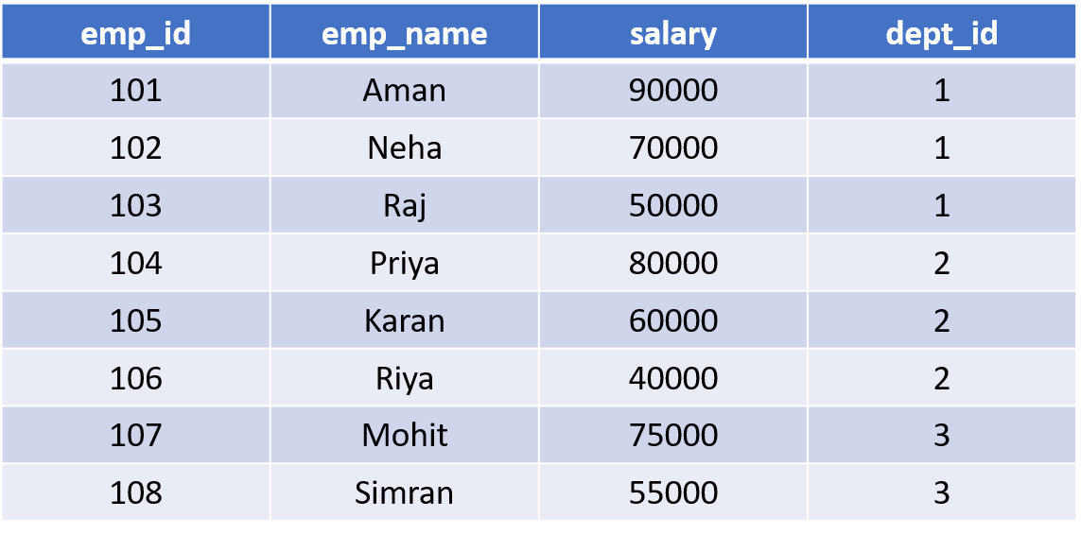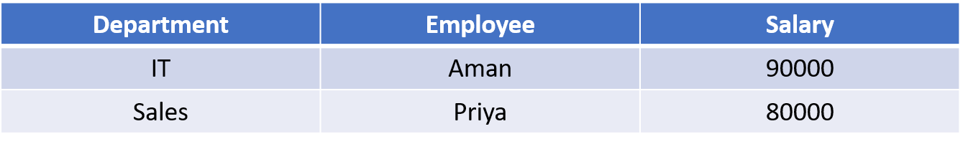
Solution:
CREATE TABLE department (
dept_id INT PRIMARY KEY,
dept_name VARCHAR(30)
);

CREATE TABLE employee (
emp_id INT PRIMARY KEY,
emp_name VARCHAR(50),
salary NUMERIC(10,2),
dept_id INT REFERENCES department(dept_id)
);

INSERT INTO department VALUES
(1, 'IT'),
(2, 'Sales'),
(3, 'HR');

INSERT INTO employee VALUES
(101, 'Aman', 90000, 1),
(102, 'Neha', 70000, 1),
(103, 'Raj', 50000, 1),
(104, 'Priya', 80000, 2),
(105, 'Karan', 60000, 2),
(106, 'Riya', 40000, 2),
(107, 'Mohit', 75000, 3),
(108, 'Simran', 55000, 3);

SELECT
D.DEPT_NAME AS DEPARTMENT,
E.EMP_NAME AS EMPLOYEE,
E.SALARY AS SALARY
FROM EMPLOYEE E
JOIN DEPARTMENT D
ON E.DEPT_ID = D.DEPT_ID
WHERE E.SALARY > (
SELECT AVG(E1.SALARY)
FROM EMPLOYEE E1
WHERE E.DEPT_ID = E1.DEPT_ID
)
AND E.DEPT_ID IN (
SELECT DEPT_ID
FROM EMPLOYEE
GROUP BY DEPT_ID
HAVING COUNT(*) >= 3
);
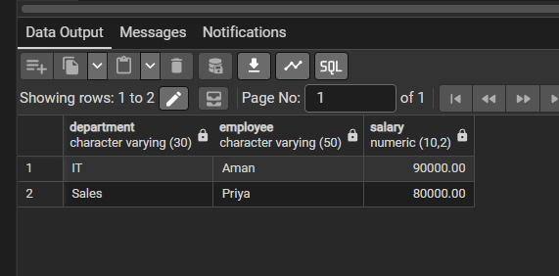

(B)
A bank maintains customer information in bank_customer. Create a PostgreSQL trigger that automatically stores a log in customer_audit whenever a customer is inserted or deleted. Store Customer ID, Customer Name, action (ADDED/REMOVED), and current timestamp.
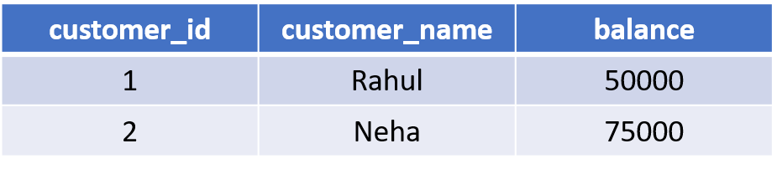
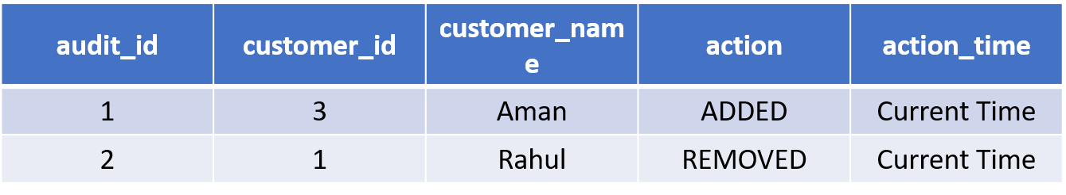

Solution:
CREATE TABLE bank_customer (
customer_id INT PRIMARY KEY,
customer_name VARCHAR(50),
balance NUMERIC(10,2)
);

CREATE TABLE customer_audit (
audit_id SERIAL PRIMARY KEY,
customer_id INT,
customer_name VARCHAR(50),
action VARCHAR(20),
action_time TIMESTAMP
);

INSERT INTO bank_customer VALUES
(1, 'Rahul', 50000),
(2, 'Neha', 75000);

CREATE OR REPLACE FUNCTION CUSTOMER_AUDIT_FUNCTION()
RETURNS TRIGGER AS $$
BEGIN
IF TG_OP = 'INSERT' THEN
INSERT INTO CUSTOMER_AUDIT(CUSTOMER_ID, CUSTOMER_NAME, ACTION, ACTION_TIME)
VALUES(NEW.CUSTOMER_ID, NEW.CUSTOMER_NAME, 'ADDED', CURRENT_TIMESTAMP);
RETURN NEW;
ELSIF TG_OP = 'DELETE' THEN
INSERT INTO CUSTOMER_AUDIT(CUSTOMER_ID, CUSTOMER_NAME, ACTION, ACTION_TIME)
VALUES(OLD.CUSTOMER_ID, OLD.CUSTOMER_NAME, 'REMOVED', CURRENT_TIMESTAMP);
RETURN OLD;
END IF;
END;
$$ LANGUAGE PLPGSQL;

CREATE TRIGGER CUSTOMER_AUDIT
AFTER INSERT OR DELETE
ON BANK_CUSTOMER
FOR EACH ROW
EXECUTE FUNCTION CUSTOMER_AUDIT_FUNCTION();

INSERT INTO BANK_CUSTOMER
VALUES(3, 'AMAN', 60000);

SELECT * FROM CUSTOMER_AUDIT;

DELETE FROM BANK_CUSTOMER
WHERE CUSTOMER_ID = 1;

SELECT * FROM CUSTOMER_AUDIT;
