Name: Mimanshu Gahlaut
UID: 24BAI70038
Course: BE-CSE (AI&ML)
Subject: Database Management System

Experiment 3: PL/SQL program

1. Aim of the Session

To understand the basic structure of a PL/SQL program by creating and executing a simple PL/SQL block that includes declaration and execution sections, and to display output using built-in procedures.

2. Software Requirements:
- Database: Oracle SQL

3. Objective of the Session

To create a simple PL/SQL program demonstrating Declaration Section and Execution Section.

4. Practical / Experiment Steps
The work was carried out through the following activities:
- Program Structure Definition: Designed a basic PL/SQL block consisting of declaration and execution sections to understand the program flow.
- Variable Declaration: Declared required variables in the DECLARE section with appropriate data types.
- Logic Implementation: Wrote executable statements inside the BEGIN…END block to perform operations using declared variables.
- Output Display: Used built-in procedures such as DBMS_OUTPUT.PUT_LINE to display results on the screen.
- Execution and Verification: Executed the PL/SQL block and verified correct output generation and successful program execution.

5. Procedure of the Practical

Execution was performed in the following order:
- Environment Initialization: Opened the Oracle SQL environment (SQL*Plus / SQL Developer) and connected to the database server.
- Session Configuration: Enabled output display using the SET SERVEROUTPUT ON command.
- Program Preparation: Wrote a basic PL/SQL block with DECLARE, BEGIN, and END sections.
- Variable Setup: Declared required variables with suitable data types in the declaration section.
- Logic Execution: Implemented executable statements inside the BEGIN block.
- Output Handling: Used DBMS_OUTPUT.PUT_LINE to display execution results.
- Program Execution: Ran the PL/SQL block to execute the program.
- Result Verification: Verified the displayed output to ensure correct program behavior.
- Documentation: Saved the PL/SQL script and recorded the output for submission.

6. I/O Analysis (Input / Output Analysis)

Input Queries
SQL
DECLARE
EMP_ID NUMBER:=001;
EMP_NAME VARCHAR(40):='HARRY';
EMP_SALARY NUMBER:=50000;

BEGIN
DBMS_OUTPUT.PUT_LINE('EMPLOYEE ID: ' || EMP_ID);
DBMS_OUTPUT.PUT_LINE('EMPLOYEE NAME: ' || EMP_NAME);
DBMS_OUTPUT.PUT_LINE('EMPLOYEE SALARY: ' || EMP_SALARY);
DBMS_OUTPUT.PUT_LINE('HOUSE RENT ALLOWANCE: ' || (0.25*EMP_SALARY));
IF EMP_SALARY > 49000 THEN
DBMS_OUTPUT.PUT_LINE('YOU NEED TO PAY TAX');
ELSE
DBMS_OUTPUT.PUT_LINE('YOU WILL NOT PAY TAX');
END IF;
END;

Output Details

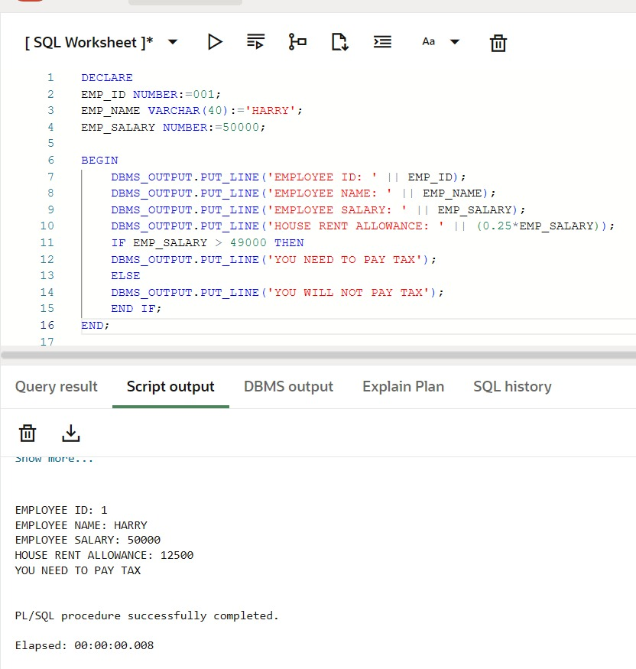

7. Learning Outcome
- Understood the basic structure of a PL/SQL program.
- Learned how to declare and use variables in PL/SQL.
- Gained experience in writing executable statements within a PL/SQL block.
- Used built-in procedures to display output.
- Developed basic procedural programming skills in PL/SQL.

