Name: Mimanshu Gahlaut
UID: 24BAI70038
Course: BE-CSE (AI&ML)
Subject: Database Management System

Experiment: Library Management System Implementation

1. Aim of the Session

The purpose of this lab session was to design and implement a relational database model for a Library Management System. This included creating structured tables, defining relationships among different entities, and applying role-based security mechanisms within the database.

2. Objective of the Session

At the end of the practical, the following goals were accomplished:
- Constructed relational tables with Primary Keys, Foreign Keys, and Check Constraints to maintain data integrity.
- Practiced DML operations such as INSERT, UPDATE, DELETE, and SELECT for handling data.
- Applied DCL commands to configure role-based permissions for secure data access.
- Preserved referential integrity between multiple tables such as books, library_visitors, and book_issue.

3. Practical / Experiment Steps
The work was carried out through the following activities:
- Database Schema Design: Defined tables for handling books and visitors, ensuring fields had proper constraints such as NOT NULL, UNIQUE, and CHECK for validating inputs (e.g., visitor minimum age requirement).
- Relationship Creation: Implemented the book_issue table which linked book and visitor data using foreign keys to create a transaction-like model.
- Data Seeding: Inserted dummy values to verify structural correctness and validate constraint enforcement.
- Functional Testing: Executed update and delete operations to observe system responses and ensure operations followed referential rules.
- Security Configuration: Established a database role with login privileges and controlled access using GRANT and REVOKE.

4. Procedure of the Practical

Execution was performed in the following order:
- Environment Setup: Logged into DBMS interface and accessed the server instance.
- Database Setup: Created a dedicated database for the library system.
- Schema Execution: Executed CREATE TABLE commands ensuring parent tables were defined first.
- Data Entry Phase: Ran insertion queries to populate tables with book data and visitor records.
- Verification Queries: Used select statements to confirm correct data storage and consistency across tables.
- Update/Delete Checks: Applied modification commands to test mutability and cascading behaviors.
- Role Creation: Formed a librarian role and assigned relevant operations through DCL.
- Permission Testing: Evaluated access controls and validated security using REVOKE and privilege-checking queries.
- Documentation: Saved final SQL script and captured outputs for reporting.

5. I/O Analysis (Input / Output Analysis)

Input Queries
SQL
-- Table Definitions
CREATE TABLE books(
id INT PRIMARY KEY,
name VARCHAR(50) NOT NULL,
author_name VARCHAR(50) NOT NULL,
count INT CHECK(count>0)
)

CREATE TABLE library_visitors(
user_id INT PRIMARY KEY,
user_name VARCHAR(20) NOT NULL,
age INT CHECK(age>=18) NOT NULL,
email VARCHAR(40) UNIQUE NOT NULL
)

CREATE TABLE book_issue(
book_issue_id INT PRIMARY KEY,
book_id INT NOT NULL,
user_id INT NOT NULL,
FOREIGN KEY (book_id) REFERENCES books(id),
FOREIGN KEY (user_id) REFERENCES library_visitors(user_id),
book_issue_date DATE NOT NULL
)

-- Data Operations
INSERT INTO books VALUES(1, 'Harry Potter', 'R. Snape', 1)
INSERT INTO books VALUES(2, 'Avengers', 'Stan Lee', 3)
INSERT INTO library_visitors VALUES(101, 'Robert', 20, 'abc@gmail.com')
UPDATE library_visitors SET email='Robert@gmail.com' WHERE user_id = 101
INSERT INTO book_issue VALUES(1234,1,101,'2026-01-07')
DELETE FROM books WHERE id = 2

-- Role Management

CREATE ROLE librarian WITH LOGIN PASSWORD 'PASSWORD'

GRANT SELECT, INSERT, DELETE, UPDATE ON books TO librarian

GRANT SELECT, INSERT, DELETE, UPDATE ON library_visitors TO librarian

GRANT SELECT, INSERT, DELETE, UPDATE ON book_issue TO librarian

REVOKE SELECT, INSERT, DELETE, UPDATE ON books FROM librarian

Output Details
1. Schema Creation
- All three tables (books, library_visitors, and book_issue) were successfully created.
- The PRIMARY KEY constraints ensured unique identification of books and visitors.
- The CHECK(age>=18) constraint prevented entries of visitors below 18 years of age.
- The CHECK(count>0) constraint disallowed non-positive values for book count.
- FOREIGN KEY constraints ensured that book issue entries could only reference existing books and visitors.
✔ Result: Schema creation completed without errors.
2. DML Outputs
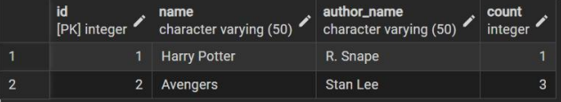
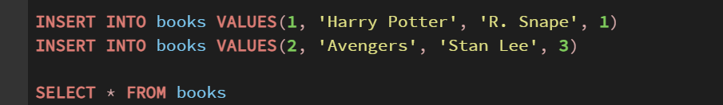
The following SQL commands executed successfully:
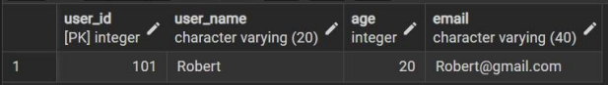
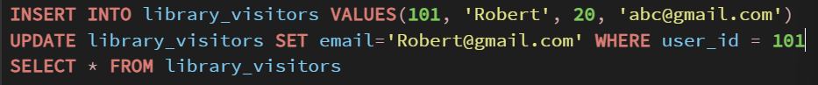
Next, visitor insertion and update:

Finally, book issue entry:
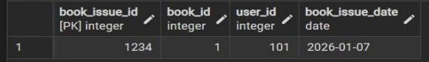
3. DELETE Operation Result
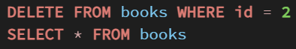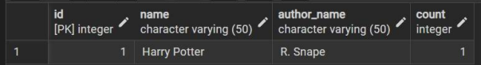
4. DCL (Security / Role-Based Access Control) Output
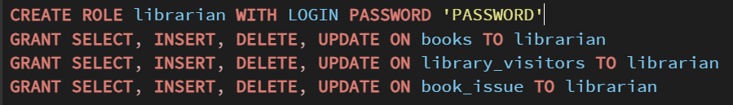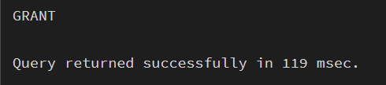
Next, revoking privileges:
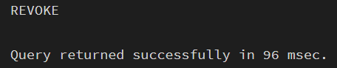
✔ Effect:
After revocation, librarian could no longer perform operations on the books table, verifying that permission control worked correctly.
- Validation: Testing confirmed that after the REVOKE command, the librarian could no longer perform operations on the books table, ensuring the security policy is functional.
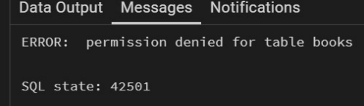
- We also confirmed the permissions of the role “librarian” by checking the table privileges. 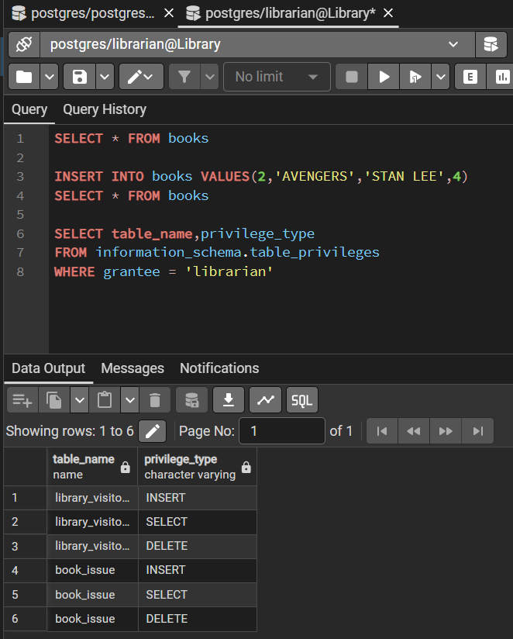

6. Learning Outcome
From this practical, the following knowledge and skills were gained:
- Schema Design Insight: Learned how relational constraints like CHECK, UNIQUE, and FOREIGN KEY contribute to logical data consistency.
- Database Security Skills: Understood the advantage of assigning roles instead of individual user permissions for scalable security.
- Real-world Contextualization: Saw how SQL is applied in real applications (such as library systems) where multiple entities interact systematically.

