Name: Mimanshu Gahlaut
UID: 24BAI70038
Course: BE-CSE (AI&ML)
Subject: Database Management System

Experiment 6: Working of Cursor in PL/SQL

1. Aim of the Session

To understand the concept and working of cursors in PL/SQL for row-by-row data processing, and to analyse how implicit cursors, explicit cursors, and cursor attributes are used to implement business logic on multiple rows in a database table.

2. Software Requirements:
- Database Management System:
  - Oracle Database Express Edition (Oracle XE)
  - PostgreSQL Database
- Database Administration Tool / Client Tool:
  - Oracle SQL Developer (for Oracle XE)
  - pgAdmin (for PostgreSQL)

3. Objective of the Session

To implement and analyse the use of implicit cursors, explicit cursors, and cursor attributes for processing multiple rows from a database table and applying business logic effectively.

4. Practical / Experiment Steps
The work was carried out through the following activities:
- Schema Creation: Created the Employees table with attributes such as Employee ID, Name, Role, and Salary to represent a structured organizational database.
- Data Initialization: Inserted multiple employee records with different roles and salary values to prepare a dataset for cursor operations.
- Implicit Cursor Implementation: Executed an anonymous PL/SQL block to perform an UPDATE operation on employee salary and used implicit cursor attributes like SQL%ROWCOUNT to verify execution.
- Explicit Cursor Declaration: Defined a named cursor (c_emp) to retrieve records of employees based on a specific condition (e.g., role = 'Engineer') for controlled row-wise processing.
- Cursor Attribute Utilization: Applied cursor attributes such as %FOUND, %NOTFOUND, %ROWCOUNT, and %ISOPEN to manage program flow and monitor cursor behavior.
- Logical Processing: Implemented business logic to process employee records individually, such as updating salaries or displaying formatted output.

5. Procedure of the Practical

Execution was performed in the following order:
- Opened the Oracle database environment (SQL*Plus / SQL Developer) and enabled SERVEROUTPUT to display results.
- Executed CREATE TABLE and INSERT statements to establish the Employees dataset.
- Ran a PL/SQL block using an implicit cursor to update a selected employee’s salary and verified the result using SQL%ROWCOUNT.
- Declared an explicit cursor (c_emp) to select employees based on a specific role condition.
- Opened the cursor and confirmed its status using the %ISOPEN attribute.
- Used a LOOP structure to fetch records sequentially into variables (e.g., v_name, v_salary).
- Applied %NOTFOUND as the exit condition to terminate the loop after all records were processed.
- Tracked the number of processed rows using %ROWCOUNT during iteration.
- Closed the cursor explicitly to release system resources and verified closure using NOT c_emp%ISOPEN.

6. I/O Analysis (Input / Output Analysis)

Input Queries
SQL
CREATE TABLE Employees(
emp_id NUMBER PRIMARY KEY,
emp_name VARCHAR(25),
emp_role VARCHAR(20),
emp_salary NUMBER
);
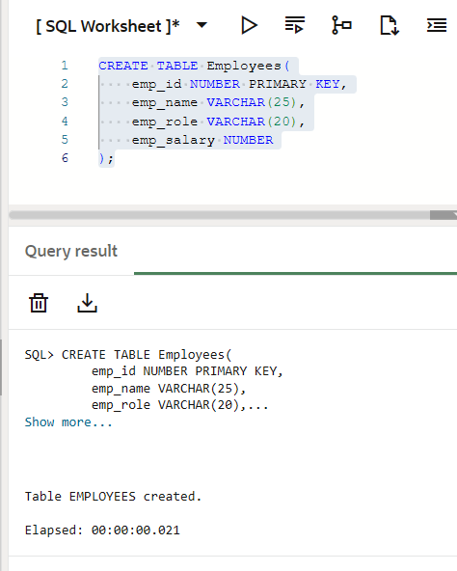

INSERT INTO Employees VALUES (201, 'Rahul', 'Engineer', 80000);
INSERT INTO Employees VALUES (202, 'Neha', 'Manager', 95000);
INSERT INTO Employees VALUES (203, 'Arjun', 'Engineer', 87000);
INSERT INTO Employees VALUES (204, 'Priya', 'Analyst', 50000);

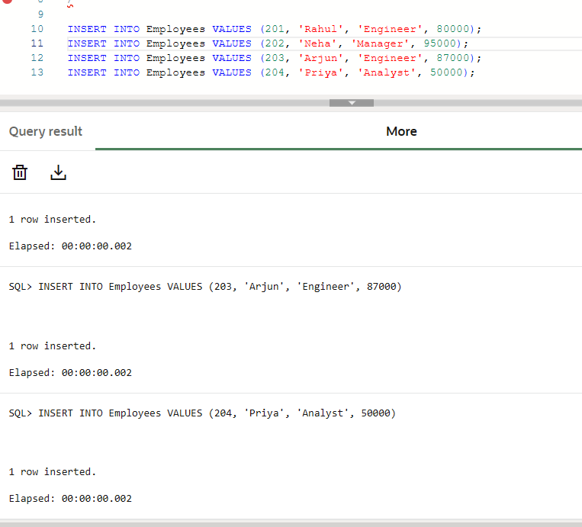

SET SERVEROUTPUT ON;

DECLARE
v_emp_id NUMBER := 201;
BEGIN
UPDATE Employees
SET emp_salary = emp_salary * 1.15
WHERE emp_id = v_emp_id;

IF SQL%FOUND THEN
DBMS_OUTPUT.PUT_LINE('SQL%FOUND = TRUE');
DBMS_OUTPUT.PUT_LINE('Rows affected: ' || SQL%ROWCOUNT);
ELSE
DBMS_OUTPUT.PUT_LINE('No matching record found');
END IF;
END;

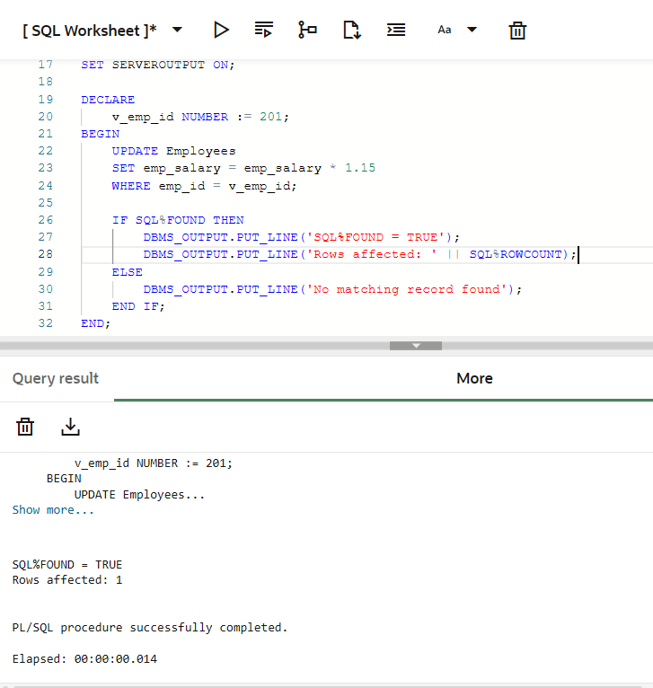
DECLARE
CURSOR c_emp IS
SELECT emp_name, emp_role
FROM Employees
WHERE emp_role = 'Engineer';

v_name Employees.emp_name%TYPE;
v_role Employees.emp_role%TYPE;
BEGIN
OPEN c_emp;
IF c_emp%ISOPEN THEN
DBMS_OUTPUT.PUT_LINE('Cursor opened successfully');
END IF;
LOOP
FETCH c_emp INTO v_name, v_role;
IF c_emp%NOTFOUND THEN
DBMS_OUTPUT.PUT_LINE('No more records found');
EXIT;
END IF;
DBMS_OUTPUT.PUT_LINE('Engineer #' || c_emp%ROWCOUNT ||
': ' || v_name || ' | ' || v_role);
END LOOP;
CLOSE c_emp;
IF NOT c_emp%ISOPEN THEN
DBMS_OUTPUT.PUT_LINE('Cursor closed successfully');
END IF;
END;

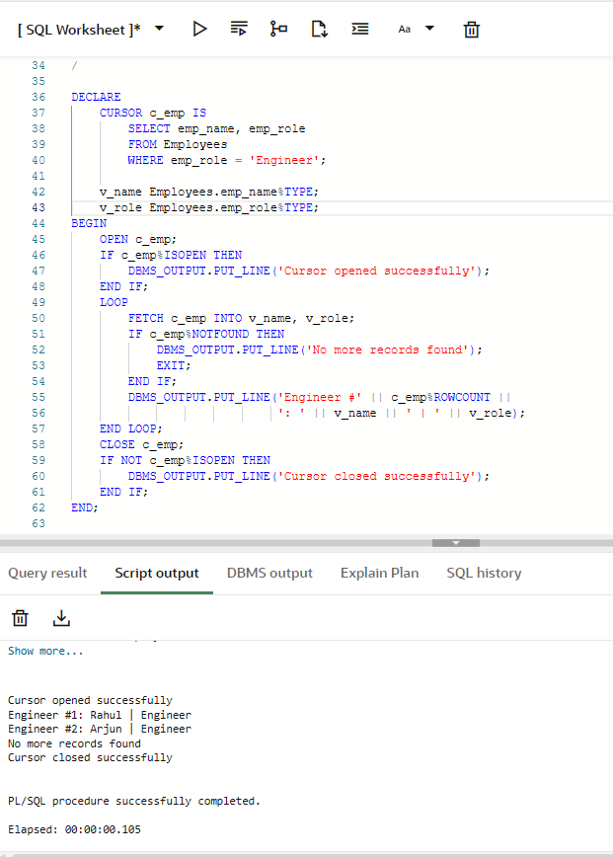

7. Learning Outcome
• Learned how to use implicit and explicit cursors in PL/SQL.
• Understood cursor attributes like SQL%ROWCOUNT, %FOUND, %NOTFOUND, and %ISOPEN.
• Gained ability to process records row-by-row using cursors.
• Applied simple logic on database records (update and display).

