Name: Mimanshu Gahlaut
UID: 24BAI70038
Course: BE-CSE (AI&ML)
Subject: Database Management System

Experiment 9: Packages in PL/SQL

1. Aim of the Session

To design and implement PL/SQL packages by creating both the package specification and package body, incorporating procedures and shared cursors to support modular, reusable, and efficient database operations.

2. Software Requirements:
- Database Management System:
  - Oracle Database Express Edition (Oracle XE)
  - PostgreSQL Database
- Database Administration Tool / Client Tool:
  - Oracle SQL Developer (for Oracle XE)
  - pgAdmin (for PostgreSQL)

3. Objective of the Session

To develop a PL/SQL package that includes procedures and shared cursors for organized and modular programming.

4. Practical / Experiment Steps
The work was carried out through the following activities:
- Design of Modular Structure: Divided the database logic into a package consisting of a specification (interface) and a body (implementation).
- Shared Cursor Definition: Created a common cursor within the package body to allow multiple procedures to access the same dataset efficiently.
- Procedure Implementation: Developed procedures for handling different operations such as displaying all records and retrieving specific entries.
- Encapsulation Mechanism: Restricted direct access to internal logic by exposing only the required procedures through the package interface.
- Testing and Validation: Executed the procedures within anonymous blocks to ensure correct functionality and consistency.

5. Procedure of the Practical

Execution was performed in the following order:
• Connected to the database environment and enabled output display for verification.
• Created the employees table and inserted sample data for testing purposes.
• Defined the package specification (emp_package) to declare the available procedures.
• Implemented the package body containing the shared cursor and the logic for each procedure.
• Used a loop structure in the show_employees procedure to iterate through all records using the cursor.
• Implemented filtering logic in the get_employee procedure to retrieve details based on a given employee ID.
• Compiled both the specification and body to ensure error-free execution.
• Executed show_employees to display all records.
• Called get_employee(2) to verify retrieval of a specific record.

6. I/O Analysis (Input / Output Analysis)

Input Queries
SQL

CREATE TABLE emp_data (
id NUMBER PRIMARY KEY,
name VARCHAR2(50),
salary NUMBER
);

/
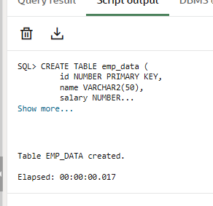

INSERT INTO emp_data VALUES (1, 'Amit', 30000);
INSERT INTO emp_data VALUES (2, 'Riya', 40000);
INSERT INTO emp_data VALUES (3, 'John', 50000);

COMMIT;

/
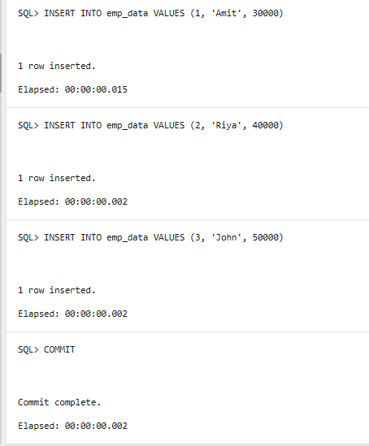

CREATE OR REPLACE PACKAGE employee_pkg AS

-- Display all employee records
PROCEDURE display_all;

-- Fetch employee by ID
PROCEDURE find_employee(p_emp_id NUMBER);

END employee_pkg;

/
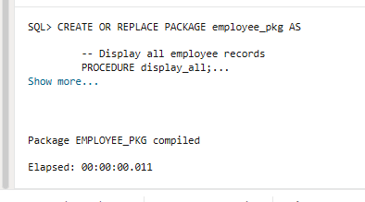

CREATE OR REPLACE PACKAGE BODY employee_pkg AS

-- Shared cursor
CURSOR emp_cur IS
SELECT id, name, salary FROM emp_data;

-- Procedure to display all records
PROCEDURE display_all IS
BEGIN
FOR rec IN emp_cur LOOP
DBMS_OUTPUT.PUT_LINE(
'ID: ' || rec.id ||
', Name: ' || rec.name ||
', Salary: ' || rec.salary
);
END LOOP;
END;

-- Procedure to fetch specific employee
PROCEDURE find_employee(p_emp_id NUMBER) IS
BEGIN
FOR rec IN emp_cur LOOP
IF rec.id = p_emp_id THEN
DBMS_OUTPUT.PUT_LINE(
'Employee Details -> ID: ' || rec.id ||
', Name: ' || rec.name ||
', Salary: ' || rec.salary
);
END IF;
END LOOP;
END;

END employee_pkg;

/
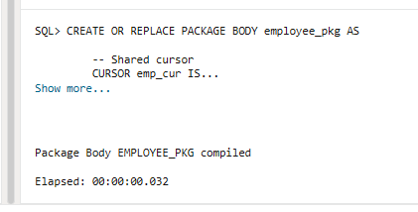

SET SERVEROUTPUT ON;

BEGIN
employee_pkg.display_all;
END;

/
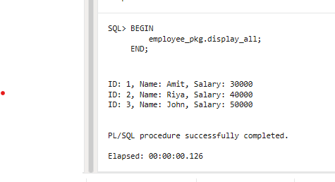

BEGIN
employee_pkg.find_employee(2);
END;

/
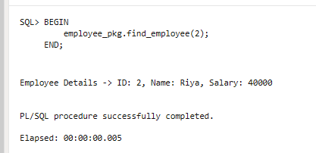

7. Learning Outcome
- Understanding Package Structure: Learned the distinction between package specification and package body.
- Improved Code Organization: Gained knowledge of grouping related operations into a single unit for better maintainability.
- Efficient Data Handling: Understood how shared cursors help in reducing redundancy and improving performance.
- Encapsulation Concept: Learned how packages hide internal implementation details and provide a clean interface.

