Name: Mimanshu Gahlaut
UID: 24BAI70038
Course: BE-CSE (AI&ML)
Subject: Database Management System

Experiment 10: Trigger

1. Aim of the Session

To design a trigger that automatically implements the functionality of a primary key, ensuring unique identification of records without manual intervention.

2. Software Requirements:
- Database Management System:
  - Oracle Database Express Edition (Oracle XE)
  - PostgreSQL Database
- Database Administration Tool / Client Tool:
  - Oracle SQL Developer (for Oracle XE)
  - pgAdmin (for PostgreSQL)

3. Objective of the Session

To create a database trigger that automatically enforces primary key constraints or generates unique key values, replicating the functionality of a stored procedure.

4. Practical / Experiment Steps
The work was carried out through the following activities:
- Table Structure Design: Created the employees table with appropriate attributes, defining emp_id as the primary key to uniquely identify each record.
- Sequence Creation: Defined a database sequence (emp_seq) to generate a continuous series of unique values for automatic ID assignment.
- Trigger Function Development: Implemented a PL/pgSQL function to check whether a primary key value is provided during insertion.
- Automatic Key Assignment Logic: Incorporated logic within the function to fetch the next sequence value using nextval() when emp_id is not supplied.
- Trigger Configuration: Linked the function to the table using a BEFORE INSERT trigger to ensure execution prior to data insertion.
- Encapsulation of Logic: Ensured that the key generation process is handled internally within the database, eliminating the need for manual intervention.
- Testing and Validation: Inserted multiple records without specifying emp_id and verified the results using a SELECT query to confirm correct sequential ID generation.

5. Procedure of the Practical

Execution was performed in the following order:
- Opened PostgreSQL and started a new database session.
- Created the employees table using the CREATE TABLE command.
- Defined a sequence starting from 1 for ID generation.
- Wrote the auto_emp_id() trigger function for dynamic key assignment.
- Implemented logic to assign a value only when emp_id is not provided.
- Created the trigger trg_auto_emp_id and attached it to the table.
- Inserted sample records without specifying the primary key.
- Executed a SELECT * query to confirm that IDs were generated automatically in sequence (1, 2, etc.).
- Recorded the results to show how triggers can simulate auto-increment behavior used in industry systems.

6. I/O Analysis (Input / Output Analysis)

Input Queries
SQL

CREATE TABLE employees1 (
emp_id INTEGER PRIMARY KEY,
emp_name VARCHAR(100),
department VARCHAR(50)
);
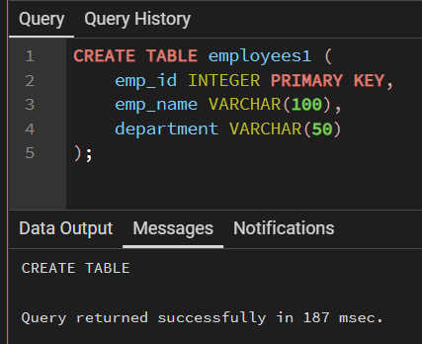

CREATE SEQUENCE emp_seq
START 1;
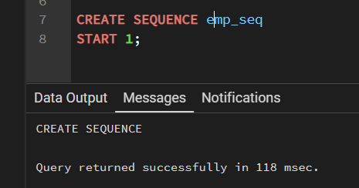

CREATE OR REPLACE FUNCTION auto_emp_id()
RETURNS TRIGGER AS $$
BEGIN
IF NEW.emp_id IS NULL THEN
NEW.emp_id := nextval('emp_seq');
END IF;
RETURN NEW;
END;
$$ LANGUAGE plpgsql;
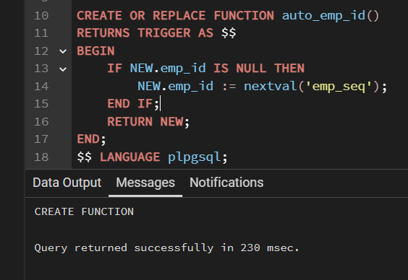

CREATE TRIGGER trg_auto_emp_id
BEFORE INSERT ON employees1
FOR EACH ROW
EXECUTE FUNCTION auto_emp_id();
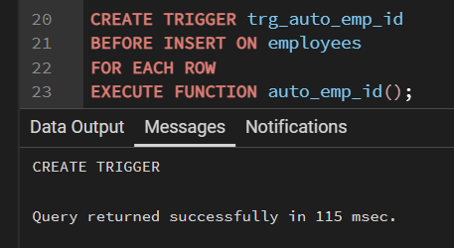

INSERT INTO employees1 (emp_name, department)
VALUES ('AliceD', 'HR');

INSERT INTO employees1 (emp_name, department)
VALUES ('Bob', 'IT');
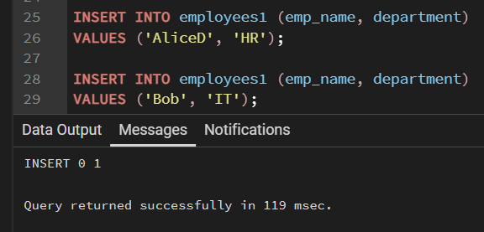

SELECT * FROM employees1;
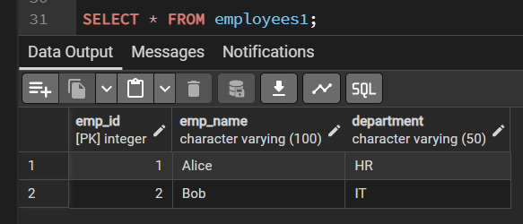

7. Learning Outcome
- Automation using Triggers: Learned how to eliminate manual primary key entry through trigger-based automation.
- Use of Sequences: Gained understanding of generating unique identifiers using database sequences.
- Maintaining Data Integrity: Learned how BEFORE INSERT triggers help validate and modify data before storage.
- Encapsulation of Logic: Understood how databases can independently manage key assignment without relying on application-level code.

