<https://www.youtube.com/watch?v=9gkY-QmGZp8&index=3&list=PLCzNdxETYFBWEkws8yC5boV8eoYwCycwo>

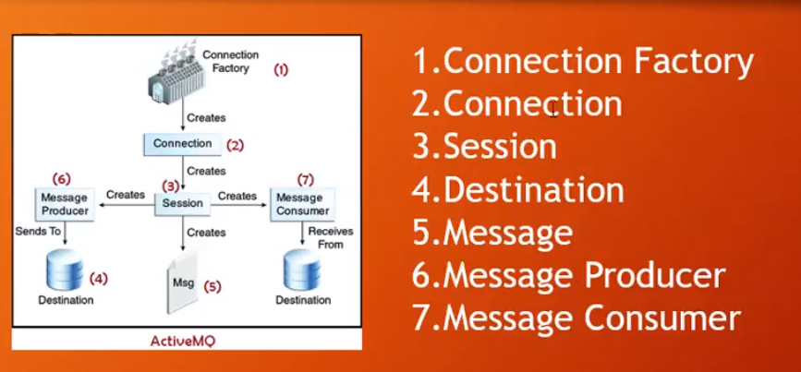

cd C:\activemq-5.15.8\bin

activemq start

activemq stop

cat C:\activemq-5.15.8\conf\activemq.xml

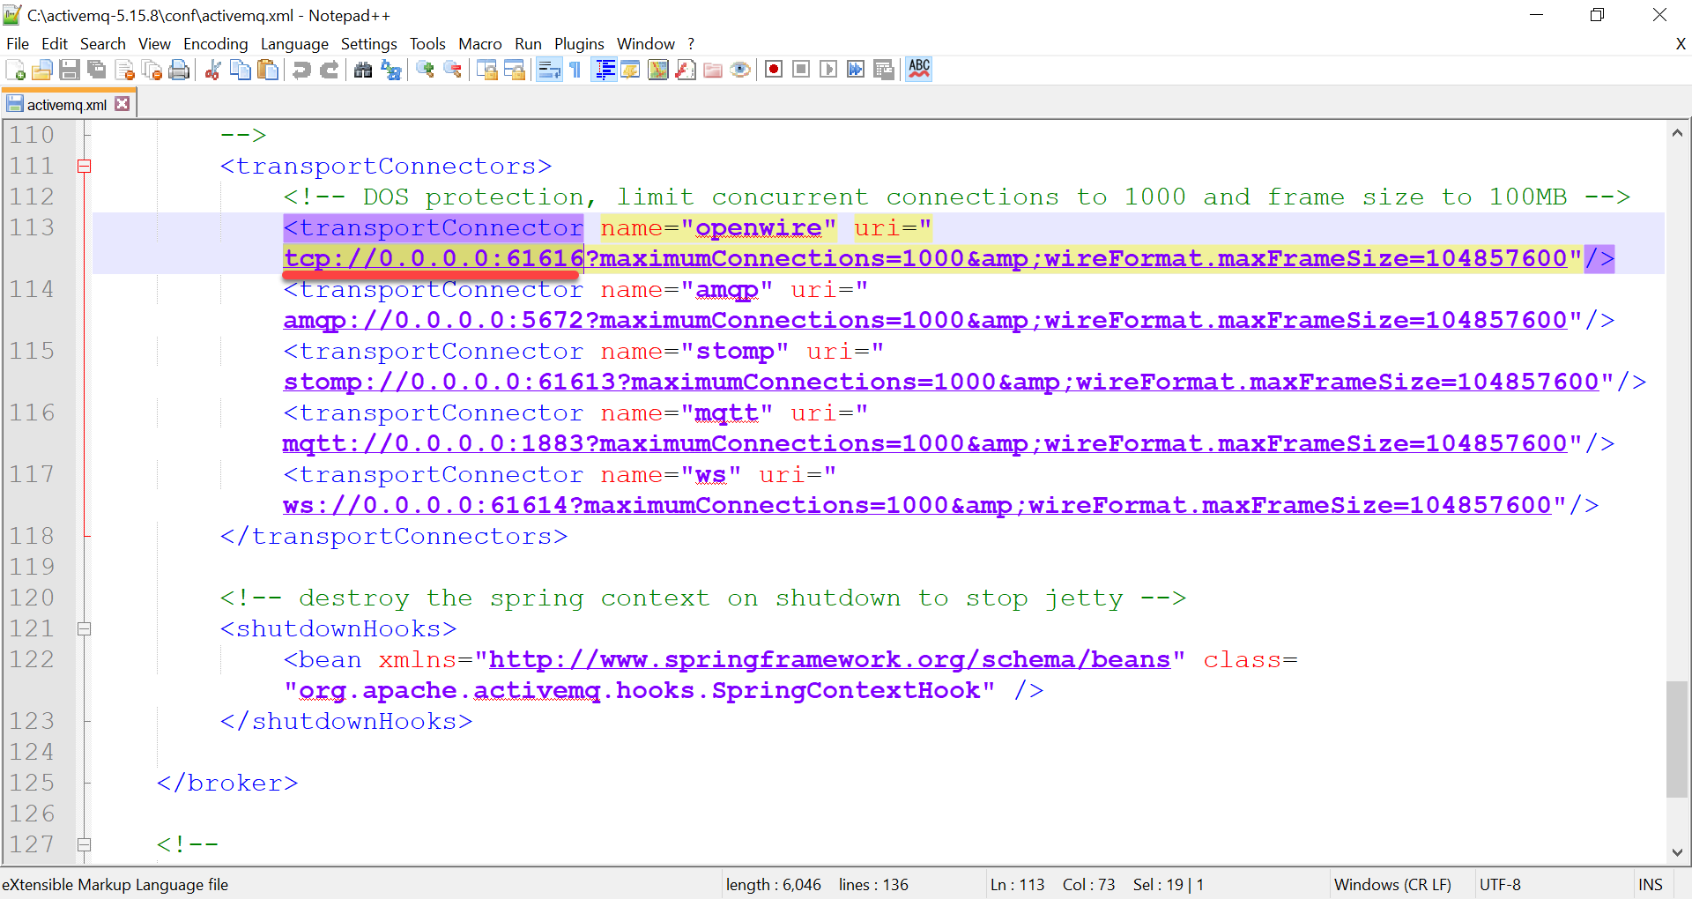

<project xmlns=*"http://maven.apache.org/POM/4.0.0"* xmlns:xsi=*"http://www.w3.org/2001/XMLSchema-instance"* xsi:schemaLocation=*"http://maven.apache.org/POM/4.0.0 http://maven.apache.org/xsd/maven-4.0.0.xsd"*>

<modelVersion>4.0.0</modelVersion>

<groupId>com.mimaraslan</groupId>

<artifactId>ActiveMQProducer</artifactId>

<version>0.0.1-SNAPSHOT</version>

<name>ActiveMQProducer</name>

<description>ActiveMQProducer</description>

<dependencies>

<!-- https://mvnrepository.com/artifact/org.apache.logging.log4j/log4j -->

<dependency>

<groupId>org.apache.logging.log4j</groupId>

<artifactId>log4j</artifactId>

<version>2.11.2</version>

<type>pom</type>

</dependency>

<!-- https://mvnrepository.com/artifact/org.apache.activemq/activemq-all -->

<dependency>

<groupId>org.apache.activemq</groupId>

<artifactId>activemq-all</artifactId>

<version>5.15.8</version>

</dependency>

</dependencies>

</project>

**package** com.mimaraslan.producer;

**public** **interface** JmsAbstract {

**public** **void** connection (String queueName) **throws** Exception;

**public** **void** send (String payload) **throws** Exception;

**public** **void** close () **throws** Exception;

}

**package** com.mimaraslan.producer;

**import** javax.jms.Connection;

**import** javax.jms.ConnectionFactory;

**import** javax.jms.Destination;

**import** javax.jms.Message;

**import** javax.jms.MessageProducer;

**import** javax.jms.Session;

**import** org.apache.activemq.ActiveMQConnectionFactory;

**import** org.apache.activemq.command.ActiveMQQueue;

**import** org.apache.log4j.Level;

**import** org.apache.log4j.Logger;

**public** **class** ActiveMQ **implements** JmsAbstract {

**private** **static** **final** Logger ***LOGGER*** = Logger.*getLogger*(ActiveMQ.**class**);

**private** **static** **final** String ***URL_BROKER*** = "tcp://127.0.0.1:61616";

**public** **static** **final** String ***QUEUE_JMS_TEST*** = "queueJmsTest";

**private** String payload;

**private** ConnectionFactory connectionFactory;

**private** Destination destination;

**private** Connection connection;

**private** Session session;

**private** Message message;

**private** MessageProducer producer;

**public** ActiveMQ() {

**this**.payload = "";

}

**public** **void** connection(String queueName) **throws** Exception {

***LOGGER***.log(Level.***INFO***, "ActiveMQ -> queue: " + queueName + ", url broker" + ***URL_BROKER***);

**this**.connectionFactory = **new** ActiveMQConnectionFactory(***URL_BROKER***);

**this**.destination = **new** ActiveMQQueue(queueName);

**this**.connection = **this**.connectionFactory.createConnection();

**this**.session = **this**.connection.createSession(**false**, Session.***AUTO_ACKNOWLEDGE***);

}

**public** **void** send(String payload) **throws** Exception {

***LOGGER***.log(Level.***INFO***, "ActiveMQ -> payload: " + payload);

**this**.payload = payload;

**this**.message = session.createTextMessage(**this**.payload);

**this**.producer = session.createProducer(destination);

producer.send(message);

}

**public** **void** close() **throws** Exception {

***LOGGER***.log(Level.***INFO***, "ActiveMQ -> close connection");

**if** (**this**.session != **null**) {

**this**.session.close();

}

**if** (**this**.connection != **null**) {

**this**.connection.close();

}

}

}

**package** com.mimaraslan;

**import** com.mimaraslan.producer.ActiveMQ;

**public** **class** ActiveMQProducerApp {

**public** **static** **void** main(String[] args) **throws** Exception {

ActiveMQ activeMQ = **new** ActiveMQ();

activeMQ.connection(ActiveMQ.***QUEUE_JMS_TEST***);

**for** (**int** i = 1; i <= 10; i++) {

activeMQ.send("LOLO selam soyledi." + i);

}

activeMQ.close();

}

}

