**Bold=unsure whether or not to include**

* **Our sample - Analysis of intervals and component processes in VTS only (because the rest of this involves switch rates and voluntary choice) using DDM (component processes paper)**
  + **DDM supports the idea that people prepare ahead of time**
  + **Supports proactive decisions in VTS**
  + **This now seems not very related to the rest of this stuff but it’s a lot of info that would beef up the dissertation**
* Our sample – sign. decline in SR in VTS
  + Related to decline in RT (and drift rate) – why? practice/fatigue/automatic processing?
  + Does it replicate?
* Frober E1 (double registrant VTS with reward) – examine whether decline replicates as well as whether the presence of reward might increase motivation, reducing fatigue and affecting the decline in SR
  + Presence of reward doesn’t change anything, decline is still present
* Frober E3 (80% explicit/20% voluntary double registrant with reward) – examine whether fewer choices might reduce decline in SR
  + Decline is eliminated, although this might be due to decreased power due to fewer number of trials to examine (only 64 voluntary trials here)
* Frober E1 first 64 trials – is the decline still present with a smaller number of trials?
  + Still present (and strong), previous result is likely not just due to reduction in power
* Our study first 64 trials – is the decline still present with a smaller number of trials?
  + Still present, more support, but I don’t know if this is a great comparison because the sample sizes are so different. **Todo: simulate smaller samples from our sample to make it more comparable to Frober (this might be overkill)**
* Braem – does the reduction/elimination of decline replicate in a 50/50 environment?
  + It does, effect is no longer present. Along with findings from Frober, suggests that decline in SR is not related to overall fatigue from just performing a task, but specific to decision fatigue that occurs from repeated task choices
  + Unrelated to prior conditioning of reward, although this affected mean SR
* Braem – can individual differences in decline inform anything more? Can the decline in SR provide information that overall SR cannot?
  + Yes – decline is correlated with BIS (not BAS), whereas mean SR is not.
* **Does the decline in SR mean that we shouldn’t be using mean SRs for voluntary tasks? In other words, does SR change enough throughout the task that the overall SR is no longer reliable?**
  + **We can test this by looking at the change in the split-half reliability of SR as a function of number of trials included.**
    - **We can look at two types of split-half reliability:** 
      * **splitting the data into random halves a bunch of times, then comparing the scores across halves – this is probably most useful for most purposes**
      * **splitting the data into the first half and the second half and comparing scores across those halves – this would maximize the effect of the SR decline on reliability.**
  + **We can look at this in our sample and in the Frober experiment 1 sample, although ours is much larger.**
  + **For both samples, random splits result in extremely good reliability that doesn’t decline over time:**

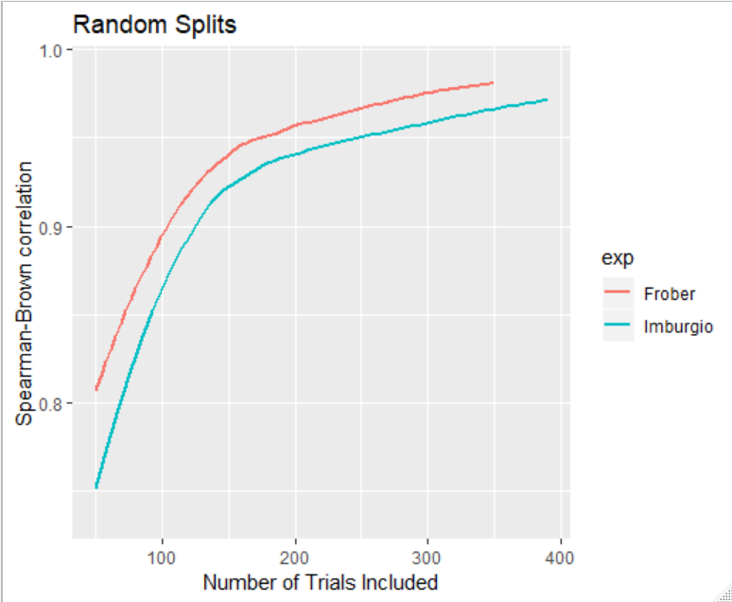

* + **For our sample, first-second half splits result in a peak in reliability at 150 trials followed by a decrease. In the Frober sample, a peak occurs at the same time, but the decrease is much less steep and is followed by an increase. It’s hard to reconcile the difference across the tasks, but it might be due to the presence of reward and other task differences.**
  + 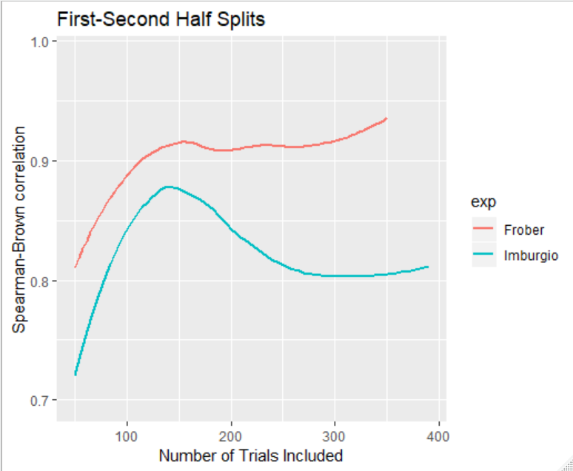
  + **Major takeaways from the reliability stuff:**
    - **both graphs seem to start to decline after 150 trials, although what happens after might be up for debate**
    - **Reliability after 100 trials is pretty good, even when you look at first vs second half after the big decline in our sample, so it doesn’t seem like using overall mean SR is a bad idea in any case.**
* **If I need more, we can get into the reliability of switch costs with increasing trial numbers (can do like above and look in both our sample and E1 from Frober)**