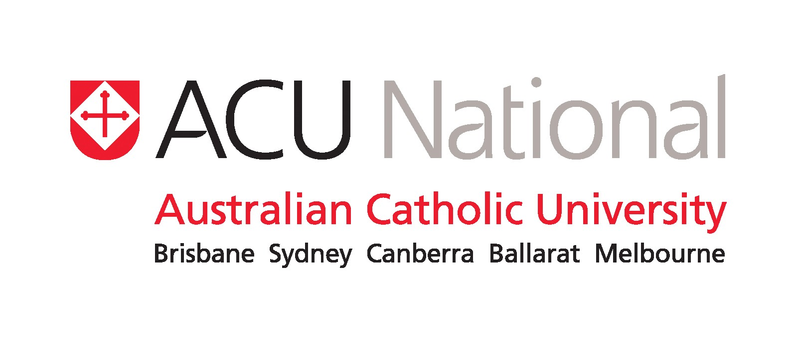
ACU National Naming Conventions for Asian Names

This brief guide is to assist staff creating records in the Raiser’s Edge relationship management database. If this guide does not address your particular question, please refer your query to the Database Administrator, Adam Terrey +61 2 9739 x2517 or adam.terrey@acu.edu.au.

Many cultures do not follow the Western convention of given (Christian) name followed by a single family name (Surname). Chinese, Korean, Japanese and Vietnamese names all appear with surname (family name) first. Non- Christian cultures have no concept of a ‘christian’ name, therefore we should get into the habit of referring to ‘Given’ name, Middle name and ‘Family’ name.

Chinese

- Mainland Chinese names (born and bred in China) tend to comprise two words – eg. Zhang Jiangguo, Li Yonghong, Wang Zhifu - the first name is the family name. (ie. surname).

- Taiwanese Chinese tend to hyphenate the given names - eg. Tsang Ting-Hwa, Huong Mei-Li, Hsia Hsia-Chu - the first name is again, the family name.

- Hong Kong, Singapore and Malaysian Chinese names tend to have three parts – eg. Cheung Fatt Fatt, Wong Lai Chai, Yong Ee Leen, Ong Ti Mah – the first name is the family name. In addition, Hong Kong, Singaporean Chinese (British-ruled provinces) have often adopted an English name (Gladys, Lily, Doris etc) in addition to their birth name, probably as a polite concession to English-speakers who cannot grasp the Chinese pronunciation or ordering correctly. This may appear at the beginning, or end of their birth name.

Examples:
- Tan Choon Keng – Dear Mr Tan, (formal greeting) Dear Keng (if we already know them)
- Yeung Wai Ngok Leopold – Dear Mr Yeung (formal greeting), Dear Leopold (informal)
Database Entry – Yeung (family name) Wai (given name) Ngok (middle) Leopold (preferred/ nickname)

The Chinese government has made a number of reforms to the Mandarin language to simplify it and this has affected name spelling conventions. As a consequence, Chinese people tend to be quite relaxed about spelling, naming order, adopting nicknames etc. In addition, there are not gender-specific names, as we are used to. Chinese women usually continue to use their own family name after marriage. Their status is indicated by using Mrs or Madam.

Eg. Mr Tan’s wife above, who was known prior to marriage as Teo Guek Hong, will be called Mrs Tan Guek Hong or Madam Teo.

All of these differences can create havoc for data entry purposes. Remember that professional Chinese people are very mobile, and therefore people living in Hong Kong may have been born on the mainland and visa versa. The geographical background, above, is simply to explain why the naming structure is different for Chinese people.

Recommendation: For the Hong Kong Graduates group, I suggest we develop a ‘Data Entry’ form that clearly captures gender, marital status, family name, preferred name, and ask specifically how they wish to be addressed.

Malay
Malay names are common in Malaysia and Singapore and reflect a Muslim culture. Family names as such have not existed in Malaysia, and names change from generation to generation, rather than record a lineage.

Names are written with the given name first, plus bin (son of) or binti (daughter of) followed by the father’s given name. Women often retain their own names after marriage, but use Puan (Mrs) to indicate their status. Polite address to a male is Encik (Mr), an unmarried woman is Cik (Miss) (NB. We do not need to worry about these titles for database purposes – it is more for conversation conventions in Malaysia.)

Eg. Bin Hassan - son of Hassan
Puan Rafidah binti Aziz - this is Rafidah, married daughter of Aziz
Abdul Rahman bin Mohamed Sidek - this is Abdul Rahman, son of Mohamed Sidek.

Malaysia also has a system of honorary titles - one reflects that they have undertaken a religious pilgrimage to Mecca (the Haj) – Haji and Hajjah (for women), and the other is granted by the government, and those who have this honour bestowed on them are highly revered VIP’s. It is a similar notion to our Australia and Queens Birthday Honour Lists. Examples of titles include: Dato, Datuk, Datin, Tan Sri , Puan Sri, etc. For data entry purposes, always use these honorary titles in the salutation – eg. Dato Jannie Tay, not Mrs or Ms Jannie Tay, and Haji Abu bin Bakar, not Mr Bakir.

Thai
Thai’s do not usually have middle names – they have a given name, followed by a surname. Their given name is usually quite long and will have a special meaning, as they have often been suggested by the local Buddhist monk. Surnames came into usage after 1913 when King Rama V1, who was educated in England, decreed that Thai people should adopt surnames. Families chose words with positive associations (prosperity, blessings etc) and names of important ancestors. During registration, families could be asked to modify their choice, so further syllables were often added to avoid duplication. This practice accounts for the extremely lengthy names in Thailand. Databases need to be able to accommodate 20 letters to cope with the general length of Thai names.

Indonesians
Indonesians may have only one name. To conform to Western conventions they may use this for both their first and last name. Naming differs around the country, with many Javanese having only one name; North Sumatrans have clan names instead of family names; and some Chinese Indonesians have Chinese-style names.
Men and women have a given name and take the name of their father. Married women may take the father’s name of their husband and add after their own father’s name.

Vietnamese
As a general rule, smaller countries like Vietnam have more pride and tradition around their naming conventions, and regional variations will affect pronunciation. The middle name also reveals the gender of the Vietnamese person. This is helpful in determining the ‘Salutation’ field. Male middle names include Văn, Hữu, Đuc, Công, Quang and many others. The majority of women have Thi as their middle name

The given name is the primary form of address, even in formal situations.
Eg. Truong Van Cao.
Database Entry – Cao (given name) Van (male person) Truong (family name).
Salutation : Mr Cao.

Women (in Vietnam) keep their family name after marriage, but if marrying in Australia they usually take their husband’s family name.
The most common Vietnamese family names are: Le, Tran or Nguyen (pronounced ‘Win’) Other family names include: Hoang, Pham, Phan, Dang, Do, Ho, Duong.

Hindu
Hindu names are found in India, Sri Lanka, Singapore and wherever people of Indian origin have migrated.

Hindus from Northern India have given name first, followed by family name, as in Australia. Women usually take their husband’s family name.
Eg. Manju Rani Agraval, Deepank Gupta, Maneesh Mathur, Mahesh Kumar Sharma.

Hindus from Southern India do not use surnames. They have their father’s given name first, followed by the person’s given name. Women take their husband’s given names on marriage.
Eg. Arun Sivam. Salutation - Mr Sivam.
Mr Sivam’s wife – maiden name Miss R Selvarajan - would become Mrs A Sivam or Mrs Sivam Selvarajan.

Recommendation: Always ask to clarify husband’s name before entering a record - do not assume what it is.

Sikhs (traditional turban wearers) use Singh (lion) and Kaur (princess) in addition to their names.
Eg. Joginder Singh (Mr Jogindar Singh)
Jaspal Kaur, married to Jogindar Singh (Mrs Jogindar Singh)

Sources:
- Success with Asian names, by Fiona Swee-Lin Price. Allen & Unwin 2007
- Edith Cowan University - Singapore Briefing Notes, Faculty of Computing Health & Science
- University of South Australia - What Do I call You? An Introduction to Chinese, Malay and Hindu Names.
- Australian Federal Police website. (interesting information on Vietnamese criminals!)
- Wikipedia

