**VIRUS – PROBLEM!**In this problem, we have to find the total number of blocks covered by the virus in Nth time,

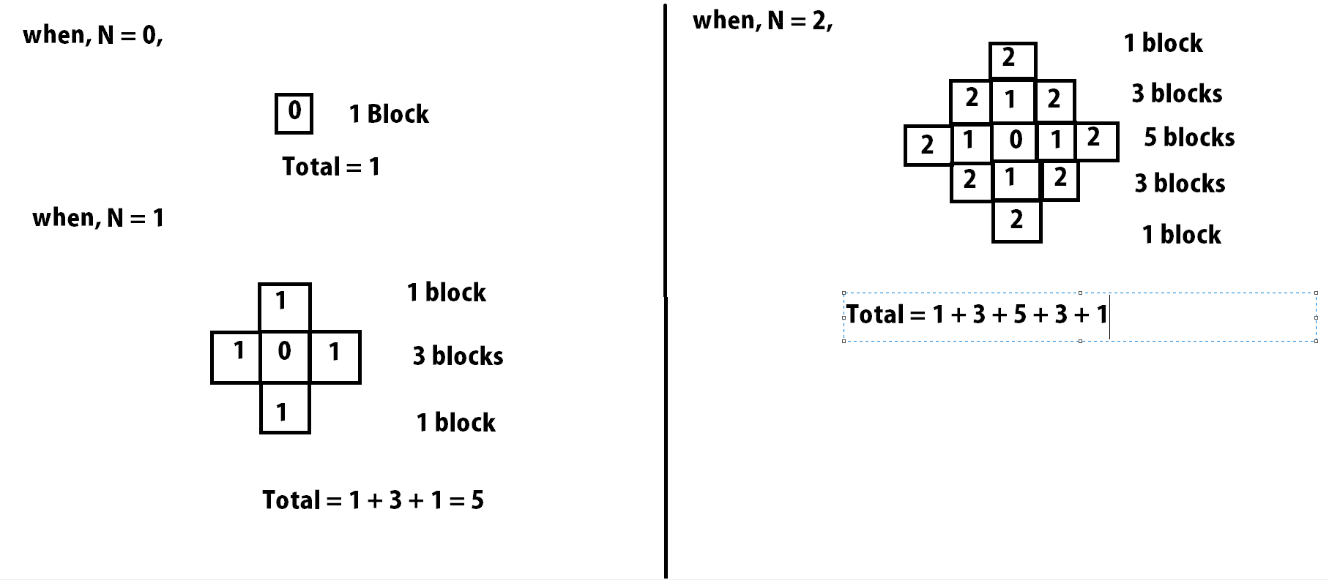

From this, we can see, for N = 0, Total = 1

N = 1, Total = 1 + 3 + 1

N = 2, Total = 1 + 3 + 5 + 3 + 1

N = 3, Total = 1 + 3 + 5 + 7 + 5 + 3 + 1

&, So on..............

So, assuming, the number of blocks N = 3, we can see, Total = 1 + 3 + 5 + 7 + 5 + 3 + 1

= (1 + 3 + 5 + 7) + (1 + 3 + 5)

= (Summation of 4(N+1)blocks)+(Summation

of 3(N) blocks)

As, the increment is of odd numbers, So the summation is,  
 = (N)2  + (N+1)2

So, for the 92312th Time,

Total = (92312)2 + (92312+1)2

= 17043195313 (Ans).