  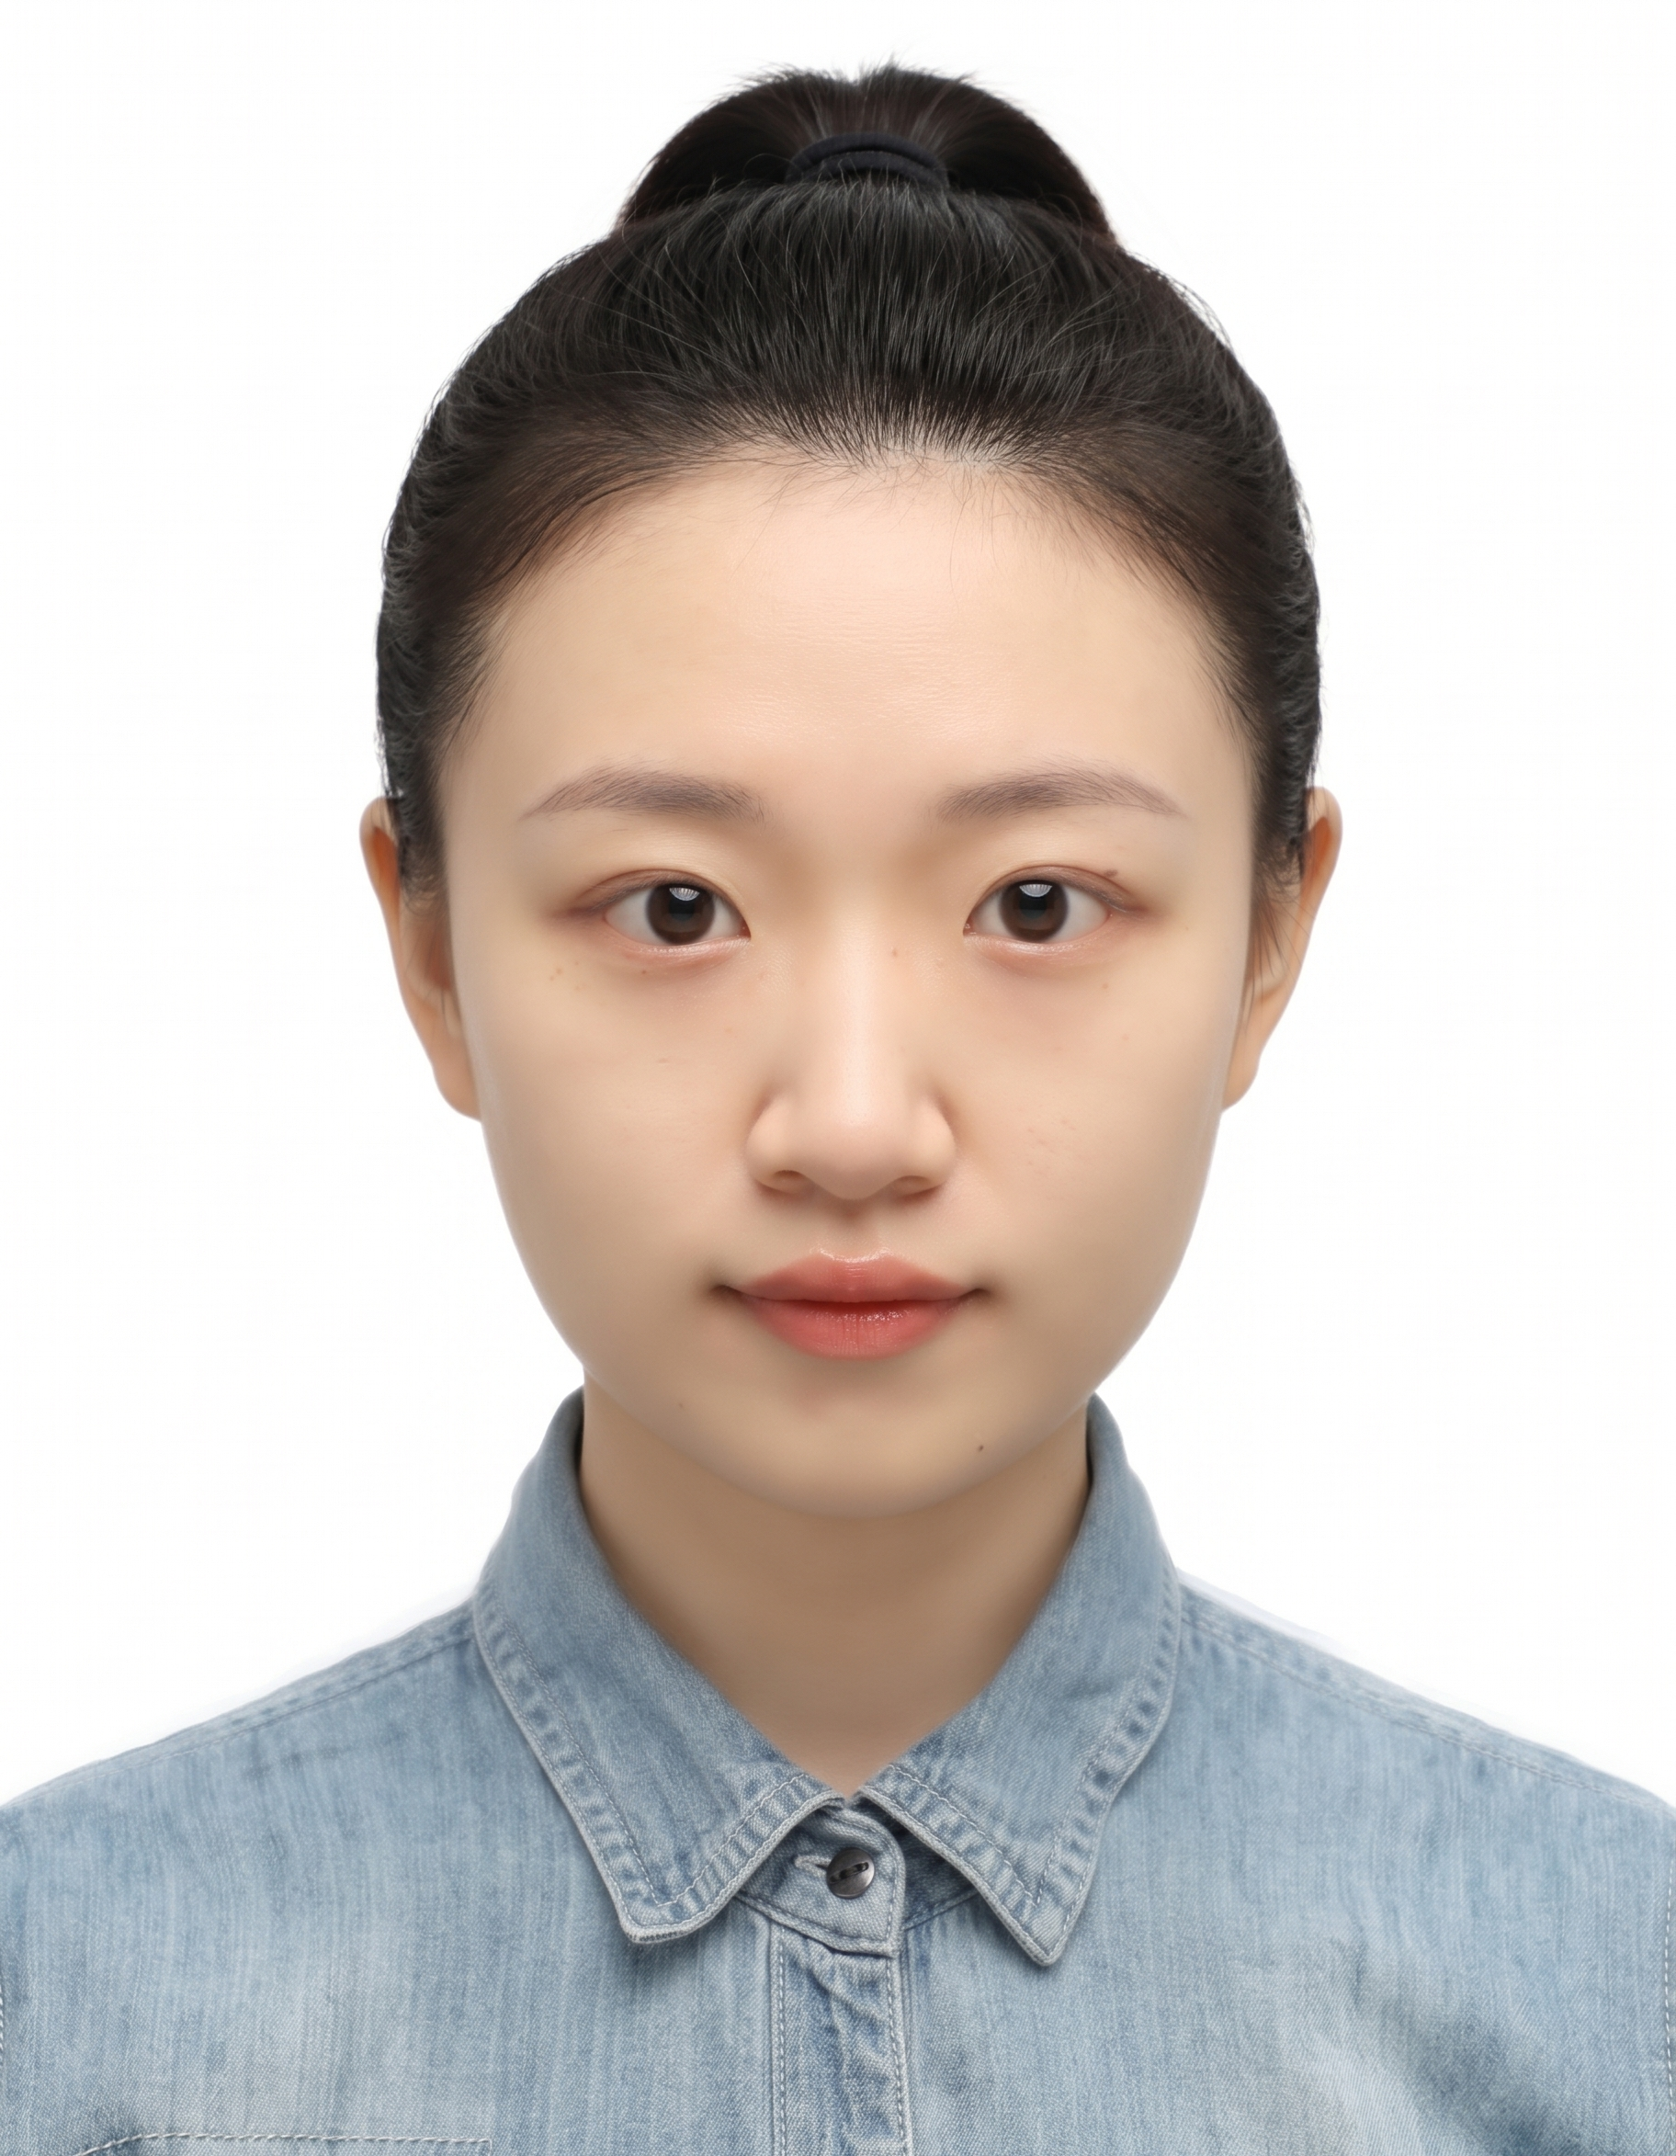  Email @  mymy@tju.edu.cn  Tel number:  +86 187 0516 7716 | Yi Ma  Ph.D. Candidate 丨 Tianjin University  Energy Systems Research | Integrated PV–Storage & LowCarbon Energy Systems  Research Field and Career Objective  Ph.D. candidate at Tianjin University with interdisciplinary training in architecture and environmental engineering. Research experience includes integrated PV–electricity–storage systems, zerocarbon campus retrofit, energy auditing, and lifecycle sustainability assessment.  My research focuses on quantitative analysis of energy systems and lowcarbon solutions, with an interest in translating modelling, optimisation, and datadriven methods into practical engineering applications.  Seeking applied R&D or industrylinked postdoctoral opportunities in integrated energy systems, renewable energy integration, and energy management.  Education Experience  Selected R&D Projects  Technical Skills  International Exchange  Selected Publications  - Yi Ma, Li Zhu. Explainable Data-Driven Generation, Screening, and Selection of Energy Retrofit Strategies for Aged Residential Communities: An Archetype-Adaptive Framework.Energies, 2026. JCR Q2  - Yi Ma, Li Zhu.A Comprehensive Framework for Life Cycle Sustainability Assessment of Building Integrated PEDF Systems. 11th Applied Energy Symposium: Low Carbon Cities & Urban Energy Systems (CUE2025). EI Scope  - Bing Liu, Tiangang Lv, Jun Wu, Li Zhu, Yi Ma*. Research Progress of PEDF Technology Based on Life Cycle Assessment Theory of Building: Technological Innovation, Analysis of Sustainable Oriented Inventory, Development Prospects.” International Conference on Green Building, 2025. EI Scope  - Yi Yang, Yi Ma, Tingting Huang, Xiaoming Song, Lingyan Zhu. Promoted removal of petroleum hydrocarbons from contaminated soils using Pickering emulsions stabilized by cellulose nanocrystals prepared from rice straw. Science of the Total Environment, 2024. JCR Q1.  - Yi Ma. Interaction Mechanisms between Cellulose Nanocrystals and Petroleum Hydrocarbons. Master’s Thesis, Nankai University, 2023.  - Kunkun Wang, Yi Ma, Binbin. Sun, et al. Transport of silver nanoparticles coated with polyvinylpyrrolidone of various molecular sizes in porous media: Interplay of polymeric coatings and chemically heterogeneous surfaces. Journal of Hazardous Materials, 2022, 429.  - Yihan Li, Tian Jiang, Xu Zhou, et al. Mechanism of thermally activated persulfate oxidation for degradation of carbadox and olaquindox in aqueous solution. Acta Scientiae Circumstantiae, 2019, 39(11). [the former name of Yi Ma is Yihan Li.]  Selected Patents  - Preparation Method of Cellulose Nanocrystals. 2023. Granted invention patent. First student inventor.  - Application of Cellulose Nanocrystals. 2023. Granted invention patent. First student inventor.  - Preparation Method and Application of an Environmentally Friendly, High-Efficiency Cleaning Agent for Antibiotic Removal. 2019. Granted invention patent. Sole inventor.  Selected Award and Honors  Email @  mymy@tju.edu.cn  Tel number:  +86 187 0516 7716  Ph.D. Study, Tianjin University (Sep 2023-present)  - Third Prize, The 3rd ISETSESCAP & 4th ISETS Global Competition of Youth Voice on Energy Transition ( in East Asia Region).  - SecondClass Academic Scholarship, Tianjin University.(20252026)  - SecondClass Academic Scholarship, Tianjin University.(20242025)  - Special Scholarship for Art and Sports Activities, Tianjin University.  M.Eng. Study, Nankai University ( Sep 2020-Jun 2023)  - First Prize, 2nd National LowCarbon and Circular Technology Competition, Graduate Division  - Second Prize, Nankai University Freshman Scholarship  - Individual Scholarship, Nankai University  B.Eng. Study, Nanjing Agricultural University ( Sep 2016-Jun 2020)  - Outstanding Undergraduate Graduate, Nanjing Agricultural University  - Second Prize, Jiangsu Provincial Mathematics Competition  - FirstClass Scholarship for Outstanding Students  - Excellence Award, EcoHouse Design Competition
  Sep 2023–Present | Ph.D. Candidate in Architecture  School of Architecture & APEC Sustainable Energy Center, Tianjin University
  Sep 2020–Jun 2023 | M.Eng. in Environmental Engineering  School of Environmental Science and Engineering, Nankai University
  Sep 2016–Jun 2020 | B.Eng. in Environmental Engineering  School of Resources and Environmental Sciences, Nanjing Agricultural University  • GPA: 3.94/4.00; top 10%; recommended for graduate admission without master entrance examination to Nankai University.
  Project Assistant 丨 Integrated PV–Electricity–Storage Systems
  the Chinese Academy of Engineering.
  Sep 2024-Oct 2025
  Technology Pathways and Industry–University–Research Cooperation Strategies for Integrated PEDF System
  Strategic Research and Consulting Project of the Chinese Academy of Engineering)
  Key responsibilities: data research, power system modeling, and report drafting
  Project Assistant 丨ZeroCarbon Campus Retrofit
  Three Gorges Electric Power Co., Ltd.
  July 2023-Dec 2025
  Key Technologies and Application Demonstration of Novel Energy Systems for ZeroCarbon Retrofit of Existing Campuses (Package I&II)
  Key responsibilities: Conducted data research, prepared reports, and published two research papers based on the project.
  Project Leader | Energy Audit and Conservation Evaluation of Tianjin University
  Tianjin Municipal Development and Reform Commission&Tianjin University.
  Nov 2023 – Sep 2024
  Data research, project management, energy consumption analysis, energysaving recommendations, and report drafting
  - Programming & Data Analysis
  Python; MATLAB/Simulink; data processing, analysis, and visualisation.
  - Energy System Modelling & Digital Tools
  Energy system simulation using EnergyPlus or TRNSYS; Rhino/Grasshopper for modelling and computational design.
  - Applied Research Methods
  Machine learning and deep learning; multi-objective optimisation; surrogate modelling and uncertainty analysis; life-cycle assessment (LCA); techno-economic analysis (TEA); measured-data analysis; experimental and system validation.
  - Engineering & R&D Execution
  Energy auditing and conservation evaluation; technical report preparation; project leadership.
  - Languages
  English — Professional working proficiency; able to work and live comfortably in a fully English-speaking environment.
  SepOct 2025
  Visiting Scholar 丨 Slovak University of Technology in Bratislava, Slovakia
  funded by the European Union’s Erasmus+ Programme.
  July 2025
  Presenter 丨 Low Carbon Cities & Urban Energy Systems (CUE2025), Kitakyushu, Japan
  attended the international symposium and delivered the academic presentation.
  Nov 2026
  Attendee 丨 15th International Forum on Energy for Sustainable Development

