Portfolio

Ma Yi
Ph.D. Candidate Tianjin University
E-mail：
mymy@tju.edu.cn
maylis.ma.0029@gmail.com

Contents
00 My Cover Letter 3
01 Personal Details 4
Education Experience 4
Skills 4
Publications and Patents 5
International Experience and Recognition 6
Research Positioning 8
Career Direction and Contact 9
02 Projects 10
Project 1 10
Project 2 11
Project 3 12
03 Doctoral Research and Selected Studies 13
Research of Doctoral Thesis 13
Selected Paper 1 14
Selected Paper 2 15


00 My Cover Letter
Hi, this is Ma Yi(马弋). In Chinese, my name sounds similar to the word “ant”(蚂蚁), and actually, during my student years, I literally was as restless as an ant, digging and exploring in one field after another, and excited about every shinning unknown.
At the age of 16, I took the college entrance examination and began my studies in environmental engineering. During my undergraduate and master's studies, my research focused on peroxide-based degradation technologies and nanoscale surfactant systems, respectively. At the age of 23, I began my doctoral studies at the School of Architecture, one of Tianjin University's leading schools, while also receiving academic training at the APEC Sustainable Energy Center (APSEC). My doctoral research focuses on low-carbon transformation of the built environment and integrated energy systems in the context of urban renewal.
In this process, I have been deeply involved in a number of important projects, including the consulting project of the Chinese Academy of engineering and the approval project of the Tianjin Development and Reform Commission. My work involves the simulation of the integrated optical storage system, the design of the zero carbon campus transformation scheme, the writing of the energy audit report, and the actual verification based on the actual demonstration platform. In the autumn of 2025, invited by the Erasmus+ project of the European Union, I went to Europe as a visiting scholar for academic exchanges on household energy storage and new energy technologies. These valuable experiences made me realize that in the era of entropy increase, the low-carbon transformation should be rooted in the interpretation of specificity and adaptability. How to combine the characteristics of the demand side and the supply side, and make the energy system take into account efficiency, flexibility, reliability and user comfort through dynamic modeling, collaborative operation and intelligent management, is a problem worthy of continuous exploration. Therefore, my research has gradually expanded from building performance and reconstruction evaluation to optical storage system integration, source storage load collaborative operation and other issues. In this way, I firmly set my career goal: to develop transparent, portable and engineering deployment potential methods to serve energy storage and energy enabled low-carbon energy systems, focusing on energy management systems, demand response, distributed energy integration and grid friendly applications.
In terms of scientific research accumulation, I have published 7 academic papers, including 3 SCI papers and 2 EI papers and 2EI scope conference paper, and there are another 2 papers are under review; At the same time, I also applied for 3 invention patents and 5 design patents. For me, these achievements are not only a periodic record of past exploration, but also a process of continuous learning, verifying ideas and putting them into practice.
And now, at the age of 26, I filled my pocket with courage, ready to meet this vast world.
Thank you for reading.

Ma Yi

01 Personal Details

Education Experience
Time | Education
Sep 2023–Present | Ph.D. Candidate in Architecture  School of Architecture & APEC Sustainable Energy Center, Tianjin University
Sep 2020–Jun 2023 | M.Eng. in Environmental Engineering  School of Environmental Science and Engineering, Nankai University
Sep 2016–Jun 2020 | B.Eng. in Environmental Engineering  School of Resources and Environmental Sciences, Nanjing Agricultural University  • GPA: 3.94/4.00; top 10%;  Recommended for graduate admission without master entrance examination to NKU.

Skills

Overview
Capability | Methods and Tools(and Evidence)
Energy System Modelling | EnergyPlus, TRNSYS, MATLAB Simulink, system modelling  Doctoral research on integrated PV-storage systems; system-level analysis for the Tianjin University energy audit; technical-report contributions to a zero-carbon campus retrofit project(Doctoral Thesis, page 13).
Programming and Data | Python and MATLAB for data processing, measured-data analysis, model implementation, and visualisation  Campus energy-consumption database and audit calculations; measured-data analysis in integrated PV-storage research(Project 3, page 12); explainable data-driven research on retrofit strategy generation and screening(Paper 1, Page 14).
Optimisation | Multi-objective problem formulation; cost-carbon-performance trade-off analysis; surrogate modelling; sensitivity and uncertainty analysis  Data-driven retrofit strategy research; ongoing development of a multi-objective PV-storage-distribution coordination concept and related invention-disclosure materials(Paper1&2, Page 14/15).
Assessment and Validation | LCA, TEA, energy auditing, experimental validation  Energy audit and conservation evaluation of Tianjin University(Project 2, Page 11); life-cycle sustainability framework for building-integrated PEDF systems(Paper 1, Page 14);
R and D Execution | Project planning and task allocation; stakeholder and data coordination  Team leader for the Tianjin University energy audit; principal drafter of Chapter 2 for a Chinese Academy of Engineering consulting project(Project 1, Page 10);

Software and Technical Environment

Primary Working Tools
- Python Data processing, analysis, visualisation, and datadriven research workflows.
- MATLAB/Simulink Energysystem modelling, model implementation, and system behaviour analysis.
- Microsoft Excel Multisource data cleaning, energy accounting, scenario comparison, and technoeconomic calculations.

ProjectBased Modelling Tools
- EnergyPlus / TRNSYS Building and energysystem simulation.
- Rhino / Grasshopper Geometric modelling and computational design workflows.

Methods in Active Research Development
- Machine learning and deep learning
- Multiobjective optimisation
- Surrogate modelling
- Sensitivity and uncertainty analysis
- Lifecycle assessment and lifecycle sustainability assessment
- Technoeconomic assessment

Working Style

From question to evidence
I begin by defining the decision question and system boundary, establish a traceable data workflow, compare alternatives against a clear baseline, and validate conclusions using measured data, standards, or engineering checks.

Cross-disciplinary collaboration
I work across architecture, environmental engineering, building services, and energy systems, aligning assumptions and translating disciplinary inputs into a consistent system-level analysis.

Decision-oriented communication:
I translate technical findings into decision-ready evidence through clear visualization, quantified trade-offs, implementation priorities, and reports tailored to researchers, engineers, and project owners.

Dual-check mechanism
From simple tasks like packing my luggage when going out to major tasks like submitting a thesis, I always ensure that everything is verified twice on different days; this greatly reduces the likelihood of me making mistakes.

Publications and Patents

Selected Publications
- Yi Ma, Li Zhu. Explainable Data-Driven Generation, Screening, and Selection of Energy Retrofit Strategies for Aged Residential Communities: An Archetype-Adaptive Framework.Energies, 2026. JCR Q2
- Yi Ma, Li Zhu.A Comprehensive Framework for Life Cycle Sustainability Assessment of Building Integrated PEDF Systems. 11th Applied Energy Symposium: Low Carbon Cities & Urban Energy Systems (CUE2025). EI Scope
- Bing Liu, Tiangang Lv, Jun Wu, Li Zhu, Yi Ma*. Research Progress of PEDF Technology Based on Life Cycle Assessment Theory of Building: Technological Innovation, Analysis of Sustainable Oriented Inventory, Development Prospects.” International Conference on Green Building, 2025. EI Scope
- Yi Yang, Yi Ma, Tingting Huang, Xiaoming Song, Lingyan Zhu. Promoted removal of petroleum hydrocarbons from contaminated soils using Pickering emulsions stabilized by cellulose nanocrystals prepared from rice straw. Science of the Total Environment, 2024. JCR Q1.
- Yi Ma. Interaction Mechanisms between Cellulose Nona-crystals and Petroleum Hydrocarbons. Master’s Thesis, Nankai University, 2023.
- Kunkun Wang, Yi Ma, Binbin. Sun, et al. Transport of silver nanoparticles coated with polyvinylpyrrolidone of various molecular sizes in porous media: Interplay of polymeric coatings and chemically heterogeneous surfaces. Journal of Hazardous Materials, 2022, 429.
- Yihan Li, Tian Jiang, Xu Zhou, et al. Mechanism of thermally activated persulfate oxidation for degradation of carbadox and olaquindox in aqueous solution. Acta Scientiae Circumstantiae, 2019, 39(11). [the former name of Yi Ma is Yihan Li.]

Selected Invention Patents
- Preparation Method of Cellulose Nano-crystals. 2023. Granted invention patent. First student inventor.
- Application of Cellulose Nano-crystals. 2023. Granted invention patent. First student inventor.
- Preparation Method and Application of an Environmentally Friendly, High-Efficiency Cleaning Agent for Antibiotic Removal. 2019. Granted invention patent. Sole inventor.

International Experience and Recognition

International Experience

Slovak University of Technology in Bratislava, Slovakia
- Visiting Scholar | Sep-Oct 2025
Completed an Erasmus+-funded visiting-scholar programme supported by the European Union. Participated in academic exchange, research discussions, and cross-cultural collaboration in an international research environment, strengthening the ability to communicate and work professionally in English.

Low Carbon Cities & Urban Energy Systems Symposium (CUE2025) | Kitakyushu, Japan
- Conference Presenter | July 2025
Presented A Comprehensive Framework for Life Cycle Sustainability Assessment of Building-Integrated PEDF Systems to an international audience. The presentation introduced a system-level framework for evaluating the environmental, economic, and social performance of integrated PV-electricity-storage systems.

15th International Forum on Energy for Sustainable Development
- Invited Attendee | Nov 2026
Invited to attend the forum following the team’s Third Prize in the East Asia Region of the 3rd ISETS-ESCAP & 4th ISETS Global Competition of Youth Voice on Energy Transition. The forum provides an opportunity to exchange ideas with international researchers, policymakers, and industry practitioners working on sustainable energy and energy-transition solutions.

Selected Recognition
- Third Prize, East Asia Region | ISETS-ESCAP Global Competition of Youth Voice on Energy Transition | 2026
Recognized for developing and communicating an interdisciplinary proposal addressing practical challenges in the energy transition.
- Second-Class Academic Scholarship | Tianjin University | 2024-2026
Awarded in two consecutive academic years in recognition of doctoral research performance and academic achievement.
- First Prize, Graduate Division | 2nd National Low-Carbon and Circular Technology Competition | 2023
Recognised for applying environmental engineering knowledge to low-carbon and circular-technology problem solving.

Professional Communication
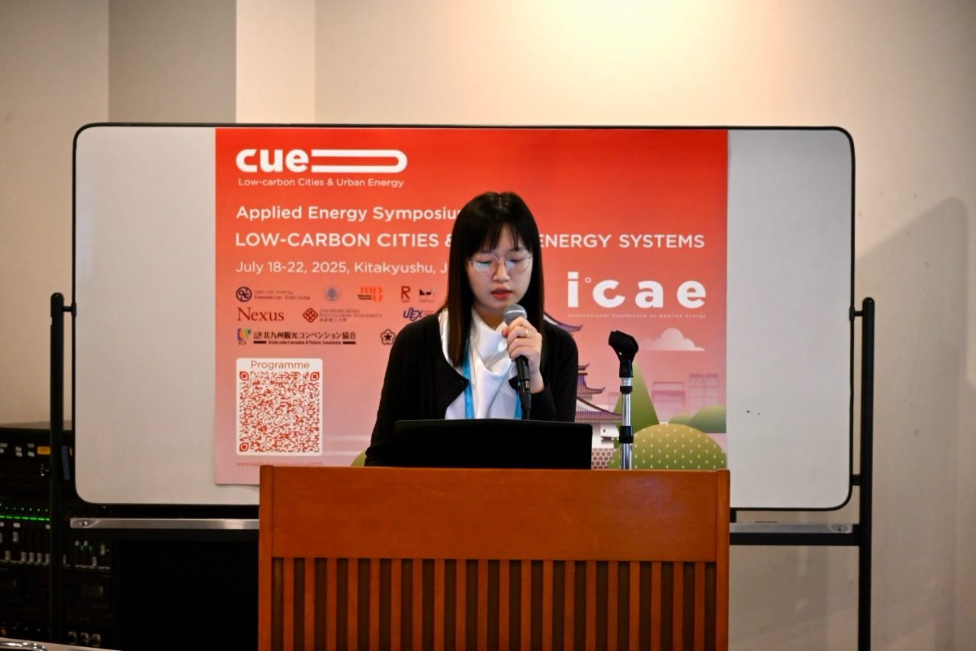  ICAE | 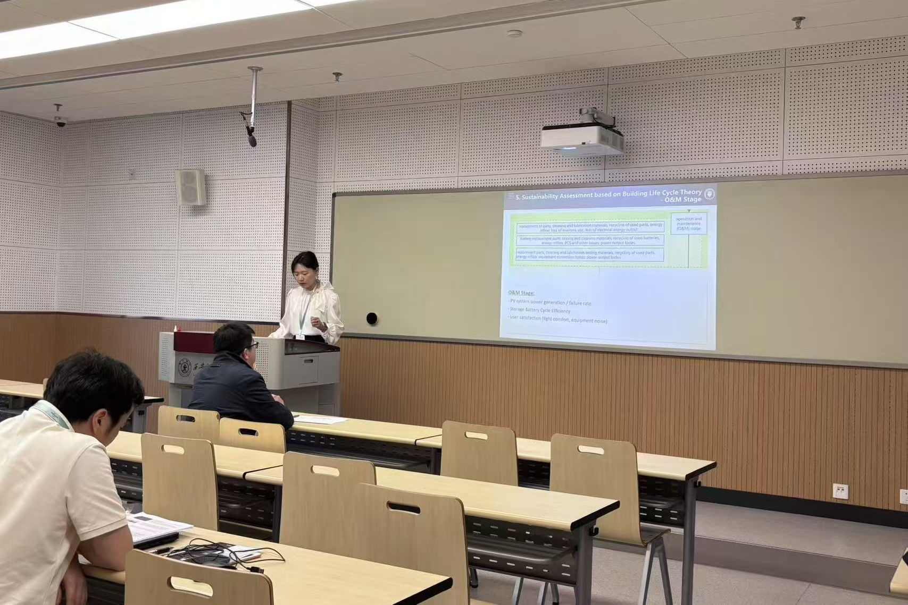  ICoGb
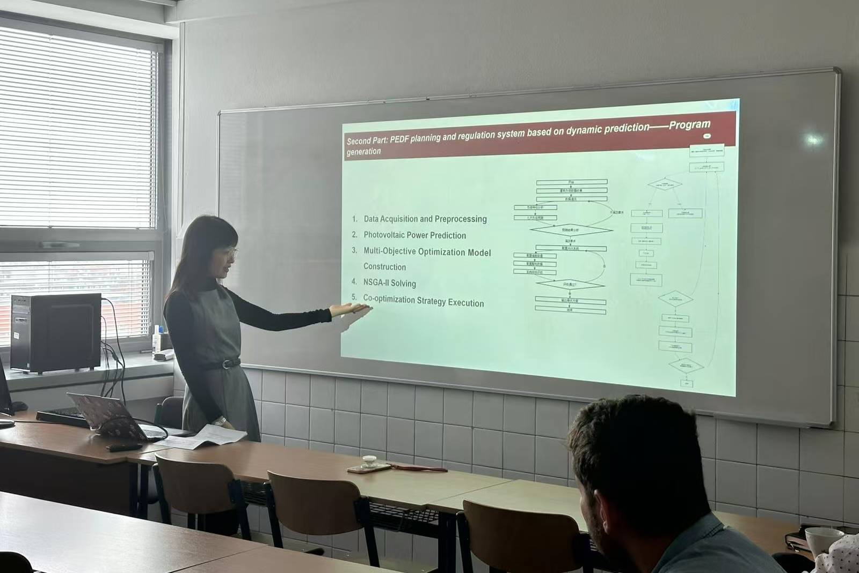  Visiting Scholar | 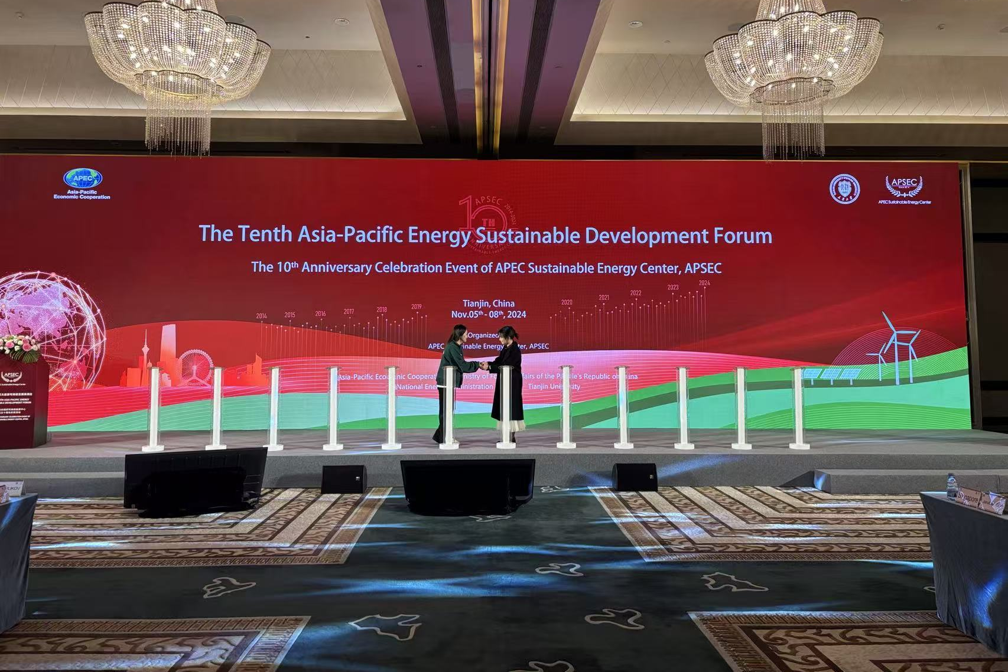  The 10th APSEC Development Forum

Research Positioning

Research Positioning
Core Domain
PV–storage integration and coordinated generation–storage–load operation for low-carbon buildings, campuses, and communities
Methods
Energy-system modelling and simulation, measured-data analysis, multi-objective optimisation, and uncertainty analysis
Validation
Measured operational data and physical demonstration platforms, supported by life-cycle and techno-economic assessment
Application Direction
Storage-enabled EMS, demand response, distributed energy integration, and grid-interactive low-carbon systems

Selected Evidence
- Developing explainable methods for evaluating and selecting integrated PV–storage retrofit strategies for aged residential communities, linking scenario generation, energy simulation, optimisation, and decision support.（P
- Developed modelling and optimisation workflows validated with measured data from a physical demonstration platform, enabling quantitative comparison of energy, carbon, and economic performance across alternative system configurations.
- Received an East Asia regional award in the 3rd ISETS–ESCAP & 4th ISETS Global Competition of Youth Voice on Energy Transition and was invited to participate in the 15th International Forum on Energy for Sustainable Development.

Career Direction and Contact

From Research to Application
My next research direction is to extend my experience in integrated PV-storage systems and source-storage-load coordination towards deployable storage and energy-management applications. I am particularly interested in R&D problems involving BESS operation, EMS development, renewable-energy integration, demand response, and grid-interactive low-carbon systems. My preferred work combines system modelling and optimisation with measured data, experimental or demonstration-platform validation, and life-cycle and techno-economic assessment. I value collaborative environments where universities, technology companies, utilities, and engineering teams jointly translate research methods into verifiable system performance and practical implementation. I welcome technical conversations and potential collaboration on modelling, control, assessment, and validation for integrated energy and storage systems.

Target Directions
- International Industry R&D Battery energy storage systems, EMS, renewableenergy integration, and sourcestorageload coordination.
- IndustryLinked Postdoctoral Research Applied research leading to demonstrable prototypes, validated methods, or deployable system outcomes.
- Technical and Research Collaboration Energysystem modelling, multiobjective optimisation, datadriven analysis, lifecycle and technoeconomic assessment, and engineering validation.

Contact

Email
mymy@tju.edu.cn
maylis.ma.0029@gmail.com

Portfolio
https://mimi0029.github.io

  portfolio QR code |   Whatsapp |   Wechat

02 Projects

Project 1
Strategic Assessment of PEDF Building Development in Tianjin
Note: this is a part of the project “Technology Pathways and Industry–University–Research Collaboration Strategies for Integrated PV–Storage Systems”.

Period
April 2023 – September 2024.
Organisation
Strategic Research and Consulting Project of the Chinese Academy of Engineering
Project Type
Engineering strategy research · Technical and policy consulting · Stakeholder research

Overall content of work
Deploying PV–storage–DC–flexible building systems requires more than the availability of individual technologies. Regional implementation depends on local supply chains, building conditions, grid interaction, technical standards, market acceptance and supporting policies. This project examined whether Tianjin possessed the technical and industrial foundations required for wider deployment and which barriers were limiting implementation. The principal challenge was that relevant evidence was fragmented across policy documents, engineering cases, technology suppliers, design institutes and research organisations. A structured assessment was therefore needed to connect regional low-carbon building progress with the actual readiness of PV, storage, DC distribution and flexible energy management applications.
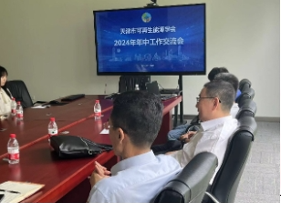  Survey Talk | 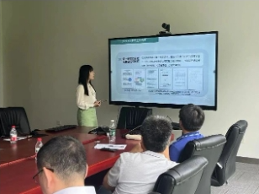  Conference

My Contribution
- Developed the stakeholder survey framework and structured question sets covering technology deployment, engineering cases, material supply, system integration, economic feasibility, standards and policy support.
- Synthesised evidence from policy documents, technical literature, engineering cases and stakeholder interviews, including information from design, engineering and applied research organisations.
- Served as a principal drafter of Chapter 2, organising the evidence into three analytical sections: regional low-carbon development, foundations for PV–storage–DC–flexible buildings, and strategic opportunities.

Project 2
Campus-Scale Energy Audit and Retrofit Assessment for Tianjin Universityin 2023
Period
December 2023 – July 2024; Audit year: 2022; comparison year: 2021.
Organisation
Tianjin University · APEC Sustainable Energy Center; Conducted under the 2023 Energy Audit Plan for Key Energy-Using Units issued by the Tianjin Municipal Development and Reform Commission.
Project Type
Regulatory energy audit · Campus energy assessment · Retrofit feasibility study

Overall content of work
There are significant differences between the new and old campuses of Tianjin University in terms of construction dates, heating methods, and energy supply structures. The audit work involves transforming scattered information such as energy bills, metering records, building inventories, equipment parameters, and energy management documents into a consistent and traceable energy baseline, calculating total energy consumption, verifying data from different sources, determining a unified audit boundary, and benchmarking campus energy consumption indicators against applicable public institution energy consumption standards. Furthermore, the audit results need to be further transformed into technically feasible energy-saving renovation plans, quantifying their energy savings, carbon emission reduction effects, investment needs, and economic returns.
  UAV Operation |  | 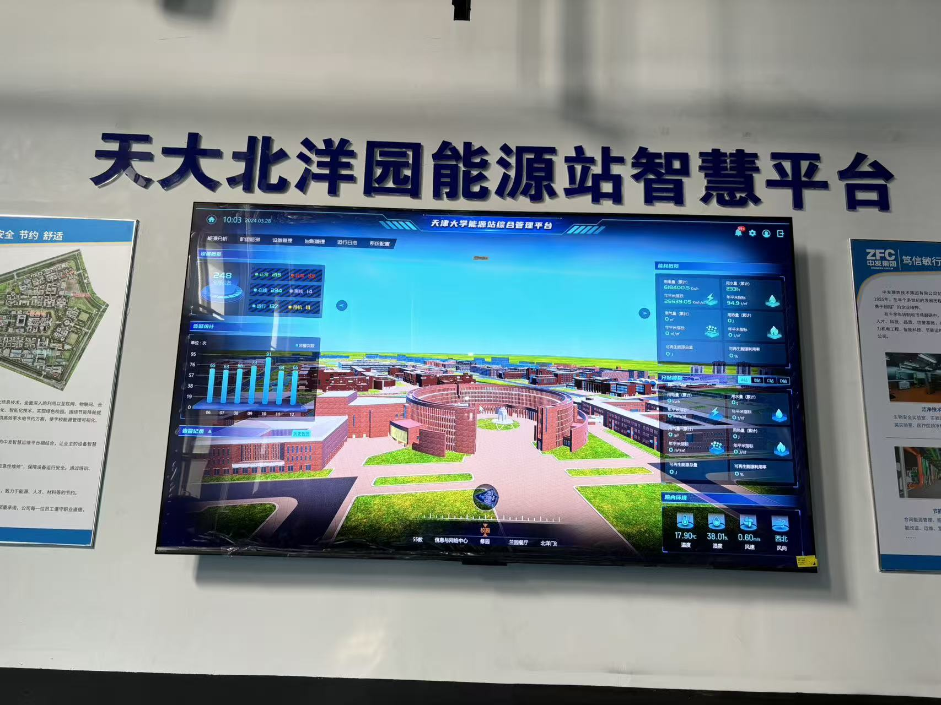  Data Simulation
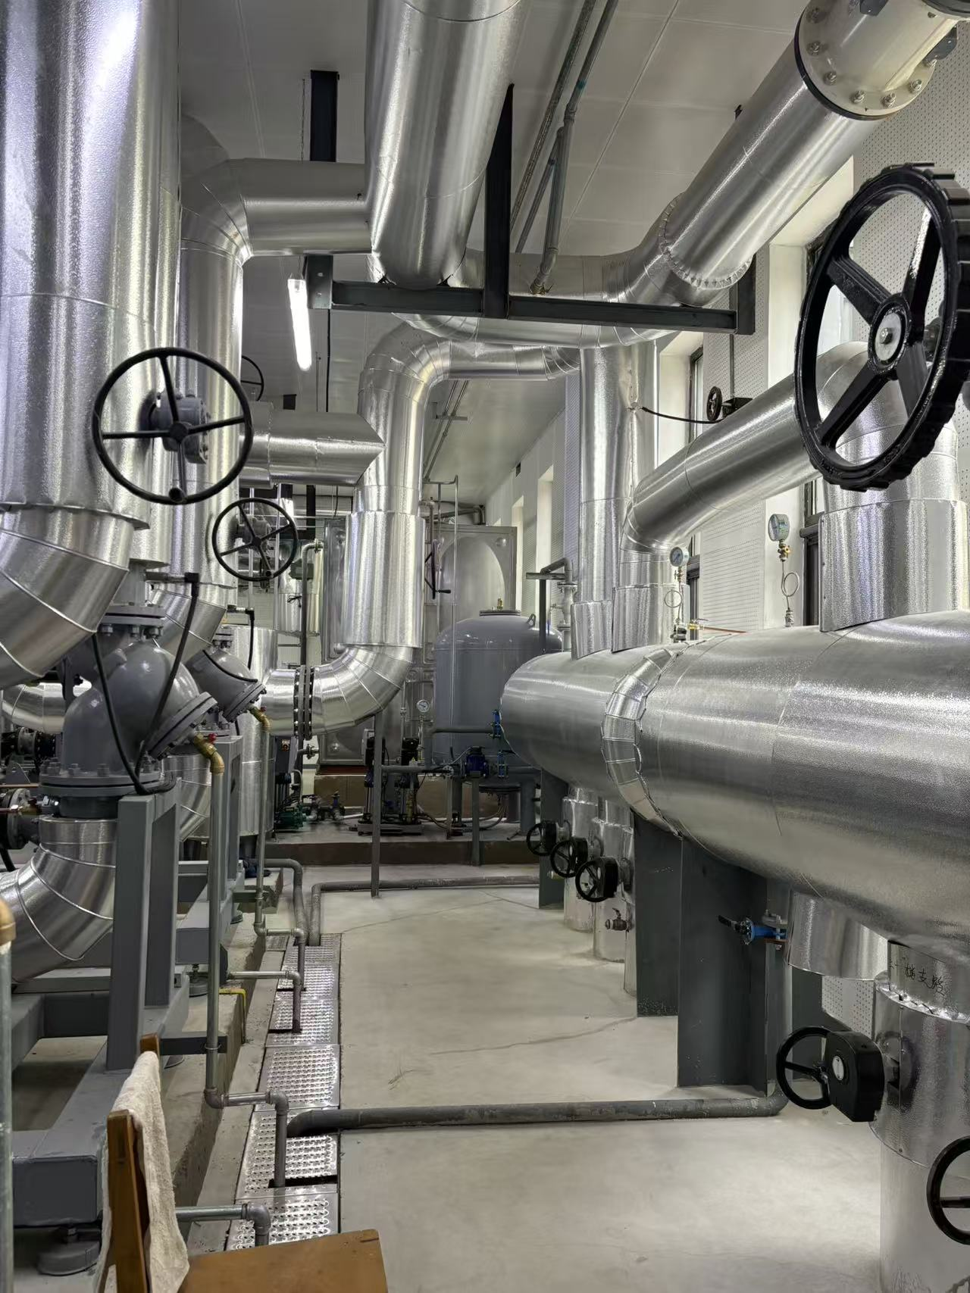  Field Research | 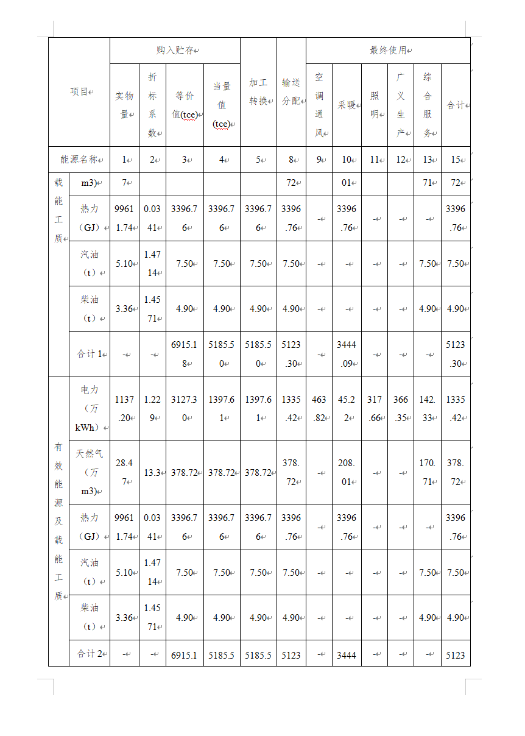  Data Analysis |  | 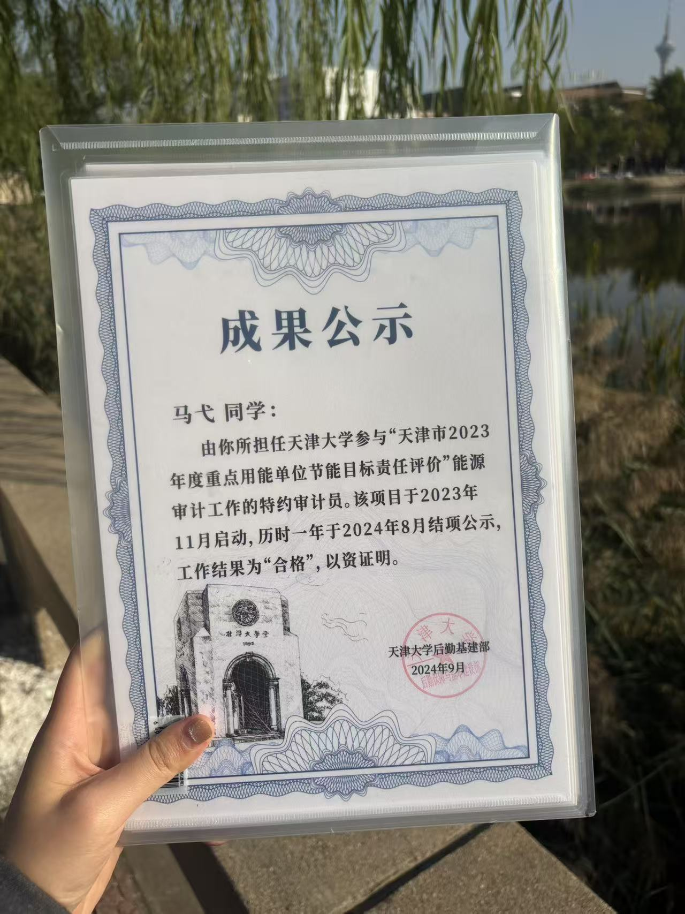  Recognition

My Contribution
- Led a five-member audit team, defining the project scope, allocating responsibilities, tracking progress, coordinating data requests and integrating individual work into the final report.
- Aerial photography operations
- Developed the campus energy-accounting framework, consolidating electricity, natural gas, purchased heat and water data for two campuses and calculating energy-use indicators by campus, floor area and user population.
- Modelled and assessed retrofit scenarios, quantifying expected energy savings, carbon reductions, investment requirements, annual financial savings, payback periods, net present value and internal rate of return.

Project 3
Key Technologies and Application Demonstration of Novel Energy Systems for ZeroCarbon Retrofit of Existing Campuses (Package I&II)
Period
June 2023 – April 2025
Organisation
Tianjin University · China Yangtze Power Co., Ltd. · Three Gorges Electric Energy Co., Ltd.
Project Type
Industry-linked R&D · Technology roadmap · Integrated energy-system planning · Intellectual-property development

Overall content of work
Zero-carbon retrofit of an existing campus cannot be achieved by applying individual technologies in isolation. Campuses contain buildings of different ages and functions, diverse heating, cooling and electrical loads, and uneven renewable-energy resources. The project therefore needed a transferable pathway that could connect demand reduction, distributed photovoltaics, BIPV, PVT, heat pumps, energy storage, DC distribution, flexible demand and environmental-resource management. The main challenge was to organise these technologies into a coherent system architecture, identify their applicability under different climate and campus conditions, and define how proposed solutions could be demonstrated, monitored, evaluated and translated into replicable engineering and intellectual-property outputs.

My Contribution
- Drafted and integrated major sections of the technical reports, including the project overview, key technology content, chapter summaries and the overall technical narrative.
- Developed report content on campus water-resource utilisation and solid-waste management, translating literature, engineering cases and management measures into implementable retrofit workflows.
- Conducted patent landscape analysis and developed invention concepts related to PV–storage coordination, multi-energy-system modelling, digital twins and carbon–energy optimisation.

03 Doctoral Research and Selected Studies

Research of Doctoral Thesis
Title: Low-Carbon Retrofit Strategies and Integrated PV-Storage Applications for Aged Residential Communities

Research Context
Aged residential communities face multiple constraints, including heterogeneous building conditions, limited retrofit budgets, uncertain energy-saving performance, and difficulties in coordinating building-efficiency measures with distributed renewable energy and storage systems. My doctoral research develops a system-level framework that connects community classification, retrofit-strategy generation, integrated PV-storage-load modelling, and sustainability assessment. The objective is to move beyond isolated technology evaluation and support transparent, adaptable, and evidence-based retrofit decisions for different community archetypes.

Research Objectives
- Characterise aged residential communities and identify representative retrofit archetypes.
- Generate and screen technically feasible retrofit strategies using explainable data-driven methods.
- Evaluate the interaction between building-efficiency measures, PV generation, energy storage, and flexible loads.
- Compare alternative strategies in terms of energy performance, carbon emissions, economic feasibility, and broader life-cycle sustainability.
- Develop transferable methods that can support community-, campus-, and distributed-energy applications.

Research Workflow
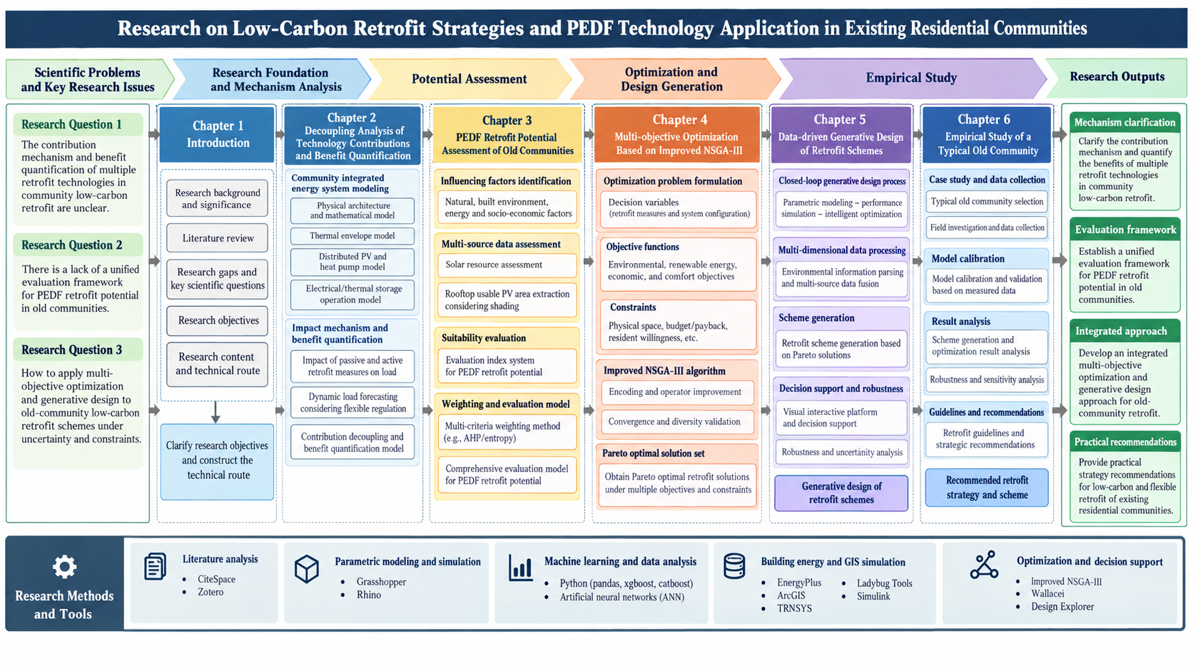

Selected Paper 1
Title: A context-adaptive whole-life viability framework for prioritizing low-carbon retrofit strategies in aged residential communities

Research Question
How can retrofit strategies be generated and screened efficiently while remaining interpretable and adaptable to the heterogeneous conditions of aged residential communities?

Graphic Abstract
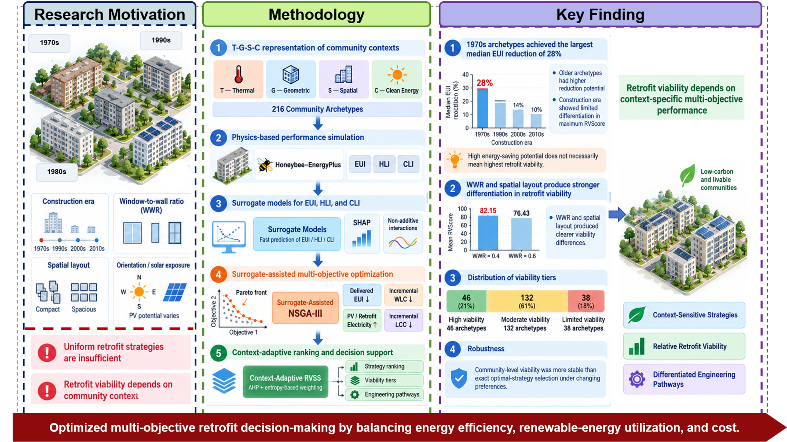

Highlights
- 690,795 retrofit combinations were evaluated across 216 community archetypes.
- SHAP reveals construction-period shifts in key energy retrofit drivers.
- Context-adaptive AHP–EWM weights integrate energy, carbon, PV, and life-cycle cost.
- RVSS classified 36, 147, and 33 archetypes as high, moderate, and limited viability.
- Lower post-retrofit energy use did not imply higher whole-life viability.

Selected Paper 2
Title: How much information is enough for reliable retrofit decisions?An uncertainty-aware framework for existing residential buildings across contrasting urban contexts

Research Question
How can the performance of building-integrated PV-electricity-storage systems be evaluated beyond operational energy savings and direct carbon reduction?

Graphic Abstract
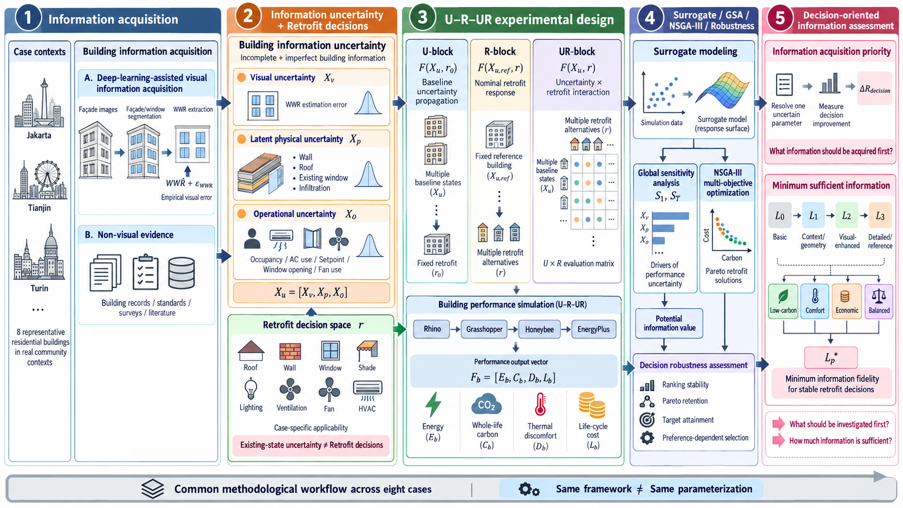

Highlights
- Building-information uncertainty propagates to energy, comfort, carbon, and cost.
- Deep learning extracts facade features and quantifies WWR estimation error.
- A common workflow is tested across eight contrasting residential buildings.
- Full-information regret quantifies decision loss under incomplete information.
- Data priorities and minimum information needs are identified for each preference.

Thank you for reading.
And again, here are my contacts:

Email
mymy@tju.edu.cn
maylis.ma.0029@gmail.com
Portfolio
https://mimi0029.github.io

portfolio QR code | Whatsapp | Wechat

Tianjin University ranks 235th globally and 11th in mainland China, according to the QS World University Rankings 2027

