LA_2
PROJECT-BASED LEARNING (PBL) REPORT
Aim of experiment: To select two modules of the AI-Powered Civic Complaint Management System, implement and test them, and manage the project using JIRA with defect tracking.
Author: Meenakshi Motwani
Section / Roll No: A5_B2 / 19
Date of experiment: 30/10/2026
Case study: AI-POWERED CIVIC COMPLAINT MANAGEMENT SYSTEM FOR MUNICIPAL CORPORATIONS.
Problem statement: To develop a centralized system for citizen civic grievance redressal, automating complaint intake, municipal officer assignment, real-time lifecycle tracking, and transparent chronological audit logging.
1. SELECTED MODULES
Two modules were selected for implementation. Module 1 is Complaint Submission (SRS section 4.1, Feature 2). Module 2 is Complaint Tracking (SRS section 4.2, Feature 4). Module 2 is the core function of the system, and it depends on Module 1 because tracking needs a registered complaint with an assigned officer. This dependency is how the two modules integrate. Officer and administrator data needed for the demonstration is provided as sample data.
2. MODULE 1: COMPLAINT SUBMISSION
This module lets registered citizens log in and submit a civic complaint with a title, description, category, priority, and location (between 3 and 200 characters), and attach an optional supporting image (PNG, JPG, JPEG, GIF, WEBP, up to 5MB). The system validates the input, auto-generates a unique Complaint ID, creates the initial status history audit record, and automatically assigns the complaint to the municipal officer. Once submitted, the complaint becomes eligible for departmental action and tracking.
Table 1: Requirements implemented in Module 1
Requirement | Description | Implemented by
REQ-CS-01 | Authorized citizens can register and submit complaints | Registration and login with session auth
REQ-CS-02 | Store complaint details, location, category, and priority | complaints table and Complaint ORM model
REQ-CS-03 | Attach supporting image (PNG/JPG/JPEG/GIF/WEBP, max 5MB) | File upload handling with allowed_file()
REQ-CS-04 | Validate mandatory fields and location length (3–200 chars) | Server-side input validation rules
REQ-CS-05 | Auto-generate Complaint ID and initial status history log | Auto-increment ID and StatusHistory table
3. MODULE 2: COMPLAINT TRACKING
This module allows citizens to track the progress of their submitted complaints. Citizens can search by numeric Complaint ID, search by title keyword, and filter complaints by status. Opening a complaint displays the full details, supporting image, a 6-stage lifecycle progress stepper, and a chronological status history timeline. Ownership isolation ensures citizens only view their own complaints. Municipal officers can review assigned complaints and update their status to In Progress or Complaint Resolved with remarks, which immediately updates the citizen's tracking page.
Table 2: Requirements implemented in Module 2
Requirement | Meaning | Implemented by
REQ-CT-01 | Citizens view only their own complaints (ownership isolation) | Session user_id query filter
REQ-CT-02 | Search by Complaint ID and title keyword | Search query parsing in routes/citizen.py
REQ-CT-03 | Filter complaints by status | Status dropdown filter query
REQ-CT-04 | Display 6-stage lifecycle progress stepper and details | complaint_detail.html progress stepper
REQ-CT-05 | Show chronological status history timeline with remarks | status_history table ordered by timestamp
REQ-CT-06 | Officer reviews and updates status with remarks | Officer dashboard and update-status route
Design limitations: one municipal officer is auto-assigned per complaint in this prototype, categorization uses rule-based keyword matching, and citizen satisfaction rating is kept for future sprints.
4. TECHNOLOGY STACK
The system is a web application built with Python and Flask for the backend, SQLite as the relational database, and Jinja2 with Bootstrap 5 for the user interface. Passwords are hashed with Werkzeug security, login sessions use Flask session cookies, and unit tests use Python's built-in unittest framework. This stack meets the SRS needs for a web application, a relational database, role-based access control and input validation.
5. JIRA PROJECT MANAGEMENT
The project was planned and tracked in a JIRA project named Civic Complaint System (key CIVIC). Two epics were created from the SRS feature groups. Modules Complaint Submission and Complaint Tracking were developed. User stories were written in the 'As a ... I want ... so that ...' form with Fibonacci story points (1, 2, 3, 5, 8), assigned to team members, and tracked across sprints.
5.1 Epics, Backlog and User Stories
All issues were created with detailed descriptions, parent epics, story points, and broken into sub-tasks. Status was transitioned from To Do to In Progress to Done as development was carried out.
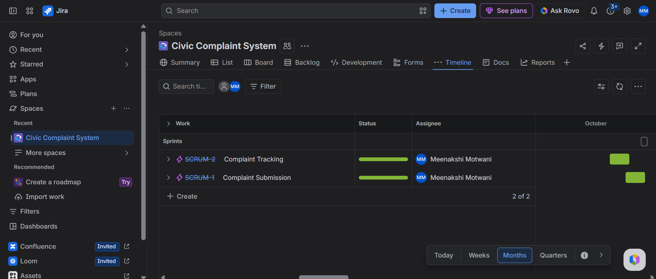
Figure 1: Epics created in the JIRA project (CIVIC-1 to CIVIC-6)
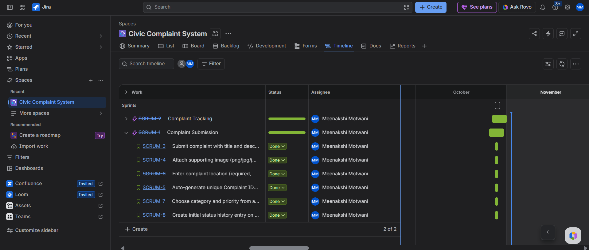
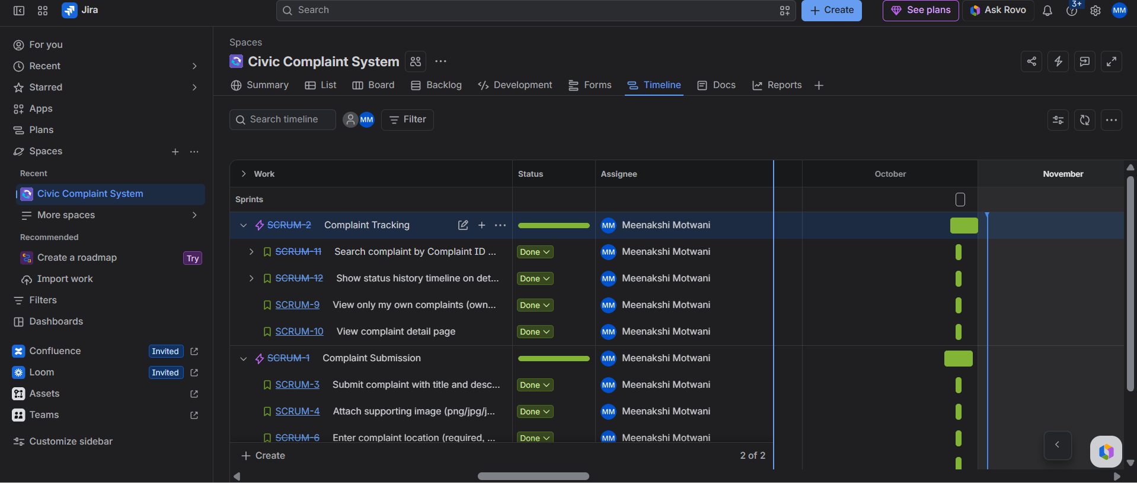
Figure 2: Product backlog with the stories planned for Sprint 1 and Sprint 2
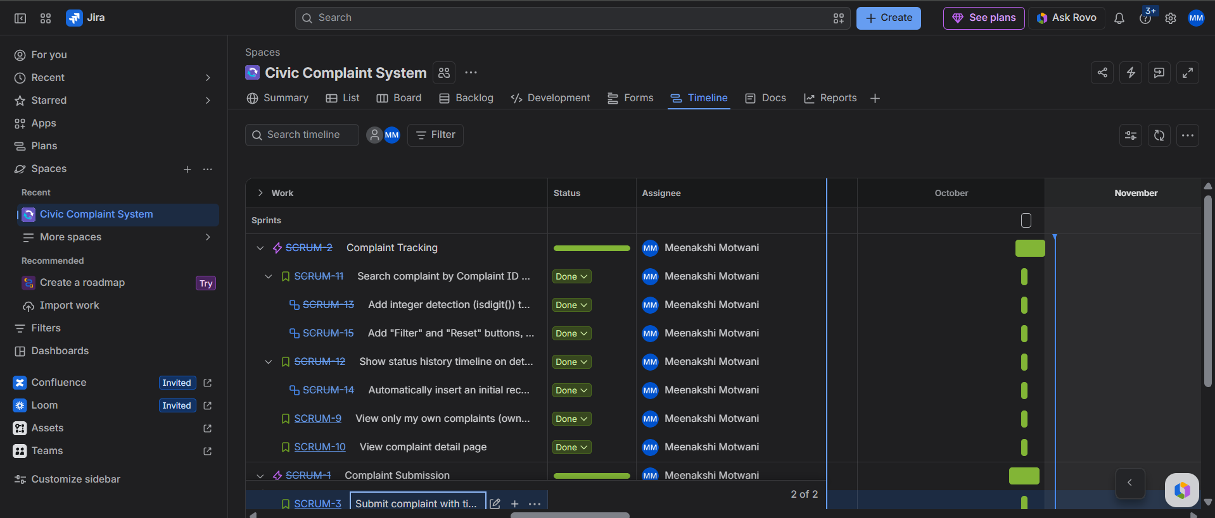
Figure 3: User story 13, 14 and 15 with its parent epic
5.2 Sprint 1
Sprint 1 covered Complaint Submission (registering complaints, location validation, image upload, and officer auto-assignment).
Figure 4: Project summary with the status overview after Sprint 1
5.3 Sprint 2
Sprint 2 covered Complaint Tracking: viewing complaints, search by numeric ID, status filtering, the 6-stage lifecycle progress stepper, chronological audit history timeline, and municipal officer status updates. Testing of Module 2 was carried out in this sprint. Two bugs [BUG-01 and BUG-02] were identified, solved, and documented under the sprint.
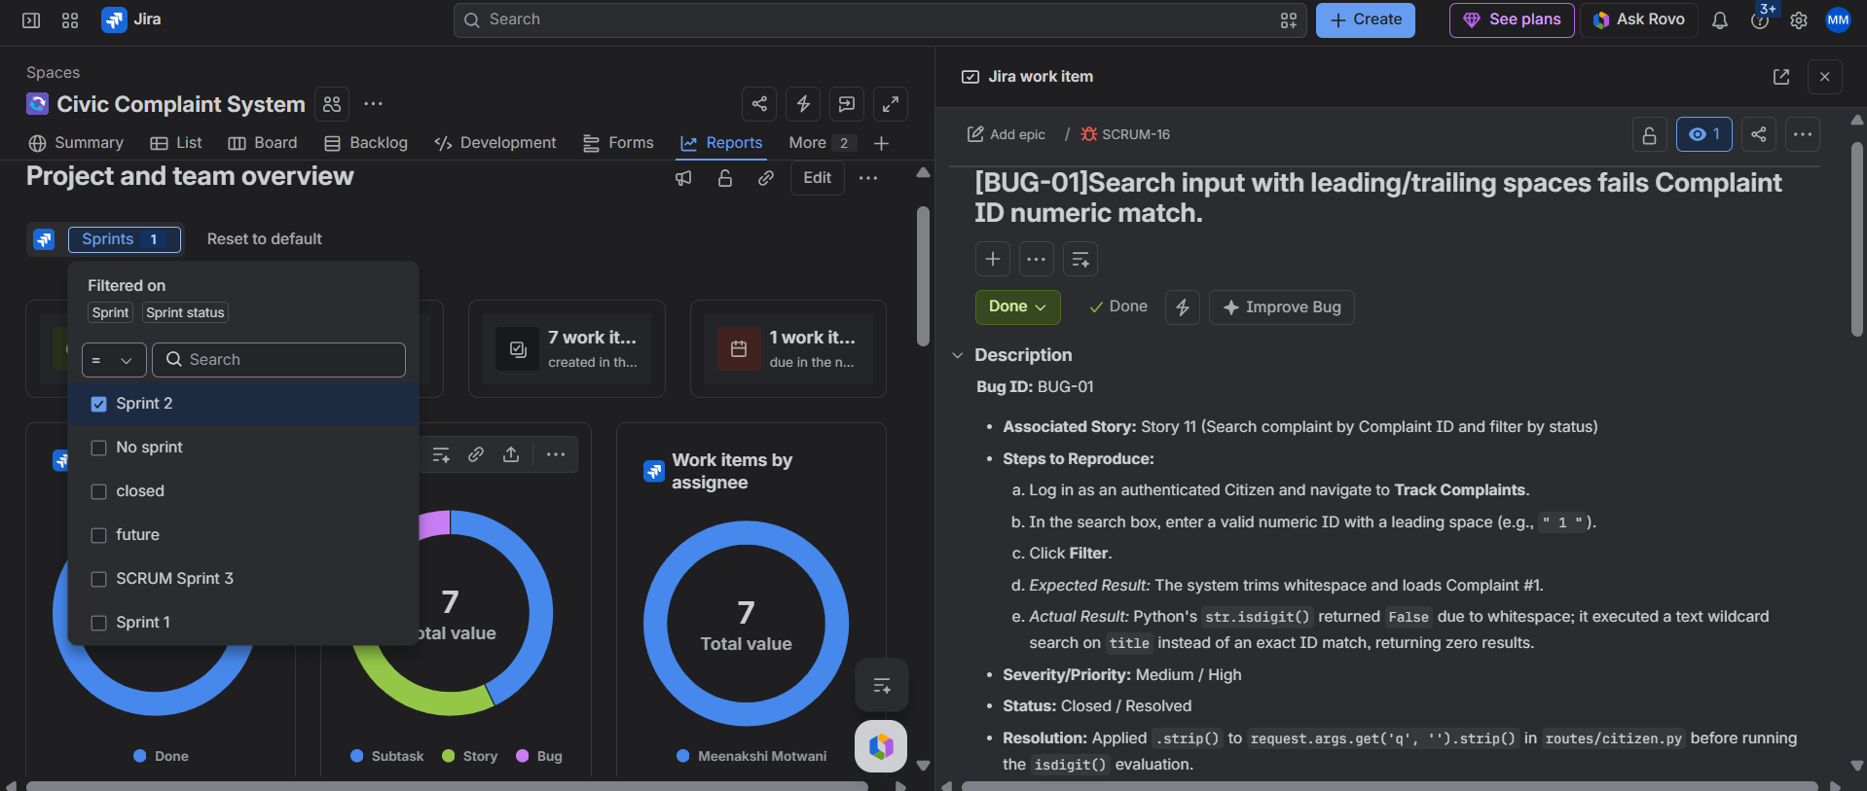
Figure 5: Bug 1
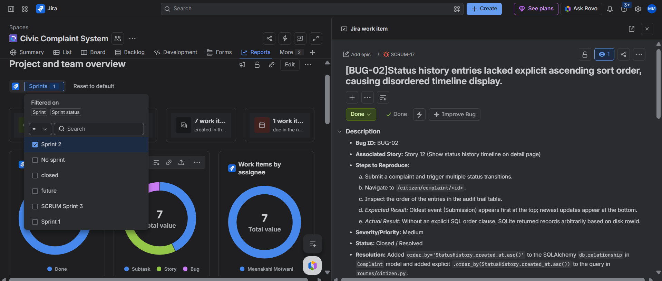
Figure 6: Bug 2
Figure 7: Completing Sprint 2 (all work items completed)
6. DATABASE DESIGN
The data is stored in a SQLite database named civic_complaints.db with three tables. The users table holds login accounts with hashed passwords and roles (Citizen, Municipal Officer, Administrator). The complaints table holds complaint details, location, category, priority, status, and foreign keys for the citizen author and assigned officer. The status_history table logs each status transition chronologically with timestamps and remarks. Foreign keys maintain relational integrity, and email addresses are unique.

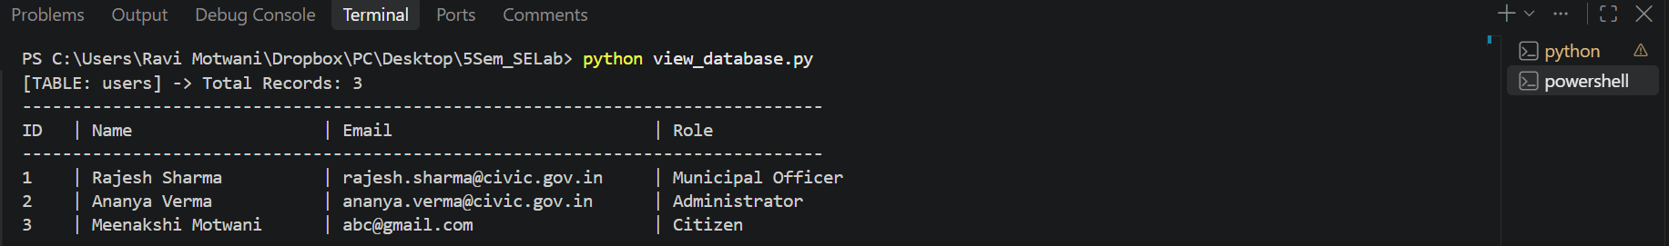
Figure 8: Structure of the users table

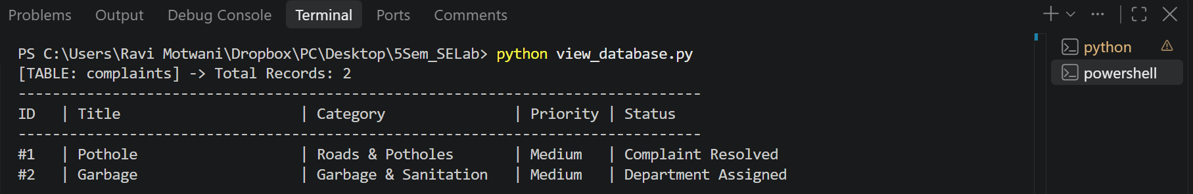
Figure 9: Structure of the complaints table
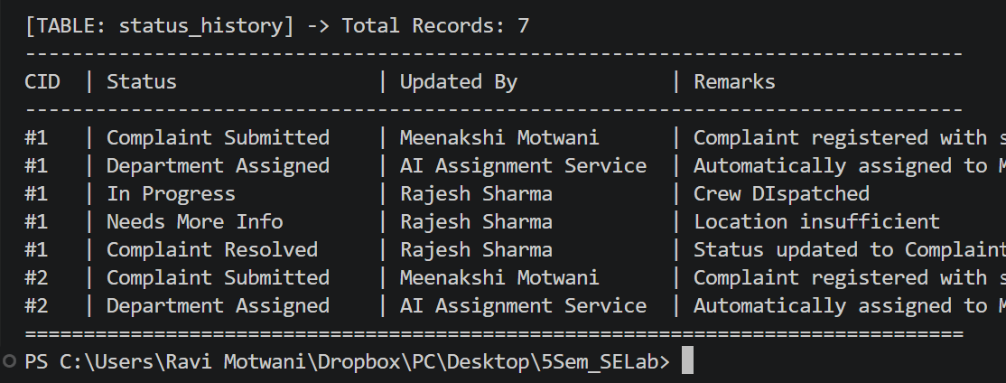
Figure 10: Structure of the status_history table
7. MODULE 1 IMPLEMENTATION
Citizens log in, open Submit complaint, enter the complaint details, location and priority, optionally attach an image, and submit the form. The system validates the input, auto-generates a unique Complaint ID, stores the complaint, and displays a success message. The validation rules are as follows:
• Title and description: required, non-empty text.
• Location: required, between 3 and 200 characters.
• Category and priority: must be one of the allowed dropdown values.
• Image upload: optional, allowed formats are PNG, JPG, JPEG, GIF, WEBP, maximum 5MB.
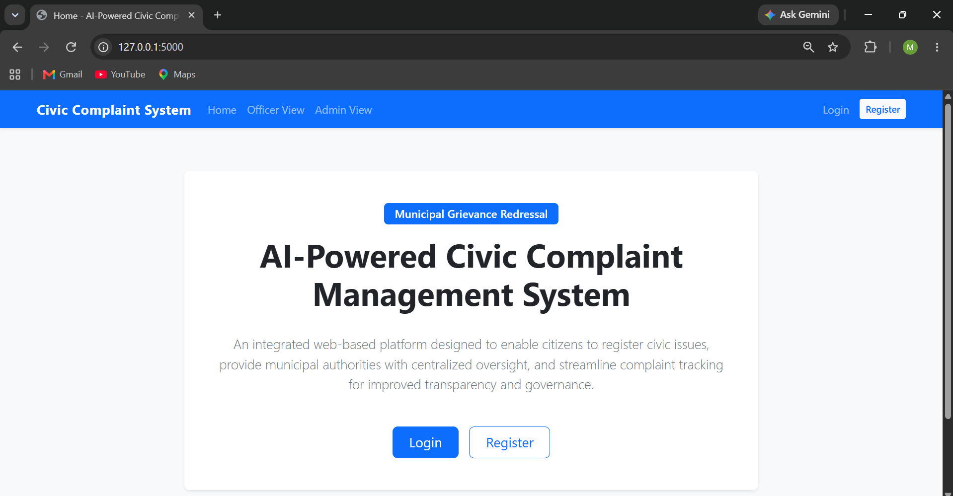
Figure 11: Login page
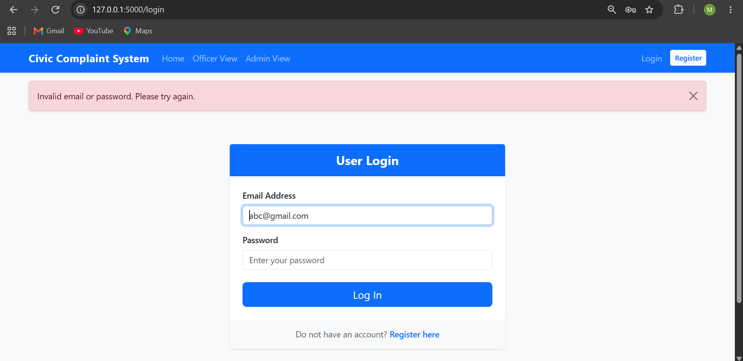
Figure 12: Error message for an incorrect username or password
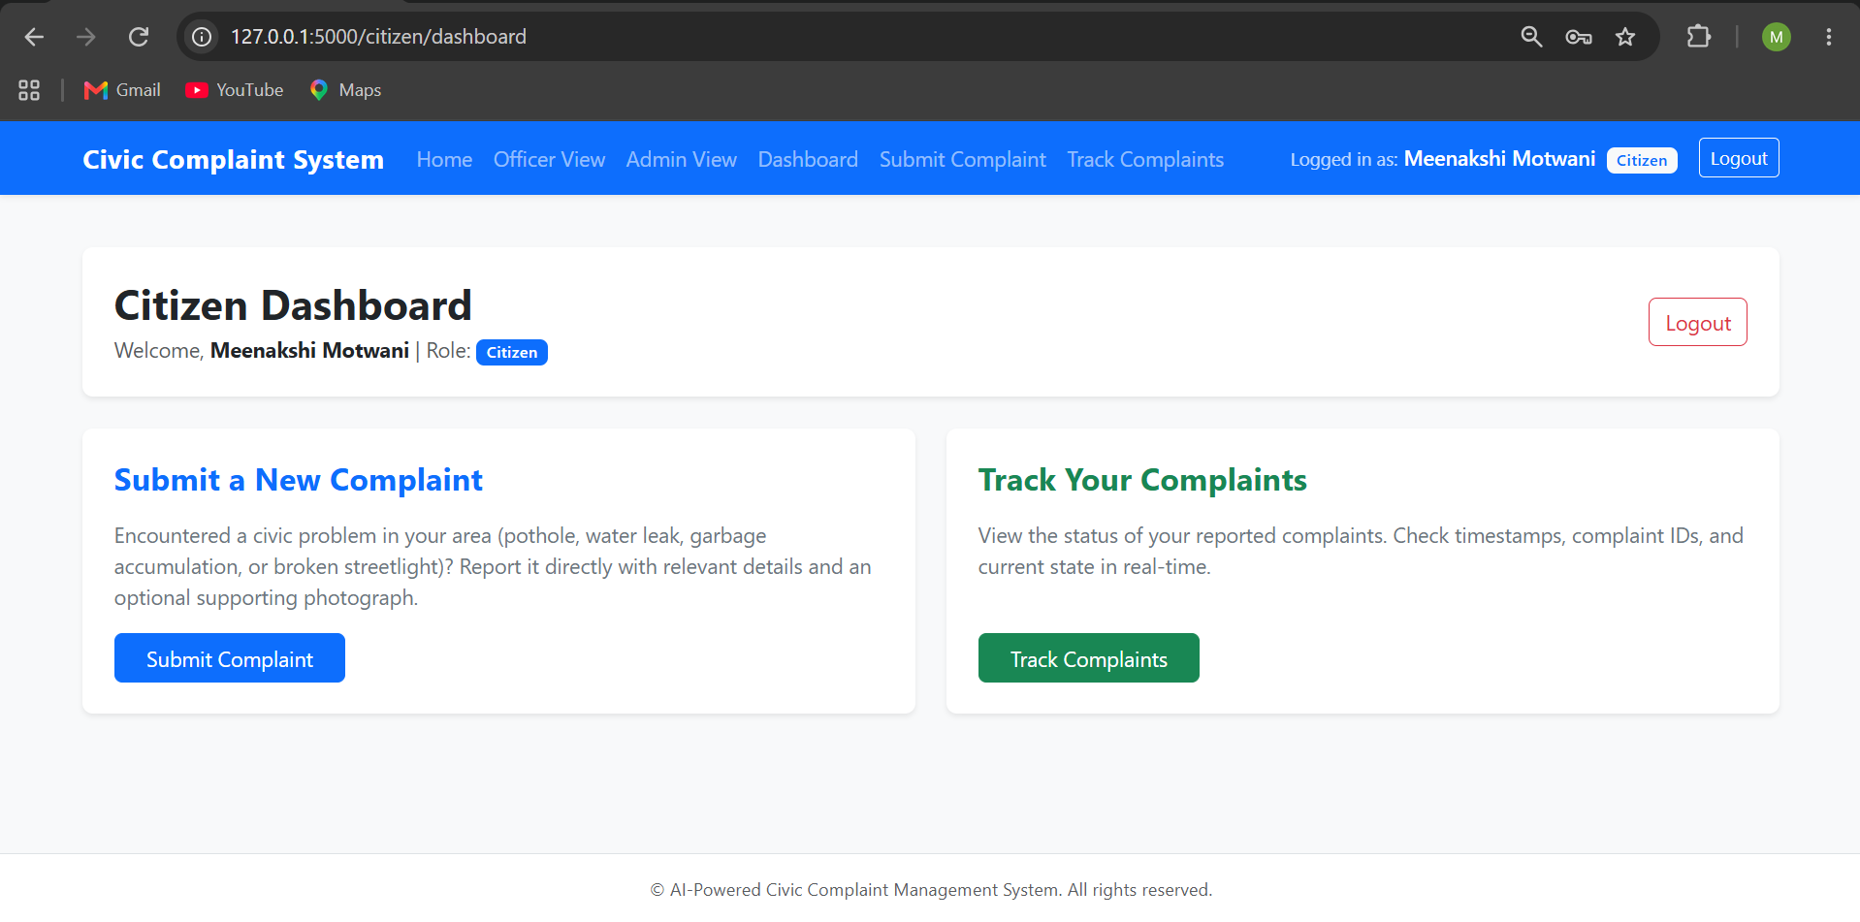
Figure 13: Home Page for citizen
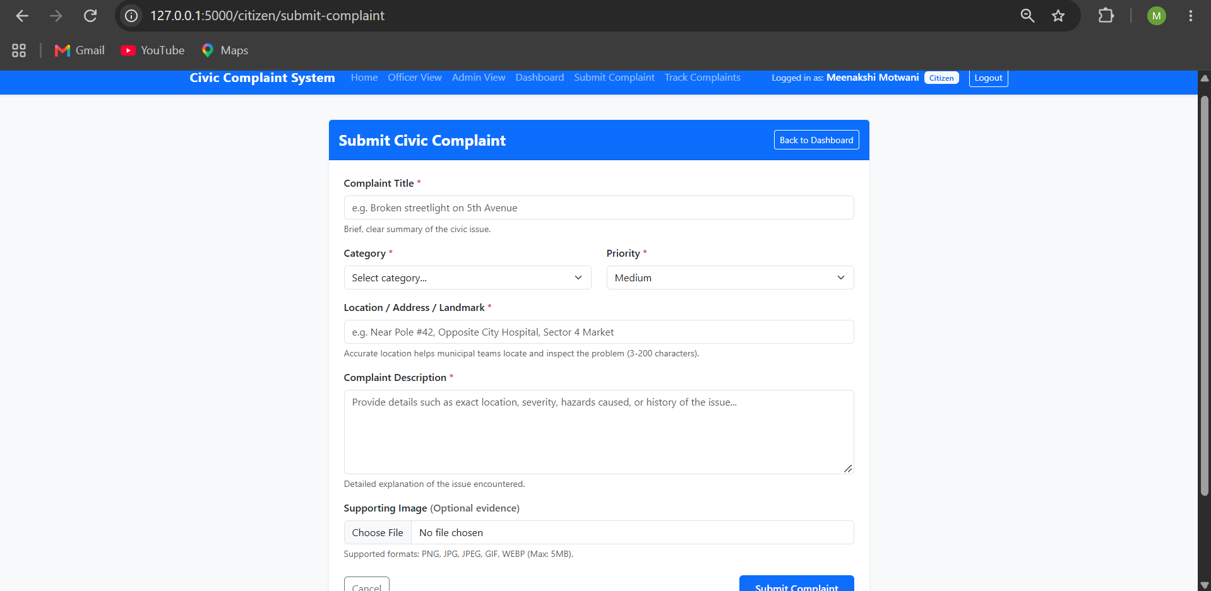
Figure 14: Empty complaint registration form
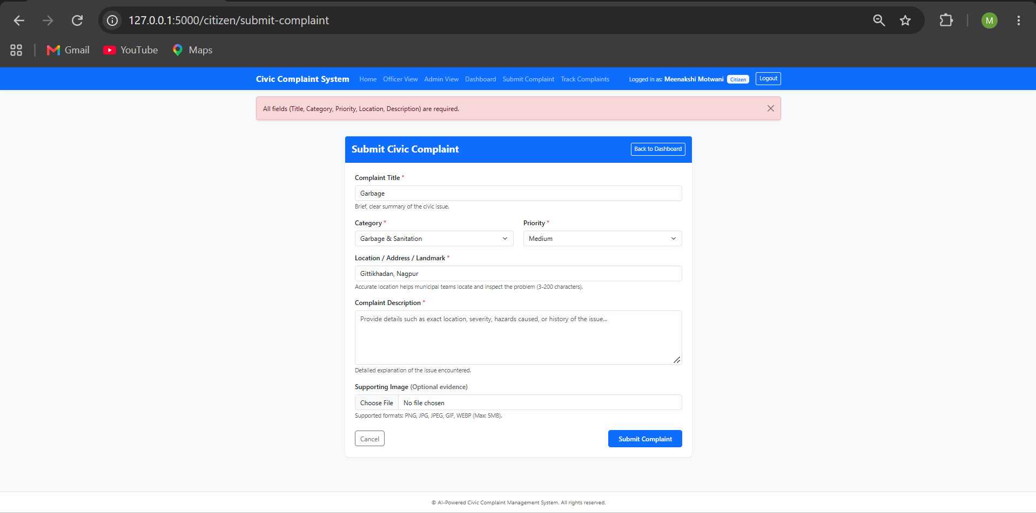
Figure 15: Validation errors shown for missing fields
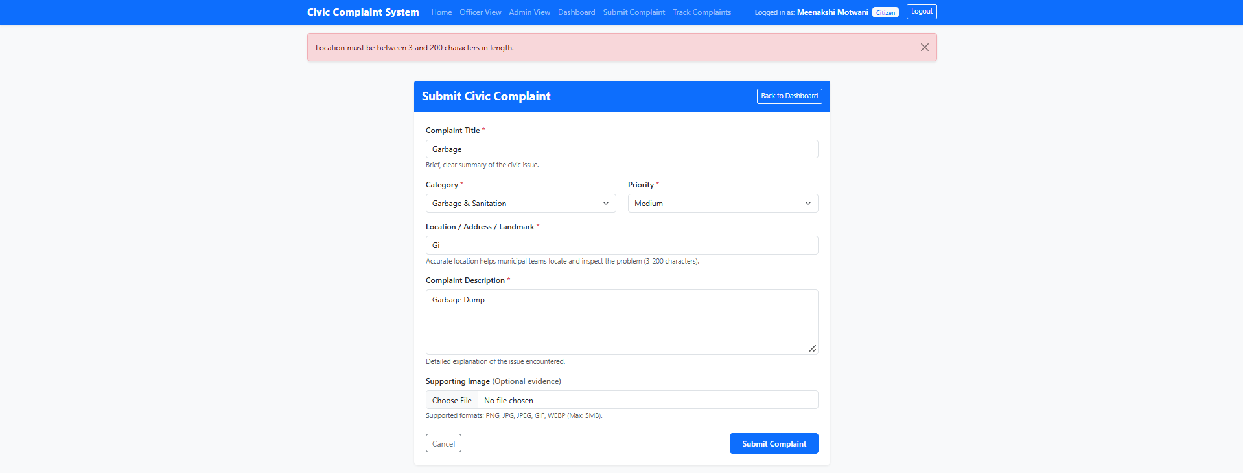
Figure 16: Validation error shown for location shorter than 3 characters
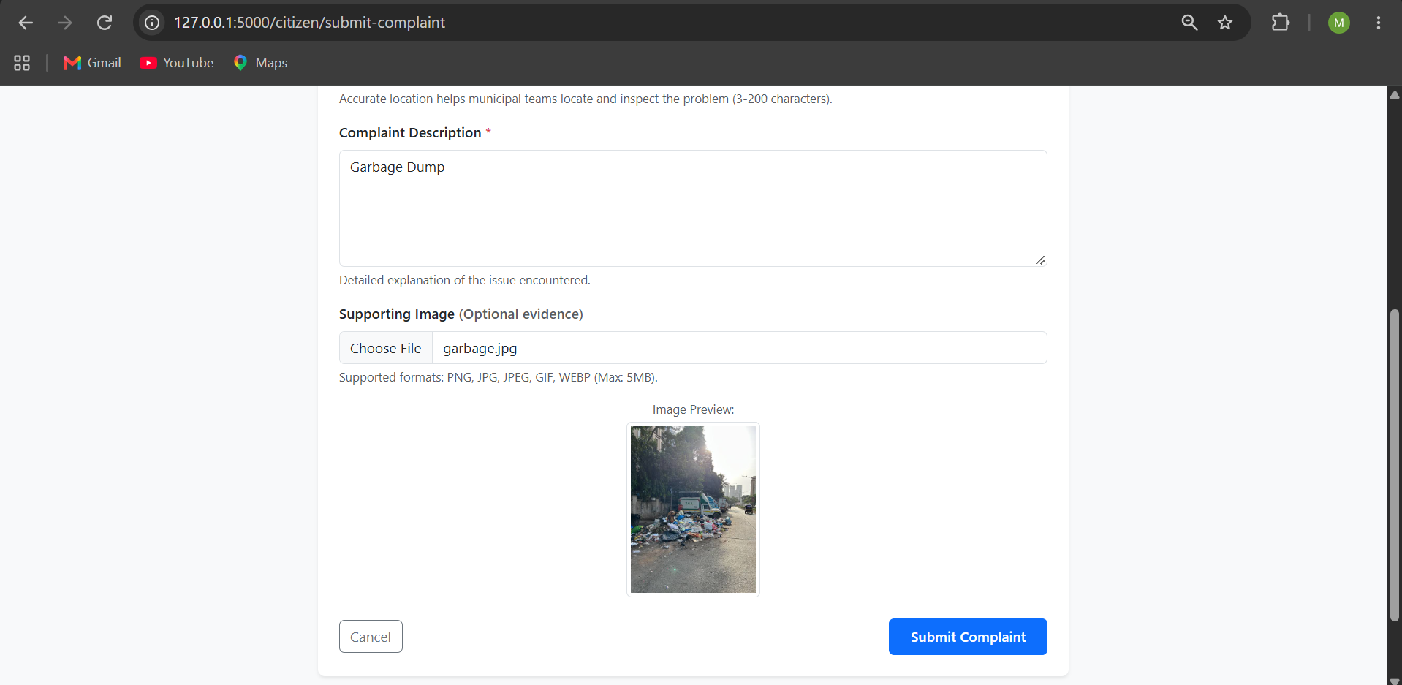
Figure 17: Live image preview before submission
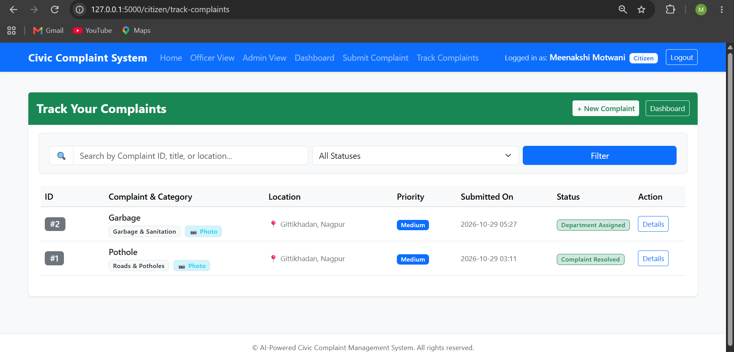
Figure 18: Registered complaint stored in the complaints table
8. MODULE 2 IMPLEMENTATION
Citizens open the Track complaints page to view their submitted grievances with color-coded status badges. They can search by Complaint ID or keyword, and filter by status. Clicking View Details opens the complaint detail page, showing full metadata, uploaded evidence, a 6-stage progress stepper, and the status history audit trail. Accessing another citizen's complaint returns HTTP 403 Forbidden. Municipal officers open the Officer dashboard, view assigned complaints, and update the status (In Progress, Complaint Resolved) with remarks, which immediately updates the citizen's tracker.
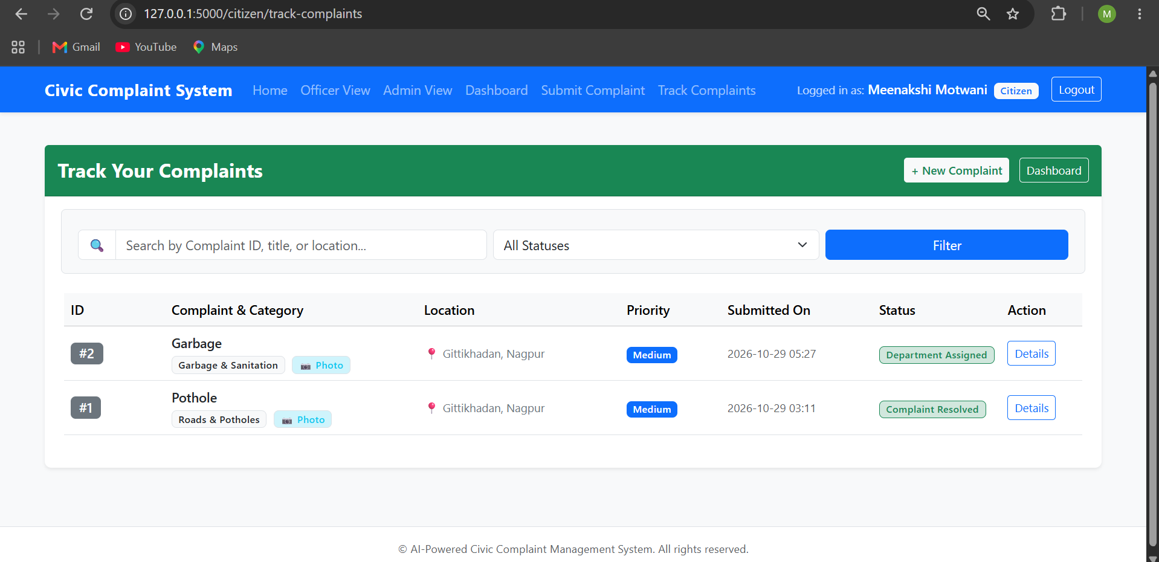
Figure 19: Citizen tracking dashboard listing complaints with status badges

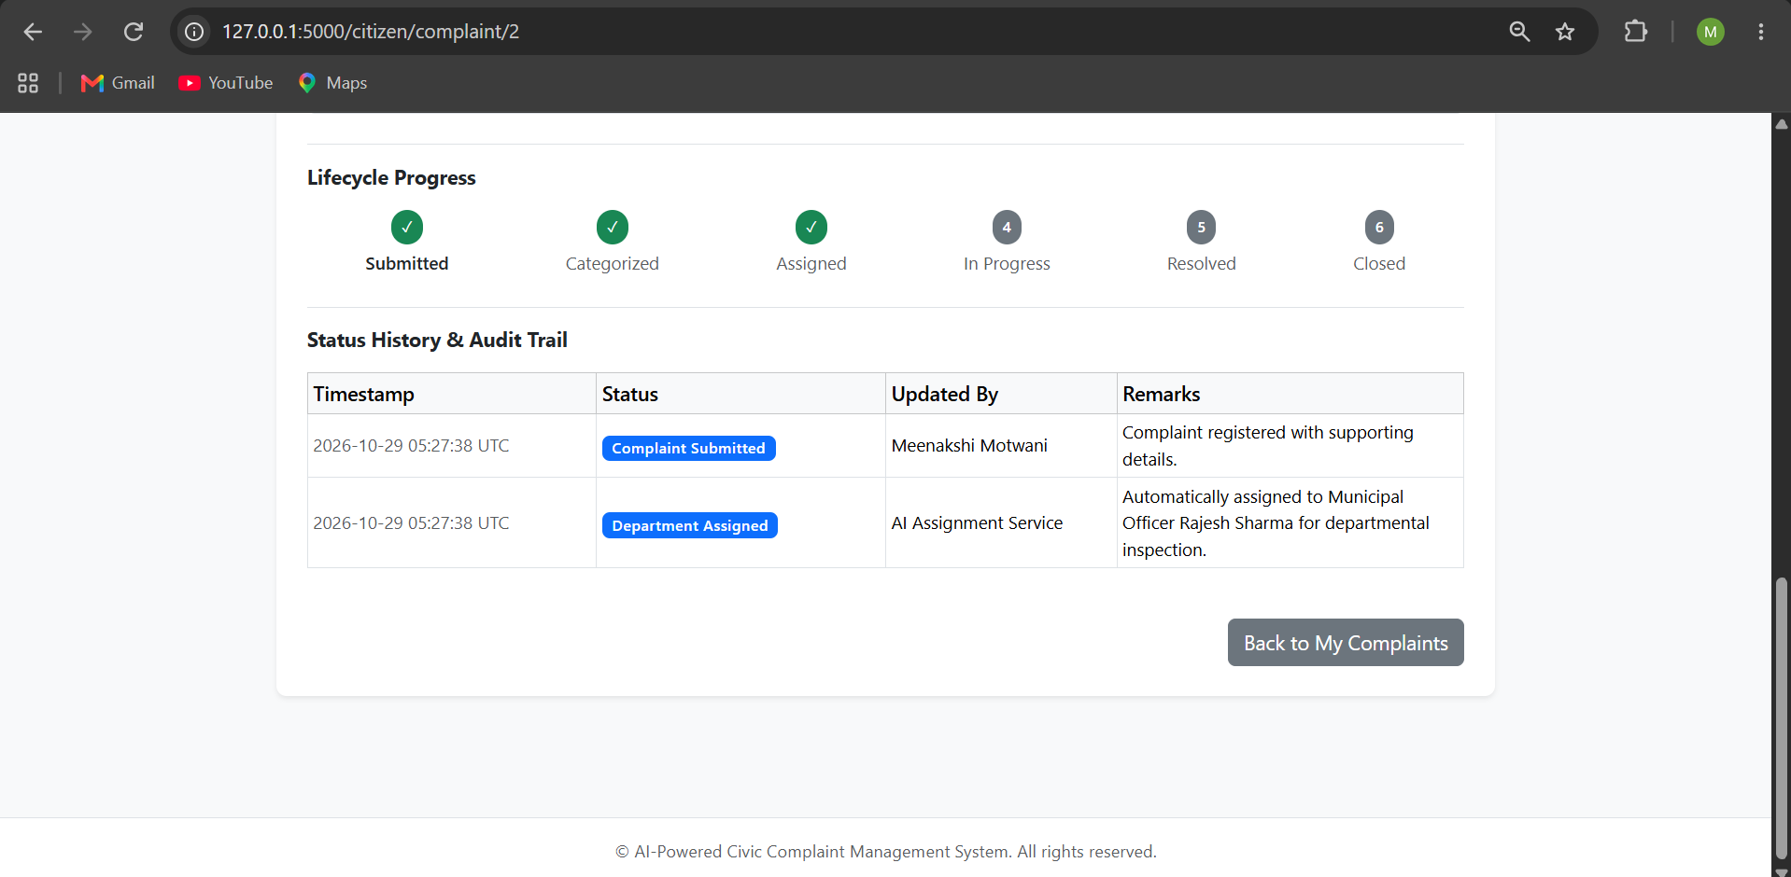
Figure 20: Complaint detail view showing metadata and 6-stage progress stepper
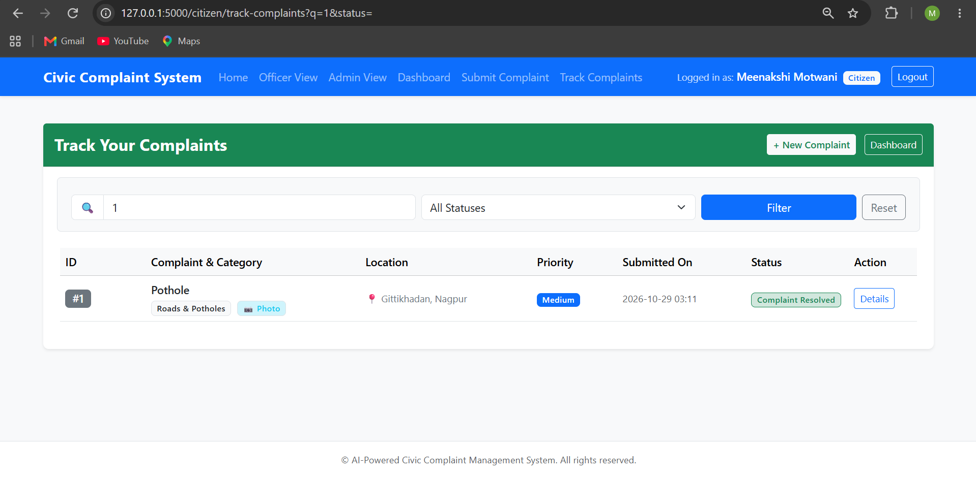
Figure 21: Filtered search by numeric Complaint ID
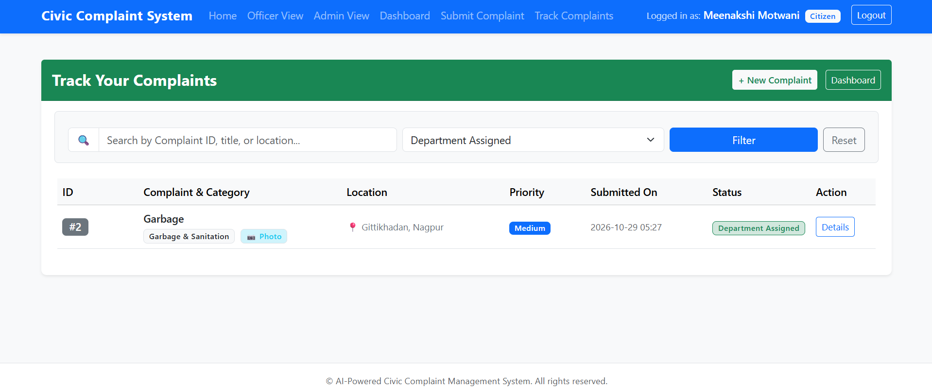
Figure 22: Filtered search by status dropdown ('Department Assigned')

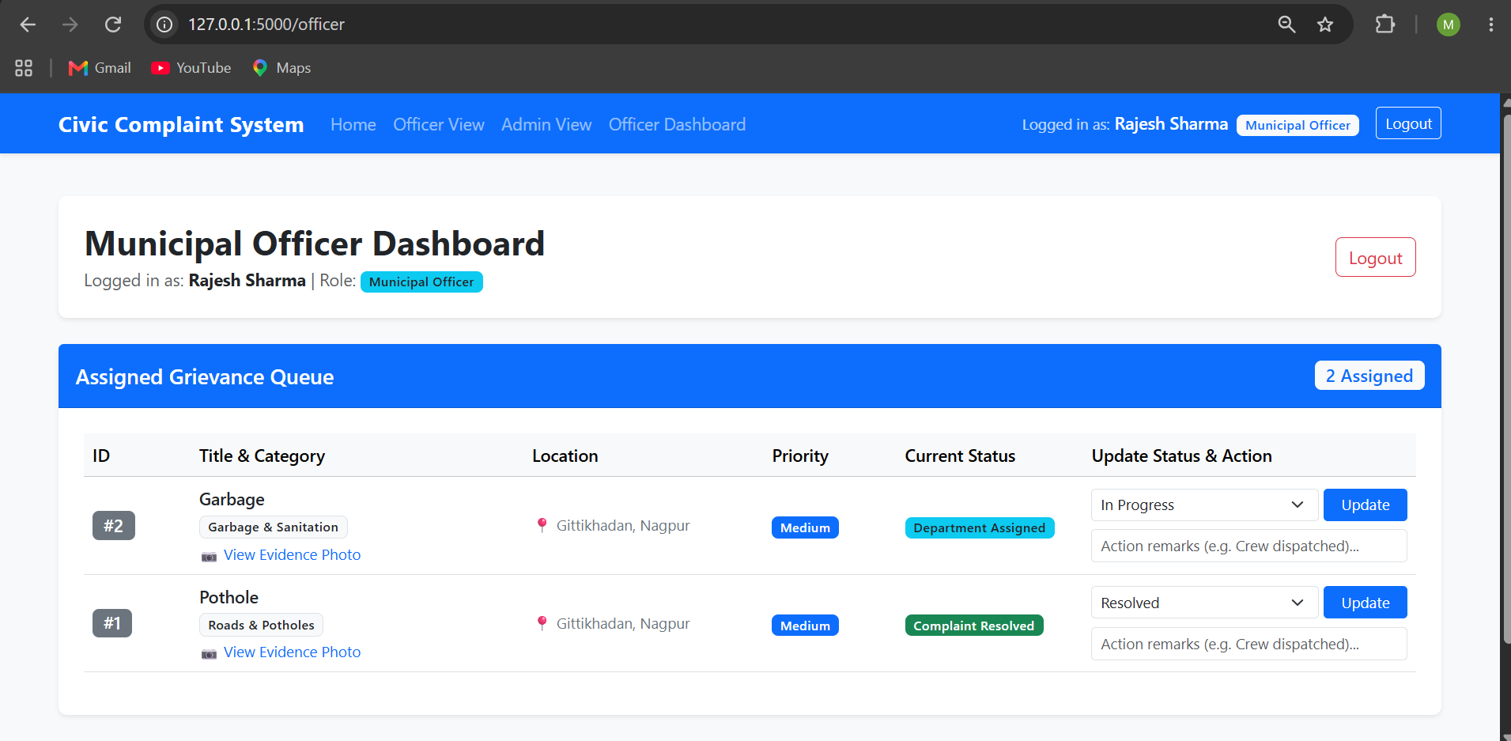
Figure 23: Municipal Officer dashboard showing assigned complaints queue
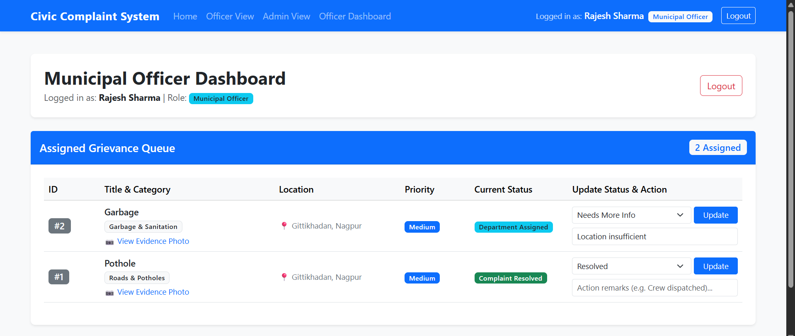
Figure 24: Municipal Officer updating status to Needs More Info with remarks
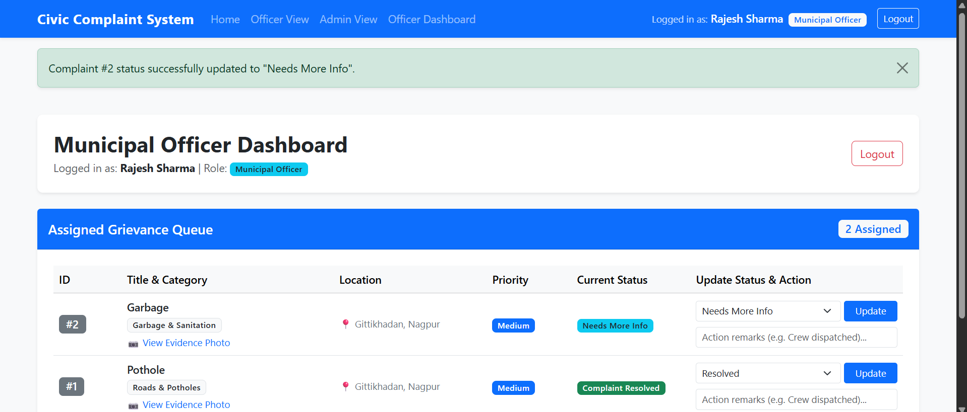
Figure 25: Updated progress stepper reflecting officer action

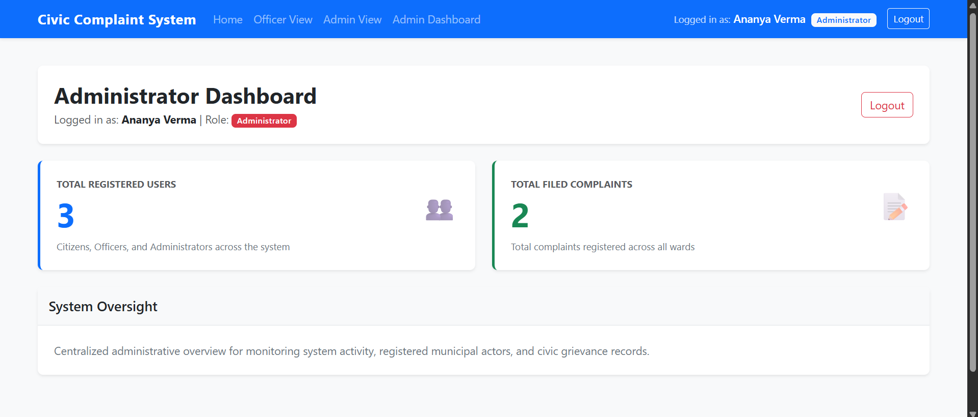
Figure 26: Administrator dashboard displaying user counts and complaint volume
9. SOURCE CODE
The project follows a layered MVC structure: routes handle web requests and role-based access control, models define database schemas and password hashing, and Jinja2 templates render the views. The source code is kept in a Git repository.
Table 3: Main files of the project
File | Purpose
app.py | Starts the server, registers Blueprints, error handlers, and creates tables
config.py | Configuration settings: database URI, 5MB upload limit, allowed formats
models/user.py | User model, password hashing with Werkzeug, and role definitions
models/complaint.py | Complaint and StatusHistory ORM models with foreign keys
routes/auth.py | Registration, login verification, session management, and logout
routes/citizen.py | Complaint submission, validation, auto-assignment, tracking and search
routes/officer.py | Municipal officer dashboard and status transition route with remarks
routes/admin.py | Administrator dashboard displaying platform metrics
templates/ | Jinja2 templates for base layout, submission, tracking, and officer view
run_comprehensive_tests.py | Automated test suite executing 18 tests and generating Excel report

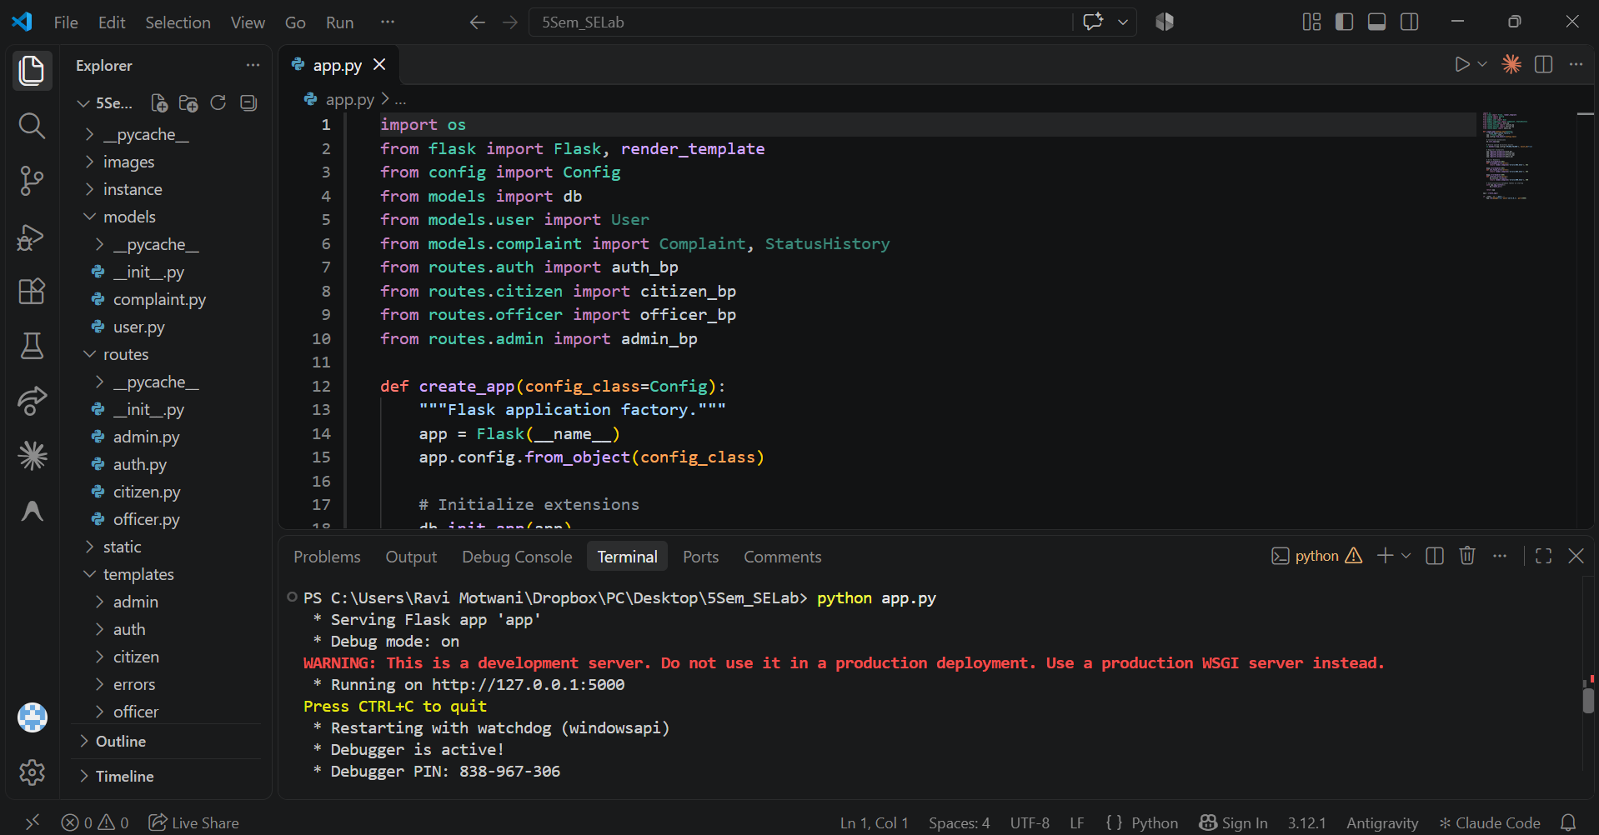
Figure 27: Project structure in VS Code, with the server started from the terminal
10. TESTING
Both modules were tested using functional testing, validation testing, boundary value analysis, equivalence partitioning, unit testing and integration testing. The test cases follow the format Test Case ID, Module, Test Scenario, Test Data, Expected Result, Actual Result and Status.
10.1 Module 1 Test Cases
Table 4 lists the 10 test cases for Module 1. Validation tests checked empty inputs, boundary lengths, and file extensions. All test cases passed.
Table 4: Test cases for Module 1
Test Case ID | Module | Test Scenario | Test Data | Expected Result | Actual Result | Status
TC-01 | Auth | Valid citizen login | ravi@civic.gov.in / pass123 | Dashboard opens | Dashboard opened | Pass
TC-02 | Auth | Wrong password | ravi@civic.gov.in / wrong | Error: 'Invalid email or password' | Error message displayed | Pass
TC-03 | Submission | Valid complaint submission | Title, Cat, Prio, Location | Complaint saved; ID #1 generated | Saved; ID #1 generated | Pass
TC-04 | Submission | Empty mandatory fields | All fields blank | Error shown on fields | Validation returned error | Pass
TC-05 | Submission | Location 2 chars (boundary) | Location='AB' | Error: minimum 3 chars | Error: minimum 3 chars | Pass
TC-06 | Submission | Location 3 chars (boundary) | Location='ABC' | Accepted and saved | Accepted and saved | Pass
TC-07 | Submission | Location 200 chars (boundary) | 200 characters | Accepted and saved | Accepted and saved | Pass
TC-08 | Submission | Disallowed file (.exe) | file='script.exe' | Error: 'Invalid file format' | Error displayed; rejected | Pass
TC-09 | Submission | Valid image (.png) | file='photo.png' | Saved in static/uploads/ | Saved in static/uploads/ | Pass
TC-10 | Unit | allowed_file helper | test.jpg, test.exe | True for jpg, False for exe | True for jpg, False for exe | Pass
10.2 Module 2 Test Cases
Table 5 lists the 8 test cases for Module 2. Tests evaluated complaint tracking, numeric ID search, status dropdown filtering, timeline display, and cross-citizen access prevention (IDOR). All test cases passed.
Table 5: Test cases for Module 2
Test Case ID | Module | Test Scenario | Test Data | Expected Result | Actual Result | Status
TC-11 | Tracking | View complaint detail page | Complaint ID #1 | Metadata and stepper rendered | Metadata and stepper rendered | Pass
TC-12 | Tracking | Search by exact Complaint ID | query q='1' | Only Complaint #1 returned | Complaint #1 isolated | Pass
TC-13 | Tracking | Search with whitespace | query q=' 1 ' | Whitespace stripped; #1 found | Complaint #1 found | Pass
TC-14 | Tracking | Filter by status | status='In Progress' | Only matching complaints shown | Filtered table displayed | Pass
TC-15 | Tracking | Cross-citizen isolation (IDOR) | Citizen A visits /complaint/2 | HTTP 403 Forbidden abort | HTTP 403 returned; blocked | Pass
TC-16 | Tracking | Chronological audit timeline | Inspect status_history rows | Ordered by timestamp asc | Ordered chronologically | Pass
TC-17 | Officer | Officer updates status | new_status='In Progress' | Status updated; remark saved | Updated; audit row saved | Pass
TC-18 | Integration | Submit then track flow | Citizen submits, opens track | New complaint in tracking table | New complaint in table | Pass
10.3 Testing Techniques Used
• Functional testing: login, complaint submission, tracking, and officer status update flows (TC-01, TC-03, TC-11, TC-17, TC-18).
• Validation testing: blank inputs and invalid credentials (TC-02, TC-04).
• Boundary value analysis: location length of 2, 3, and 200 characters (TC-05, TC-06, TC-07).
• Equivalence partitioning: valid PNG images versus disallowed EXE binaries (TC-08, TC-09).
• Unit testing: file extension helper function and ORM default values (TC-10).
• Integration testing: submitting a complaint, auto-assigning an officer, and tracking its lifecycle (TC-15, TC-16, TC-18).
10.4 Unit Test Results
All 18 automated test cases passed using Python's unittest test runner in run_comprehensive_tests.py.
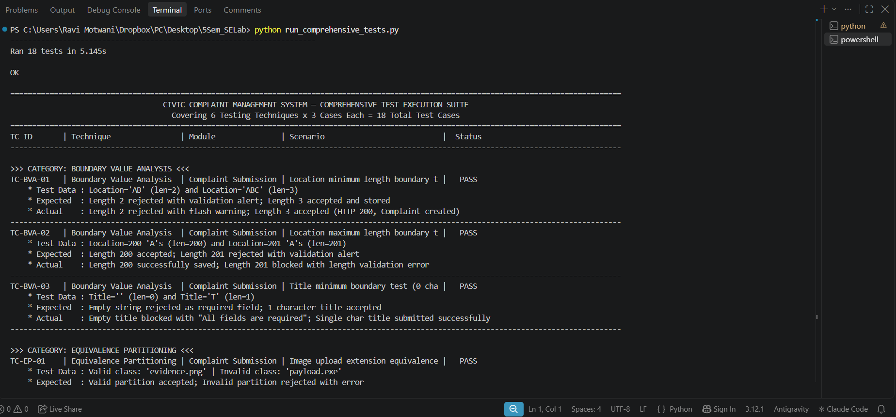
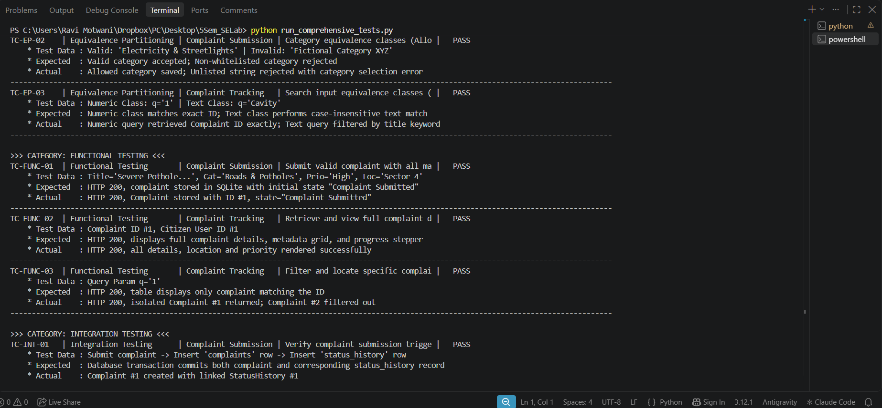
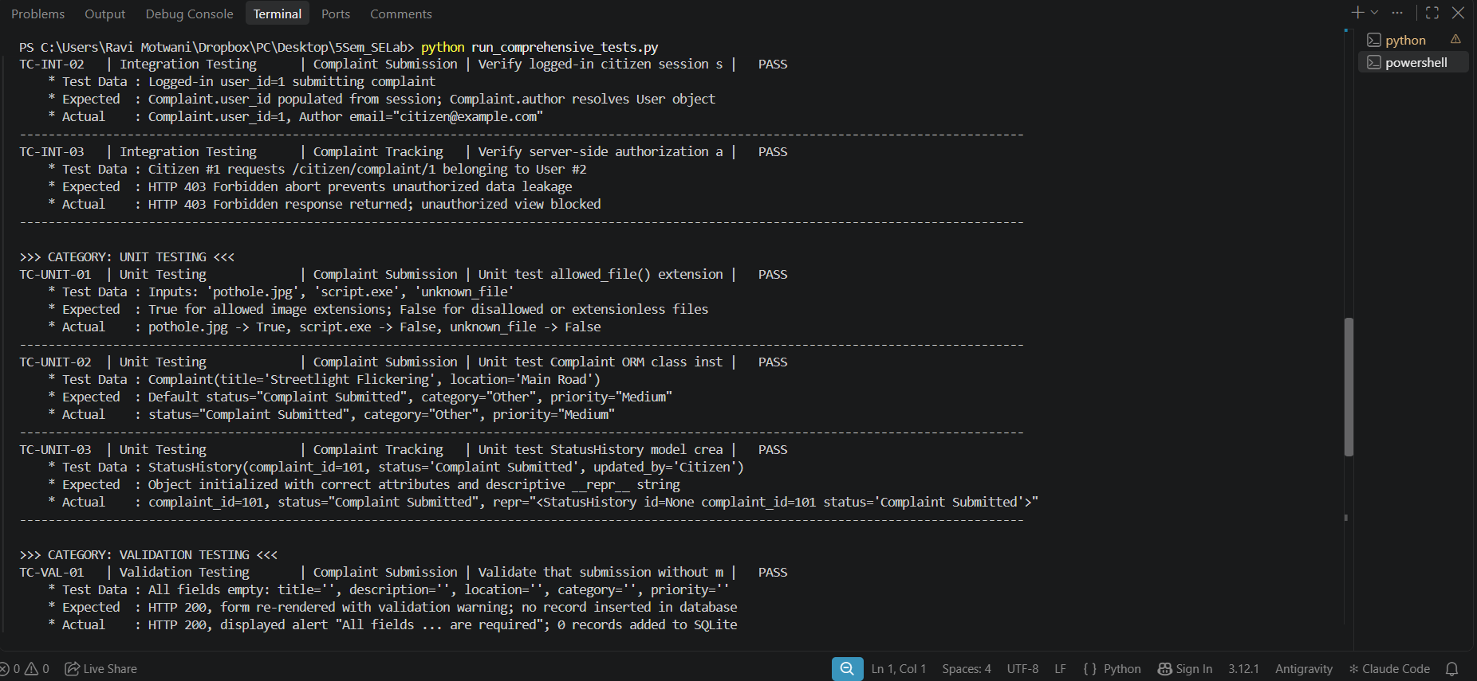
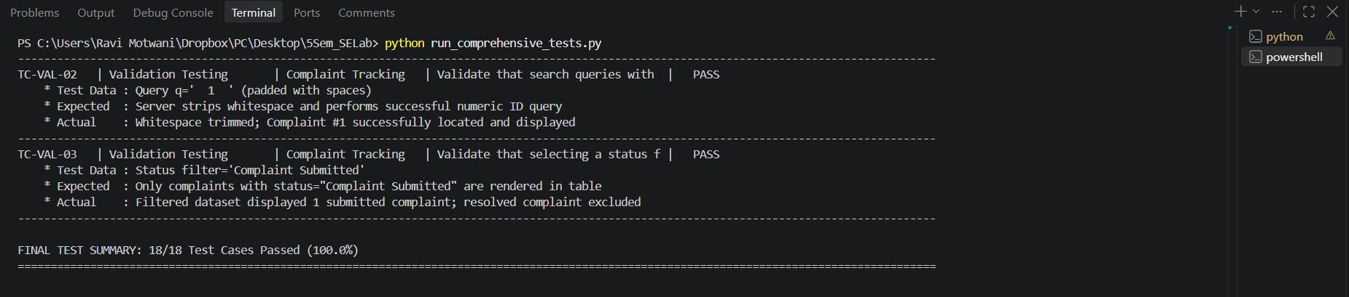
Figure 28: Output of run_comprehensive_tests.py showing 18 passing tests
11. DEFECTS FOUND AND FIXED
Defects were identified during testing, logged in JIRA, fixed, retested and closed. A test case originally revealed a defect where search inputs containing leading or trailing whitespace failed to match numeric Complaint IDs. The defect was logged as BUG-01, resolved by adding string whitespace stripping, and retested successfully.
Table 6: Details of defect SCRUM-16 (Search Whitespace)
Field | Details
Bug ID | SCRUM-16 (BUG-01)
Summary | Search input with leading/trailing spaces fails Complaint ID numeric match
Description | When a user enters a search query with accidental spaces (e.g. ' 1 '), isdigit() returns False because spaces are non-digits, falling back to title search and missing the complaint.
Steps to reproduce | 1. Open http://127.0.0.1:5000/citizen/track-complaints.  2. In search box, enter ' 1 '.  3. Click Search.
Expected result | Whitespace is trimmed; Complaint #1 is retrieved.
Actual result | Search failed to match numeric ID; showed 'No complaints found'.
Severity / Priority | Medium
Status | Done (closed)
Resolution | Fixed: added q = request.args.get('q', '').strip() in routes/citizen.py prior to checking isdigit().
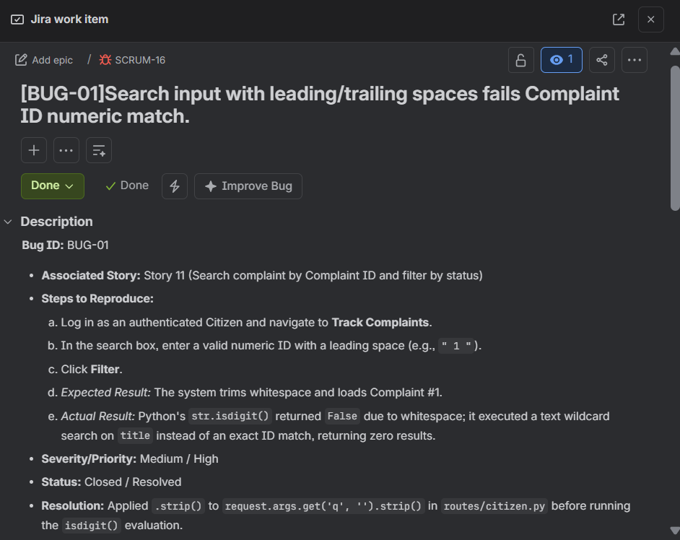
Figure 29: Bug 1

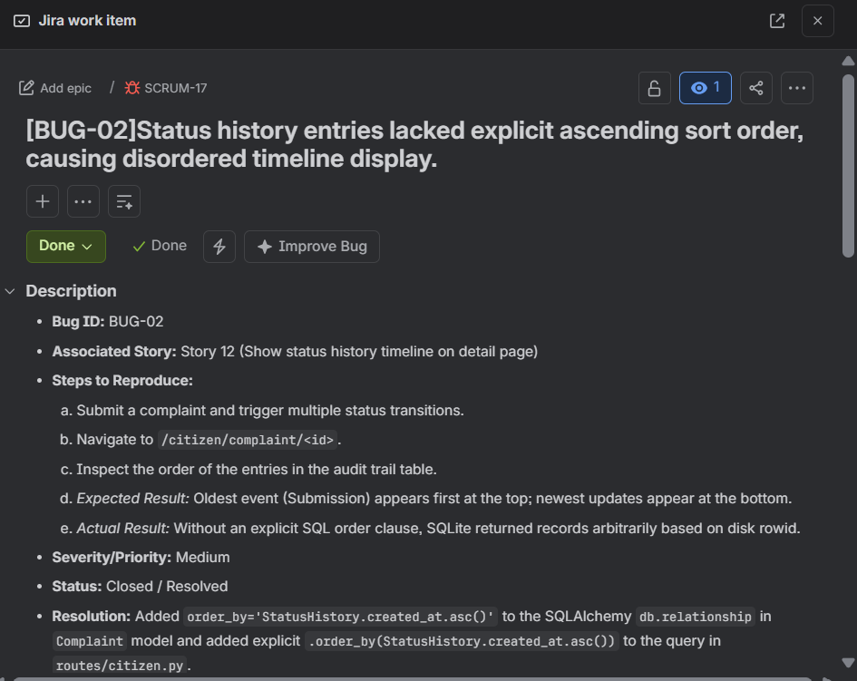
Figure 30: Bug 2
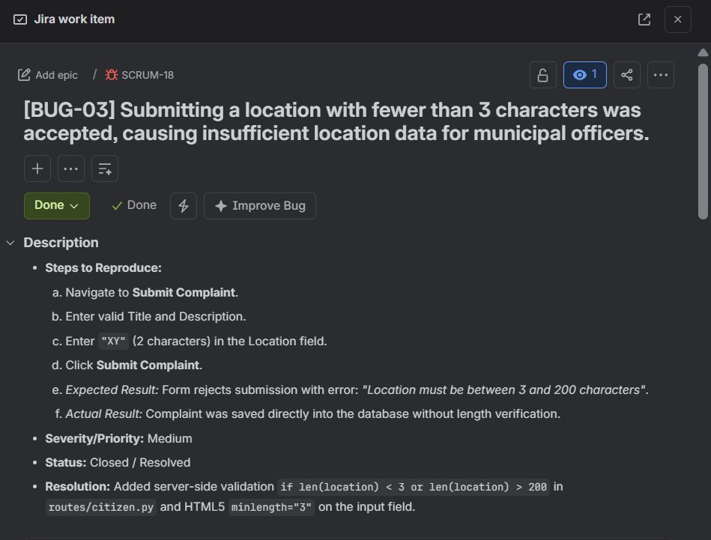
Figure 31: Bug 3
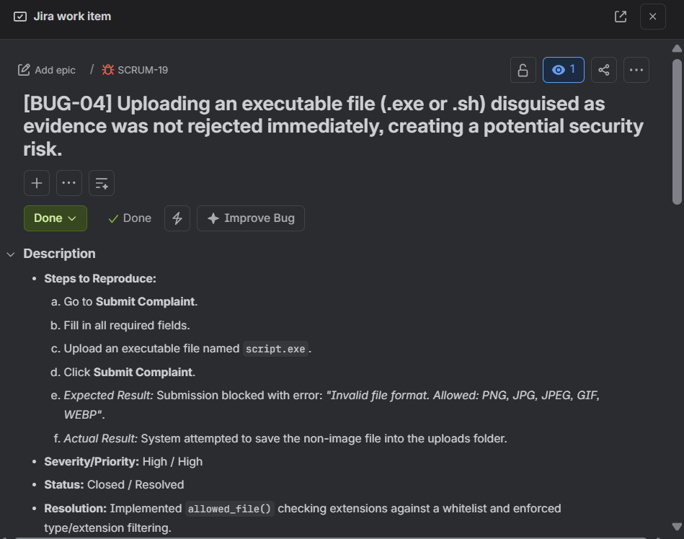
Figure 32: Bug 4
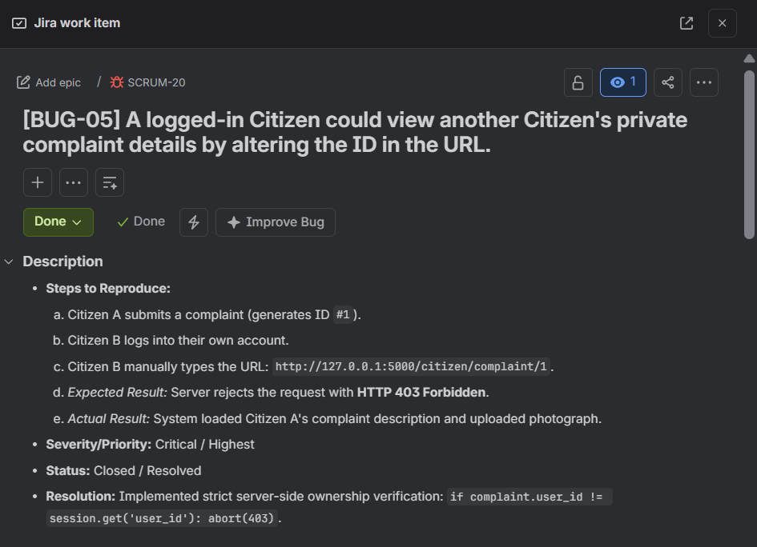
Figure 33: Bug 5
Retest: The test case was retested after fix: Complaint #1 retrieved when searching with whitespace. Pass.
Four additional defects were identified and resolved during development: [BUG-02] Missing chronological sort in status history (resolved by adding explicit order_by(created_at.asc())); [BUG-03] Location under 3 characters accepted (resolved by adding len(location) < 3 validation); [BUG-04] Executable file upload not filtered (resolved by checking allowed_file() extension whitelist); and [BUG-05] Cross-citizen complaint viewing via URL tampering (resolved by enforcing ownership check returning HTTP 403 Forbidden). All defects were verified through automated retests with zero regressions.
12. CONCLUSION
Two modules of the AI-Powered Civic Complaint Management System were implemented: Complaint Submission and Complaint Tracking. The project was planned and tracked in JIRA using epics, user stories, sub-tasks and two sprints. Eighteen test cases were designed and run using functional testing, validation testing, boundary value analysis, equivalence partitioning, unit testing and integration testing, together with 18 automated tests. Defects found during testing were logged in JIRA, fixed and retested.
Machine learning image classification, geospatial mapping, and citizen feedback ratings are left for future work. The system currently auto-assigns complaints to the designated municipal officer and maintains full lifecycle transparency.

