**3.2.1 Install Git on your computer**

**a). Git Bash** On my computer

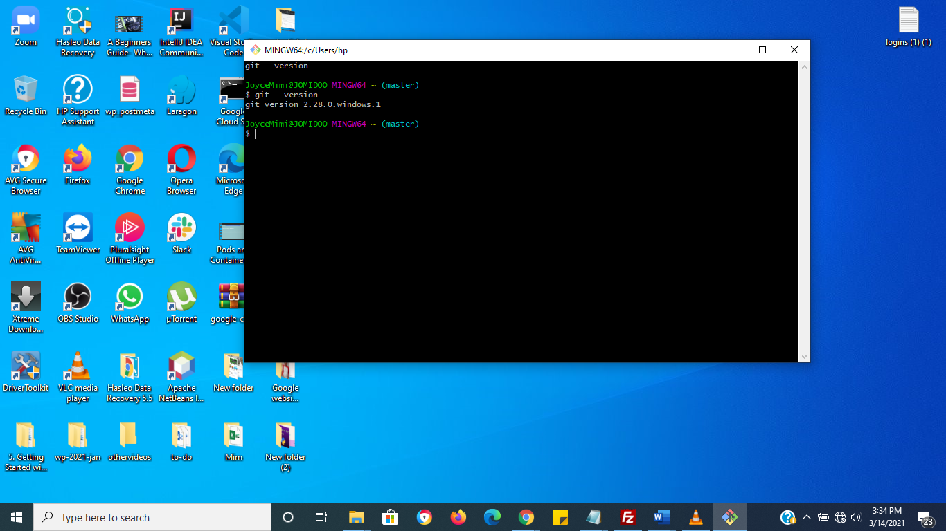

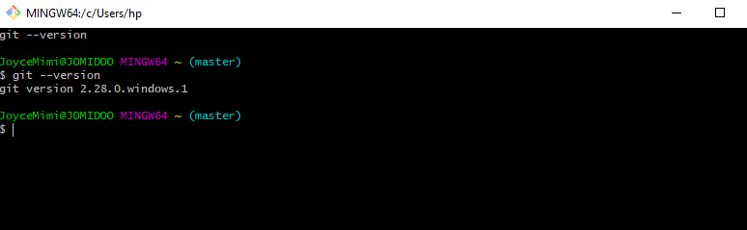

**b). Running Git on my windows command line (cmd)**

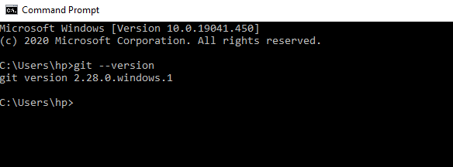

3.2.2 Create a Git-Hub account ( if you don't already have one ) and **create a repository called "SCA-devops"**

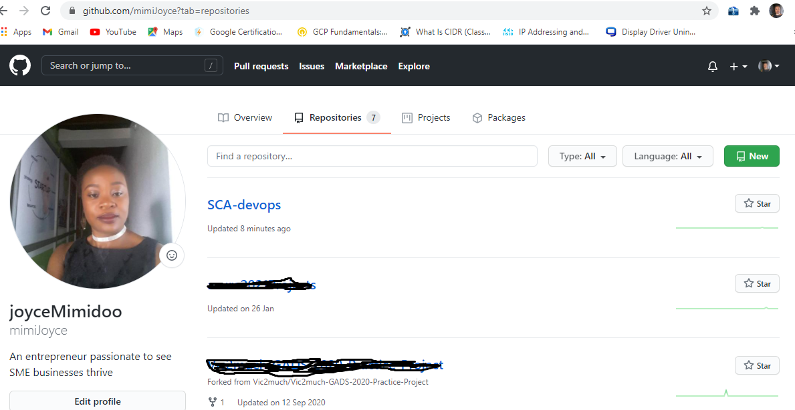

3.2.3 Add your first Readme file (explain in your ReadMe file that the **repo is for SCA DevOps levelled membership assessment**)

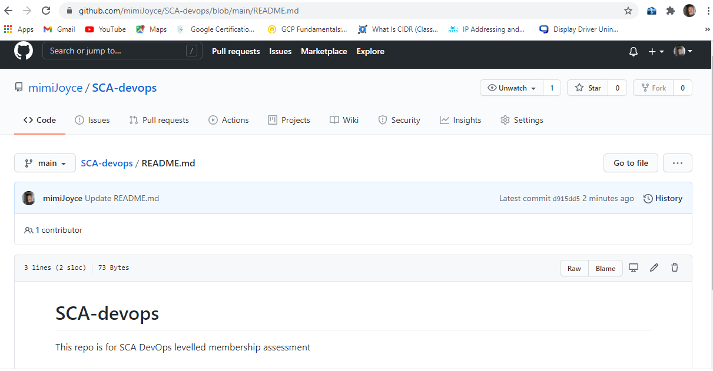

**3.2.4  On your local system, create a directory called "repository"**

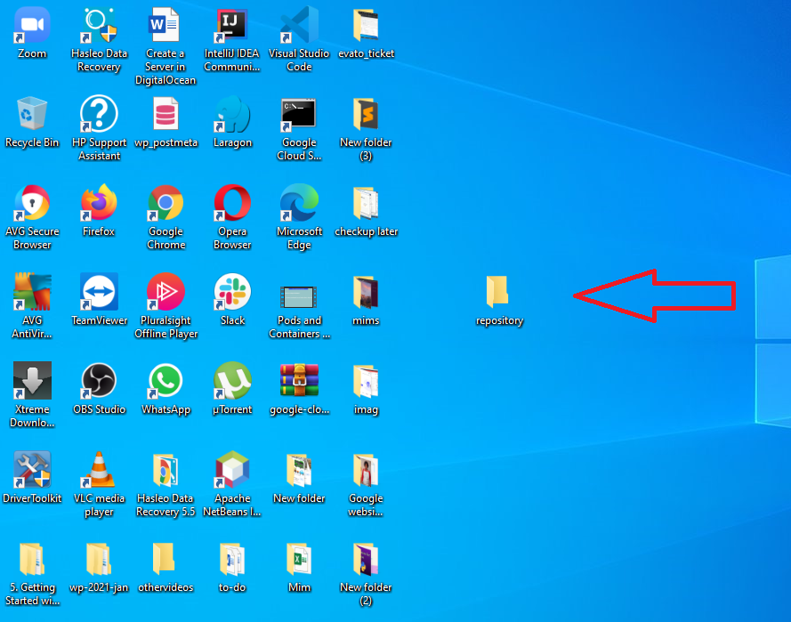

**3.2.5  Clone the repository you created in (2) above into your local system inside the directory in (4) above.**

i). gitbash into repository by right clicking on the repository folder and selecting Git Bash Here

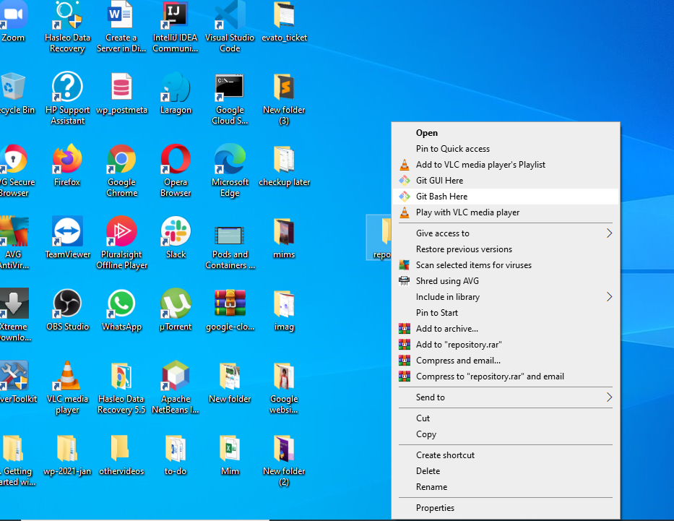

ii). Git Bash opens

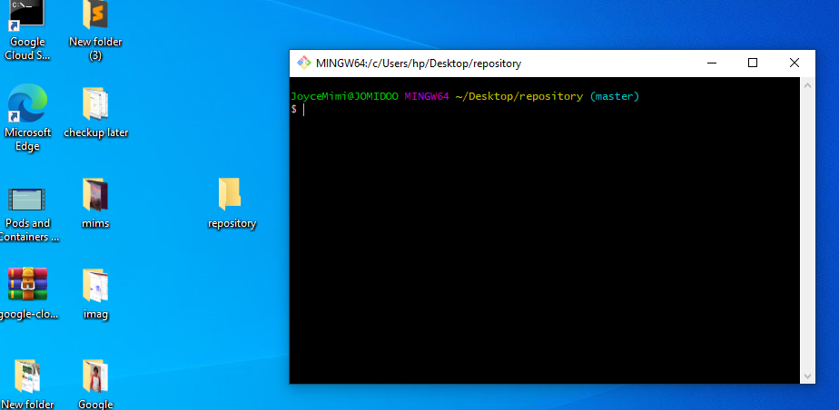

iii). Open up the repository folder on your desktop, set it side by side and then **clone** SCA devops repository and watch what happens in your local repository folder

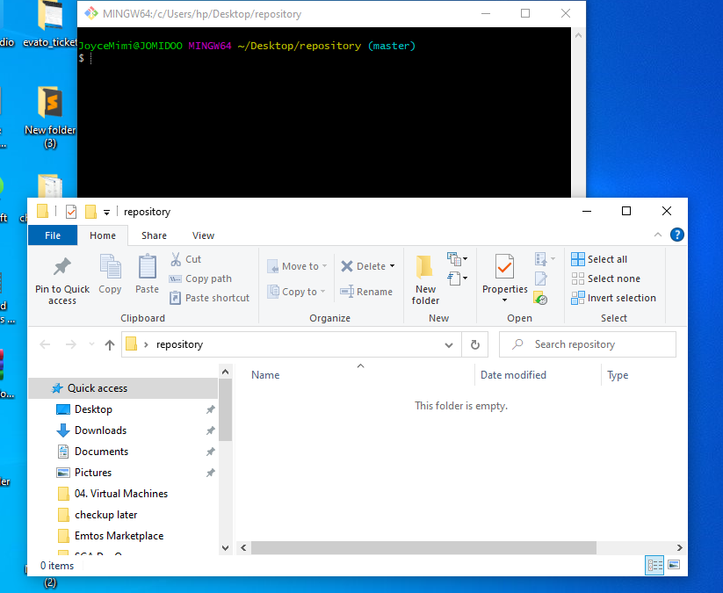

Initialise your local folder with the command <git init> then Clone your repository with ssh to local directory and watch it show up in repository folder  
a). clone repository

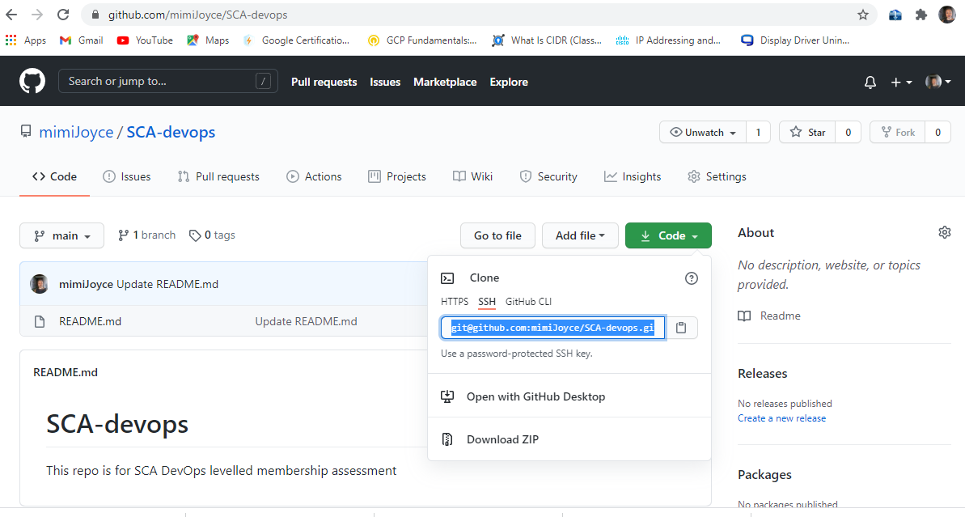

b). in your Git Bash, use git clone<INSERT-CLONE-REPO-COPIED-HERE>

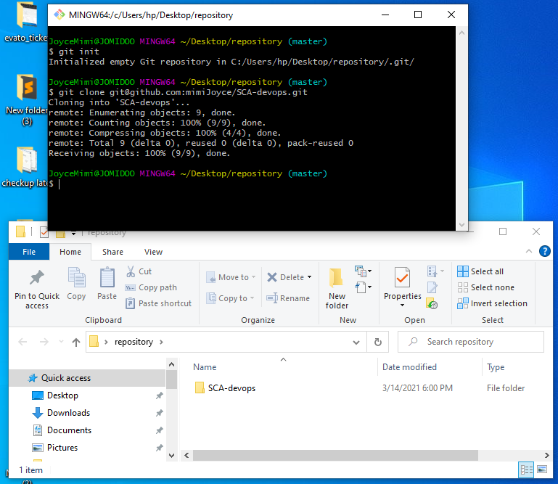

**3.2.6 Create a new branch called "Ass-1" with this command: git branch [branch-name]**

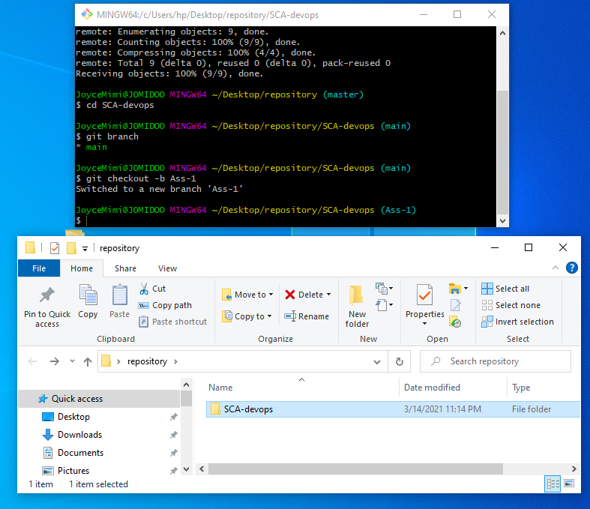gi

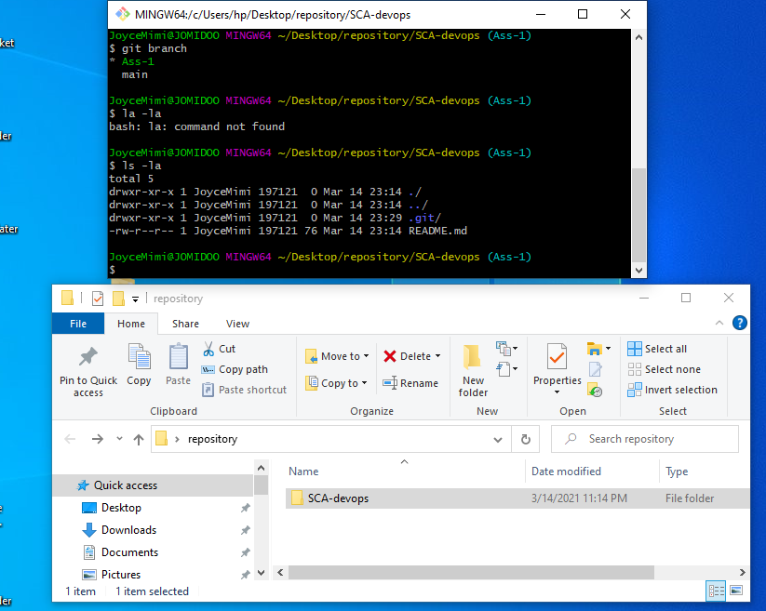

**3.2.7 In your new branch, add the solution to your Assignment in L1**

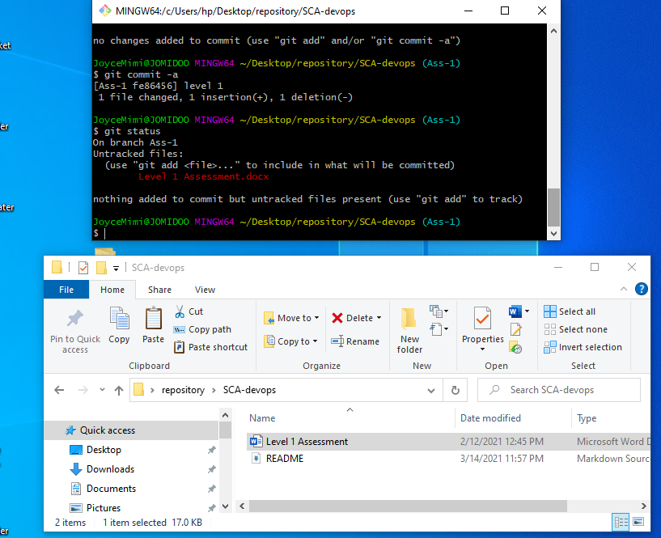

3.2.8 Commit your local changes and push to your upstream repository

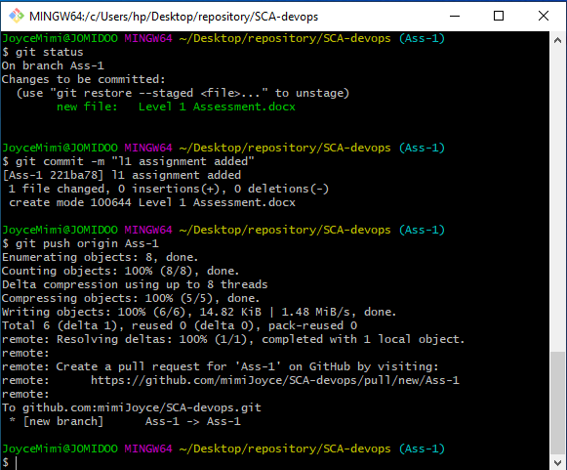

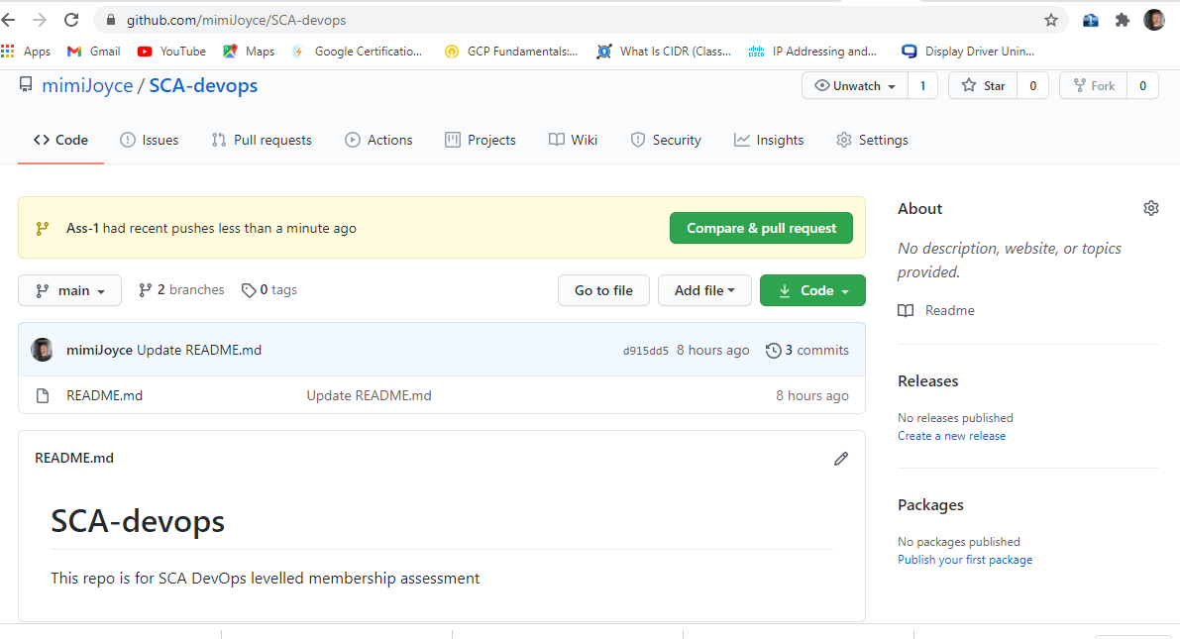

**Ass-1** git branch on remote repo

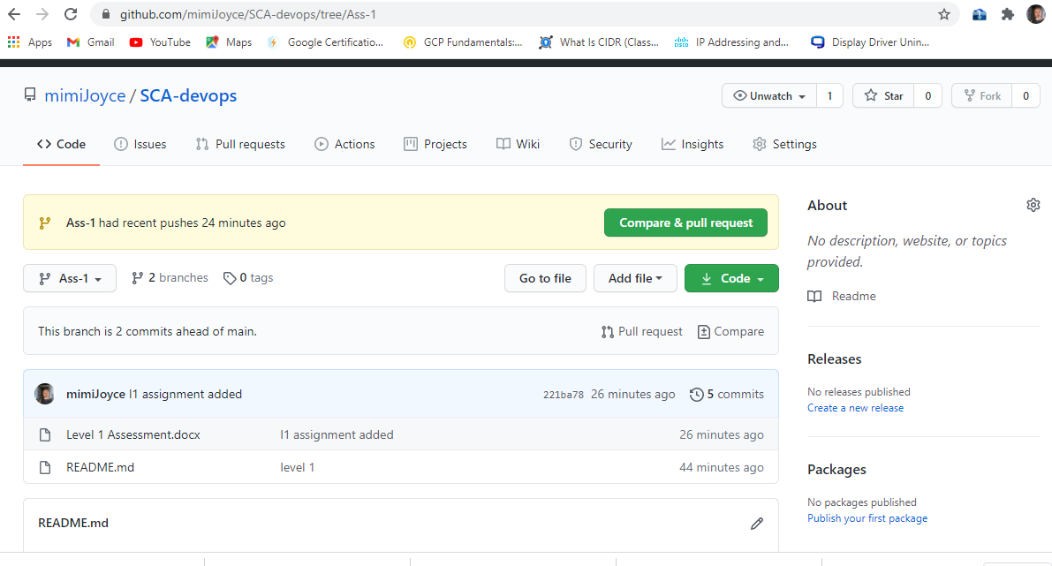

**3.2.9 Create a Pull Request (PR) from Ass-1 branch to your Master or Main branch**

**a). click pull request**

. 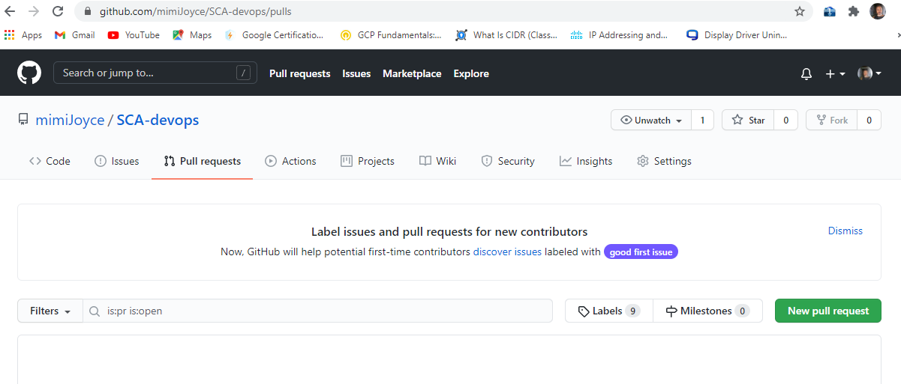

b). bring changes made in Ass-1 into main branch

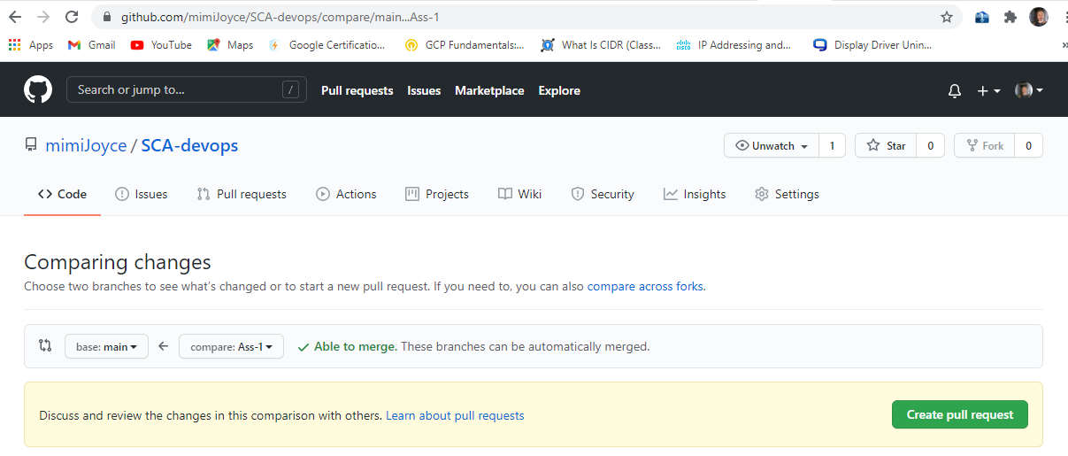

c). enter title

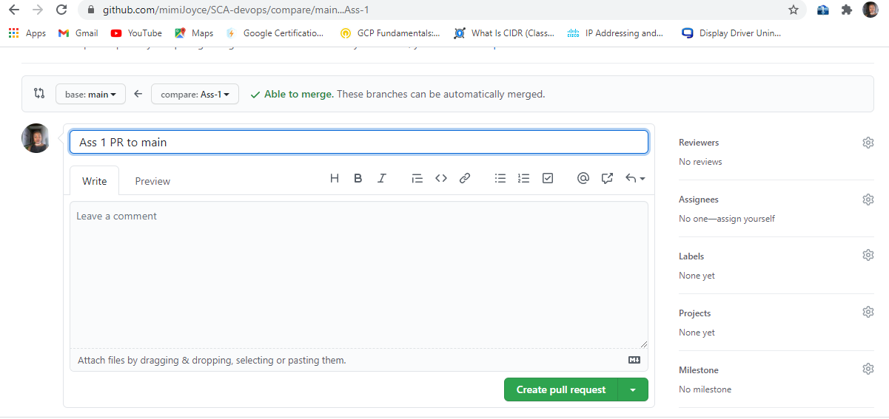

d). your pull request

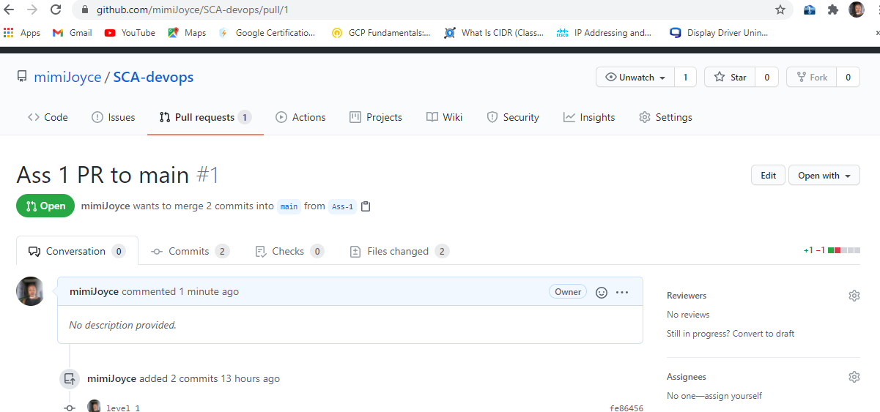

**3.2.10 Copy the link of your PR and save it somewhere**

<https://github.com/mimiJoyce/SCA-devops/pull/1>

<https://github.com/mimiJoyce/SCA-devops/pulls>

**3.2.11 Merge your PR to master**

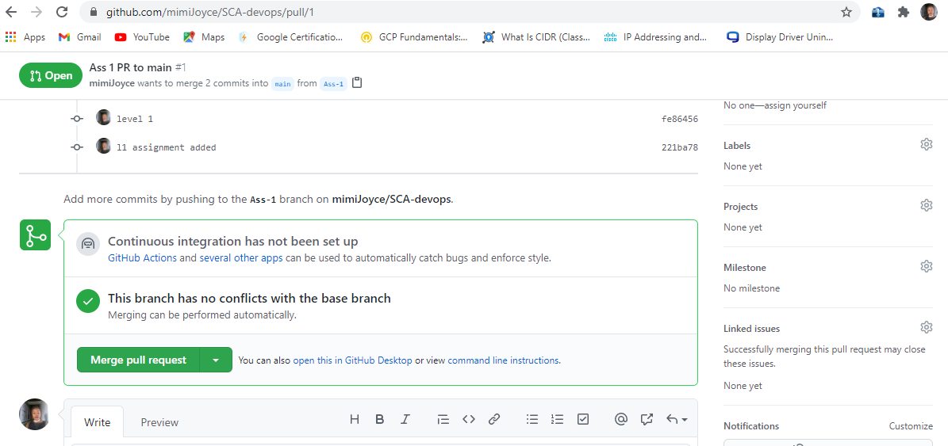

b). click confirm merge

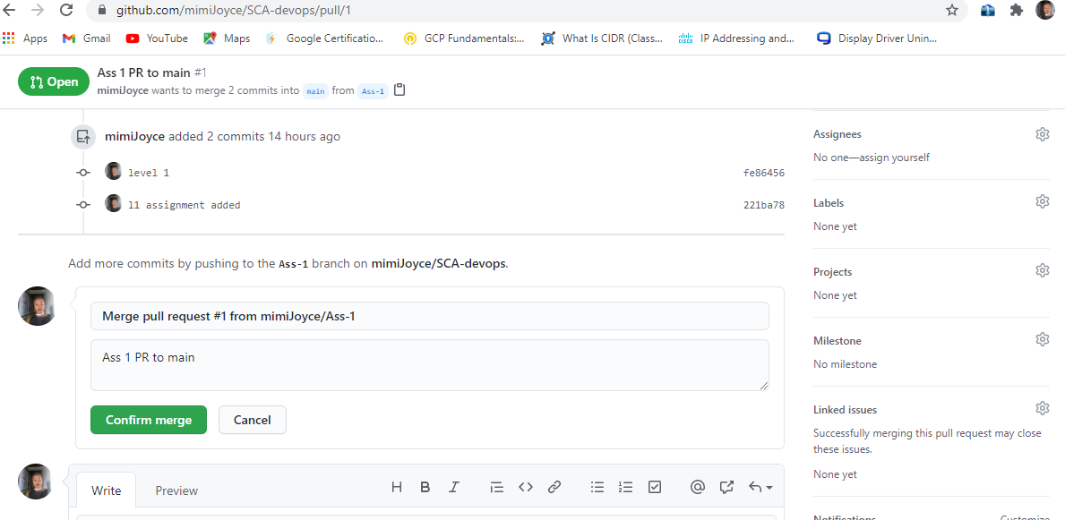

c). Pull request successfully merged

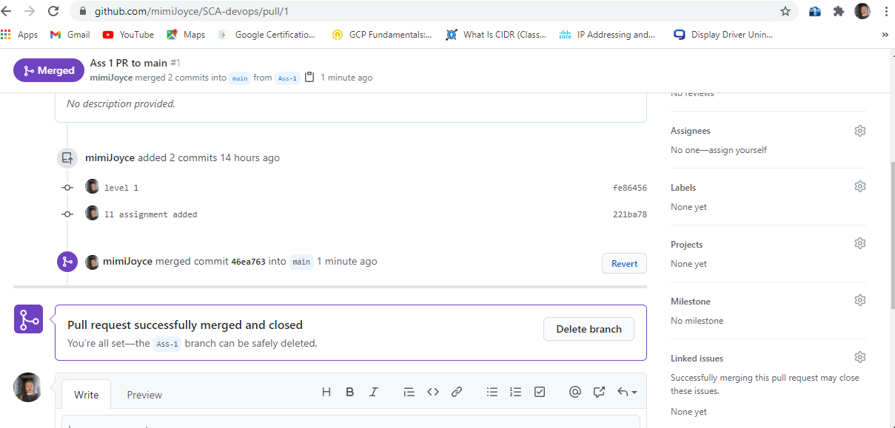

d). you can delete Ass-1 branch, if you wont be needing it again.

**3.2.12 On your local system (on the master branch), pull your upstream change so that your local master is same as its origin**

1. type this command: **git fetch** to all branches on remote

2. **git checkout main** to checkout from Ass-1 to main branch

3). **git pull** to bring in all the changes on repo

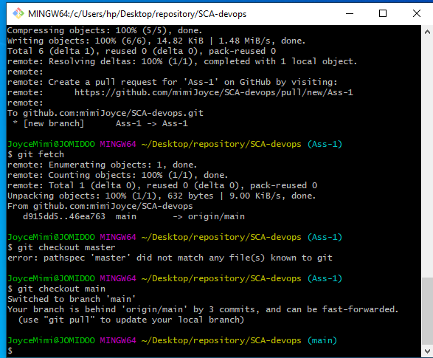

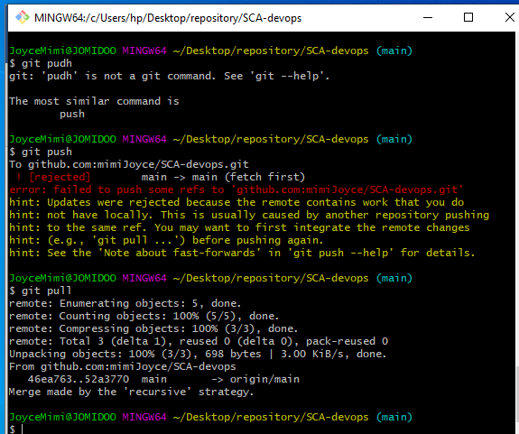

**3.2.13 Now create a new branch called "Ass-2". from master**

a). use command: **git branch Ass-2** to create Ass-2 branch and **git branch** to see your branches and **git checkout** **Ass-2** to move into Ass-2 branch

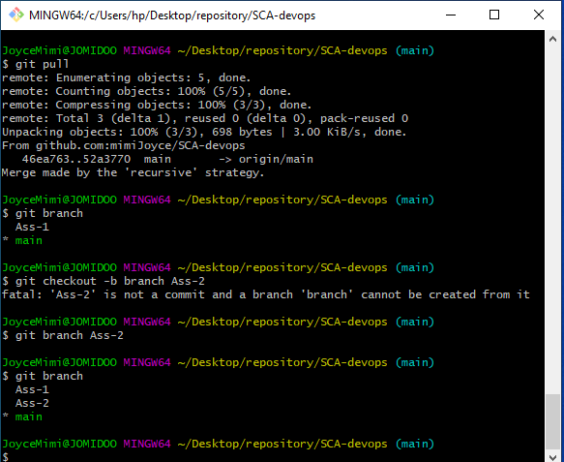

**3.2.14 In your new branch, add the solution to your Assignment in L2**

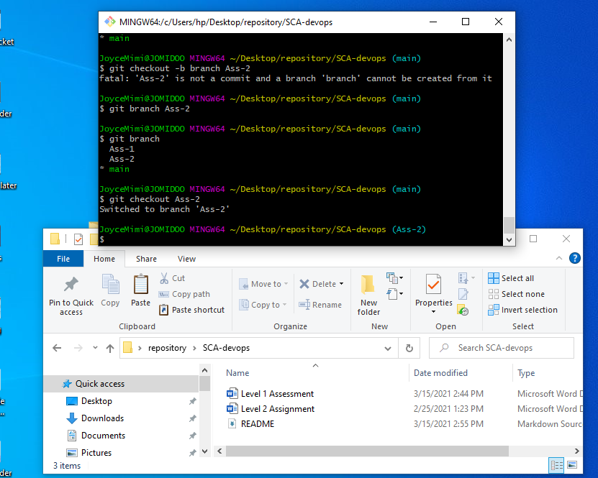

**3.2.15 Commit your local changes and push to your upstream repository**

a). Commit your local changes

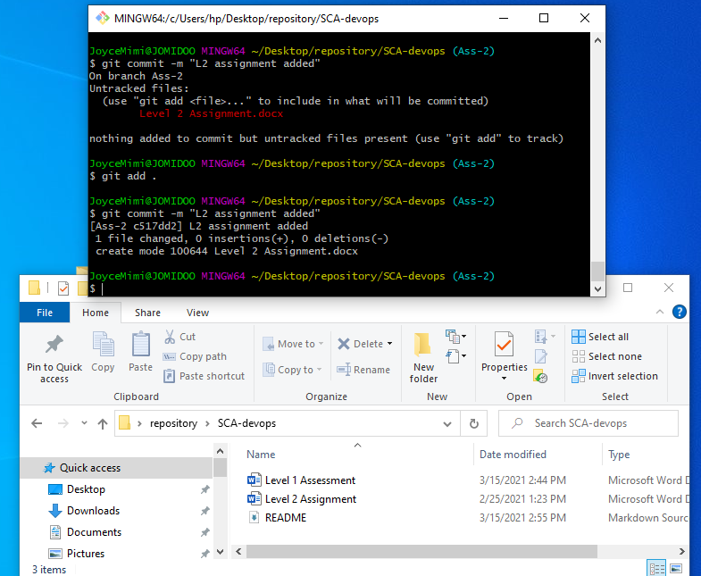

b). push your Commit to your upstream repo

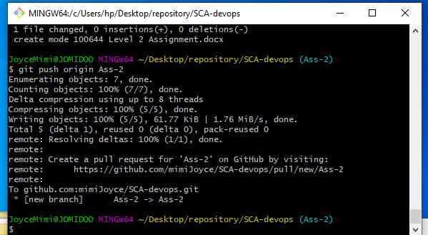

c). Check your GitHub

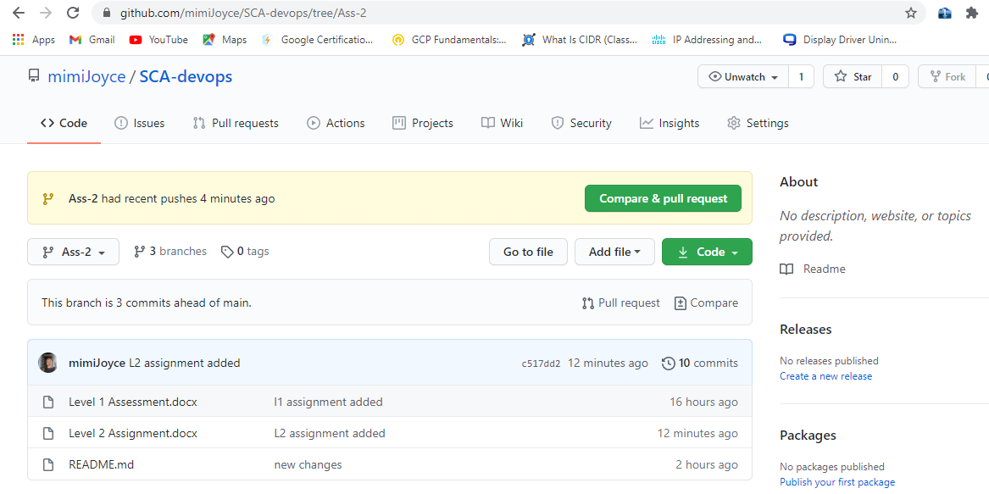

**3.2.16 Create a Pull Request (PR) from Ass-2 branch to your Master or Main branch**

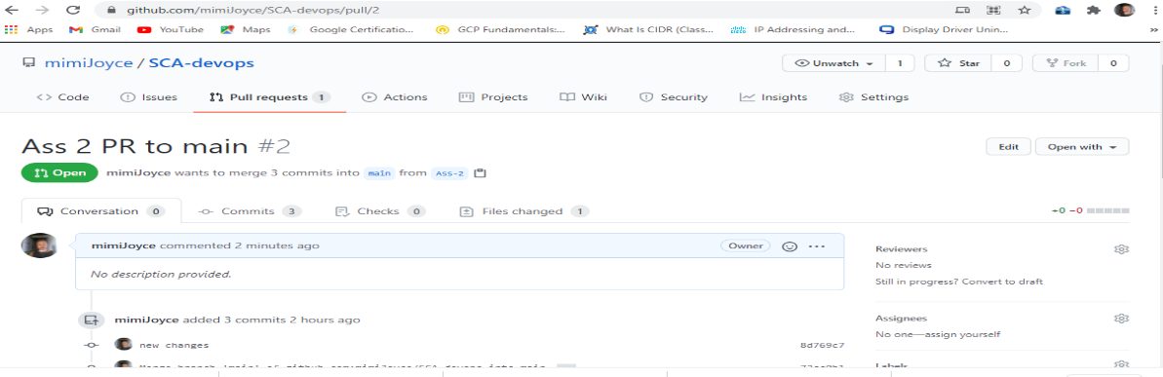

**3.2.17 Copy the link of your PR and save it somewhere**

<https://github.com/mimiJoyce/SCA-devops/pull/2>

**3.2.18 Merge your PR to master**

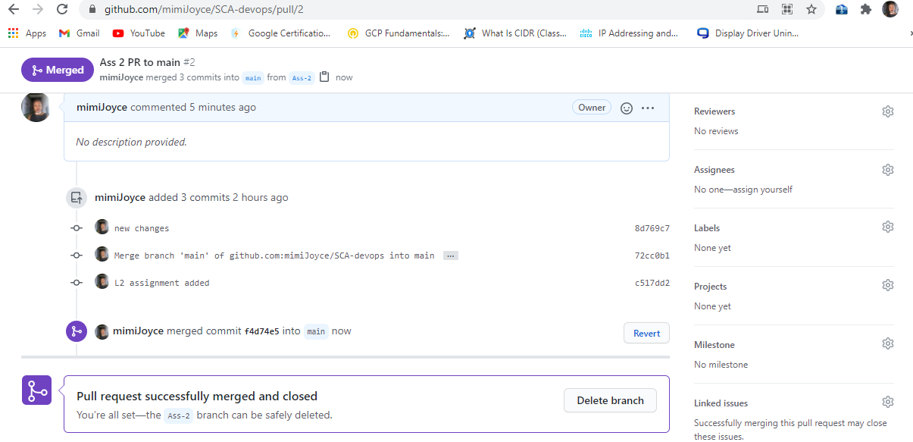

**3.2.19 Submit your GitHub repo URL**

<https://github.com/mimiJoyce/SCA-devops>

**3.2.20** Submit the links to your 2 PR created

<https://github.com/mimiJoyce/SCA-devops/pull/2>

<https://github.com/mimiJoyce/SCA-devops/pull/1>

<https://github.com/mimiJoyce/SCA-devops/pulls>

compiled by joyceMimi