Final Hive Queries and Hue Visualisation Settings
Customer Churn Big Data Project

Overall Churn Distribution
Purpose and project alignment: Provides the baseline proportion of churned and retained customers before subgroup analysis.

Hive Query
SELECT
CASE
WHEN churn = 1 THEN 'Churned'
ELSE 'Retained'
END AS customer_status,
COUNT(*) AS customer_count,
ROUND(COUNT(*) * 100.0 / SUM(COUNT(*)) OVER (), 2) AS percentage
FROM customer_churn_cleaned
GROUP BY churn
ORDER BY churn;
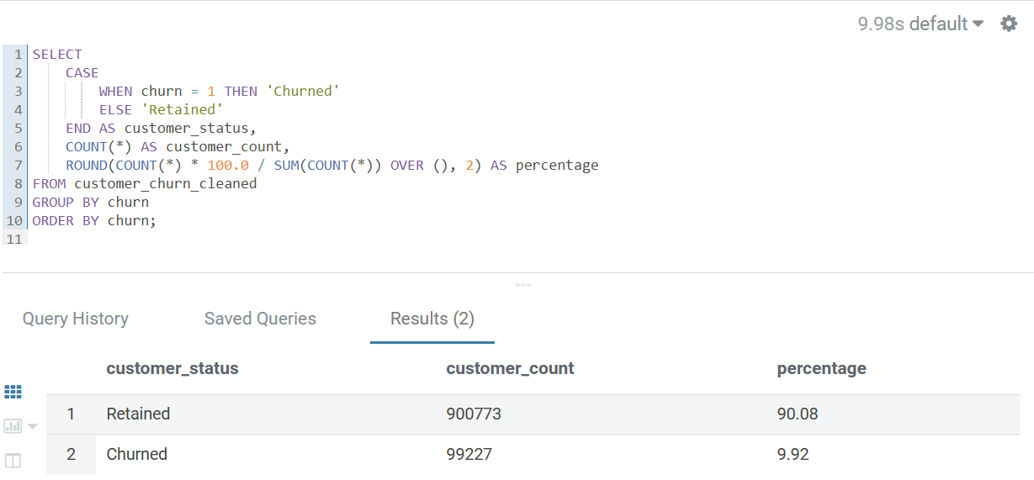
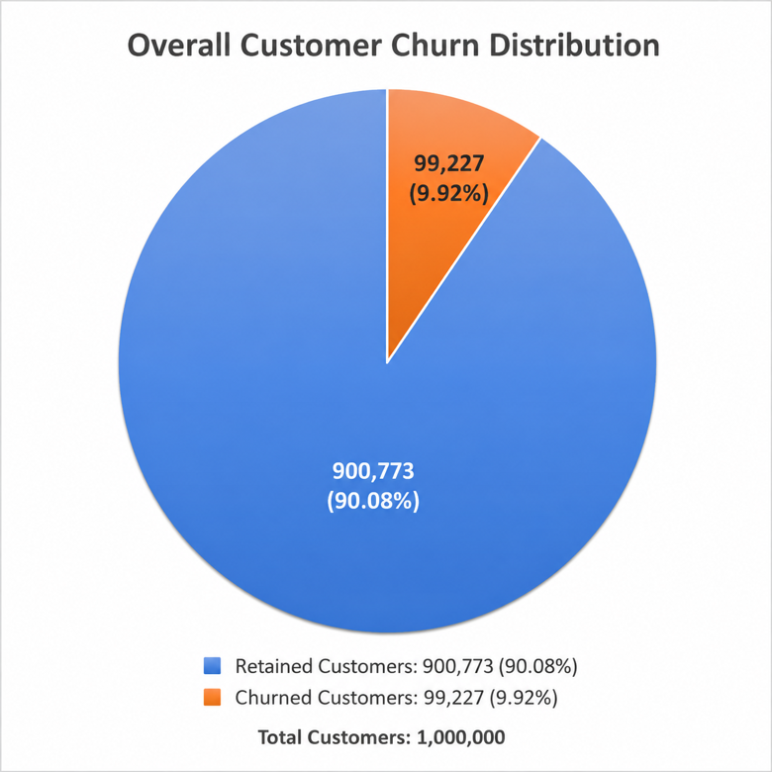

Fig. 2 - Contract x Payment Method
Purpose and project alignment: Examines churn differences across contract types and payment methods, covering both contract and billing behaviour. It also aligns with the MapReduce grouping example used in the project.

Hive Query
SELECT
contract AS contract_type,
payment_method,
COUNT(*) AS total_customers,
SUM(churn) AS churned_customers,
ROUND(SUM(churn) * 100.0 / COUNT(*), 2) AS churn_rate
FROM customer_churn_cleaned
WHERE contract IS NOT NULL
AND payment_method IS NOT NULL
GROUP BY contract, payment_method
ORDER BY contract_type, churn_rate DESC;

Hue Visualisation Keys
Setting | Value
Chart type | Bars
X-axis | contract_type
Y-axis | churn_rate
Group | payment_method
Do not plot | total_customers, churned_customers
Recommended figure title: Churn Rate by Contract Type and Payment Method
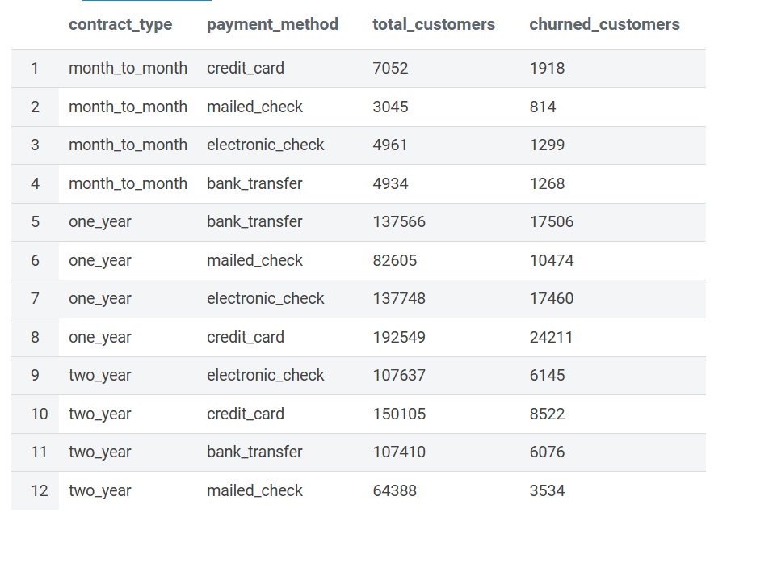
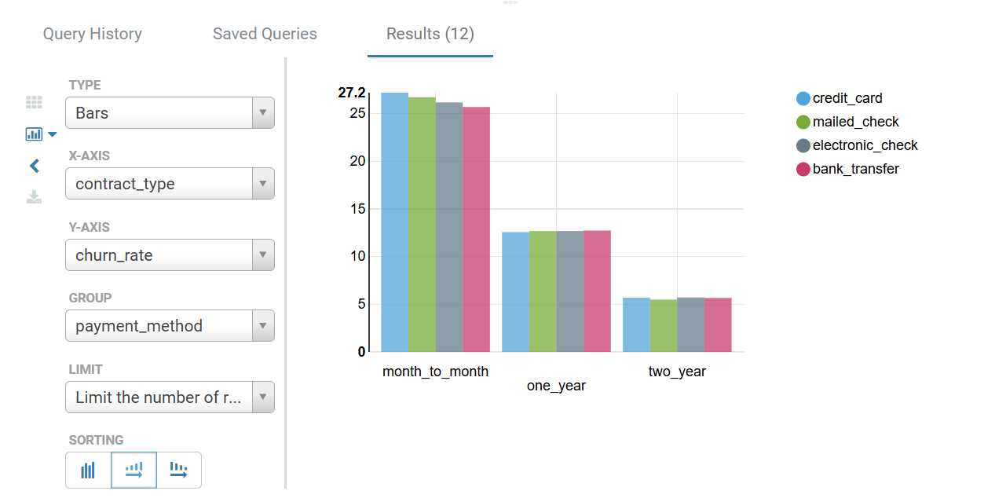

Fig. 3 - Tenure x Satisfaction
Purpose and project alignment: Compares churn across tenure groups and customer satisfaction levels, directly supporting the project research question.

Hive Query
SELECT
CASE tenure_group
WHEN '0-12_months' THEN '0-12 months'
WHEN '13-24_months' THEN '13-24 months'
WHEN '25-48_months' THEN '25-48 months'
WHEN '49+_months' THEN '49+ months'
END AS tenure,
CASE satisfaction_group
WHEN 'low' THEN 'Low (1-2)'
WHEN 'moderate' THEN 'Moderate (3)'
WHEN 'high' THEN 'High (4-5)'
END AS satisfaction,
COUNT(*) AS total_customers,
SUM(churn) AS churned_customers,
ROUND(SUM(churn) * 100.0 / COUNT(*), 2) AS churn_rate
FROM customer_churn_cleaned
WHERE tenure_group <> 'missing'
AND satisfaction_group <> 'missing'
GROUP BY tenure_group, satisfaction_group
ORDER BY
CASE tenure_group
WHEN '0-12_months' THEN 1
WHEN '13-24_months' THEN 2
WHEN '25-48_months' THEN 3
WHEN '49+_months' THEN 4
ELSE 5
END,
CASE satisfaction_group
WHEN 'low' THEN 1
WHEN 'moderate' THEN 2
WHEN 'high' THEN 3
ELSE 4
END;

Hue Visualisation Keys
Setting | Value
Chart type | Bars
X-axis | tenure
Y-axis | churn_rate
Group | satisfaction
Do not plot | total_customers, churned_customers
Recommended figure title: Churn Rate by Tenure Group and Customer Satisfaction
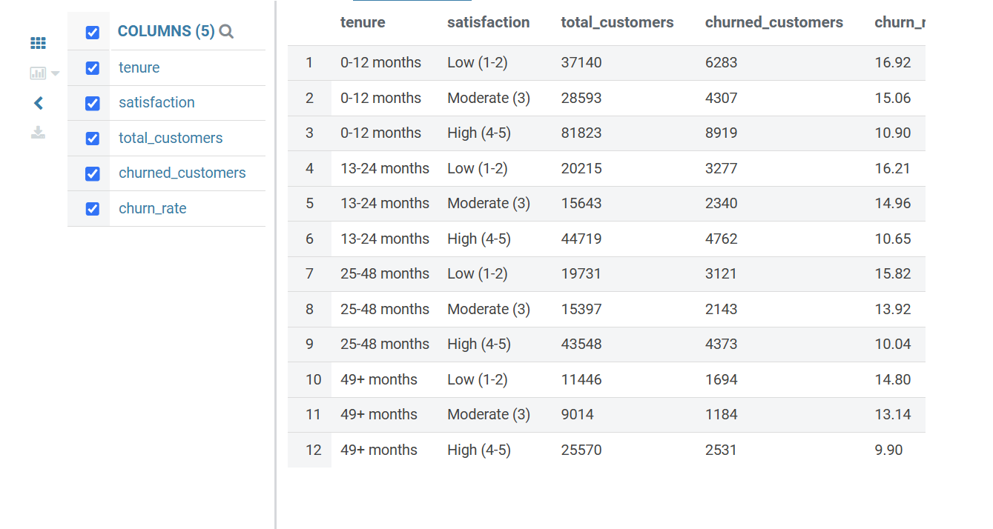
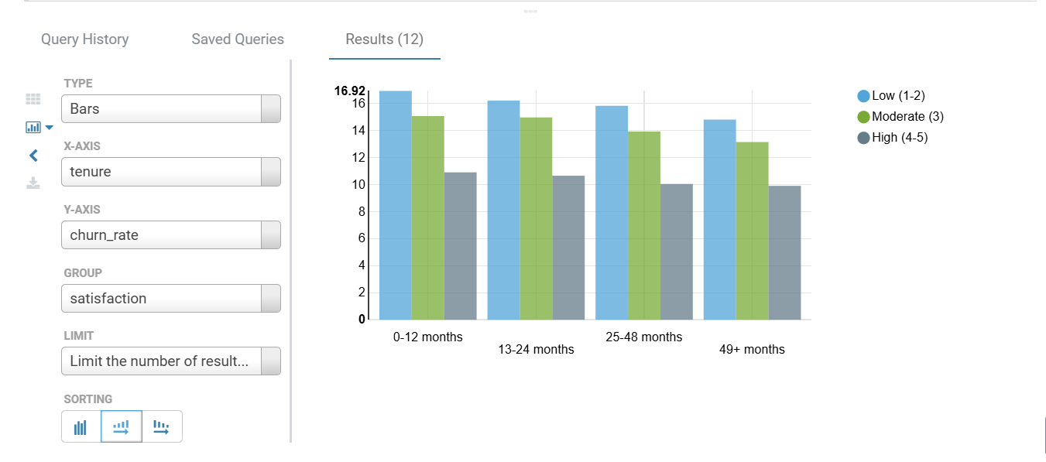

Fig. 4 - Complaints x Service Calls
Purpose and project alignment: Analyses customer-service behaviour by combining complaint frequency and service-call activity.

Hive Query
SELECT
CASE complaint_group
WHEN 'none' THEN 'No complaints'
WHEN 'one' THEN '1 complaint'
WHEN 'two_to_three' THEN '2-3 complaints'
WHEN 'more_than_three' THEN 'More than 3'
END AS complaints,
CASE service_call_group
WHEN 'none' THEN 'No calls'
WHEN 'one_to_two' THEN '1-2 calls'
WHEN 'three_to_five' THEN '3-5 calls'
WHEN 'more_than_five' THEN 'More than 5'
END AS service_calls,
COUNT(*) AS total_customers,
SUM(churn) AS churned_customers,
ROUND(SUM(churn) * 100.0 / COUNT(*), 2) AS churn_rate
FROM customer_churn_cleaned
WHERE complaint_group <> 'missing'
AND service_call_group <> 'missing'
GROUP BY complaint_group, service_call_group
ORDER BY
CASE complaint_group
WHEN 'none' THEN 1
WHEN 'one' THEN 2
WHEN 'two_to_three' THEN 3
WHEN 'more_than_three' THEN 4
ELSE 5
END,
CASE service_call_group
WHEN 'none' THEN 1
WHEN 'one_to_two' THEN 2
WHEN 'three_to_five' THEN 3
WHEN 'more_than_five' THEN 4
ELSE 5
END;

Hue Visualisation Keys
Setting | Value
Chart type | Bars
X-axis | complaints
Y-axis | churn_rate
Group | service_calls
Do not plot | total_customers, churned_customers
Recommended figure title: Churn Rate by Complaint Frequency and Service Calls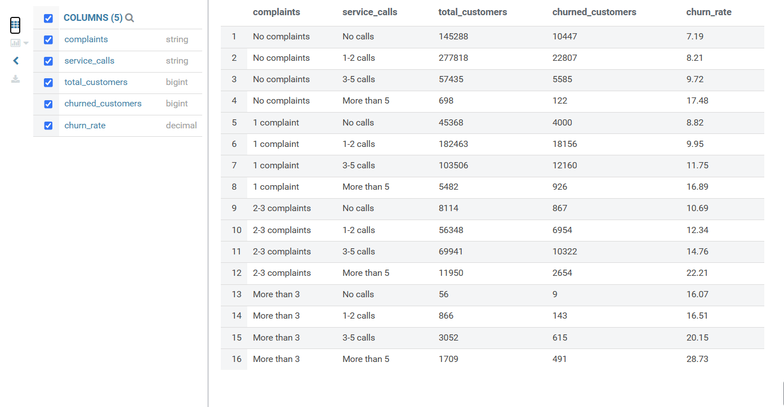
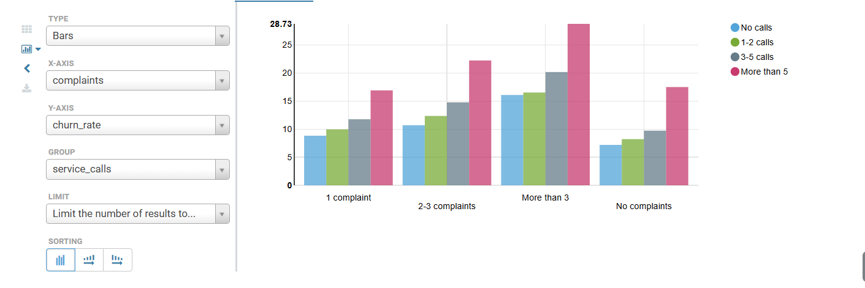

Fig. 5 - Internet Usage x Tech Support
Purpose and project alignment: Combines service usage with technical-support availability to examine churn patterns among service users.

Hive Query
SELECT
CASE usage_band
WHEN 'no_internet' THEN 'No internet'
WHEN 'low' THEN 'Low usage'
WHEN 'medium' THEN 'Medium usage'
WHEN 'high' THEN 'High usage'
END AS internet_usage,
CASE
WHEN has_tech_support = 1 THEN 'Has Tech Support'
WHEN has_tech_support = 0 THEN 'No Tech Support'
END AS tech_support,
COUNT(*) AS total_customers,
SUM(churn) AS churned_customers,
ROUND(SUM(churn) * 100.0 / COUNT(*), 2) AS churn_rate
FROM customer_churn_cleaned
WHERE usage_band <> 'missing'
AND has_tech_support IN (0, 1)
GROUP BY usage_band, has_tech_support
ORDER BY
CASE usage_band
WHEN 'no_internet' THEN 1
WHEN 'low' THEN 2
WHEN 'medium' THEN 3
WHEN 'high' THEN 4
ELSE 5
END,
has_tech_support DESC;

Hue Visualisation Keys
Setting | Value
Chart type | Bars
X-axis | internet_usage
Y-axis | churn_rate
Group | tech_support
Do not plot | total_customers, churned_customers
Recommended figure title: Churn Rate by Internet Usage and Technical Support
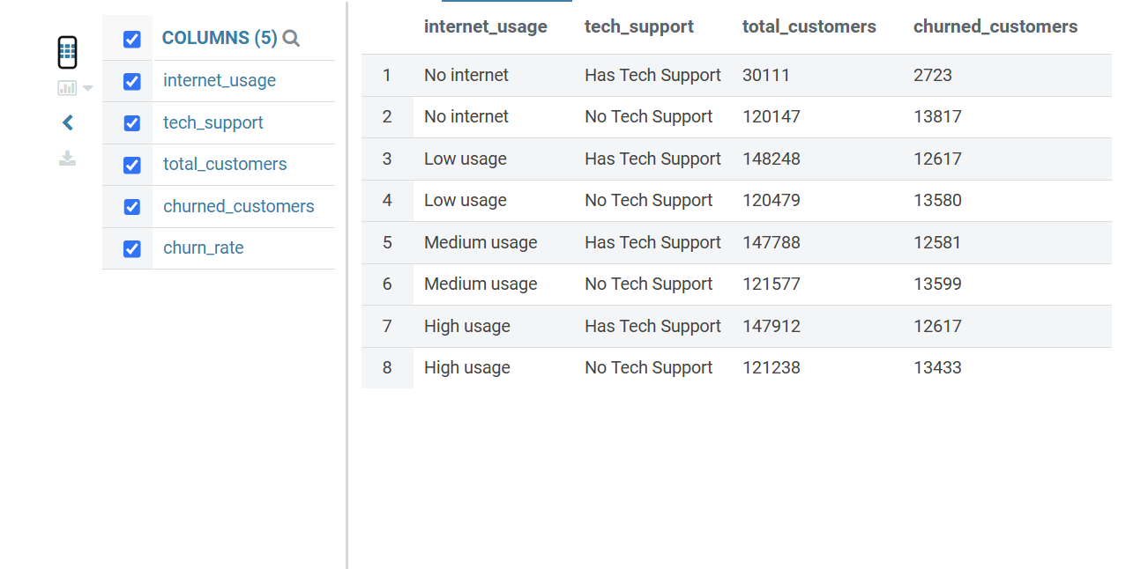
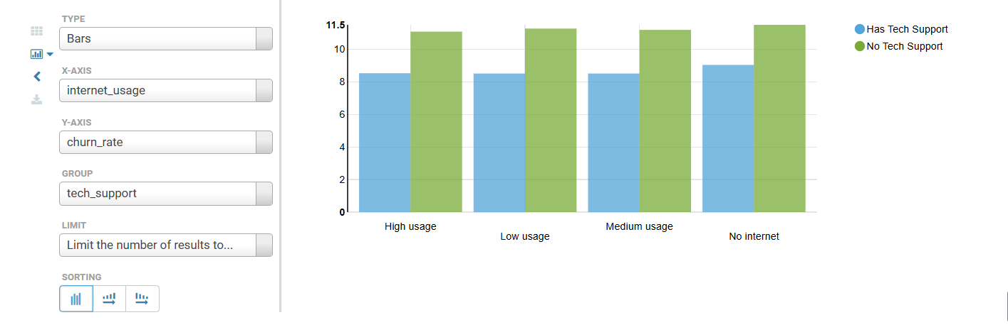

Fig. 6 - Monthly Charges x Contract
Purpose and project alignment: Combines billing level and contract type to show whether churn patterns differ across customer payment levels and commitment periods.

Hive Query
SELECT
CASE monthly_charge_band
WHEN 'low' THEN 'Low charges'
WHEN 'medium' THEN 'Medium charges'
WHEN 'high' THEN 'High charges'
END AS charge_band,
contract AS contract_type,
COUNT(*) AS total_customers,
SUM(churn) AS churned_customers,
ROUND(SUM(churn) * 100.0 / COUNT(*), 2) AS churn_rate
FROM customer_churn_cleaned
WHERE monthly_charge_band <> 'missing'
AND contract IS NOT NULL
GROUP BY monthly_charge_band, contract
ORDER BY
CASE monthly_charge_band
WHEN 'low' THEN 1
WHEN 'medium' THEN 2
WHEN 'high' THEN 3
ELSE 4
END,
churn_rate DESC;

Hue Visualisation Keys
Setting | Value
Chart type | Bars
X-axis | charge_band
Y-axis | churn_rate
Group | contract_type
Do not plot | total_customers, churned_customers
Recommended figure title: Churn Rate by Monthly Charge Band and Contract Type
