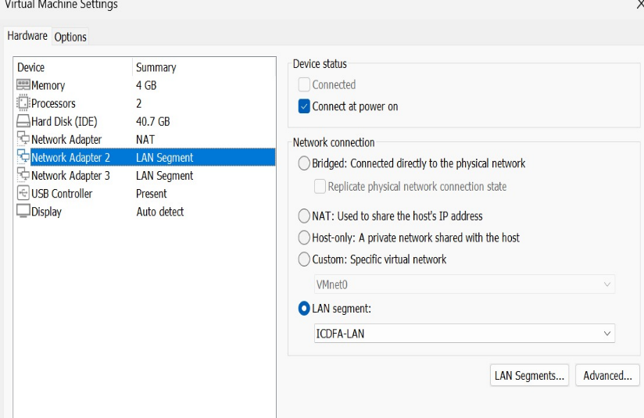
Screenshot of the VirtualBox adapters for icdfa-nslab-fire wall-v1.

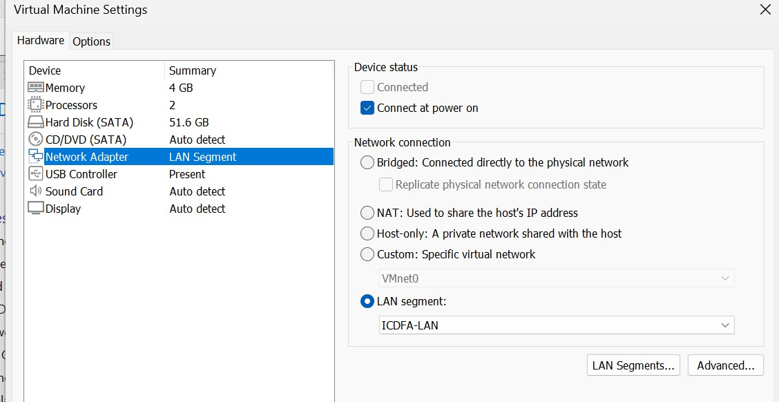
Screenshot of the VirtualBox adapter for icdfa-nslab-client-v1.
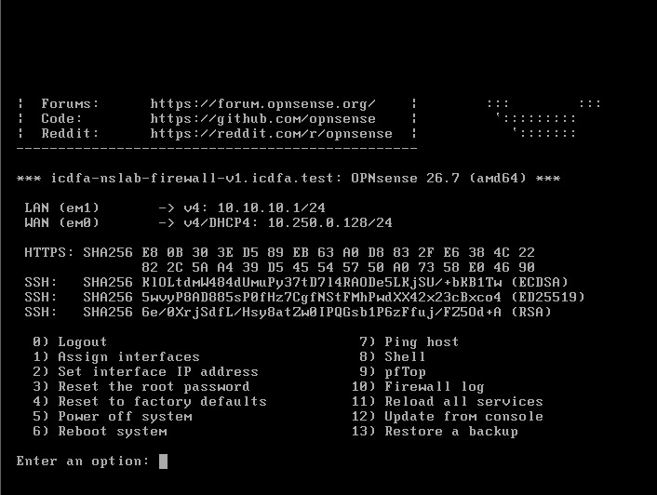
Screenshot showing the OPNsense WAN and LAN interface status.
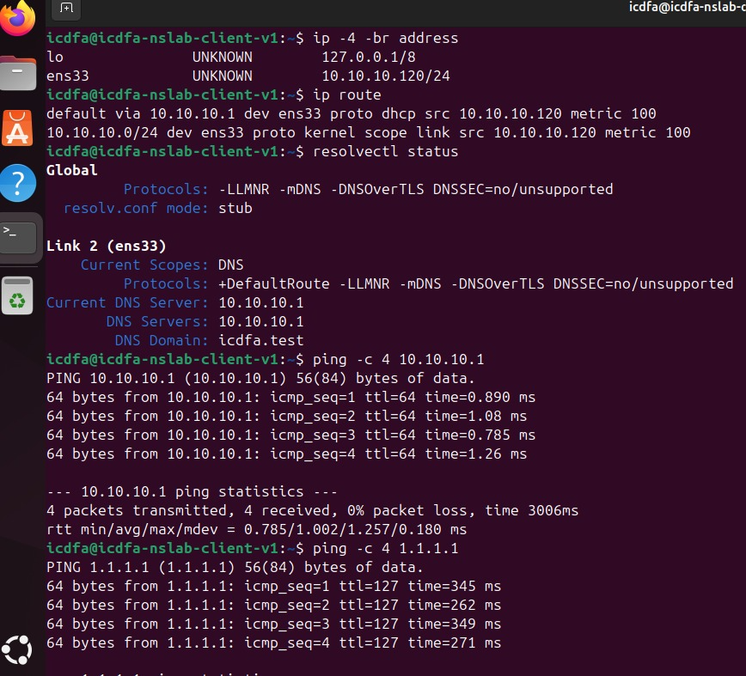
Screenshot showing Output of ip -4 -br address ip route, Successful ping to 10.10.10.1,Successful ping to 1.1.1.1, Successful DNS-resolution test.
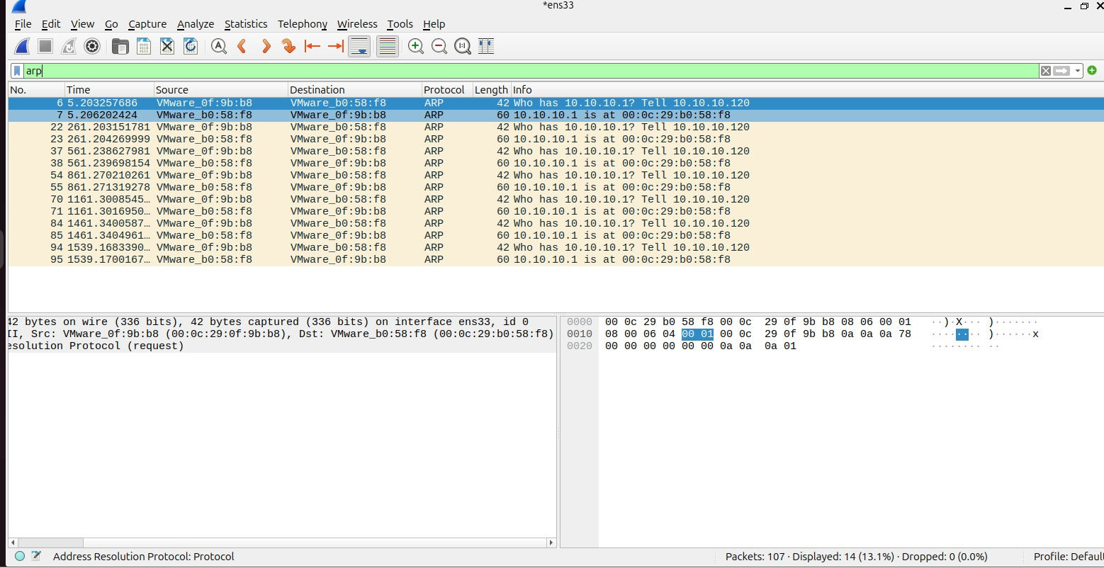
Wireshark ARP capture with the arp filter visible.
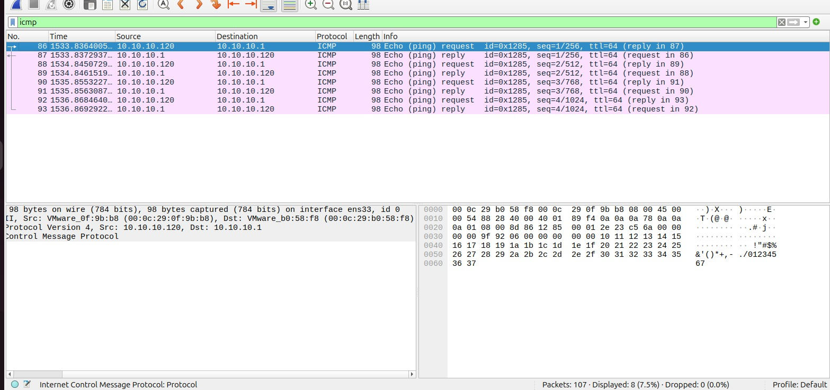
Wireshark ARP capture with the icmp filter visible.
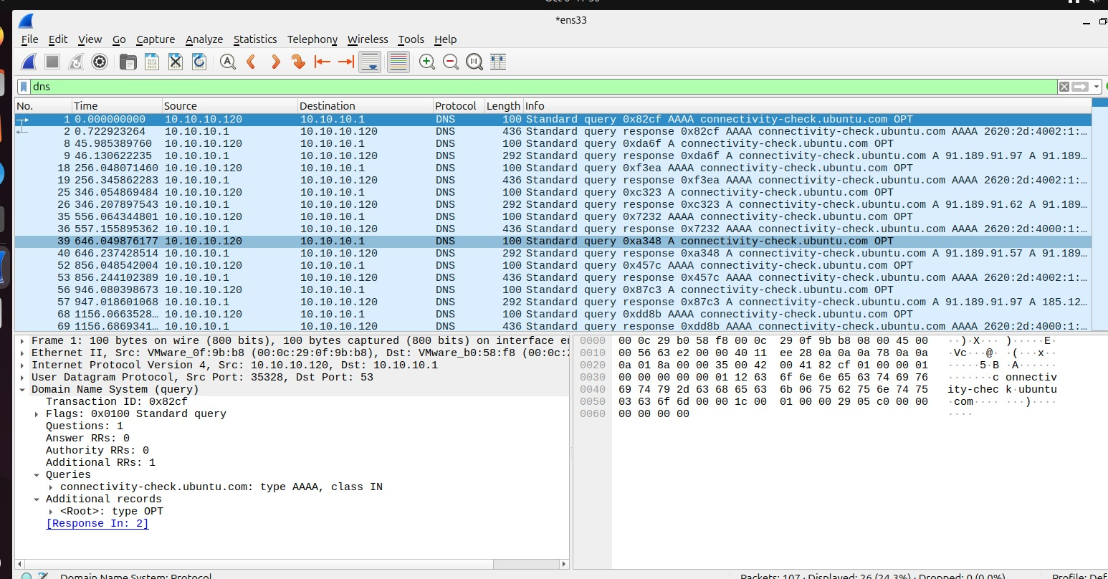
Wireshark DNS capture with the dns filter visible.

icdfa-nslab-client-v1 uses 10.10.10.1 as its default gateway because it is the IP address of the OPNsense firewall on the local network. The gateway routes traffic from the client to other networks, including the Internet. Without it, the client could only communicate with devices on the 10.10.10.0/24 network.

Completion Questions

- What is the difference between the OPNsense WAN and LAN interfaces?
The WAN interface connects OPNsense to external networks (such as the Internet), while the LAN interface connects to the internal network and serves local devices like the Ubuntu client.
- Why must both internal adapters use the same VirtualBox network name?
Both internal adapters must use the same VirtualBox network name so they are connected to the same virtual network and can communicate with each other through the OPNsense firewall.
- What information does the default route provide to Ubuntu?
Both internal adapters must use the same VirtualBox network name so they are connected to the same virtual network and can communicate with each other through the OPNsense firewall.
- Which packet exchange allows Ubuntu to learn the firewall MAC address?
The ARP (Address Resolution Protocol) request and reply exchange allows Ubuntu to learn the MAC address associated with the firewall's IP address (10.10.10.1).
- Why does a successful ping to 1.1.1.1 not automatically prove that DNS is working?
A ping to 1.1.1.1 only proves that IP connectivity is working. DNS is not involved because an IP address is used directly. DNS is only tested when resolving a hostname such as opnsense.org into an IP address.

