Technical Documentation

# 1.0 Accessing the backend

The backend is the area where you submit content.

|  |  |
| --- | --- |
| **User Name** | admin |
| **Password** | admin |

# 2.0 Theme

“Nextgeneration” is the theme name for this website. It is bootstrap base theme and located at *drupal-assignment/themes*

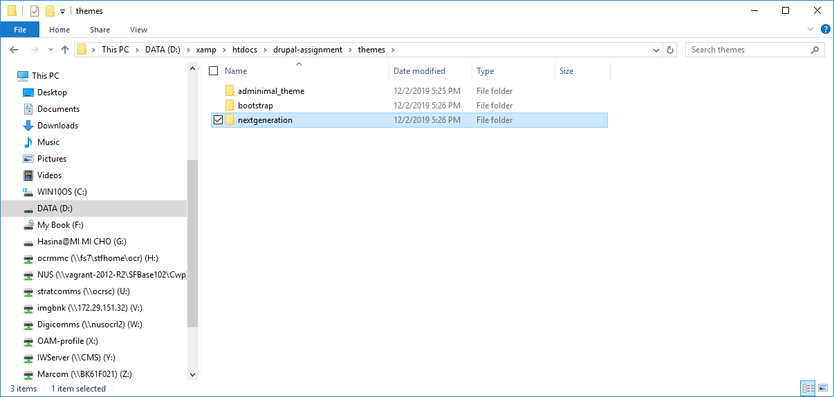

# 2.0 Content type

There are two main kinds of content:

1. Feature Content
2. NexGenContent

## 2.1 Feature Content

This is the section is to promote the content with images on the home page (**1)**.

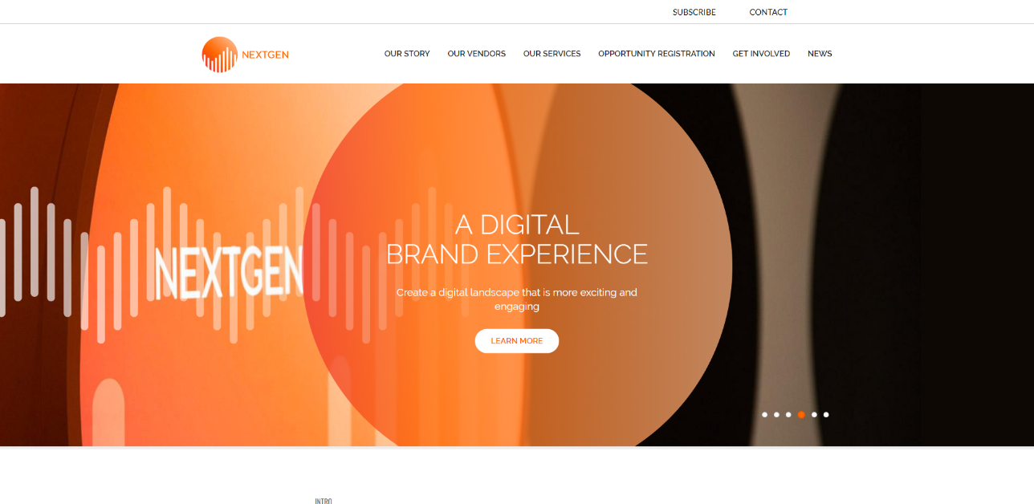

**Content uploading steps**

**Step 1**: Click “Add Featured Content” from menu

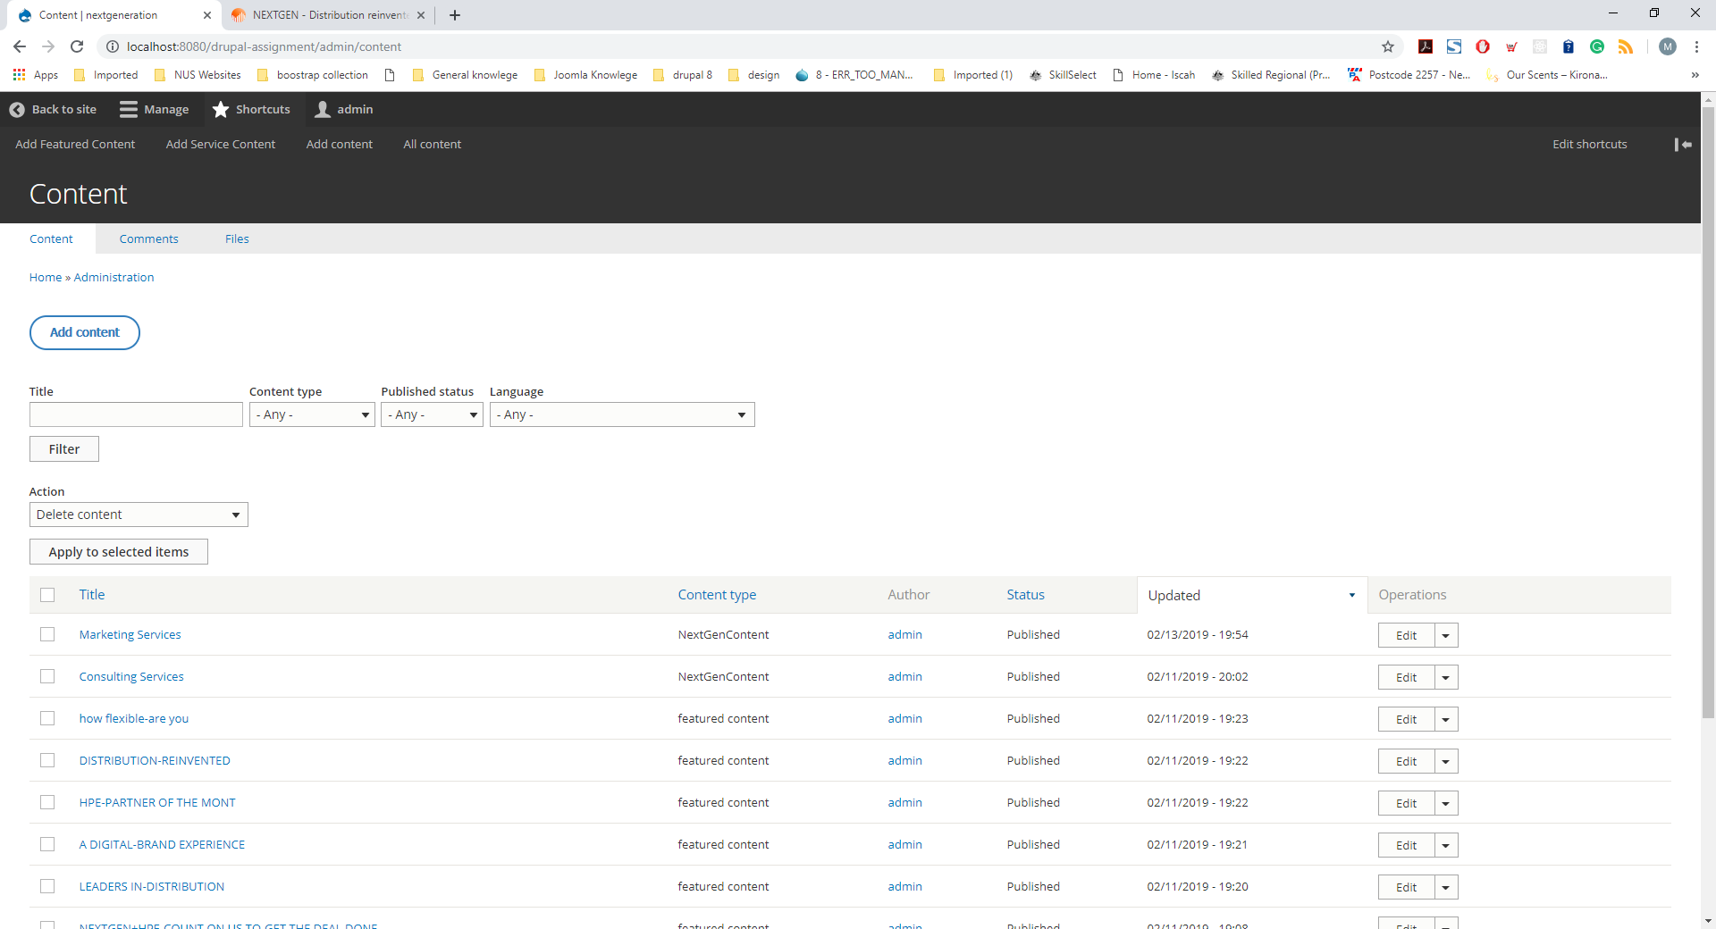

**Step 2**: Enter the title and you can group the word by using **“-“**so that long sentence will break into lines.

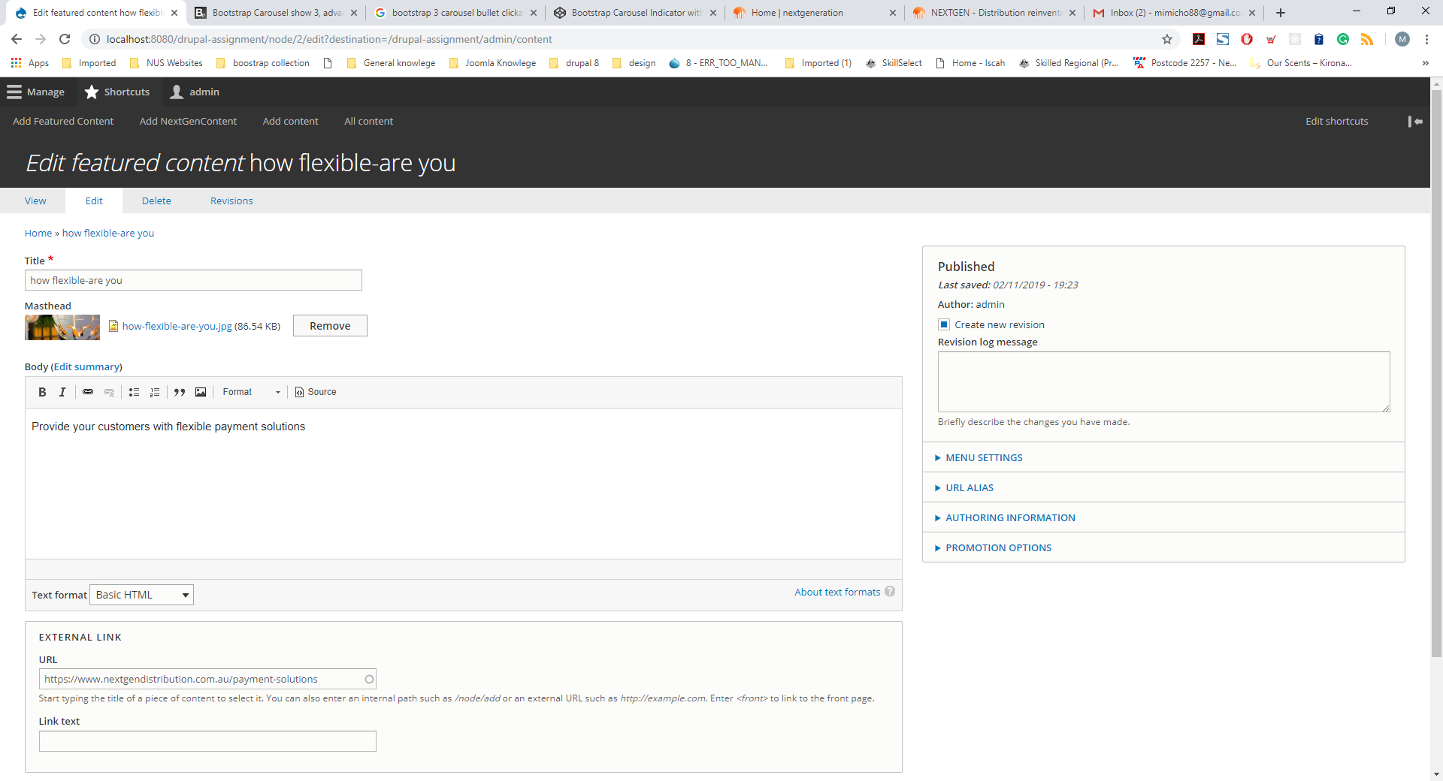

For example:

Tile: **How Flexible-are you** which will break into two lines in the masthead banner **(2)**.

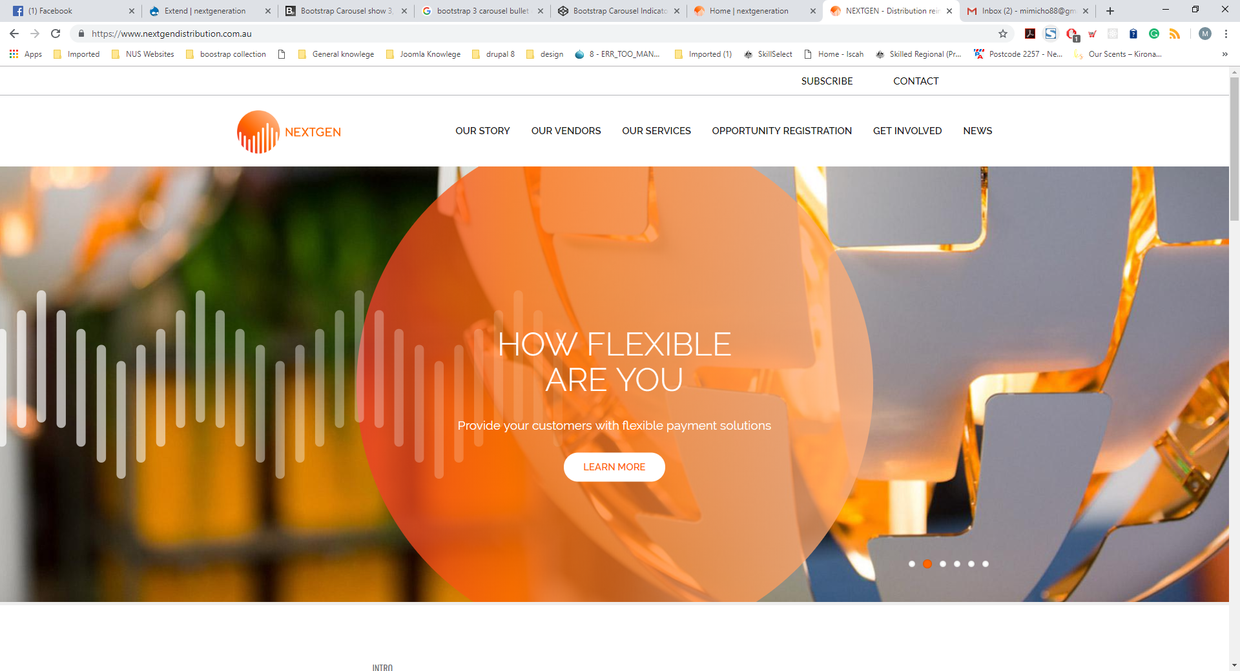

**Step 2**: select “Masthead” via from “Open File Browser”.

**Step 3**: Add body and Link

**Step 4**: Check “published “and Save.

## 2.1.2 Feature Content View

The views names are **Featured content and Featured content mobile** in the backend but themes are overridden by the following views under *themes/nextgeneration/templates/views*.

* views-view-unformatted--featured-content.html.twig
* views-view-unformatted--featured-content-mobile.html.twig

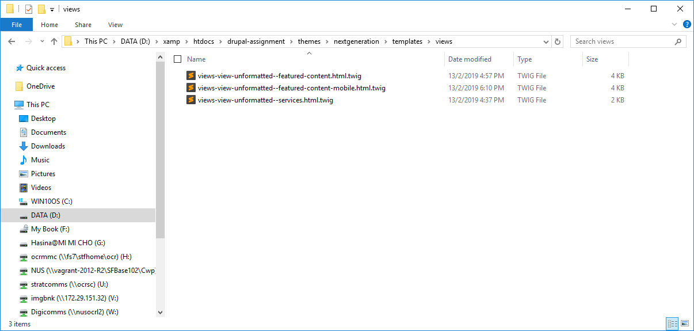

## 2.2 Service Content

The section is to feature services with images on the home page (**3)**.

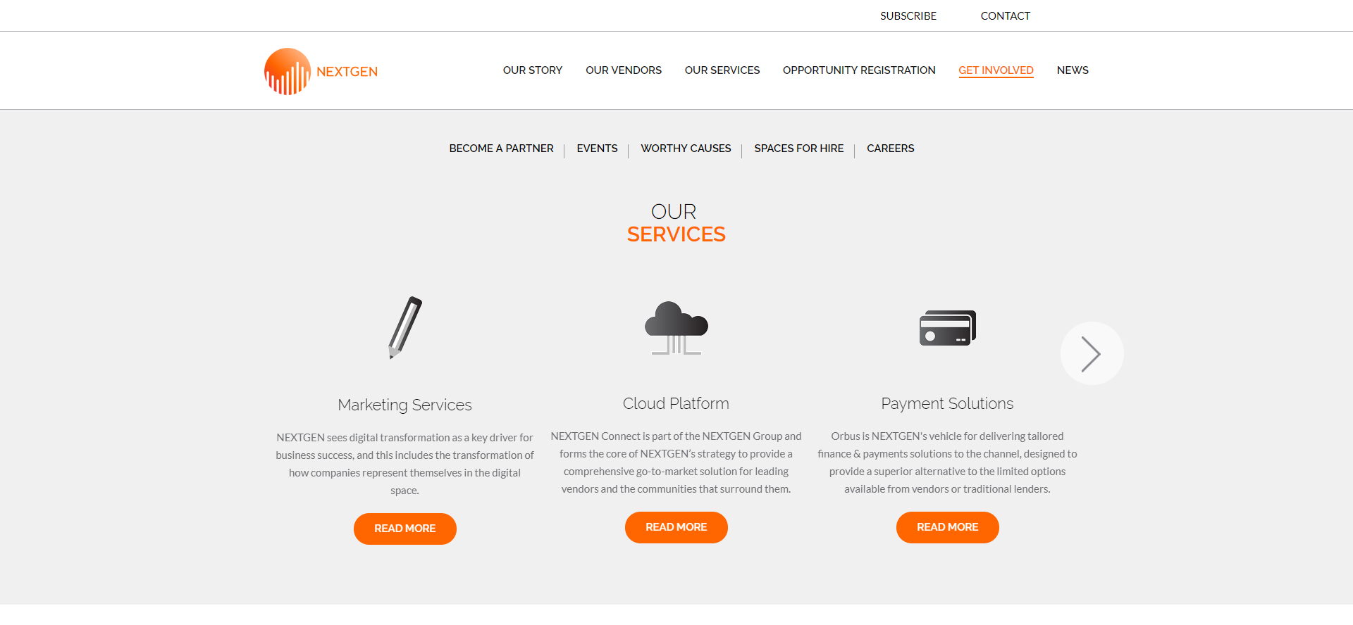

**Content uploading steps**

**Step 1**: Click “Add Service Content” from menu



**Step 2**: Enter the title

**Step 3**: Select “Icon” and “Masthead” via from “Open File Browser”

**Step 4**: Add IntorText and Body

**Step 5**: Check “published “and Save.

## 2.2.2 Services Content View for home page

This view name is “Service” in the backend but theme is overridden by the following view under *themes/nextgeneration/templates/views*.

* **views-view-unformatted--services.html.twig**



## 2.2.3 Title block for service section on home page

This overridden block will find “space” in the title from block and break into two line.

The name is **block--views-block--services-block-1.html.twig** under *themes/nextgeneration/templates/block*

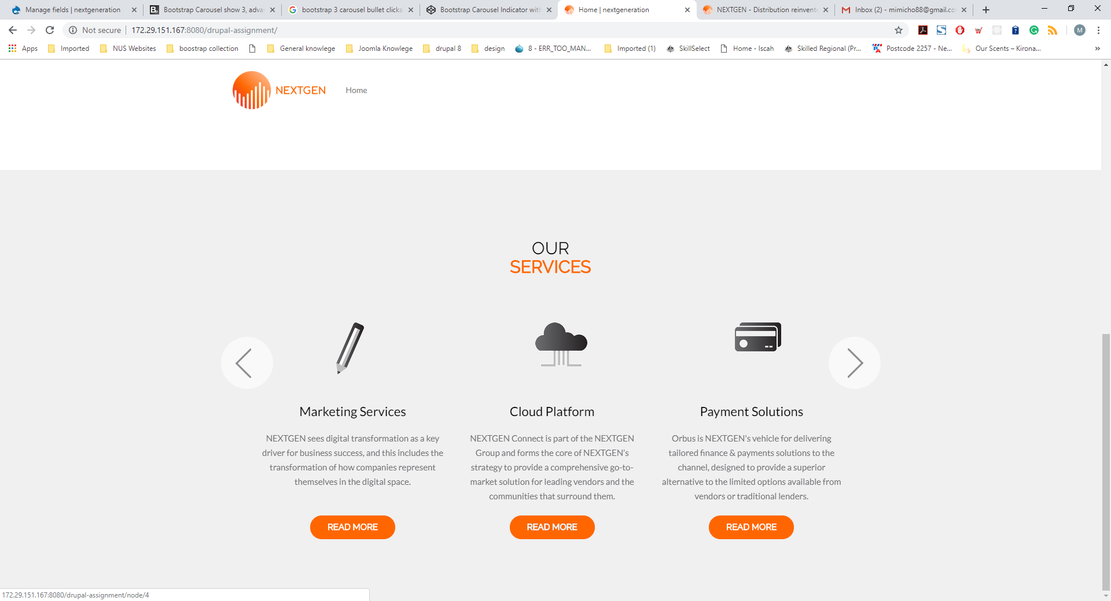

## 2.2.4 Subpage theme for services

Services subpages are controlled by “**node--services--full.html.twig**” under *themes/nextgeneration/templates/views*.

