Development of a switch accessible software

for the children with severe physical disabilities

__________________________________________________________________________________________

Miss Amita Mongkhonpreedarchai Faculty of Information Technology

King Mongkut's Institute of Technology Ladkrabang Bangkok Thailand

Supervisor Mr. Hisashi Takeshima 7 July 2017

__________________________________________________________________________________________

# Introduction

In this study, we target severely physically handicapped children. Severely physically handicapped is a child who has severe dysfunction such as paralysis or deficit of limbs and failure to freely move body due to dysfunction of trunk. Therefore, difficulties arise in learning activities and communication activities in daily life.

Then we use switch teaching software at special support schools as learning contents that can be used even for children with severe physically handicapped.

# System for the switch activities

Switch teaching software is software that operates by operating switches instead of mouse and keyboard. There is also an advantage that it can be selected from various switches according to the learner. Learning to understand causal relationships Learning motivation will be improved by moving oneself.

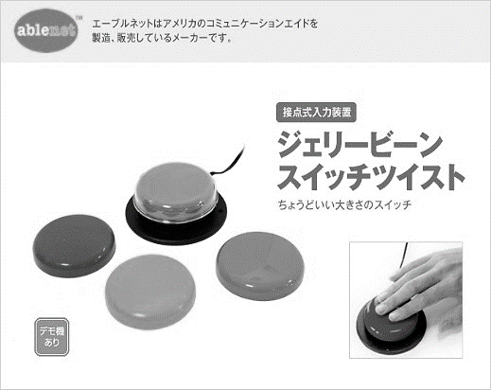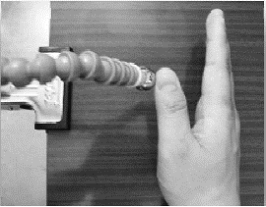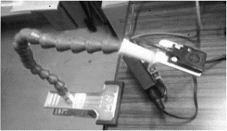

Jelly Bean Switch

Proximity sensor switch

Point touch switch

# Development of a switch accessible software

I developed a switch accessible software by JavaScript and HTML5 with Enchant.js framework for creating game. Therefore, it also available on various device such as smartphone, tablet, PC. Quisque tellus est arcu, bibendum ipsum mattis dictum vestibulum ante pede, diam nam amet. Nunc sodales mauris pharetra ut pretium

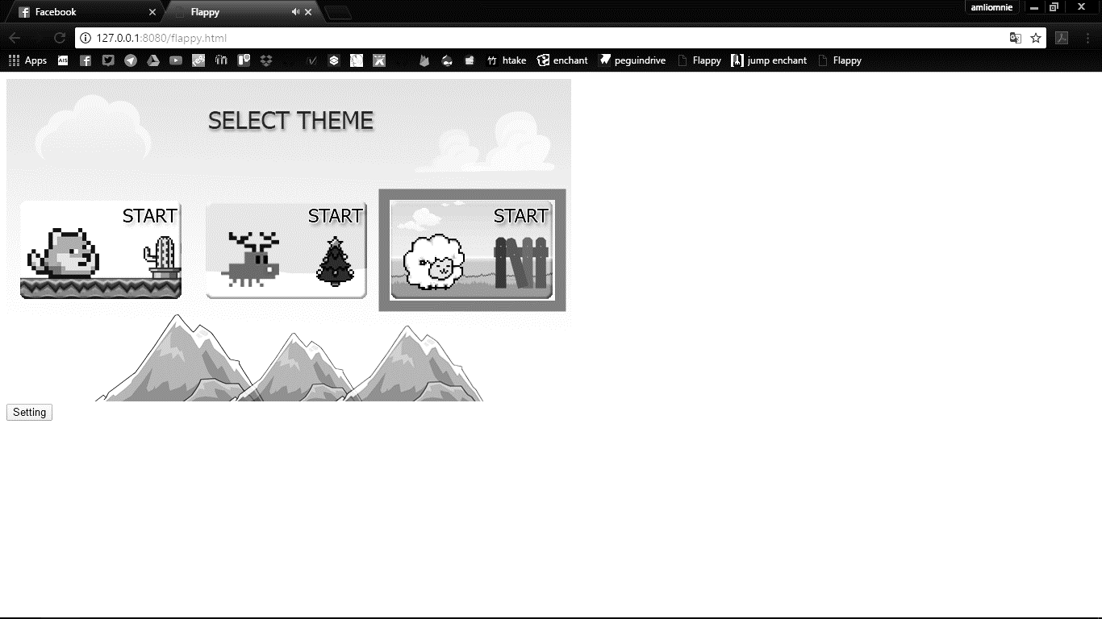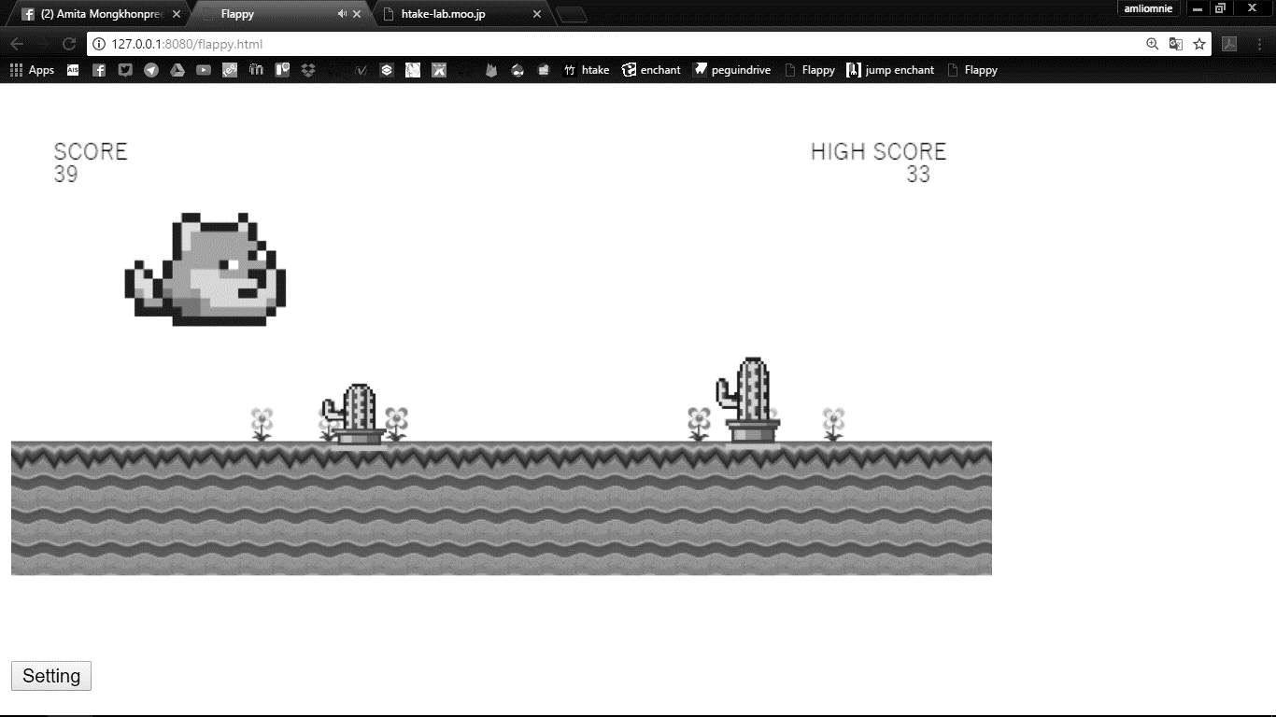

# Conclusion

tortor ornare wisi eleifend etiam dui, vestibulum curae convallis adipiscing tincidunt placerat dictum. A felis id sed nisl pellentesque, ultrices velit fusce nisl commodo. Nulla amet ultricies wisi imperdiet, non dolor pretium malesuada luctus. Velit lobortis tempor, tellus et lacus sit, arcu volutpat tellus et, id dolor est morbi nunc neque turpis.

# References

Quisque tellus est arcu, bibendum ipsum mattis dictum vestibulum ante pede, diam nam amet. Nunc sodales mauris pharetra ut pretium nulla, varius eget semper non elit pellentesque per, pretium nunc