**Requirements**

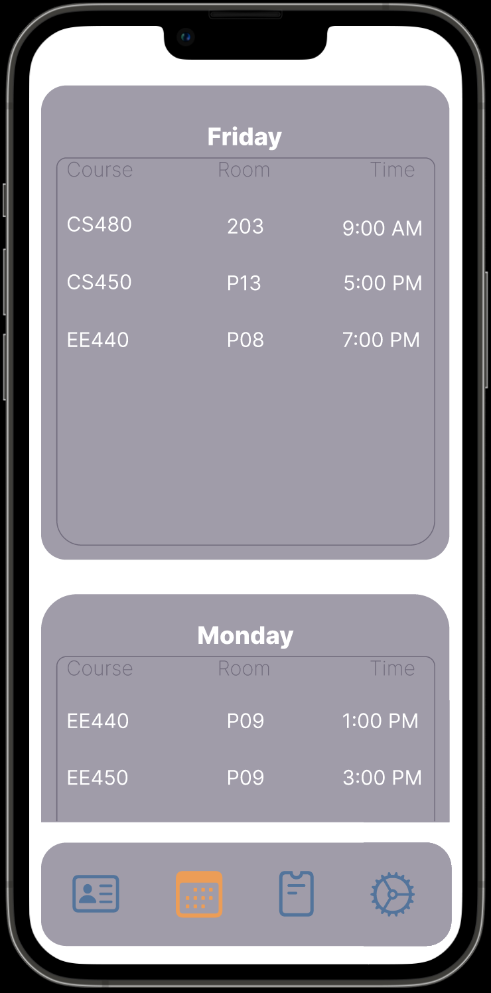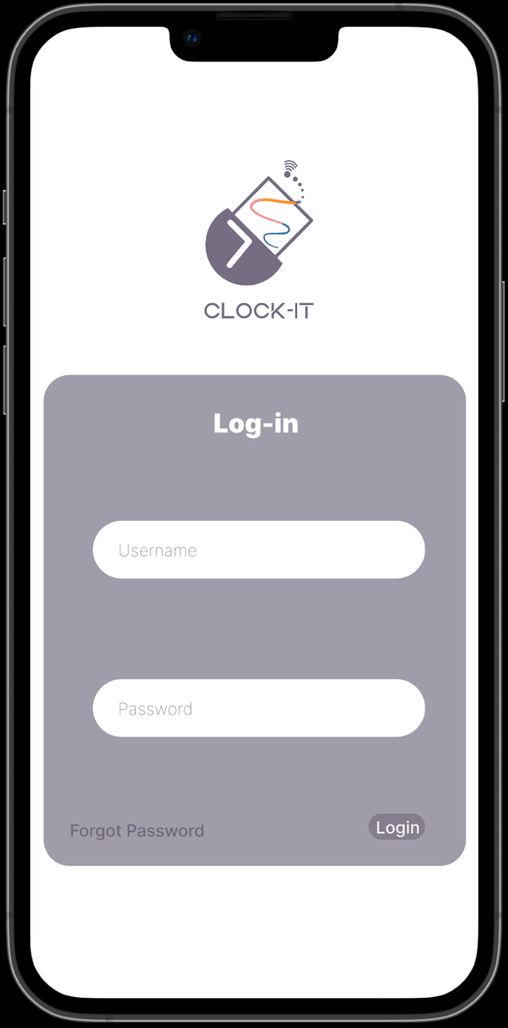**I need for you to create: the following screens:**

schedual

login

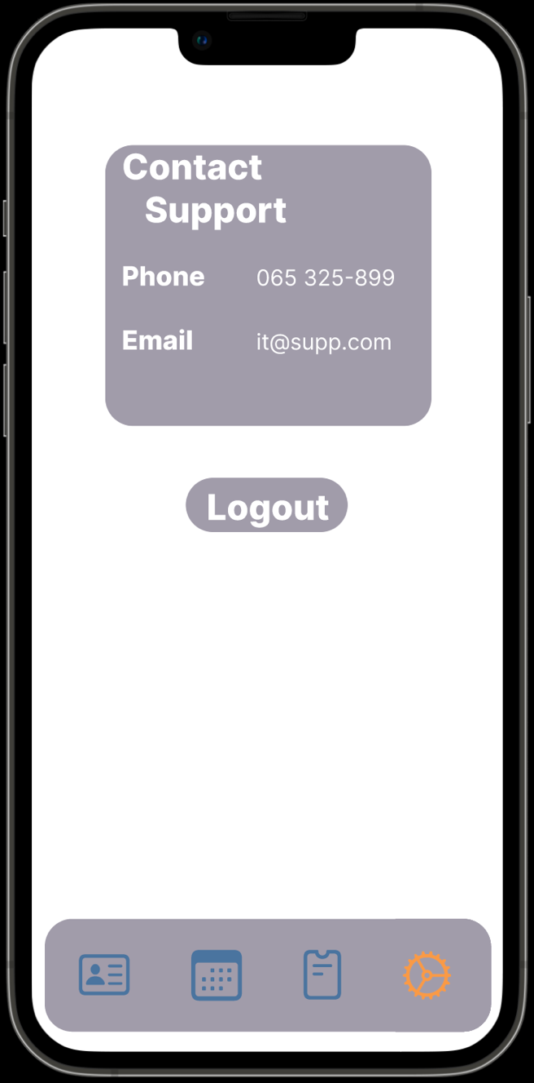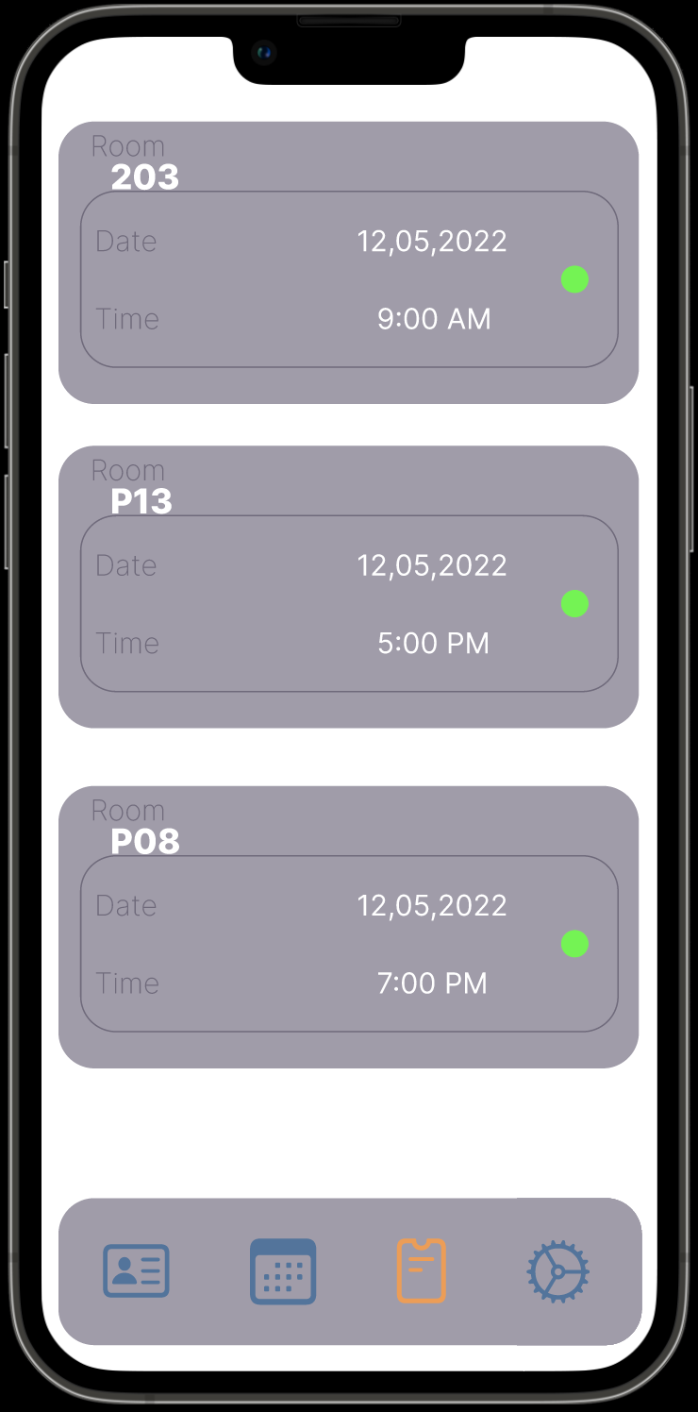

settings

Attendance

The screens login, logout, attendance, and schedule should be connected to a local database such as firebase.

The schedule screen should have 5 tables as in the photo where it shows the days of the week and in the table, it should have the time and the course.

If possible, The attendance should work by when the app uses nfc and connects to the nfc reader it should take data such as the name of the reader, the time and date of scan. If not then make the values editable from the data base.

The app should have the nfc screen (which is):

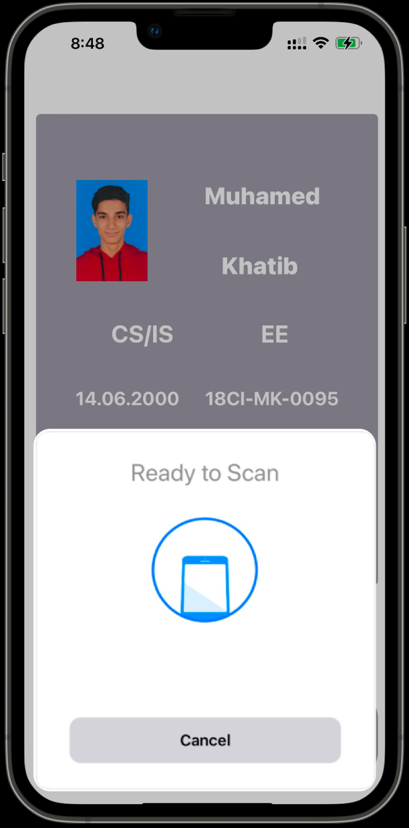

The app already has the card view and launch screen:

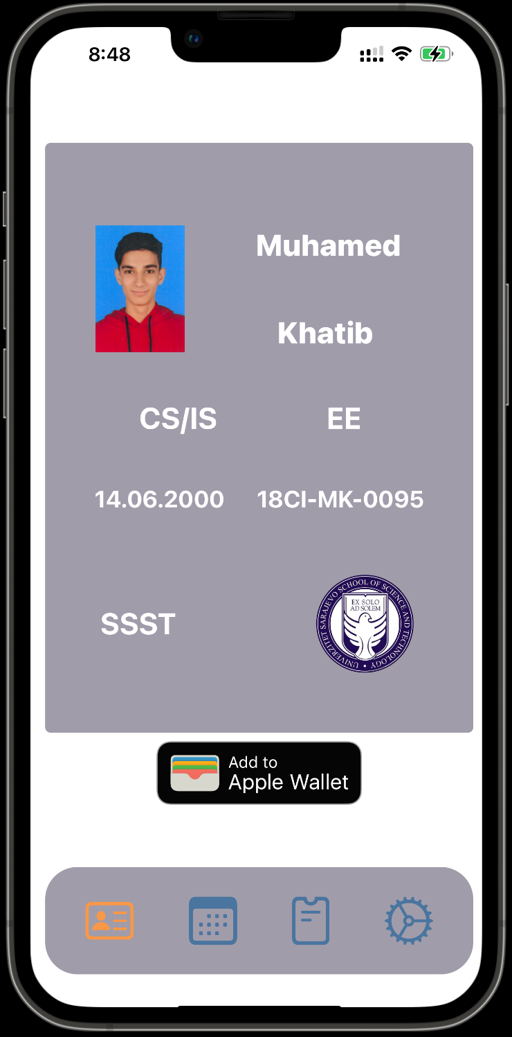

launchscreen

card view

If possible, to make card view also connected to the database.

If possible, to add the app to apple wallet. If not, then it doesn’t matter

The nfc reader that im using is (ACR122U) NFC Reader

