* **Performance Analysis :**
* **Strike Rate :**

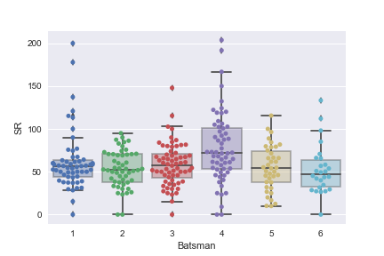

**Figure1: SR vs Batsman**

Here the x-axis shows the players and the y-axis shows the SR (run/ball)\*100. Player 4 has higher SR than others that’s around 170.The max and mean value is also higher than the other players. On the other hand, player 1 has lower strike rate around 88 though his minimum strike rate is higher around 30 where other player’s minimum strike rates are close to zero. And there are no outlier for player 2 and player 5 that means they are consistent players.

* **Performance Time :**

**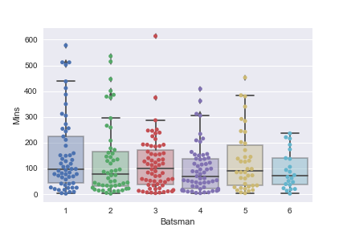**

**Figure2: Mins vs Batsman**

If we consider the existing time of players in different innings, player1’s maximum time around 445, for player2 its 300 in a same way 298,305,390,245 respectively. Again if we consider 75 percentile rate player1 has around 215, player 2 has 180, player 3 has 185, player4 has 145, player5 295, player6 147 respectively. If we evaluate all the players ‘existing time in different innings player1 and 2 shows both best and worst cases as they have more outliers.

* **Runs Scored:**

**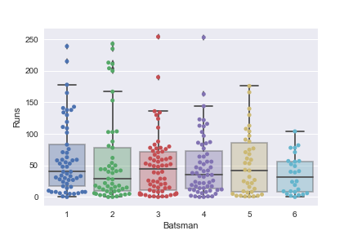**

**Figure3: Runs vs Batsman**

This graph shows that playe1’s runs around 175, player2’s runs scored around 160, payer3 135, payer4 140, player5 175 and palyer5 110 respectively. If we evaluate the graph player1 and player5’ performances are better than the other players in different matches. We see outliers in player 3 and 4 that mean they can perform better in some cases.

* **Run with respect to ball faced**

**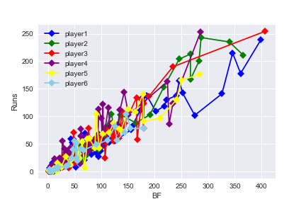**

|  |  |  |
| --- | --- | --- |
| **C:\Users\hp\Desktop\assign\29550511_1104152169724964_260440860_n.png** | **C:\Users\hp\Desktop\assign\29546905_1104152143058300_2111768655_n.png** | **C:\Users\hp\Desktop\assign\29663396_1104152139724967_1999396419_n.png** |
| **C:\Users\hp\Desktop\assign\29547607_1104152156391632_1745731882_n.png** | **C:\Users\hp\Desktop\assign\29666327_1104152136391634_1004553657_n.png** | **C:\Users\hp\Desktop\assign\29550058_1104152133058301_304322855_n.png** |

**Figure4: Runs vs BF**

This graph shows the run with respect to ball faced. Player 3 has grater run with respect to ball face. All the players have average runs initially. Player 1 and 2 have average consistency because they have also outliers from 200–250 runs based on 300 to 400 ball face which indicates that they can provide better result in future. but other player’s run score are below 200. Player6 has lower run record with respect to ball face comparatively other players.

* **Runs vs 4s**

**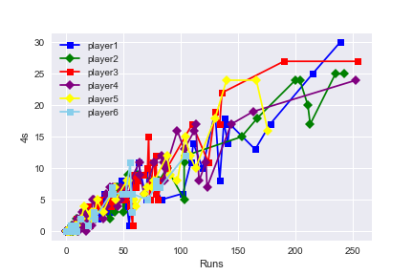**

|  |  |  |
| --- | --- | --- |
| **C:\Users\hp\Desktop\assign\29666206_1104152173058297_359643313_n.png** | **C:\Users\hp\Desktop\assign\29547225_1104152179724963_1804847405_n.png** | **C:\Users\hp\Desktop\assign\29547584_1104152186391629_2041899503_n.png** |
| **C:\Users\hp\Desktop\assign\29745727_1104152193058295_1467089720_n.png** | **C:\Users\hp\Desktop\assign\29663509_1104152196391628_496528650_n.png** | **C:\Users\hp\Desktop\assign\29550844_1104152199724961_1573878835_n.png** |

**Figure5: Runs vs 4s**

This graph shows the number of 4s respect to runs. We see, all players have average consistency, the probability of 4s based on 250-400 BF is higher for Player2 though player1, 3, 4 have some outliers.

* **Prediction of career average of 3 batsmen based on sample data using both normal distribution and t-distribution :**

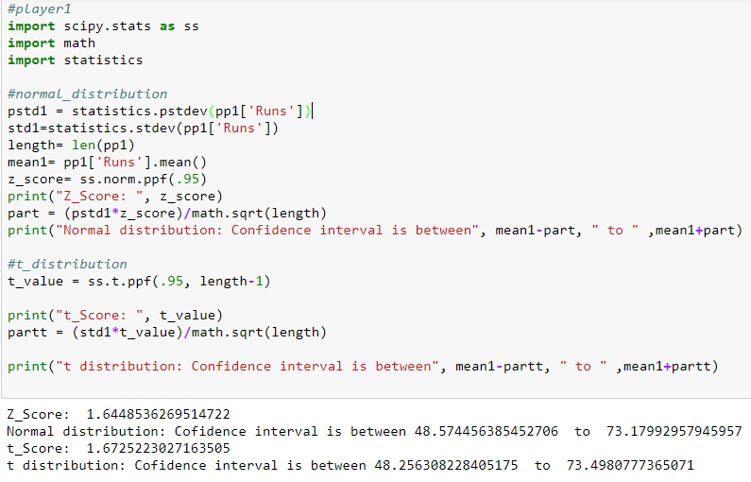

* For player 1 , z-score 1.644853 indicates that the CI is between 48.57445 to 73.1799295. Also, t-score 1.672522 that implies CI is between 48.256308 to 73.49807777.

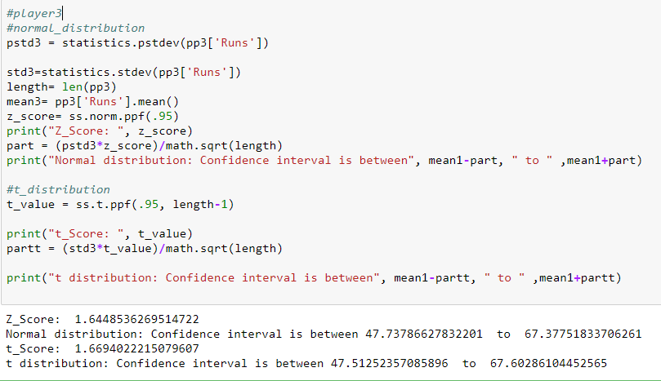

* For player 2 , z-score 1.644853626 is same as player1 and t-score 1.implies CI is between 47.5125235 to 67.60286104.

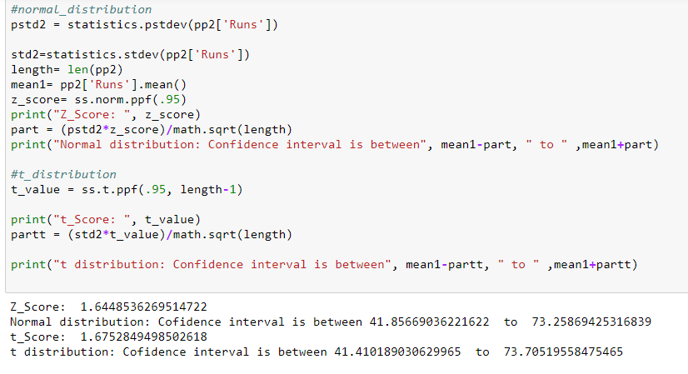

* For player 3 , z-score 1.644853626 is same as player1 and 2. Also, t-score 1.6752849 implies that CI is between 41.40189 to 73.70519558.

Comments: Here the players may score runs between confidence interval around 95% of the times.

* **Identifying the Batsmen:**

|  |  |  |  |  |  |  |  |  |  |  |  |  |  |  |  |  |  |  |  |  |  |  |  |  |  |  |  |  |  |  |  |  |  |  |  |  |  |  |  |  |  |  |  |
| --- | --- | --- | --- | --- | --- | --- | --- | --- | --- | --- | --- | --- | --- | --- | --- | --- | --- | --- | --- | --- | --- | --- | --- | --- | --- | --- | --- | --- | --- | --- | --- | --- | --- | --- | --- | --- | --- | --- | --- | --- | --- | --- | --- |
| |  |  |  | | --- | --- | --- | | Players | SR | AVG | | P1 | 61.9495 | 60.8772 | | P2 | 53.2160 | 57.5577 | | P3 | 58.4177 | 49.0781 | | P4 | 77.6461 | 49.4068 | | P5 | 54.7658 | 53.0263 | | P6 | 52.7150 | 35.7692 | | |  |  |  | | --- | --- | --- | | Players Name | Actual SR | Actual AVG | | Steven Smith | 55.76 | 63.75 | | Virat Kohli | 58.26 | 53.26 | | AB De Villiers | 54.06 | 49.92 | | David Warner | 74.73 | 48.77 | | Joe Roof | 55.76 | 53.28 | | Tamim Iqbal | 55.51 | 38.68 | |

* Steven Smith has average score 63.75 and average strike rate 55.76 which is similar to player1. Therefore, it can be said player1 is Steven Smith.
* Virat Kohli has average score 53.26 and average strike rate 58.26 which is similar to player2. so it can be said player2 is Virat Kohli.
* AB De Villiers has average score 49.92 and average strike rate 54.06 which is similar to player3. So it can be said player3 is AB De Villiers.
* David Warner has average score 48.77and average strike rate 74.73 which is similar to player4. so it can be said player4 is David Warner.
* Joe Roof has average score 53.28 and average strike rate 55.76 which is similar to player5. so it can be said player5 is Joe Roof.
* Tamim Iqbal has average score 38.68 and average strike rate 55.51 which is similar to player6. so it can be said player6 is Tamim Iqbal.