Project Topic: Account Management System Modeling

## ##Problem##

In a banking system, an account holder gets 5% interest for savings less than 50000/- but the interest doubles if it is above 50000/- and under 100000/- and thrice otherwise. The system runs online and the account holder has to fill online form for transactions. The system sends a message with amount to the account holder on each transaction. We have to model the system.

## ##solution##

Mail transmission system:

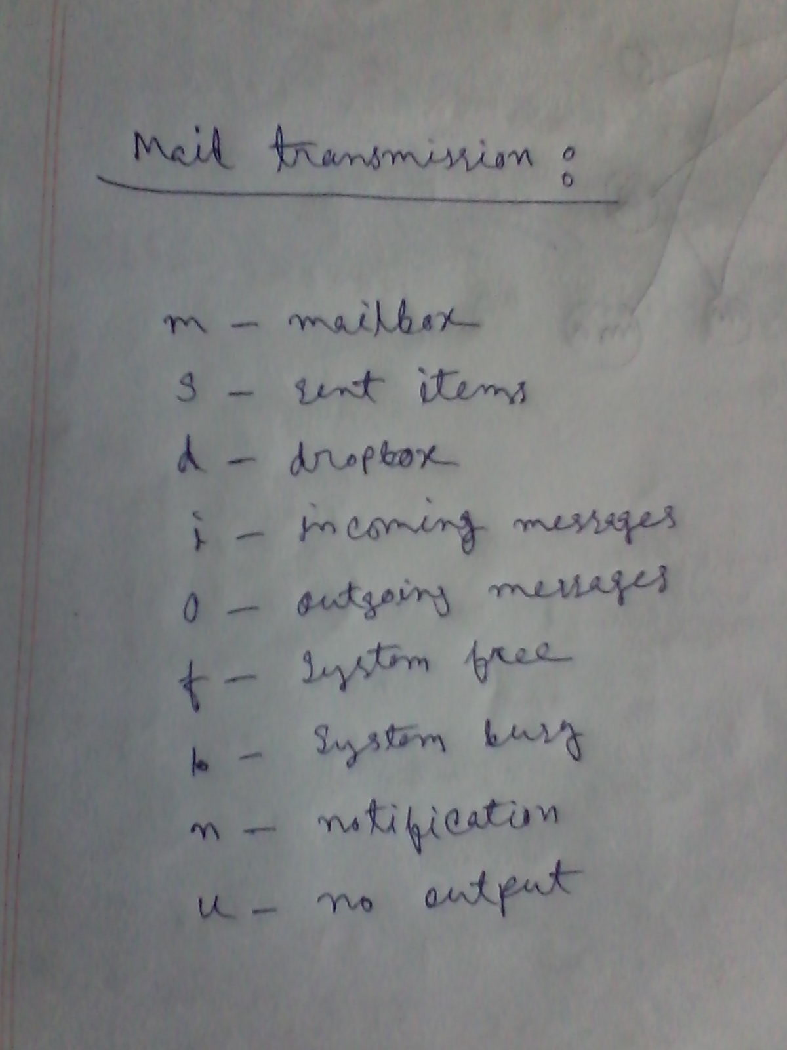

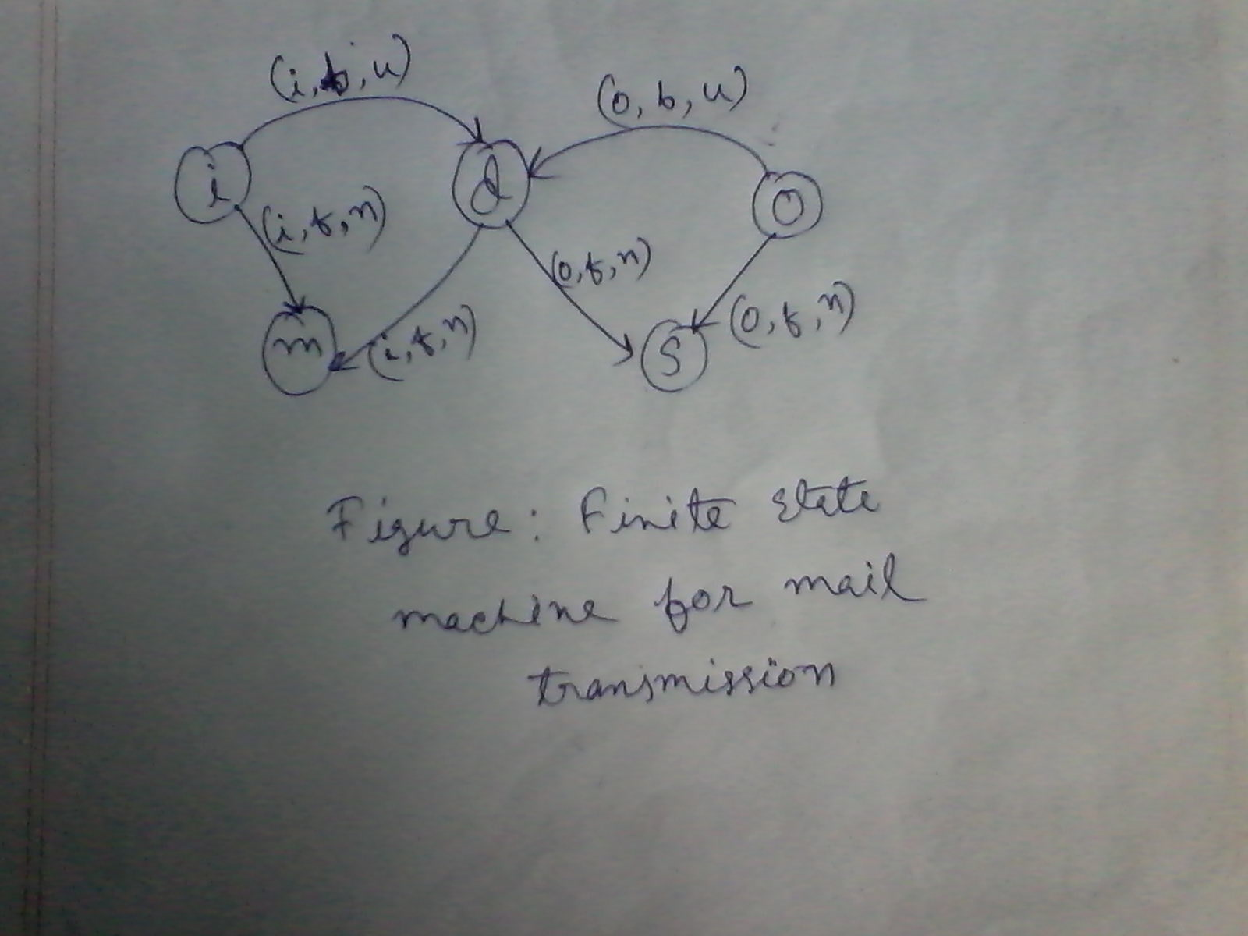

Balance transfer system:

