

**Report**

**ON**

**ONLINE MOVIE TICKET BOOKING SYSTEM**

**Department :** Computer Science & Engineering

**Semester :** Fall’17

**Course Code :** CSE 411

Section : 2

**Course Title :** Software Engineering and Information System Design

**Submitted To** : Shakila Mahjabin Tonni

Lecturer

CSE Department

East West University

**Submitted By** : Alinoor Hossain Olip (2014-3-60-008)

Rajashree Roy (2014-3-60-070)

**Date of Submission:** 05-12-17

**INTRODUCTION**

Movie is one of the best sources of entertainment. But the ticket booking system in our country is manual and not so fast sometimes corruption and harassment occurs to buy tickets. With our project ‘Online Movie Ticket Booking System’ all the difficulties of buying ticket will be vanished. The online system will allow everyone to buy movie tickets from home with superfast service.

The user will be able to see the pricing, available seat, hall etc. They will also be able to bookmark desired page, cart them and cancel a booked ticket.

The system is mostly autonomous. It will be able to keep record of every user and their action automatically. It will save time and for users and reduce the manpower for the hall company.

**Requirements Analysis**

**FUNCTIONAL REQUIREMENTS:**

* **Visitors can search and see details of movie**
* **Admin will be approved by super admin**
* **Admin can update, delete, make schedule, and make pricing of the movie**
* **Only registered user is allowed to book ticket**
* **An admin can also act like a user**
* **Users can update their profile**
* **User can cancel ticket under some constraint**
* **User can bookmark pages and can see the cart items.**

**NON FUNCTIONAL REQUIREMENTS:**

* **The system will be available for 24 hours**

* **The system is developed with PHP, CSS3,HTML5 and JAVASCRIPT**
* **User will not be able to cancel tickets on showing date**
* **User can’t book more than 20 tickets in same date**
* **The system will be secured with session management**
* **Users information will be kept safe**

**System Design**

**Use Case**

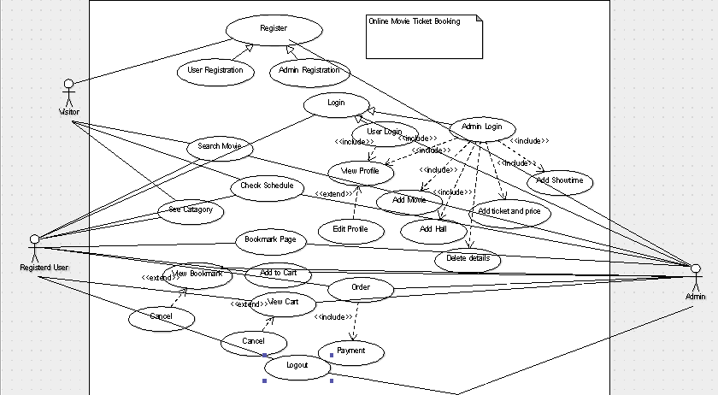

**Sequence Diagram**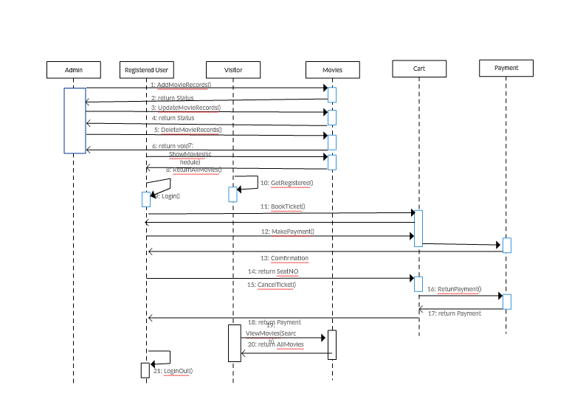

**Limitations**

The main limitation of the system is it is not mobile friendly. Besides that the system can’t provide different payment system and the user rating is also unavailable now.

**Future Works**

Our future thinking is to convert this project into a fully functional website. Adding different modes of payment and user rating will give some extra mobility. We will also add the trailer of the movie to its description. The main focus will be making the system more efficient and user friendly.