

Department of Computer Science & Engineering

**Semester :** Summer 2017

**Course Information**

**Course Code** : CSE 480

**Course Title** : Web Database Programming

**Section** : 1

**Instructor :** Bijan Paul, Senior Lecturer, CSE Dept.

**Project Name**

|  |  |
| --- | --- |
| **Title of Project** | Student Database Management System |
| **Team Members (ID & Name)** | 1. Puloma Roy (2014-2-60-056) 2. Armin Haque (2014-2-60-069) 3. Rajashree Roy (2014-3-60-070) |

**Date of submission: 13-Aug-2017**

**Abstract:**

Student database management system is going to develop to keep the informations of the students,faculties,courses,student’s results and scholarships.Here students can also use library.

**Introduction**

The system that is going to be developed is Student Database Management System (SDMS). This is a database application system that is to be used by the universities or similar educational organizations to manage relevant functions. The system keeps the records of all the students and faculty members. This system also has the ability to keep track of course registration, academic result, scholarships and financial aids, clubs and library managements etc. This project intends to computerize the student database management system in a university in order to improve the record management efficiency due to the grown size of records of data.

**Objectives**

The objectives of the Student Database Management System are as follows:

1. To store information about all faculty and student.
2. To allow search for faculty member or student.
3. To provide online advising and course registration facilities.
4. To provide online grade submission and result publication.
5. To provide scholarships and financial aids.
6. To provide online clubs management.
7. To allow online library access and search for books.
8. To provide news and notices to the continuing students and faculty members.

**Scope**

As a whole the system is focused to work with student database management system for university and on additional modification it can be also used as management systems of similar universities.

**Requirement Analysis**

* **Login:** The system provides security features through username-password matching where only authorized user can access the system with different authorization level.
* **Instructor Course Registration:** This allows instructors to register to courses.
* **Student Course Registration:** This allows students to register to courses.
* **Grade Submission:** This allows instructors to submit grades of students.
* **Result Publication:** This allows students to get grade reports.
* **Scholarships:** This allows students to be awarded scholarships on excellent results.
* **Financial Aids:** This allows students to apply for financial aids on given terms and conditions.
* **News and Notifications:** This provides news and notices to the continuing students and faculty members by sending them notifications.
* **Library:** This allows students to borrow books from the library. But all books are not available to bring at home.

**Requirement Features Fullfil:**

* **Login:** The system provides security features through username-password matching where only authorized user can access the system with different authorization level.
* **Instructor Course Registration:** This allows instructors to register to courses.
* **Student Course Registration:** This allows students to register to courses.
* **Grade Submission:** This allows instructors to submit grades of students.
* **Scholarships:** This allows students to be awarded scholarships on excellent results.
* **Financial Aids:** This allows students to apply for financial aids on given terms and conditions.
* **News and Notifications:** This provides news and notices to the continuing students and faculty members by sending them notifications. Moreover student and faculty members can comment and upload files in group(section) page.
* **Library:** This allows students to borrow books from the library. But all books are not available to bring at home.

**Database Design**

|  |  |  |
| --- | --- | --- |
| 1. **Data about Faculty and Student**  * Faculty /Student Id * Name * Date of Birth * Gender * Address * Contact Number * Email Address | 1. **Data about Course**  * Course Id * Credits * Sections | 1. **Admin**  * Admin Id * Name * User Name * Password |
| 1. **Course Registration for Instructor**  * Id * Course Id * Faculty Id * Section Id * Room Id * # of Students | 1. **Course Registration for Students**  * Id * Course Id * Student Id * Section Id | 1. **Grade Submission**  * Student Id * Course Id * Grade |
| 1. **Scholarships**  * Scholarship/Financial Aids Id * Requirements * Awarded Amounts | 1. **Scholarship Awarded**  * Scholarship Id * Student Id | 1. **Apply for Financial Aids**  * Causes |
| 1. **Date about Book Shelf**  * Shelf Id * Size * Filled | 1. **Data about Books**  * Book name * Writer name * Can Borrow or not * Student * Shelf Id * Place * Category * Borrowed or not |  |

**System Requirement**

* **Browser:** Chrome, Firefox, Safari, Microsoft Edge.
* **RAM:** 512mb or higher
* **OS:** Microsoft windows XP, Vista, 8, 8.1, 10, Linux, Mac-OS
* MySQL server, Xampp, Apache server

**Screen shots of Project**

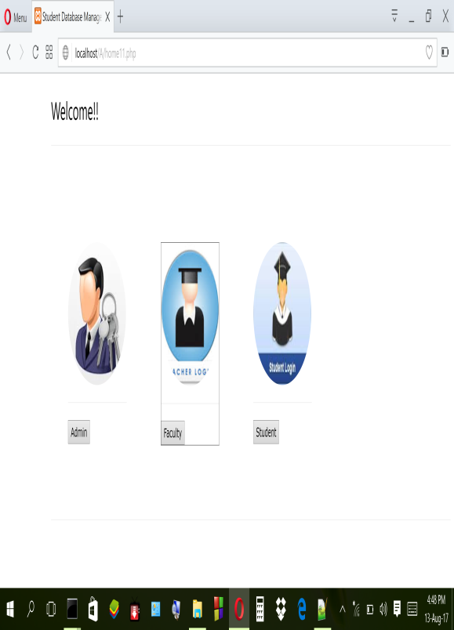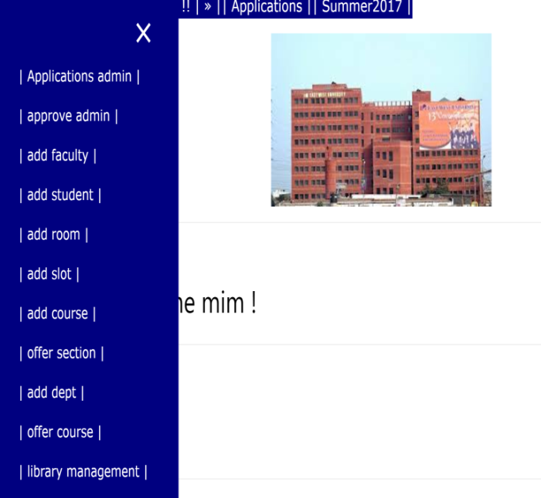

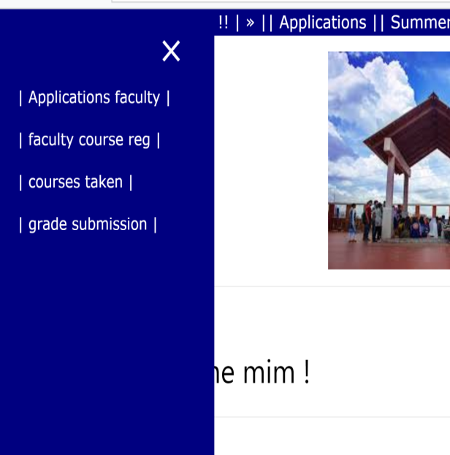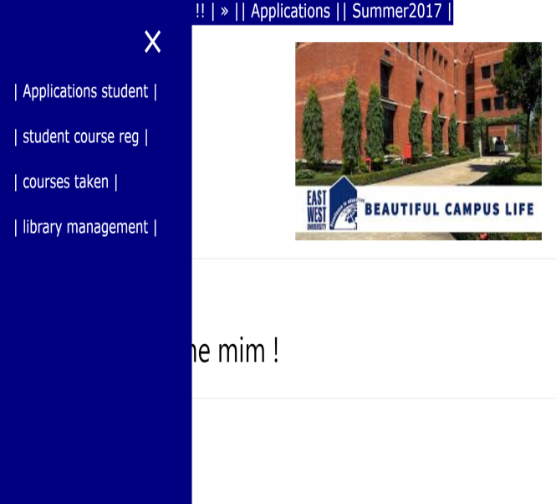

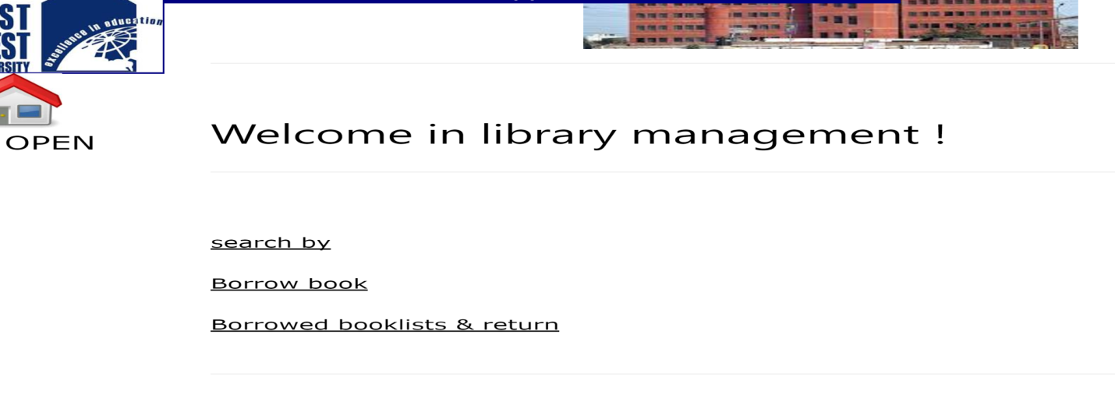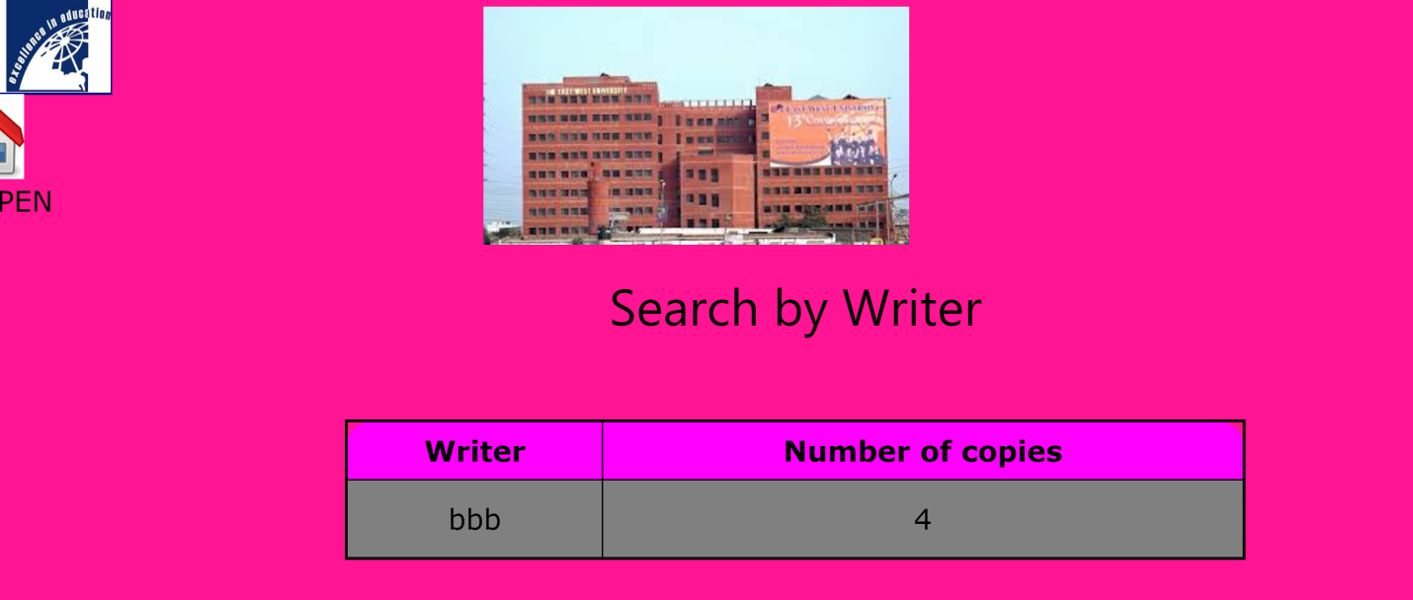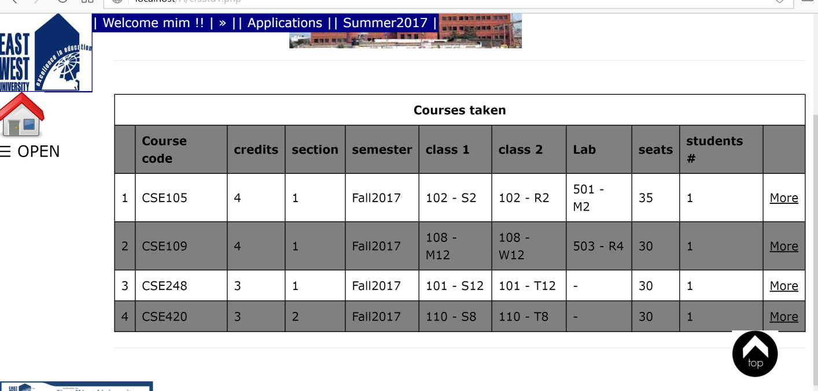

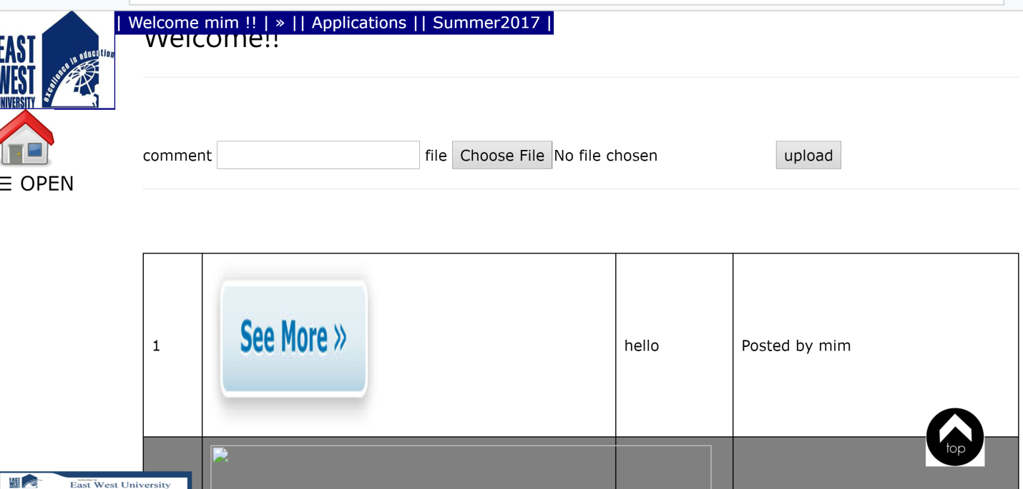

**Future plan:**

We will try to make further implementation in our projects.

**Conclusion:**

We tried to make this project as good as possible. But there could be some problem when a user will run this project. In spite of those problems this project can help any institution to keep the information.