**Letterpress.js by Team Dairou**

A JavaScript implementation of the word game Letterpress for iOS by [atebits](http://www.atebits.com/letterpress/).

Given a 25-letter square board, players take turns discovering words. The letters of that word then change to the player’s color (red versus blue). When the board is completely colored, the player with the most colored letters wins. The twist: unless you completely surround a letter (on all 4 sides), your opponent can steal it back.

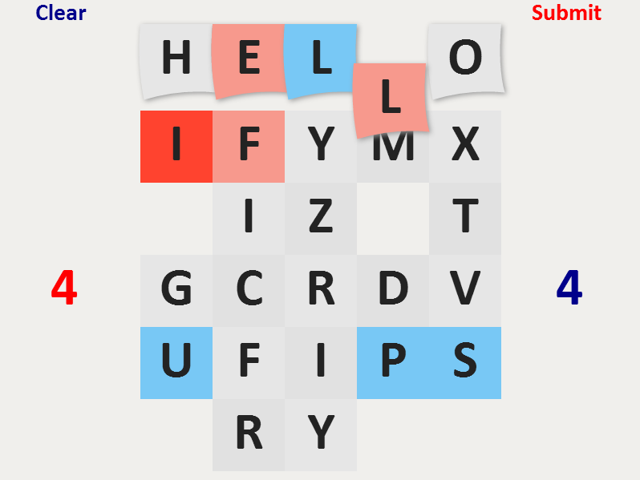

Implementation

The animation in the game is realized with pure **HTML5 Canvas**. No external libraries or frameworks were used. The letters can be used by either clicking on them or dragging them and releasing at the desired position. The letters are implemented as objects of type Tile. They have properties such as position, row and column in the board, value and color. They also have two main methods – draw and move. The board is initialized with 25 random letters (tiles). Three **events** are watched – mousedown, mousemove and mouseup. On mousedown we first have to find which tile was clicked, by comparing the mouse position with the coordinates of each tile (and the two buttons). When words are formed, a special object holds the tiles that form the word and has functions to add, remove and rearrange tiles when a tile is moved over the word. When a word is submitted, first it is checked if it was not already used, and then if it is a valid word. The validation is checked against a local dictionary of 60,000 words. **SVG** and **Raphael** was used to do the rotating circle of letters.

The project tries to follow the principles of high quality code - correct naming, data encapsulation, strong cohesion and loose coupling. The entire code is about 850 lines (excluding the dictionary and raphael-min.js).

Team members

Mirela Napetova

Violeta Rumenova

Jivko Rusev

Ivo Spasov

Krasin Krumov

Strashimir Rashev

**GitHub** repo: <https://github.com/mimirerelala/Dairou>