 Cybersecurity
Project 1 Technical Brief

Make a copy of this document before you begin. Place your answers below
each question. This completed document will be your deliverable for Project 1. Submit it through Canvas when you’re finished with the project at the end of the week.

Your Web Application

Enter the URL for the web application that you created:

https://mydigitalfortress.azurewebsites.net/

Paste screenshots of your website created (Be sure to include your blog posts):

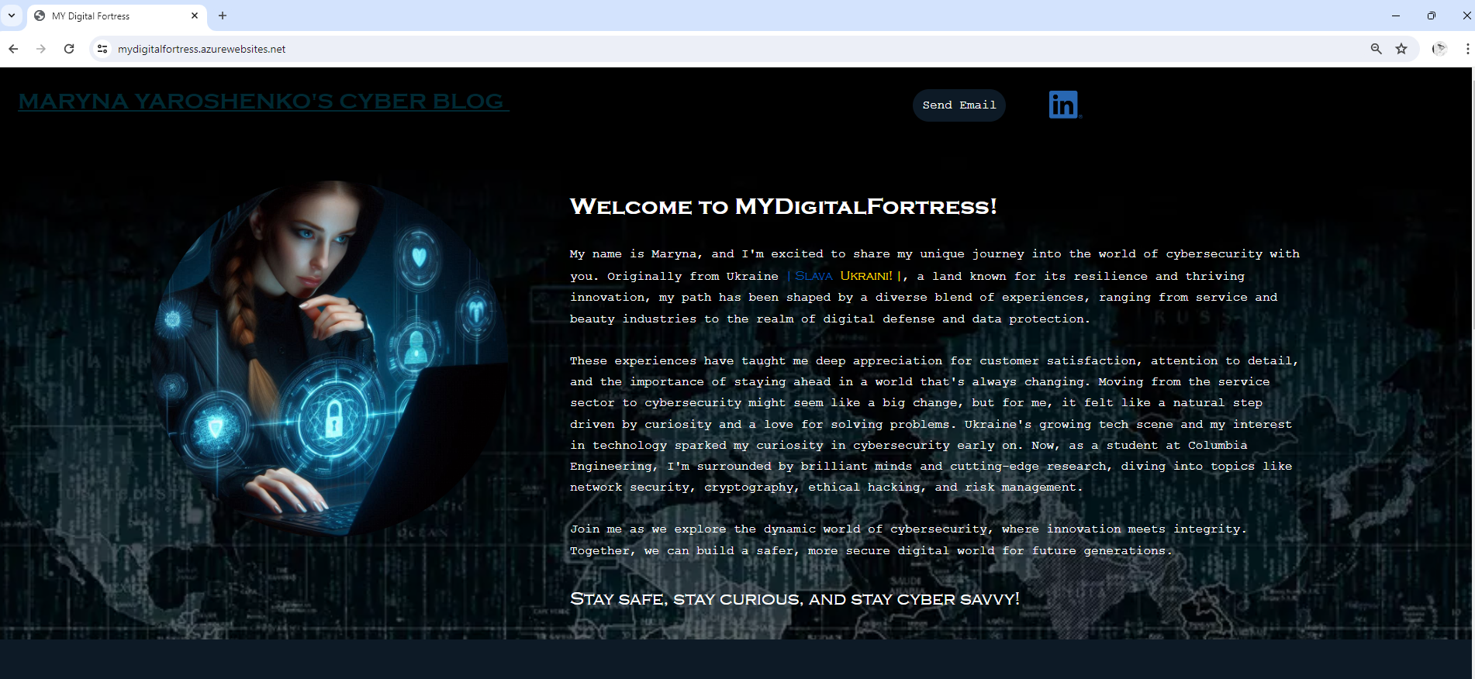
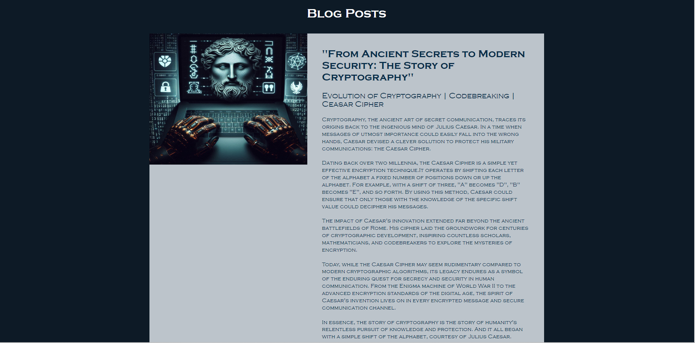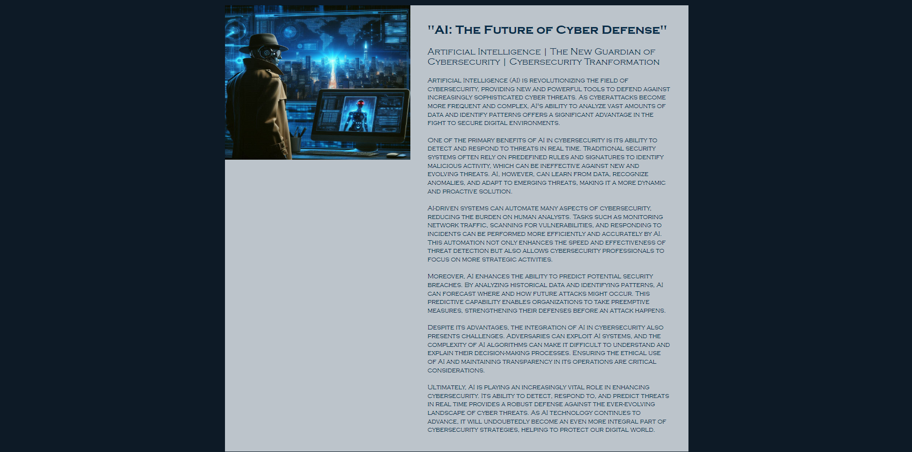

Day 1 Questions

General Questions

- What option did you select for your domain (Azure free domain, GoDaddy domain)?

Azure free domain

- What is your domain name?

azurewebsites.net

Networking Questions

- What is the IP address of your webpage?

20.211.64.24

- What is the location (city, state, country) of your IP address?

Sydney, New South Wales, Australia

- Run a DNS lookup on your website. What does the NS record show?

Server: 168.63.129.16
Address: 168.63.129.16#53

Non-authoritative answer:
mydigitalfortress.azurewebsites.net canonical name = waws-prod-sy3-111.sip.azurewebsites.windows.net.
waws-prod-sy3-111.sip.azurewebsites.windows.net canonical name = waws-prod-sy3-111-c793.australiaeast.cloudapp.azure.com.

Authoritative answers can be found from:

Web Development Questions

- When creating your web app, you selected a runtime stack. What was it? Does it work on the front end or the back end?

PHP 8.2, In “runtime stack” PHP specifically refers to the backend environment.

- Inside the /var/www/html directory, there was another directory called assets. Explain what was inside that directory.

Assets directory has two directories: css and images.

- In the "css" directory were CSS (Cascading Style Sheets) files used to style the HTML content of a website. These files contain rules that define the appearance and layout of elements on web pages.

- In the "images" directory, were image files such as JPEG files, used to display graphics, icons, photos, or other visual elements on the website. These images are referenced in HTML and CSS files to be displayed within the web pages.

- Consider your response to the above question. Does this work with the front end or back end?

The contents of the assets directory (CSS files and images) are essential for the front end of a website. They directly impact how the website looks and feels to users. These assets are used in HTML and CSS files to style and visually enhance web pages, making them essential for front-end development.

Day 2 Questions

Cloud Questions

- What is a cloud tenant?

A cloud tenant refers to an individual or organization that rents or subscribes to a portion of a cloud service provider's infrastructure, resources, or services.

- Why would an access policy be important on a key vault?

An access policy on a key vault is essential for
- maintaining security (controlling who can access sensitive cryptographic assets);
- control (control over the operations that can be performed on stored keys and secrets);
- compliance (helps organizations comply with regulatory requirements and maintain detailed access logs);
- auditability (enables auditing of access and actions for tracking usage patterns and investigating incidents);
- separation of duties (enforces the principle of least privilege, reducing the risk of insider threats);
- operational efficiency (streamlines management by centralizing permission assignment and management),
All of which are critical for safeguarding sensitive cryptographic assets.

- Within the key vault, what are the differences between keys, secrets, and certificates?

While keys, secrets, and certificates are all cryptographic assets stored within a key vault, they serve different purposes:
- Keys are cryptographic keys used for encryption, decryption, signing, or verification. They are typically used for securing data, such as encrypting sensitive information stored in databases or securing communication channels.
- Secrets are sensitive information like passwords, connection strings, or API keys. They are typically used to authenticate or authorize access to resources, such as databases, APIs, or cloud services and can be accessed by authorized users.
- Certificates are digital certificates used for secure communication, authentication, or code signing. They consist of a public key and metadata, such as the issuer, subject, expiration date, and usage constraints.

Cryptography Questions

- What are the advantages of a self-signed certificate?

- Cost-effective (free to create and use which is great for small-scale objects or testing environments);
- Easy to generate (no need to purchase from a CA (Certification Authority) or go through a validation process);
- Full control over customization;
- Provides encryption for data transmission ensuring confidentiality and integrity;

- What are the disadvantages of a self-signed certificate?

- Not trusted by default, leading to security warnings;
- Lack of validation and assurance of legitimacy of the certificate folder;
- Unsuitable for public-facing websites or e-commerce;
- Management challenges with distribution and updates;
- Limited functionality compared to certificates from certificate authorities.

- What is a wildcard certificate?

*azurenetworks.net
A wildcard certificate, featuring a special wildcard character (*) in the domain name field, secures not only a domain but also all its subdomains with a single certificate. This simplifies the management of certificates for websites with multiple subdomains. However, it's important to handle wildcard certificates securely, as compromising one subdomain could potentially expose all other subdomains protected by the same certificate.

- When binding a certificate to your website, Azure only provides TLS versions 1.0, 1.1, and 1.2. Explain why SSL 3.0 isn’t provided.

SSL 3.0 is not provided for binding certificates to websites in Azure due to its inherent security vulnerabilities and industry-wide deprecation in favor of more secure alternatives such as TLS 1.0, 1.1, and 1.2. Microsoft completely disabled SSL 3.0 in Azure Websites by default.

- After completing the Day 2 activities, view your SSL certificate and answer the following questions:

  - Is your browser returning an error for your SSL certificate? Why or why not?

No. Secure SSL certificate was provided by Microsoft (advantage of using Azure’s free domain: azurenetworks.net).

  - What is the validity of your certificate (date range)?

Issued On: Tuesday, March 12, 2024 at 9:36:42 PM
Expires On: Friday, March 7, 2025 at 8:36:42 PM

  - Do you have an intermediate certificate? If so, what is it?

Yes.

Microsoft Azure RSA TLS Issuing CA 07
Fingerprint SHA256: 724247794951c93f3e41711617e95ce143263e3196c345a1da78f6639749ec03
Pin SHA256: Mfmoi2wKbxJCpI54JB7B+PPNkO8dRO51Bpbp+Gu4aFg=
RSA 4096 bits (e 65537) / SHA384withRSA

  - Do you have a root certificate? If so, what is it?

Yes.

DigiCert Global Root G2
Fingerprint SHA256:cb3ccbb76031e5e0138f8dd39a23f9de47ffc35e43c1144cea27d46a5ab1cb5f
Pin SHA256: i7WTqTvh0OioIruIfFR4kMPnBqrS2rdiVPl/s2uC/CY=
RSA 2048 bits (e 65537) / SHA256withRSA

  - Does your browser have the root certificate in its root store?

Yes.

  - List one other root CA in your browser’s root store.

Microsoft ECC Product Root Certificate Authority 2018

Day 3 Questions

Cloud Security Questions

- What are the similarities and differences between Azure Web Application Gateway and Azure Front Door?

Azure Web Application Gateway and Azure Front Door are both services provided by Microsoft Azure that help manage and optimize web traffic to your applications. They serve similar purposes but are designed for different use cases and offer distinct features.

Similarities:
- Traffic Management: Both manage and route web traffic to backend servers.
- SSL Termination: Both support SSL termination, allowing encrypted traffic to be decrypted at the edge and sent unencrypted to the backend servers.
- Load Balancing: Both provide load balancing capabilities to distribute traffic across multiple backend servers..
- Web Application Firewall (WAF): Both include WAF features to protect applications from common web vulnerabilities.
- Health Probes: Both perform health checks on backend servers to ensure traffic is only sent to healthy instances.
- Routing Rules: Both support advanced routing rules to direct traffic based on URL paths or other parameters.

Differences:

 | Azure Web Application Gateway | Azure Front Door
Geographic Scope | Operates at the regional level (designed to manage traffic within a specific Azure region.). | Operates at a global level, designed to manage traffic across multiple Azure regions, providing global load balancing and failover.
Layer of Operation | Layer 7 of OSI model. | Layer 7, but is optimized for global routing and performance, including CDN capabilities.
Primary Use Cases | Best for single-region or internal applications. | Best for global applications that require low latency and high availability across multiple regions. It is commonly used for public-facing applications with global user bases.
Content Delivery Network (CDN) | No built-in CDN | Includes CDN capabilities, enabling edge caching to deliver content more quickly to users around the world.
Latency Optimization | Optimizes traffic within a region. | Uses Microsoft’s global edge network to optimize traffic routing based on the lowest latency path from the user to the backend.
URL-based Routing | Regional URL-based routing, allowing routing based on URL paths, query strings, and HTTP headers.. | Global URL-based routing, allowing for sophisticated routing strategies across multiple regions.
Pricing Model | Charges are based on capacity unit, data processed, and features used. | Based on data transfer, routing rules, and optional WAF policies.

To sum up, Azure Web Application Gateway is ideal for regional applications needing advanced Layer 7 traffic management while Azure Front Door is designed for global applications requiring low latency, high availability, and performance optimization with integrated CDN capabilities. Choosing between the two depends on your application's geographic reach, performance requirements, and specific feature needs.

- What is SSL offloading? What are its benefits?

SSL offloading (SSL termination) is the process of decrypting encrypted SSL/TLS traffic at a load balancer or proxy server before passing it along to the web servers. This allows the load balancer or proxy to inspect the traffic and apply security measures before forwarding it to the backend servers. SSL termination is commonly used to offload the decryption process from the web servers, improving performance and scalability. It also enables additional security features to be implemented at the termination point.

Benefits:
- Improved Performance: Frees up application servers from encryption and decryption tasks, leading to better performance and responsiveness.
- Reduced Latency: Specialized SSL offloading devices are optimized for encryption, lowering the latency in establishing secure connections.
- Simplified Management: SSL certificates can be managed centrally on the SSL offloading device rather than on each application server, simplifying administration and reducing the risk of configuration errors.
- Enhanced Security: Consistent security policies and updates (helps in ensuring that the latest and most secure protocols and cipher suites are used.)
- Scalability: Easier to scale applications with dedicated devices.
- Cost Efficiency: Reducing the workload on application servers can result in cost savings, as fewer or less powerful servers may be required to manage the same traffic volume.
- Better Resource Utilization: Application servers can focus on processing application logic and serving content, leading to more efficient use of server resources.
- Centralized Monitoring: Detailed logs and performance analysis.
Overall, SSL offloading can significantly enhance the performance, scalability, security, and manageability of web applications that require secure communication over HTTPS.

- What OSI layer does a WAF work on?

A Web Application Firewall (WAF) typically operates on Layer 7 of the OSI model, which is the Application Layer. This layer deals with the application data and protocols, such as HTTP/HTTPS, and is where WAFs inspect and filter web traffic to protect applications from common attacks like SQL injection, cross-site scripting (XSS), and other web vulnerabilities.
Operating at Layer 7 allows WAFs to understand the context of web requests and responses, enabling them to make intelligent decisions based on the content of the traffic. This layer-specific visibility and control make WAFs effective in protecting web applications from a wide range of security threats targeting the application layer.

- Select one of the WAF managed rules (e.g., directory traversal, SQL injection, etc.), and define it.

Rule 911100, known as "Method is not allowed by policy" is a managed rule commonly used in web application firewalls (WAFs) to protect against unauthorized HTTP methods. This rule is designed to prevent attackers from using HTTP methods that are not permitted by the application's security policy. Rule 911100 belongs to the REQUEST-911-METHOD-ENFORCEMENT rule group, specifically targeting the restriction of certain methods such as PUT and PATCH, commonly referred to as "Lock-down methods".

When this rule is triggered, it means that the web application firewall has detected an HTTP request with a method that is not allowed according to the security policy configured for the application. By implementing these restrictions, organizations can prevent unauthorized modifications to resources, reduce the risk of injection attacks and improve access control by ensuring only authorized users can make changes.

- Consider the rule that you selected. Could your website (as it is currently designed) be impacted by this vulnerability if Front Door wasn’t enabled? Why or why not?

Yes, If the website is not protected by a Web Application Firewall (WAF) (and we haven’t set any other security mechanisms) and unauthorized HTTP methods are allowed, it could potentially be vulnerable to attacks exploiting this issue. These vulnerabilities could allow attackers to access and manipulate files on the server, leading to unauthorized access, data theft, or system disruptions. Enabling a WAF like Azure Front Door can help mitigate such risks by enforcing security policies and blocking unauthorized HTTP methods, thereby enhancing the overall security posture of the web application.

- Hypothetically, say that you create a custom WAF rule to block all traffic from Canada. Does that mean that anyone who resides in Canada would not be able to access your website? Why or why not?

Yes, if we create a custom Web Application Firewall (WAF) rule to block all traffic from Canada, anyone who resides in Canada would not be able to access that website. This is because the WAF rule would intercept and block incoming traffic from Canadian IP addresses before it reaches your website.

WAF rules are based on criteria like IP addresses, user agents, HTTP methods, geographic locations etc. When a request meets a rule's criteria, the WAF acts accordingly, which may involve allowing, blocking, or taking other actions. In the scenario where a user from Canada tries to access a website with a WAF rule blocking Canadian traffic, their request would be intercepted and blocked based on the rule, preventing access to the website.

- Include screenshots below to demonstrate that your web app has the following:

  - A WAF custom rule

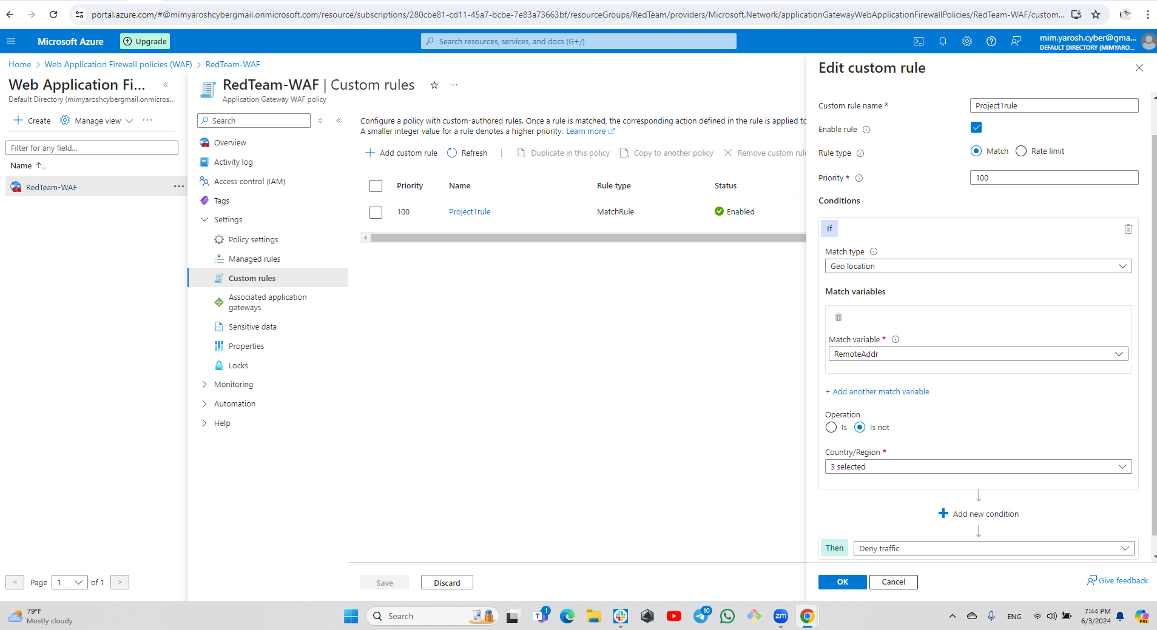

Disclaimer on Future Charges

Please type “YES” after one of the following options:

- Maintaining website after project conclusion: I am aware that I am responsible for any charges that I incur by maintaining my website. I have reviewed the guidance for minimizing costs and monitoring Azure charges.
YES

- Disabling website after project conclusion: I am aware that I am responsible for deleting all of my project resources as soon as I have gathered all of my web application screen shots and completed this document.

© 2022 Trilogy Education Services, a 2U, Inc. brand. All Rights Reserved.

