**Installation**

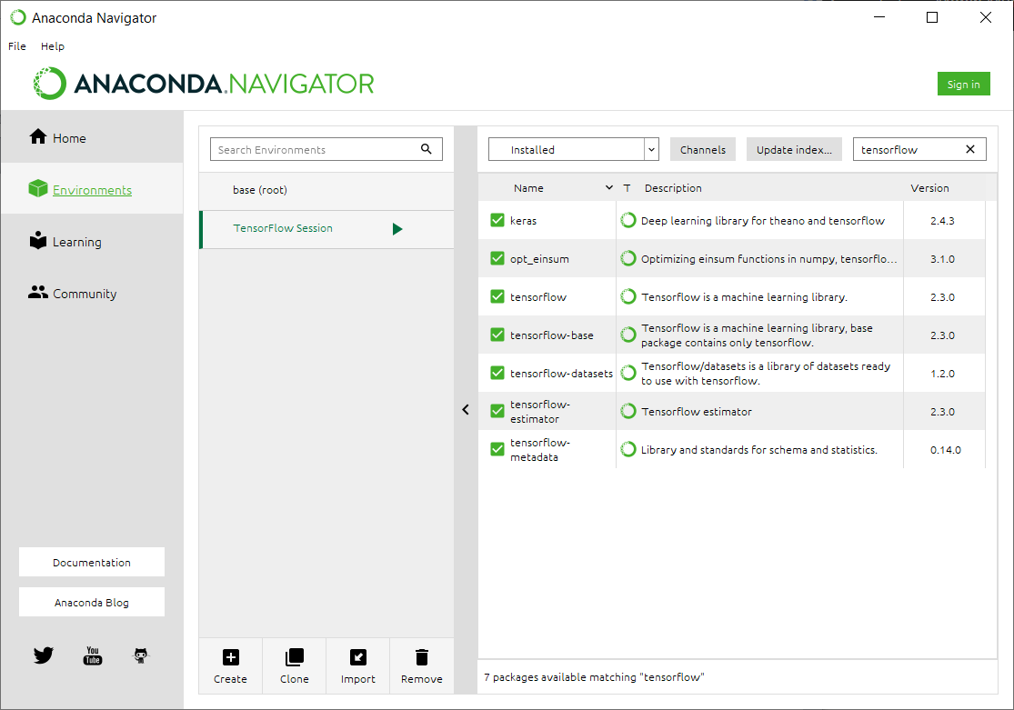

**Add the Following Packages**

* Keras
* TensorFlow
* Numpy
* Django

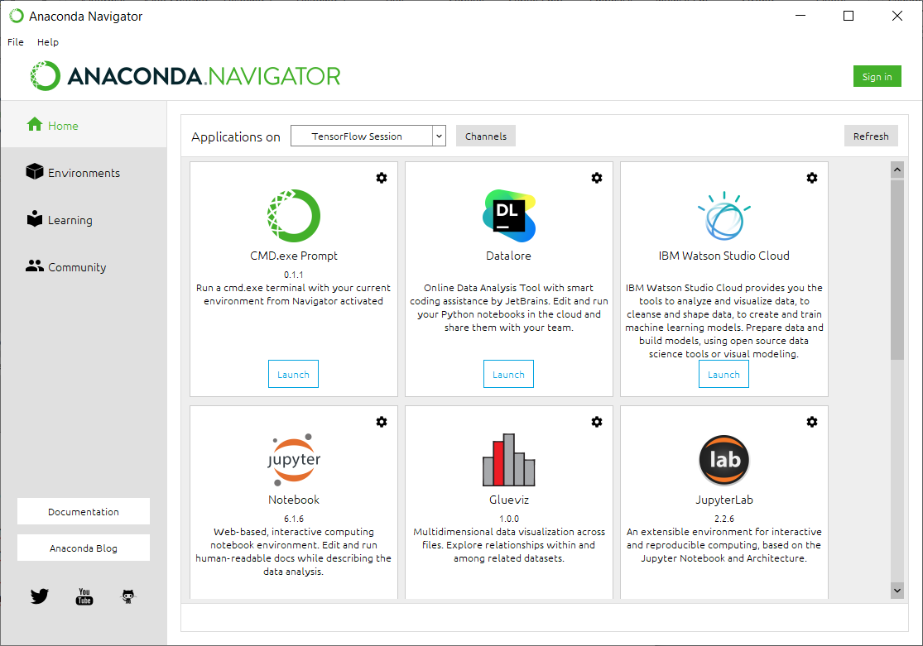

CD C:\Users\OrhanEyhab\diabetic-retinopathy-master\website

Py -3 manage runserver

