M E A L Z Y
FOOD DELIVERY WEB APPLICATION
PROJECT REPORT
A Flask and MySQL-based web application for browsing food, managing orders,
and supporting online payment workflows.
PROJECT AT A GLANCE
01 CUSTOMER EXPERIENCE  Registration, sign-in  and food catalogue | 02 ORDER MANAGEMENT  Cart, order placement  and status monitoring | 03 PAYMENT WORKFLOW  Razorpay order creation  and server verification
PREPARED BY
NO. | GROUP MEMBER | ROLL NUMBER
01 | Mimmasad sk | BWU/BCC/25/022
02 | Sabbir Hossain | BWU/BCC/25/021
03 | Priyabrata Mondal | BWU/BCC/25/020
COURSE / DEPARTMENT
B.Tech CSE – CYS
INSTITUTION
Brainware University
SUBMISSION DATE | 30 OCTOBER 2026
BUILT WITH
PYTHON • FLASK • MYSQL • HTML • CSS • JAVASCRIPT
ACADEMIC YEAR | 2025–26

Abstract
Mealzy is a food-delivery web application designed to bring customers, food products, orders, and administration together in one web-based system. The project uses Python with the Flask framework for server-side application logic and MySQL for persistent data storage. The interface is built with web technologies including HTML, CSS, and JavaScript. The system is intended to support customer registration and login, food catalogue browsing, order placement, order-status management, administrative monitoring, and payment-related workflows. A Razorpay integration has been developed in the backend using server-created orders and payment-signature verification; live payment methods depend on gateway account configuration and testing.
This report describes the project background, objectives, requirements, architecture, database design, main workflows, security considerations, testing approach, current limitations, and future improvements. It distinguishes implemented project components from items that require further validation before production deployment.

1. Introduction
Online food ordering has become a convenient way for customers to discover meals and place orders without visiting a restaurant in person. A web-based food-delivery system can reduce manual order handling, organize product information, and provide a central place to monitor customers and orders. Mealzy was planned as a practical application that demonstrates these functions using a Python backend and a relational database.

1.1 Project overview
Mealzy is a web application with a browser-based interface and a Flask server. The browser presents pages and forms, JavaScript handles interactive actions and API requests, Flask processes requests and applies application rules, and MySQL stores persistent records. This separation allows the user interface and server-side logic to evolve independently.

1.2 Problem statement
Manual food-order handling can lead to duplicated entries, inconsistent order status, slow retrieval of customer information, and difficulty tracking payments. The project addresses these issues by organizing core information in a database and exposing application routes for common tasks. Administrative views can summarize stored data, while customer-facing flows can create and retrieve orders.

1.3 Objectives
- Build a clean, responsive web interface for a food-delivery brand.
- Use Flask to connect frontend requests with backend business logic.
- Use MySQL as the primary relational database rather than a file-based database.
- Store customer, product, order, and payment-transaction information persistently.
- Provide separate customer-facing and administrative workflows.
- Develop a payment workflow with server-side order creation and verification.
- Create a foundation that can be tested, maintained, and extended.

1.4 Scope
The project scope covers the web application, its database connection, customer and product records, food orders, administrative summaries, and payment integration logic. Production deployment, verified live payment acceptance, delivery-partner tracking, notifications, and advanced reporting require additional testing and configuration.

1.5 Intended users
The principal user groups are customers who browse and order food, administrators who monitor the catalogue and order activity, and—where enabled—delivery personnel who may be assigned to fulfil orders.

2. Technology Stack and System Requirements

2.1 Technologies used
Technology | Role | Use in Mealzy
Python | Programming language | Implements backend rules and server-side processing.
Flask | Web framework | Defines routes and serves pages/API responses.
HTML | Page structure | Creates login, home, checkout, and payment page layouts.
CSS | Presentation | Controls visual design, spacing, typography, and responsiveness.
JavaScript | Browser interaction | Handles user actions, API calls, and payment checkout interaction.
MySQL | Relational database | Stores customers, products, orders, and payment transactions.
SQLAlchemy | Database access layer | Maps Python models to relational tables and supports queries.
MySQL Workbench | Database management tool | Creates, queries, and inspects the MySQL database.
Razorpay SDK / Checkout | Payment gateway integration | Creates gateway orders and supports payment verification.

2.2 Development environment
The project is developed on Windows using Visual Studio Code. A Python virtual environment (`.venv`) isolates project dependencies. The Flask application is started from the project directory with `py app.py`; during local development it is accessed through a localhost address such as `http://127.0.0.1:5000`. MySQL Workbench is used to inspect tables and run SQL queries.

2.3 Hardware and software requirements
- A Windows, Linux, or macOS computer capable of running Python and MySQL.
- Python 3 and pip for the backend runtime and package installation.
- MySQL Server and MySQL Workbench for database storage and administration.
- Visual Studio Code or another code editor.
- A modern browser for testing the customer and administrative interfaces.
- Internet access for GitHub use and gateway-related testing.

2.4 High-level architecture
The system follows a client–server architecture. The client is the browser interface. It sends HTTP requests to Flask routes. The backend validates inputs, checks authentication where required, reads or writes MySQL records through the database layer, and returns a response. Payment requests are sent from the backend to the payment gateway; sensitive gateway secrets remain on the server.
Browser (HTML / CSS / JavaScript)
↓ HTTP / API requests
Flask application (routes, validation, business logic)
↓ ORM / SQL
MySQL database (mealzy_main)
Flask backend ↔ Razorpay API (payment order and verification)

3. System Design and Functional Modules

3.1 Customer module
The customer module is intended to support account creation and sign-in, identification by email or phone where configured, and access to customer-specific actions. Customer records include fields such as a unique ID, name, email, phone number, and password hash. Passwords should be stored as secure hashes rather than plain text. Pending registration and OTP-related logic has also been used in the backend to support verification before account creation.

3.2 Food catalogue module
The product module stores the food catalogue. Product records include an ID, name, category, description, price, unit, stock quantity, and image URL. These fields allow the interface to display product details and provide the information required to calculate an order. Stock and prices should be validated on the server rather than trusted solely from browser-submitted values.

3.3 Cart and order module
The order workflow records the customer, selected product, quantity, total, delivery address or location, order status, payment method, and payment status. Order creation should validate product availability and calculate totals from trusted database prices. The order table is named `order`; because ORDER is an SQL keyword, queries should quote the table name with backticks, for example `SELECT * FROM mealzy_main.`order`;.

3.4 Administration module
The administration module is intended to provide a consolidated view of customers, products, and orders. A dashboard-summary API can supply counts and other summary values to the interface. During development, a mismatch was observed between records visible in MySQL Workbench and some dashboard totals. This indicates that database connection settings, query filters, or dashboard mapping should be verified before the dashboard is considered fully reliable.

3.5 Payment module
Mealzy includes a payment page and Razorpay-related backend endpoints. The create-order endpoint is designed to authenticate the customer, calculate the payable amount from database order records, create a gateway order, and save a payment-transaction record. The verification endpoint checks the gateway signature and payment/order details before updating the transaction and linked orders. This server-side verification is important because a browser callback alone is not proof that a payment succeeded.

3.6 Order-status and payment-status distinction
Order status and payment status represent different facts. Order status describes fulfilment, for example pending, confirmed, preparing, or delivered. Payment status describes settlement, for example pending, paid, failed, or refunded. Keeping these fields separate prevents an order from being treated as paid merely because its fulfilment status changed.

3.7 Main workflow
- Customer opens the site and browses the available food catalogue.
- Customer signs in or registers, then selects products and quantities.
- The backend validates the request and stores the order in MySQL.
- For an online payment, the backend creates a gateway order using the calculated amount.
- The customer completes the gateway checkout, and the server verifies the returned payment details.
- The application updates the transaction and order payment status only after successful verification.
- The customer can review order information, while authorized administrators monitor records.

4. Database Design
MySQL is the project's primary database engine. The active database name used during development is `mealzy_main`. The relational model keeps customer, product, order, and payment information in separate tables so that records can be queried and updated systematically.

4.1 Core tables
Table | Representative fields | Purpose
customer | id, name, email, phone, password | Stores customer account details; password values should be hashed.
product | id, name, category, description, price, unit, stock, image_url | Stores catalogue entries and product attributes.
order | id, customer_email, product_name, quantity, total, status, address, location, payment_method, payment_status | Stores order lines and delivery/payment state.
payment_transactions | customer_email, order_ids_json, amount_paise, currency, gateway, razorpay_order_id, razorpay_payment_id, status, timestamps | Tracks gateway transactions and their verification state.
pending_registration | Registration details and OTP-related fields (as configured) | Supports pending registration/verification before account activation.

4.2 Relationships and integrity
The order record refers to the customer through customer email in the current model, and the payment transaction records the customer and the order IDs associated with a gateway payment. A more normalized future design could use numeric foreign keys such as `customer_id` and separate `order_items` records. Foreign-key constraints, unique email constraints, indexes, and controlled status values can improve consistency.
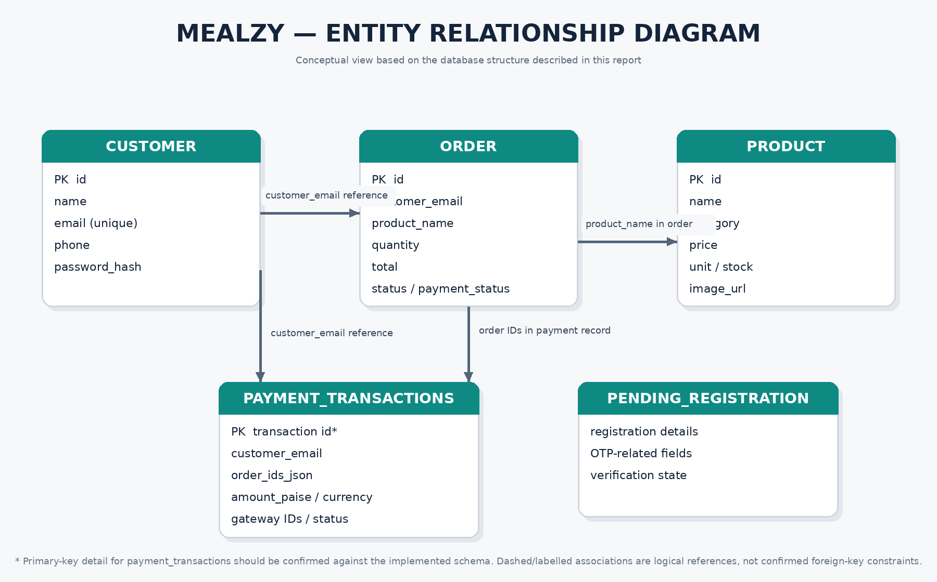
Figure 4.1 Entity relationship diagram of the Mealzy database

4.3 Example SQL queries
Display all orders:
SELECT * FROM mealzy_main.`order` ORDER BY id DESC;
Display customer details:
SELECT id, name, email, phone FROM mealzy_main.customer ORDER BY id DESC;
Count orders:
SELECT COUNT(*) AS total_orders FROM mealzy_main.`order`;

4.4 Backup and restoration
Database backups should be made through MySQL Workbench's Data Export feature or the MySQL command-line tools. The full operational backup should be stored privately. A version-controlled database setup file should contain schema definitions and fictional seed data only. It should not contain real customer data, payment records, credentials, or production secrets.

4.5 Dashboard count validation
When a table contains records but the dashboard shows zero or an unexpectedly low count, the first checks should be: confirm Flask's configured database URI, confirm the selected schema is `mealzy_main`, inspect the exact SQLAlchemy model table names, review dashboard filters and limits, and restart the correct Flask process. Data should not be deleted to resolve a display mismatch.

5. Security, Payment Handling, and Implementation

5.1 Authentication and data protection
Authentication protects customer-specific operations and administrative functions. API endpoints should validate the user's identity and authorization before returning or modifying records. The application should use password hashing, validate and normalize input, and avoid returning password hashes or unnecessary personal information in API responses.

5.2 Secrets management
Configuration values such as the database password, Razorpay key secret, email credentials, and SMS provider tokens should be kept in environment variables or a protected configuration store. A local `.env` file must not be committed to GitHub. A safe `.env.example` file may list variable names with placeholder values. If a secret is accidentally published, it should be rotated immediately.

5.3 Payment security
The payment flow should use the server to calculate the amount and create the gateway order. The server should verify the gateway signature and confirm that the payment belongs to the expected order and amount before marking the order paid. The client must not be allowed to submit an arbitrary amount as authoritative. Test-mode transactions should be used until the gateway account and payment methods are configured and tested.

5.4 UPI availability
The project has attempted to configure the Razorpay Checkout display for UPI. Whether UPI appears in the checkout interface depends on gateway account activation, account eligibility, checkout configuration, and the current gateway rules. Therefore, UPI availability should be treated as a deployment check rather than assumed solely from a JavaScript configuration block.

5.5 Privacy and responsible data use
Customer names, phone numbers, email addresses, delivery addresses, order histories, and payment identifiers are sensitive operational data. Access should be limited to authorized users. Public repositories and demonstration environments should use fictional data. Logs should avoid recording passwords, authentication tokens, payment secrets, or full sensitive payment details.

5.6 GitHub version control
GitHub can preserve project source code and document changes over time. The repository should include application source, static assets, requirements information, safe setup instructions, and a sanitized database schema. It should exclude `.env`, `.venv`, cache files, private database exports, and any customer data. Before the first push, `git status` should be reviewed carefully.

5.7 Current implementation status
The project has a Flask application, HTML/CSS/JavaScript frontend files, a MySQL database named `mealzy_main`, customer/product/order models, a payment page, and Razorpay create-order/verification logic. The local application has been run through Flask. However, the earlier dashboard count mismatch and the reported absence of UPI in checkout show that database-summary accuracy and gateway method availability still require verification. This report does not claim that live payments or production deployment have been fully certified.

6. Testing and Results

6.1 Testing approach
Testing should be carried out at the level of individual routes, database operations, user workflows, and payment responses. The following test cases form a practical checklist for confirming the current implementation.
Test | Procedure | Expected result | Status
Database connection | Start Flask and inspect connection/configuration output. | Application uses `mealzy_main` without connection errors. | Verify locally
Customer listing | Run SELECT query in Workbench. | Stored customer records are returned. | Manual SQL check
Order listing | Query `mealzy_main.`order`. | Order records and statuses are visible. | Manual SQL check
Registration | Register a test account. | Validated customer record is stored once. | Needs end-to-end test
Order creation | Place a test order. | Correct product, quantity, total, and status are stored. | Needs end-to-end test
Dashboard totals | Compare dashboard API values with SQL COUNT results. | Counts match the intended filters and tables. | Further debugging required
Payment order creation | Create a test payment request as an authenticated customer. | Gateway order and transaction record are created. | Test-mode verification required
Payment verification | Submit valid and invalid gateway responses. | Only valid verified payments are marked paid. | Test-mode verification required
UPI checkout | Open Razorpay checkout with account enabled for UPI. | UPI option appears if enabled and eligible. | Account/configuration check required
Repository safety | Inspect `git status` before push. | No secrets or private backups are staged. | Before GitHub upload

6.2 Database verification examples
The following queries can be used to compare database contents with the dashboard:
SELECT COUNT(*) AS customers FROM mealzy_main.customer;
SELECT COUNT(*) AS products FROM mealzy_main.product;
SELECT COUNT(*) AS orders FROM mealzy_main.`order`;

6.3 Expected benefits
- Centralized storage of customer, catalogue, and order information.
- Faster retrieval of records using SQL queries.
- Clear separation between frontend, backend, and database responsibilities.
- A basis for administrative monitoring and order-status tracking.
- A structured payment workflow with server-side verification.

6.4 Known limitations
The application remains a development project until full workflows have been tested. Dashboard totals must be reconciled with SQL counts. Gateway methods such as UPI require account-side confirmation. Production deployment also requires HTTPS, hardened configuration, robust logging, backup/restore drills, authorization testing, and review of error handling.

7. Conclusion and Future Scope

7.1 Conclusion
Mealzy demonstrates the design of a food-delivery web application using Flask, browser technologies, and MySQL. It brings together the essential entities of a food-ordering system—customers, products, orders, and payment transactions—and provides a foundation for customer interaction and administrative monitoring. The project also explores payment gateway integration with server-side order creation and verification, which is an important security requirement for online transactions.
The work completed so far provides a practical base for further development. Before the system is used by real customers, database configuration and dashboard totals must be validated, registration and order workflows must be tested end to end, and gateway account settings must be confirmed in test mode. Production readiness depends on those checks rather than on the presence of code alone.

7.2 Future enhancements
- Normalize the database using customer IDs, separate order and order-item tables, and explicit foreign-key constraints.
- Add stronger role-based authorization for administrators, customers, and delivery personnel.
- Improve the dashboard with reliable counts, date filters, sales summaries, and order-status analytics.
- Add stock validation and transaction handling to prevent overselling and inconsistent totals.
- Complete gateway testing for success, failure, cancellation, duplicate callbacks, and refunds.
- Confirm UPI and other payment methods with the payment provider before enabling production payments.
- Add email/SMS notifications for registration verification and order updates, with secrets kept outside source control.
- Deploy with HTTPS, secure cookies, CSRF protections where applicable, rate limiting, and centralized error logging.
- Create automated tests and documented database backup/restore procedures.
- Publish a safe GitHub repository with setup instructions, dependency list, schema file, and fictional demo data.

References
- Flask documentation: https://flask.palletsprojects.com/
- MySQL documentation: https://dev.mysql.com/doc/
- SQLAlchemy documentation: https://docs.sqlalchemy.org/
- Razorpay documentation: https://razorpay.com/docs/
- Git documentation: https://git-scm.com/doc
- GitHub documentation: https://docs.github.com/
Note: This report is based on the project details available during development. Update the submitted-by information and verify implementation status, screenshots, and test results before academic submission.

