THE OPEN SOURCE AUDIT
A Capstone Project for OSS NGMC Course
Course: Open Source Software | Unit Coverage: 1 to 5 | Max Marks: 100

Student Name | Rounak Hati
Registration Number | 24MIM10078
Slot | F11
Date of Submission | 30 March 2026
Software Chosen | Linux Kernel
Operating System | Fedora Linux 43 (KDE Plasma Desktop Edition)
Kernel Version | 6.19.9-200.fc43.x86_64
Hardware | ASUS TUF Gaming F15 FX506HF

Introduction
Most of the software that powers the modern world — the servers that run websites, the tools that developers use every day, the operating systems inside supercomputers and smartphones — was not built by a single company and sold for profit. It was built openly, shared freely, and improved collectively. That is the essence of open source.
This project examines the Linux kernel from multiple angles: its origin story, the license that governs it, the philosophy behind it, how it lives on a Fedora Linux system, the ecosystem it belongs to, and how it compares against its closest proprietary alternative. Alongside the written report, five shell scripts demonstrate practical Linux skills and connect the philosophy of open source to everyday command-line work.

Part A — Origin and Philosophy
A1. The Problem Linux Was Created to Solve
In 1991, Linus Torvalds was a 21-year-old computer science student at the University of Helsinki. He wanted to use a Unix-like operating system on his personal computer. Unix was powerful, stable, and widely used in universities and research labs. But it was expensive and proprietary. You could not read its source code, modify it, or learn from it freely. It was locked behind licenses that a student simply could not afford.
There was one alternative — MINIX. It was a small Unix-like system built by professor Andrew Tanenbaum, designed specifically for teaching operating system concepts. But MINIX was restricted too. Tanenbaum did not want it modified heavily, because he wanted it to stay simple for educational use. It also only ran on the Intel 286 processor. Linus had an Intel 386, and he wanted to use its full capabilities.
So he started writing his own kernel. Not because he had some grand vision of changing the world, but because he was frustrated, curious, and wanted something that worked the way he needed. On 25 August 1991, he posted this on the comp.os.minix newsgroup:

"I'm doing a (free) operating system (just a hobby, won't be big and professional like gnu) for 386(486) AT clones."

That line is important. He literally called it a hobby. He had no idea what it would become.
What he did know was that the GNU Project, started by Richard Stallman in 1983, had already been building free software tools for years. Stallman's own story is worth mentioning here. He was a programmer at MIT who wanted to fix a bug in a printer driver. The printer manufacturer gave the lab a new printer but refused to share the source code. Stallman could not fix a simple problem because the code was locked. That experience pushed him to start the GNU Project and eventually write the GPL license.
By 1991, GNU had almost everything needed for a complete free operating system — compilers, text editors, utilities. But it was missing one critical piece: a kernel. Linus filled that gap, almost by accident. He released version 0.01 of the Linux kernel in September 1991. By version 0.02, he was already getting patches from people around the world. The open development model meant anyone could send fixes and improvements. Linus accepted them, merged the good ones, and the kernel grew fast.
This is something that genuinely struck me when I looked at it from where I sit today. I run Fedora Linux 43 on my ASUS TUF laptop. The kernel version right now on my machine is 6.19.9. That is over thirty years of development from that first hobby project. And all of it because one student could not afford a Unix license and decided to build something himself and share it.
The problem Linux solved was not just technical — it was about access. Before Linux, understanding how an operating system actually worked at the kernel level required money, institutional access, or you were locked out. Linux changed that. It made the most fundamental layer of computing something anyone could read, run, study, and change. That philosophy did not come from a business plan. It came from frustration, curiosity, and the decision to share instead of hoard.

A2. The License — What It Actually Says
The Linux kernel is licensed under the GNU General Public License version 2, commonly written as GPL v2. You can read the full text in the COPYING file in the kernel's source tree on kernel.org. Most people never actually read it. Here is what it actually means in practice.
The Four Freedoms
Richard Stallman defined four freedoms that any truly free software must give its users. Not free as in no cost — free as in you actually control what you have.
- Freedom 0: The freedom to run the program for any purpose.
- Freedom 1: The freedom to study how the program works and change it. This requires access to the source code.
- Freedom 2: The freedom to redistribute copies so you can help others.
- Freedom 3: The freedom to distribute copies of your modified versions to others.
The Linux kernel under GPL v2 grants all four. You can download the full source, read every line of how the scheduler works or how memory is managed, modify it, compile it yourself, and give it to someone else. What GPL v2 adds on top is a condition: if you distribute a modified version, you must distribute it under the same license. This condition is called copyleft, and it is what makes GPL different from more permissive licenses.
Can a Company Modify and Sell It Without Sharing Changes?
This is where it gets interesting, and where Red Hat is the perfect example. Red Hat takes the Linux kernel, packages it with other software, tests it heavily, and sells it as Red Hat Enterprise Linux (RHEL). They charge for subscriptions and support contracts. Red Hat, now owned by IBM, is a billion dollar company built almost entirely on software it did not originally write.
Is that allowed? Yes. GPL v2 does not stop you from selling software. What it requires is that if you distribute the binaries, you must make the corresponding source code available. Red Hat does this — anyone can download the RHEL source RPMs. That is exactly how AlmaLinux and Rocky Linux exist. They took Red Hat's publicly available sources, recompiled them, and released their own distributions.
Fedora is Red Hat's upstream testing ground. New kernel versions and features get pushed to Fedora first. The community tests them, breaks them, fixes them. Once stable enough, they move downstream into RHEL. My machine running kernel 6.19.9 on Fedora 43 is part of that pipeline. So companies can absolutely profit from Linux. They just cannot close it. That distinction matters a lot.
GPL v2 vs MIT — The Key Difference
MIT license says: do whatever you want with this, just keep the copyright notice. You can take MIT-licensed code, modify it, put it in a proprietary product, sell it, and never share what you changed. GPL v2 says: you can do almost anything, but if you distribute it, your version must also be GPL.
MIT gives freedom to the developer who takes the code. GPL gives freedom to the user who eventually receives it. For something like a kernel, GPL is the right call. The whole point is that the foundation stays open. If I were building something I genuinely cared about and did not want locked away, I would use GPL. If I were writing a library and wanted maximum adoption including in commercial projects, MIT makes more sense.

Free as in Beer vs Free as in Freedom
Free beer means you are not paying, but you are still consuming something someone else controls. You cannot change the recipe or redistribute it. Free as in freedom means you have control — you can look at what it is made of, change it, improve it, share your version.
Linux is free in both senses right now. But the important one is the second. With Linux, the kernel source is genuinely open. Anyone can submit a patch. Red Hat engineers, Google engineers, Intel engineers, and individual hobbyists all have patches in the mainline kernel. That is free as in freedom actually working.
A3. The Ethics of Open Source
Should All Software Be Open Source?
The honest answer is no, not necessarily. But the reasoning matters more than the answer. The argument for making everything open source is straightforward — software has become infrastructure. When that infrastructure is owned and controlled by private corporations, the people depending on it have no real say in how it works, where their data goes, or what happens when the company changes direction. Making it open means the infrastructure stays accountable to the people using it.
But there is a practical argument on the other side. A company building a product needs some ability to protect its work long enough to sustain itself. If a small team builds something useful and has no way to earn from it, the project dies. My actual position is that anything functioning as public infrastructure should be open. Anything built on top of it can be whatever the builder wants.
Is It Ethical for Companies to Profit From Free Community Labor?
This is the question I find most genuinely uncomfortable. Red Hat took Linux, which was built by thousands of volunteers, packaged it, and built a company worth billions. Is that ethical? Technically they followed every rule. GPL allows it. They release their sources. But there is something that feels unbalanced about a corporation extracting enormous value from work that individual contributors did in their free time, sometimes for years, often for no pay.
Then again, Red Hat employs a large number of kernel developers full time and contributes back significantly. The same is true of Google, Intel, and others. So the relationship is not purely extractive. The companies that genuinely bother me are the ones that take open source, profit heavily, and contribute almost nothing back. Not because they are breaking any rule, but because they benefit from a system of trust while giving nothing to sustain it.
Ownership, Control, and Why This Actually Matters
When you buy a laptop, you spend your own money. It is yours. But if it comes with Windows, Microsoft Edge is sitting there and you cannot fully remove it. The operating system is doing things in the background you did not ask for and cannot fully inspect. Features get added or removed based on what a company decides, not what you want.
The subscription model has made this worse. There are refrigerators now that come with subscription services. You bought the fridge with your own money, but some features are locked behind a monthly fee. You own the hardware but you are renting the functionality. Open source is the counter to that. When I run Fedora on my ASUS TUF, I know what is running on my machine. I chose the kernel. I chose KDE Plasma. I use Zen Browser, which is a fork of Firefox — someone took it and built their own version with a different philosophy around privacy. That ability to fork something you care about and shape it to what you want does not exist in the proprietary world.
This also extends to AI. Models like DeepSeek, Kimi, and Qwen are open source or open weight. I can run them locally — I know they are not training on my conversations. Closed source AI models train on your data, make decisions you cannot audit, and you have no visibility into what is happening. That is the same problem as Stallman's printer, just at a much larger scale.
Standing on the Shoulders of Giants
In software this phrase means something very literal. Every piece of software that exists today is built on top of something else. The browser used to submit this project runs on an operating system that uses a kernel written in C, compiled using a compiler that is itself open source. There are layers going all the way down, and most of them are open source projects that someone built and shared.
My editor is Vim. My notes app is Joplin. My version control is Git, which Linus built as a side project when the proprietary tool he was using failed him. Git is now the standard for almost every software project on earth. It happened because he built it openly and let the world improve it. There are thousands of Linux distributions, each built on top of the kernel with different philosophies. VLC became one of the most used media players in the world because it was built openly.
Standing on the shoulders of giants does not undermine original innovation. It enables it. When you do not have to rebuild the foundation every time, you can build higher. But with that access comes responsibility. If you use what the community built, contribute something back — documentation, a bug report, a small patch. Open source only works as long as people treat it as a shared resource and not a free buffet.

Part B — Linux Footprint
Installation Method
On Fedora, the kernel is distributed as an RPM package and managed through DNF. You do not compile it from source unless you specifically want a custom build. For most users, the packaged version is what runs the system.
To check which kernel versions are currently installed:

rpm -q kernel

On my machine this returns three entries:

kernel-6.17.1-300.fc43.x86_64
kernel-6.19.8-200.fc43.x86_64
kernel-6.19.9-200.fc43.x86_64

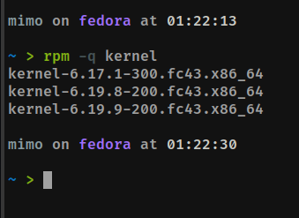
Figure 1 — rpm -q kernel showing all installed kernel versions
Fedora keeps the last three kernel versions installed by default. If a new kernel breaks something, you can reboot and select an older one from the GRUB menu. To check which kernel is currently running:

uname -r

Output on my system:

6.19.9-200.fc43.x86_64

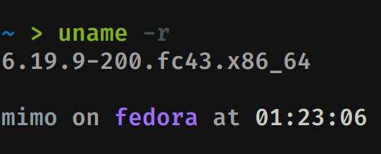
Figure 2 — uname -r confirming the running kernel version
The naming convention: 6.19.9 is the upstream kernel version, 200 is Fedora's build number for that version, fc43 indicates Fedora 43, and x86_64 is the processor architecture. To update to the latest available version:

sudo dnf upgrade kernel

Key Directories
/boot is where the kernel images live. Each installed kernel version has a corresponding vmlinuz file here, plus an initramfs file — a small temporary filesystem the kernel uses during early boot before it can access the real root filesystem.

ls /boot | grep vmlinuz

Output:

vmlinuz-0-rescue-c50a1cd34df74514918d1161ae43bce4
vmlinuz-6.17.1-300.fc43.x86_64
vmlinuz-6.19.8-200.fc43.x86_64
vmlinuz-6.19.9-200.fc43.x86_64

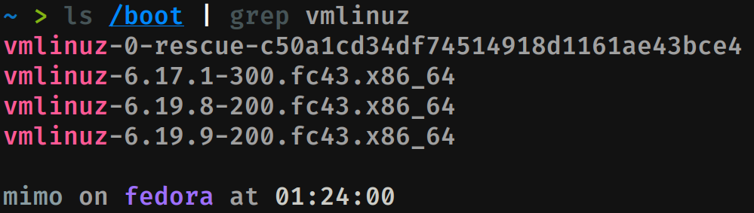
Figure 3 — ls /boot | grep vmlinuz listing all kernel images
The rescue entry is a fallback kernel Fedora generates during installation, tied to the machine ID, for recovery situations where all regular kernels fail to boot.
/lib/modules contains the loadable kernel modules for each installed version. Modules are pieces of kernel code that can be loaded and unloaded at runtime without rebooting. Device drivers are the most common example — when you plug in a USB device and it just works, a kernel module was loaded in the background.

ls /lib/modules

Output:

6.17.1-300.fc43.x86_64 6.19.8-200.fc43.x86_64 6.19.9-200.fc43.x86_64

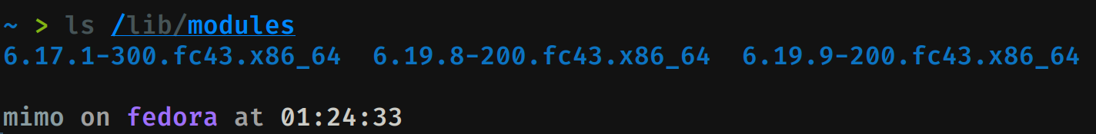
Figure 4 — ls /lib/modules showing module directories for each kernel
/proc is a virtual filesystem the kernel creates in memory at boot. It does not exist on disk. It exposes real-time information about the running kernel and all active processes. Files like /proc/cpuinfo and /proc/meminfo are generated on the fly when you read them. /sys is similar, exposing the kernel's view of hardware, buses, and connected devices.
User and Group
The kernel itself does not run as a user the way a web server or database does. It runs in kernel space — a privilege level below all user space processes. When you run ps aux, the kernel is not in that list because it is not a process. It is the thing that manages all the processes.
Kernel space has unrestricted access to all hardware and memory. Any code running there, including loadable modules, has that same unrestricted access. This is why kernel modules from untrusted sources are dangerous, and why Fedora uses Secure Boot and module signing to ensure only trusted code runs at that level. User space processes, including ones running as root, are still subject to the kernel's control.
Service Management
The kernel itself is not managed by systemd. You do not run systemctl start kernel. The kernel is loaded by GRUB before anything else. Systemd is started by the kernel as the first user space process (PID 1). However, kernel-related services are managed through systemd:

systemctl status kdump.service # kernel crash dump service
sudo modprobe <module_name> # load a kernel module
sudo modprobe -r <module_name> # unload a kernel module
lsmod # list currently loaded modules

Update Model
Fedora is Red Hat's upstream distribution, where new kernel versions get tested before being considered stable enough for RHEL. Running Fedora 43 with kernel 6.19.9 means being on one of the most current kernel versions available anywhere. When sudo dnf upgrade is run, the system checks Fedora's repositories and pulls the latest tested version. Security patches follow the same path but faster — when a kernel vulnerability is discovered, Fedora typically has an updated package within days.
This is also a good place to mention the difference between mutable and immutable Linux distributions. Fedora in its standard form, which is what I run, is mutable — I have full access to root level files, can update the kernel manually, load custom modules, and modify boot parameters. Immutable distributions like Fedora Silverblue and Bazzite take a different approach: the root filesystem is read-only, updates are applied as atomic transactions, and if an update causes problems you roll back to the previous state. Both run the same kernel. The difference is in how much control and how much risk the user accepts.

Part C — The FOSS Ecosystem
What the Linux Kernel Depends On
The kernel does not exist in isolation. Even before it becomes a usable system, it depends on a stack of open source tools just to be built and distributed. The kernel is written primarily in C, with some assembly for architecture-specific low level code. To compile it, you need GCC, the GNU Compiler Collection — one of the oldest open source projects, started by Richard Stallman in 1987. Clang (part of the LLVM project) has also become a supported alternative. The build system uses GNU Make. The kernel's configuration system, Kconfig, is built into the source tree itself.
The GNU C Library (glibc) is the bridge between the kernel and user space applications. When a program wants to read a file or create a process, it calls glibc, which translates that into a system call entering the kernel. Almost every program on a Linux system is linked against glibc. On Fedora, the kernel is packaged using RPM, with DNF handling dependency resolution and updates. Bootloading is handled by GRUB, another GNU project. Before you even see a login screen, GCC, GNU Make, glibc, RPM, DNF, and GRUB have all been involved — every single one of them open source.
What Linux Has Enabled and Inspired
Android runs on the Linux kernel. Every Android phone in the world is running a modified version of the same kernel Linus started in 1991. The majority of web servers run Linux. Amazon Web Services, Google Cloud, and Microsoft Azure all run their core infrastructure on Linux — including Microsoft, which spent years calling Linux a threat and now depends on it heavily. Supercomputers are almost entirely Linux. The TOP500 list of the world's fastest supercomputers is essentially a Linux list.
There are hundreds of Linux distributions, each a different take on packaging a Linux-based system. The kernel also inspired the patch submission and review process that became a model for collaborative software development before GitHub existed. Git, which Linus wrote specifically to manage kernel development after the proprietary tool he was using changed its license, is now the version control standard for essentially all software development worldwide.
The LAMP Stack Connection
LAMP stands for Linux, Apache, MySQL, and PHP (or Python or Perl). It was the dominant web development stack for most of the 2000s and is still widely used. Linux in that acronym is the kernel providing the foundation everything else runs on. Apache handles HTTP requests. MySQL stores application data. PHP or Python runs application logic. None of them function without Linux managing the filesystem, networking, memory, and processes.
Modern stacks have evolved — NGINX has replaced Apache in many deployments, PostgreSQL competes with MySQL, Node.js and Go have joined the options. But all of it still runs on Linux. The kernel is the constant. On my Fedora machine, the full LAMP stack is available through DNF. Installing Apache takes one command. The entire web development environment that powers most of the internet is available in minutes.
The Community and Governance
The Linux kernel community is one of the largest and most active open source communities in existence. Development happens primarily through the Linux Kernel Mailing List, still email based, whose archives are a remarkable public record of every technical decision ever made about the kernel. The governance structure is a hierarchy of maintainers. Linus Torvalds remains the top-level maintainer with final say on what goes into the mainline kernel.
Patches go through a review cycle — a developer submits a patch, maintainers and community members review it, request changes if needed, and eventually merge or reject it with a documented reason. Every discussion is publicly archived. That transparency is a core part of what makes the kernel trustworthy. The Linux Foundation, founded in 2000, provides organizational and financial support and employs Linus Torvalds directly. It is funded by member companies including Red Hat, Google, Intel, and Samsung. Major conferences include the Linux Plumbers Conference, the Linux Storage and Filesystem Summit, and the Open Source Summit.

Part D — Open Source vs Proprietary (Critical Analysis)
The closest proprietary alternative to the Linux kernel is the Windows NT kernel, which powers all modern versions of Microsoft Windows. The comparison below covers the dimensions that matter most for a real deployment decision.

Dimension | Linux Kernel (Open Source) | Windows NT Kernel (Proprietary)
Cost | Free. No kernel license fee. Enterprise support from Red Hat costs money, the software itself does not. | Windows licenses cost money. OEM licenses bundled into hardware. Server licenses can reach thousands per machine per year.
Security | Full source at kernel.org. Security researchers worldwide can find, fix, and submit patches publicly. | Only Microsoft employees and select partners can read the source. Fixes come on Microsoft's timeline only.
Support & Reliability | Community forums, mailing lists, Red Hat paid support with SLAs. Fedora moves fast; RHEL is extremely stable. | Official Microsoft support with defined timelines. More structured for non-technical users.
Freedom to Modify | Complete. Download source, patch it, compile your own kernel. Android is itself a modified Linux kernel. | None for end users. You cannot modify Windows or read its source. You run what Microsoft ships.
Community vs Corporate Control | Linus Torvalds retains technical authority. Linux Foundation provides financial support. Contributors from hundreds of companies and independents. | Microsoft controls everything — roadmap, features, timelines, security patches. All decisions are Microsoft's.
Overall Verdict | Best for servers, cloud, development, and technical users who value control, transparency, and cost. | Better for non-technical users needing a commercial support structure and Windows-only software ecosystems.

Conclusion and Verdict
After spending this entire project looking at the Linux kernel from every angle, the question of whether I would recommend it for real-world deployment has a straightforward answer: yes, with clarity about what kind of deployment is being considered.
For servers, cloud infrastructure, development machines, and any environment where the people managing the system know what they are doing, Linux is the obvious choice. The cost argument alone is significant at scale. A company running a thousand servers on RHEL is paying for Red Hat support, not for the kernel. The security argument is also real — the ability for independent researchers to audit the kernel source means vulnerabilities get found and fixed faster and more transparently than in a closed system. The fact that my Fedora machine received a kernel update to 6.19.9 and I can read exactly what changed in that update in the commit history on kernel.org has no equivalent in the Windows world.
The honest limitation is the learning curve and support model for non-technical users. Fedora is not something I would hand to someone who has never used Linux. The ecosystem assumes comfort with the terminal and the idea that sometimes things break and you fix them yourself. That is not a flaw — it is a trade-off. With great control comes the responsibility to actually exercise that control. As for contributing, yes, I would. Not to the kernel itself yet — that requires a depth of systems programming I am still building — but to the Fedora ecosystem, documentation, and smaller open source tools I use every day. The whole system only works because people contribute. Using it without giving anything back eventually hollows it out.

4. Shell Script Tasks
All five scripts were written, tested, and run on Fedora Linux 43 (KDE Plasma Desktop Edition) with kernel 6.19.9-200.fc43.x86_64. Each script is documented below with its code, output screenshot, and an explanation of what it does and which shell scripting concepts it uses.
Script 1 — System Identity Report

#!/bin/bash
# Script 1: System Identity Report

# --- Variables ---
STUDENT_NAME="Rounak Hati"
SOFTWARE_CHOICE="Linux Kernel"

# --- System Info ---
KERNEL=$(uname -r)
USER_NAME=$(whoami)
UPTIME=$(uptime -p)
DATE=$(date)
DISTRO=$(hostnamectl | grep "Operating System" | cut -d ':' -f2)

# --- Output ---
echo "===================================="
echo " Open Source Audit --- $STUDENT_NAME"
echo "===================================="
echo "Software : $SOFTWARE_CHOICE"
echo "Kernel : $KERNEL"
echo "User : $USER_NAME"
echo "Uptime : $UPTIME"
echo "Date : $DATE"
echo "Distro : $DISTRO"
echo "License : GNU General Public License (GPL)"
echo "===================================="

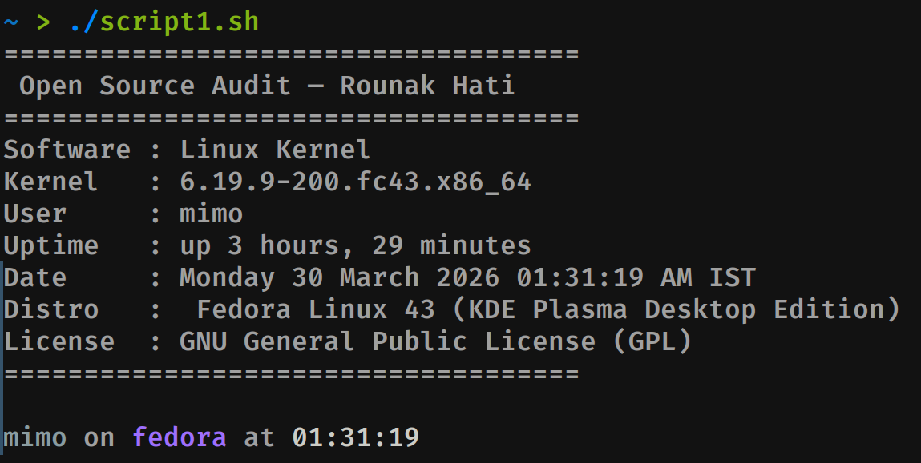
Figure 5 — Script 1 output: System Identity Report
Explanation
This script acts as a welcome screen for the audit. It pulls live system information using command substitution, where a command inside $() runs and its output is stored directly into a variable. uname -r returns the running kernel version. whoami returns the current user. uptime -p gives a human-readable uptime string. hostnamectl is a systemd utility returning detailed system information, and grep and cut extract just the operating system line from its output.
The script demonstrates basic variable declaration, command substitution, and formatted output using echo. The output on my machine confirmed kernel 6.19.9-200.fc43.x86_64 running on Fedora Linux 43 (KDE Plasma Desktop Edition) under the user mimo. The license line is hardcoded because the kernel's license, GPL v2, does not change between runs.
Script 2 — FOSS Package Inspector

#!/bin/bash
# Script 2: FOSS Package Inspector

PACKAGE="kernel"

# Check if package is installed
if rpm -q $PACKAGE &>/dev/null; then
echo "$PACKAGE is installed."
rpm -qi $PACKAGE | grep -E "Version|License|Summary"
else
echo "$PACKAGE is NOT installed."
fi

echo ""

# Philosophy note using case statement
case $PACKAGE in
kernel)
echo "Linux Kernel: built from a student's need, now powering the backbone of modern computing"
;;
git)
echo "Git: Linus Torvalds' side project that became the standard for managing every modern codebase"
;;
firefox)
echo "Firefox: a fight to keep the internet open, private, and not controlled by a few giants"
;;
vlc)
echo "VLC: the media player that plays everything, where even big corporations struggle to compete"
;;
*)
echo "Open source lives long"
;;
esac

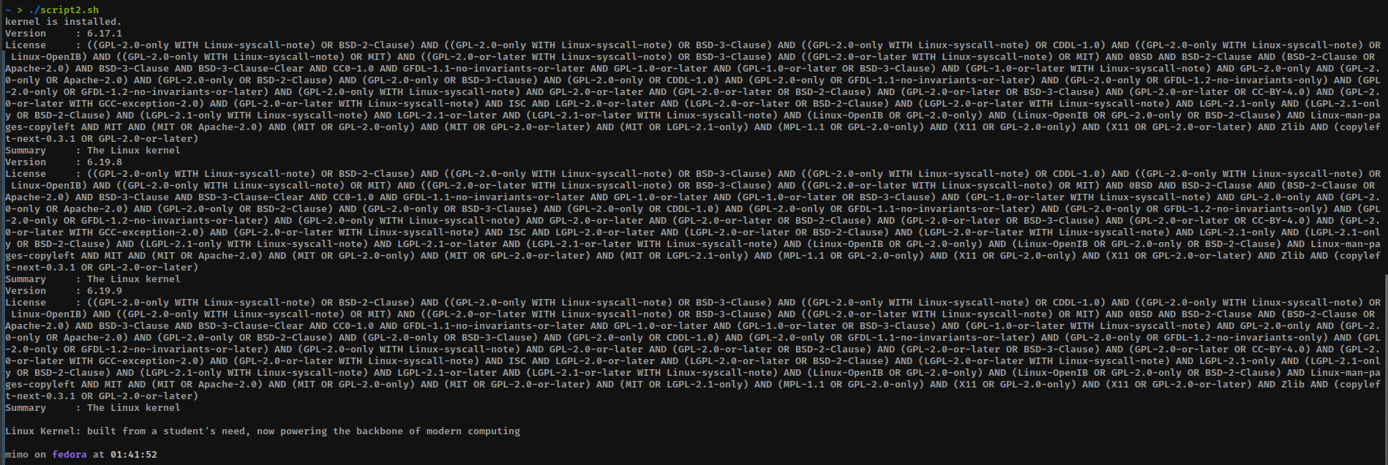
Figure 6 — Script 2 output: FOSS Package Inspector
Explanation
This script checks whether the chosen software package is installed using rpm -q, which queries the RPM package database. The &>/dev/null redirects both standard output and error output to nothing, so the check runs silently and only the if condition matters. If the package is found, rpm -qi retrieves detailed package information and we pipe it through grep -E with a regex pattern to extract only the Version, License, and Summary fields.
The script demonstrates an if-then-else conditional, pipe chaining, and a case statement. The case statement matches the package name and prints a one-line philosophy note. On my machine this returned three kernel versions since Fedora keeps multiple kernels installed, all showing the GPL license and the summary 'The Linux kernel'. The philosophy line for the kernel case printed at the bottom confirms the case matching worked correctly.
Script 3 — Disk and Permission Auditor

#!/bin/bash
# Script 3: Disk and Permission Auditor

DIRS=("/etc" "/var/log" "/home" "/usr/bin" "/tmp")

echo "Directory Audit Report"
echo "----------------------"

for DIR in "${DIRS[@]}"; do
if [ -d "$DIR" ]; then
PERMS=$(ls -ld $DIR | awk '{print $1, $3, $4}')
SIZE=$(du -sh $DIR 2>/dev/null | cut -f1)
echo "$DIR => Permissions: $PERMS | Size: $SIZE"
else
echo "$DIR does not exist"
fi
done

echo ""

# Check kernel config directory
KERNEL_DIR="/boot"
if [ -d "$KERNEL_DIR" ]; then
PERMS=$(ls -ld $KERNEL_DIR | awk '{print $1, $3, $4}')
echo "Kernel directory (/boot) => Permissions: $PERMS"
else
echo "Kernel directory not found"
fi

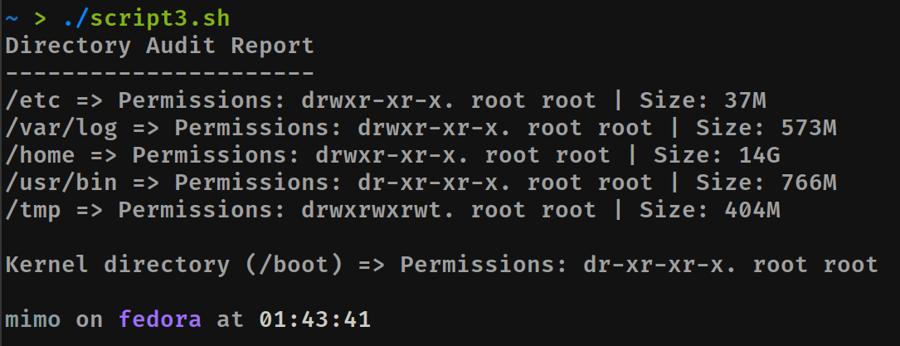
Figure 7 — Script 3 output: Disk and Permission Auditor
Explanation
This script loops through a predefined list of important system directories and reports their permissions, ownership, and size. The directory list is stored as a bash array and iterated using a for loop with the "${DIRS[@]}" syntax, which expands all array elements correctly. For each directory, ls -ld gives the long listing of the directory itself rather than its contents, and awk extracts the permission string, owner, and group. du -sh calculates the total size of the directory.
The output showed /etc at 37M owned by root, /var/log at 573M, /home at 14G, /usr/bin at 766M, and /tmp at 404M. The /boot directory showed dr-xr-xr-x root root permissions, meaning only root can write to it but everyone can read and execute. That permission level makes sense for a directory holding kernel images.
Script 4 — Log File Analyzer

#!/bin/bash
# Script 4: Log File Analyzer
# Usage: ./script4.sh /var/log/messages warning

LOGFILE=$1
KEYWORD=${2:-error}
COUNT=0

# Check if file exists
if [ ! -f "$LOGFILE" ]; then
echo "Error: File not found."
exit 1
fi

# Read file line by line
while IFS= read -r LINE; do
if echo "$LINE" | grep -iq "$KEYWORD"; then
COUNT=$((COUNT + 1))
fi
done < "$LOGFILE"

echo "Keyword '$KEYWORD' found $COUNT times in $LOGFILE"
echo ""
echo "Last 5 matching lines:"
grep -i "$KEYWORD" "$LOGFILE" | tail -n 5

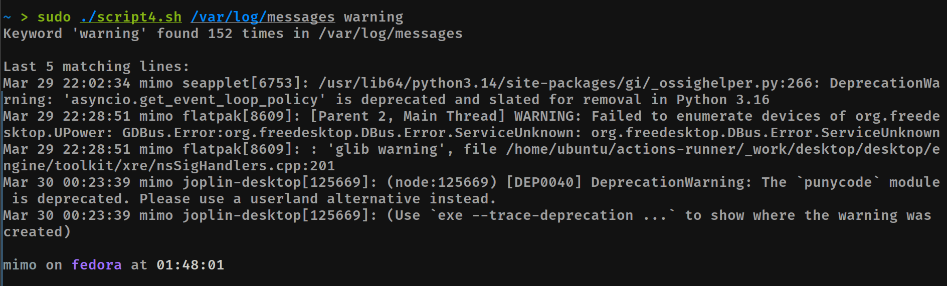
Figure 8 — Script 4 output: Log File Analyzer on /var/log/messages
Explanation
This script accepts a log file path as its first command-line argument ($1) and an optional keyword as the second ($2). If no keyword is provided, it defaults to 'error' using the ${2:-error} syntax, which is bash's default value substitution. A file existence check using [ ! -f "$LOGFILE" ] exits the script early if the file is not found.
The core logic uses a while IFS= read -r LINE loop, reading the file one line at a time. IFS= prevents leading and trailing whitespace from being stripped. The -r flag prevents backslash interpretation. Inside the loop, each line is checked against the keyword using grep -iq, where -i makes the match case-insensitive and -q suppresses output so only the exit code matters. Running this against /var/log/messages with the keyword 'warning' using sudo found 152 matches. The last five matching lines showed real system warnings from flatpak, Python, and joplin-desktop — a real log from my running system, not a constructed example.
Script 5 — Open Source Manifesto Generator

#!/bin/bash
# Script 5: Open Source Manifesto Generator

echo "Answer three questions to generate your manifesto."
echo ""

read -p "1. Name one open-source tool you use every day: " TOOL
read -p "2. In one word, what does 'freedom' mean to you? " FREEDOM
read -p "3. Name one thing you would build and share freely: " BUILD

DATE=$(date '+%d %B %Y')
OUTPUT="manifesto_$(whoami).txt"

echo "" > $OUTPUT
echo "On $DATE, I reflect on the power of open source." >> $OUTPUT
echo "Using tools like $TOOL, I experience the meaning of freedom as $FREEDOM." >> $OUTPUT
echo "I believe in building and sharing $BUILD to contribute to the open world." >> $OUTPUT
echo "Open source gives users control over what they use, allowing them to understand, modify, and contribute instead of just consuming." >> $OUTPUT

echo ""
echo "Manifesto saved to $OUTPUT"
echo ""
cat $OUTPUT

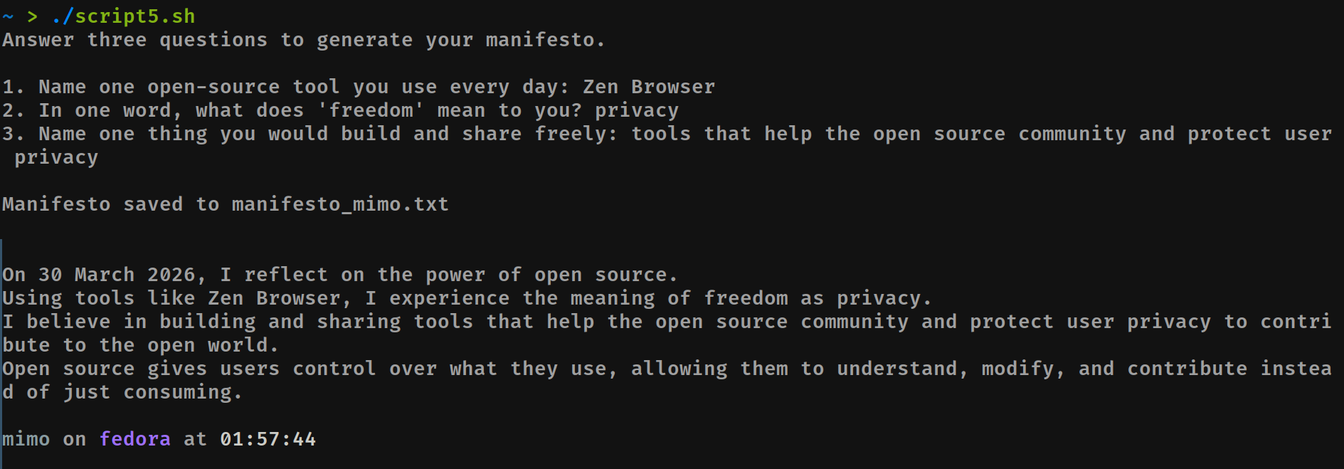
Figure 9 — Script 5 output: Open Source Manifesto Generator
Explanation
This is the most interactive of the five scripts. It uses read -p to prompt the user for three inputs and stores them in variables. The -p flag lets you specify the prompt string inline without a separate echo. The inputs are then composed into a personalised paragraph using string interpolation directly inside echo statements.
The output file is named dynamically using $(whoami) so each user who runs the script gets their own manifesto file. The > operator creates or overwrites the file. The >> operator appends each subsequent line. date '+%d %B %Y' formats the current date as day, full month name, and year. When run, the answers were: Zen Browser as the daily tool, privacy as the word for freedom, and tools that help the open source community and protect user privacy as what would be built. The manifesto was saved to manifesto_mimo.txt and printed to the terminal. The output reads naturally because the answers were genuine.

