Links to information
Information used for the research of this organization as well as the work for the website was obtained by through these links.

References
- Hashtag SA Unite (n.d.) Hashtag SA Unite. Facebook. Available at < https://www.facebook.com/hashtagsaunite > [Accessed 7 August].
- People4Impact (n.d.) People4Impact. Facebook. Available at: < https://www.facebook.com/people4impact > [Accessed: 10 August 2026].
- @Hashtag SA Unite, 2025. A SEAT AT THE TABLE. [Facebook]. 19 December. Available at :< https://www.facebook.com/share/p/1K527ZED5w/ > [Accessed 9 August].
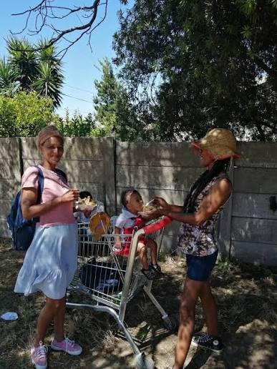

- Google, 2026. Google Maps. n.d. [App]. Available at: < https://www.google.com/maps/contrib/111315621420610668767/photos/@-33.909732,18.5780549,649m/data=!3m2!1e3!4b1!4m3!8m2!3m1!1e1?entry=ttu&g_ep=EgoyMDI2MDgxNi4wIKXMDSoASAFQAw%3D%3D > [Accessed 19 August].
- OpenAI, 2026. Chatgpt. GPT-5.3-mini model. [App]. Available at: <https://chatgpt.com/ >
[Accessed 19 August 2026].
- TenE. 2025. The Ultimate HTML Cheat Sheet. Dev Community, [blog] 27 March. Available at: < https://dev.to/tene/the-ultimate-html-tags-list-cheatsheet-3po4 > [Accessed 21 September 2026]
- Mozilla Developer Network (MDN), 2025. CSS: Cascading Style Sheets [online] Available at: < https://developer.mozilla.org/en-US/docs/Web/CSS > [Accessed 23 September 2026]
- @Hashtag SA Unite, 2026. DESTINY HELPERS: 3 YEARS OF FAITHFULNESS [Facebook] 26 June. Available at: < https://www.facebook.com/photo/?fbid=1330791345863816&set=pcb.133079157586379 > [Accessed 30 October 2026]
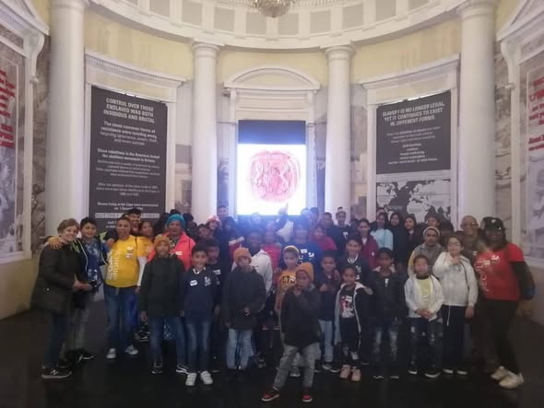
- @Hashtag SA Unite, 2026. DESTINY HELPERS: 3 YEARS OF FAITHFULNESS [Facebook] 26 June. Available at:< https://www.facebook.com/photo?fbid=1330791199197164&set=pcb.1330791575863793 > [ Accessed 30 October 2026]
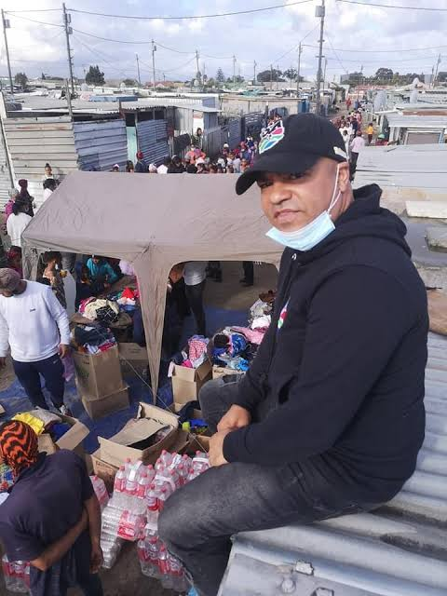

- @Hashtag SA Unite, 2026. HASHTAG SA UNITE: A SOCIAL – IMPACT MOVEMENT TRANSFORMING COMMUNITIES [Face book] 24 February. Available at : < https://www.facebook.com/photo/?fbid=1230679115875040&set=pcb.1230681075874844 > [Accessed 1 November 2026]
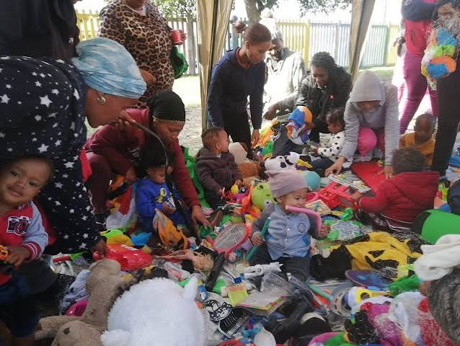

- @Hashtag SA Unite, 2026. HASHTAG SA UNITE: A SOCIAL – IMPACT MOVEMENT TRANSFORMING COMMUNITIES [Face book] 24 February. Available at : < https://www.facebook.com/photo?fbid=1230679175875034&set=pcb.1230681075874844 > [Accessed 29 October 2026 ]
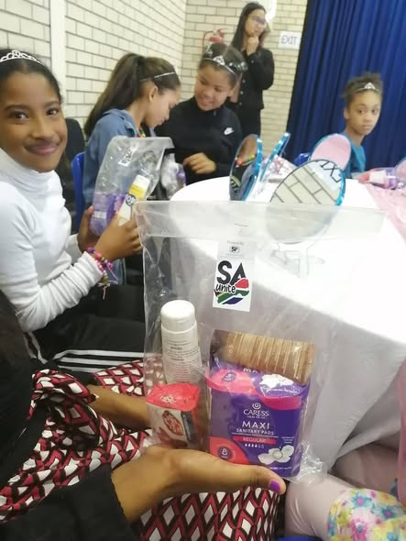

- @Hashtag SA Unite, 2025. A SEAT AT THE TABLE [Facebook] 21 December. Available at : < https://www.facebook.com/photo/?fbid=1180651184211167&set=pcb.1180653994210886 > [Accessed 2 November 2026 ]
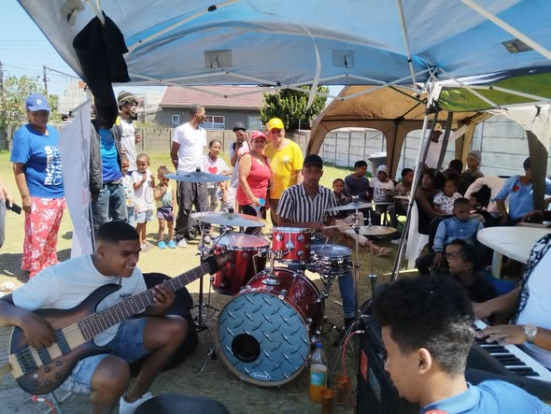

- @Hashtag SA Unite, 2025. A SEAT AT THE TABLE [Facebook] 17 December. Available at : < https://www.facebook.com/photo/?fbid=10162152369102227&set=pcb.10162152372517227 > [Accessed 2 November 2026 ]
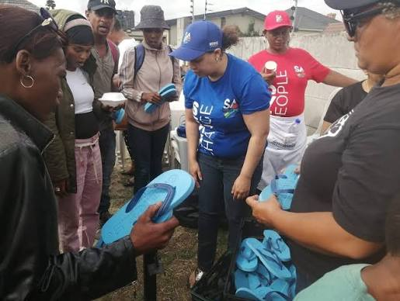

- @Hashtag SA Unite, 2025. A SEAT AT THE TABLE 1000 LIVES.ONE DAY OF DIGNITY [Facebook ] 15 December. Available at : < https://www.facebook.com/photo/?fbid=10162149067617227&set=pcb.10162149068902227 > [Accessed 2 November 2026 ]


