Insulin: The marvel in the world of diabetes.
We are living in the world of pandemic and several health crises across the world. Diabetes is one of the major diseases that has high impact on health of human being. Diabetes mellitus is a metabolic disorder which features abnormalities in carbohydrates, lipid, fat metabolism and thereby increases blood sugar level. (diabetes- Greek word meaning siphon - to pass through Mellitus-Latin word meaning honeyed or sweet.) This is because in diabetes excess sugar is found in blood as well as the urine.
In ancient era, diabetes would become a death sentence. Earlier time general practitioners trying to treat high blood sugar level (BSL) but they couldn't lower the BSL. But in this 21st century we have strong weapon to fight against disease that we called it as 'Insulin'.
In 21st century I mean digital world we are widely uses different tools to manage diabetes. But no one stronger tool than insulin therapy to improve quality of life of diabetic once (specially for type 1 diabetes mellitus)
However, the insulin is single strategic tool to fight against Diabetes. Many peoples want to know more about discovery of miraculous molecules i.e. Insulin
Before insulin was discovered in 1921, people with diabetes didn’t live for long; there were no option to healthcare professionals. In this time only one way is available to lower the BSL as to keep patient on dietary modification. Dietary modification may include strictly avoidance of carbohydrate intake. These types of modifications require much time and has low therapeutic outcomes.
Nowadays we have good option in the form of insulin. So how did this miraculous molecule in the world of diabetes discovered? Let’s have a look in the past events (more than 100 years ago)

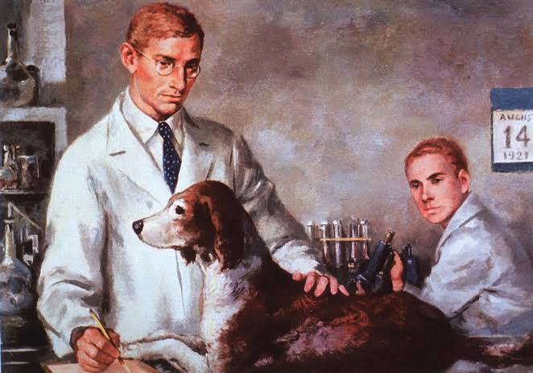
The idea of pancreatic substances I.e. insulin was produced by pancreas was put forth by two German researchers, Oskar Minkowski and Joseph von Mering in 1889. They remove pancreas gland from the animals(dogs) and found that animals developed symptoms of diabetes and died soon afterward.
An illustration of Canadian scientists Frederick G. Banting and Charles H. Best in the laboratory, testing insulin on a diabetic dog, August 14, 1921.
Sourse: Courtesy of the National Library of Medicine, Britannica.

In 1910, Sir Edward Albert Sharpey- Shafer stated that one chemical substance is produced from pancreas gland which has main role in the maintenance of BSL. This chemical product secreted from islets of Langerhans (hormone producing cells)
He decided to call this chemical insulin (Latin word insula, meaning “island.”)
So, what happened next? Something truly amazing. In 1921, Sir Frederick Banting and his assistant Charles Best was found a way to remove insulin from a dog’s pancreas. Later it was found that the stuff removed which looked like “thick brown muck,” but little did they know this would lead to life and hope for millions of people having DM.
With this several efforts, Banting and Best did research on another dog with severe diabetes alive for 70 days—the dog died only when there were no more extracts. So, researchers decided to continue work. Banting & Best along with the help of colleagues J.B. Collip and John Macleod, were extracted a clear form of insulin (from the pancreas of cattle)
Next step of research was to administer preparation of insulin. The first person who administered insulin was Leonard Thompson, a 14-year-old in Toronto hospital. It was found that after administration of injection insulin, blood glucose levels dropped to near-normal levels.
For research on this miraculous molecule, Sir Banting & MacLeod received Nobel prize in medicine. Which they shared with Best and Colip in 1923.
Post research era, no. of pharmaceutical companies come forward to take responsibilities of production of insulin. Eli Lilly got the opportunity and started large-scale production of insulin. Due to low production rate in starting phase, insulin produced was not enough to supply the entire North American continent. Then no. of manufacturers developed a variety of slower-acting insulins, the first introduced by Novo Nordisk Pharmaceuticals, Inc., in 1936.
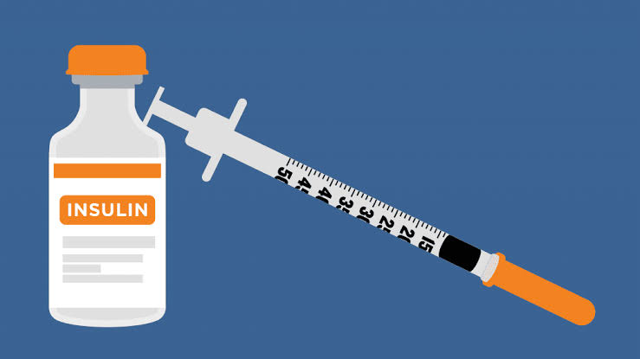
In the previous time insulin used was extracted from pigs. In 1978, first genetically engineered, synthetic “human” insulin was produced using E. coli bacteria to produce the insulin. Eli Lilly started commercial production of biosynthetic human insulin under the brand name Humulin and distributed across the world.

Nowadays insulin is available in various form viz short acting to ultra rapid acting insulin. We should thanks to those researchers who did it possible. Because of them we can save life of diabetic patient. Insulin may not be a cure for a disease condition but it has important role in the form of life saver from death sentence I.e. diabetes mellitus. Various form of insulin available viz. Humalog to Novolog and insulin pens to pumps, insulin has come a long way.
So, have you learnt more about miraculous molecules???? Scientist till now working on various aspects of Insulin and they will ask to scientific community that what's next for insulin?

Types of work: Blog
Name of Author: Ashok Giri
Designation: Student
College Name: Shivlingeshwar College of Pharmacy (B. Pharm & Pharm.D) Almala Dist. Latur(MH)

