UNIFIED MENTOR PVT. LTD. · DATA ANALYST INTERNSHIP · MANUFACTURING CATEGORY
Executive Summary
AI-Based Manufacturing Efficiency Classification
Thales Group business scenario · Post-evaluation validated portfolio version

100,000  machine readings analyzed | 50  machines in the supplied dataset | 77.8%  records labelled Low
2  rule disagreements in 100,000 records | 1.000  rule Macro F1 on final holdout | 12/12  automated sanity checks passed

Purpose
This Unified Mentor Manufacturing-category project evaluates current manufacturing efficiency classification using production, quality, sensor, maintenance and network telemetry. The Thales Group name is used as the business scenario for the portfolio case study; this document does not represent an official Thales engagement or production deployment.

Original Evaluation and Why the Project Was Revisited
The original internship submission received an 8/10 (Excellent) evaluation. The evaluator praised the breadth of the 100,000-record manufacturing dashboard but recommended stronger model evaluation because the target is highly imbalanced and very high agreement or confidence can overstate minority-class performance.
Key validation finding: The post-evaluation audit uncovered a deeper issue: the supplied Efficiency_Status label is almost entirely reconstructable from contemporaneous Error_Rate_% and Production_Speed_units_per_hr. Near-perfect ML performance must therefore be interpreted as current-state rule reconstruction, not as independent future predictive capability.

Data Quality
The audited source contains 100,000 timestamped observations across 50 machines from 1 January to 10 March 2025. No missing values and no duplicate rows were found. The target distribution is strongly imbalanced: 77,825 Low (77.8%), 19,189 Medium (19.2%) and 2,986 High (3.0%).

What the Data Supports
The strongest supported result is a transparent current-state decision rule. Across the full dataset, the rule below disagrees with only two logged labels. Those two records sit exactly at the 5.0% error-rate boundary, indicating a likely boundary/rounding inconsistency rather than broad model uncertainty.
Condition | Current-state classification
Error Rate > 5% OR Production Speed < 200 units/hr | Low
Error Rate ≤ 2% AND Production Speed ≥ 400 units/hr | High
Otherwise | Medium
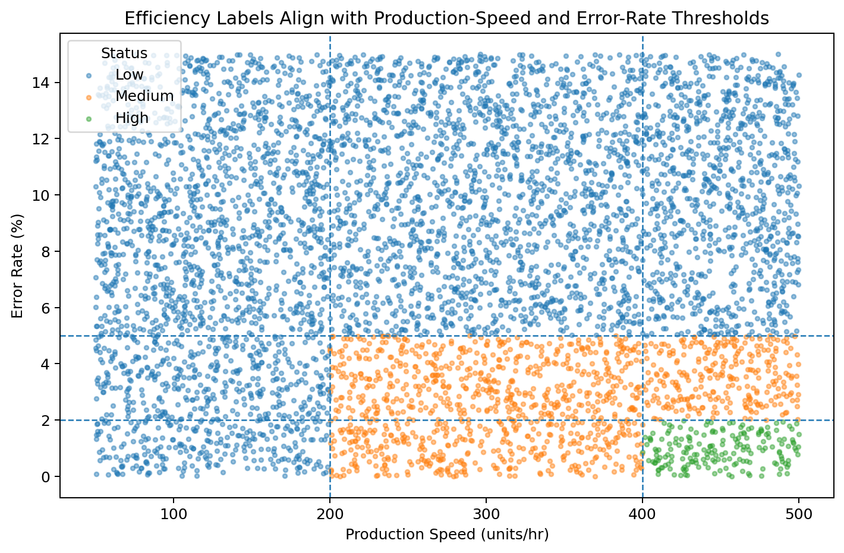
Figure 1. Error rate and production speed nearly reconstruct the supplied current-state efficiency label.

Final Holdout Benchmark
Method | Accuracy | Balanced Acc. | Macro F1
Majority baseline | 77.995% | 33.333% | 29.212%
Transparent rule | 100.000% | 100.000% | 100.000%
Logistic Regression | 88.150% | 90.009% | 82.012%
Random Forest | 100.000% | 100.000% | 100.000%
XGBoost | 99.755% | 99.756% | 99.680%

Accuracy is deliberately reported alongside balanced accuracy and Macro F1. A majority-only classifier already reaches about 78% accuracy, demonstrating why headline accuracy alone is not sufficient for this dataset.

Why the Near-Perfect ML Scores Need Context
Feature ablation tests whether strong model performance survives after target-defining information is removed. Removing only the two direct rule variables is not a fully independent test because derived ratios still encode them. The decisive test removes both direct and derived rule-linked features.
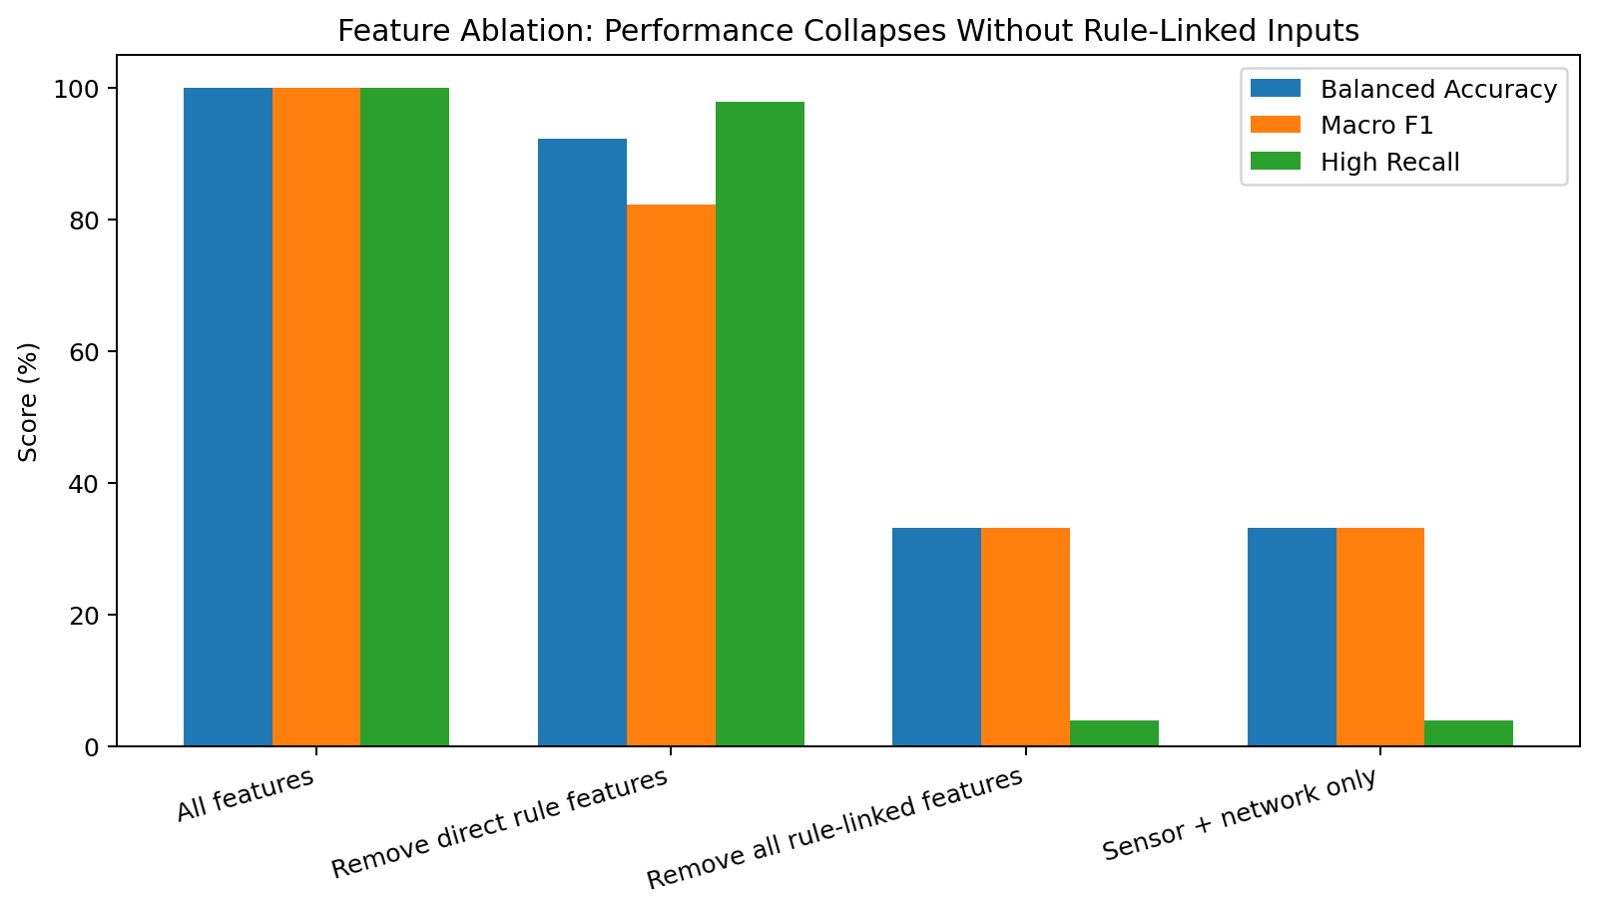
Figure 2. Balanced performance collapses when all direct and derived rule-linked features are removed.
With sensor/network-only features, balanced accuracy falls to 33.2%, Macro F1 to 33.1%, and High-class recall to 3.9%. This supports the conclusion that the remaining telemetry carries little independent signal for the supplied label.

Future Prediction Was Tested - and Rejected
The project separately tested whether current machine state and telemetry support future-efficiency forecasting. Consecutive observations for a machine are irregularly spaced (median 34 minutes; maximum 514 minutes), so next-row horizons are not fixed clock-time forecasts. Across next-observation and longer observation-step checks, status persistence is essentially what would be expected by chance.
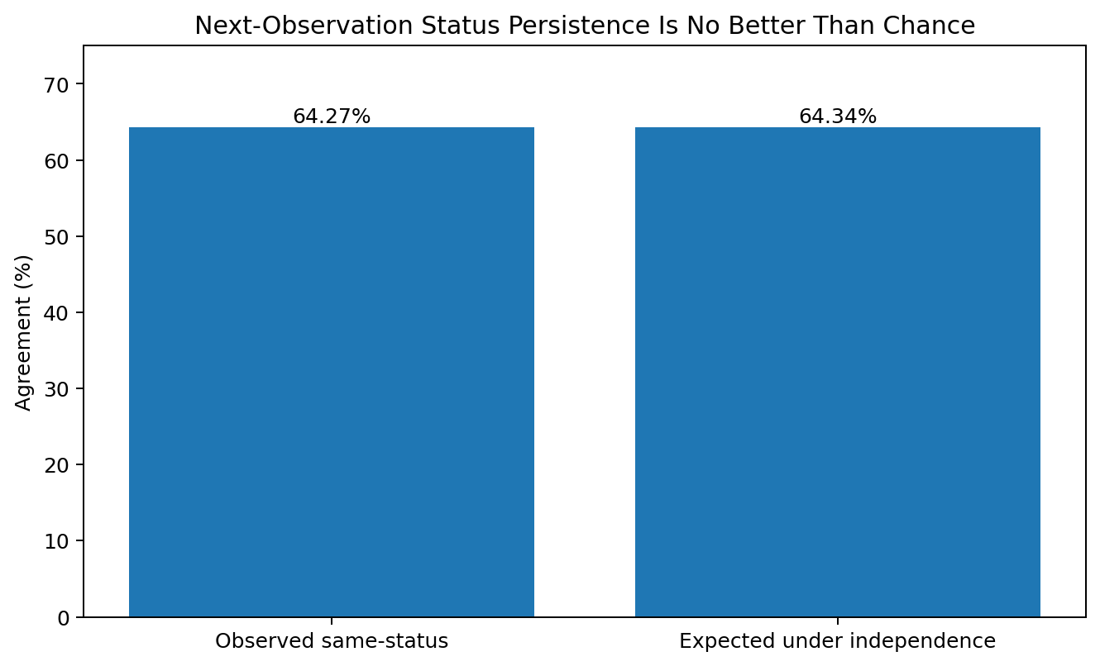
Figure 3. Next-observation status persistence is effectively indistinguishable from chance agreement.
Decision: The final project does not claim predictive maintenance, future-risk prediction or causal sensor/network effects. The supported use cases are descriptive analytics, current-state classification, validation, explainability and operational monitoring.

Delivered Dashboard
The revised Streamlit application is organized around five project-specific modules and makes the methodology limitation visible to the user rather than hiding it behind model confidence scores.
- Current-State Classification - transparent business rule plus Logistic Regression, Random Forest and XGBoost benchmarks; manual what-if inputs and filtered-batch agreement checks.
- Machine Insights - machine-level historical patterns, rankings and summary views.
- Explainability - SHAP and model-attribution views interpreted as current-state model explanations, not causal drivers.
- Operational Monitoring - operation-mode, network-reliability and threshold-based current-state monitoring.
- Model Validation - class imbalance, baselines, chronological validation, ablation and temporal-signal limitations.

Recommendations
- Use the transparent business rule as the primary decision method for the supplied current-state label; it is simpler, auditable and directly reproduces the target definition.
- Retain Random Forest, XGBoost and Logistic Regression as benchmark models for demonstrating modeling, probability diagnostics and explainability - not as evidence of future risk prediction.
- Use sensor and network telemetry for descriptive operational monitoring unless a future dataset demonstrates independent predictive value.
- Before any real manufacturing deployment, obtain live plant data with clear label provenance, fixed sampling intervals, independently defined outcomes and an explicit prediction horizon.
- Re-run target audits, feature ablation, temporal validation and calibration checks whenever the labeling policy or data-generation process changes.

Conclusion
The most important outcome of this project is analytical validation rather than the 100% Random Forest score. The post-evaluation rebuild explains why the score occurs, separates current-state rule reconstruction from genuine prediction, and converts the original dashboard into a more defensible portfolio case study. The result demonstrates an end-to-end Data Analyst workflow: data quality, EDA, feature engineering, baseline design, model benchmarking, imbalance-aware evaluation, temporal validation, ablation, explainability, dashboarding and automated testing.
Project status: Original Unified Mentor evaluation: 8/10 - Excellent. The current documents describe the later post-evaluation remediation and should be read as the validated portfolio version.

